SPRINGBOOT INTERVIEW QUESTIONS
1.Why springboot over spring?
Spring Boot-la dependency management romba easy. Version conflicts varaadhu, embedded Tomcat irukardhunala deployment fast-ah irukkum, and configuration-kaga extra effort edukka vendam.
1.dependency resolution
2.avoid additional configuration eg – anda web.xml and spring-servlet.xml
3.embed server tomcat no need for WAR
4 prod ready features suchs as metrics,health checks
2.What are the springboot starter you have used ?
3.How will you run you spring boot application?
We can run using the ide and initially jar will not be ther in target folder then how it will run so it first go target-clases- youmainclass it triigger
After build you get snapshot inside that you have manifest.mf file inside that you every things that needs to trigger you app

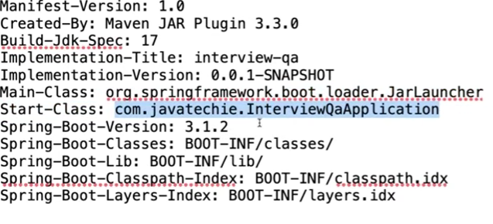
What is the purpose of @Springbootapplication?
@Configuration , @ EnableAutoConfiguration @ComponentScan
Componentscan identify the bean app context create obj and manage
Appcontext is contiainer it does bean create , store , and manage
@EnableAutoConfiguration
Scan the package to detect the bean eg service , component ,
Autoconfiguration ( actullay pom file la irukura dependency check pannum)
Spring Boot-la Auto Configuration enbadhu oru super feature. Idhu yenna pannum na, ungala oda dependency mathum class path-la irukura files-a vachi, ungala application-kku enna configuration thavaiyo, adha automatically set pannidum. Neenga ellathaiyum manual-a configure panna vendiya avasiyam illai.
Idhu yeppadi velai seiyudhu nu pakka, neenga debug=true nu application.properties-la set panni parthakale, positive matches mattum negative matches nu rendu categories-la enna configure aagudhu, yedhu aagala nu clear-a theriyum.
Auto configuration class-la pala conditions irukkum. Oru specific feature-a enable panna, Spring Boot sila conditions check pannum. Udaharanathukku, Jackson Auto Configuration panna, object mapper class class path-la irukanum nu condition irukkum. Edhavadhu oru jar file missing na, adhu negative match-la vandhudum.
Oruvela ungala-kku oru auto configuration vendam nu ninaicha, neenga adhai disable pannalam. Idhai exclude attribute use panni main class-la pannalam, illana properties file-la spring.autoconfigure.exclude nu kuduthu kuda exclude pannalam.
Summa sollum na, Spring Boot background-la ella logic-aiyum check panni, namma kodukura dependency-kku ethapola default setup-a ready panni kuduthudum. Idhunaala namma time romba micham aagudhu.
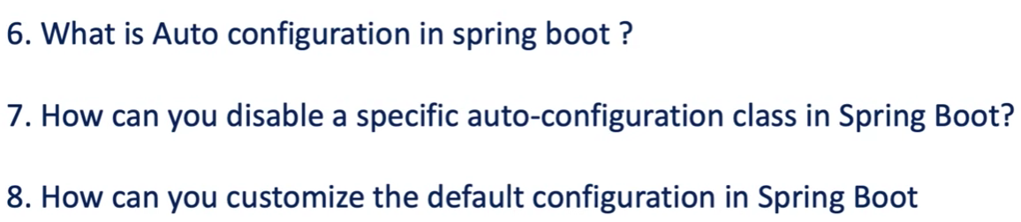
Ques – 7 two way to exclude below is one and another is in app.prop
Ques – 8 overide the default port in app.prop and app.yml
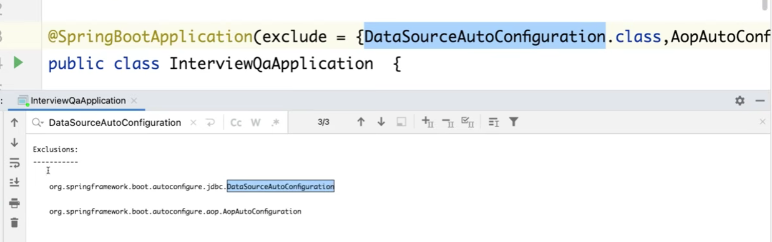
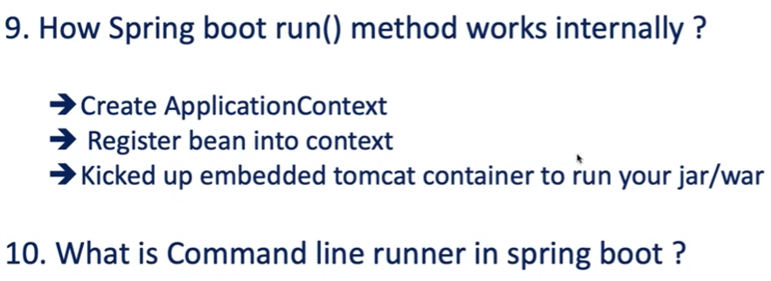

Ques 9
Spring Boot-la run() method yeppadi work aagudhu nu author ivlo vishayangala explain panni irukkar:
Main Process:
- Application Context Creation: Namma main method-la irundhu SpringApplication.run() call pannum pothu, adhu mudhala oru ApplicationContext-a create pannum. Idhu thaan spring container-oda heart.
- Environment Setup: Context create panradhuku munnadiye, adhu namma system environment properties ellathaiyum load pannidum.
- Application Type Checking: Namma add panni irukkura dependency vachi, idhu Servlet web application-a, Reactive application-a, illana normal Standalone application-a nu check pannum. Adhukku etha madhiri correct-ana context factory-a choose pannum.
- Bean Registration: Appuram, namma code-la irukura @Component, @Service, @Controller mari annotations-a scan panni, athai ellathaiyum beans-a context-la register pannum.
- Embedded Server Startup: Ellam ready anadhum, embedded Tomcat server-a start panni, namma application-a deploy pannum. Ithu ellathaiyum automatic-a backend-la handle pannidudhu.
Summary: Sollanum na, run() method thaan namma application-oda full lifecycle-a manage pannudhu. Environment-a load panni, context-a create panni, beans-a register panni, kadasiya tomcat server-a run panni, namma app-a live-la kondu varudhu.

Ques 10
The author explains that CommandLineRunner in Spring Boot is an interface used to execute specific logic automatically when the application starts up (1:07:51).
Key takeaways regarding CommandLineRunner:
- Purpose: It is ideal for running pre-processing tasks, such as establishing database connections, populating initial data, or any setup logic required immediately after the application context is ready (1:08:02 - 1:09:54).
- Implementation: Since it is a functional interface, you can implement it in your main class or a separate bean by overriding its run method (1:08:44).
- Execution Order: A common interview point the author clarifies is the execution order: the SpringApplication.run() method executes first, and then the CommandLineRunner's run method is triggered (

