Flaky order APP

The application I've tried has several issues. One of them is that when opening a link, the user is redirected to a login page that hasn't been created in HTML format yet.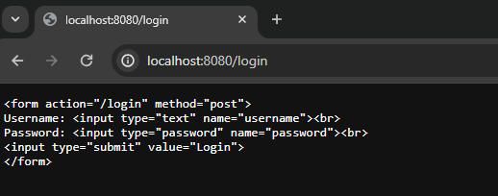

Issue: Inside fmt.Fprint, there is no content-type specified as HTML. In order to render HTML in Go, we need to add the content type text/html to all HTML responses.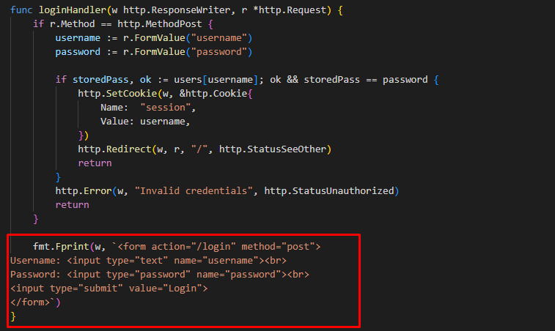

Solution 1: Setting Content-Type Header: Add the Content-Type: text/html header to all HTML responses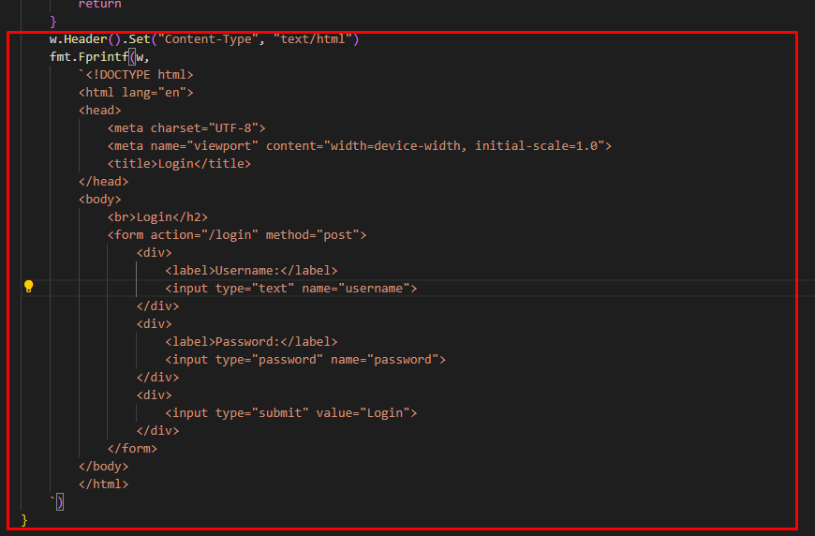

Alternative Solution: Creating a Page Redirecting to login.html

The loginPagePath function, which uses filepath.Abs(filepath.Join("static", "login.html")), is used to combine the relative path to the HTML login page with the root directory and return the absolute path. This ensures that the web server can always find the login.html file regardless of the current working directory when the application is running.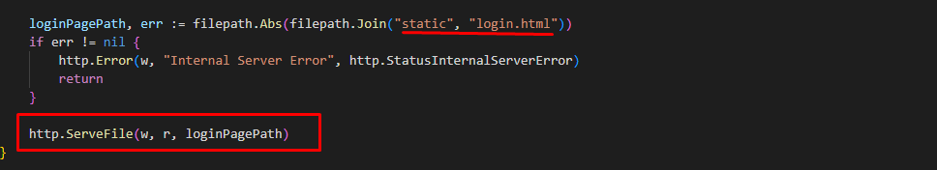

Next, we create a static folder containing the login.html file

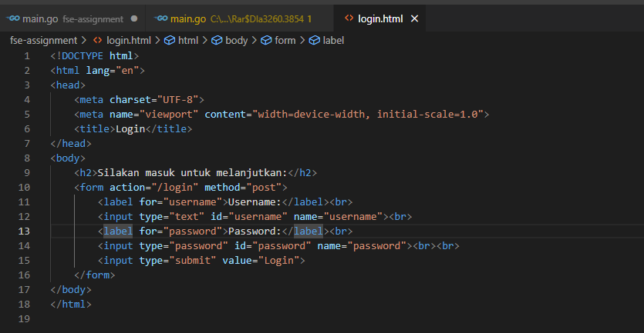

Output :

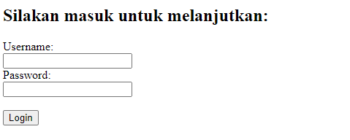

Issue with Product Cart:

1. In the checkoutHandler, if a product is not available in products, this is not handled properly.
2. If a user tries to add a non-existent product to the cart, the application still adds it.
3. In the unrevised code, there are HTML links that haven't had their content-type set

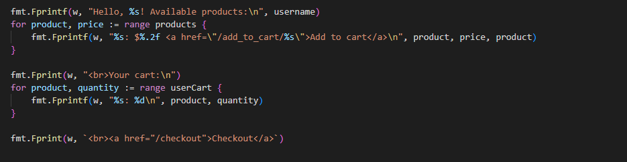

Solution: Setting Content-Type to HTML and Improving UI for Product Cart

1. Add the Content-Type: text/html header to ensure proper rendering of HTML.
2. Improve the user interface (UI) for the product cart to provide a better user experience.

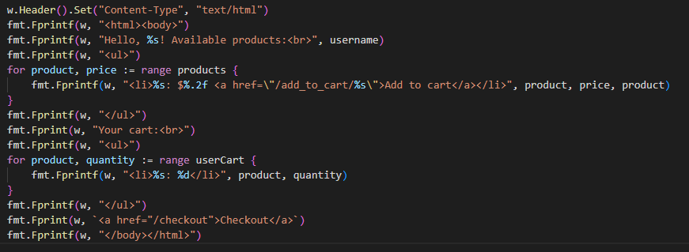

Output :

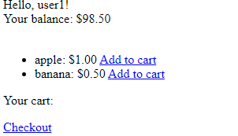

Checkout Page:

To fix the issue of the total price of products not being displayed and the information not appearing on the HTML page, we need to modify the checkoutHandler function to display the total and empty the cart after checkout. Additionally, we also need to update the HTML page to display this total price information on the checkout page.

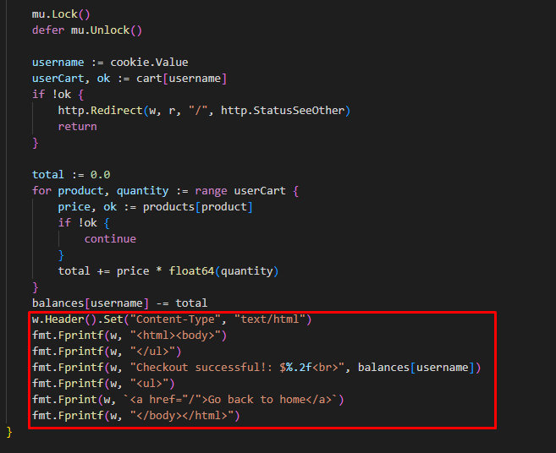

Proses Checkout

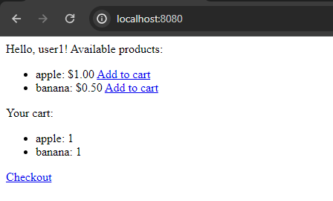

Output :

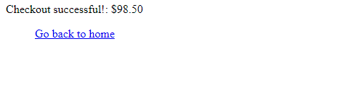

**Security Vulnerabilities and User Experience Improvements**

1. **Security Vulnerabilities:**

* The website still uses HTTP, it would be better to switch to the HTTPS format for enhanced security.
* Handling of Passwords: Storing passwords in plaintext within the code in the users variable poses a security risk.
* Authentication: The current authentication system only uses the POST method without considering security measures such as protection against brute force attacks, man-in-the-middle attacks, or secure session management.

1. **User Experience:**

* Checking User Balances: Users' balances are checked to cover their total purchases. If the balance is insufficient, users receive an "Insufficient balance" error message.
* Handling of Invalid Products: There is no validation for invalid products added to the cart.
* Emptying Cart after Checkout: The cart is not emptied after checkout.
* Lack of Feedback during Checkout: There is a lack of feedback on the checkout page. After checkout, users receive no feedback regarding the success or failure of the transaction. Users may not know if their purchase was successful or if there was an error during the checkout process.