Hospital Readmission Prediction

(Machine Learning)

Prepared by:
Hari Gharti Magar

Contents
Introduction: 3
Dataset Overview 3
Exploratory Data Analysis (EDA) 4
Pre-processing & Feature Engineering 4
Model Training 5
Model Evaluation 6
Limitations 8
Future Improvements 8
Conclusion 9

Introduction:
Hospital readmissions within 30 days are a major operational and financial challenge for healthcare systems.
Predicting which patients are at high risk enables:
- Better resource planning
- Early interventions
- Reduced pressure on emergency services
- Improved patient outcomes
This phase focuses on building a machine learning model to predict 30‑day readmission using the UCI Diabetic Readmission dataset.
Dataset link:
UCI Diabetic Readmission Dataset
https://archive.ics.uci.edu/dataset/296/diabetes+130-us+hospitals+for+years+1999-2008

Dataset Overview
The dataset contains 101,766 hospital encounters for diabetic patients across 10 years.
Key Characteristics:
- Rows: 101,766
- Columns: 50
- Target variable: readmitted_30
- Positive class: ~11% (highly imbalanced)
- Feature types:
- Demographics
- Diagnosis codes (ICD‑9)
- Medication changes
- Visit history
- Lab results
Data Protection & Privacy:
This project uses publicly available, fully anonymised datasets. No personal or identifiable patient information was accessed, so data protection regulations such as GDPR and the UK Data Protection Act do not apply.
Challenges
- Missing values represented as "?"
- High‑cardinality categorical variables
- Imbalanced target
- No clinical notes or time‑series data

Exploratory Data Analysis (EDA)
Key Findings
- 37 categorical variables
- Several columns with >80% missing values
- Diagnosis codes contain hundreds of unique ICD‑9 categories
- Target imbalance:
- 0: 90,409
- 1: 11,357
Recommended Screenshot Locations
- Missing values summary
- Target distribution plot
- Sample of raw dataset

Pre-processing & Feature Engineering
Handling Missing Values
- Replaced "?" with NaN
- Dropped columns with extremely high missingness
- Filled categorical missing values with "Unknown"

Target Engineering
Converted original readmitted column into binary:
<30 → 1
NO → 0
>30 → 0
Encoding
- Converted categorical columns to category dtype
- Applied one‑hot encoding
- Cleaned column names for XGBoost compatibility
Scaling
- Applied StandardScaler to numeric features
- Ensured target column remained untouched
Saving the Processed Dataset
The final ML‑ready dataset was exported for model training.
Saved to:
data/processed/processed_diabetic_data.csv
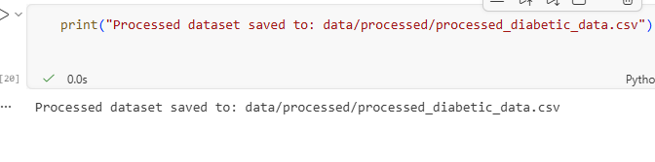
Fig 1. Processed dataset saved to the project directory

Model Training
Models Evaluated
- Logistic Regression
- Random Forest
- XGBoost (Best Performer)
Best Model Performance (XGBoost)
Metric | Score
Accuracy | 0.889
ROC-AUC | 0.693
Precision | 0.633
Recall | 0.016
F1 Score | 0.032

Interpretation
- High accuracy due to class imbalance
- Low recall indicates difficulty identifying positive cases
- ROC‑AUC of 0.693 shows moderate predictive power
Saved Model
models/xgb_readmission.pkl
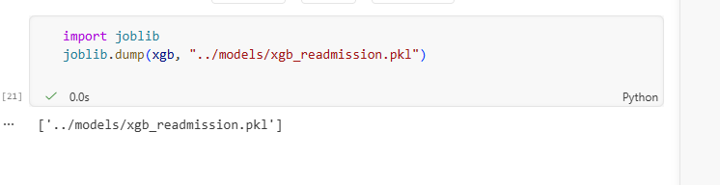
Fig 2. Final trained model saved as a .pkl file for deployment and evaluation.

Model Evaluation
Confusion Matrix
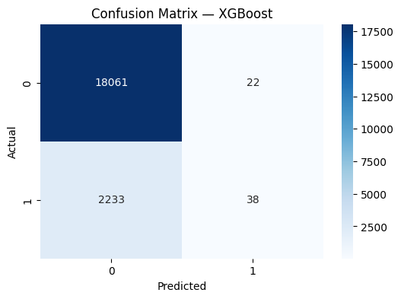
Fig 3. Confusion Matrix showing model performance on test data
Shows strong prediction of majority class but limited detection of readmissions.
Classification Report
- Precision is acceptable
- Recall is low
- F1 score reflects imbalance
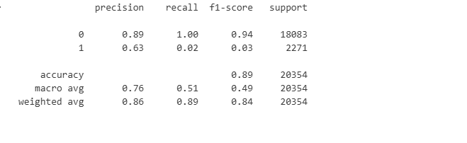
Fig 4. Classification report with precision, recall, and F1-score
ROC Curve
XGBoost achieved the highest AUC (~0.693).
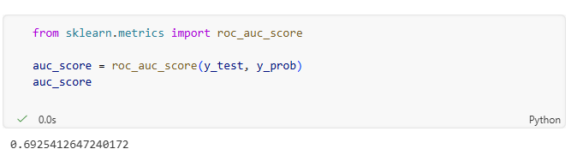
Fig 5. ROC curve showing model discrimination ability.

Precision‑Recall Curve
Confirms difficulty in identifying minority class.
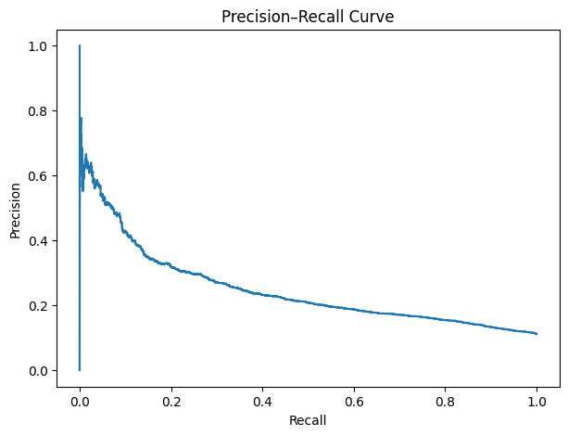
Fig 6. Precision-Recall curve for imbalanced classification.
Calibration Curve
Model moderately calibrated but under‑predicts risk.
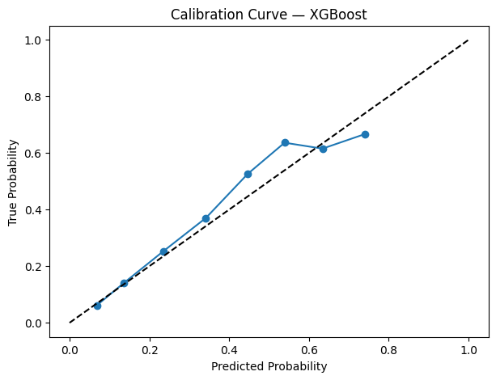
Fig 7. Calibration curve showing probability calibration.

Feature Importance
Feature importance was not included because the evaluation notebook focused on performance metrics and probability-based evaluation plots.

Limitations
- Severe class imbalance
- High‑cardinality diagnosis codes
- Dataset originates from US hospitals (not NHS)
- No clinical notes or time‑series data
- Limited recall for positive class

Future Improvements
- Apply SMOTE or class‑weighting
- Hyperparameter tuning for XGBoost
- Add SHAP explainability
- Deploy via FastAPI
- Integrate predictions into Power BI
- Explore NHS‑specific datasets

Conclusion
Phase 2 successfully delivers a complete machine learning pipeline for predicting 30‑day hospital readmission.
Combined with Phase 1 (NHS A&E Dashboard), this project demonstrates:
- End‑to‑end data engineering
- BI reporting
- Predictive modelling
- Healthcare analytics capability

