A&E Performance Dashboard Report

NHS England

March 2026
(Revised 14.05.26)

Prepared by:
Hari Gharti Magar

Power BI Dashboard & Analytical Report Urgent and Emergency Care – NHS England

Contents
1. Executive Summary 1
2. Data Source 1
3. Purpose of the Dashboard 1
4. Methodology 1
4.1 Data Preparation 1
4.2 Data Modelling 1
4.3 Measures (DAX) 2
5. Key Performance Indicators (KPIs) 2
5.1 Total A&E Attendances 2
5.2 Emergency Admissions 2
5.3 4 Hour Performance 2
5.4 ICB Level Metrics 2
6. Dashboard Overview 2
6.1 Full Dashboard Screenshot 2
6.2 KPI Row Screenshot 3
6.3 Charts Section Screenshot 3
7. Key Insights 4
7.1 National Demand 4
7.2 4 Hour Performance 4
7.3 High Pressure ICBs 4
7.4 Flow Bottlenecks 4
8. Limitations 4
9. Recommendations 4
10. Appendix 4

1. Executive Summary
This report provides a comprehensive analysis of Accident & Emergency (A&E) performance across NHS England for March 2026, using the official NHS England Monthly A&E dataset (Revised 14.05.26). The analysis highlights national demand, system pressures, 4 hour performance, and variation across Integrated Care Boards (ICBs). The accompanying Power BI dashboard enables operational leaders to monitor performance, identify bottlenecks, and support data driven decision making.

2. Data Source
This report uses the official NHS England dataset:
Monthly A&E Time Series — March 2026 (Revised 14.05.26)
Source: NHS England — A&E Attendances and Emergency Admissions
Statistics » A&E Attendances and Emergency Admissions 2025-26
The dataset includes national, regional, and provider level metrics for A&E attendances, emergency admissions, and 4 hour performance.

3. Purpose of the Dashboard
The dashboard was developed to:
- Provide a clear, interactive view of A&E performance
- Highlight operational pressures across ICBs
- Support urgent and emergency care planning
- Enable comparison across regions and systems
- Offer a single source of truth for monthly A&E reporting
This aligns with NHS England’s operational priorities for urgent and emergency care improvement.

4. Methodology

4.1 Data Preparation
- Cleaned missing or incomplete values
- Standardised ICB names and codes
- Converted date fields to correct formats
- Ensured numeric fields were properly typed

4.2 Data Modelling
A simple star schema model was used:
- Fact Table: A&E activity and performance metrics
- Dimensions: ICB, region, date

4.3 Measures (DAX)
Key measures created:
- Total Attendances
- Total Emergency Admissions
- 4 Hour Performance %
- Attendances by ICB
- Admissions by ICB
These measures power the dashboard visuals.

5. Key Performance Indicators (KPIs)

5.1 Total A&E Attendances
Represents total patient attendances across all A&E services.

5.2 Emergency Admissions
Number of patients admitted following an A&E attendance.

5.3 4 Hour Performance
Percentage of patients seen, treated, admitted, or discharged within 4 hours.

5.4 ICB Level Metrics
Breakdown of performance across Integrated Care Boards to identify variation and system pressures.

6. Dashboard Overview

6.1 Full Dashboard Screenshot
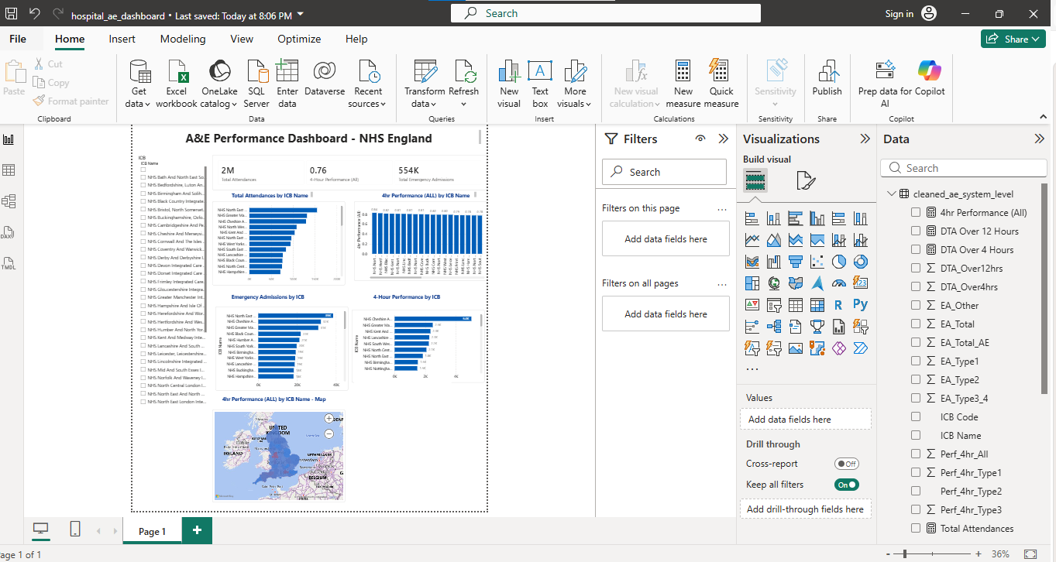
Description: This provides a high level overview of A&E activity, admissions, and 4 hour performance across NHS England.

6.2 KPI Row Screenshot
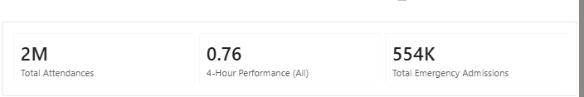
Description: Displays headline metrics including total attendances, emergency admissions, and 4 hour performance for March 2026.

6.3 Charts Section Screenshot
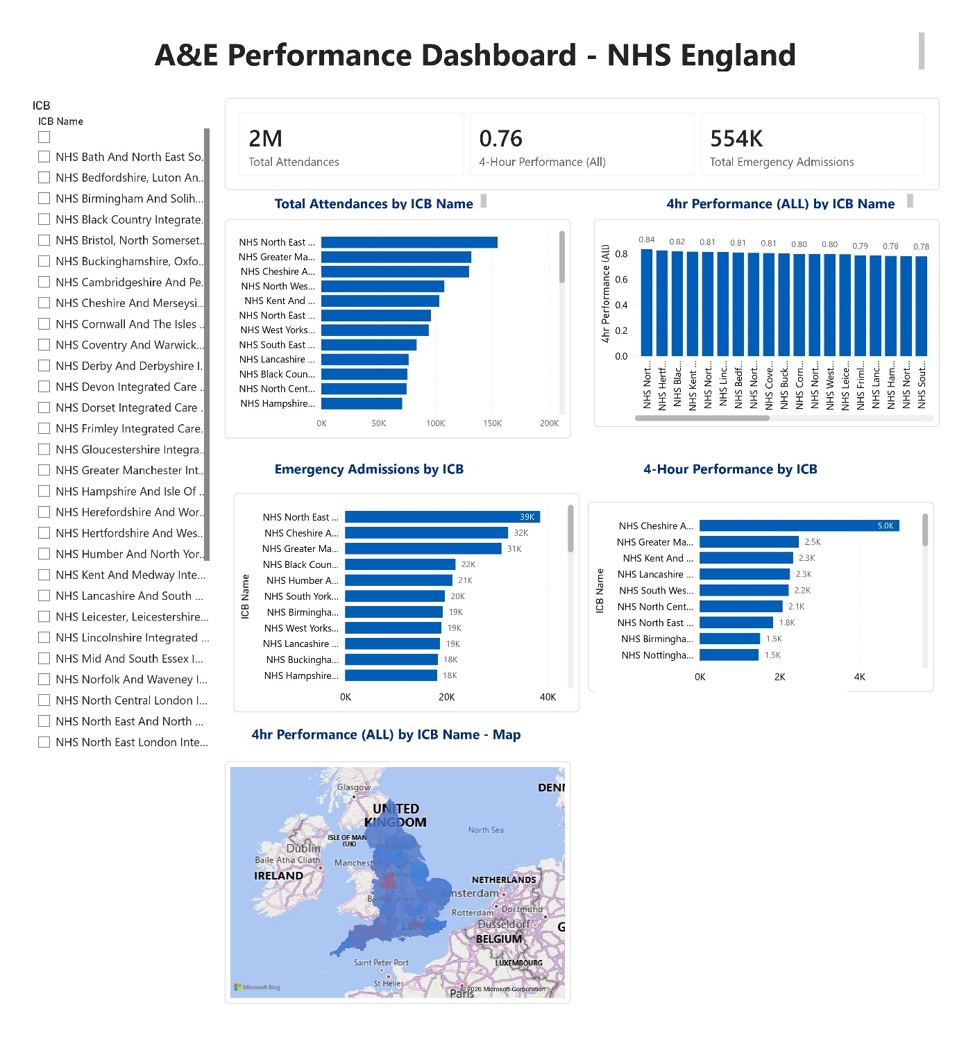
- Attendances by ICB
- Emergency Admissions by ICB
- 4 Hour Performance by ICB
These visuals highlight variation and identify systems under pressure.

7. Key Insights

7.1 National Demand
A&E attendances remain high, indicating sustained pressure on urgent care services.

7.2 4 Hour Performance
Performance remains below the national standard, with significant variation across ICBs.

7.3 High Pressure ICBs
Some ICBs show high attendances and high emergency admissions, suggesting increased operational strain.

7.4 Flow Bottlenecks
Lower 4 hour performance correlates with:
- High bed occupancy
- Delayed admissions
- Workforce constraints

8. Limitations
- Monthly data does not capture real time operational pressures
- Provider level granularity varies
- Dataset revisions may alter historical values

9. Recommendations
Short Term
- Focus operational support on high pressure ICBs
- Improve discharge processes to reduce bed occupancy
- Strengthen triage and streaming pathways
Long Term
- Expand urgent treatment centres
- Invest in digital flow tools and predictive analytics
- Enhance workforce planning for emergency care

10. Appendix
A. Dataset Revision Notes
The March 2026 dataset was revised on 14 May 2026 following updated provider submissions.
B. Tools Used
- Power BI
- DAX
- NHS England Open Data
- GitHub for version control

