Classification of Disaster Tweets using NLP

Team: Manasa Hari, Amit Kamboj, Feiyu Cai, Tushar Sharma

**Abstract** — Twitter has been the most important part of digital communication these days. It has been the channel of communication across the world for daily news starting from television gossips to case-of-emergency news. But due to large amounts of data flooding into the twitter base every minute, sometimes, a highly important piece of news such as a disaster occurrence can be submerged amidst not at all important tweets. Due to this, it may take days or even weeks before the disaster news reaches to people, meanwhile, a huge irrevocable loss can happen already. This project aims to highlight the disaster emergency news so that users can be constantly notified on the emergency issues out of millions of other tweets. We take the challenge to build a machine learning model that classifies between tweets about real disasters and the rest. The key challenge is to distinguish metaphorical usage of tragedy vocabulary and the real intended usage of disaster terms. For example, a user tweets ‘Thoughts are a storm, unexpected’. This is clearly a metaphorical statement. Even though it is obvious for humans to interpret that this tweet is not about a real disaster, but it is less clear to a machine. This problem is also an actively ongoing Kaggle competition. We want to explore possible predictors and conclude on the right predictors to solve this classification problem. The dataset has 10,000 tweets that were hand classified[1]. We will explore Naïve Bayes, LSTM and CNN classifiers to solve this problem.

1. Introduction

This report describes the step by step process of building a recurrent neural network (RNN) that classifies tweets to one of two potential classes: Disaster related tweet or Not Disaster related tweet. A basic implementation of a Long Short-Term Memory Network (LSTM) along with a specialized embedding matrix is used in this method. We also explored the variation of test score with input batch size and optimization iterations in this process. We also used a 10-fold cross validation logistic regression with bag of words model which was modified to classify the tweets. This attributes to the inherent ’features’ that the models emphasize.

1. Literature review/related work

In this project, our goal is to make a classification that predicts is the tweet disaster or not. We chose to use neural networks over other classifiers for this project regarding our data input is going to be English words that are way more complicated than just numbers and word of characteristics. Different sentence structures and context can make the same word have different meanings. According to Shamina and Banerjee state in the article Improved Speech Inversion Using General Regression Neural Network, “It was shown that a three-layered feedforward neural network (NN) can perform better speech inversion than trajectory mixture density models, support vector regression, autoregressive NN, and distal supervised learning.” For this reason, we decided to use the neural network, which is very effective for high dimensionality problems, able to deal with complex relations between variables, non-exhaustive category sets, and complex functions relating input to output variables. Here is an example given by Finch and Schneider in Classification accuracy of neural networks vs. discriminant analysis, logistic regression, and classification and regression trees: Three- and five-group cases when comparing NN with common regression “If, for example, two variables interact and none of the others play a role, then the hidden layer would be represented by large weights for each of the two and near 0 weights for the others. On the other hand, a hidden layer could be thought of as the combination of several of the predictors with some contributing slightly more and, thus, having slightly larger weight values.” The strengths of NN is creating a hidden layer that contained nodes as weighted products of variables while expressing the interactions among the predictor variables.

With all the neural network methods, we chose the Recurrent Neural Network (RNN) with Long Short-Term Memory (LSTM) for this project. According to Hsu, Zhang, and Glass state in the paper A prioritized grid long short-term memory RNN for speech recognition that “Recurrent neural networks (RNNs) are naturally suitable for speech recognition because of their ability of utilizing dynamically changing temporal information.” First of all, RNN is a generalization of feedforwarding neural network that has an internal memory, which means RNN performs the same function for every input of data with the output of previous outputs. After every computation, the output is copied and sent back into the RNN function internal state (memory). For this reason, this characteristic makes it better for speech recognition while all inputs are related to each other.

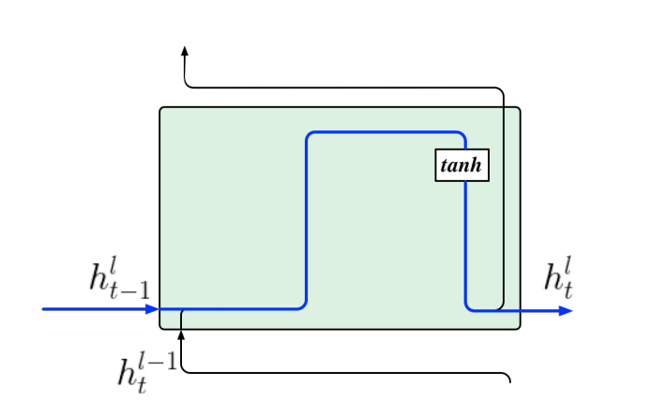

Figure 1: RNN block model

However, the internal state cannot last forever. RNN has gradient vanishing while the process takes too long. Gradients are values used to update neural network weights, which will shrink during back-propagation. When the gradient becomes too small, it doesn't contribute to the learning process. So, we use LSTM to resolve this problem. LSTM is a modified version of RNN, which improved in remembering past data in memory. According to Hsu, Zhang, and Glass state in the paper A prioritized grid long short-term memory RNN for speech recognition that “…more importantly, a gated linear dependence is introduced between memory cell states across two consecutive time steps which allows memories to be preserved.” LSTM uses back-propagation to train the model within the LSTM's cell which is better when classify, process, and predict time series given time lags of unknown duration. In each LSTM cell model, 3 gates presented to help to decide what information to keep or throw away:

* Forget gate: used to decide what detail can be discarded from the block
* Input gate: used to decide which input should be used to modify the memory
* Output gate: used to calculate the cell state

Figure 2: LSTM block model

1. Project Architecture

Supervised learning – classification problem:

This problem is clearly a classification algorithm. It has only two classes (Class 1 – represents that is a disaster identified tweet and Class 0 – represents that is not a disaster tweeted about). Since, we are provided with the known labels in the training set, this is considered as a supervised problem. So, in total, we call this problem as a supervised classification problem.

We want to build a model of these examples, then use that model to make predictions. Hence, this is model-based learning.

We are going to follow five major steps in this project:

1. Study the data
2. Select/Develop a model for the data
3. Train the model on the training data
4. Finally, apply the model to make predictions on new cases (inference)
5. In this process, we strive for better accuracy and hope that this model will generalize well. We will fine-tune the model, while studying the data.

Here, the given datasets are 1) train.csv and 2) test.csv files.

Train.csv:-

1. Testing methodology/Accuracy testing (5 pts)

<We will add prediction/results and the accuracy from the python notebook>

1. Result, conclusion, future work detailed description (10 pts)

<Results of the Kaggle competition and future work to use it for classification problems>

CMPE-257 Project Developed in Spring 2020

—————————— ◆ ——————————

**References**

1. Data and Problem source: <https://www.kaggle.com/c/nlp-getting-started/data>.
2. Najnin, Shamima, and Bonny Banerjee. “Improved Speech Inversion Using General Regression Neural Network.” *Journal of the Acoustical Society of America*, vol. 138, no. 3, 2015, pp. EL229–EL235.
3. Wei-Ning Hsu, J, et al. “A Prioritized Grid Long Short-Term Memory RNN for Speech Recognition.” *2016 IEEE Spoken Language Technology Workshop (SLT)*, 2016, pp. 467–473.
4. Finch, Holmes, and Mercedes K. Schneider. “Classification Accuracy of Neural Networks vs. Discriminant Analysis, Logistic Regression, and Classification and Regression Trees: Three- and Five-Group Cases.” *Methodology: European Journal of Research Methods for the Behavioral and Social Sciences*, vol. 3, no. 2, 2007, pp. 47–57.

**Dataset and Description**

Link: <https://www.kaggle.com/c/nlp-getting-started/data>

1. Data format: Each sample in the train and test set has the following information:
2. The text of a tweet
3. A keyword from that tweet (although this may be blank!)
4. The location the tweet was sent from (may also be blank)
5. Files we have:
6. train.csv - the training set
7. test.csv - the test set
8. sample_submission.csv - a sample submission file in the correct format
9. Columns we use:
10. id - a unique identifier for each tweet
11. text - the text of the tweet
12. location - the location the tweet was sent from (may be blank)
13. keyword - a particular keyword from the tweet (may be blank)
14. target - in train.csv only, this denotes whether a tweet is about a real disaster (1) or not (0)
15. Output: We will predict whether a given tweet is about a real disaster or not. If so, predict a 1. If not, predict a 0.

**Technologies we plan to use:** Python, Keras, Tensorflow.