WEEK-1 ASSIGNMENT

INTRODUCTION TO POWER BI

STEP 1- DOWNLOAD POWER BI IN YOUR DESKTOP

<https://www.microsoft.com/en-us/download/details.aspx?id=58494>

STEP 2- OPEN POWER BI IN YOUR DESTOP AND OPEN A NEW FILE (SELECT A BLANK REPORT)

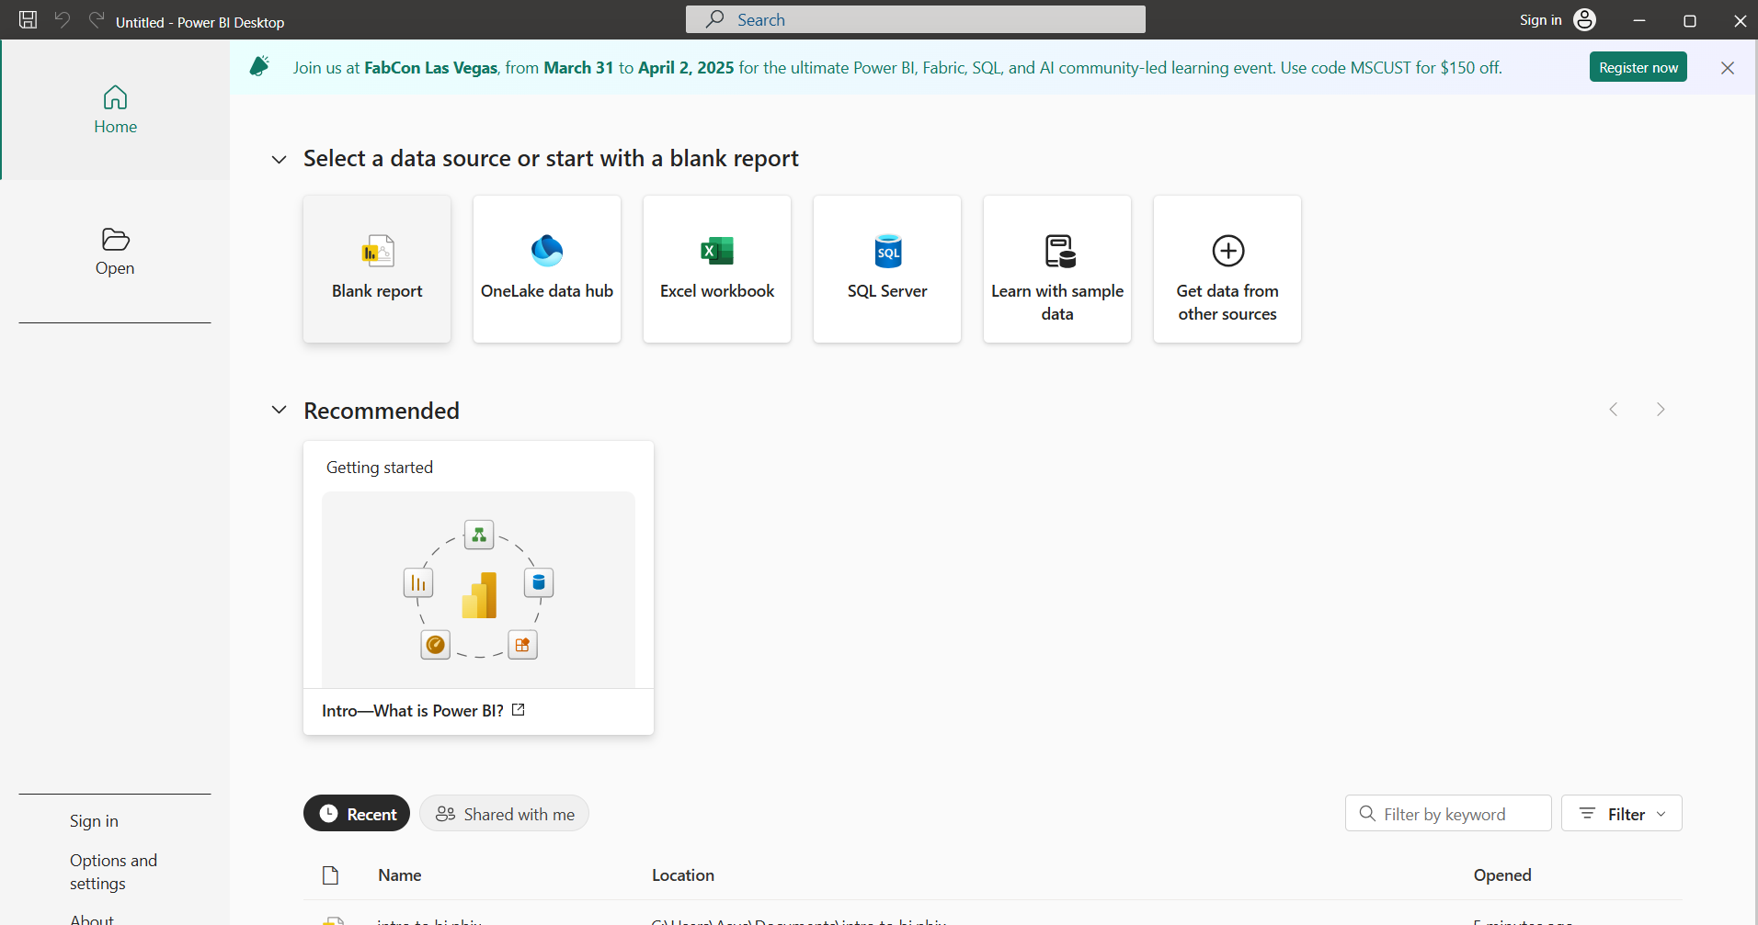

STEP 3- AFTER OPENING A NEW REPORT WE NEED A DATASET TO OPEN DATA SET IN HOME THERE BE A GET DATA IN GET DATA.(I USED TEST/CSV)

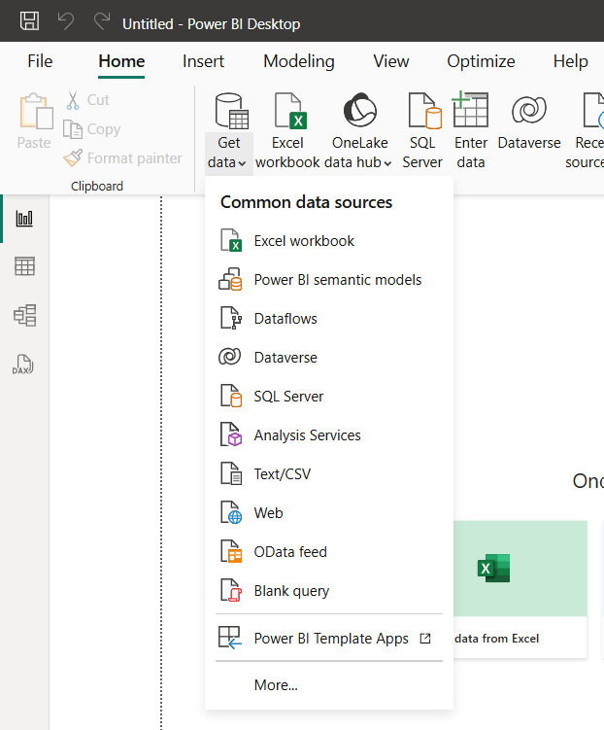

STEP 4 – THE DATA SET IS OPENED AND STORED IN DATA

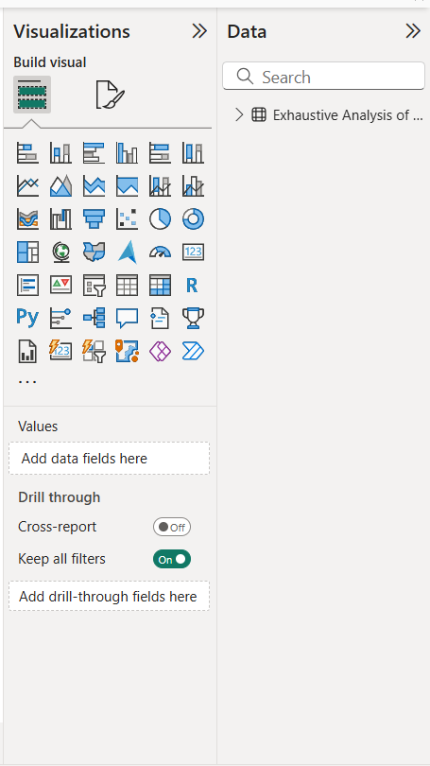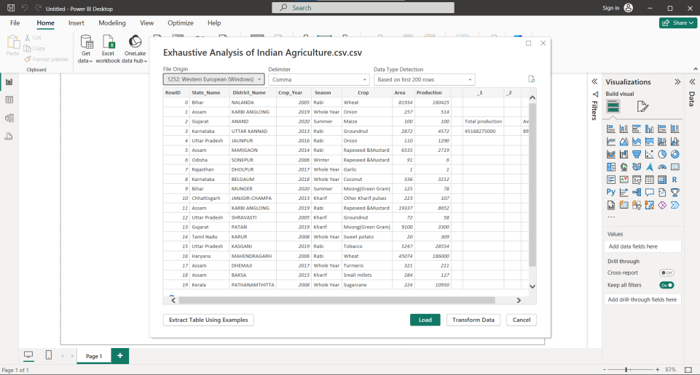

STEP 5 – NOW WE LOAD THE DATA AND THE DATA CAN BE VIEWED IN TABLE VIEW AND NOW WE NEED TO TRANSFORM DATA WHILE DOING THAT WE GET A NEW PAGE 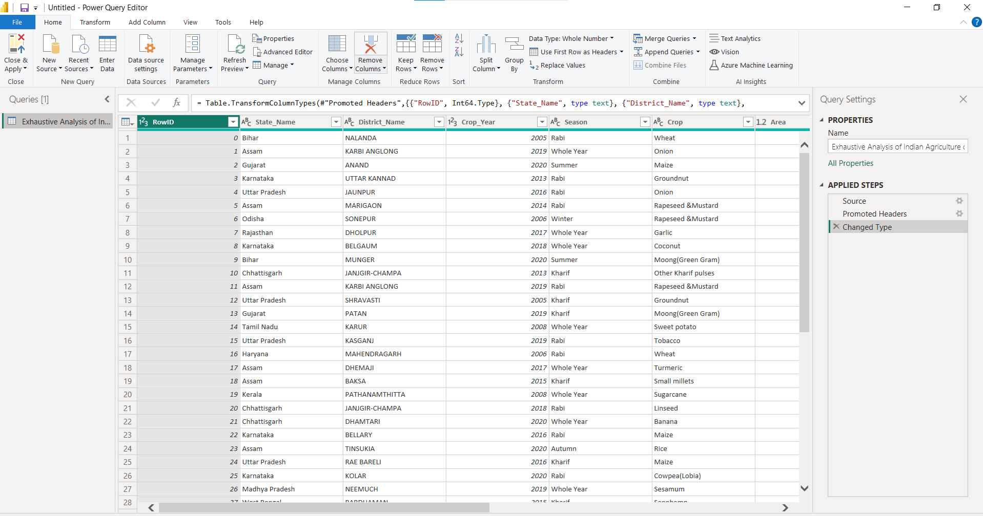

STEP 6 : NOW WE CAN REMOVE THE UNWANTED ROWS AND EMPTY ROW BY RIGHT CLICK AND REMOVE AND WE CAN REDO IT

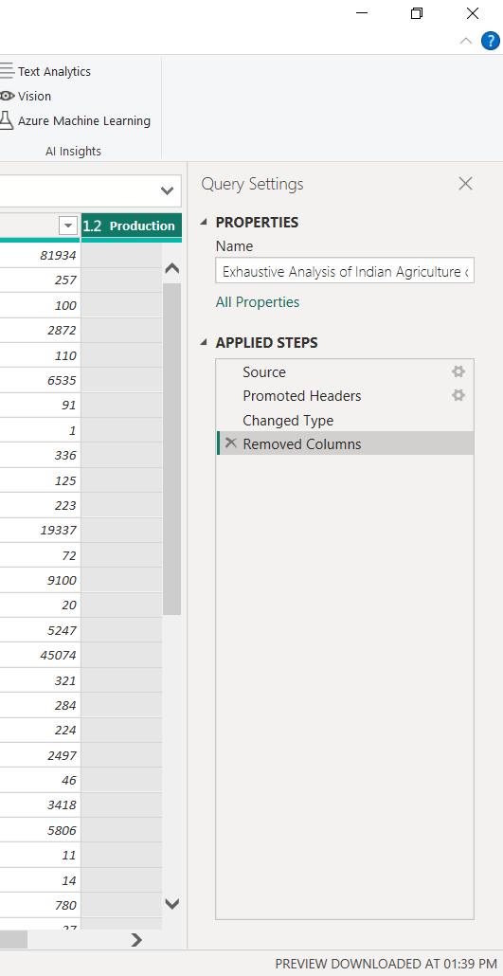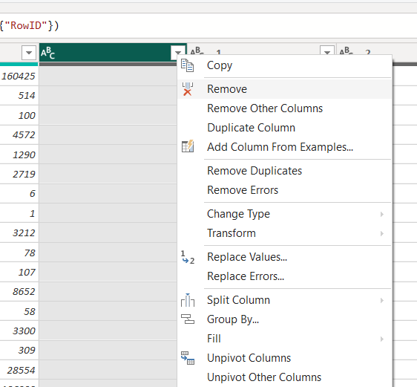

STEP 7:CHECK WHETHER THERE IS ANY DUPLICATE ROWS AND ERROR

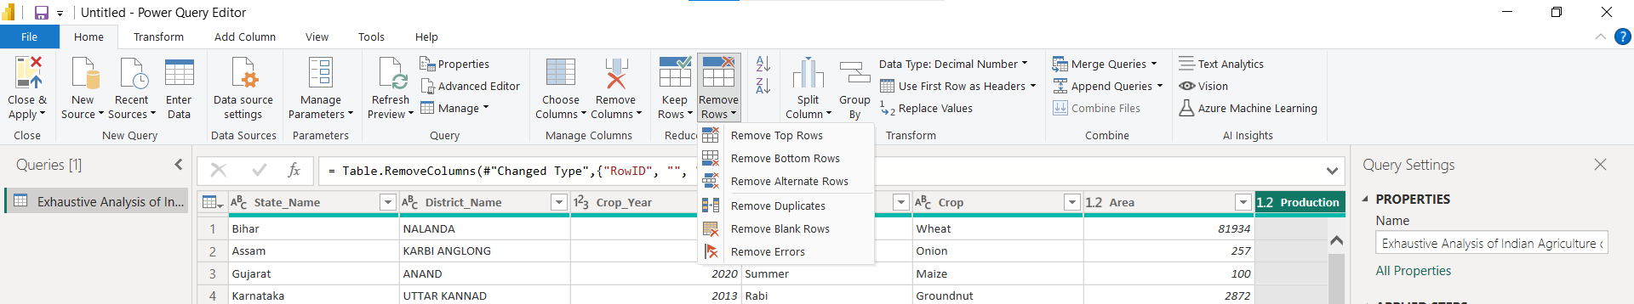

STEP 8: GO TO VIEW AND CHECK COLUMN QUANTITY

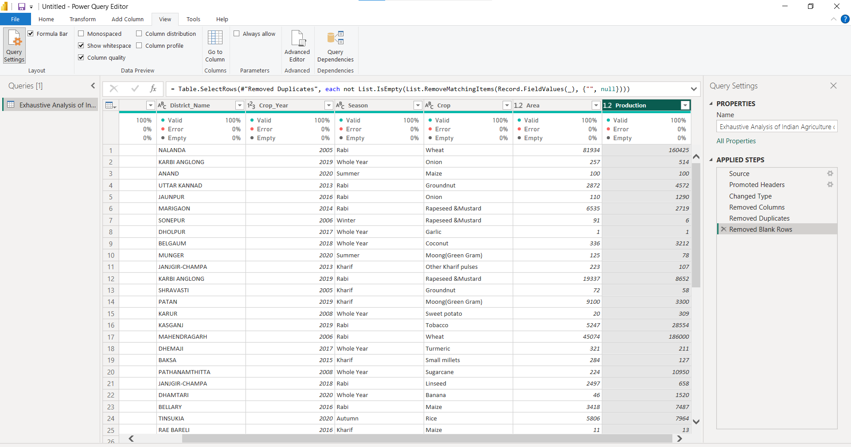

STEP 9 – GO TO FILE AND SAVE THE CHANGES

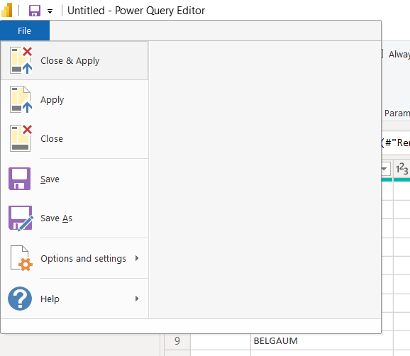

STEP 10 – FINALLY THE CHANGES ARE MADE AND SET CAN BE VIEWED TABLE VIEW