Final Capstone Project

Background:
I am an Indian residing with my family in the city of Franklin, WI for the past 12 years. Though, there is a sizable Indian population resising in and around Milwaukee (the largest city in Wisconsin), and many businesses that employ Indians, I believe that there are not many good Indian restaurants that I would like to go with my family or friends who are visiting Milwaukee. My husband and I have always dreamed of opening an Indian restaurant ourselves to satisfy the Indian community and also people who love authentic Indian Cuisine(Indian Cuisine is getting pretty popular among many ethnic groups). Opening a brand new restaurant is not a joke and definitely depends on many factors. While I was doing research on the factors to consider before opening a restaurant, good location is almost always among the top.
Web Reference: https://www.business.com/articles/7-things-to-consider-restaurant/
No matter how good the food and the service are, if there is not enough visibility, parking and traffic to increase customer base, then the restaurant is doomed to die within a few years, unable to make profit. So, in this capstone project I am trying to find a good location to open my dream Indian restaurant. Hopefully, this process might probably motivate us to take the risk in fulfilling this dream idea.

Problem Definition:
So, the problem question that I am trying to solve using Foursquare location data and my learnings thus far in this course, is to do the required data analysis and determine
"What is the best location to open my dream "Indian restaurant" in/around Milwaukee, WI?"

Data Required:
I think the following data will help me determine the best location for my restaurant.
- Do some web scraping from the website mentioned below and gather some demographic information about Indian population in Wisconsin, especially in and around Franklin city, WI.
Web Reference :http://zipatlas.com/us/wi/city-comparison/percentage-indian-population.htm
- Competitor Analysis: Use Foursquare Location data to collect data related to existing Indian restaurants in the locations of interest. Gather information related to existing Indian restaurants in Milwaukee and analyze their ratings and locations.
- Clean and analyze required data from both these sources.
- Use clustering algorithm to determine top 3 locations to open my dream Indian restaurant.

Methodology:
Step 1: I found out Indian demographic information in Wisconsin from this website
http://zipatlas.com/us/wi/city-comparison/percentage-indian-population.htm Using Beautiful Soup, we can scrape the needed Indian demographic information in Wisconsin. I could get all the cities with high Indian population in Wisconsin in descending order. I collected the name of all the top 25 cities in Wisconsin with highly populated Indian community.
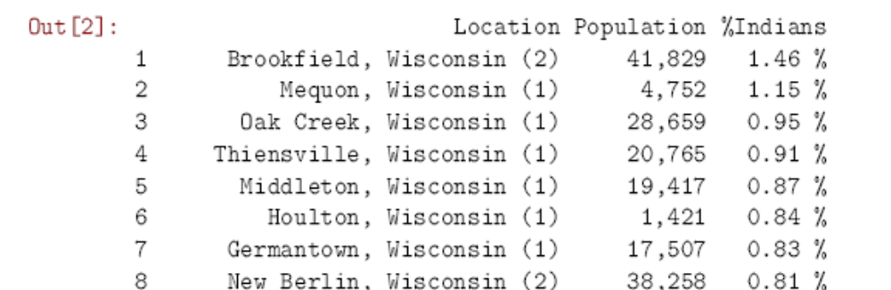
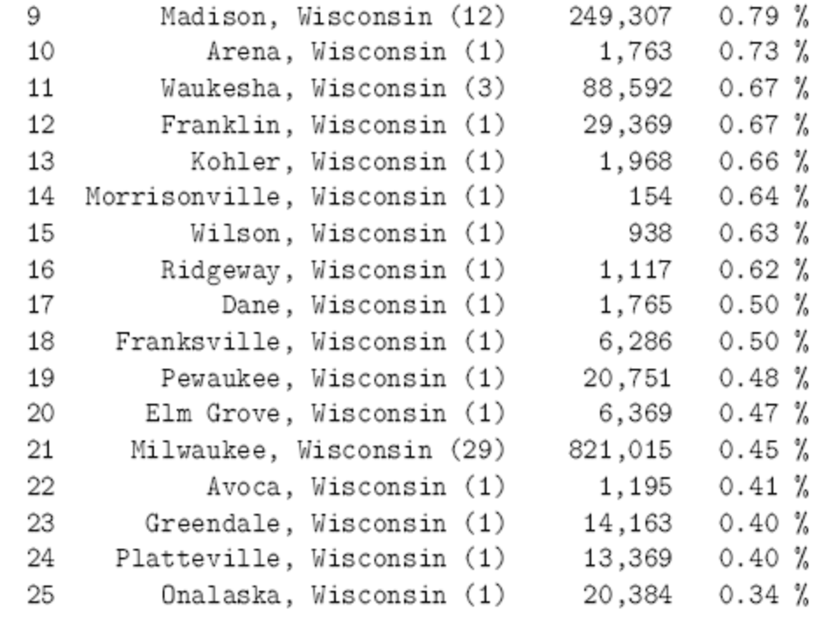
Step 2: Using the necessary libraries, I found the latitudes and longitudes for these top 25 cities in Wisconsin.
Step 3: Since my family lives in Franklin, WI, I wanted to calculate the distance of these top 25 cities in WI from Franklin, WI and the dataframe shows the cities and their distances from Franklin, WI in ascending order. I used the Haversine formula to calculate distance between Franklin and other cities using their latitudes and longitudes respectively.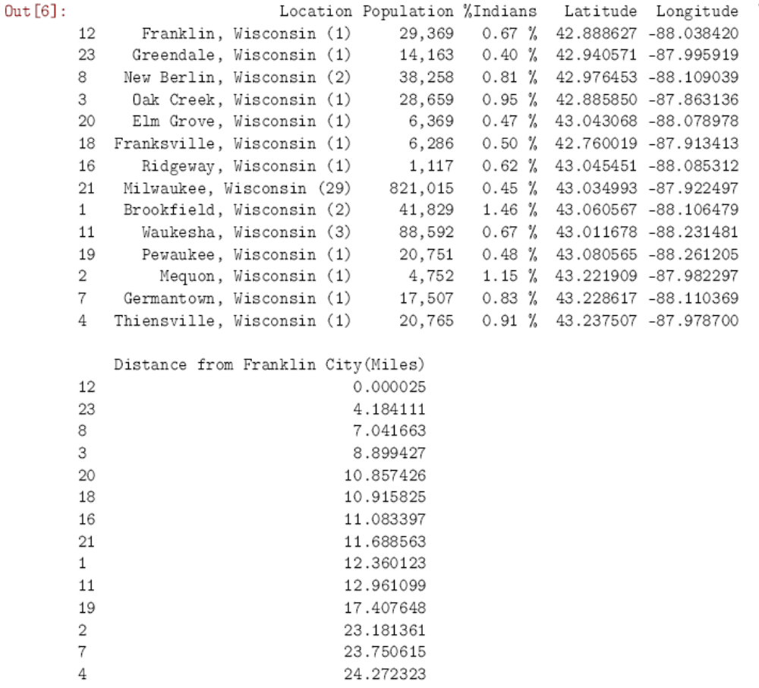
Step 4: I picked the top 14 city locations that were closest to Franklin,WI and also had high Indian population as my areas of interested locations in Wisconsin.
Step 5: Using my client ID and client secret, I gathered all venues from Foursquare Location data using the search query "Indian". I then filtered out only the Indian restaurants in my areas of interested locations in/around Franklin, WI. I had to run the search query with each of the interested locations latitude and longitude. Since, the radius overlaps for these locations, I dropped all the duplicates and created a dataframe with all the unique Indian restaurants in the interested locations.
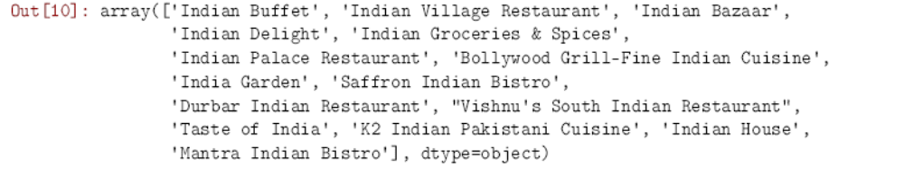
Step 6: I plotted the location of these Indian restaurants with respect to Franklin, WI using the Folium library
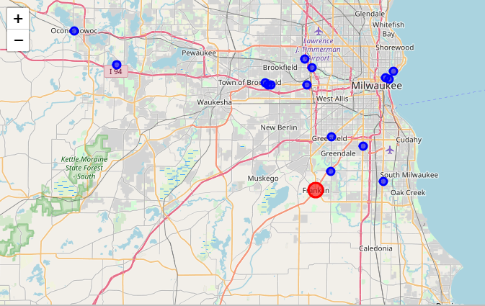
Indian Restaurants in/around Franklin, WI
Step 7: I also calculated the number of restaurants in each of these interested locations based on the venue address. I plotted this information as a bar graph. As you can see from the bar graph, though there are cities with high Indian population, there are little or no Indian restaurants. Most restaurants seemed to be in the city of Milwaukee, WI which is the downtown area even though Milwaukee ranks 11th in Indian population within Wisconsin. Another reason for more restaurants at Downtown area is due to recreations spots and businesses and Universities. These could contribute to high traffic. Since I live in this area, I know my results match the reality.
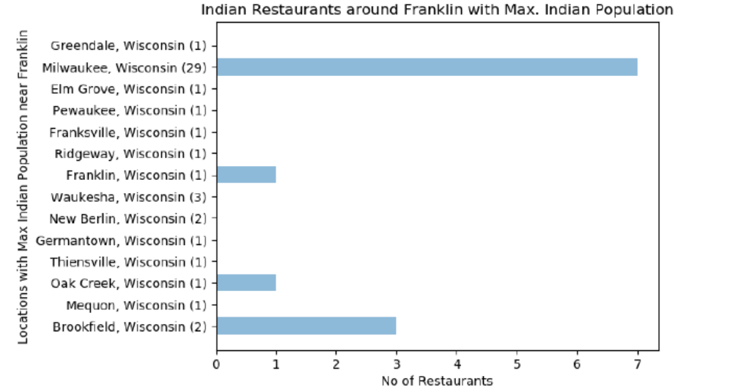
Step 8: I also calculated the average rating of these Indian restaurants using Foursquare Location data API. Few of these Indian restaurants were not rated and hence the average was just 7.6.
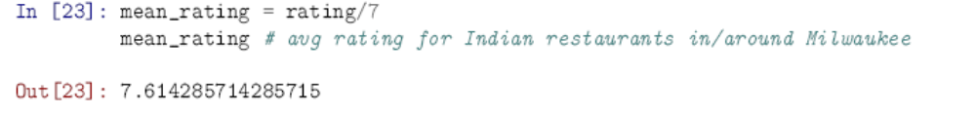
Step 9: I have collected required data in 2 dataframes.The first dataframe gives me the top 11 interested locations with high Indian population in/around Franklin, WI. My second dataframe had the number of Indian restaurants in each of these interested locations. I merged these two dataframes to create my final dataframe on which I wanted to run the KNN Clustering algorithm. The columns in the final dataframe has Ranking based on Indian Population|No of Indian Restaurants Latitude|Longitude|Distance from Franklin City(Miles). I dropped all other columns that had string values, since to run the "KNN clustering algorithm", all values must be numbers.
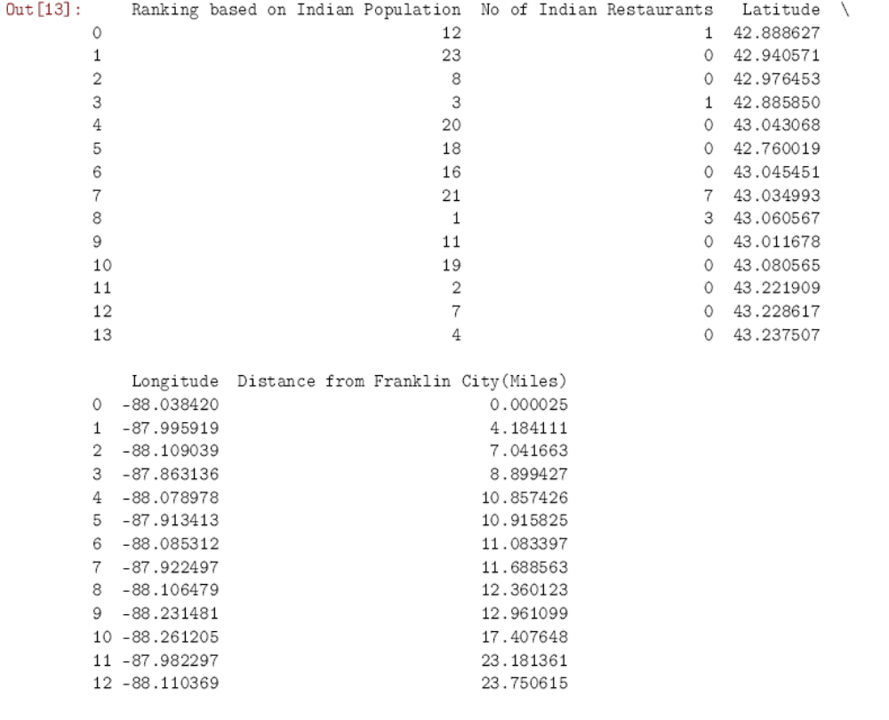
Step 10: I ran the KNN algorithm with cluster size = 3, 4 and 5. I chose to keep the cluster size = 4, since it gave the most sensible results. I plotted 2 graphs of these clusters. The first graph shows the relationship between No of Indian Restaurants wrt to Ranking of Indian Populated Cities in/around Franklin, WI. The second graph shows the relationship between Ranking of Indian Populated Cities in/around Franklin, WI and their distance from Franklin, WI.
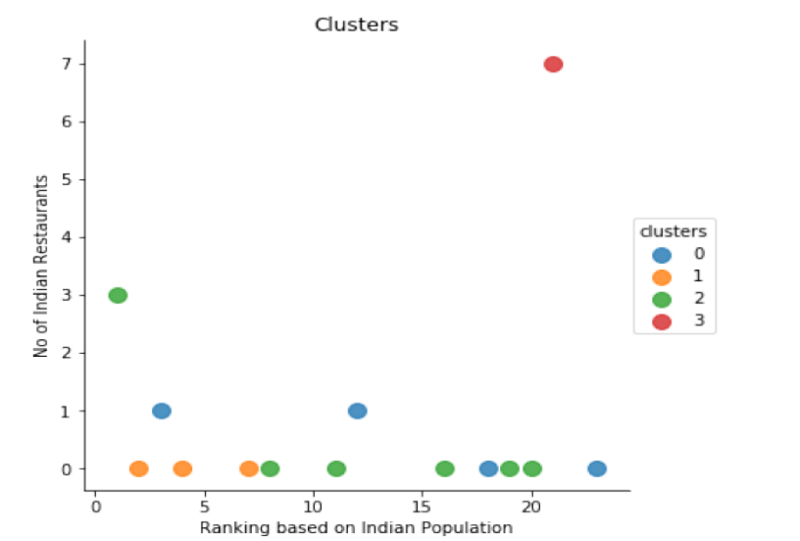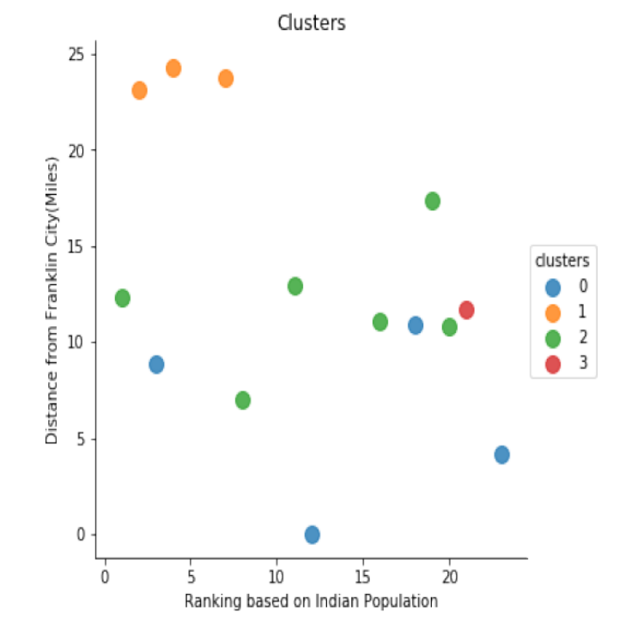
Step 11: I plotted a location map that showed the top 4 best locations that came as a result of the KNN clustering algorithm in/around Franklin, WI
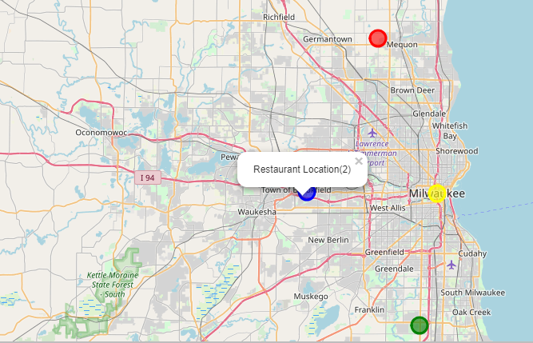
Top 4 Locations for Indian Restaurants
( Red Dot – First, Blue Dot – Second, Green Dot- Third, Yellow Dot – Fourth)

Results:
- The average rating of the Indian restaurant was 7.6.
- Cities in/around Franklin, WI that had high Indian population have little or no Indian restaurants.
- The clustering algorithm could help me break it down into 4 categories
  - High % Indian Population - No Indian Restaurant - Farthest from Franklin, WI
  - Low % Indian Population - More Indian Restaurants- Midway from Franklin, WI
  - Middle % Indian Population - Low Indian Restaurants - Closest to Franklin, WI
  - Middle % Indian Population - Low Indian Restaurants - Midway to Franklin, WI

Conclusion:
- Since, the avg user rating for Indian restaurants was only 7.6. This makes it desirable to start an Indian Restaurant with high rating.
- Another motivating factor is that knowing the demographics of Indian population in the cities around Franklin, WI has shown that we have shortage of Indian restaurants in the right places. Cities with high Indian population have little or no Indian restaurants.
- Though there is no Indian restaurant that has high % of Indian population, I do not like that first location (Red) because it is more than 20 miles from home (Franklin, WI). The fourth location (yellow) choice has already enough Indian restaurants that I do not want to compete with and anyways it has low Indian population even though I can guess that more restaurants are situated there for visiting traffic from businesses, tourist spots and university campus. I have concluded that the second location (blue) in Brookfield, WI is my first choice, since it is also close to home and has the highest Indian population. The map shows me on Bluemound road, Brookfield, WI. I was surprised because it does have enough traffic, visibility and high Indian population in reality. I loved that the algorithm picked that location. My second best choice, which is the third location (green), could be closer to Franklin, WI which is a growing community and has barely any good restaurants let alone Indian. So in conclusion, if I had to start an Indian restaurant right away, I would go with Brookfield Location. If I had some more years to decide, then I could also seriously consider Franklin area.
- Overall, since this project was conducted in a city that I am quite familiar with, I could easily verify results from data analysis to reality. I am pleased, amazed and convinced that clean, useful data with appropriate machine learning algorithms for data analysis will yield dependable results to make good business decisions. Python language has also been quite easy and efficient to do all this project work.

Project Improvements:
- I could have used more demographic information about my interested cities in/around Franklin, WI like crime rates, median household income, number of businesses, etc. This information when added could help me decide what kind of Indian restaurant I would like to open like Fine Dining, Lunch buffet, Fast food, Brunch, etc.
- If I could get details about Venue menus from Foursquare, I could pick a unique, stand-out menu for my Indian restaurant.
- Also, if I could find high traffic areas in my interested location, it could narrow my radius to choosing the best location. I could also use trending venues at different times of the day to help me narrow my best location.
- There are also lot more details you can collect about each venue from Foursquare that can help the algorithm perform better.

