 SREENIDHI INSTITUTE OF SCIENCE AND TECHNOLOGY

DEPARTMENT OF COMPUER SCIENCE AND ENGINEERING
IV Year B.Tech-II Semester Major Project Individual Summary Sheet
Project Title: |  | A Systematic Review on Community Detection Algorithms for Complex Network Analysis
Project Details : |  | Code: 8E896 |  | Batch Size: 03 |  | Batch No: E04 |  | AY: 2022-26
Domain / Area: |  | COMPUTER NETWORKS / DATA MINING / GRAPH ANALYSIS |  |  |  | Application/Product: A system for analyzing complex networks and detecting community structures using multiple community detection algorithms such as Louvain, Girvan–Newman, CNM, and Max–Min.
Abstract: |  | With the rapid growth of online social networks, detecting communities—groups of closely connected users—has become essential for understanding interaction patterns and information flow. This study evaluates four community detection algorithms: Louvain, Girvan–Newman, CNM, and Max–Min, using the Dolphin social network dataset. Their performance is analyzed based on modularity and Normalized Mutual Information (NMI). The Louvain algorithm achieves the best results with a modularity of 0.5188 and NMI of 0.911, indicating high accuracy in identifying community structures. In contrast, the Max–Min method shows comparatively lower performance. Overall, the results highlight that modularity-based approaches are more effective in detecting meaningful communities.
Existing System |  |  |  | Proposed System
1. Limited analysis using single algorithm approaches  2. Lack of comparative evaluation between algorithms  3. Difficulty in interpreting large-scale network structures  4. Limited visualization of detected communities  5. No standardized evaluation using metrics like modularity and NMI |  |  |  | 1. Implementation of multiple algorithms (Louvain, GN,  CNM, Max–Min)  2. Comparative analysis using modularity and NMI  3. Efficient detection of community structures in networks  4. Visualization of communities using graph-based  models  5. Improved understanding of network behavior and  structure  6. Better accuracy in identifying meaningful clusters
Technical (S/w & H/w) Specifications |  |  |  | Module(s) Specifications
Hardware Specifications Software Specifications:  1.Intel Core i5 or above 1. OS:Windows 10/11 or Linux  2.Minimum 8GB RAM 2. Programming: Python |  |  |  | - Data Input Module  - Preprocessing Module  - Louvain Algorithm Module  - Girvan–Newman Module  - CNM Algorithm Module  - Max–Min Algorithm Module  - Performance Evaluation Module  - • Visualization Module
Architecture Diagram |  |  |  | Methodology
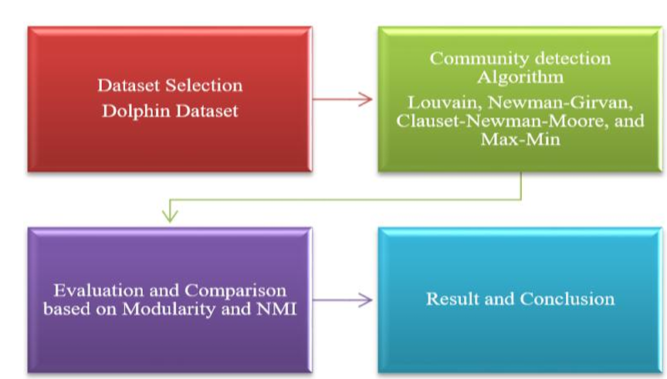 |  |  |  | The project follows a structured approach starting with dataset collection and graph representation, where nodes denote entities and edges denote interactions. Community detection algorithms such as Louvain, Girvan–Newman, CNM, and Max–Min are applied to identify community structures.  The results are evaluated using modularity and Normalized Mutual Information (NMI) to measure performance. Finally, the detected communities are visualized using graph representations for easy interpretation and comparison.
Guide Details |  |  | Batch Members Details
 | Mr Amedapu Srinivas  Reddy  Assistant Professor  Dept. of CSE  Sreenidhi Institute of Science and Technology  Hyderabad |  | 
 |  |  | B Vinay |  | Akshara Murali |  | M Bhanu Prakash
 |  |  | 22311A05V1 |  | 22311A05V2 |  | 22311A05V4

