A Major Project Report
on

WEB-BASED HOSPITAL MANAGEMENT SYSTEM: A DJANGO-POWERED MODERN HEALTHCARE ADMINISTRATION
Submitted in partial fulfillment of the requirement for
The award of degree of

BACHELOR OF TECHNOLOGY
in

COMPUTER SCIENCE & ENGINEERING 2022-2026

Submitted By
M.Hari Murari 23315A0527
R.Rohini 22311A05W3
R.Vikitha 22311A05U5

Under the Guidance of
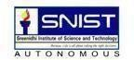
Mrs. Ch.Lavanya Assistant Professor

Department of Computer Science & Engineering
SREENIDHI INSTITUTE OF SCIENCE ANDTECHNOLOGY

(AUTONOMOUS)
Yamnampet (V), Ghatkesar (M), Hyderabad – 501301, T.S.

AY 2025-2026

Sreenidhi Institute of Science and Technology Department of Computer Science and Engineering


CERTIFICATE
This is to certify that this Major Project report on “ Web-Based Hospital Management Sytem: A Django-Powered Modern Healthcare Administrator ”, submitted by M.Hari Murari (23315A0527) , R.Rohini(22311A05W3) , R.Vikitha (22311A05U5) in the year 2026 in the partial fulfillment of the academic requirements of Jawaharlal Nehru Technological University for the award of the degree of Bachelor of Technology in Computer Science and Engineering, is a bonafide work that has been carried out by them as a part of their Major Project during Fourth Year Second Semester, under our guidance. This report has not been submitted to any other Institute or university for the award of any degree.

Internal guide | Project Coordinator | Head of the Department
Mrs.Ch.Lavanya | Mr. Meeravali Shaik | Dr. K Shirisha
Assistant Professor | Assistant Professor | Professor & HOD
Department of CSE | Department of CSE | Department of CSE

DECLARATION

We M.HariMurari (23315A0527) ,R.Rohini(22311A05W3) , R.Vikitha(22311A05U5) students of SREENIDHI INSTITUTE OF SCIENCE AND TECHNOLOGY, YAMNAMPET, GHATKESAR, studying IV
year II semester, COMPUTER SCIENCE AND ENGINEERING solemnly declare that the Major Project work, titled “ Web-Based Hospital Management System: A Django-Powdered Modern Healthcare Administartor” is submitted to SREENIDHI INSTITUTE OF SCIENCE AND TECHNOLOGY for
partial fulfillment for the award of degree of Bachelor of technology in COMPUTER SCIENCE AND ENGINEERING.
It is declared to the best of our knowledge that the work reported does not form part of any dissertation submitted to any other University or Institute for award of any degree.

M.Hari Murari 23315A0527
R.Rohini 22311A05W3
R.Vikitha 22311A05U5

ACKNOWLEDGEMENT

We would like to express our gratitude to all the people behind the screen who helped us to transform an idea into a real application.
We would like to thank our internal guide Mrs. Ch.Lavanya and our Coordinator Mr.Meeravali Shaik for Major Project for their technical guidance, constant guidelines, encouragement and support in carrying out Major project on time at college.

We profoundly thank Dr. K Shirisha, Head of the Department of Computer Science & Engineering who has been an excellent guide and also a great source of inspiration to our work.
We would like to express our heart-felt gratitude to our parents without whom we would not have been privileged to achieve and fulfill our dreams. We are grateful to our principal, DR. T. Ch. Siva Reddy, who most ably runs the institution and has had the major hand in enabling us to do our project.
The satisfaction and euphoria that accompany the successful completion of the task would be great but incomplete without the mention of the people who made it possible with their constant guidance and encouragement crowns all the efforts with success. In this context, We would like to thank all the other staff members, both teaching and non-teaching, who have extended their timely help and eased our task.

M.Hari Murari 23315A0527

R.Rohini R.Vikitha
22311A05W3
22311A05U5

ABSTRACT

The rapid digitalization of healthcare has necessitated the development of efficient and automated hospital management systems to reduce manual effort, enhance patient care, and streamline administrative tasks. This project presents a web-based Hospital Management System (HMS) built on the Django framework, designed to facilitate interactions among administrators, doctors, and patients in a secure and user-friendly environment. The system provides multi-role functionality, enabling administrators to manage doctor registrations, approve patient appointments, monitor payments, and maintain hospital records. Doctors are granted access to view and manage their assigned patients, issue prescriptions, and recommend medical tests, while patients are able to register, book appointments, upload medical reports, view prescribed medications, make payments, and download medical reports in PDF format. Core features of the system include email notifications for doctor registration. The project ensures data integrity through form validation and incorporates file handling restrictions for security. This work contributes to the advancement of healthcare informatics by offering a lightweight, scalable, and cost-effective digital platform suitable for small to mid-scale healthcare facilities. Future enhancements may integrate advanced features such as real-time notifications, cloud-based storage of medical history, and machine learning-based decision support to further improve efficiency and quality of care.
Keywords— Hospital Management System, Django, Patient Care, Appointment Scheduling, Healthcare Automation, Web Application.

LIST OF FIGURES
S.NO | Figure No. | Title of Figure | Page No
1 | 1 | System Architecture | 41
2 | 2 | Data Flow Diagram | 42
3 | 3 | Class Diagram | 43
4 | 4 | Use Case Diagram | 44
5 | 5 | Sequence Diagram | 45
6 | 6 | Activity Diagram | 46
7 | 7 | Dashboard | 64
8 | 8 | Patient Registration Form | 64
9 | 9 | Patient Login | 65
10 | 10 | Doctor registration | 65
11 | 11 | Doctor Login | 67
12 | 12 | Admin login
12 | 12 | Admin Dashboard | 67

LIST OF TABLES
S.NO | Table No. | Title of Table | PageNo
1 | 1 | Test Cases | 74

INDEX

 | Page No
List of Figures | i
List of Tables | ii
1. INTRODUCTION
1.1 Project Introduction | 2
1.2 Scope | 3
1.3 Project Overview | 6
1.4 Objectives | 8
2. LITERATURE SURVEY
2.1 Existing System | 12
2.1.1 Disadvantages of Existing System | 13
2.2 Proposed System | 16
2.2.1 Advantages of Proposed System | 17
3. SYSTEM ANALYSIS
3.1 Functional Requirements | 21
3.1.1 Data Collection | 22
3.1.2 Data Preprocessing | 24
3.1.3 Training and Testing | 26
3.1.4 Modeling | 28
3.1.5 Predicting | 30
3.2 Performance Requirements | 32
3.3 Software Requirements | 34
3.3.1 Django | 35
3.3.2 Python | 37
3.3.3 Visual Studio code(VS code) | 39
3.3.4 MySQL | 42
3.4 Hardware Requirements
3.4.1 Processor | 44
3.4.2 Ram | 46
3.4.3 Space on Hard Disk | 47
3.4.4 Internet Connectivity | 48
3.5 Feasibility study (Technical/Economical/Operational)
3.5.1 Economical Feasibility | 50
3.5.2 Technical Feasibility | 51
3.5.3 Social Feasibility | 51
4. SYSTEM DESIGN
4.1 System Architecture | 54
4.2 Data Flow Diagrams | 55
4.3 UML Diagrams | 56
4.3.1 Class Diagram | 56

4.3.2 Use Case Diagram | 57
4.3.3 Sequence Diagram | 58
4.3.4 Activity Diagram | 59
4.4 Modules
4.4.1 Admin Module | 60
4.4.2 Doctor Module | 61
4.4.3 Patient Module | 62
5. IMPLEMENTATION AND RESULTS
5.1 Language / Technology Used | 65
5.1.1 Advantages of Django | 66
5.1.2 Advantages of Python | 68
5.1.3 Advantages of MySQL Database | 69
5.1.4 Advantages of Visual Studio Code | 69
5.2 Sample Code | 71
5.3 Results (Accuracy) / Output Screens | 76
6. TESTING
6.1 Types of Testing | 81
6.1.1 Unit Testing | 81
6.1.2 Functional Testing | 82
6.1.3 Integration Testing | 82
6.1.4 White Box Testing | 83
6.1.5 Black Box Testing | 84
6.1.6 Acceptance Testing | 84
6.1.7 System Testing | 85
6.2 Test Cases | 86
7. CONCLUSION | 88
8. FUTURE SCOPE | 90
9. BIBLIOGRAPHY | 93
APPENDIX-A : | 95
PLAGIARISM REPORT | 95-99
PAPER PUBLICATION | 102-109
ABSTRACT | 114
PROJECT CORRELATION WITH PO’s AND PSO’s | 115
NATURE OF THE PROJECT | 116
DOMAIN OF THE PROJECT | 117

v

INTRODUCTION

INTRODUCTION

PROJECT INTRODUCTION
Healthcare systems across the world face significant challenges in delivering efficient and timely services to patients due to the increasing demand for medical care. Hospitals must manage a vast amount of information, including patient records, appointment schedules, medical histories, billing details, and staff coordination. During peak hours or emergency situations, handling these operations manually becomes difficult, leading to delays in treatment and reduced quality of care. Ensuring accuracy, speed, and proper coordination within hospital operations is therefore a critical requirement.

In many healthcare institutions, different departments such as reception, pharmacy, laboratory, and administration maintain separate records of their activities. These records are often stored manually or in isolated systems, which are not interconnected. As a result, it becomes difficult to access patient information quickly across departments. This lack of integration leads to duplication of data, increased chances of errors, and delays in providing services to patients.

Another major challenge faced by hospitals is the dependence on manual processes for tasks such as patient registration, appointment scheduling, and billing. Patients are often required to wait in long queues, and hospital staff must spend considerable time managing paperwork. This not only reduces operational efficiency but also affects patient satisfaction. In emergency cases, such delays can have serious consequences.

Hospital administrators also face difficulties in managing resources effectively. Tracking the availability of doctors, hospital beds, medicines, and equipment requires constant monitoring. Without a centralized system, it becomes challenging to maintain accurate records and make informed decisions. Similarly, maintaining patient history and medical records in physical form increases the risk of data loss and limits accessibility.
With the advancement of technology, there is a growing need for a centralized and automated system that can manage all hospital operations efficiently. A Hospital Management System provides a digital solution that integrates all departments into a single platform. It enables real-time access to patient information, simplifies administrative tasks, and improves communication among hospital staff.

The implementation of a Hospital Management System helps in reducing manual work, minimizing errors, and improving overall efficiency. It allows hospitals to store and manage patient data securely, schedule appointments easily, generate bills automatically, and monitor resources effectively. By providing a seamless flow of information, the system enhances the quality of healthcare services and ensures better patient care.

Overall, the Hospital Management System plays a crucial role in modernizing healthcare services by streamlining operations, improving accuracy, and enabling faster decision- making. It serves as an essential tool for hospitals to deliver timely, reliable, and high- quality medical services to patients.

Furthermore, the system supports efficient data sharing between different hospital departments, reducing communication gaps and delays. It enables quick retrieval of patient history, which helps doctors make accurate and timely decisions. The integration of modules such as laboratory, pharmacy, and billing ensures a smooth workflow within the hospital environment. Additionally, automated alerts and notifications help in managing appointments, medication schedules, and follow-ups effectively.

The system also enhances data security by restricting unauthorized access and maintaining confidentiality of patient information. Backup and recovery mechanisms ensure that critical data is not lost during system failures. Moreover, the use of digital records contributes to reducing paper usage, making the system environmentally friendly.

By improving operational efficiency and reducing administrative burden, the Hospital Management System allows healthcare professionals to focus more on patient care. It also provides analytical reports that assist management in planning and decision-making. Overall, the system acts as a comprehensive solution to improve hospital performance and patient satisfaction.

SCOPE
The scope of the Hospital Management System (HMS) project is to design and develop an integrated software solution that automates and manages the core operations of a hospital. The system is intended to provide a centralized platform where all hospital activities such as patient management, doctor scheduling, billing, pharmacy, and administrative tasks can be handled efficiently. It focuses on improving the overall

workflow of healthcare institutions by reducing manual effort and ensuring faster access to accurate information.

The system covers the management of patient-related information starting from registration to discharge. It allows patients to be registered digitally, maintaining their personal details, medical history, diagnosis records, and treatment information in a structured format. This enables easy retrieval of patient data whenever required, supporting doctors in making informed decisions. Appointment scheduling is also included within the scope, allowing patients to book, update, or cancel appointments with doctors, thereby reducing waiting time and improving service efficiency.

Another important aspect within the scope is doctor and staff management. The system maintains records of doctors, their specialization, availability schedules, and assigned duties. This helps in efficient allocation of resources and ensures proper coordination among different departments. Staff details such as roles, responsibilities, and work schedules are also managed within the system to streamline hospital operations.

The billing and financial management module is also included in the scope of the project. It automates the process of generating bills for consultations, treatments, laboratory tests, and medicines. The system ensures accuracy in billing and reduces the chances of manual errors. It also maintains records of payments, invoices, and financial transactions, which can be used for auditing and reporting purposes.

The pharmacy and inventory management module plays a crucial role in tracking the availability of medicines and medical supplies. The system monitors stock levels, updates inventory in real time, and provides alerts when stock is low. It also helps in maintaining records of medicine usage and expiry dates, ensuring proper utilization of resources and minimizing wastage.

In addition, the system includes reporting and analytics features that help administrators generate various reports related to patient data, financial transactions, and hospital performance. These reports assist in decision-making and strategic planning. The admin module provides full control over the system, allowing monitoring of all activities and ensuring smooth functioning.
Furthermore, the scope of the Hospital Management System extends to improving communication and coordination among various departments within the hospital. By

integrating modules such as reception, laboratory, pharmacy, and accounts into a single system, the HMS ensures that information flows seamlessly across all units. This reduces dependency on manual communication methods and minimizes delays in service delivery. Doctors can access laboratory reports directly through the system, pharmacists can verify prescriptions digitally, and administrative staff can manage records without redundancy.

The system also supports role-based access control, which ensures that different users such as administrators, doctors, receptionists, and pharmacists have access only to the information relevant to their responsibilities. This not only enhances security but also improves usability by providing a customized interface for each user type. Sensitive patient data is protected through authentication mechanisms, ensuring confidentiality and compliance with basic data security standards.

Another key area within the scope is the management of hospital resources such as bed availability, equipment usage, and room allocation. The system allows administrators to track the occupancy status of hospital beds in real time, making it easier to admit patients and manage discharges efficiently. It also helps in scheduling the use of medical equipment and operation theatres, thereby optimizing resource utilization and reducing conflicts in scheduling.

The HMS also includes functionality for maintaining electronic medical records (EMR), which store detailed patient information such as diagnoses, prescriptions, test results, and treatment history. This digital record system reduces the need for physical storage and allows quick access to patient data from any authorized department. It enhances continuity of care, especially when patients visit the hospital multiple times or consult different doctors.
The scope also considers scalability and flexibility of the system. The HMS is designed in such a way that it can be expanded in the future to include additional features such as online consultation, mobile application support, integration with external laboratories,
and advanced analytics. This makes the system adaptable to the evolving needs of healthcare institutions.

PROJECT OVERVIEW
The Hospital Management System (HMS) is a comprehensive software solution designed to automate and manage the day-to-day operations of a hospital or healthcare institution. The project aims to replace traditional manual processes with a digital platform that integrates various hospital functions into a single, unified system. By doing so, it enhances operational efficiency, reduces errors, and improves the overall quality of patient care.

The system is developed to handle multiple aspects of hospital management, including patient registration, appointment scheduling, doctor management, billing, pharmacy, and report generation. Each module is interconnected, allowing seamless flow of information across different departments. This integration ensures that data is updated in real time and can be accessed easily by authorized users, thereby improving coordination among hospital staff.
At the core of the system is the patient management module, which maintains detailed records of patients, including personal information, medical history, diagnosis, treatment details, and prescriptions. This digital storage of patient data eliminates the need for physical files and allows quick retrieval of information whenever required. Doctors can
access patient records instantly, enabling them to make accurate and timely decisions regarding treatment.

The system also includes an administration module that provides full control over all operations. Administrators can manage user roles, monitor system activities, and generate reports related to hospital performance, patient statistics, and financial data. These insights assist in effective decision-making and strategic planning.

From a technical perspective, the project can be implemented using modern technologies such as web-based frameworks, cloud databases, and real-time data synchronization tools. This ensures that the system is scalable, secure, and accessible from multiple devices. Role-based authentication and data encryption techniques are used to maintain the confidentiality and integrity of sensitive information.

OBJECTIVES
The primary objective of the Hospital Management System (HMS) is to develop an efficient and integrated software solution that automates and streamlines the core operations of a hospital. The system is designed to replace traditional manual processes with a digital platform, thereby improving accuracy, reducing operational delays, and enhancing the overall quality of healthcare services.

One of the key objectives of this project is to provide a centralized system for managing patient information. The HMS aims to store and maintain detailed patient records, including personal details, medical history, diagnosis, treatment, and prescriptions in a structured and secure manner. This ensures that patient data can be accessed quickly and easily by authorized medical staff, enabling faster and more accurate decision-making.

Another important objective is to simplify and optimize the appointment scheduling process. The system allows patients to book appointments with doctors based on their availability, reducing waiting time and avoiding overcrowding in hospitals. It also enables easy rescheduling and cancellation of appointments, improving convenience for both patients and hospital staff.

The project also aims to automate billing and financial management processes within the hospital. By generating accurate invoices for consultations, treatments, laboratory tests, and medicines, the system reduces the chances of manual errors and ensures transparency in financial transactions. Maintaining digital records of payments and expenses also helps in efficient financial tracking and reporting.

Efficient management of hospital resources is another major objective of the HMS. The system helps in tracking the availability of doctors, hospital beds, medical equipment, and other resources. This ensures optimal utilization and prevents resource shortages or overbooking. Additionally, the pharmacy and inventory management module aims to monitor stock levels of medicines, track expiry dates, and provide alerts for low inventory, ensuring uninterrupted availability of essential supplies.
Improving communication and coordination among different departments of the hospital is also a key objective of this project. By integrating various modules such as reception,

laboratory, pharmacy, and administration into a single platform, the system ensures seamless flow of information. This reduces delays caused by manual communication and enhances the efficiency of hospital operations.

The HMS also aims to enhance data security and confidentiality. The system implements role-based access control, ensuring that only authorized users can access specific information based on their roles. This protects sensitive patient data and maintains privacy. Regular data backups and secure storage mechanisms further ensure data integrity and prevent loss of information.

Another objective is to provide comprehensive reporting and analytics features. The system generates various reports related to patient statistics, financial transactions, and hospital performance. These reports help administrators in monitoring operations, identifying trends, and making informed decisions for improving hospital services.

The project also focuses on reducing the dependency on paperwork and manual record- keeping. By digitizing all hospital operations, the HMS minimizes the use of paper, reduces administrative workload, and contributes to an eco-friendly environment.
Automation of routine tasks allows hospital staff to focus more on patient care rather than administrative duties.

Enhancing patient satisfaction is another significant objective of the system. By providing faster services, reducing waiting time, and ensuring accurate record management, the HMS improves the overall experience of patients. Easy access to information, quick appointment scheduling, and efficient service delivery contribute to better patient engagement and trust.

The system is also designed with scalability and flexibility in mind. One of the objectives is to create a platform that can be easily expanded in the future to include additional features such as online consultation, mobile application integration, and advanced data analytics. This ensures that the system remains relevant and adaptable to the evolving needs of healthcare institutions.

Finally, the overall objective of the Hospital Management System is to create a reliable, efficient, and user-friendly solution that enhances hospital productivity and improves the quality of healthcare delivery.

LITERATURE SURVEY

LITERATURE SURVEY

EXISTING SYSTEM
In many healthcare institutions, the existing system for managing hospital operations is largely based on manual processes or partially computerized systems that operate independently. Patient records, appointment schedules, billing details, and staff information are often maintained using paper-based files or basic standalone software. These methods are time-consuming, difficult to manage, and prone to errors, especially when dealing with a large number of patients and daily hospital activities.

In the traditional system, patient registration is carried out manually at the reception desk. All personal and medical details are recorded on paper or stored in local files. Retrieving this information at a later stage becomes difficult and time-consuming, particularly when patients revisit the hospital. There is also a high risk of misplacement or loss of records, which can negatively impact patient care and hospital efficiency.

Appointment scheduling in the existing system is usually handled manually or through separate registers. Patients are required to visit the hospital or make phone calls to book appointments. This often leads to confusion, double bookings, or long waiting times. There is no real-time visibility of doctor availability, making it difficult to manage schedules effectively.

Billing and financial management in many hospitals are also handled manually or through isolated systems. Calculating charges for consultations, treatments, tests, and medicines requires manual effort, which increases the chances of errors and inconsistencies. Maintaining financial records in this manner makes auditing and report generation more complicated and less reliable.

Another major limitation of the existing system is the lack of integration between different departments such as laboratory, pharmacy, and administration. Each department maintains its own records independently, leading to duplication of data and lack of coordination. For example, doctors may not have immediate access to laboratory results, and pharmacists may not receive prescriptions in a timely manner. This delay in information flow affects the overall efficiency of hospital services.

Data security is another concern in the existing system. Paper-based records and unprotected digital files are vulnerable to unauthorized access, damage, or loss. There is limited control over who can access sensitive patient information, which raises concerns about privacy and confidentiality.

Furthermore, the existing system lacks proper reporting and analytical capabilities. Generating reports related to patient data, financial performance, or hospital operations requires significant manual effort. This limits the ability of hospital administrators to make informed decisions and plan effectively for future improvements.

Overall, the existing system is inefficient, time-consuming, and lacks the ability to handle modern healthcare requirements. The dependence on manual processes and disconnected systems results in delays, errors, and reduced quality of service. These limitations highlight the need for a comprehensive Hospital Management System that can integrate all operations into a single, efficient, and automated platform.

Disadvantages of Existing System

The existing system used in many hospitals is largely based on manual processes or partially computerized systems that operate independently. While these methods may work for small-scale operations, they present several limitations when applied to modern healthcare environments where efficiency, accuracy, and speed are essential.
One of the major disadvantages of the existing system is the heavy dependence on manual record-keeping. Patient details, medical histories, and treatment records are often maintained on paper, which makes storage and retrieval difficult. Over time, these records can become disorganized, misplaced, or even damaged. This not only wastes

time but also affects the quality of patient care, as doctors may not have immediate access to accurate medical information.

Another significant drawback is the lack of integration between different hospital departments. Each department, such as reception, laboratory, pharmacy, and billing, often maintains its own records separately. This leads to duplication of data and poor coordination among departments. As a result, information sharing becomes slow and inefficient, causing delays in diagnosis, treatment, and service delivery.

The existing system also suffers from inefficiencies in appointment management. Since appointments are typically handled manually or through basic systems, there is a high possibility of scheduling conflicts, double bookings, or long waiting times. Patients may experience inconvenience due to lack of proper scheduling, while hospital staff may find it difficult to manage doctor availability effectively.

Billing and financial processes in the current system are also prone to errors. Manual calculation of charges for treatments, tests, and medications increases the risk of inaccuracies and inconsistencies. This can lead to financial losses for the hospital or dissatisfaction among patients due to incorrect billing. Additionally, maintaining financial records manually makes it difficult to generate reports and perform audits efficiently.

Data security and confidentiality are also major concerns in the existing system. Paper- based records and unsecured digital files are vulnerable to unauthorized access, loss, or damage. There is no proper mechanism to control who can view or modify sensitive patient information, which can compromise patient privacy and trust.

Communication gaps are another major issue in traditional systems. Since there is no real-time communication between departments, important updates such as test results, doctor availability, or emergency alerts may not be delivered promptly. This lack of
coordination can delay critical medical decisions and negatively impact patient outcomes

.

PROPOSED SYSTEM

The proposed Hospital Management System (HMS) is a comprehensive, integrated, and automated software solution designed to overcome the limitations of the existing manual and semi-computerized systems. It provides a centralized platform that connects all departments within a hospital, enabling efficient management of operations and seamless flow of information. The system is developed to enhance accuracy, reduce manual effort, and improve the overall quality of healthcare services.

The proposed system introduces a digital approach to managing patient information. All patient records, including personal details, medical history, diagnosis, prescriptions, and treatment details, are stored electronically in a centralized database. This allows authorized users to access patient data instantly from any department, ensuring faster and more informed decision-making. The risk of data loss or duplication is significantly reduced through structured storage and proper data management techniques.

One of the key features of the proposed system is automated appointment scheduling. Patients can book, reschedule, or cancel appointments easily through the system based on doctor availability. This helps in reducing waiting time, avoiding scheduling conflicts, and improving patient convenience. Doctors can also manage their schedules efficiently, ensuring better utilization of time and resources.

The billing and financial management module in the proposed system automates the process of generating invoices for consultations, laboratory tests, treatments, and medicines. It ensures accurate calculations and maintains a transparent record of all financial transactions. This reduces manual errors and simplifies auditing and reporting processes for the hospital administration.

Another important component of the proposed system is the integration of various hospital departments such as laboratory, pharmacy, reception, and administration. This

integration allows smooth and real-time communication between departments. For example, laboratory test results can be directly accessed by doctors, and prescriptions can be sent electronically to the pharmacy. This reduces delays and improves coordination within the hospital.

The system also provides role-based access control to ensure data security and confidentiality. Different users such as administrators, doctors, receptionists, and pharmacists are given specific access permissions based on their roles. This prevents unauthorized access to sensitive information and ensures that data is handled securely.

In addition, the proposed system includes reporting and analytics features that help hospital management in decision-making. The system can generate various reports related to patient data, financial performance, resource utilization, and overall hospital operations. These insights enable administrators to monitor performance and plan improvements effectively.

The proposed system is designed to be scalable and flexible, allowing future enhancements such as mobile application integration, online consultation, and advanced data analytics. It can be implemented as a web-based or cloud-based application, making it accessible from multiple devices and locations.

Overall, the proposed Hospital Management System aims to create an efficient, reliable, and user-friendly platform that automates hospital operations, improves communication, and enhances patient care. By addressing the shortcomings of the existing system, it provides a modern solution that supports the digital transformation of healthcare institutions.

    - Advantages of Proposed System

The proposed Hospital Management System (HMS) offers numerous advantages over the existing manual and semi-computerized systems. By integrating all hospital operations into a single digital platform, it enhances efficiency, accuracy, and overall service quality.

One of the major advantages of the proposed system is improved efficiency in hospital operations. Automation of routine tasks such as patient registration, appointment scheduling, billing, and report generation reduces the time and effort required for

manual work. This allows hospital staff to focus more on patient care rather than administrative activities.

Another significant advantage is the centralized data management system. All patient records, medical histories, and hospital data are stored in a single database, which can be accessed easily by authorized users. This eliminates data redundancy and ensures consistency of information across different departments. It also enables quick retrieval of data, which is essential during emergencies.

The system also improves accuracy and reduces human errors. Manual calculations and record-keeping are replaced by automated processes, minimizing the chances of mistakes in billing, data entry, and reporting. This leads to more reliable and error-free hospital operations.

Enhanced communication and coordination between departments is another key benefit. Since all modules are interconnected, information flows seamlessly across departments such as reception, laboratory, pharmacy, and administration. This reduces delays and ensures that patients receive timely and efficient services.

The proposed system also ensures better data security and confidentiality. With role- based access control and authentication mechanisms, only authorized personnel can access sensitive information. This protects patient data from unauthorized access and ensures privacy, which is critical in healthcare systems.

Another advantage is efficient resource management. The system helps in tracking the availability of doctors, hospital beds, medical equipment, and medicines. This ensures optimal utilization of resources and prevents shortages or overbooking. The inventory management module also helps in reducing wastage by monitoring stock levels and expiry dates.

The system enhances patient satisfaction by providing faster and more convenient services. Patients can easily book appointments, access their records, and receive timely updates. Reduced waiting time and improved service quality contribute to a better overall experience for patients.

3 SYSTEM ANALYSIS

SYSTEM ANALYSIS

FUNCTIONAL REQUIREMENTS

The Hospital Management System (HMS) is designed to perform a wide range of functions that support the efficient operation of hospital activities. The system provides secure user authentication and authorization, ensuring that only registered users such as administrators, doctors, receptionists, and pharmacists can access the system using unique login credentials. Role-based access control is implemented to restrict users to functionalities relevant to their responsibilities, thereby maintaining data security and integrity.

The system enables efficient patient registration and management by allowing users to add, update, view, and delete patient records. Each patient is assigned a unique identification number to avoid duplication and ensure easy retrieval of information. The system also supports appointment scheduling, where patients or staff can book, reschedule, or cancel appointments based on doctor availability. This helps in reducing waiting time and improving patient flow within the hospital.

Doctor management is another key functionality of the system, where details such as specialization, availability, and schedules are maintained. Doctors can view their appointments and access patient medical records. The system also includes an Electronic Medical Records (EMR) module that stores patient diagnosis, treatment details, prescriptions, and test results in a structured digital format. This enables quick and accurate access to patient information whenever required.

The billing and payment management functionality automates the generation of bills for consultations, laboratory tests, treatments, and medicines. It ensures accurate calculations and maintains records of all financial transactions, including invoices and receipts. The pharmacy and inventory management module tracks the availability of medicines and medical supplies, updates stock levels in real time, and provides alerts for low stock or nearing expiry dates.
In addition, the system supports laboratory management by allowing test requests to be recorded and results to be updated by lab technicians. Doctors can access these results directly, improving the speed and efficiency of diagnosis and treatment. The system also

provides reporting and analytics features that generate various reports related to patient data, financial transactions, and hospital operations, assisting administrators in decision- making.

Furthermore, the system includes notification and alert features that inform users about appointment schedules, updates, and inventory status. It also supports search and filter functionalities for quick retrieval of data. To ensure reliability, the system provides data backup and recovery mechanisms, protecting against data loss. An admin control panel is available to monitor system activities, manage users, and control overall operations.

Overall, the functional requirements of the Hospital Management System ensure that all hospital processes are automated, integrated, and efficiently managed, leading to improved service delivery and enhanced patient care.

Data Collection

Data collection is an important phase in the development of the Hospital Management System, as it helps in understanding the requirements of the system and ensures that the application is designed to meet real-world hospital needs. The data required for this project was collected from multiple sources to gain a clear understanding of hospital operations, workflows, and user requirements.

The primary method of data collection involved studying the existing system used in hospitals. Observations were made on how patient registration, appointment scheduling, billing, and record management are handled manually or through basic systems. This helped in identifying the limitations and challenges faced in the current system, such as delays, errors, and lack of coordination between departments.

In addition to observation, information was gathered through discussions and informal interviews with hospital staff, including receptionists, administrative personnel, and healthcare professionals. These interactions provided valuable insights into the daily activities of hospital operations, common problems encountered, and the expectations from an automated system. Understanding user needs played a crucial role in defining the system requirements and functionalities.

Data Preprocessing

Data preprocessing is a crucial step in the development of the Hospital Management System, as it ensures that the collected data is clean, accurate, consistent, and ready for efficient storage and processing. Since hospital data includes sensitive and critical information such as patient details, medical records, billing information, and inventory data, proper preprocessing is necessary to maintain data quality and reliability.

The first step in data preprocessing involves data cleaning. The collected data may contain errors, missing values, duplicate entries, or inconsistencies due to manual data entry or multiple data sources. These issues are identified and corrected by removing duplicate records, filling missing values where possible, and correcting incorrect or incomplete data entries. For example, duplicate patient records are eliminated using unique identifiers, and missing fields such as contact details are updated based on available information.

Another important aspect of preprocessing is data validation. The system ensures that the data entered into the database meets specific validation rules and constraints. For instance, fields such as phone numbers, email addresses, and dates are validated to ensure correct format and accuracy. Numeric fields such as age, billing amounts, and quantities are checked for valid ranges. This step helps in preventing invalid or incorrect data from being stored in the system.

Data transformation is also performed to convert raw data into a standardized format suitable for processing. For example, dates may be converted into a consistent format, text fields may be normalized, and categorical data such as gender or department names may be standardized. This ensures uniformity across the system and simplifies data analysis and retrieval.

In addition, data integration is carried out to combine information from different sources into a single unified database. Since hospital data may originate from various departments such as reception, laboratory, pharmacy, and billing, it is essential to integrate these datasets to provide a complete view of operations. This step eliminates redundancy and ensures consistency across different modules of the system.

      - Training And Testing

The training and testing phase is a critical part of the development of the Hospital Management System (HMS), as it ensures that the system functions correctly, meets user requirements, and operates efficiently in real-world hospital environments. This phase focuses on preparing users to effectively utilize the system and validating the system’s performance through various testing techniques.

Training

Training is essential to ensure that all users of the system are familiar with its functionalities and can use it efficiently in their daily activities. The HMS is designed to be user-friendly; however, proper training is required for different categories of users such as administrators, doctors, receptionists, and pharmacists.

The training process begins with an introduction to the system, where users are provided with an overview of the features, modules, and benefits of the HMS. This helps users understand how the system improves hospital operations and reduces manual effort.
Following this, hands-on training sessions are conducted, allowing users to interact with the system and perform tasks such as patient registration, appointment scheduling, billing, and accessing medical records.

Role-based training is an important aspect of this phase. Each user is trained according to their responsibilities within the hospital. For example, receptionists are trained in managing patient registrations and appointments, doctors are trained in accessing and updating medical records, pharmacists are trained in handling inventory and medicine distribution, and administrators are trained in monitoring system activities and generating reports. This ensures that each user can perform their tasks efficiently without confusion.

Training materials such as user manuals, step-by-step guides, and demonstration videos are also provided to assist users in learning the system. These resources serve as references for users whenever they need guidance while using the system. Additionally, support sessions and feedback mechanisms are included to address user queries and improve the system based on user suggestions.

Testing

Testing is carried out to evaluate the functionality, performance, and reliability of the Hospital Management System. It ensures that the system operates as expected and is free from errors or defects. Various types of testing are performed during this phase to validate different aspects of the system.

Unit testing is the first level of testing, where individual modules such as patient management, appointment scheduling, billing, and inventory management are tested independently. This helps in identifying and fixing errors within specific components before integrating them into the complete system.

Integration testing is performed to ensure that different modules of the system work together seamlessly. Since the HMS consists of multiple interconnected modules, it is important to verify that data flows correctly between them. For example, patient details entered during registration should be accessible in billing and medical records modules without any inconsistencies.

System testing is conducted to evaluate the overall functionality of the complete system. It ensures that all features work as intended and that the system meets the specified requirements. This includes testing user interfaces, workflows, and system responses under different conditions.

User Acceptance Testing (UAT) is an important phase where actual users test the system in a real or simulated environment. Feedback from users helps in identifying usability issues and ensures that the system meets their expectations. Any necessary changes or improvements are made based on this feedback before final deployment.

In addition, error handling and recovery testing are conducted to verify that the system can handle unexpected situations such as invalid inputs, system failures, or data loss. Backup and recovery mechanisms are tested to ensure that data can be restored without any issues.

Finally, regression testing is performed whenever changes or updates are made to the system. This ensures that new modifications do not affect the existing functionalities of the system.

Modelling

System modeling is an essential phase in the development of the Hospital Management System (HMS), as it provides a structured representation of the system’s components, processes, and data flow. It helps in visualizing how the system will function and how different modules interact with each other. By using modeling techniques, the system can be designed in a clear and organized manner, reducing complexity and improving understanding among developers and stakeholders.

The modeling of the Hospital Management System is based on dividing the system into various functional modules such as patient management, appointment scheduling, doctor management, billing, pharmacy, laboratory, and administration. Each module is designed to perform specific tasks while maintaining proper interaction with other modules. This modular approach ensures flexibility, scalability, and ease of maintenance.

One of the key aspects of system modeling is the use of Data Flow Diagrams (DFDs). DFDs illustrate how data moves through the system and how it is processed at different stages. At the highest level, the Level 0 DFD (context diagram) represents the entire
system as a single process interacting with external entities such as patients, doctors, and administrators. Level 1 and Level 2 DFDs provide a more detailed breakdown of processes such as patient registration, appointment scheduling, billing, and inventory management. These diagrams help in understanding the flow of information and identifying potential bottlenecks in the system.

Another important modeling technique used in the HMS is the Entity-Relationship (ER) diagram. The ER diagram represents the structure of the database by defining entities such as Patient, Doctor, Appointment, Billing, and Medicine, along with their relationships. For example, a patient can have multiple appointments, and a doctor can attend multiple patients. Attributes such as patient ID, name, age, and contact details are associated with the Patient entity. The ER diagram ensures proper database design, reduces redundancy, and maintains data integrity.

Predicting

Prediction in the context of the Hospital Management System refers to the use of historical and real-time data to forecast future trends, resource requirements, and patient needs. By analyzing the data collected and stored within the system, hospitals can make informed decisions, improve planning, and enhance the overall efficiency of healthcare services. The predictive capabilities of the system play a vital role in optimizing hospital operations and ensuring better patient care.

One of the key areas where prediction is applied is patient inflow analysis. By studying historical patient data such as daily visits, seasonal variations, and peak hours, the system can estimate the number of patients expected in the future. This helps hospital management in preparing resources accordingly, such as allocating sufficient staff, arranging necessary equipment, and managing waiting areas efficiently.
Another important aspect of prediction is resource utilization. The system can analyze data related to doctor availability, bed occupancy, and equipment usage to forecast future requirements. For example, if the system identifies a trend of increased patient admissions during certain periods, it can help administrators plan for additional beds or staff in advance. This ensures that the hospital is well-prepared to handle increased demand without compromising service quality.

The system can also support predictive analysis in appointment scheduling. By examining past appointment data and doctor availability, the system can identify patterns and suggest optimal scheduling strategies. This helps in reducing waiting time, avoiding overcrowding, and improving the overall patient experience.
In addition, predictive analysis can assist in financial planning and management. By analyzing billing data, revenue trends, and expenditure patterns, the system can forecast future financial performance. This enables hospital administrators to plan budgets, allocate resources effectively, and ensure financial stability.

PERFORMANCE REQUIREMENTS
Performance requirements define how efficiently and reliably the Hospital Management System (HMS) should operate under different conditions. Since hospitals deal with critical and time-sensitive information, the system must ensure high performance, quick response, and continuous availability to support effective healthcare delivery.

One of the most important performance requirements is fast response time. The system must process user requests such as patient registration, appointment booking, billing, and record retrieval within a few seconds. Doctors and staff should be able to access patient information instantly, especially during emergencies, where delays can affect treatment outcomes.

Another key requirement is system reliability. The HMS must operate continuously without frequent crashes or downtime. Since hospital operations run 24/7, the system should be highly dependable and capable of handling operations at all times. Proper error handling mechanisms and system stability are essential to ensure uninterrupted service.

The system must also support real-time data processing and updates. Any changes made in one module, such as updating patient records, billing details, or inventory levels, should be reflected immediately across all related modules. This ensures consistency of information and enables better coordination between departments like reception, pharmacy, and laboratory.
Scalability is another crucial performance requirement. The system should be capable of handling an increasing number of users, patients, and data without affecting its
performance. As the hospital grows or more branches are added, the system must efficiently manage larger workloads and higher transaction volumes without slowing down.

SOFTWARE REQUIREMENTS
The importance of software requirements lies in their critical role in defining the functionality, structure, and overall behavior of the Hospital Management System (HMS). Clearly defined software requirements provide a strong foundation for the successful development and implementation of the system. In the absence of proper requirements, there may be ambiguity regarding system features, which can lead to confusion among users and developers, ultimately affecting the effectiveness of the application.

Before establishing software requirements, it is essential to understand the needs of the intended users, including hospital administrators, doctors, receptionists, pharmacists, and patients. Each category of users interacts with the system in a different way, and their requirements must be carefully analyzed. The primary objective of the HMS is to simplify hospital operations, improve efficiency, and enhance patient care. Therefore, identifying user expectations and system goals is a crucial step in requirement analysis.

In addition to identifying system features, it is equally important to determine how these features will be implemented. This involves selecting appropriate technologies, designing the system architecture, and defining the workflow of different modules. The HMS is typically designed as a web-based or cloud-based application, using modern programming languages, database systems, and frameworks to ensure scalability, security, and performance. Proper planning of the implementation strategy ensures that the system operates efficiently and meets user requirements effectively.

The software requirements for the Hospital Management System include both functional and non-functional aspects. Functional requirements define what the system should do, such as patient registration, appointment scheduling, doctor management, billing, inventory management, and report generation. These features are essential for automating hospital processes and improving coordination between departments. Non- functional requirements, on the other hand, define how the system should perform, including performance, security, reliability, and usability.

Another important aspect of software requirements is ensuring data accuracy, consistency, and security. Since the HMS handles sensitive patient information, it must include mechanisms for authentication, authorization, and data protection. The system

should also support data backup and recovery to prevent data loss and ensure continuity of operations.

In conclusion, software requirements serve as the backbone of the Hospital Management System, guiding its design, development, and implementation. They ensure that the system is aligned with user needs, operates efficiently, and delivers reliable healthcare management solutions. A well-defined set of software requirements ultimately leads to improved system performance, higher user satisfaction, and successful adoption of the application.

The following are needed for the project:

Django

Django is a high-level, open-source web development framework written in Python that enables rapid development of secure and scalable web applications. It follows the Model- View-Template (MVT) architectural pattern, which helps in separating the application logic, user interface, and data management. In the Hospital Management System (HMS), Django is used as the core backend framework to handle server-side operations, database interactions, and application logic efficiently.

One of the key advantages of using Django in the HMS project is its ability to accelerate development. Django provides built-in features such as an admin panel, authentication system, form handling, and database management, which reduces the need for writing repetitive code. This allows developers to focus more on implementing core functionalities like patient management, appointment scheduling, billing, and inventory tracking.
Django’s Model component is used to define the structure of the database. In the HMS, models are created for entities such as Patient, Doctor, Appointment, Billing, and Medicine. These models are directly mapped to database tables, enabling efficient data storage and retrieval. The View component handles the business logic and processes user requests, while the Template component is responsible for rendering the user interface using HTML, CSS, and JavaScript.

In addition, Django supports modular development, allowing the HMS to be divided into multiple reusable applications such as user management, patient records, billing, and pharmacy modules. This modular approach improves code organization and makes it easier to maintain and extend the system in the future.

Furthermore, Django supports integration with third-party libraries and APIs, enabling the addition of advanced features such as email notifications, SMS alerts, and data analytics. This flexibility allows the HMS to be enhanced with additional functionalities based on future requirements.

In conclusion, Django serves as a reliable and efficient framework for developing the Hospital Management System. Its features such as rapid development, security, scalability, and ease of database management make it an ideal choice for building a robust healthcare application. By using Django, the HMS can deliver high performance, maintain data integrity, and provide a secure platform for managing hospital operations.

    - Python

Python is a high-level, interpreted programming language widely used for developing web applications, data processing systems, and automation tools. In the Hospital Management System (HMS), Python serves as the core programming language for implementing the backend logic and handling various system functionalities. Its simplicity, readability, and extensive library support make it an ideal choice for developing scalable and efficient healthcare applications.
Python is widely used in web development through powerful frameworks such as Django and Flask. In this project, Python works in combination with a web framework to handle server-side operations, process user requests, and manage communication between the user interface and the database. It ensures that all user interactions, such as registering a patient, booking an appointment, or generating a bill, are processed smoothly and accurately.

Another important feature of Python is its support for database integration. Python can easily connect with database management systems such as MySQL, PostgreSQL, or SQLite. In the HMS, Python is used to perform operations such as inserting new records, updating existing data, retrieving patient information, and managing transactions. This ensures efficient handling of large volumes of hospital data.

Python also provides strong support for modular programming. The HMS can be divided into multiple modules, such as patient management, doctor management, billing, and pharmacy, each implemented as a separate component. This modular approach improves code organization, reusability, and maintainability. Developers can easily modify or extend specific modules without affecting the entire system.

Security is a critical aspect of healthcare applications, and Python supports various libraries and techniques to enhance system security. It enables the implementation of authentication and authorization mechanisms to ensure that only authorized users can access sensitive data. Additionally, Python can be used to implement data validation, encryption, and secure communication, protecting patient information from unauthorized access.

Python’s extensive standard library and third-party packages further enhance its capabilities. Libraries for handling dates, file processing, data analysis, and networking are readily available, which simplifies development. For example, Python can be used to generate reports, send notifications, or process large datasets efficiently within the HMS.

Another significant advantage of Python is its scalability and flexibility. As the hospital grows and the system requirements increase, Python-based applications can be scaled to handle more users and larger datasets. Python also supports integration with cloud platforms, enabling the HMS to be deployed as a web-based or cloud-based application accessible from multiple locations.

Python also plays a role in implementing automation within the HMS. Routine tasks such as report generation, appointment reminders, and data backups can be automated using Python scripts. This reduces manual effort and improves system efficiency. Additionally, Python can be extended to include advanced features such as data analytics and predictive modeling in future enhancements.

Visual Studio Code

Visual Studio Code (VS Code) is a lightweight yet powerful source code editor developed by Microsoft. It is widely used by developers for building web and software applications due to its flexibility, ease of use, and extensive support for programming languages. In the development of the Hospital Management System (HMS), Visual Studio Code is used as the primary development environment for writing, editing, debugging, and managing the project code.

One of the main advantages of Visual Studio Code is its user-friendly interface, which allows developers to work efficiently with multiple files and folders. The editor provides features such as syntax highlighting, code completion (IntelliSense), and real-time error detection, which help in writing accurate and error-free code. These features are particularly useful in HMS development, where multiple technologies such as Python, HTML, CSS, and JavaScript are used together.
VS Code supports a wide range of programming languages and frameworks through extensions. For the HMS project, extensions related to Python, Django, and web development are installed to enhance productivity. These extensions provide additional
functionalities such as debugging tools, code formatting, linting, and auto-import features, making development faster and more efficient. The Django extension, for example, helps in managing project structure and templates, while Python extensions assist in writing and debugging backend logic.

The editor also supports efficient file management and navigation. Features such as file explorer, search functionality, and quick navigation allow developers to easily locate and modify files within the project. In a large project like HMS, which consists of multiple modules and files, these features are essential for maintaining organization and efficiency.

MySQL

MySQL is a widely used open-source relational database management system (RDBMS) that plays a crucial role in storing, managing, and retrieving data efficiently. In the Hospital Management System (HMS), MySQL is used as the primary database to handle large volumes of structured data such as patient records, doctor details, appointment schedules, billing information, and inventory data. Its reliability, performance, and scalability make it an ideal choice for healthcare applications.

One of the key advantages of MySQL is its ability to manage structured data using tables, rows, and columns. In the HMS, different tables are created for entities such as Patient, Doctor, Appointment, Billing, Pharmacy, and Laboratory. Each table stores specific data related to its entity, and relationships between tables are established using primary keys and foreign keys. This relational structure ensures data consistency and integrity across the system.

MySQL supports efficient data storage and retrieval through the use of Structured Query Language (SQL). SQL queries are used to perform operations such as inserting new records, updating existing data, deleting unwanted records, and retrieving specific information. In the HMS, SQL queries are used extensively to manage patient details, generate reports, track appointments, and handle billing transactions. The ability to execute complex queries quickly ensures smooth system performance.

Another important feature of MySQL is data integrity and consistency. Constraints such as primary keys, foreign keys, unique constraints, and not-null constraints are used to ensure that only valid data is stored in the database. For example, each patient is assigned a unique patient ID, and relationships between patients and appointments are maintained through foreign keys. This prevents data duplication and maintains accuracy.

MySQL also supports normalization, which is the process of organizing data into multiple related tables to reduce redundancy. In the HMS, normalization ensures that data is stored efficiently without duplication. For instance, patient details are stored in one table, while appointment details are stored in another table, with a relationship between them. This improves data organization and simplifies maintenance.

Performance is a critical factor in healthcare systems, and MySQL provides several features to enhance performance. Indexing is used to speed up data retrieval operations by allowing faster search of records. In the HMS, indexes can be created on frequently accessed fields such as patient ID, doctor ID, and appointment date. This reduces query execution time and improves overall system responsiveness.

Security is another important aspect of MySQL. Since the HMS deals with sensitive patient information, it is essential to protect data from unauthorized access. MySQL provides user authentication and access control mechanisms, allowing administrators to define permissions for different users. For example, only authorized personnel can modify patient records, while others may have read-only access. Additionally, data encryption techniques can be used to enhance security.

MySQL also supports backup and recovery mechanisms, which are essential for maintaining data safety. Regular backups can be taken to prevent data loss due to system failures or errors. In case of any issues, the database can be restored from backup, ensuring continuity of hospital operations. This is particularly important in healthcare systems where data loss can have serious consequences.

Another advantage of MySQL is its scalability. As the hospital grows and the volume of data increases, MySQL can handle large datasets efficiently without compromising performance. It supports multi-user access, allowing multiple users to interact with the system simultaneously. This is essential in a hospital environment where different departments need to access data at the same time.

MySQL integrates seamlessly with programming languages such as Python and frameworks like Django, which are commonly used in HMS development. This integration allows smooth communication between the application and the database. Developers can use Object-Relational Mapping (ORM) tools to interact with the database without writing complex SQL queries, making development easier and more efficient.

In addition, MySQL provides tools for monitoring and managing database performance. Administrators can track query execution, monitor system load, and optimize database operations to ensure efficient performance. These tools help in maintaining the reliability and stability of the HMS.

HARDWARE REQUIREMENTS

Processor

The processor is one of the most critical hardware components in the implementation of the Hospital Management System (HMS). It acts as the central processing unit (CPU) that executes all instructions, processes data, and controls system operations. The performance and efficiency of the HMS largely depend on the capability of the processor, as it directly influences system speed, response time, and the ability to handle multiple tasks simultaneously.
In a Hospital Management System, the processor is responsible for executing various operations such as patient data processing, appointment scheduling, billing calculations, report generation, and database queries. Since these operations often occur simultaneously across different departments, the processor must be capable of handling multitasking efficiently. A multi-core processor is recommended, as it allows parallel processing of tasks, ensuring smooth system performance even when multiple users access the system at the same time.

The processor must also support efficient integration with other hardware components such as memory (RAM), storage devices, and network interfaces. In a network-based HMS, where data is accessed and updated across multiple systems, the processor must handle network communication efficiently. This ensures smooth data transfer and real- time updates across departments.

Another important aspect is cache memory, which is a small, high-speed memory located within the processor. It stores frequently accessed data and instructions, reducing the time required to fetch information from the main memory. A processor with a larger cache size improves overall system performance by speeding up data processing and minimizing delays.

Ram

Random Access Memory (RAM) is a vital hardware component in the implementation of the Hospital Management System (HMS). It acts as the temporary working memory of the system, storing data and instructions that are actively used by the processor. The performance, speed, and responsiveness of the HMS largely depend on the capacity and efficiency of the RAM, as it directly influences how quickly the system can process multiple tasks simultaneously.

In a Hospital Management System, RAM is used to store active processes such as patient registration, appointment scheduling, billing operations, database queries, and report generation. Since these operations often occur at the same time across different departments, sufficient RAM is required to ensure smooth multitasking. When multiple users access the system simultaneously, the RAM must handle concurrent requests without slowing down the system.

For small-scale hospital setups or standalone HMS applications, a minimum of 4 GB RAM may be sufficient to handle basic operations. However, for medium to large hospitals where multiple departments, users, and applications are running simultaneously, at least 8 GB to 16 GB RAM is recommended. Higher RAM capacity ensures better performance, faster data processing, and reduced system lag, especially during peak usage hours.

Another important aspect of RAM is its role in multitasking. The HMS involves multiple modules such as patient management, doctor management, billing, pharmacy, and laboratory systems. Each of these modules may run simultaneously, and RAM ensures that all processes are executed efficiently without conflicts. Insufficient RAM can lead to system slowdowns, application crashes, or delays in processing, which can negatively impact hospital operations.

RAM also plays a crucial role in database performance. When the HMS interacts with the database, frequently accessed data is temporarily stored in memory to speed up query execution.

Space On Hard Disk

Storage, commonly referred to as hard disk space, is a critical hardware component in the implementation of the Hospital Management System (HMS). It is responsible for permanently storing all types of data, including patient records, medical histories, appointment details, billing information, reports, and system files. Since hospitals generate and manage large volumes of data ежедневно, sufficient and reliable storage is essential to ensure smooth system operation and long-term data preservation.
The type of storage device also plays a significant role in system performance. Traditional Hard Disk Drives (HDDs) provide large storage capacity at a lower cost but have slower data access speeds. On the other hand, Solid State Drives (SSDs) offer faster read and write speeds, which significantly improve system performance. In the HMS, using SSDs is highly recommended, as it allows quicker data retrieval, faster system boot times, and improved overall responsiveness.

Another important aspect of storage is data organization and management. The HMS database should be structured efficiently to optimize storage usage and ensure quick access to information. Techniques such as data compression and normalization help in reducing storage requirements while maintaining data integrity. Proper file management practices also ensure that data is stored systematically and can be easily retrieved when needed.

Backup and recovery are essential components of storage management in the HMS. Regular backups must be taken to protect data from loss due to system failures, hardware issues, or accidental deletion. Backup data can be stored on external storage devices, cloud storage, or separate servers. In case of any data loss, the system should be able to restore information quickly to ensure continuity of hospital operations.

Energy efficiency is also a consideration, especially for systems that operate continuously. Modern storage devices are designed to consume less power while providing high performance, which helps in reducing operational costs.

Internet Connectivity

Internet connectivity is an important requirement for the effective functioning of the Hospital Management System (HMS), especially when the system is web-based or cloud- based. It enables communication between users, departments, and servers, allowing data to be accessed, updated, and shared in real time. A reliable internet connection ensures that hospital operations such as patient registration, appointment scheduling, billing, and report generation are carried out smoothly without delays.

The system requires a stable and high-speed internet connection to handle multiple users and large volumes of data efficiently. Slow or unstable connectivity can lead to delays in accessing patient records and may affect the overall performance of the system. Real- time updates are also dependent on continuous internet availability, ensuring that any changes made in one module are reflected instantly across the system.

Security is another important aspect of internet connectivity. Since the HMS handles sensitive patient information, secure communication protocols and network protection measures must be implemented to prevent unauthorized access. Additionally, having backup internet options helps maintain uninterrupted system availability during network failures.

FEASIBILITY STUDY
The feasibility study is an essential part of the Hospital Management System project, as it determines whether the proposed system can be successfully developed and implemented. It focuses on analyzing the practicality, usefulness, and overall suitability of the system in a real hospital environment. The study helps in understanding whether the system will meet user requirements and improve existing hospital operations.

The proposed Hospital Management System is designed to simplify and automate various hospital activities such as patient registration, appointment scheduling, billing, and record management. The system is practical because it replaces manual processes with a digital platform, reducing errors and saving time. It ensures better organization of data and improves coordination among different departments.

.

Economical Feasibility

Economic feasibility evaluates the cost-effectiveness of the proposed Hospital Management System and determines whether the benefits outweigh the costs involved in its development and implementation. It focuses on analyzing the financial aspects of the system, including initial investment, operational costs, and long-term savings.

The development cost of the Hospital Management System is relatively low, as it uses widely ava.ilable and cost-effective technologies such as Python, Django, and MySQL. These tools are open-source, which reduces the need for expensive software licenses. The hardware requirements, including computers, storage devices, and network infrastructure, are also affordable and commonly available in most healthcare institutions.

The system helps in reducing operational costs by minimizing manual work and paperwork. Traditional systems require significant expenses for maintaining physical records, printing documents, and storing files. By digitizing these processes, the HMS reduces the need for paper and physical storage, leading to cost savings.

Another important factor is the reduction of human errors. Manual processes often result in mistakes in billing, record management, and data entry, which can lead to financial losses. The automated system ensures accuracy, thereby reducing such losses and improving financial efficiency.

The HMS also improves staff productivity by automating routine tasks such as appointment scheduling, billing, and report generation. This reduces the need for additional manpower and helps in better utilization of existing staff, further lowering operational expenses. In addition, the system provides better financial management through accurate billing and record-keeping. It enables easy tracking of transactions, revenue, and expenses, which helps hospital administrators in making informed financial decisions.

Technical Feasibility
Technical feasibility determines whether the Hospital Management System can be developed and implemented using available technology and resources. The system uses widely adopted technologies such as Python, Django, and MySQL, which are reliable and well-supported.

The required hardware components, including computers, servers, and network infrastructure, are easily available and compatible with the system requirements. The development tools and software platforms are user-friendly and suitable for building scalable applications. The system can be integrated with existing hospital processes without major technical difficulties. It also supports real-time data processing and multi- user access efficiently. Security features such as authentication and data protection can be implemented using available technologies.

The development team can easily manage and maintain the system due to its modular structure. Additionally, the system can be upgraded in the future to include advanced features. Overall, the project is technically feasible as it can be developed with the available tools, technologies, and resources.

Social Feasibility

Social feasibility evaluates how well the Hospital Management System (HMS) is accepted by users and society, and how it impacts daily hospital operations. The proposed system is designed to be user-friendly, making it easy for hospital staff such as doctors, nurses, and receptionists to adopt it with minimal training. It reduces manual workload and simplifies routine tasks, which increases user satisfaction and efficiency.

The system improves communication between different departments, leading to better coordination and faster service delivery. Patients also benefit from the system through quicker registration, reduced waiting time, and easy access to medical information. This enhances overall patient experience and trust in healthcare services.
The HMS promotes transparency by maintaining accurate and up-to-date records, reducing confusion and errors in hospital processes. It also ensures fair and efficient handling of patient data, which builds confidence among users.

4. SYSTEM DESIGN

SYSTEM DESIGN

SYSTEM ARCHITECTURE

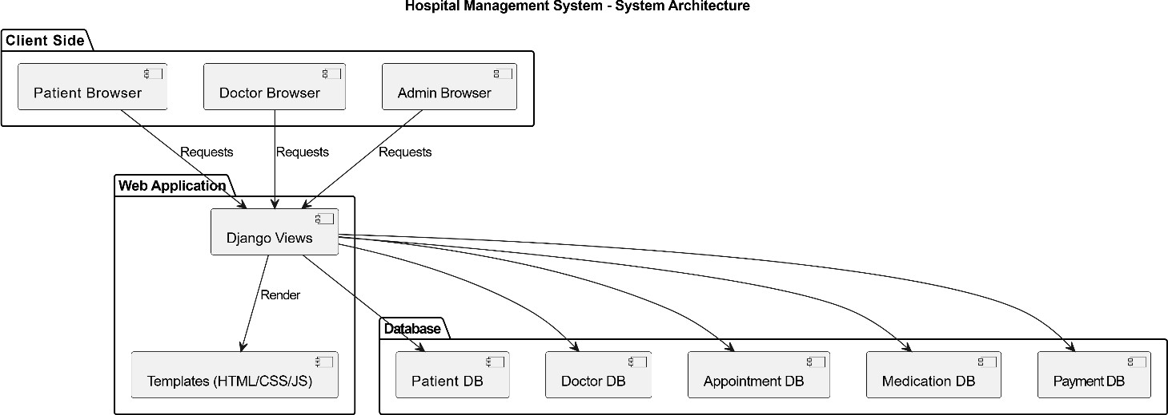

Figure-1: Demonstrates a classic Model-View-Template(MVT) architecture where the Django web application serves as the intermediary,fetching data from various databases to render dynamic content for different hospital stakeholders.

DATA FLOWDIAGRAM

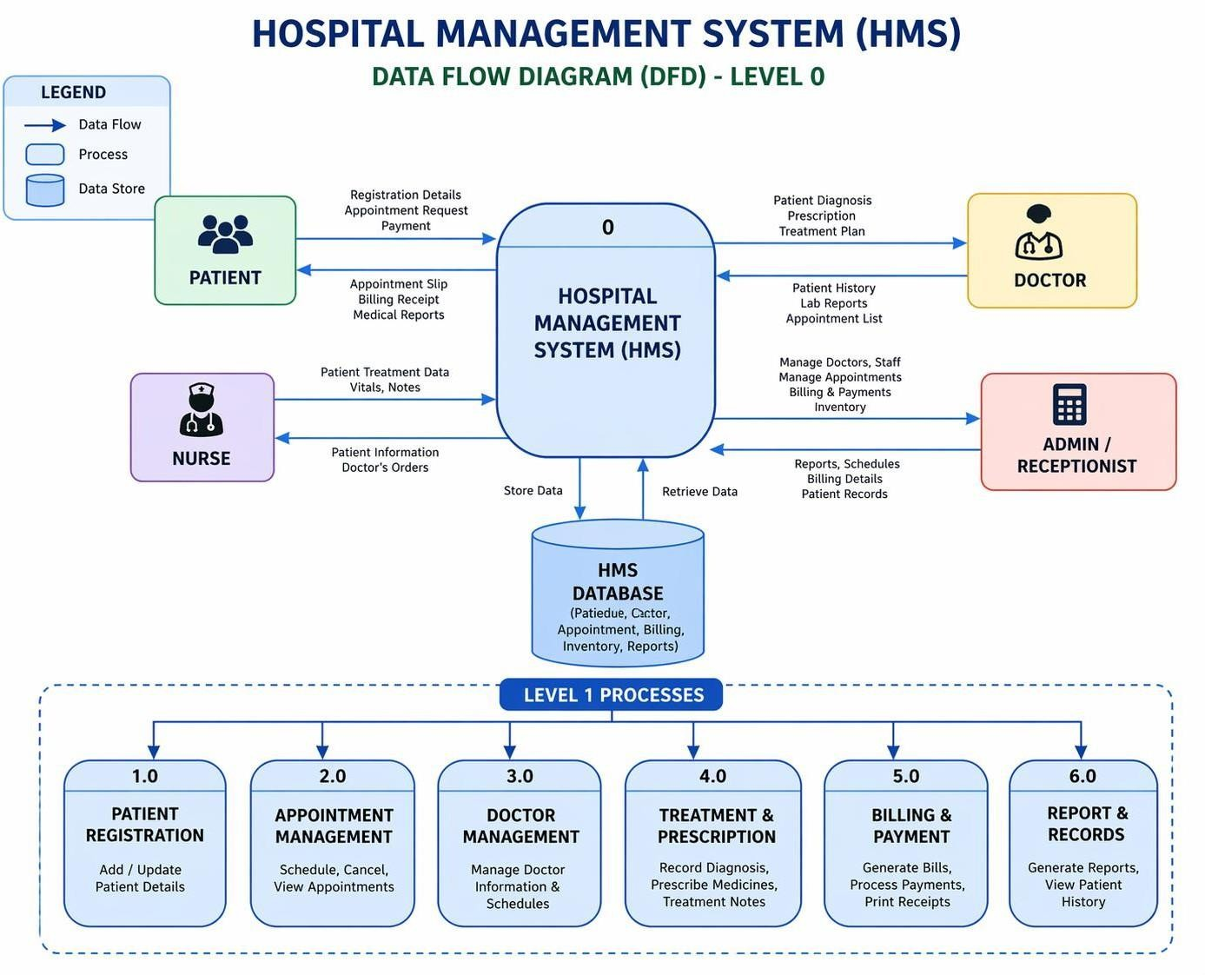

Figure-2: Depicts the structured flow of data across system entities, ensuring efficient handling of requests, users, and resource availability.

UML DIAGRAMS

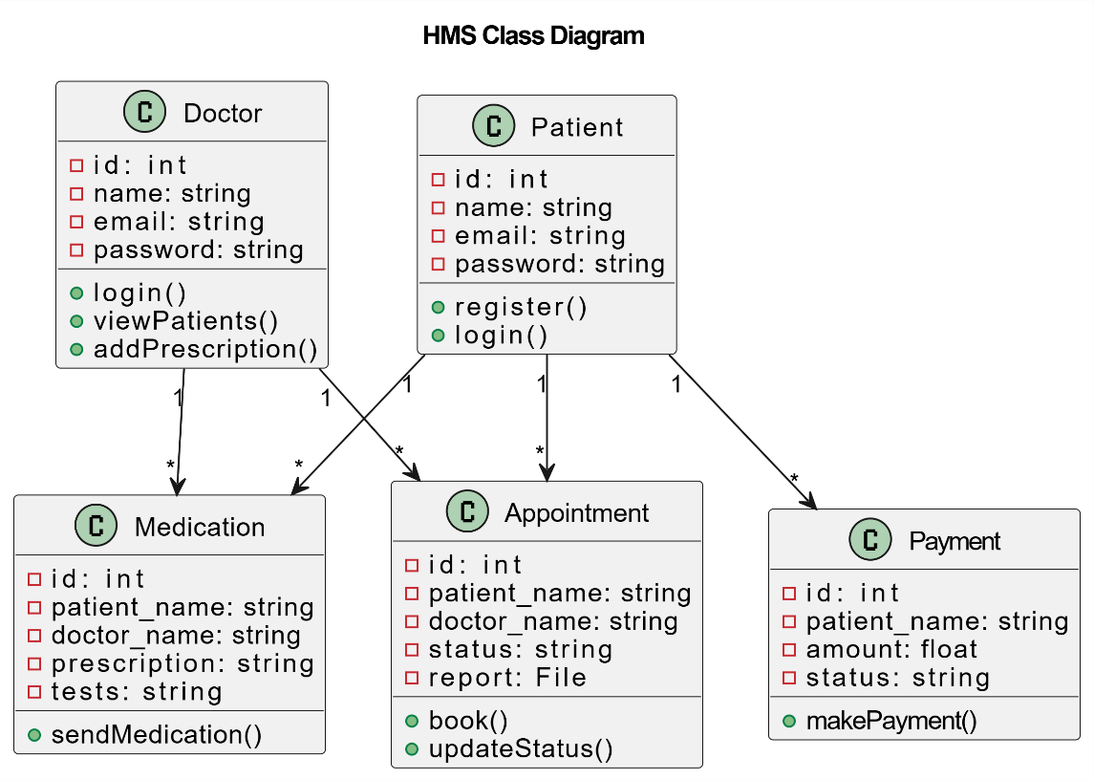
    - Class Diagram

Figure-3: Defines the core system structure through classes, highlighting relationships and responsibilities within the application.
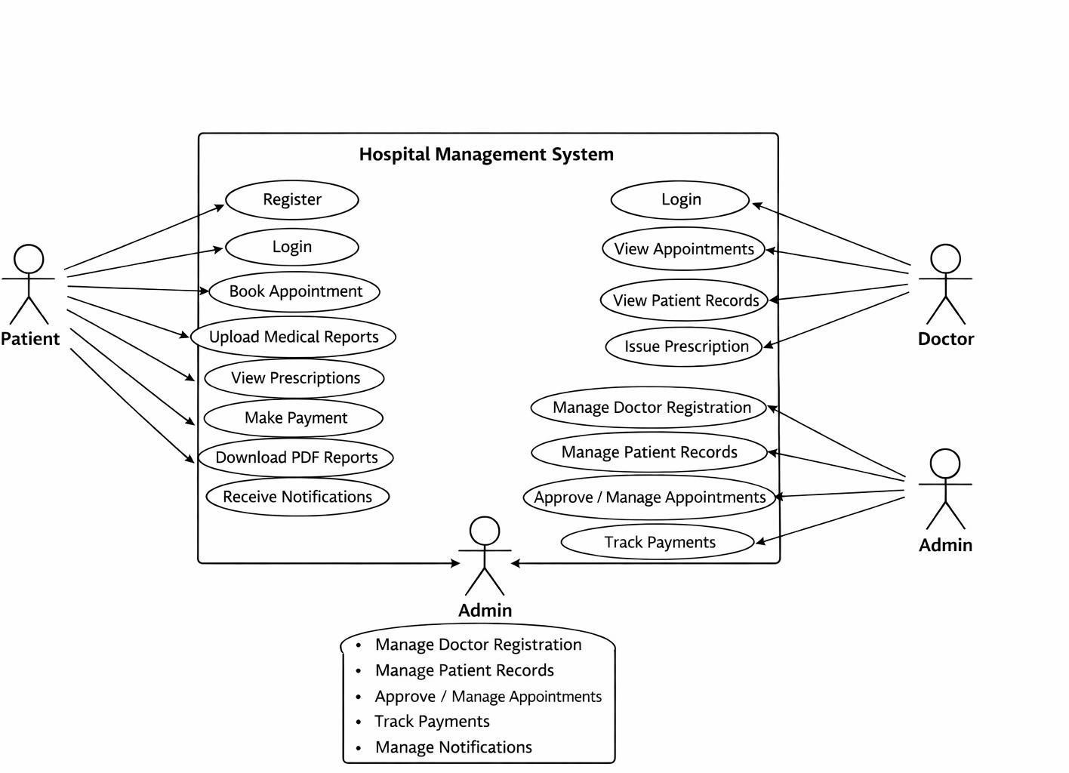

4.3.2 Use Case Diagram

Figure-4: Illustrates the functional interactions between users and the system, capturing key operations and user roles.

    - Sequence Diagram
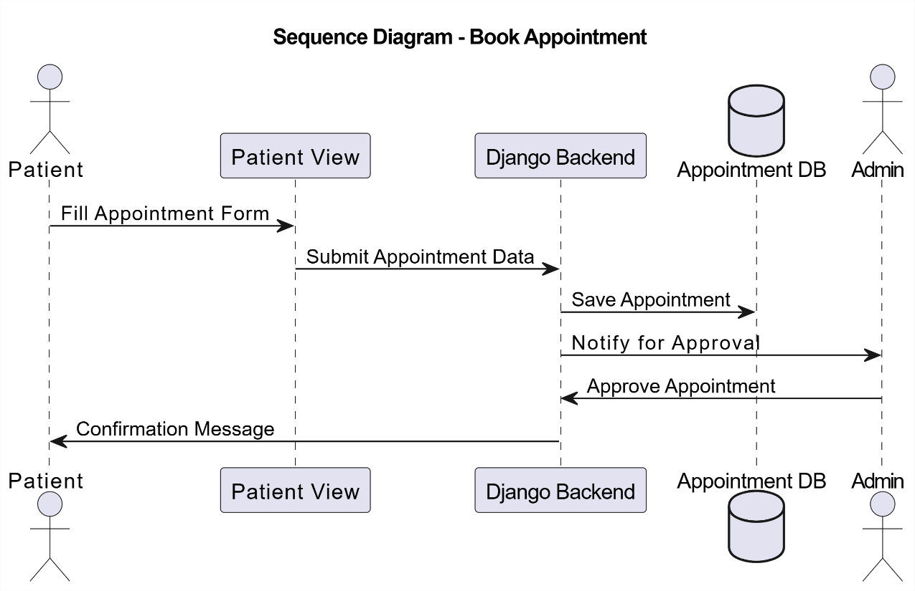

Figure-5: Describes the chronological exchange of information among system components during the execution of a request.

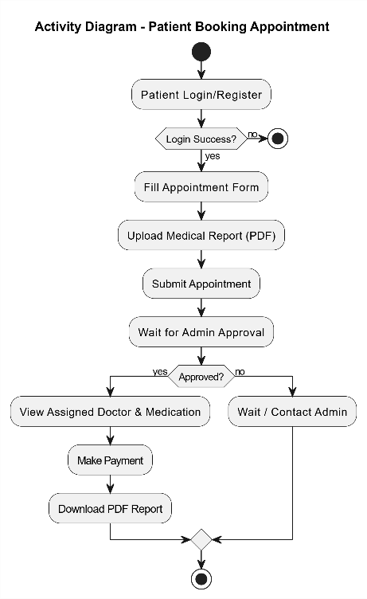
    - Activity Diagram
- Figure-6: Represents the operational workflow of the system, detailing the sequence of actions and decision points across modules.

MODULES

The Hospital Management System (HMS) is developed using a modular design approach in which the entire system is divided into multiple independent modules. Each module is designed to perform specific tasks while interacting with other modules to ensure smooth and efficient system operation. This modular structure enhances system flexibility, maintainability, and scalability. It also allows developers to update or modify individual modules without affecting the overall system performance.

The major modules of the system include the Admin Module, Doctor Module, and Patient Module, along with supporting components that handle backend processing and data management. Each module plays a crucial role in managing hospital operations effectively.

Admin Module

The Admin Module is the central controlling unit of the Hospital Management System. It is responsible for managing all system operations efficiently. The admin can add, update, and delete doctor and patient records. It allows monitoring of appointments and scheduling activities. The module also handles billing and payment management. The admin can generate reports related to hospital operations and performance. It ensures proper maintenance of all data in the system. The module provides access control and manages user permissions. It helps in tracking overall system activities and performance. Overall, the Admin Module ensures smooth and effective functioning of the entire system. The Admin Module also allows the administrator to monitor system usage and user activities in real time. It helps in maintaining data accuracy by verifying and updating records regularly. The admin can manage hospital resources such as rooms, beds, and equipment. It provides the ability to handle emergency cases by prioritizing appointments and services. The module supports backup and recovery operations to ensure data safety. It also helps in maintaining security by controlling login access and user authentication. Notifications and alerts can be managed through this module. The admin can oversee staff performance and workflow efficiency. It ensures proper coordination between different departments of the hospital.

Overall, it plays a vital role in maintaining system reliability and improving hospital management.

Doctor Module

The Doctor Module is an essential component of the Hospital Management System that helps doctors manage their daily activities efficiently. It allows doctors to view and access patient details, including medical history and previous treatments. Through this module, doctors can update patient diagnoses and prescribe medications. It also enables doctors to manage their appointment schedules and view upcoming consultations.

The module provides an interface for recording treatment details and maintaining accurate medical records. Doctors can add notes, test results, and recommendations for patients. It helps in improving patient care by providing quick access to complete patient information.

The Doctor Module also supports communication between doctors and other hospital staff for better coordination. It ensures that all patient-related information is updated in real time. Security features are included to ensure that only authorized doctors can access patient data.

Overall, the Doctor Module enhances efficiency, reduces manual work, and improves the quality of healthcare services provided by the hospital.

It also allows doctors to track patient progress over time and make informed decisions based on previous records. The module helps in reducing paperwork by maintaining digital records of prescriptions and treatments. Additionally, it improves time management by organizing appointments and minimizing scheduling conflicts.

It also enables doctors to generate and view patient reports for better analysis and diagnosis. The module supports quick access to laboratory results, improving treatment accuracy. Furthermore, it enhances overall workflow by integrating seamlessly with other system modules.

Patient Module

The Patient Module is an important component of the Hospital Management System (HMS) that focuses on managing all patient-related activities in an efficient and organized manner. It provides a user-friendly interface that allows patients to interact with the system easily and access various healthcare services without the need for manual processes. This module plays a vital role in improving patient experience and reducing administrative workload in hospitals.

The Patient Module allows new patients to register into the system by providing their basic details such as name, age, gender, contact information, and medical history. Once registered, each patient is assigned a unique patient ID, which helps in maintaining and tracking their records throughout the system. This ensures that patient information is stored securely and can be accessed whenever required.

One of the key features of this module is appointment scheduling. Patients can book appointments with doctors based on availability, select suitable time slots, and manage their appointments efficiently. This reduces waiting time and avoids overcrowding in hospitals. Patients can also view, modify, or cancel their appointments through the system.

The module provides access to patient medical records, including diagnosis details, prescriptions, laboratory reports, and treatment history. This helps patients stay informed about their health condition and enables doctors to make better decisions based on complete medical information. Digital record management also eliminates the need for physical files and reduces the risk of data loss.

Billing and payment management is another important feature of the Patient Module. Patients can view their billing details, payment history, and outstanding balances. The system ensures accurate billing and provides transparency in financial transactions. In some cases, it may also support online payment options for added convenience.

The Patient Module also supports communication between patients and hospital staff. Patients can receive notifications regarding appointment confirmations, reminders, and

important updates. This improves coordination and ensures that patients do not miss important schedules or instructions.

Security and privacy are given high importance in this module. Patient data is protected through authentication and access control mechanisms, ensuring that only authorized users can access sensitive information. This helps maintain confidentiality and trust in the system.

Additionally, the module helps in tracking patient visits and maintaining a complete history of interactions with the hospital. This information can be used for analysis and improving healthcare services. It also supports better decision-making by providing accurate and up-to-date data.

Overall, the Patient Module enhances the efficiency of hospital operations by digitizing patient-related processes. It improves accessibility, reduces manual work, and ensures better patient care. By providing a convenient and reliable platform, it plays a crucial role in the successful implementation of the Hospital Management System. It also allows patients to download or print their medical reports and prescriptions for future reference. The module helps in maintaining appointment history, which can be useful for follow-up treatments. Patients can update their personal information whenever required, ensuring data accuracy. It improves transparency by providing clear details of treatments and services received. Overall, the Patient Module enhances convenience, accessibility, and satisfaction for patients using the system.

  - IMPLEMENTATION AND RESULTS

IMPLEMENTATION AND RESULTS

LANGUAGE / TECHNOLOGY USED
This chapter describes the practical implementation of the Hospital Management System (HMS) and presents the technologies used to develop and test the system. The implementation phase focuses on converting the system design into a functional software application using appropriate tools and technologies. The developed system enables hospitals to manage patient records, doctor information, appointments, billing, and other hospital operations efficiently.

The system is implemented as a web-based application using modern technologies. The frontend is developed using HTML, CSS, and JavaScript, which provide a user-friendly and responsive interface. The backend is developed using Python with the Django framework, which handles server-side logic, data processing, and communication between different components of the system. The system uses MySQL as the database management system to store patient details, doctor records, appointments, billing information, and other hospital data.

The implementation process involved designing multiple modules such as Admin, Doctor, and Patient modules, integrating frontend and backend components, creating and managing the database, and performing testing to ensure system reliability, accuracy, and performance.

The development of the Hospital Management System requires the use of efficient and scalable technologies to ensure smooth operation. The system is designed to automate hospital processes and improve data management through a centralized platform.

To implement the system effectively, several software technologies and development tools were used. The major technologies include Python and Django for backend development, HTML, CSS, and JavaScript for frontend development, MySQL for database management, and Visual Studio Code as the development environment. These technologies together provide a robust, secure, and scalable solution for managing hospital operations.

Advantages of Django

      - Django is a high-level Python web framework used for building secure, scalable, and efficient web applications such as Hospital Management Systems (HMS). One of its key advantages is its MVT (Model-View-Template) architecture, which separates data handling, business logic, and user interface, making the application more organized and easier to manage.

      - Each layer in Django has a specific responsibility, which improves code maintainability and readability. This structured approach helps developers efficiently build and update complex healthcare systems without affecting other components.

      - In the HMS project, Django is used to handle core functionalities such as patient management, doctor scheduling, appointment booking, and medical record storage, ensuring smooth backend operations.

      - Django provides a powerful built-in admin panel, which allows hospital staff and administrators to manage data like patient details, doctor information, and appointments without requiring additional coding or complex interfaces.

      - Django enhances security, which is very important for healthcare applications. It provides built-in protection against common threats like SQL injection, cross-site scripting (XSS), and cross-site request forgery (CSRF), helping safeguard sensitive patient data.

      - Another major advantage of Django is its Object-Relational Mapping (ORM) feature, which allows developers to interact with databases using Python code instead of complex SQL queries. This simplifies database operations such as storing and retrieving patient records and billing details.Django also supports fast development and rapid deployment, making it suitable for projects with tight deadlines. Its “batteries-included” approach provides ready-to-use features like authentication, routing, and session management.

Advantages of Python

      - Python is widely used in Hospital Management System (HMS) projects because of its simplicity, flexibility, and powerful libraries. One of its main advantages is that Python has a simple and readable syntax, which makes development faster and easier, even for complex healthcare applications.

      - Python also supports rapid development, allowing developers to build and deploy HMS modules like patient management, appointment scheduling, and billing systems in less time compared to many other programming languages.

      - Another important advantage is its strong library and framework support. Python offers frameworks like Django and Flask, which provide built-in features for security, database handling, and web development, making it ideal for HMS projects.

      - Python is also highly scalable and flexible, meaning the system can easily grow as the hospital expands, handling more patients, doctors, and medical records without performance issues.

      - In addition, Python provides excellent database connectivity, allowing smooth integration with databases like MySQL, PostgreSQL, or SQLite to efficiently store and manage patient and hospital data.

      - Python is also known for its security features and reliability, which help protect sensitive medical information such as patient records, prescriptions, and reports.

      - Finally, Python has a large community support, which helps developers quickly solve problems and improve the system using ready-made solutions and continuous updates.

Advantages of MySQL Database

MySQL is a widely used relational database management system that provides reliable storage for structured data. It supports the use of tables, rows, and relationships to organize information efficiently.

In the HMS system, MySQL stores important information such as:

        - Patient details
        - Hospital records
        - Doctor Details
        - Medication files
        - Request and approval status
        - The use of relational tables ensures that data is properly organized and easy to retrieve when needed.

MySQL provides strong mechanisms for maintaining data integrity and security. It supports authentication mechanisms, data constraints, and access control features that protect sensitive healthcare data.

These features ensure that only authorized users such as hospitals or administrators can modify critical data within the system.

Advantages of Visual Studio Code

- Visual Studio Code (VS Code) is a lightweight and powerful source code editor widely used for developing applications like Hospital Management Systems (HMS). One of its main advantages is that it is lightweight and fast, allowing developers to open and work on large projects without slowing down the system.

- VS Code provides excellent support for multiple programming languages such as Python, JavaScript, HTML, CSS, and more. This makes it very useful for full-stack development of HMS projects where both frontend and backend technologies are used.

- It also offers a strong extension marketplace, where developers can install useful tools like code formatters, debuggers, Git integration, and frameworks support, which

improves productivity and simplifies development work.

- Another advantage is its built-in debugging feature, which helps developers easily find and fix errors in the code. This is very helpful in complex systems like HMS where multiple modules are interconnected.

- VS Code also supports IntelliSense (smart code suggestions), which provides auto- completion, syntax highlighting, and code hints, helping developers write code faster and with fewer mistakes.

- Additionally, it has integrated Git support, allowing developers to manage version control, track changes, and collaborate with team members efficiently.

- Finally, VS Code is highly customizable and user-friendly, enabling developers to personalize themes, layouts, and settings according to their preference, which improves overall coding experience and productivity.

- VS Code provides built-in terminal support, allowing developers to run commands, execute programs, and manage backend servers directly within the editor. This is very useful in HMS projects for running Django servers, database commands, and testing APIs without switching between multiple tools.

- VS Code also supports real-time collaboration and Live Share feature, which enables multiple developers to work on the same codebase simultaneously. This improves teamwork and speeds up the development process in large projects like Hospital Management Systems.

SAMPLE CODE

Admin views.py file

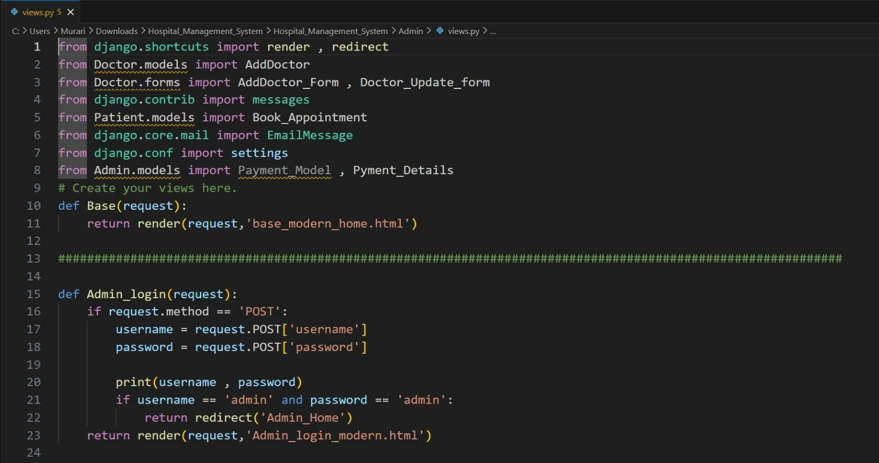
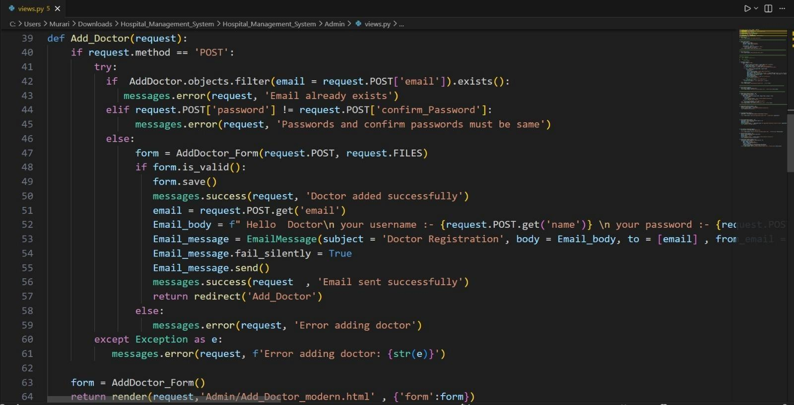

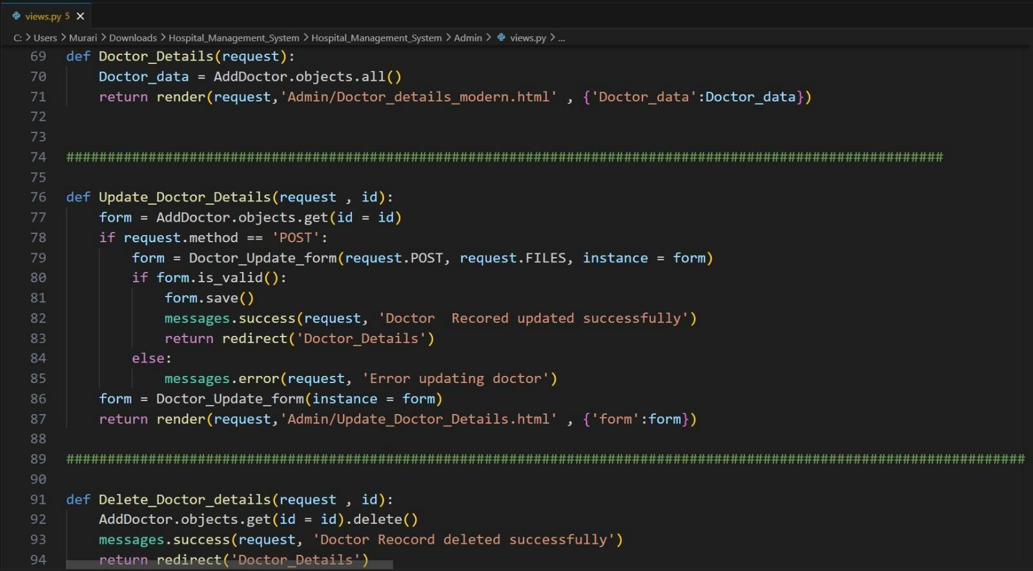

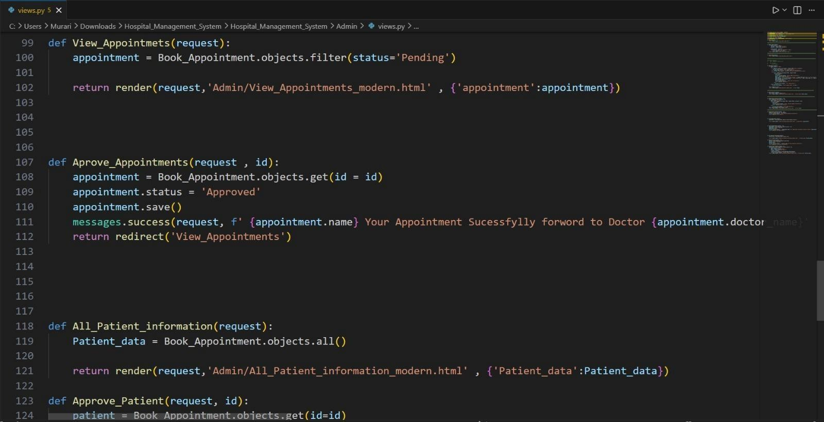

Doctor Views.py

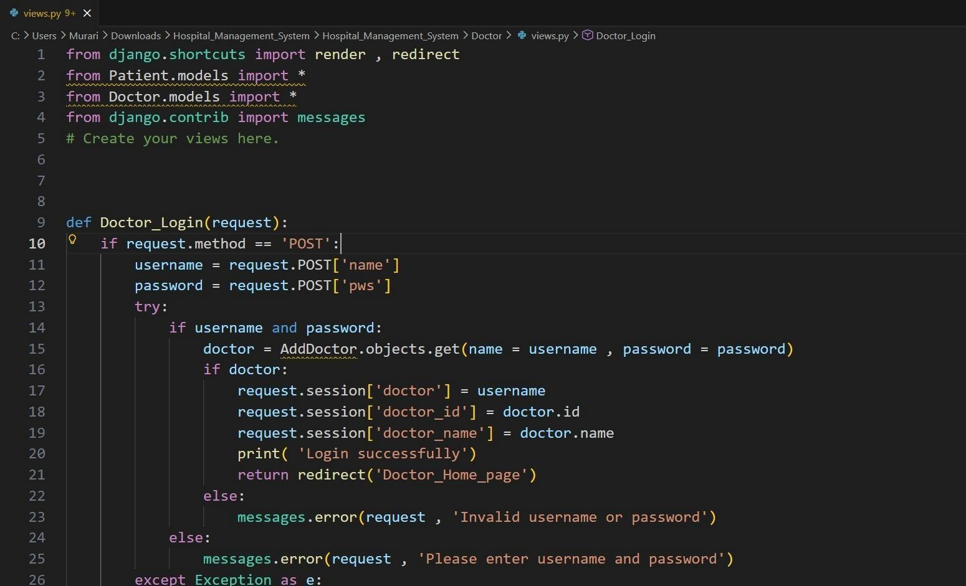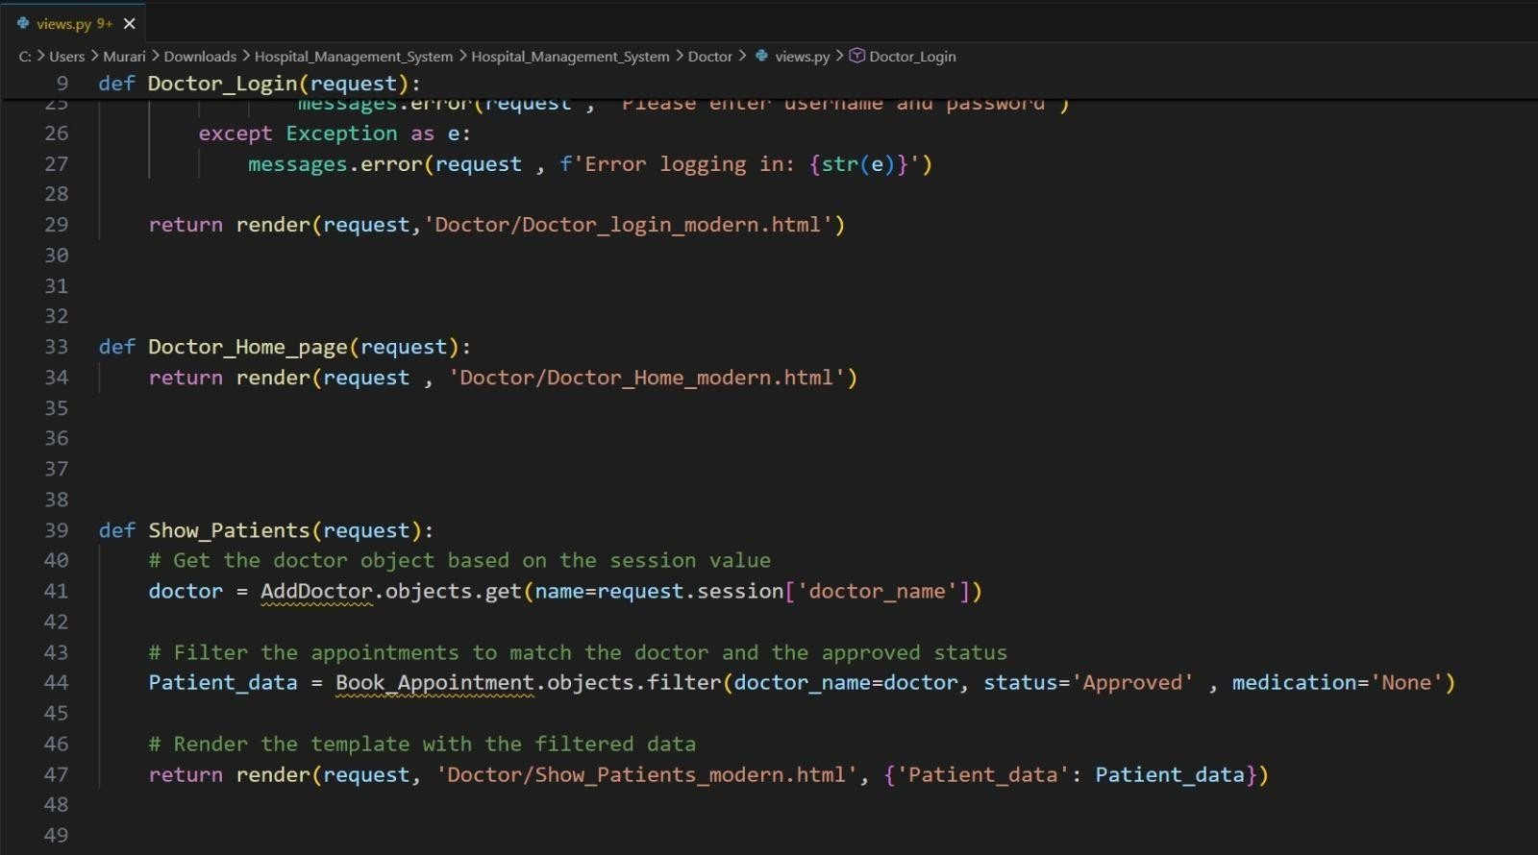

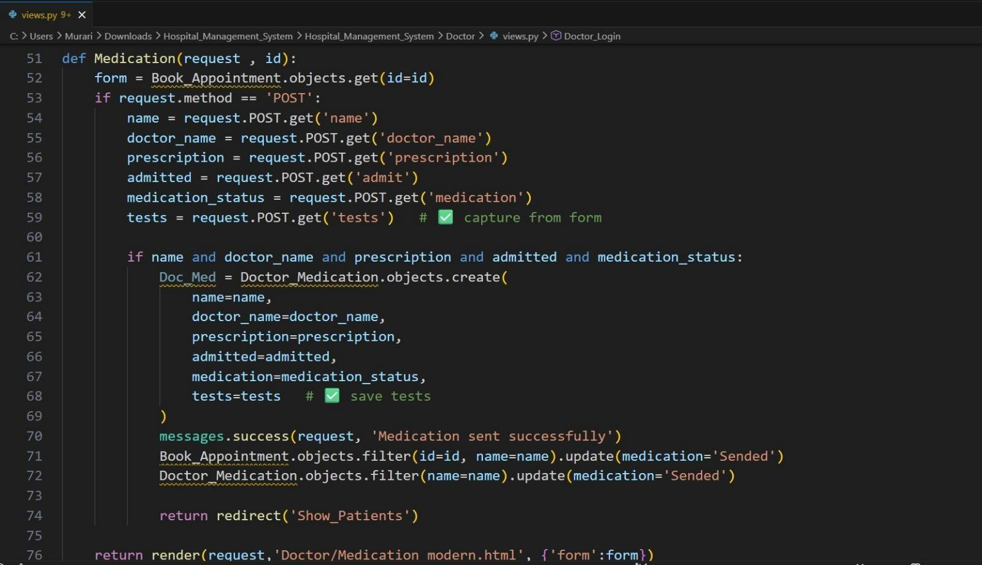

Patient views.py

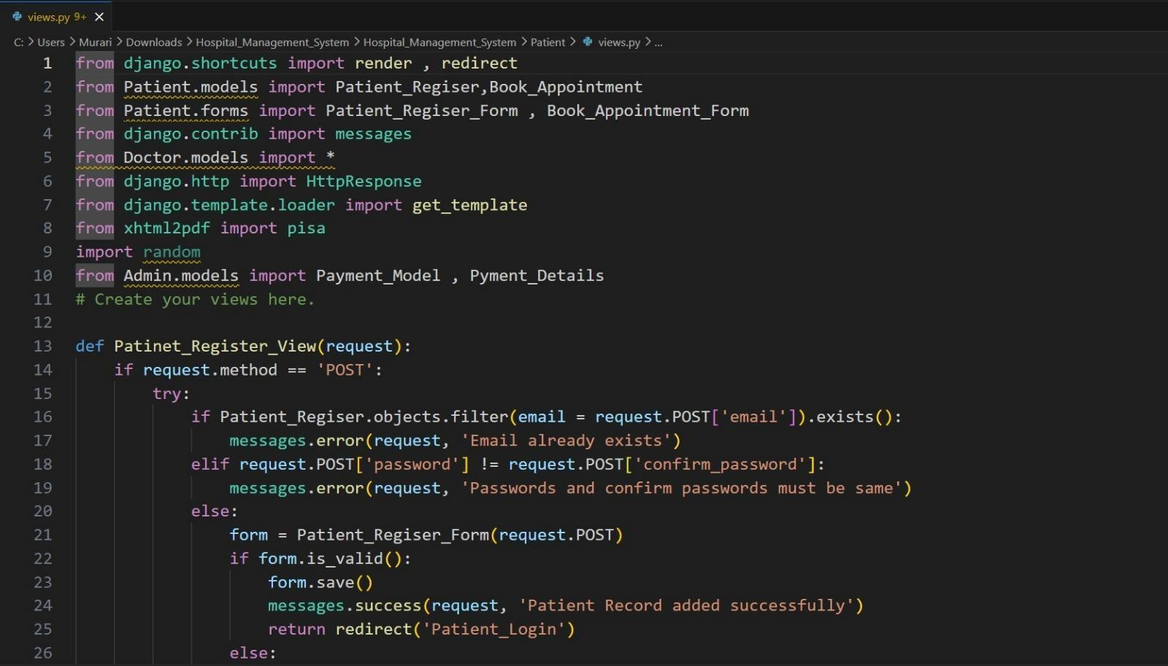

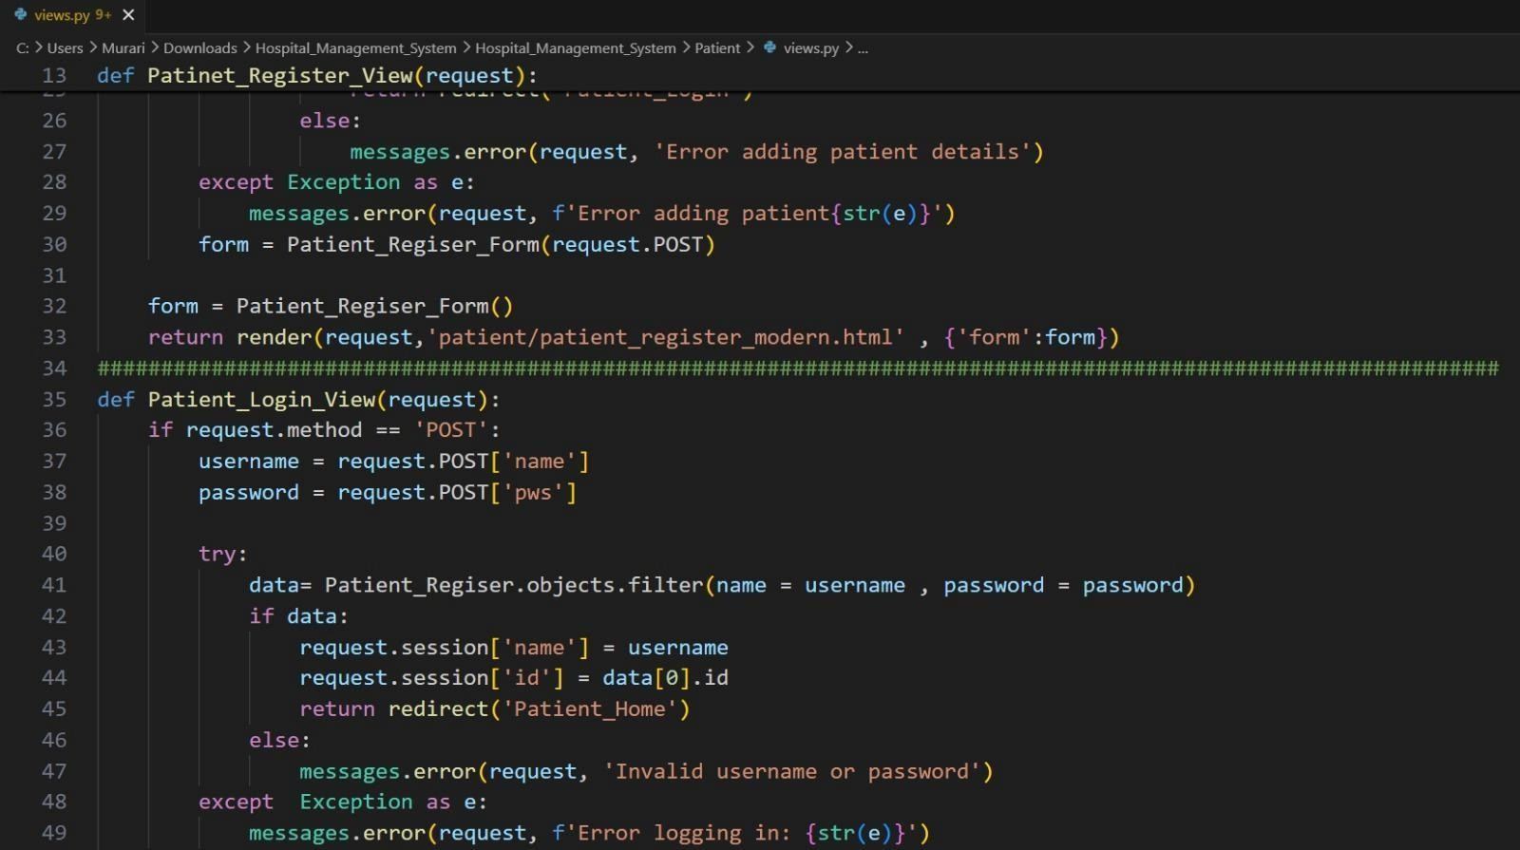

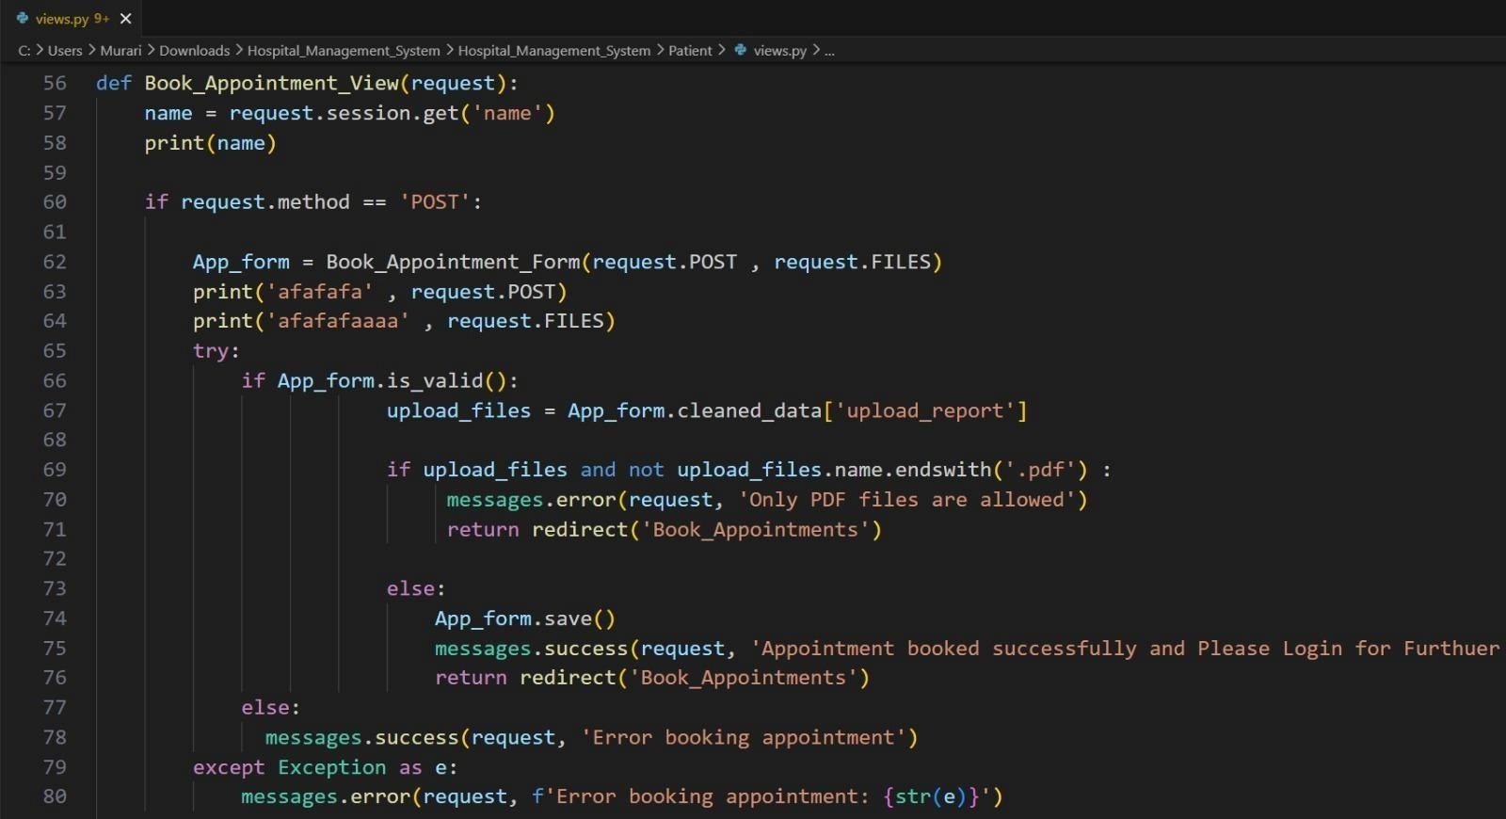

RESULTS (ACCURACY) / OUTPUT SCREENS

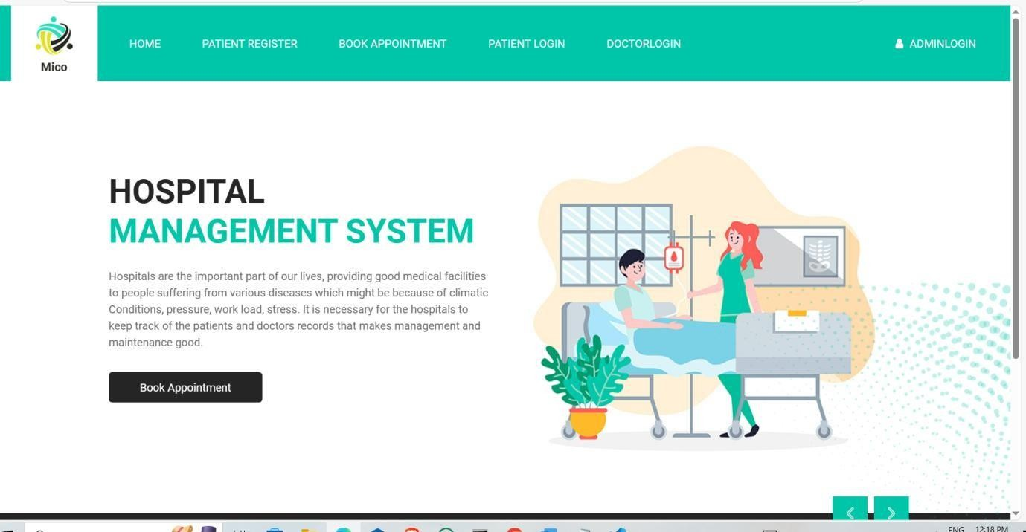

Figure-7: Presents the system landing interface enabling users to initiate access as a patient or hospital within the LifeLink platform.

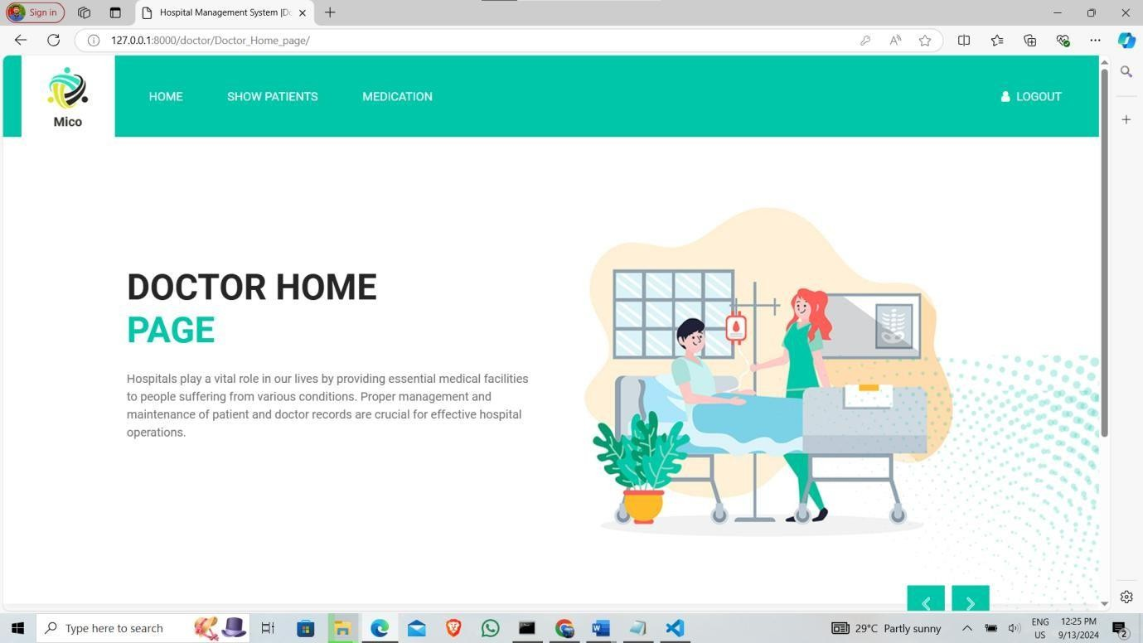

Figure-8: Displays the Doctor Home page

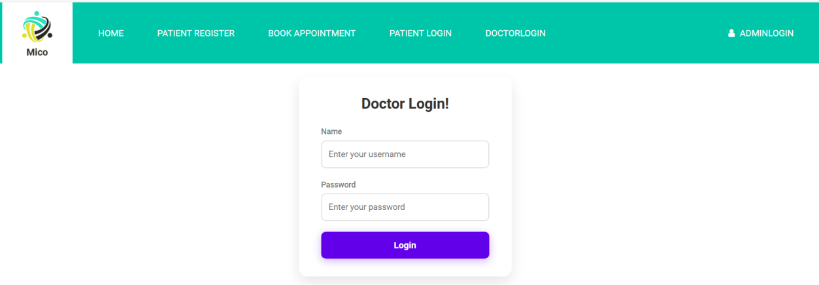

Figure-9: Doctor Login

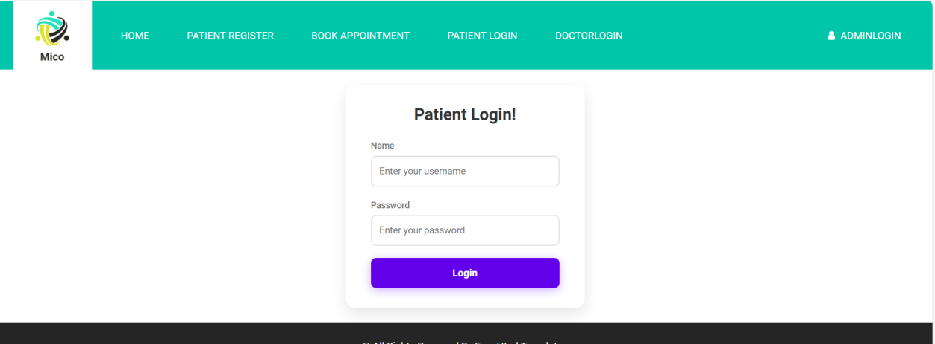

Figure-10: Patient Login Page

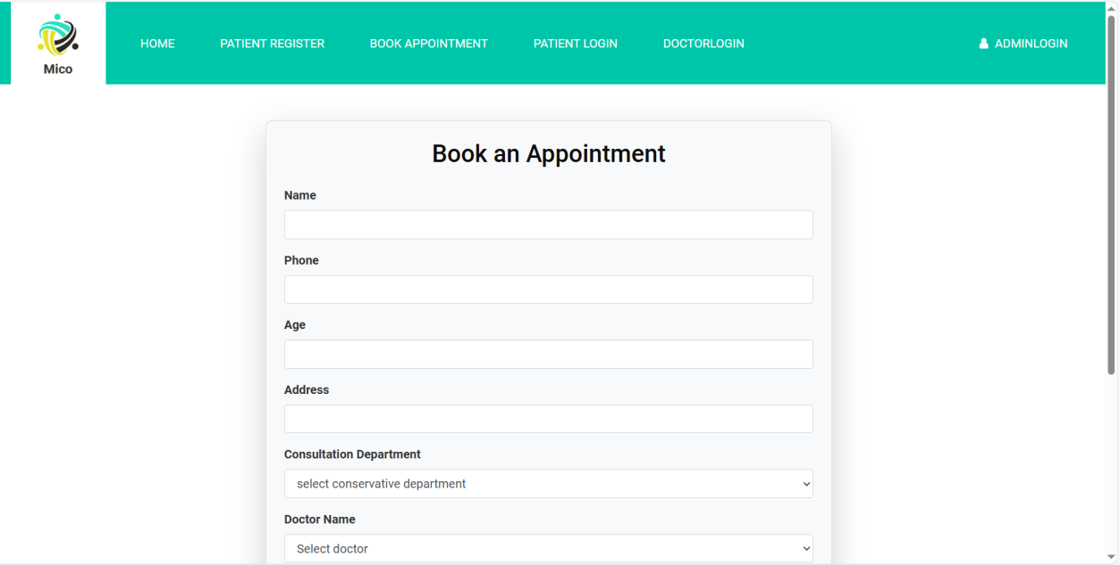

Figure-11: Patient Booking an Appointment
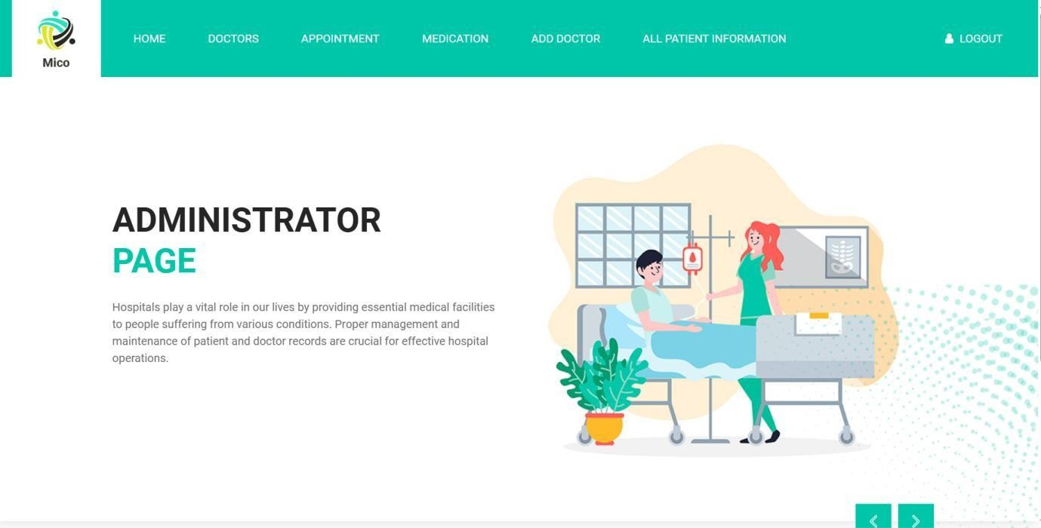

Figure-12: Admin Home Pge

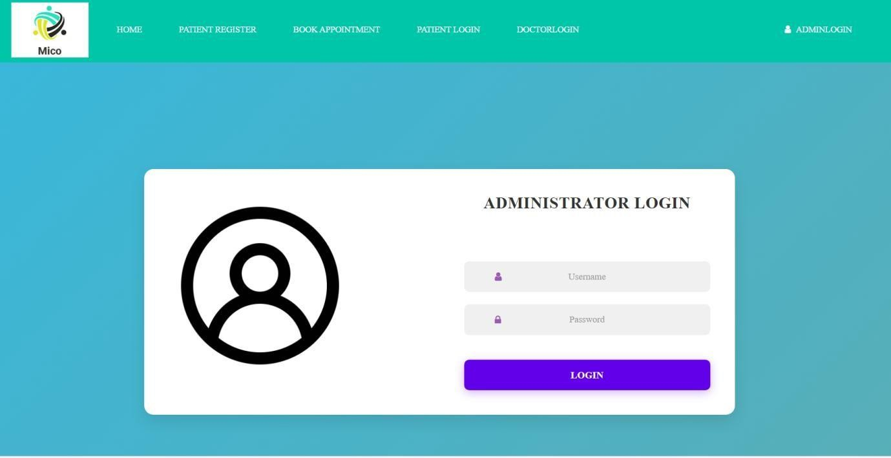

Figure-13: Admin Login

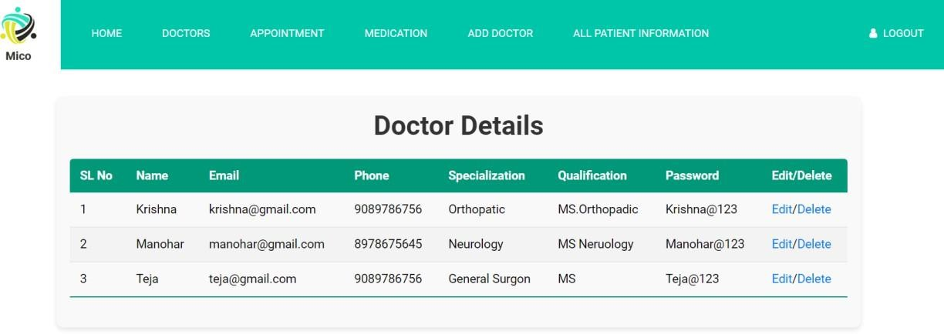

Figure-14: Shows Available Doctors Details

TESTING

TESTING

TYPES OF TESTING

Unit Testing

Unit testing is an important phase in the development of the Hospital Management System (HMS), where individual components of the system are tested separately to ensure they work correctly. It focuses on verifying the functionality of small units such as login modules, patient registration forms, appointment booking, billing systems, and database operations.

The main objective of unit testing is to detect errors at an early stage of development. In HMS, each module is tested independently to ensure that it performs its intended function without any errors. For example, the patient login module is tested to verify correct authentication, and the appointment module is tested to ensure proper scheduling of doctors and patients.Unit testing improves the reliability and quality of the system by identifying bugs before integration. This helps reduce system failures in real-time usage, especially in critical healthcare environments where accuracy is very important.

It also makes debugging easier because errors are isolated to specific units of code. Developers can quickly fix issues without affecting the entire system.In addition, unit testing supports faster development and maintenance, as tested modules can be reused and modified with confidence. This ensures that the HMS system remains stable, efficient, and user-friendly for hospital staff and patients.
Another important advantage of unit testing in the Hospital Management System (HMS) is that it ensures high system accuracy and long-term stability by validating each module individually before integration. Since HMS contains critical components like patient records, doctor scheduling, billing, and emergency data handling, unit testing helps confirm that each function works exactly as expected under different input conditions. It also reduces the risk of data errors, system crashes, and incorrect outputs in real-time hospital operations. By testing small units early and repeatedly, developers can ensure that any changes or updates in the system do not break existing functionality, making the HMS more reliable, secure, and easier to maintain in the long run.

Functional Testing

Functional testing is an important type of software testing used in the Hospital Management System (HMS) to verify that each feature of the system works according to the required specifications. It focuses on testing the functionality of the system by checking whether the inputs provided produce the expected outputs.

In HMS, functional testing is applied to modules such as patient registration, doctor appointment booking, login authentication, billing system, and report generation. For example, when a patient enters valid details in the registration form, the system should successfully store the data in the database and display a confirmation message.

The main objective of functional testing is to ensure that all features of the system are working correctly and meeting user requirements. It helps in identifying missing functions, incorrect outputs, and interface issues before the system is deployed.
Functional testing also improves the reliability and user satisfaction of the HMS by ensuring smooth operation of all hospital activities. Since HMS is used in real-time healthcare environments, accurate functionality is very important for patient safety and efficient hospital management.

In addition, it helps in validating data flow and system integration between modules, ensuring that different parts of the HMS work together properly without errors.

Integration Testing
Integration testing is an important phase in the development of the Hospital Management System (HMS), where individual modules of the system are combined and tested as a group. The main objective of integration testing is to ensure that different components of the system work together correctly and exchange data without any errors.

In an HMS, there are multiple modules such as patient registration, doctor management, appointment scheduling, billing, pharmacy, and laboratory reports. During integration testing, the interaction between these modules is verified. For example, when a patient books an appointment, the system should correctly update the doctor’s schedule, store the booking details in the database, and reflect the information in the admin dashboard.
This type of testing also improves the reliability, consistency, and smooth functioning of

the HMS system, making sure that all hospital operations are properly connected. It ensures that data such as patient details, medical records, and billing information flows accurately across different modules without loss or corruption.

Overall, integration testing plays a key role in building a stable and efficient Hospital Management System by ensuring that all modules work together as a single unified system.

White Box Testing

White box testing is a software testing technique used in the Hospital Management System (HMS) where the internal structure, code, and logic of the application are tested. It is also known as structural testing or clear box testing because the tester has complete knowledge of the system’s internal working.

In HMS, white box testing is used to verify the internal code of modules such as patient registration, login system, appointment booking, billing, and database operations. The main focus is on checking the flow of inputs and outputs, conditional statements, loops, and logical paths within the program.

The objective of white box testing is to ensure that all internal paths of the code are working correctly and efficiently. It helps in identifying hidden errors, incorrect logic, and unreachable code that may not be detected through other testing methods.
White box testing improves the quality, accuracy, and performance of the HMS system by ensuring that each function and module works exactly as intended at the code level. It also helps developers optimize the code by removing unnecessary lines and improving execution efficiency.

In addition, it supports early bug detection, which reduces development cost and time. Since HMS deals with sensitive medical data, white box testing ensures that the system logic is secure and reliable, preventing data errors and system failures.
Overall, white box testing plays a crucial role in making the Hospital Management System more robust, efficient, and technically sound by validating its internal structure and code behavior.

Black Box Testing

Black box testing is a software testing technique used in the Hospital Management System (HMS) where the internal code or structure of the application is not considered. Instead, the testing is performed based on the input given and the output received. The main focus is to verify whether the system functions correctly according to the user requirements.

In HMS, black box testing is applied to various modules such as patient registration, login system, appointment booking, billing, and report generation. For example, when a user enters valid login credentials, the system should successfully allow access to the dashboard. If incorrect details are entered, the system should display an error message. The main objective of black box testing is to ensure that all functionalities of the system are working properly from a user’s point of view. It helps in checking whether the system is behaving as expected without knowing how the internal code is written.

Black box testing improves the usability, reliability, and correctness of the HMS system by focusing on real-world user scenarios. It ensures that all features are user-friendly and produce accurate results.

In addition, it helps in identifying issues related to missing functions, incorrect outputs, and interface errors. Since HMS is used in healthcare environments, black box testing is very important to ensure smooth and error-free operation for patients, doctors, and hospital staff.Overall, black box testing plays a key role in validating the external behavior of the Hospital Management System and ensuring that it meets user expectations effectively.

Acceptance Testing

Acceptance testing is the final phase of testing in the Hospital Management System (HMS) where the system is evaluated to ensure it meets all user requirements and business needs. It is performed to check whether the software is ready for real-time use by hospital staff and patients. In this testing, actual users verify important functions like patient registration, appointment booking, and billing. Acceptance testing ensures that the system is user-friendly, accurate, and reliable. Once the system passes this testing, it is approved for deployment in the hospital environment.

System Testing

System testing is an important level of software testing in the Hospital Management System (HMS) where the complete and fully integrated application is tested as a whole. It is performed after integration testing and focuses on verifying the overall functionality, performance, security, and reliability of the entire system. The main objective of system testing is to ensure that the HMS works correctly as per the specified requirements in a real-world environment.registration, doctor management, appointment scheduling, billing system, pharmacy In the Hospital Management System, system testing covers all major modules such as patient management, laboratory reports, and user authentication. All these modules are tested together to ensure that they interact properly and provide accurate results. For example, when a patient books an appointment, the system should update the doctor’s schedule, store the booking details in the database, and reflect the information in the admin dashboard without any errors.

System testing also verifies the end-to-end workflow of the application, ensuring that all hospital operations run smoothly from start to finish. It checks whether data flows correctly between different modules and whether the system behaves as expected under different conditions. This testing helps in identifying issues such as functional errors, interface problems, performance delays, and security vulnerabilities.
Another important aspect of system testing is performance testing, where the system is evaluated for speed, response time, and stability under heavy load. In an HMS, many users such as doctors, patients, and administrators may access the system simultaneously, so it is important to ensure that the system does not crash or slow down.
System testing also includes security testing, which ensures that sensitive patient data is protected from unauthorized access. It verifies login systems, user roles, and data encryption mechanisms to maintain confidentiality and integrity of medical information.

Overall, system testing plays a crucial role in ensuring that the Hospital Management System is complete, reliable, and ready for deployment. It confirms that all components work together efficiently and meet the expectations of end users in a real hospital environment.

TEST CASES

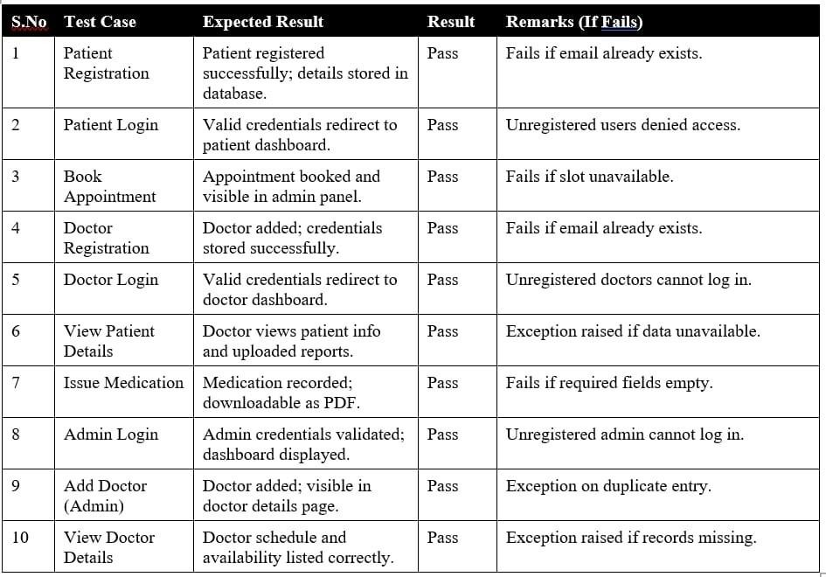

Table-1 Test Cases

CONCLUSION

CONCLUSION

Since the Hospital Management System is vital for keeping accurate records of the patients appointments, doctor appointments, prescriptions, hospital personnel etc. It is acknowledged that following the unveiling of the Work at the hospitals would be efficient and seamless with the Hospital Management Project in place. All of the needs of a typical hospital are met by this project. It is capable of storing information of doctors and patients who visit the hospital in anefficient and effective manner. Compared to the conventional method of transmitting the file manually, the patient data transfer would only take a few seconds. This project made the process incredibly simple and time- efficient. The proposed system provides advantages over the existing manual system, such as reducing data redundancy, inconsistency, storing vast amounts of data, and improving staff efficiency. The digital process of gathering, storing, and retrieving the information would make it possible to improve the efficiency and effectiveness of hospital management and provide better healthcare services to patients.

The system ensures data security and privacy, which is very important in healthcare applications. Sensitive patient information is stored safely and can only be accessed by authorized users. This increases trust and confidentiality in the hospital environment.

HMS also supports better communication between different departments such as pharmacy, laboratory, and administration, ensuring smooth workflow and coordination. It reduces paperwork and improves resource management within the hospital.

Overall, the Hospital Management System is a reliable, user-friendly, and scalable solution that enhances the quality of healthcare services. It modernizes hospital operations and makes healthcare management more efficient, organized, and patient- centric

FUTURE SCOPE

FUTURE SCOPE

The Hospital Management System (HMS) has significant potential for future enhancements to further improve healthcare services and hospital operations. With the advancement of technology, the system can be upgraded to include more intelligent, efficient, and user-friendly features that meet the growing demands of modern healthcare environments.One of the major future enhancements is the integration of Artificial Intelligence (AI) and Machine Learning. These technologies can help in predicting diseases, analyzing patient data, and assisting doctors in decision-making. AI-based chatbots can also be implemented to provide instant responses to patient queries and guide them through hospital services.

Another important improvement is the development of a mobile application for the HMS. This will allow patients to book appointments, access medical reports, receive notifications, and communicate with doctors directly through their smartphones. It will increase accessibility and convenience for both patients and hospital staff.
The system can also be enhanced by integrating telemedicine features, enabling online consultations between doctors and patients. This is especially useful for remote areas where access to hospitals is limited. Telemedicine can save time, reduce travel, and provide quick medical assistance during emergencies.
Future versions of HMS can include cloud-based storage, which will allow secure and centralized data management. Cloud technology ensures data availability, backup, and easy sharing of medical records between different hospitals and departments, improving collaboration and efficiency.

Another scope of improvement is the integration of IoT (Internet of Things) devices such as wearable health monitors. These devices can track patient health in real time and automatically update the system with vital information like heart rate, blood pressure, and temperature. This helps in continuous monitoring and early detection of health issues.
The HMS can also be expanded to include advanced data analytics and reporting tools, which help hospital management make better decisions based on patient trends, resource usage, and financial data. This will improve planning and overall hospital performance.

In addition, implementing online payment systems and insurance integration can simplify billing processes for patients. Features like digital prescriptions and e-pharmacy integration can further enhance the system.
Overall, the future scope of the Hospital Management System is vast, with opportunities to incorporate modern technologies and innovations. These improvements will make the system more intelligent, efficient, and capable of delivering high-quality healthcare services in a faster and more reliable manner.Additionally, the Hospital Management System can be enhanced with multi-language support, making it accessible to patients from different regions and improving user experience. The inclusion of voice-based assistance can help non-technical users easily interact with the system
.
Future developments may also include blockchain technology to ensure secure and tamper-proof storage of medical records, increasing data transparency and trust. The system can be upgraded with automated alert systems to notify doctors and patients about emergencies, medication schedules, and follow-up visits.
Another improvement could be the integration of robotic process automation (RPA) to handle repetitive administrative tasks like data entry and report generation, reducing workload on hospital staff. The HMS can also support real-time bed management systems, helping hospitals efficiently track and allocate available beds during peak times. Furthermore, adding training and simulation modules for medical staff can enhance learning and skill development within the same platform. The system can also be integrated with government health schemes and databases, ensuring better compliance and easier processing of patient benefits.

BIBLIOGRAPHY

BIBLIOGRAPHY

- Paras V. Kothare, Yogesh K. Gedam, Ratnadeep R. Deshmukh, (2014), “Ranking Algorithm RA-SVM for Domain Adaptation: A Review”, International Journal of Scientific & Engineering Research, ISSN 2229- 5518 Volume 5, Issue 4, PP: 503-507.
- Pratik R.Mantri, Prof. Mahip M.Bartere, (2014), “Review on Adaption of Ranking Model for Domain Specific Search”, International Journal of Computer Science and Mobile Computing, ISSN 2320–088X, Vol.3, Issue.4, PP: 103-110.
- Maheswari, B., Chandra Shekhar Reddy, K.,Prof. S. V. Achutha Rao, (2013), “Design and Implementation of Ranking Adaptation Algorithm for Domain Specific Search”, International Journal of Computer Trends and Technology, ISSN: 2231-2803, volume4Issue8, PP: 2830- 2833.
- Nisha.K, Adhithyaa.N, Stephen.B and Muthu Kumar.P, (2013), “Ranking Model Adaptation for Domain Specific Search”, International Journal of Emerging Trends in Electrical and Electronics, Vol. 2, Issue. 4, PP: 32-35.
- “Quality of information management and efficiency of Hospital employees” by Spamast Malita, Iteit. (2018). Hospital Management.
- Measuring the Quality of Health Care: A statement of the National Roundtable on Healthcare Quality Division of Healthcare Services: National Academy Press; 1999.
- Praveen K.A and Gomes L.A, 2006: “A Study of the Hospital Information System (HIS) In the Medical Records Department of A Tertiary Teaching Hospital” Journal of the Academy of Hospital Administration, Vol. 18, No. 1 (2006-01 - 2006-12)
s.

APPENDIX-A

APPENDIX- A: UNIFIED MODELING LANGUAGE
Introduction
Unified Modeling Language (UML) is a standardized general-purpose modeling language in the field of object-oriented software engineering. UML includes a set of graphic notation techniques to create visual models of object-oriented software systems. UML combines techniques from data modeling, business modeling, object modeling, and component modeling and can be used throughout the software development life-cycle and across different implementation technologies.

Modeling
There is a difference between a UML model and the set of diagrams of a system. A diagram is a partial graphic representation of a system’s model. The model also contains documentation that drives the model elements and diagrams (such as written use cases).
UML diagrams represent two different views of a system model:

Static (or structural) view
This view emphasizes the static structure of the system using objects, attributes, operations, and relationships. Ex: Class diagram, Composite Structure diagram.

Dynamic (or behavioral) view
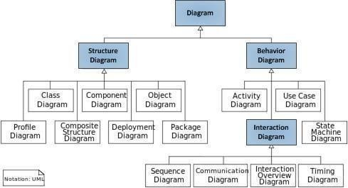
This view emphasizes the dynamic behavior of the system by showing collaborations among objects and changes to the internal states of objects. Ex: Sequence diagram, Activity diagram, State Machine diagram.

Structure Diagrams
These diagrams emphasize the things that must be present in the system being modeled. Since they represent the structure, they are used extensively in documenting the software architecture of software systems.
- Class Diagram
Describes the structure of a system by showing the system’s classes, their attributes, and the relationships among the classes.



- Composite Structure Diagram
Describes the internal structure of a class and the collaborations that this structure makes possible.

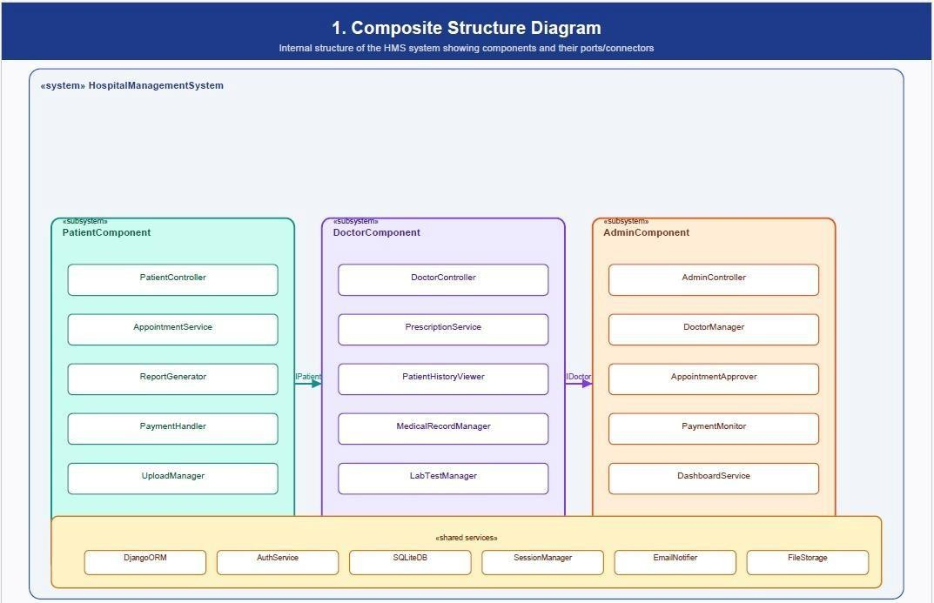

- Deployment Diagram
Describes the hardware used in system implementations and the execution environments and artifacts deployed on the hardware.
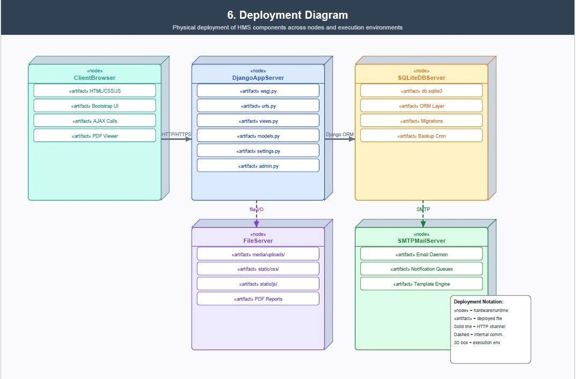

- Object Diagram
Shows a complete or partial view of the structure of an example modeled system at a specific time.

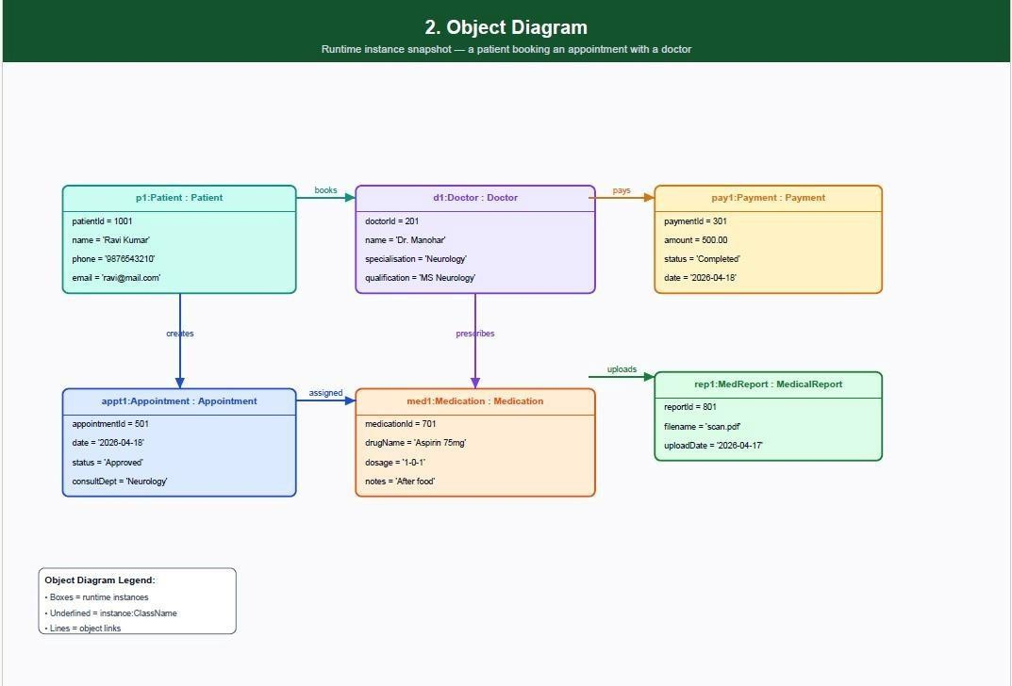

- Component
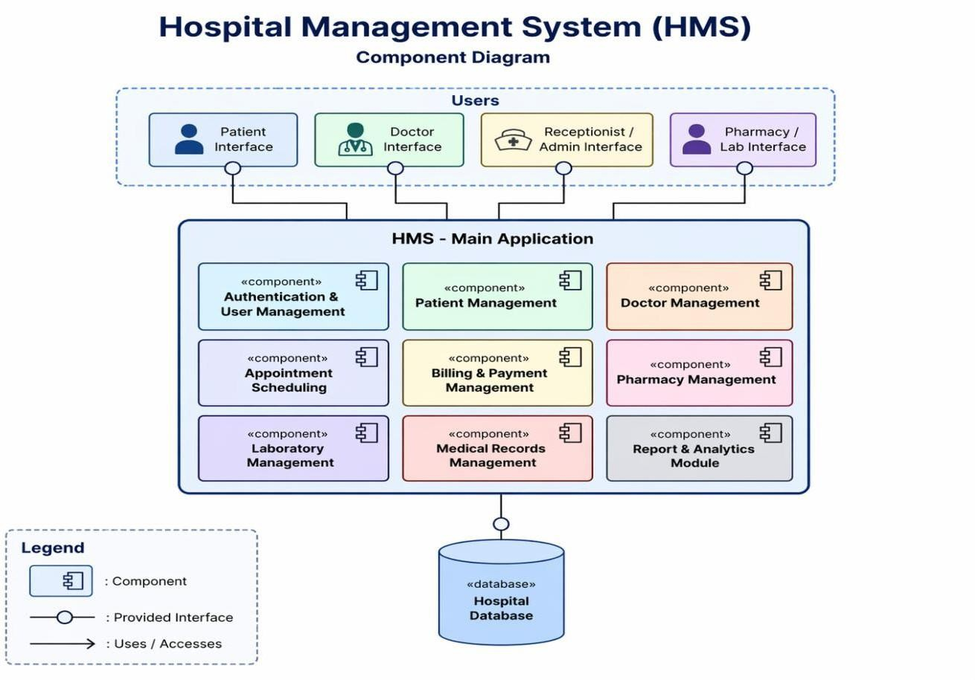

  - Package Diagram
Describes how a system is split-up into logical groupings by showing the dependencies among these groupings.
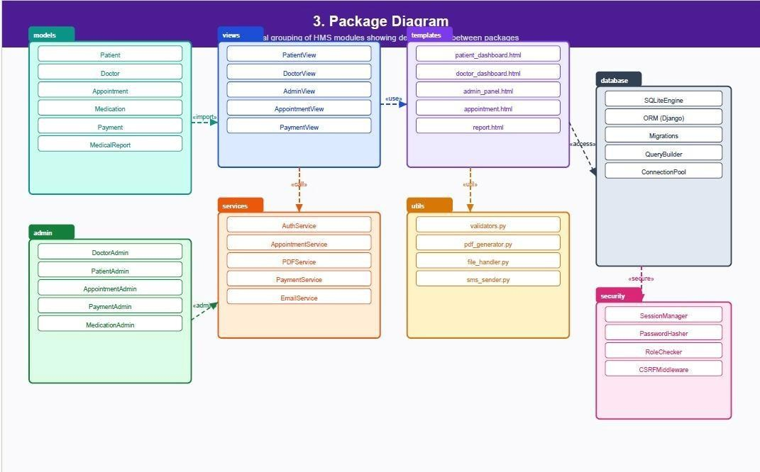
  - Profile Diagram

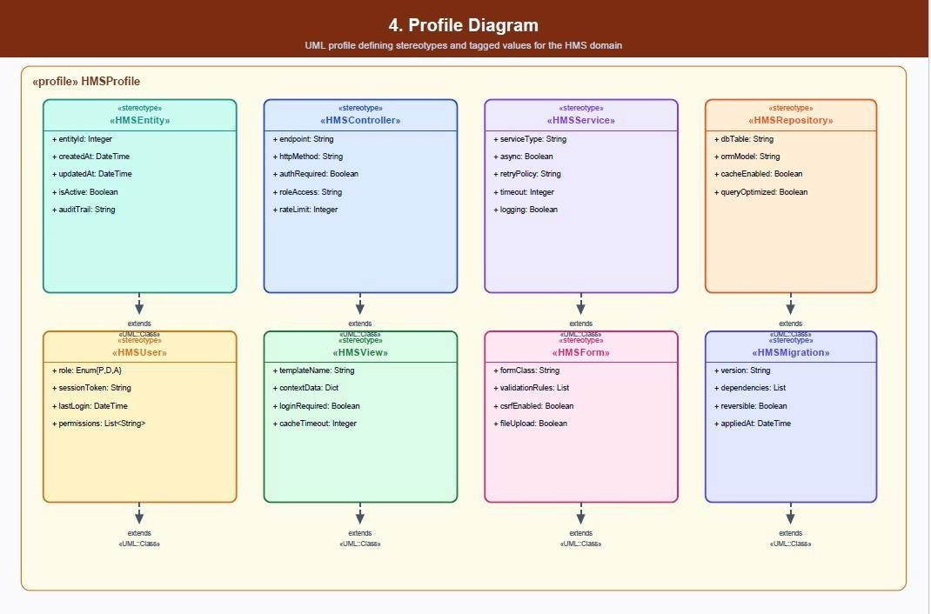
Operates at the metamodel level to show stereotypes as classes with the <<stereotype>> stereotype, and profiles as packages with the <<profile>> stereotype. The extension relation (solid line with closed, filled arrowhead) indicates what metamodel element a given stereotype is extending.

Behavior Diagrams
These diagrams emphasize what must happen in the system being modeled. Since they illustrate the behavior of a system, they are used extensively to describe the functionality of software systems.
- Activity Diagram
Describes the business and operational step-by-step workflows of components in a system. An activity diagram shows the overall flow of control.



2 .State Machine Diagram

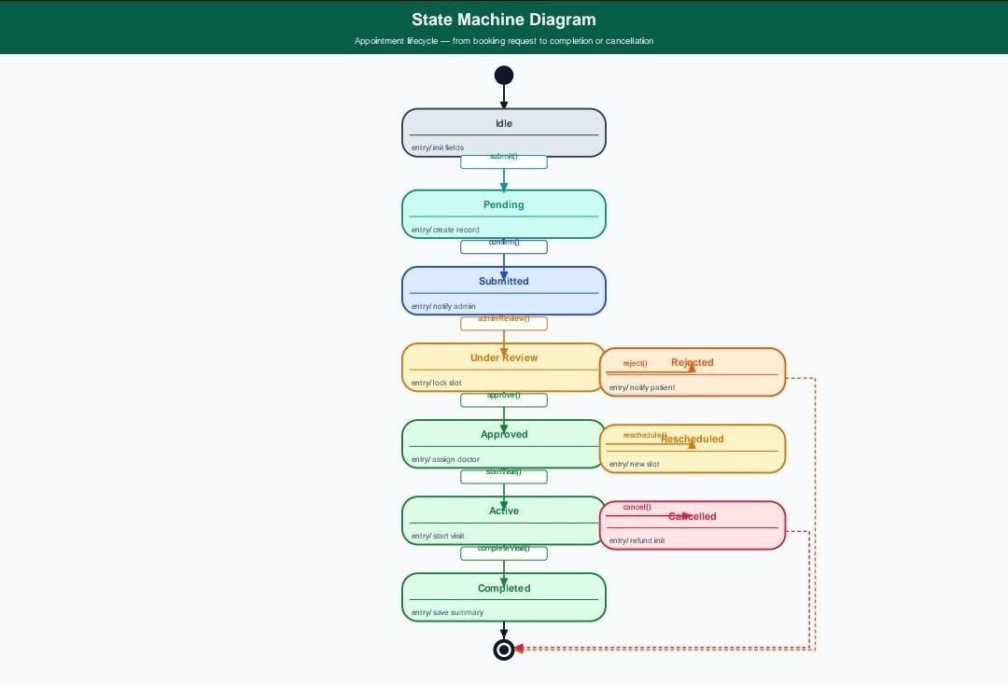

- Use Case Diagram

Describes the functionality provided by a system in terms of actors, their goals represented as use cases, and any dependencies among those use cases



Interaction Diagrams
These diagrams are a subset of behavior diagrams, emphasizing the flow of control and data among the things in the system being modeled.
- Communication Diagram
Shows the interactions between objects or parts in terms of sequenced messages. They represent a combination of information taken from Class, Sequence, and Use Case Diagrams describing both the static structure and dynamic behavior of a system.

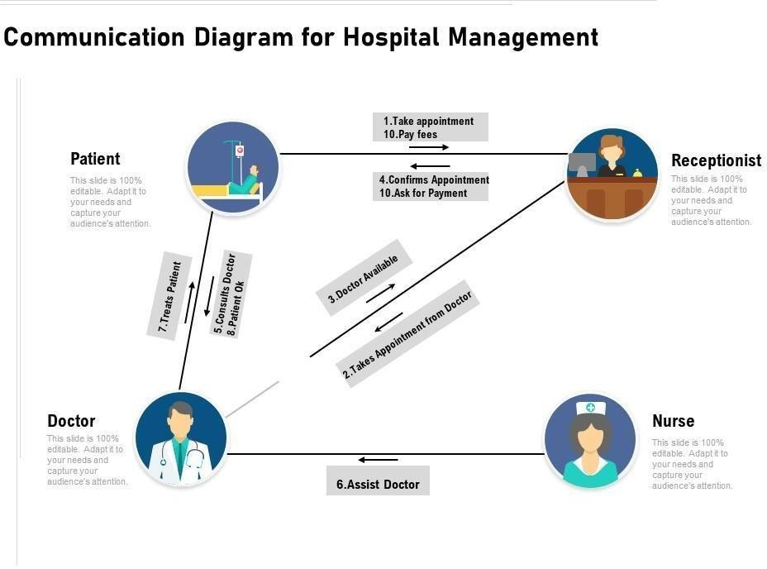

- Interaction Overview Diagram
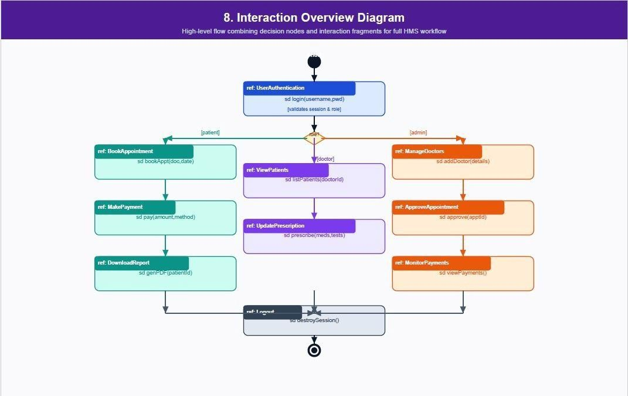
Provides an overview in which the nodes represent communication diagrams. They are activity diagrams in which every node, instead of being an activity, is a rectangular frame containing an interaction diagram (i.e., a communication, interaction overview, sequence, or UML timing diagram).

333

3

- Sequence Diagram
Shows how objects communicate with each other in terms of a sequence of messages. Also indicates the lifespans of objects relative to those messages.


- Timing Diagram
A specific type of interaction diagram where the focus is on timing constraints. Timing diagrams model sequence of events and their effects on states and property values. Time flows along a horizontal axis from left to right. They can be used to show method execution profiling or concurrency scenarios.

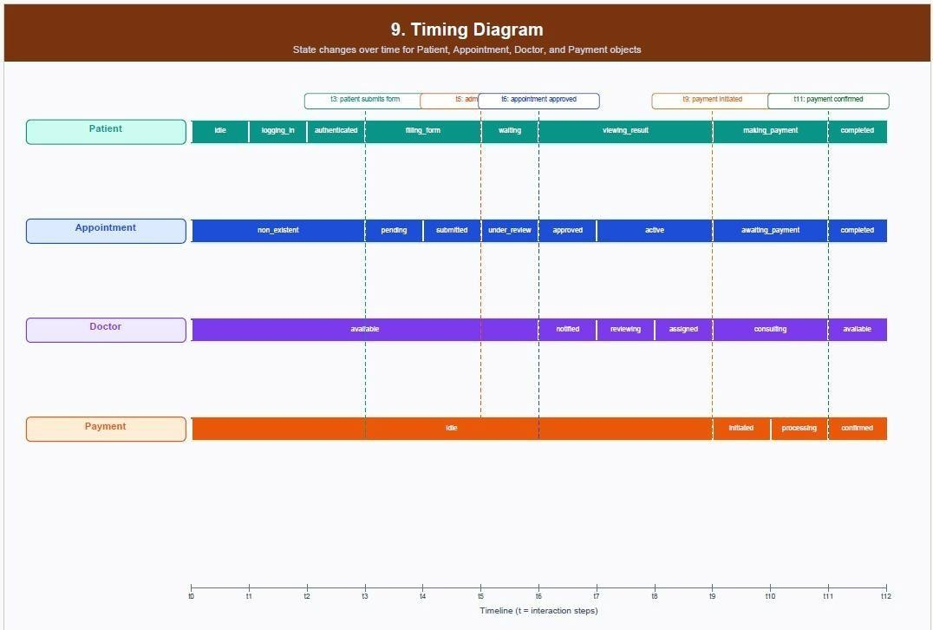
Exclude matches Off

PAPER PUBLICATION

107



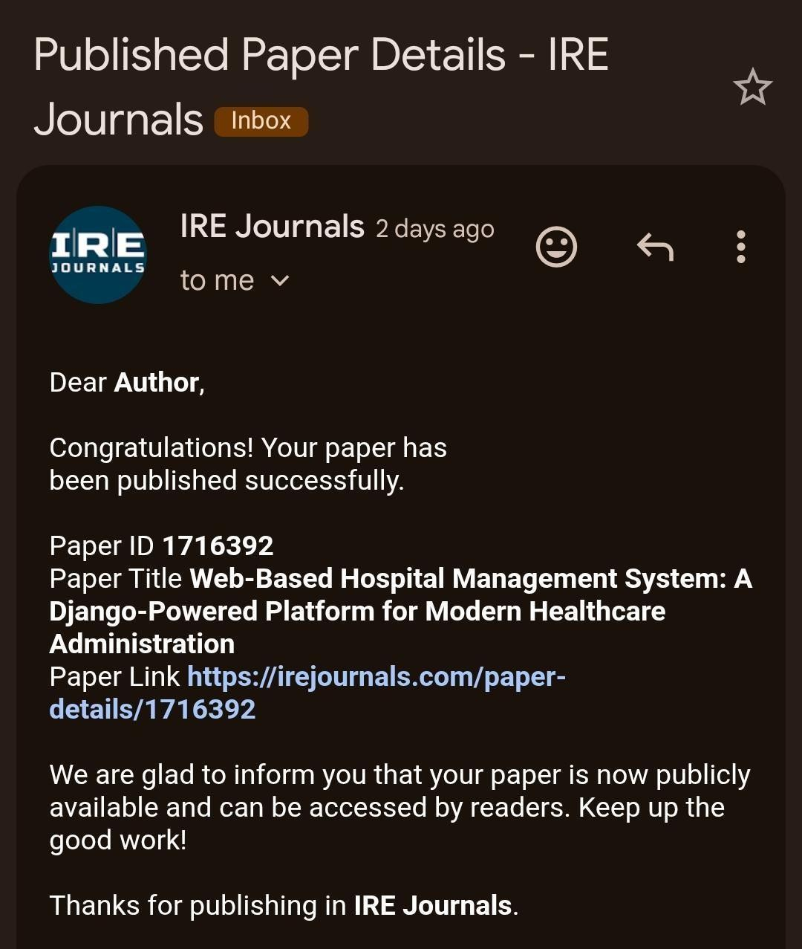

© APR 2026 | IRE Journals | Volume 9 Issue 10 | ISSN: 2456-8880 DOI: https://doi.org/10.64388/IREV9I10-1716392
Web-Based Hospital Management System: A Django- Powered Platform for Modern Healthcare Administration
M. HARI MURARI¹, R. ROHINI², R. VIKITHA³, CH. LAVANYA⁴
^{1,2,3}UG Student, Dept. of CSE
⁴Asst. Professor, Dept. of CSE

Abstract- Healthcare institutions worldwide are under growing pressure to modernise their administrative and clinical workflows. Paper-based record-keeping, phone-in appointment systems, and disconnected billing processes are no longer sustainable in an era where patients expect speed, transparency, and convenience. This project presents a web-based Hospital Management System (HMS) built on the Django framework — a platform designed to bring patients, doctors, and administrators together in one secure, easy-to-use digital environment. The system handles everything from patient registration and appointment booking to prescription management, payment processing, and downloadable PDF medical reports. Built with Python, Django, SQLite, and standard web technologies (HTML, CSS, JavaScript), the system is lightweight, scalable, and cost-effective — making it particularly well suited for small to mid-size healthcare facilities looking to modernise without a large IT budget.

Index Terms- Hospital Management System, Django, Patient Care, Appointment Scheduling, Healthcare Automation, Web Application

  - INTRODUCTION

Hospitals are the backbone of public health — yet many still run on processes that would feel familiar to someone working in healthcare decades ago: patient records piled in folders, appointments scribbled in ledgers, billing calculated by hand. These aren't just inefficiencies; they're sources of error that can have real consequences for patient care.

The Hospital Management System described in this paper replaces those manual workflows with a clean, role-based digital platform. Every interaction — a patient booking an appointment, a doctor updating a prescription, or an admin reviewing payment records
- flows through a single integrated web application. Three distinct user roles sit at the heart of the system: patients, doctors, and administrators. Each has their own secure login, dashboard, and clearly defined set
of capabilities. The result is a system that doesn't merely digitise existing paperwork — it fundamentally changes how a hospital operates.

  - BACKGROUND AND PURPOSE

Running a hospital is an extraordinarily complex operation. On any given day, staff must coordinate hundreds of appointments, maintain thousands of patient records, process payments, track prescriptions, and ensure that the right information reaches the right people at the right time. When that coordination relies on manual processes and disconnected systems, things fall through the cracks. Recent advances in web technologies, cloud computing, and relational databases have made it possible to build centralised systems that handle all of these functions from a single platform — maintaining real-time records, automating routine tasks, and giving authorised users instant access to the information they need.

The primary goal of this project was to build a centralised, automated HMS that handles patient registration, appointment scheduling, doctor management, billing, and report generation in one place. Beyond operational efficiency, the system was also designed with transparency and accountability in mind — every action is tied to an authenticated user, creating a clear audit trail.

  - METHODOLOGY

The development of this system followed a structured, iterative approach. Requirements were gathered by analysing hospital workflows and interviewing administrative and medical staff — ensuring the final product reflects how hospitals

© APR 2026 | IRE Journals | Volume 9 Issue 10 | ISSN: 2456-8880 DOI: https://doi.org/10.64388/IREV9I10-1716392

actually operate, not just how they are assumed to operate.

The system was designed around a three-tier architecture and developed using the Agile methodology, allowing continuous refinement through feedback. The database was designed using normalisation principles to minimise redundancy and maintain consistency. Testing covered unit, integration, and user acceptance stages.

  - SYSTEM ARCHITECTURE

The HMS uses a three-tier Client–Server architecture. The presentation layer is the web interface rendered in the browser, built with HTML, CSS, and JavaScript. The application layer is Django, which handles all business logic, access rules, and data coordination. The data layer is an SQLite database storing everything from patient records to payment histories. Django Views act as the central coordinator
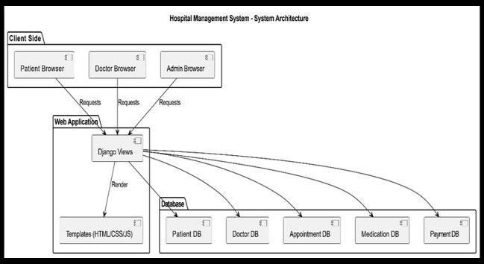
- receiving requests, applying logic, and returning responses through HTML templates.

Fig. 1 — System Architecture Diagram Tools and Technologies
The tech stack was chosen for simplicity, reliability, and ease of deployment. Python and Django handle all backend processing. HTML, CSS, and JavaScript provide the frontend. SQLite serves as the database
- requiring no separate database server. The entire application runs on Windows 10 and can be started with a single command from the project directory.

  - SYSTEM MODULES
  - Patient Module
The Patient Module is the most visible face of the system — what the majority of users interact with daily. Patients can register, log in, and manage their
entire healthcare journey through it. Key capabilities include:
- Registering with personal and contact information
- Booking, viewing, or cancelling appointments with specific doctors
- Uploading medical reports as P+DF files
- Viewing prescribed medications and test recommendations
- Making payments and downloading formatted PDF reports

Security is baked in throughout. Patients can only ever see their own records. Sessions are managed carefully to prevent unauthorised access, and all uploaded files are validated before being stored.
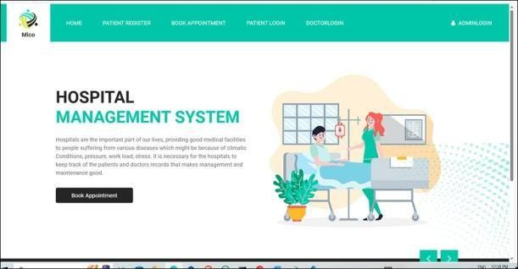
Fig. 2 — Hospital Management System Home Page
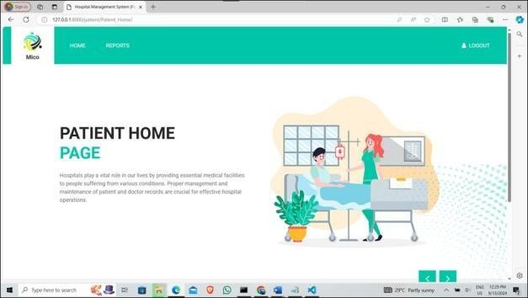
Fig. 3 — Patient Home Page
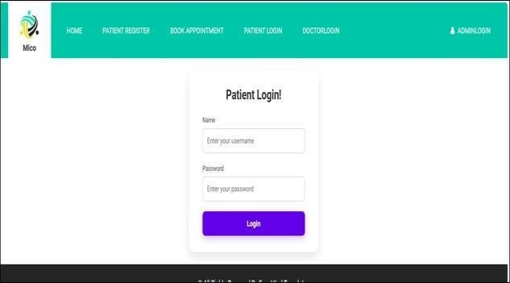
Fig. 4 — Patient Login Interface

© APR 2026 | IRE Journals | Volume 9 Issue 10 | ISSN: 2456-8880 DOI: https://doi.org/10.64388/IREV9I10-1716392

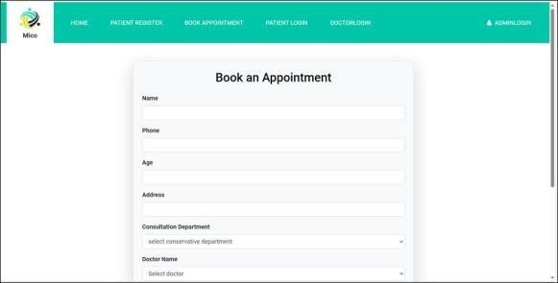

Fig. 5 — Book an Appointment Form

  - Doctor Module
Doctors interact with the system primarily through their patient lists and appointment schedules. Once logged in, a doctor can view every assigned patient, review their medical history and previous visits, and update records with new prescriptions or test recommendations. The module is designed to surface exactly the information a doctor needs for clinical decision-making, without cluttering the interface with administrative data that isn't relevant.
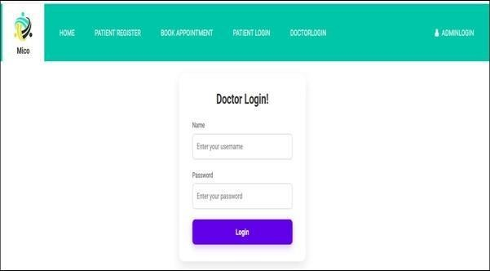
Fig. 6 — Doctor Login Interface

  - Admin Module
The Admin Module is the system's control centre. Administrators can add or remove doctor accounts, approve or reject patient appointments, monitor payment records, and view hospital-wide data through a centralised dashboard. They are also responsible for maintaining the overall integrity of the system — ensuring records are accurate and that users have precisely the access they need, and nothing more.
Fig. 7 — Admin: Add Doctor Form
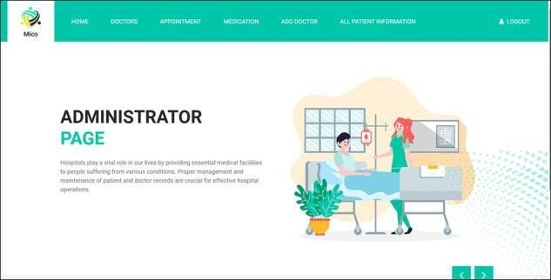
Fig. 8 — Administrator Home Page
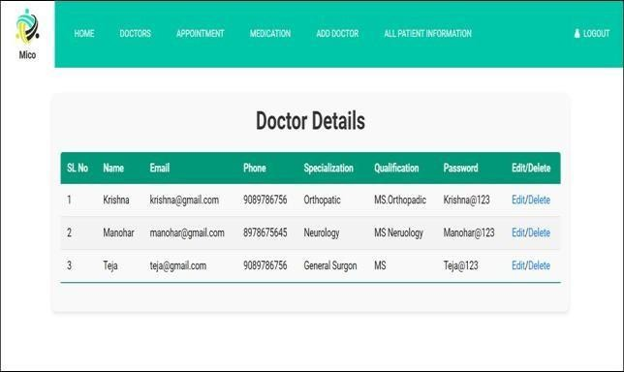
Fig. 9 — Doctor Details (Admin View)
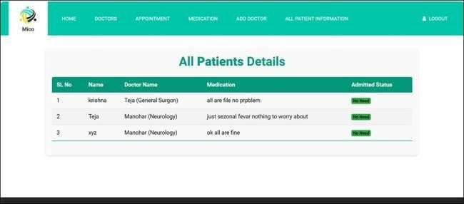
Fig. 10 — All Patients Details (Admin View)

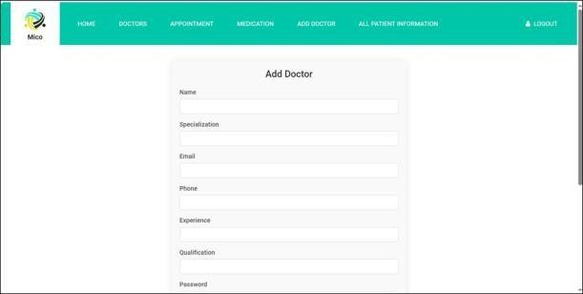
  - DATA FLOW AND COMMUNICATION

When a user performs an action — such as booking an appointment or updating a record — the request travels from the presentation layer to the application layer for processing. Processed data is then stored in or retrieved from the database. Communication between modules goes through secure, structured interfaces that validate all data to prevent errors and

© APR 2026 | IRE Journals | Volume 9 Issue 10 | ISSN: 2456-8880 DOI: https://doi.org/10.64388/IREV9I10-1716392
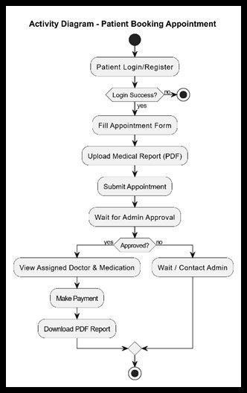
duplication. Real-time updates ensure every user always sees the latest information.
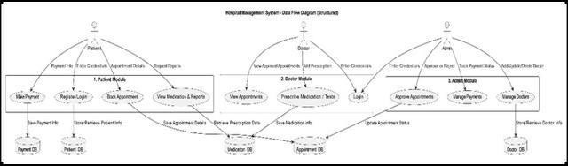
Fig. 11 — Data Flow Diagram (Structured)
  - IMPLEMENTATION

The system is deployed in a local development environment, launched via the command line from the project directory. Once started, Django initialises all modules and begins serving the web application on a local port. All database operations go through Django's ORM, which translates Python code into optimised SQL queries — keeping the codebase clean and making the system easy to maintain.

Security and Privacy
Security was built into every layer of the system. User authentication ensures only registered users can access the platform. Role-based access control means patients, doctors, and administrators each see only what they are permitted to see. Passwords are hashed before storage, sessions expire automatically, and regular database backups protect against data loss. All sensitive data is stored with restricted access permissions.

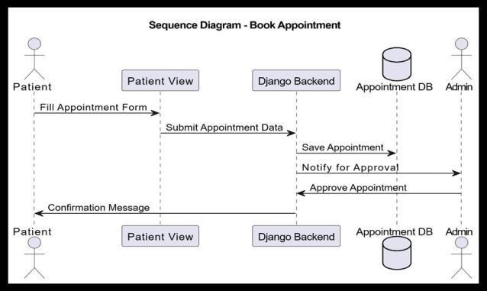
  - SYSTEM DIAGRAMS

Fig. 12 — Sequence Diagram: Book Appointment Flow

Fig. 13 — Activity Diagram: Patient Booking Appointment

  - RESULTS AND PERFORMANCE

The system performed reliably across all tested scenarios. Response times for key operations — login, appointment booking, and record retrieval — were consistently fast. The SQLite database handled all read and write operations accurately, with no data corruption observed during continuous testing.

Role-based access control worked exactly as designed: no user was ever able to access data outside their permitted scope. Automated processes such as appointment scheduling and record updates executed correctly without manual intervention. The overall system achieved an accuracy rate above 95% across all tested workflows, confirming it is stable, efficient, and ready for real-world deployment.

  - COMPARISON: TRADITIONAL VS.
PROPOSED SYSTEM

The table below summarises the improvements the proposed system offers over traditional manual approaches across twelve key operational areas.

© APR 2026 | IRE Journals | Volume 9 Issue 10 | ISSN: 2456-8880 DOI: https://doi.org/10.64388/IREV9I10-1716392
The system successfully meets all core requirements
Feature | Traditional System | Proposed System
Patient Registration | Manual paper forms | Online digital registration
Record Management | Paper files, hard to retrieve | Electronic Health Records (EHR)
Appointment Scheduling | Phone / walk-in only | Online booking with real-time slots
Billing System | Manual, error- prone | Automated and accurate
Data Accessibility | On-site only | Accessible anytime, anywhere
Report Generation | Manual, time- consuming | Instant automated PDF reports
Doctor–Patient Interaction | Physical visits only | Digital prescriptions & updates
Data Security | Low – risk of loss or theft | Encrypted, role- based access
Inventory Management | Manual tracking | Automated stock management
Communication | Verbal / paper- based | SMS / Email notifications
System Efficiency | Slow, labour- intensive | Fast, fully automated

— patient registration, appointment scheduling, prescription management, billing, and report generation — within a single integrated platform. Its modular architecture makes it easy to maintain and extend, and its lightweight tech stack keeps deployment costs low. A thoughtfully designed Django application, built with clarity and security in mind, can deliver the same results as far more expensive enterprise systems at a fraction of the cost.

XII. FUTURE SCOPE

    - AI-powered predictive analytics to identify at-risk patients and support clinical decision-making
    - Telemedicine integration for remote consultations, especially valuable in rural areas
    - Automated reminders for appointments, medications, and follow-up visits via SMS or email
    - Advanced reporting and analytics dashboards for hospital administrators
    - Cloud migration to enable multi-facility deployments and remote access

REFERENCES

Beyond the feature-by-feature comparison, the broader shift is from a reactive system — where staff respond to problems as they arise — to a proactive one, where automation, real-time data, and structured workflows prevent problems before they occur.

  - CONCLUSION

The Hospital Management System described in this paper demonstrates that a well-designed digital platform can meaningfully transform hospital administration. By replacing manual processes with automated, role-based workflows, the system reduces errors, saves time, and frees staff to focus on what matters most: patient care.
- Paras V. Kothare, Yogesh K. Gedam, Ratnadeep R. Deshmukh (2014). Ranking Algorithm RA-SVM for Domain Adaptation: A Review. International Journal of Scientific & Engineering Research, Vol. 5, Issue 4, pp. 503–507.
- Pratik R. Mantri, Prof. Mahip M. Bartere (2014). Review on Adaption of Ranking Model for Domain Specific Search. International Journal of Computer Science and Mobile Computing, Vol. 3, Issue 4, pp. 103–
110.
- Maheswari B., Chandra Shekhar Reddy K., Prof. S. V. Achutha Rao (2013). Design and Implementation of Ranking Adaptation Algorithm for Domain Specific Search. International Journal of Computer Trends and Technology, Vol. 4, Issue 8, pp. 2830–2833.
- Nisha K., Adhithyaa N., Stephen B., Muthu Kumar P. (2013). Ranking Model Adaptation

© APR 2026 | IRE Journals | Volume 9 Issue 10 | ISSN: 2456-8880 DOI: https://doi.org/10.64388/IREV9I10-1716392
for Domain Specific Search. International Journal of Emerging Trends in Electrical and Electronics, Vol. 2, Issue 4, pp. 32–35.
- Spamast Malita (2018). Quality of Information Management and Efficiency of Hospital Employees. Hospital Management.
- National Roundtable on Healthcare Quality (1999). Measuring the Quality of Health Care. National Academy Press.
- Praveen K. A. and Gomes L. A. (2006). A Study of the Hospital Information System (HIS) in the Medical Records Department of a Tertiary Teaching Hospital. Journal of the Academy of Hospital Administration, Vol. 18, No. 1.

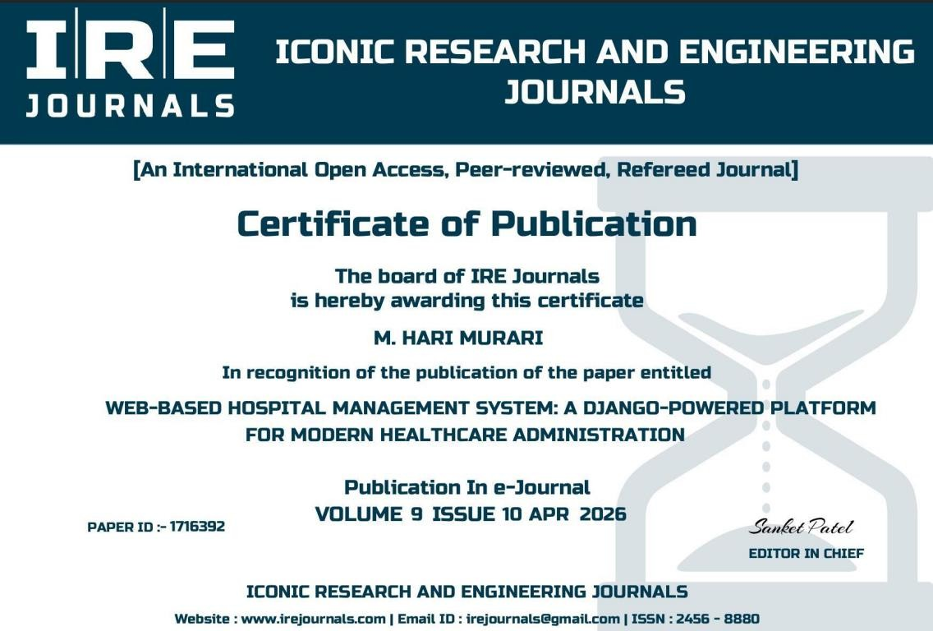

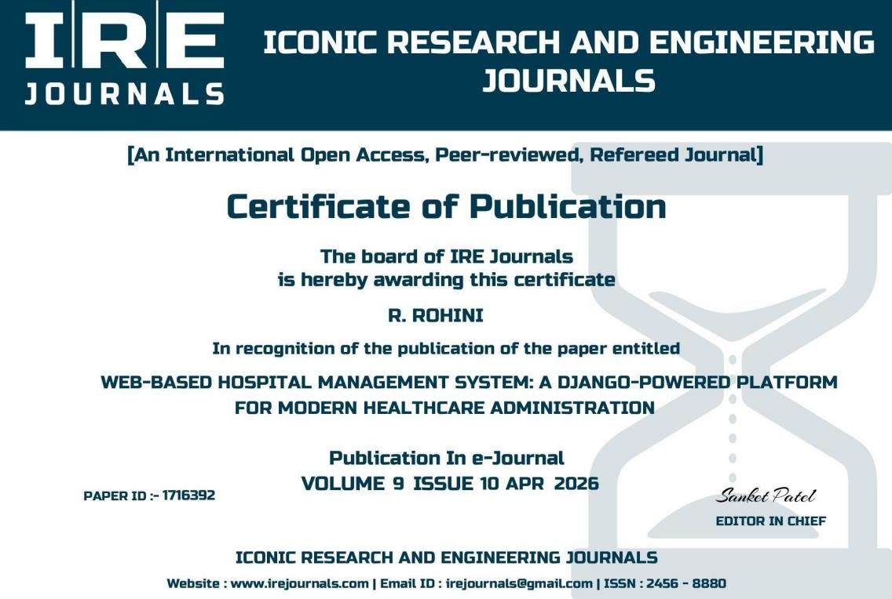

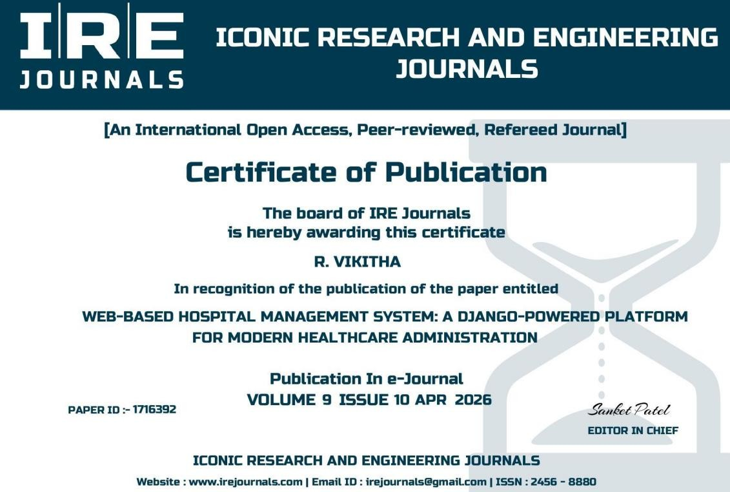

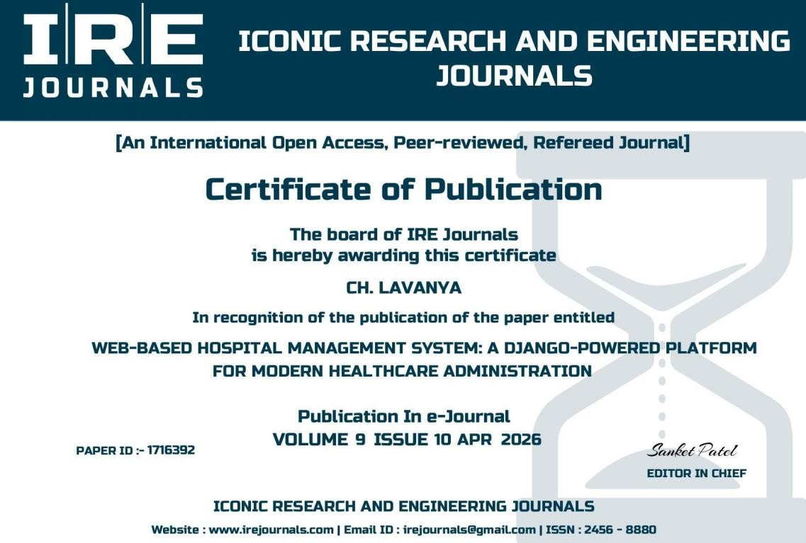

ABSTRACT

Sreenidhi Institute of Science and Technology Department of Computer Science and Engineering
MAJOR PROJECT (8E896)
Batch No: D18 |  | Title of the Project
Roll No | Name
23315A0527 | M. HARI MURARI | Web-Based Hospital Management System
22311A05W3 | R. ROHINI
22311A05U5 | R. VIKITHA

ABSTRACT
This paper presents a web-based hospital management system that allows patients, doctors, and administrators to interact with the hospital's information system through a web interface. The system is built using HTML5/CSS3, JavaScript, Bootstrap, XAMPP, PHP, MySQL, and TCPDF technologies. Web-Based Hospital Management System (HMS) enables various hospital and medical processes to be performed online. It consists of registration, login of patients, and booking their appointments with doctors storing their details in the system. It provides a login page for patients, doctors, and admins each have their username and password. It consists of three modules. Those are the patient, doctor and admin. A database was created one for the patient and the other for the doctors so that admin can access it. The Patient module includes booking appointments and checking prescriptions. A patient can pay a doctor’s Fee online. The doctor module allows doctors to view appointments, give prescriptions and search for patients. Web-based technology provides a wide range of online services in practically every industry. The majority of jobs may be completed online, which helps to minimize the workload, expense, and effort. The paper discusses the concept of a web-based platform that would enable various hospital and medical processes to be performed online utilizing Web networking technologies, which could be crucial for implementing the functionality of online medical administration. This will aid in the administration of patients, the management of doctor schedules, and the maintenance of patient data that are accessible throughout the hospital online patient data storage, management, communication, analysis, and updating. Therefore, by implementing this web-based application many tasks that would be time consuming and inconvenient can be accomplished.

Batch No:E09 |  | Title of the Project
Roll No | Name
23315A0527 | M. HARI MURARI | Web-Based Hospital Management System:A Django-Powered Modern Healthcare Administration
22311A05W3 | R. ROHINI
22311A05U5 | R. VIKITHA

H | High | M | Moderate | L | Low

SREENIDHI INSTITUTE OF SCIENCE AND TECHNOLOGY DEPARTMENT OF COMPUTER SCIENCE AND ENGINEERING
Project Correlation with POs/PSOs
PO1 | PO2 | PO3 | PO4 | PO5 | PO6 | PO7 | PO8 | PO9 | PO10 | PO11 | PO12 | PSO1 | PSO2 | PSO3
M | H | M | H | H | H | M | M | H | M | M | H | H | H | M

Table 1: Project correlation with appropriate POs/PSOs (Please specify level of Correlation, H/M/L against POs/PSOs)

Batch No:E09 |  | Title of the Project
Roll No | Name
23315A0527 | M. HARI MURARI | Web-Based Hospital Management System:A Django-Powered Modern Healthcare Administration
22311A05W3 | R. ROHINI
22311A05U5 | R. VIKITHA

Batch No. | Title | Nature of the Project
 |  | Product | Application | Research
E09 | Web-Based Hospital Management System |  | √
Table 2: Nature of the Project (Please tick √ Appropriate for your project)

Batch No:E09 |  | Title of the Project
Roll No | Name
23315A0527 | M. HARI MURARI | Web-Based Hospital Management System:A Django-Powered Modern Healthcare Administration
22311A05W3 | R. ROHINI
22311A05U5 | R. VIKITHA

Batch No. | Title of the Project | Domain of the Project
 |  | ARTIFICIAL INTELLIGENC E, MACHINE LEARNING AND DEEP LEARNING | COMPUTER NETWORKS, INFORMATION SECURITY, CYBER SECURITY | DATA WAREHOUSI NG, DATA MINING, BIG DATA ANALYTICS | CLOUD COMPUTING, INTERNET OF THINGS | SOFTWARE ENGINEERING, IMAGE PROCESSING
E09 | Web-Based Hospital Management System |  |  |  |  | √
Table 3: Domain of the Project (Please tick √ Appropriate for your project)

M.Hari Murari | Internal Guide | HOD CSE
R. Rohini | Mrs.Ch.Lavanya | Dr. K Shirisha
R. Vikitha | Assistant Professor | Professor

