A Major Project Report
on

TRANSPLANT TRACK: A LIFE LINK FOR REAL-TIME ORGAN AND BLOOD AVAILABILITY INTELLIGENCE MONITORING SYSTEM
Submitted in partial fulfillment of the requirement for
The award of degree of

BACHELOR OF TECHNOLOGY
in

COMPUTER SCIENCE & ENGINEERING 2022-2026

Submitted By
S. Nikhil 22311A05K0
A. Venu Gopal Reddy 22311A05K3
P. Manas Kumar 22311A05K6

Under the Guidance of

Mrs. B Nikhila Assistant Professor

Department of Computer Science & Engineering
SREENIDHI INSTITUTE OF SCIENCE ANDTECHNOLOGY

(AUTONOMOUS)
Yamnampet (V), Ghatkesar (M), Hyderabad – 501301, T.S.

AY 2025-2026

Sreenidhi Institute of Science and Technology Department of Computer Science and Engineering


CERTIFICATE
This is to certify that this Major Project report on “ Transplant Track: A Life Link for Real-Time Organ and Blood Availability Intelligence Monitoring System”, submitted by S. Nikhil (22311A05K0) , A. Venu Gopal Reddy (22311A05K3) , P. Manas Kumar (22311A05K6) in the year 2026 in the partial fulfillment of the academic requirements of Jawaharlal Nehru Technological University for the award of the degree of Bachelor of Technology in Computer Science and Engineering, is a bonafide work that has been carried out by them as a part of their Major Project during Fourth Year Second Semester, under our guidance. This report has not been submitted to any other Institute or university for the award of any degree.

Internal guide | Project Coordinator | Head of the Department
Mrs. B Nikhila | Mr. P Ramu | Dr. K Shirisha
Assistant Professor | Assistant Professor | Professor & HOD
Department of CSE | Department of CSE | Department of CSE

Signature of the External Examiner
Date:-

DECLARATION

We S. Nikhil (22311A05K0) , A. Venu Gopal Reddy (22311A05K3) ,
P. Manas Kumar (22311A05K6) students of SREENIDHI INSTITUTE OF SCIENCE AND TECHNOLOGY, YAMNAMPET, GHATKESAR, studying IV
year II semester, COMPUTER SCIENCE AND ENGINEERING solemnly declare that the Major Project work, titled “ Transplant Track: A Life Link for Real-Time Organ and Blood Availability Intelligence Monitoring System” is submitted to SREENIDHI INSTITUTE OF SCIENCE AND TECHNOLOGY for
partial fulfillment for the award of degree of Bachelor of technology in COMPUTER SCIENCE AND ENGINEERING.
It is declared to the best of our knowledge that the work reported does not form part of any dissertation submitted to any other University or Institute for award of any degree.

S. Nikhil 22311A05K0
A. Venu Gopal Reddy 22311A05K3
P. Manas Kumar 22311A05K6

ACKNOWLEDGEMENT

We would like to express our gratitude to all the people behind the screen who helped us to transform an idea into a real application.
We would like to thank our internal guide Mrs. B Nikhila and our Coordinator Mr. P Ramu for Major Project for their technical guidance, constant guidelines, encouragement and support in carrying out Major project on time at college.

We profoundly thank Dr. K Shirisha, Head of the Department of Computer Science & Engineering who has been an excellent guide and also a great source of inspiration to our work.
We would like to express our heart-felt gratitude to our parents without whom we would not have been privileged to achieve and fulfill our dreams. We are grateful to our principal, DR. T. Ch. Siva Reddy, who most ably runs the institution and has had the major hand in enabling us to do our project.
The satisfaction and euphoria that accompany the successful completion of the task would be great but incomplete without the mention of the people who made it possible with their constant guidance and encouragement crowns all the efforts with success. In this context, We would like to thank all the other staff members, both teaching and non-teaching, who have extended their timely help and eased our task.

S. Nikhil 22311A05K0

A. Venu Gopal Reddy
P. Manas Kumar
22311A05K3
22311A05K6

ABSTRACT

Emergencies demand speed, yet patients and their families often lose precious time searching for hospitals that have the required blood units or transplantable organs. This delay, caused by fragmented and unreliable systems, can turn critical situations into life-threatening ones. To overcome this challenge, we present LifeLink, a Real- Time Organ & Blood Availability System designed to bridge the gap between hospitals and patients by delivering instant, trusted information when it matters the most. In this system, hospitals can securely update their current stock of essential resources such as blood, kidney, liver, and cornea, while an authorizer verifies each hospital to ensure authenticity and reliability. The system also manages automatic expiry tracking, ensuring that outdated units are removed promptly to prevent medical risks and wastage. Practical applications of this solution include locating a compatible blood unit during surgery, coordinating organ transplants across hospitals, and enabling healthcare authorities to monitor availability transparently. By combining real-time updates, verification, and emergency notifications in a single platform, LifeLink – a Real-Time Organ & Blood Availability System not only saves critical time but also builds trust and accountability, ultimately improving survival rates and strengthening healthcare delivery in emergencies.

LIST OF FIGURES
S.NO | Figure No. | Title of Figure | Page No
1 | 1 | System Architecture | 41
2 | 2 | Data Flow Diagram | 42
3 | 3 | Class Diagram | 43
4 | 4 | Use Case Diagram | 44
5 | 5 | Sequence Diagram | 45
6 | 6 | Activity Diagram | 46
7 | 7 | Dashboard | 64
8 | 8 | Registration Form | 64
9 | 9 | Login Form | 65
10 | 10 | Hospital Dashboard | 65
11 | 11 | Form Filling-I | 66
12 | 12 | Form Filling-II | 66
13 | 13 | Result Page | 67
14 | 14 | Admin Dashboard | 67

LIST OF TABLES
S.NO | Table No. | Title of Table | PageNo
1 | 1 | Test Cases | 74

INDEX

 | Page No
List of Figures | i
List of Tables | ii
1. INTRODUCTION
1.1 Project Introduction | 2
1.2 Scope | 3
1.3 Project Overview | 5
1.4 Objectives | 6
2. LITERATURE SURVEY
2.1 Existing System | 9
2.1.1 Disadvantages of Existing System | 10
2.2 Proposed System | 12
2.2.1 Advantages of Proposed System | 13
3. SYSTEM ANALYSIS
3.1 Functional Requirements | 16
3.1.1 Data Collection | 17
3.1.2 Data Preprocessing | 18
3.1.3 Training and Testing | 20
3.1.4 Modeling | 22
3.1.5 Predicting | 25
3.2 Performance Requirements | 26
3.3 Software Requirements | 26
3.3.1 React.js | 27
3.3.2 node.js | 28
3.3.3 Express.js | 29
3.3.4 MySQL | 30
3.3.5 FireBase | 31
3.3.6 Visual Studio Code (VS Code) | 33
3.4 Hardware Requirements
3.4.1 Processor | 34
3.4.2 Ram | 35
3.4.3 Space on Hard Disk | 35
3.4.4 Internet Connectivity | 36
3.5 Feasibility study (Technical/Economical/Operational)
3.5.1 Economical Feasibility | 37
3.5.2 Technical Feasibility | 37
3.5.3 Social Feasibility | 38
4. SYSTEM DESIGN
4.1 System Architecture | 41
4.2 Data Flow Diagrams | 42
4.3 UML Diagrams | 42
4.3.1 Class Diagram | 43

4.3.2 Use Case Diagram | 44
4.3.3 Sequence Diagram | 45
4.3.4 Activity Diagram | 46
4.4 Modules
4.4.1 Admin Module | 47
4.4.2 Hospital Module | 48
4.4.3 Patient Module | 49
4.4.4 Authorization Module | 49
4.4.5 Notification Module | 50
4.4.6 Node Modules | 50
4.4.7 Node Package Manager (NPM) | 51
4.4.8 DOTENV Configuration | 51
4.4.9 Node Mailer | 52
5. IMPLEMENTATION AND RESULTS
5.1 Language / Technology Used | 54
5.1.1 Advantages of React.js | 55
5.1.2 Advantages of Node.js | 56
5.1.3 Advantages of Express.js | 56
5.1.4 Advantages of MySQL Database | 57
5.1.5 Advantages of Visual Studio Code | 57
5.2 Sample Code | 59
5.3 Results (Accuracy) / Output Screens | 64
6. TESTING
6.1 Types of Testing | 69
6.1.1 Unit Testing | 69
6.1.2 Data Flow Testing | 70
6.1.3 Integration Testing | 70
6.1.4 Big Bang Integration Testing | 71
6.1.5 User Interface Testing | 72
6.2 Test Cases | 74
7. CONCLUSION | 76
8. FUTURE SCOPE | 78-80
9. BIBLIOGRAPHY | 82-83
APPENDIX-A : | 85-93
PLAGIARISM REPORT | 95-99
PAPER PUBLICATION | 102-109
ABSTRACT | 114
PROJECT CORRELATION WITH PO’s AND PSO’s | 115
NATURE OF THE PROJECT | 116
DOMAIN OF THE PROJECT | 117
v

INTRODUCTION

INTRODUCTION

PROJECT INTRODUCTION
Healthcare systems across the world face serious challenges in providing timely access to essential medical resources such as blood and transplantable organs. During medical emergencies, patients often require immediate blood transfusions or organ transplants in order to survive. However, locating compatible blood units or available organs within a short period of time remains a major difficulty for hospitals, patients, and healthcare professionals. Delays in accessing these life- saving resources can lead to severe health complications and, in many cases, loss of human life.

In many healthcare institutions, blood banks and organ transplant departments maintain separate and isolated records of available resources. These records are usually stored in local hospital databases or maintained manually. Because these systems are not interconnected, it becomes difficult for patients or medical staff to quickly identify where the required blood type or organ is available. As a result, valuable time is lost while contacting multiple hospitals or blood banks to confirm availability.

Another issue faced by the healthcare system is the lack of a centralized platform where real-time information about blood and organ availability can be accessed. Patients and their families often rely on manual communication, personal contacts, or social media platforms to search for blood donors or hospitals that may have available organs. These methods are unreliable and time-consuming, particularly during emergency situations where quick response is essential.

Blood banks also face challenges in managing their inventory effectively. Blood units have a limited shelf life and must be used before their expiration date. Without an efficient digital monitoring system, hospitals may face difficulties in tracking the quantity and expiry of blood units available in their inventory. Similarly, organ transplant coordination requires proper communication between hospitals and transplant centers. A lack of proper coordination may result in delays or under utilization of available organs.

To address these problems, the Real-Time Blood and Organ Availability System (RBOAS) has been proposed. RBOAS is a web-based system designed to provide real-time information about blood and organ availability across registered hospitals. The system connects hospitals, administrators, and patients through a centralized digital platform, enabling efficient sharing of healthcare resource information.

Through this system, hospitals can update the availability of blood units and organs in real time. Authorized hospital staff can log into the system and maintain updated records of blood groups, quantities, and organ availability. This information is immediately stored in a centralized database and becomes accessible to users searching for specific resources.

Patients or healthcare providers can search the system to identify hospitals that have the required blood group or organ available. The system provides detailed information about the hospital and the available resources, which helps reduce the time required to locate life-saving medical supplies. This feature plays a critical role in improving emergency healthcare response.

The RBOAS platform also includes an administrative module that ensures the reliability and authenticity of the system. Only verified hospitals are allowed to update resource information, which helps maintain the accuracy and credibility of the data. The administrator manages hospital registrations, verifies institutional details, and monitors system activities to ensure proper functioning.

By integrating hospitals into a unified network, the Real-Time Blood and Organ Availability System enhances communication and coordination among healthcare institutions. It improves the management of critical medical resources and provides patients with quick access to reliable information.

Overall, the RBOAS system aims to reduce delays in emergency medical situations, improve healthcare resource management, and create a transparent and efficient platform for tracking blood and organ availability.

SCOPE
The scope of the Real-Time Blood and Organ Availability System (RBOAS) focuses on improving the accessibility, management, and sharing of healthcare resource information among hospitals and patients. The system is designed to

provide a reliable platform where information related to blood banks and organ availability can be maintained and accessed in real time.

One of the major areas within the scope of the system is hospital blood inventory management. Hospitals can maintain digital records of their blood bank inventory, including different blood groups and the number of units available. The system allows hospital staff to update blood stock information whenever new blood donations are received or when blood units are used for medical treatments. This helps hospitals maintain accurate records and avoid shortages during emergencies.

Another important part of the system’s scope is organ availability tracking. Hospitals involved in organ transplantation procedures can update the system regarding available organs suitable for transplantation. This feature enables medical professionals to quickly identify potential transplant opportunities for patients who require immediate treatment.

The system also includes patient search functionality, which allows patients or healthcare professionals to search for specific blood groups or organs across registered hospitals. By entering the required resource in the search field, the system retrieves information from the centralized database and displays hospitals where the resource is available.

The RBOAS platform supports real-time updates, ensuring that any changes made by hospitals are instantly reflected in the system database. This feature ensures that users always receive the most accurate and updated information regarding healthcare resources.

Another important component of the system is verified hospital authorization. Only hospitals that have been approved and verified by the system administrator are allowed to access and update the system. This process ensures that all information available on the platform comes from trusted medical institutions.

Additionally, the system includes an emergency notification mechanism that helps hospitals respond quickly to urgent patient requirements. When a patient searches for a particular blood group or organ, the system can notify hospitals about the request, allowing them to take immediate action.

Overall, the scope of the RBOAS system includes hospital inventory management, real-time information sharing, secure verification processes, and patient accessibility. These features collectively aim to improve healthcare coordination and ensure that life-saving medical resources can be accessed quickly during emergencies.

PROJECT OVERVIEW
The Real-Time Blood and Organ Availability System (RBOAS) is designed as a web-based application that connects hospitals, administrators, and patients through a centralized platform. The system ensures efficient management and retrieval of healthcare resource information through a structured workflow.

The operation of the system begins with hospital registration and login. Hospitals that wish to participate in the system must first register by providing institutional details. Once the registration request is submitted, the system administrator verifies the authenticity of the hospital before granting access.

After successful verification, hospital staff can log into the system using their credentials. Through the hospital dashboard, staff members can update information regarding blood bank inventory and organ availability. They can add new blood units, update quantities, or remove records when blood units are used or expired.

The administrator module plays an important role in maintaining the integrity of the system. The administrator verifies hospitals, manages user accounts, and ensures that the system functions properly. The admin also monitors system activities and ensures that only authorized users can access the platform.

Patients or healthcare providers can access the search functionality to locate required resources. By entering the specific blood group or organ type, the system retrieves relevant data from the database and displays hospitals where the resources are available.

The system also supports real-time data synchronization, meaning that any updates made by hospitals are immediately reflected in the database. This ensures that patients receive accurate and up-to-date information.

Another feature of the system is blood expiry tracking. Since blood units have a limited storage period, the system monitors expiration dates and alerts hospital staff when certain blood units are nearing expiry. This helps hospitals manage their inventory efficiently and reduce wastage.

By integrating these features into a single platform, the RBOAS system simplifies the process of managing healthcare resources and improves access to life-saving medical information.

OBJECTIVES
The main objective of the Real-Time Blood and Organ Availability System is to improve the efficiency of healthcare resource management and provide quick access to life-saving medical supplies during emergencies.

One of the primary objectives of the project is reducing emergency search time. Patients and healthcare providers can quickly identify hospitals that have the required blood group or organ available, which significantly reduces delays in medical treatment.

Another important objective is improving coordination among hospitals. By connecting multiple hospitals through a centralized system, the platform enables better communication and sharing of healthcare resource information.

The system also aims to create a centralized real-time database that stores information about blood and organ availability across different hospitals. This centralized approach ensures that users can access accurate information from a single platform.

Ensuring verified hospital participation is another key objective of the project. Only authorized hospitals can update resource information, which helps maintain the reliability and credibility of the system.

The system also aims to increase transparency in healthcare resource availability. Patients often face difficulties in finding reliable information about blood and organ availability. The RBOAS platform provides a transparent system where verified information is easily accessible.

Another objective is improving healthcare resource management within hospitals. By tracking inventory levels, monitoring blood expiration dates, and updating availability in real time, hospitals can manage their resources more efficiently.

Overall, the objectives of the RBOAS system focus on improving emergency response, enhancing healthcare coordination, and providing a reliable digital platform for managing blood and organ availability.

LITERATURE SURVEY

LITERATURE SURVEY

EXISTING SYSTEM
The existing systems used in many hospitals for managing blood banks and organ donations are primarily based on traditional methods. In most healthcare institutions, blood bank records and organ transplant information are maintained separately within each hospital. These systems often operate independently without integration with other hospitals or healthcare networks.

Blood banks typically maintain information about blood donors, blood groups, and available blood units in local databases or manual registers. When a patient requires a specific blood type, hospital staff check their internal records to determine whether the required blood group is available. If the blood is not available within the hospital, medical staff must contact nearby hospitals or blood banks through phone calls, emails, or other manual communication methods. This process can take a considerable amount of time, especially in emergency situations where immediate access to blood is critical.

Similarly, organ transplant coordination systems also face several operational challenges. Organ transplantation requires proper communication between hospitals, transplant centers, and donor registries. However, in many regions, organ availability information is not centrally maintained. Each hospital maintains its own records, and information is not easily accessible to other healthcare institutions. As a result, identifying a suitable organ donor and coordinating the transplantation process becomes a complex and time-consuming task.

Another common characteristic of existing systems is the lack of real-time data sharing. Even when hospitals maintain digital records, these records are usually limited to internal use. There is no centralized platform where multiple hospitals can update and share their information simultaneously. Because of this limitation, patients and healthcare providers often struggle to locate available blood units or organs quickly.

In addition, many blood banks still rely on manual data entry and physical documentation. These methods are prone to human errors and may result in inaccurate or outdated information. For example, blood units may expire without being properly tracked, or incorrect inventory information may be recorded due to manual mistakes.

Patients and their families often face significant difficulties when searching for blood donors or transplantable organs. In many cases, they rely on personal contacts, social media platforms, or voluntary organizations to locate donors. Although these approaches sometimes help in locating donors, they are not reliable or efficient during emergency situations.

Several research studies have attempted to address these problems by proposing digital healthcare systems. For example, some researchers have developed blood bank management systems that store donor information and blood availability in centralized databases. Others have proposed healthcare information systems that use web technologies to connect hospitals and improve communication.

Despite these advancements, many of the existing systems still lack features such as real-time updates, automated notifications, and centralized hospital coordination. These limitations highlight the need for a more efficient and integrated system that can provide accurate and up-to-date information about blood and organ availability.

Disadvantages of Existing System

Although traditional blood bank and organ management systems play an important role in healthcare services, they have several limitations that affect their efficiency and reliability. These disadvantages often lead to delays in medical treatment and difficulties in managing healthcare resources effectively.

One of the major disadvantages of the existing system is the lack of real-time data availability. In many hospitals, blood bank records are updated manually or stored in isolated databases. This means that the information available to healthcare providers may not always reflect the current status of blood inventory or organ availability. As a result, patients may receive outdated information about the availability of resources.

Another limitation is the difficulty in locating available donors or compatible resources. When blood or organs are not available within a hospital, medical staff must contact other hospitals individually to check availability. This process is time- consuming and inefficient, particularly during emergencies where quick access to information is crucial.

Hospital coordination issues also represent a significant challenge in existing systems. Since most hospitals operate independently, there is limited communication and collaboration between healthcare institutions. Without a centralized system to share information, hospitals may not be aware of resources available in nearby facilities.

The use of manual record-keeping methods further contributes to inefficiencies in the healthcare system. Maintaining paper-based records or manually updating databases increases the risk of errors, data loss, and inconsistencies. These problems can lead to incorrect inventory records or mismanagement of blood and organ resources.

Another important disadvantage is related to data reliability and transparency. Patients and healthcare providers may not always trust the information obtained from unofficial sources such as social media or personal networks. Without a verified system that ensures the authenticity of the data, it becomes difficult to rely on the information available.

Additionally, existing systems often lack mechanisms for monitoring blood expiration dates. Blood units have a limited shelf life and must be used before they expire. Without proper monitoring systems, hospitals may face difficulties in managing their inventory efficiently, leading to wastage of valuable resources.

These limitations clearly demonstrate the need for an improved system that can provide real-time data, enhance hospital coordination, and ensure reliable access to healthcare resources.

PROPOSED SYSTEM
To overcome the limitations of traditional healthcare resource management systems, the Real-Time Blood and Organ Availability System (RBOAS) is proposed. This system is designed as a web-based platform that connects hospitals, administrators, and patients through a centralized database.

The proposed system aims to provide real-time information about the availability of blood units and transplantable organs across multiple hospitals. Through this platform, hospitals can update their blood inventory and organ availability information whenever changes occur. These updates are immediately reflected in the system database, allowing users to access the most recent information.

In the proposed system, hospitals must first register and obtain authorization from the system administrator. This verification process ensures that only legitimate and verified healthcare institutions can participate in the platform. Once registered, hospital staff can log into the system and manage their blood bank and organ availability records.

The system includes a search functionality that allows patients or healthcare professionals to locate specific blood groups or organs across registered hospitals. When a user searches for a particular resource, the system retrieves data from the database and displays hospitals where the required resource is available.

Another important feature of the proposed system is centralized data management. All information related to blood availability, organ resources, and hospital details is stored in a centralized database. This allows multiple hospitals to share information and collaborate more effectively.

The system also incorporates automated monitoring features, such as tracking the expiration dates of blood units. This helps hospitals manage their inventory efficiently and reduces the risk of resource wastage.
Additionally, the proposed system can include notification mechanisms that alert hospitals about urgent requests for blood or organs. These alerts enable healthcare providers to respond to patient needs and improve emergency medical services.

By integrating modern web technologies with healthcare resource management, the RBOAS system provides a reliable and efficient platform for managing life-saving medical resources.

Advantages of Proposed System

The proposed Real-Time Blood and Organ Availability System offers several advantages over traditional healthcare resource management methods. These benefits help improve efficiency, transparency, and accessibility in the healthcare sector.

One of the most important advantages of the proposed system is faster emergency response. Since the system provides real-time information about blood and organ availability, patients and healthcare providers can quickly identify hospitals where the required resources are available. This significantly reduces the time required to locate life-saving medical supplies.

Another key advantage is real-time hospital data sharing. Hospitals can update their inventory information instantly, ensuring that users always have access to accurate and current data. This feature eliminates the delays associated with manual communication and outdated records.

The system also ensures verified hospital information. Only authorized and registered hospitals are allowed to update the system database. This verification process increases the reliability of the information available on the platform and helps maintain data integrity.

A further advantage is reduction in resource wastage. By monitoring blood inventory levels and tracking expiration dates, hospitals can manage their resources more efficiently. This helps reduce the wastage of blood units and ensures better utilization of available resources.

The proposed system also promotes improved healthcare coordination. By connecting multiple hospitals through a centralized platform, the system enables better communication and collaboration among healthcare institutions. Hospitals can share information and respond to patient needs more effectively.

Another benefit of the system is improved accessibility for patients. Instead of contacting multiple hospitals manually, patients can simply search the system to find available resources. This convenience enhances the overall efficiency of healthcare services.

Overall, the Real-Time Blood and Organ Availability System provides a modern and reliable solution for managing critical healthcare resources. By addressing the limitations of traditional systems, it improves the availability, transparency, and efficiency of medical resource management.

SYSTEM ANALYSIS

SYSTEM ANALYSIS

FUNCTIONAL REQUIREMENTS
Functional requirements describe the core features and operations that the system must perform to achieve its intended purpose. In the Real-Time Organ & Blood Availability System, several functionalities are implemented to ensure smooth interaction between hospitals, administrators, and patients.

One of the primary functionalities of the system is hospital registration. Hospitals that wish to participate in the system must create an account by providing relevant institutional information such as hospital name, address, contact details, and authorized personnel information. This registration process ensures that the platform contains accurate data from verified healthcare institutions.

After the hospital submits its registration request, the system administrator reviews the information before granting access. This process is referred to as admin authorization. The administrator verifies the authenticity of the hospital to ensure that only legitimate healthcare providers can access the system. Once approved, the hospital receives login credentials that allow authorized staff to update blood and organ availability information.

Another essential functionality of the system is the blood and organ availability update feature. Through this feature, hospital staff can update their inventory details regarding blood units and transplantable organs. Hospitals can add new records whenever blood donations are received or when organs become available for transplantation. They can also update the quantity of available blood units and remove expired or used resources from the system.

The patient search functionality allows users to locate specific medical resources quickly. Patients or healthcare providers can search the system for a particular blood group or organ type. The system retrieves relevant information from the database and displays hospitals where the required resource is available. This functionality significantly reduces the time required to locate life-saving medical resources during emergencies.

Another important feature of the system is the notification system. This component helps ensure timely communication between hospitals and users. Notifications may be generated when hospitals update resource availability, when blood units are nearing expiration, or when a patient request has been approved. These notifications improve responsiveness and ensure that users receive timely updates.

Together, these functionalities form the foundation of the Real-Time Organ & Blood Availability System and enable efficient coordination between healthcare institutions and patients.

Data Collection

Data collection is an important process in the Real-Time Organ & Blood Availability System. The system collects relevant healthcare resource information from participating hospitals in order to maintain an updated database of available blood units and organs.

Hospitals provide essential data through the web interface developed using React.js. Authorized hospital staff log into the system and manually enter information regarding their available resources. The system allows hospital administrators to input various types of data including blood unit details, organ availability information, and hospital contact details.

The collected data includes blood unit information, such as the blood group, quantity of available units, and the date of collection. This information helps the system maintain accurate records of blood bank inventories across different hospitals.

In addition to blood data, hospitals also provide organ availability information. This includes details regarding transplantable organs that may be available for patients awaiting transplantation. Such information helps healthcare providers quickly identify suitable transplant opportunities.

Another important type of data collected by the system is blood unit expiry dates. Since blood units have a limited storage period, it is important to track their expiration dates.

Data Preprocessing

Data preprocessing is an important stage in preparing raw information before it is used within the system. In the proposed system, LifeLink – Real-Time Organ & Blood Availability Intelligence Monitoring System, information is collected from different sources such as hospitals, blood banks, and registered donors. Since the collected data may contain errors, inconsistencies, or incomplete fields, it must be processed carefully before being stored in the database. The purpose of data preprocessing is to improve the quality, accuracy, and reliability of the data so that the system can effectively provide real-time information regarding the availability of organs and blood units.

The first step in preprocessing involves cleaning the collected data. Data cleaning focuses on identifying and correcting inaccurate or inconsistent records. During the registration and data entry process, the system validates the information provided by users to ensure correctness. For example, blood group values must follow a standard format such as A+, A−, B+, B−, O+, O−, AB+, and AB−. Any incorrect or invalid entries are either corrected or rejected by the system. In addition, duplicate records may occur when hospitals or donors submit the same information more than once. These duplicate entries are detected and removed to maintain the integrity and accuracy of the database.

Another important aspect of preprocessing is handling missing data. Sometimes users may leave certain fields empty during registration or when updating availability information. The system manages such situations by marking critical fields as mandatory and prompting the user to complete them before the data is stored. If some optional fields remain empty, the system may assign default values or temporarily store the available information until the missing details are updated. This approach helps maintain the completeness and reliability of the stored records.

Consistency of data is also maintained through standardization. Since data is collected from different sources, variations in naming conventions, formats, or units may occur. To avoid confusion and ensure uniformity, the system converts all incoming data into predefined formats. Blood group names, organ types, hospital

names, and location information are standardized so that the system can easily process and compare them.

In addition, the system performs data transformation to convert user input into a structured format suitable for storage and processing. Information entered through the user interface is processed by the backend application before it is stored in the database. This transformation step ensures that the data fits the required schema of the MySQL database and can be easily accessed by the application. The integration between the frontend interface developed using React and the backend services implemented with Node.js and Express enables smooth data processing and storage.

Data integration is another important step because the system gathers information from multiple entities such as hospitals, blood banks, and donors. These datasets are combined into a unified structure so that users can view accurate and up-to-date availability information in one place. Real-time synchronization services are used to ensure that any updates made by hospitals or blood banks are immediately reflected in the system. This integration enables quick access to critical information during emergencies.

To improve system performance, only essential information is retained while unnecessary or redundant attributes are removed. This process helps reduce storage requirements and speeds up database queries. Important attributes such as blood group, organ type, location, availability status, and donor details are preserved because they are necessary for matching requests and displaying availability results. Eliminating irrelevant data ensures that the system operates efficiently even when the volume of records increases.

Proper formatting of data is also maintained to ensure consistency throughout the system. Dates, time stamps, and location fields are stored using standardized formats so that they can be easily retrieved and processed by the application. Well- structured database tables and properly formatted records make it easier for the system to manage and analyze data. This improves the speed and accuracy of information retrieval when users search for available organs or blood units.
To address this imbalance, the system encourages more donor registrations and regularly updates availability records from participating hospitals and blood banks.

By continuously collecting and updating information, the system helps maintain a balanced dataset that improves the effectiveness of the matching process during emergencies.

Through the implementation of these preprocessing techniques, the raw data collected from various stakeholders is transformed into a clean, organized, and reliable dataset. This prepared data enables the system to operate efficiently and deliver accurate real-time information regarding organ and blood availability. As a result, the platform can support faster decision-making and improve the overall coordination between donors, hospitals, and patients.

Training And Testing

During the design of the LifeLink -Real-Time Organ and Blood Availability Intelligence Monitoring System, the facility undergoes training and testing processes to help make sure that the facility would work effectively and reliably as well as efficiently in real-time scenarios. These phases are necessary to test the functionality of the system, ensure that the database operations are effective and that users get the correct information on organ and blood availability.

The training can be defined as the preparation and setup of the system with sample and real-life data to ensure that the system is properly set up to handle, process, and access information. The primary training in this project will be the process of filling the database with data that is pertinent to the project like the details of donors, the details of hospitals, blood bank stocks, organ availability, and the location. They are the databases in the MySQL database that are used to emulate real-time conditions. At this stage, the system gets to know how to respond to different user requests, such as the search of available blood groups, identification of hospitals closest to them, and finding possible donors of their organs.

During the training process, testing of the interaction between the various elements of the system architecture also takes place. The user interface built with the help of React is trained to make the right communication with the backend server built with the help of Node.js and Express. The API endpoints are made and tested to make sure that the requests made by the users in the form of donor registration, hospital data submission, and blood availability updates are properly handled. Validations

and the data is stored into the database.

The other significant element of the training phase is to adjust the real-time data synchronization with the Firebase services. The system uses Firebase to manage notifications and instant updates in the system. Indicatively, when a hospital changes the availability of a given blood group or organ, the system will update the database instantly and alert the concerned users. Training helps in ensuring that these real-time updates work properly and information flows are free among all the modules that are connected.

Besides configuration of the system, training is also done on preparation of the application to handle various kinds of data inputs. Different scenarios are modeled at this phase, including different hospitals updating information at the same time, a donor at different places registering or users checking the emergence of blood. The developers expose the system to such situations during the training process such that the application can process real world scenario of usage without performance problems.

Once the training process is done, the testing phase is done to test the overall performance and reliability of the system. The purpose of testing is to help verify that all the functions of the system are working as intended and that the users can be able to retrieve correct information devoid of errors. Testing is done in modules of the application separately and as a single entity to ensure proper functionality.

Functional testing is conducted to ensure every system feature is functioning in line with the specifications of the system. As an illustration, testers will ensure that donors can create an account successfully, hospitals can update blood or organ availability, and users can find their nearest resources. The system should be able to fetch the information stored in the database appropriately and show it on the user screen.
Integration testing is also undertaken so that the different parts of the system are integrated properly. Because the application will be based on numerous technologies, including React, which is the frontend, and Node.js and Express, which constitute the backend, MySQL, which acts as a database management that these technologies interact with each other. Integration testing is done to ensure

that the data is flowing in the right direction between these components and that the changes are reflected immediately within the system.

In performance testing, the test is carried out to ascertain the behaviour of the system under varying workload. Various user requests are introduced into the system to verify that it can process a great number of queries simultaneously without any delays and crashes. This is especially crucial in cases of an emergency when a number of users can be requesting the availability of blood or organs simultaneously.

Another important component of the testing phase is security testing. The system contains sensitive data like donor data and hospital records hence proper authentication and access control measures are ensured. The system is designed in such a way that authorized users like administrators in hospital are able to update the availability data whereas the general users can only view the information.

The user acceptance testing is done to test the system according to the end users. Hospital staff, donors, and patients are just some of the sample users that will interact with the application to ensure that the information presented is accurate and helpful and that they can easily navigate the application. The feedback obtained at this level assists in establishing on the improvement in usability that can be necessary before it goes live.

These training and testing processes are used to thoroughly test the system and verify its reliability and efficiency. Thoughtful work on datasets, preparation of system parts, and testing of its performance permit the application to operate successfully under the conditions of real-time. Consequently, the LifeLink system is capable of delivering reliable information regarding organ and blood supply, which allows responding quicker in the case of medical crises, enhances communication between hospitals, donors, and the patients.

Modelling

One of the essential stages of designing and developing the LifeLink - Real-Time Organ & Blood Availability Intelligence Monitoring System will be modelling. It offers a logical description of the functioning of the system.

Modelling assists the developers in getting an insight into how the system will be structured and operate when it comes to implementation. It also helps in system requirement, better organization of the system, and the final application attaining the desired goals.

The LifeLink system applies modelling to model the interaction between different participants which include hospitals, blood banks, donors and patients. The system architecture will take care of information related to organ and blood availability collection, storage, processing, and retrieval. Through visual and logical models, developers are able to explain the relationship among components of the system and flow of data across the platform in a clear way.

The user interaction representation is one of the core concepts of system modelling. The system provides various kinds of users to the platform, whereby users of types have their respective roles and permission. As an example, hospitals and blood banks have the role of updating information related to availability of organs and blood units and donors enroll to give their information and declare their readiness to give away blood. The system can also be searched by patients or their representatives to find the available resources in case of an emergency. These user roles are established through the modelling process and they describe the interactions of the user roles with the system.

The other significant element of modelling is the description of system processes. Some of the main activities carried out by the LifeLink platform include a donor registration, hospital registration, availability updates, request processing, and search operations. All these processes are outlined in the system model to demonstrate the flow of data in each phase. To give an example, the registration of a donor will be entered into the system and verified, processed and stored in the database. Likewise when a hospital replaces its stock or bank of blood units or organs, the updated record is captured and is immediately visible to people who are searching to know the availability.
There is also data flow modelling which is used to demonstrate how the information flows through the system. The user input information is sent through the frontend and is processed by the backend server after which it is saved in the database. The developed frontend application, based on React,Business logic, data validation and

communication with database are performed by the backend server, which is implemented with Node.js and Express. Structured records that are stored in MySQL database include donor profiles, hospital data, organ availability, and blood inventory data.

Real-time services are also involved in the modelling process. The system has firebase to facilitate instant updates and notifications. Whenever adding new information or altering the existing records, Firebase will then ensure that these changes are instantly relayed to the users connected to it. This is a real-time feature that is especially crucial in case of an emergency when access to up-to-date information can considerably influence the response rate.

The other aspect of the system modelling is the definition of the relationships among various data entities. One potential example is that a hospital entity can have several blood inventory records, whereas a donor entity can have one blood group and a location specified. Through such relationship, the system is able to access the information that users need effectively when they do searches. To illustrate, an example is when a patient is searching a particular type of blood within a local area; the system becomes used to analyze the relationships among the hospitals, blood banks and donors in order to show the most appropriate results.

System modelling is also useful in the definition of the architecture of the application. The LifeLink platform has a layered architecture, which is presented layer, application layer, and data layer. The user interface is part of the presentation layer that deals with user interactive. The application layer is where the request is processed and the logic of the system is handled which also communicates with the other services. Data layer contains all the records of the database and handles them. This design is structured to enhance maintainability, scalability and performance of the system.
The modelling process also considers security issues. Control measures are used to ensure that only the authorized personnel are allowed to undertake specific functions. As an illustration, the hospital administrators can make updates to the availability records, whereas general users can only access information. Authentication is used to check the identity of the user and ensure sensitive information is not accessed by unauthorized users.

In addition, system modelling also helps in determining potential improvements, and reliability of the system. Through interaction analysis, different modules can be optimized by the developers to ensure that the system works well and that its errors are minimized. The modelling process is also useful in the process of designing effective workflows used to manage emergency requests where users can easily find available resources whenever they are required.

To conclude, system modelling gives a clear-cut outline of the structure and functioning of the LifeLink platform. It specifies user interface with the system, operation of processes and data management in various components. With the proper designing and analysis of these models, system developers can be able to make sure that the system is efficient, allows real-time communication and provides the right information to users. Such a systematic methodology eventually leads to the effective deployment of an effective system to check the availability of organ and blood.

Predicting

Although the system does not implement complex machine learning algorithms, it includes a rule-based prediction and alert mechanism to assist hospitals in managing their resources effectively.

One important feature of this mechanism is detecting low blood unit availability. When the quantity of a particular blood group falls below a predefined threshold, the system generates alerts for hospital administrators. This allows hospitals to arrange additional blood donations before shortages occur.

Another predictive function is blood expiry monitoring. The system continuously checks the expiration dates of stored blood units. When certain units are approaching their expiration date, the system generates notifications to hospital staff so that these units can be used before they expire.

The system can also notify users when requested resources become available. For example, if a patient searches for a specific organ that is not currently available, the system can notify the user when a hospital updates its records and the required organ becomes available.

These rule-based prediction features improve resource utilization and help hospitals respond more effectively to patient needs.

PERFORMANCE REQUIREMENTS
Performance requirements describe how efficiently the system must operate under various conditions. For a healthcare system that deals with emergency medical resources, performance plays a critical role.

One of the key performance requirements is fast response time. The system must process search queries quickly so that patients can locate available resources without delay.

Another important requirement is system reliability. The system must operate continuously without interruptions, ensuring that users can access accurate information whenever needed.

The system also supports real-time updates, allowing hospitals to update their inventory information immediately. This ensures that users always receive the most recent data.

Scalability is another important requirement. As more hospitals and users join the platform, the system should be capable of handling increased data and user requests without performance degradation.

Finally, the system must ensure secure handling of healthcare data. Security measures such as authentication and data validation help protect sensitive information from unauthorized access.

SOFTWARE REQUIREMENTS
The prominence of software requirements lies in their decisive function in determining the intended software function and its prospective implementation. The nonexistence of software requisites may give rise to an absence of lucidity about the features encompassed, thereby instilling hesitancy among users regarding the satisfaction of their software requirements.
Prior to establishing software requirements, it is imperative to ascertain the entails

comprehending the requirements of the intended recipient demographic, in conjunction with the objectives of the software application.

Apart from feature identification, the determination of the implementation strategy of these features is of utmost significance. The process entails a thorough examination of the software's design and architecture, in conjunction with the tools and technologies that shall be employed to undertake the program's development.

By meticulously examining these components, one can guarantee that the software application is constructed in a manner that is optimally efficient and efficacious. The act of establishing specific software prerequisites is fundamental to verifying that the software application is attuned to the requirements of its target audience.

The significance of this lies in its ability to guarantee customer contentment and foster the creation of a prosperous commodity. In the absence of proper software requirements, the functional viability of the software program may fail to sufficiently cater to the user demands, leading to subpar adoption rates, and ultimately culminate in the product's ultimate ineffectiveness.

In conclusion, it can be stated that software requirements constitute a pivotal foundation in the delineation of the attributes and operations encapsulated within a particular software application. They facilitate mutual consensus between the development team and clients concerning the functionality and execution of software.

The following are needed for the project:

React.js

React.js is a popular JavaScript library used for building interactive and responsive user interfaces. It is widely used in modern web development due to its efficiency, modular design, and ability to handle dynamic data updates. In the Real-Time Organ & Blood Availability System, React.js is used to develop the frontend of the application.

The frontend interface is responsible for allowing users to interact with the system through web browsers to perform various actions such as registration, login and

updating resource availability, and searching for blood or organs.

One of the major advantages of React.js is its component-based architecture. In this architecture, the user interface is divided into reusable components. For example, components can be created for login forms, hospital dashboards, search pages, and notification panels. This modular approach simplifies the development process and allows developers to maintain the code efficiently.

React.js also supports fast rendering through a virtual Document Object Model (Virtual DOM). Instead of updating the entire webpage whenever data changes, React updates only the required components. This improves the performance of the application and ensures a smooth user experience.

Another important feature of React.js is its ability to integrate easily with backend services through APIs. The frontend communicates with the backend server using HTTP requests, allowing users to retrieve or update information stored in the database. This capability makes React.js highly suitable for developing dynamic web applications like the proposed system.

Node.js

Node.js is a server-side runtime environment that allows developers to execute JavaScript code outside the browser. It is built on the Chrome V8 JavaScript engine and is widely used for developing scalable network applications.

In the Real-Time Organ & Blood Availability System, Node.js is used to implement the backend logic of the application. The backend server is responsible for processing user requests, performing data validation, and interacting with the database.

One of the key advantages of Node.js is its event-driven and non-blocking architecture. This architecture allows the server to handle multiple user requests simultaneously without slowing down the system. Such functionality is particularly useful for applications that require real-time updates and fast response times.

Node.js also provides a large ecosystem of libraries and modules that simplify backend development. Developers can use these modules to implement features

such as authentication, data validation, and API communication. These tools help reduce development time and improve the overall efficiency of the system.

Another important advantage of Node.js is its compatibility with JavaScript. Since both the frontend and backend use the same programming language, developers can maintain consistency across the application. This reduces complexity and improves productivity during development.

Overall, Node.js serves as the core server environment that manages the system’s operations and ensures smooth communication between users and the database.

Express.js

Express.js is a lightweight web application framework built on top of Node.js. It simplifies the process of building backend services and APIs by providing structured methods for handling HTTP requests and responses.

In the Real-Time Organ & Blood Availability System, Express.js is used to create RESTful APIs that connect the frontend interface with the database. These APIs allow the system to perform operations such as user authentication, data retrieval, and data updates.

For example, when a hospital updates blood inventory information through the React interface, the request is sent to the backend server using an API endpoint. Express.js processes this request, validates the input data, and stores the information in the MySQL database. Similarly, when a patient searches for a specific blood group, the system sends a request to the backend API, which retrieves the relevant data from the database and returns it to the user interface.

For example, when a hospital updates blood inventory information through the React interface, the request is sent to the backend server using an API endpoint. Express.js processes this request, validates the input data, and stores the information in the MySQL database. Similarly, when a patient searches for a specific blood group, the system sends a request to the backend API, which retrieves the relevant data from the database and returns it to the user interface.

Express.js provides several features that make backend development easier. These include routing mechanisms, middleware support, and simplified request handling. Middleware functions can be used for tasks such as authentication, logging, and error handling.

The framework also supports modular development, allowing developers to organize the application into different modules such as user management, hospital management, and inventory management. This structured approach improves code readability and maintainability.

Because of its flexibility and simplicity, Express.js is widely used for building web applications and backend services.

MySQL

MySQL is a widely used relational database management system that stores and manages structured data. It is an open-source database that provides reliable performance, data security, and efficient query processing.

In the Real-Time Organ & Blood Availability System, MySQL is used to store important information related to hospitals, blood inventories, organ availability, and user accounts. The database organizes data into tables that can be easily accessed and managed through SQL queries.

For example, the system may include tables such as:

      - Hospital Information Table
      - Blood Inventory Table
      - Organ Availability Table
      - User Accounts Table
      - Request and Notification Table

Each table stores specific types of information and maintains relationships with other tables through primary and foreign keys.
One of the key advantages of MySQL is its ability to handle large volumes of data efficiently.

MySQL also provides strong security features, including user authentication and access control mechanisms. These features help protect sensitive healthcare data from unauthorized access.

In addition, MySQL supports backup and recovery mechanisms, ensuring that important data can be restored in case of system failures. These capabilities make MySQL a reliable database solution for healthcare applications.

FireBase

Under the proposed system LifeLink - Real-Time Organ & Blood Availability Intelligence Monitoring System, the services provided by the cloud should facilitate real-time data synchronization, notifications, and safe data transmissions. To this end, the system will be using Firebase, a Google-developed backend platform. Firebase is a set of tools and services that allow a developer to create a responsive and scalable web and mobile app without having to operate and maintain an elaborate server infrastructure. Within the framework of incorporating Firebase into the system architecture, the system can deliver real-time updates, effective data synchronization, and a high-quality communication between the users and the system devices.

Firebase is significant in providing real-time functionality to the application. Real- time updates are required in the situation with the LifeLink system since the supply of organs and blood units can vary very often. Hospitals and blood banks can also update their inventories any time and the updates should be instant to reflect in the system and make the users have the latest information at all times. Firebase facilitates this need by its real time data synchronization features. New data is added or existing records changed and these changes are automatically synchronized automatically with the clients connected to Firebase and thus all the users can see the latest information, which does not require them to manually refresh the application.
The other important aspect of Firebase that has been applied in the system is Firebase notification service. Firebase cloud messaging is used to notify the users of any critical events in the platform through alerts and notifications. As an illustration , when a suitable organ donor is found, the system is able to send an

instant notification to registered users who might be affected by the change. These alerts are useful in improving response time in case of medical emergencies, as well as coordinating hospitals, donors, and patients.

Firebase also has authentication services that aid in ensuring there is security in the system. Authentication systems are used to make sure that system users can only access certain features. As an example, administrators and the staff of the blood bank can update the availability information, whereas the general users can only see the search results. Firebase authentication offers secure authentication procedures and assists in securing user accounts against the unauthorized users. This is a characteristic that helps in the preservation of confidentiality and integrity of the medical and donor sensitive data.

Besides authentication and notifications, Firebase can be used to support real-time managing of the database. As much as the main structured data of the system is saved in MySQL, Firebase is utilized to process live updates and temporary data synchronization. The hybrid design helps the system to enjoy the advantages of the good relational database of MySQL and at the same time, offer real-time responsiveness by using the Firebase services. Whenever changes are made in the database, firebase assists to distribute these changes to the applications linked to the database so that the user interface is always used to show the latest information.

Firebase is also scalable and reliable, which can be considered another benefit of Firebase. With more people using the system, it should be capable of supporting a larger number of requests and updates. Firebase infrastructure is created to be automatically scaled depending on the loads, therefore the system can serve many hospitals, donors and users at the same time without compromising the performance. This scalability is especially critical in the case of a nationwide or region-wide platform of organ and blood monitoring when there are many participants who are willing to use the system.
Firebase is also very easy to build backend by offering ready-to-use services and APIs. Firebase provides developers with an opportunity to use its services directly in the application instead of having to write complex code in the server-side to support messages, authentication, and real-time data manipulation. This will save proven cloud infrastructure. Firebase and the frontend application written in React

will be integrated to enable free flow of communication between a frontend and the backend services.

In addition, Firebase helps to enhance system reliability and availability. The platform is also based on the cloud infrastructure it implies that the application is always available once the system is used by more than one person. The cloud hosting also offers data protection and backup systems which alleviate the risks of loss of data. These features qualify Firebase as an appropriate choice in systems that need to be available in every instance and respond quickly.

Altogether, Firebase integration makes the performance of the LifeLink system more responsive. Firebase helps achieve the goal of the system through timely and accurate information regarding the availability of organs and blood by allowing real-time updates, secure authentication, instant notifications, and scaling infrastructure. This integration will make sure that hospitals, donors, and patients are connected to a stable platform and eventually enhance the coordination and reaction in the case of critical medical circumstances.

Visual Studio Code (VS Code)

Visual Studio Code, commonly known as VS Code, is a widely used source code editor developed by Microsoft. It provides a powerful and flexible development environment for building web applications and software systems.

In the Real-Time Organ & Blood Availability System project, VS Code is used as the primary development tool for writing, editing, and managing the application’s source code. The editor supports multiple programming languages including JavaScript, HTML, CSS, and SQL, making it suitable for full-stack web development.

One of the major advantages of VS Code is its lightweight and fast performance. Unlike traditional integrated development environments, VS Code runs efficiently even on systems with moderate hardware specifications.

VS Code also provides advanced features such as syntax highlighting, intelligent code completion, and debugging tools. These features help developers identify errors quickly and write efficient code. For example, the auto-completion feature

suggests relevant code snippets and commands while the developer is typing, which improves coding speed and accuracy.

Another important feature of VS Code is its extension marketplace. Developers can install various extensions to enhance the functionality of the editor. For instance, extensions for React development, Node.js debugging, database management, and code formatting can be added to improve productivity.

VS Code also includes an integrated terminal, allowing developers to run commands, execute scripts, and manage development servers directly within the editor. This eliminates the need for separate command-line tools.

Because of its flexibility, powerful features, and ease of use, Visual Studio Code is widely adopted by developers for building modern web applications.

HARDWARE REQUIREMENTS

Processor

The processor is one of the most important components of the system hardware. The proposed system requires a processor equivalent to Intel Core i3 or higher to ensure smooth execution of development tools and server-side applications. Modern web development environments often run multiple processes at the same time, including code editors, development servers, database servers, and web browsers. A multi-core processor helps handle these operations efficiently.

During development, the backend server built using Node.js continuously processes incoming requests from the frontend application. At the same time, the database server manages queries related to hospital information, blood inventory, and organ availability. A capable processor ensures that these operations are executed quickly and without interruptions.
Additionally, when multiple users access the system simultaneously, the server needs sufficient processing power to handle concurrent requests. A modern processor helps maintain fast response times and improves the overall performance of the system.

Ram

Random Access Memory (RAM) plays an essential role in maintaining system performance. For the development and execution of the Real-Time Organ & Blood Availability System, a minimum of 4GB RAM is recommended.

During development, several applications run simultaneously on the system. These include the code editor (such as Visual Studio Code), the Node.js backend server, the MySQL database server, and web browsers used for testing the application. Each of these applications consumes a portion of system memory.

If the system has insufficient RAM, the operating system may experience slow performance, resulting in delays during development and testing. Having at least 4GB of RAM ensures that the system can handle these processes efficiently without affecting performance.

For large-scale deployments where multiple users access the system at the same time, servers with higher memory capacity may be required. However, for the purpose of development and small-scale deployment, 4GB RAM is sufficient.

Space On Hard Disk

The system also requires adequate storage space to maintain project files, software installations, and database records. A minimum of 500GB hard disk storage is recommended for the development environment.

This storage space is used for several purposes. First, it stores the project source code, frontend files, backend server files, and configuration settings. Second, it stores the MySQL database where hospital records, blood inventory data, organ availability information, and user account details are maintained.
In addition to the main database, the system may generate log files that record system activities and errors. These logs help developers monitor system performance and troubleshoot technical issues when necessary.

Regular database backups are also stored on the system to prevent data loss in case of system failure. Having sufficient storage capacity ensures that these backups can be maintained safely.

Internet Connectivity

Reliable internet connectivity is another important requirement for the Real-Time Organ & Blood Availability System. Since the platform is designed to provide real- time information about blood and organ availability across hospitals, the system must be continuously connected to the internet.

Hospitals use internet connectivity to update their blood and organ inventory data through the web interface. Similarly, patients use internet access to search for available resources and view hospital contact information. Without stable internet connectivity, real-time communication between users and the system would not be possible.

High-speed internet also improves the responsiveness of the web application by allowing faster data transfer between the client and the server. This is particularly important in emergency situations where users need to locate medical resources quickly.

Overall, the hardware requirements for the proposed system are moderate and easily available in most modern computing environments. These requirements ensure that the system can be developed, tested, and deployed efficiently.

FEASIBILITY STUDY
A feasibility study is conducted to determine whether the proposed system is practical, achievable, and beneficial. It evaluates different aspects of the project to ensure that the system can be successfully implemented within available resources and constraints.
For the Real-Time Organ & Blood Availability System, feasibility analysis focuses on three important dimensions : economic feasibility, technical feasibility, and social feasibility. These evaluations help determine whether the system can be developed and deployed effectively.

Economical Feasibility

Economic feasibility examines whether the proposed system is financially practical and cost-effective. It evaluates the costs associated with system development, implementation, and maintenance while comparing them with the expected benefits.

The Real-Time Organ & Blood Availability System is economically feasible because it relies on open-source technologies. The major technologies used in the system, including React.js, Node.js, Express.js, and MySQL, are freely available and do not require expensive licensing fees. This significantly reduces the overall cost of development.

Additionally, development tools such as Visual Studio Code are also available at no cost. This allows developers to create and maintain the system without investing in expensive software packages.

The system also reduces operational costs for healthcare institutions. In traditional systems, hospitals often rely on manual communication methods such as phone calls and paperwork to locate blood units or organs. These processes can be time- consuming and inefficient. By providing a centralized digital platform, the proposed system reduces the need for manual coordination and improves operational efficiency.

Another economic benefit is the reduction of resource wastage. Blood units have a limited shelf life, and without proper inventory management, some units may expire before being used. The system helps hospitals monitor expiration dates and manage inventory more effectively, thereby reducing wastage.

Because the system uses existing internet infrastructure and affordable hardware, the overall implementation cost remains low. Therefore, the system is considered economically feasible.

    - Technical Feasibility

The technologies selected for the Real-Time Organ & Blood Availability System are widely used in modern web application development. React.js provides an efficient framework for creating dynamic and user-friendly interfaces. Node.js and Express.js enable developers to build scalable backend services capable of handling multiple user requests simultaneously.

MySQL provides a reliable relational database system that can store and manage structured healthcare data efficiently. The combination of these technologies forms a robust technology stack suitable for building scalable and secure web applications.

Another factor contributing to technical feasibility is the strong community support available for these technologies. Developers have access to extensive documentation, online tutorials, and open-source libraries that simplify the development process.

The system architecture also supports modular development, allowing different components of the system to be developed and tested independently. This approach simplifies debugging and improves system maintainability.

Because the required technologies are well-established and widely supported, the development team can implement the system without facing significant technical barriers. Therefore, the project is technically feasible.

Social Feasibility

Social feasibility focuses on the impact of the proposed system on society and its acceptance by users. The Real-Time Organ & Blood Availability System offers significant social benefits by improving access to critical healthcare resources.

One of the major challenges in medical emergencies is the time required to locate available blood units or transplantable organs. Delays in identifying suitable resources can lead to serious health complications or even loss of life. By providing a centralized platform that displays real-time availability information, the proposed system helps reduce these delays.

The system also improves coordination between hospitals. Instead of relying on manual communication methods, healthcare institutions can update and access resource information through a shared digital platform. This improves collaboration and enables faster decision-making during emergencies.

Another social benefit is increased transparency in healthcare resource management. Patients and healthcare providers can view accurate information about available resources, which helps build trust in the healthcare system.

Furthermore, the system encourages efficient use of donated blood and organs by ensuring that available resources are quickly identified and utilized. This helps maximize the impact of organ and blood donations.

Because the system contributes to improved healthcare services and helps save lives during emergencies, it is highly beneficial to society. As a result, the proposed system is considered socially feasible.

4. SYSTEM DESIGN

SYSTEM DESIGN

SYSTEM ARCHITECTURE

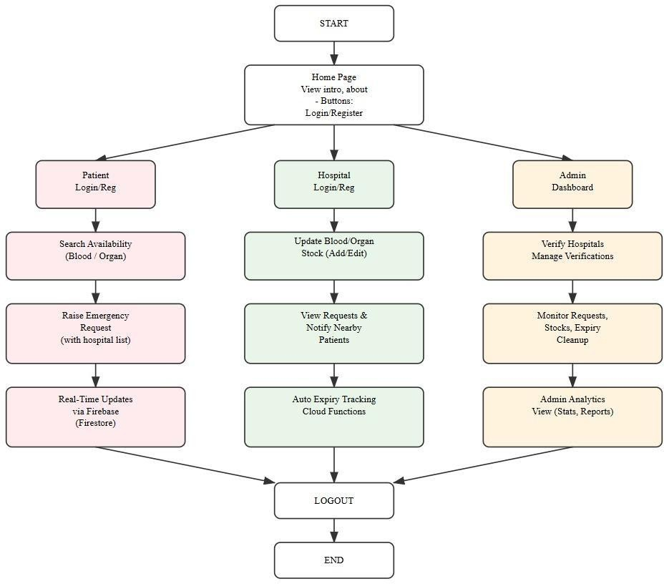

Figure-1: Presents the high-level architecture of LifeLink, outlining the coordinated roles of patients, hospitals, and administrators within the system.

DATA FLOWDIAGRAM
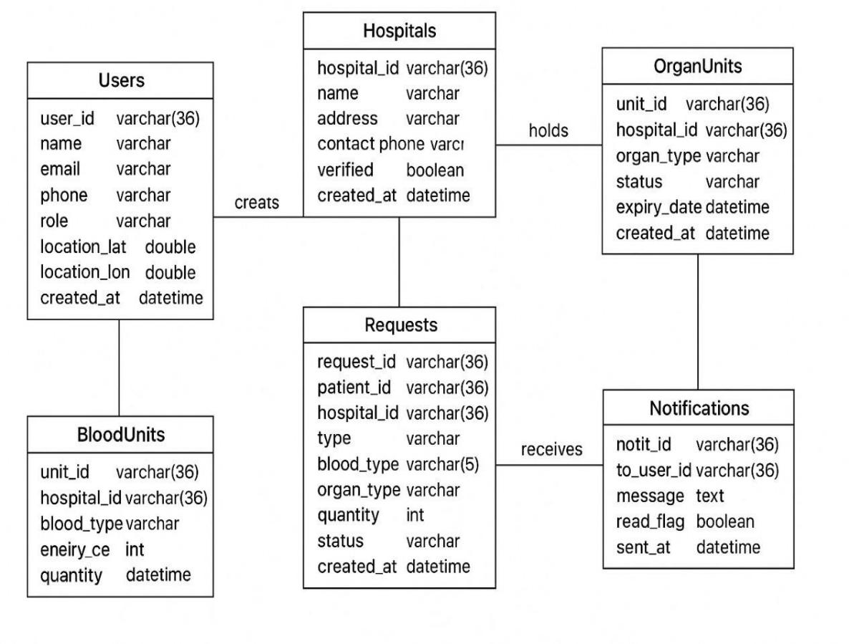

Figure-2: Depicts the structured flow of data across system entities, ensuring efficient handling of requests, users, and resource availability.

UML DIAGRAMS

    - Class Diagram
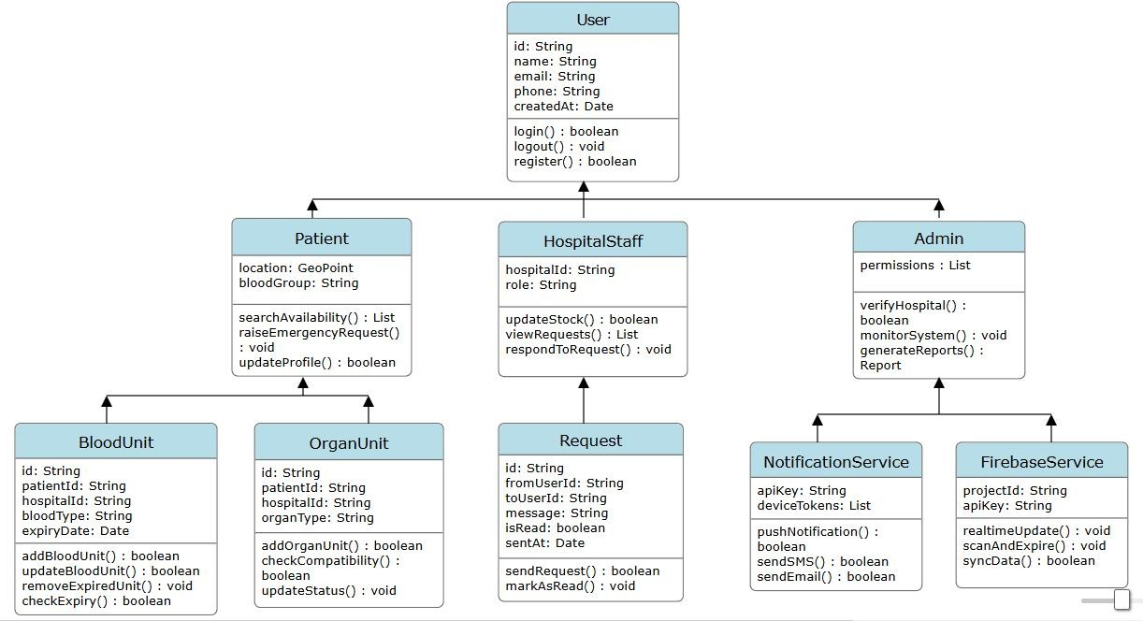



Figure-3: Defines the core system structure through classes, highlighting relationships and responsibilities within the application.

    - Use Case Diagram

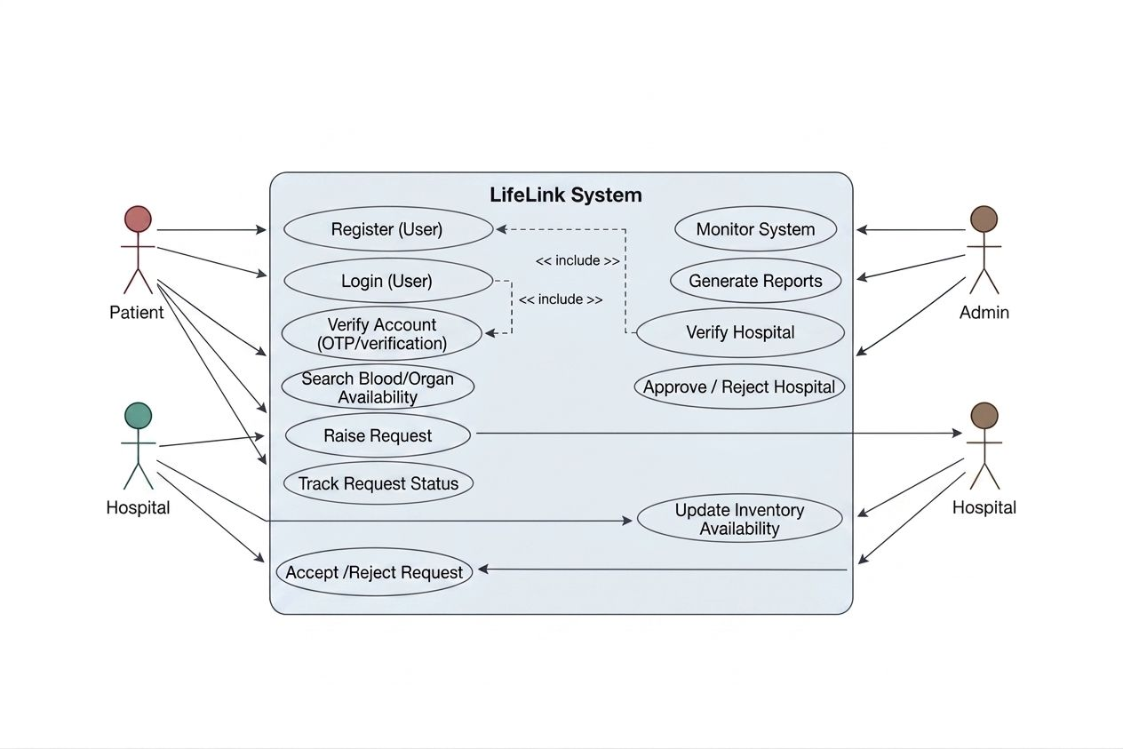

Figure-4: Illustrates the functional interactions between users and the system, capturing key operations and user roles.

    - Sequence Diagram

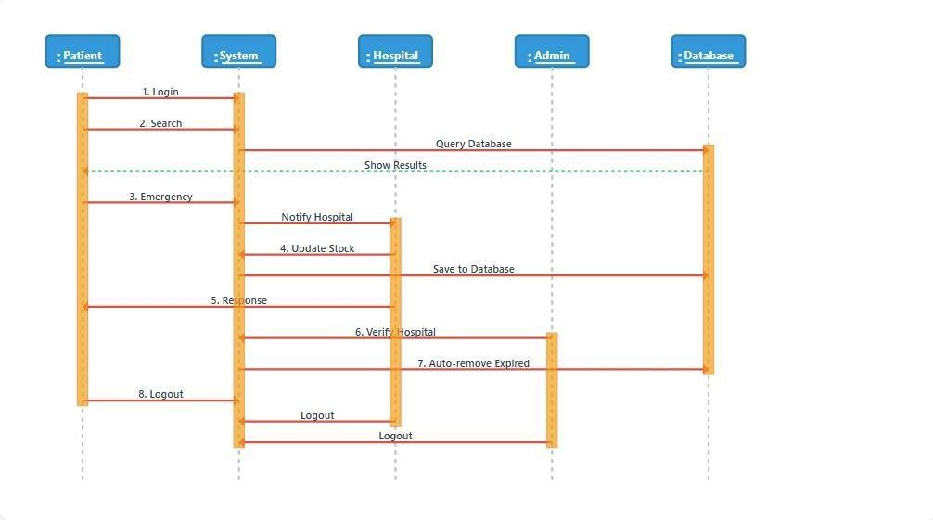

Figure-5: Describes the chronological exchange of information among system components during the execution of a request.

    - Activity Diagram
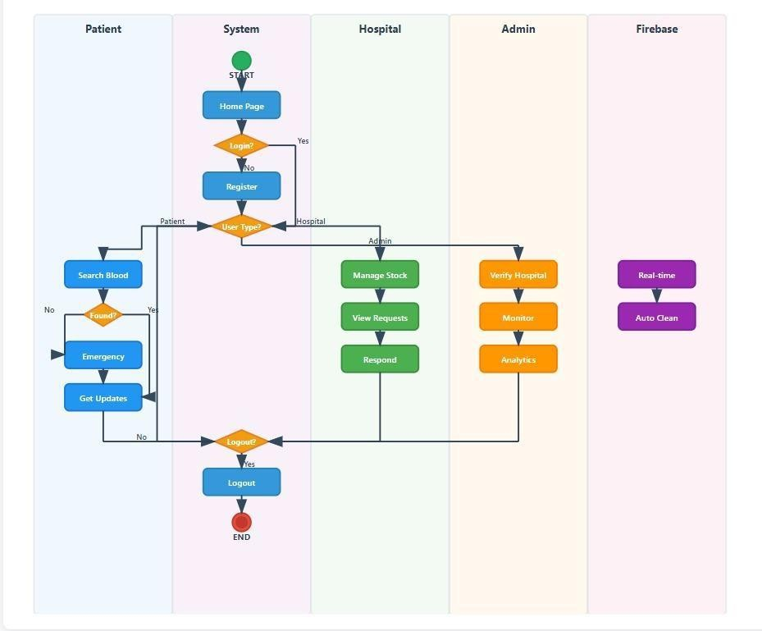


Figure-6: Represents the operational workflow of the system, detailing the sequence of actions and decision points across modules.

MODULES

The Real-Time Organ & Blood Availability System is developed using a modular design approach in which the overall functionality of the system is divided into multiple independent modules. Each module is responsible for performing a specific set of operations while interacting with other modules to ensure smooth system execution. This modular architecture improves maintainability, scalability, and system reliability. It also allows developers to modify or enhance individual modules without affecting the entire system.

The major modules of the system include the Admin Module, Hospital Module, Patient Module, Authorization Module, Notification Module, and supporting backend components such as Node Modules, Node Package Manager (NPM), Dotenv Configuration, and Node Mailer. Each of these modules plays an important role in the efficient operation of the platform.

Admin Module

The Admin Module serves as the central management unit of the system. The administrator is responsible for controlling and supervising the entire platform to ensure that only authorized hospitals and users are allowed to participate in the system. This module ensures the integrity and reliability of healthcare data stored within the platform.

One of the primary responsibilities of the administrator is hospital verification and approval. When hospitals register on the platform, they submit important details such as hospital name, location, contact information, and institutional credentials. The administrator carefully reviews these details to verify the authenticity of the hospital before granting system access. Only verified hospitals are permitted to update blood or organ availability data.

The admin module also allows administrators to monitor system activity and manage records. The administrator can review hospital registrations, track patient requests, and ensure that hospitals are updating accurate resource availability information.

Another important function of the admin module is database supervision and system maintenance. Administrators can view system logs, verify updates to blood or organ inventory, and ensure that expired resources are removed from the database. Through these features, the admin module ensures that the system maintains high reliability and accuracy.

Hospital Module

The Hospital Module is designed for healthcare institutions that participate in the system by providing information about available blood units and transplantable organs. Hospitals are the primary source of medical resource data within the platform.

Hospitals must first register with the system by submitting institutional details such as hospital name, address, contact information, and registration credentials. Once the registration request is submitted, the hospital account remains inactive until it is verified and approved by the system administrator.

After approval, hospital representatives can log into the system and access a hospital dashboard. This dashboard allows hospital administrators to manage and update information related to blood units and organ availability. Hospitals can enter details such as blood group type, number of available units, and expiry dates for stored blood.

The hospital module also allows hospitals to update organ availability status, depending on medical regulations and legal approvals. This information helps patients and other healthcare providers quickly identify where transplantable organs are available.

Additionally, hospitals can review and respond to patient requests. When a patient searches for a specific blood group or organ and submits a request, hospitals receive the request through the system interface. Hospital staff can review the request and approve or reject it depending on availability and medical eligibility criteria.

Patient Module

The Patient Module is designed to assist patients and their caregivers in locating blood units or transplantable organs during medical emergencies. This module provides a user-friendly interface that allows patients to search for medical resources across multiple hospitals.

Patients must first register on the platform by providing basic personal information such as name, email address, and contact details. After registration, patients can log into the system and access the search functionality.

The main feature of this module is the search system, which allows patients to search for specific blood groups or organs available in participating hospitals. The system retrieves relevant data from the central database and displays hospitals where the required medical resource is available.

Patients can also send requests to hospitals for the required resource. Once the request is submitted, it is forwarded to the appropriate hospital where medical staff review the request. If the hospital approves the request, the patient receives confirmation through the system.

This module significantly reduces the time required to locate life-saving medical resources, particularly in emergency situations where immediate access to blood or organs is critical.

Authorization Module

The Authorization Module is responsible for ensuring secure access to the system and protecting sensitive medical data. This module verifies user identities and controls access to different system functionalities based on user roles.

The system follows a role-based access control mechanism where different users have different privileges. For example, administrators have full control over the system, hospitals can manage resource inventory data, and patients can search for resources and send requests. Typically, When a user or any patient attempts to log

into the system, the backend verifies the credentials through authentication APIs before granting access.

The authorization module also prevents unauthorized access to restricted features such as updating hospital records or modifying resource availability data. By enforcing strict access control policies, the system ensures data confidentiality, system security, and protection of sensitive healthcare information.

Notification Module

The Notification Module plays an essential role in maintaining communication between patients and hospitals. This module ensures that users receive real-time updates regarding resource availability and request status.

When a patient submits a request for a specific blood group or organ, the hospital receives an instant notification through the system dashboard. This allows hospital staff to review the request quickly and respond accordingly.

Similarly, once the hospital approves or rejects a request, the patient receives a notification update indicating the decision. These notifications help keep users informed without requiring them to continuously check the system manually.

The notification module can also generate system alerts for hospitals. For instance, if the availability of a particular blood group becomes critically low or if stored blood units are nearing their expiry date, the system can notify hospital administrators to take appropriate action.

By providing timely communication between different users, the notification module enhances coordination and improves the efficiency of emergency healthcare services.

Node Modules

Node Modules refer to the collection of external libraries and packages used in the Node.js environment to extend the functionality of the backend application. These modules provide pre-built solutions for common programming tasks, which helps developers save time and improve development efficiency.

In this project, node modules support various backend functionalities such as creating server routes, handling HTTP requests, connecting to the database, managing authentication processes, and processing environment variables.

When developers install project dependencies using the Node Package Manager, these packages are automatically stored in a directory called node_modules. This folder contains all the libraries required for the application to run properly.

Using node modules allows developers to build scalable and efficient web applications while avoiding the need to develop complex functionalities from scratch.

Node Package Manager (NPM)

The node package manager (npm) is a package management tool used for installing, updating, and managing libraries required for Node.js applications. It is one of the most widely used tools in modern web development.

NPM simplifies the process of integrating external packages into a project. Developers can install required libraries using simple commands such as npm install. Once installed, the package information is automatically recorded in the package.json file, which serves as a configuration file for managing project dependencies.

In the Real-Time Organ & Blood Availability System, NPM is used to install important backend libraries such as Express.js for building server APIs, MySQL connectors for database interaction, and other utility packages required for system functionality.

Another important feature of NPM is dependency management, which ensures that the correct versions of libraries are used. This prevents compatibility issues and ensures stable application performance.

Dotenv Configuration

The Dotenv module is used to manage environment variables in the application.

In this project, dotenv is used to store configuration details such as database connection credentials, server port numbers, authentication keys, and email service credentials. These values are stored in a special configuration file known as the .env file.

When the application starts, the dotenv library loads the variables defined in the .env file into the Node.js environment so that they can be accessed securely by the backend code.

Using dotenv provides several advantages. It improves security by preventing sensitive information from being exposed in the source code and allows developers to easily configure the application for different environments such as development, testing, and production.

Node Mailer

Node Mailer is a widely used Node.js library that enables applications to send emails programmatically. In the Real-Time Organ & Blood Availability System, Node Mailer is used to deliver automated email notifications to users.

This module plays an important role in the communication and alert mechanism of the system. When a patient sends a request for a blood unit or organ, the system can send an email notification to the concerned hospital. Similarly, when the hospital approves or rejects a request, the system sends an email notification to the patient informing them about the request status.

Node Mailer can also be used for account verification and system alerts. For example, confirmation emails can be sent during user registration, and notification emails can be triggered when new resources become available.

The module works by connecting the application to an email service provider such as Gmail or other SMTP servers. Once configured, the system can automatically send structured email messages based on predefined triggers.

By integrating Node Mailer into the system, the platform ensures fast communication, improved user awareness, and efficient coordination between patients and hospitals.

5. IMPLEMENTATION AND RESULTS

IMPLEMENTATION AND RESULTS

LANGUAGE / TECHNOLOGY USED
This chapter describes the practical implementation of the Real-Time Organ & Blood Availability System (RBOAS) and presents the results obtained after developing and testing the system. The implementation phase focuses on translating the system design and architecture into a working software application using appropriate technologies. The developed platform enables hospitals to update the availability of blood units and organs while allowing patients to search for these resources during medical emergencies.

The system is implemented as a web-based application using modern web technologies. The frontend is developed using React.js, which provides a dynamic and responsive user interface. The backend is developed using Node.js with Express.js, which handles server-side logic and API communication. The system uses MySQL as the database management system to store hospital records, blood inventories, organ availability information, and patient requests.

The implementation process involved the development of multiple modules, integration of frontend and backend components, database design, and testing procedures to ensure system reliability and accuracy.

The development of the Real-Time Organ & Blood Availability System (RBOAS) requires a combination of modern web technologies to ensure efficiency, scalability, and reliability. The system is designed as a web-based platform that allows patients to search for available blood units and transplantable organs in hospitals during emergency situations.

To implement the system effectively, several software technologies and development tools were used. The major technologies include React.js for frontend development, Node.js with Express.js for backend server implementation, MySQL for database management, and Visual Studio Code as the development environment.

Advantages of React.js

- React.js is a popular JavaScript library used for building user interfaces, especially for single-page web applications. One of the key advantages of React is its component-based architecture, which allows developers to divide the user interface into small, reusable components.

- Each component manages its own structure and functionality, making the application easier to maintain and update. This modular approach improves code organization and helps developers work efficiently when building complex web systems.

- In the RBOAS system, React components are used to design various user interface sections such as patient login forms, hospital dashboards, blood search pages, and request management interfaces.

- React.js improves application performance through the use of a Virtual Document Object Model (Virtual DOM). Instead of updating the entire web page whenever a change occurs, React only updates the specific parts of the interface that need modification.

- This approach significantly improves application speed and provides a smoother user experience. For a healthcare system like RBOAS, fast response time is very important because users may be searching for life- saving resources during emergencies.

- Another advantage of React.js is the ability to reuse components across different parts of the application. Developers can create a component once and use it multiple times wherever required.

- For example, elements such as navigation bars, input forms, search panels, and notification messages can be reused throughout the application. This reduces development effort and ensures consistency in the user interface.

Advantages of Node.js

- Node.js is a runtime environment that allows JavaScript to be executed on the server side. It is built on Google Chrome’s V8 JavaScript engine, which provides fast execution of code.

- Node.js uses an event-driven and non-blocking architecture, allowing the server to handle multiple requests simultaneously. This makes it suitable for applications that require real-time communication and quick response times.

- In the RBOAS system, Node.js processes requests from patients and hospitals, manages login authentication, and communicates with the database to retrieve information about organ and blood availability.

- Node.js supports the development of scalable applications that can grow as the number of users increases. Its asynchronous processing model allows the server to manage large numbers of connections efficiently.

- This capability is particularly important for healthcare platforms where multiple hospitals and patients may access the system simultaneously.

- Node.js has a large global developer community and a rich ecosystem of packages available through the Node Package Manager (NPM). These packages help developers quickly integrate features such as authentication, email notifications, and data validation.

- For the RBOAS application, NPM packages are used to implement functionalities such as API routing, middleware processing, and database connectivity.

Advantages of Express.js

- Express.js is a lightweight web application framework built on top of Node.js. It simplifies the process of building server-side applications by providing a structured way to manage routes, middleware, and HTTP requests.

- Express.js makes it easy to develop RESTful APIs, which allow the frontend and backend components of the system to communicate effectively. These APIs enable the React frontend to request data from the server, such as available blood units or organ donor information.

Advantages of MySQL Database

MySQL is a widely used relational database management system that provides reliable storage for structured data. It supports the use of tables, rows, and relationships to organize information efficiently.

In the RBOAS system, MySQL stores important information such as:

        - Patient details
        - Hospital records
        - Blood stock availability
        - Organ donation information
        - Request and approval status
        - The use of relational tables ensures that data is properly organized and easy to retrieve when needed.

MySQL provides strong mechanisms for maintaining data integrity and security. It supports authentication mechanisms, data constraints, and access control features that protect sensitive healthcare data.

These features ensure that only authorized users such as hospitals or administrators can modify critical data within the system.

Advantages of Visual Studio Code

- Visual Studio Code (VS Code) is a powerful and lightweight source code editor widely used by developers for building modern applications. It provides a simple interface that allows programmers to write, edit, and manage code efficiently.

- VS Code supports multiple programming languages including JavaScript, HTML, CSS, and SQL, making it ideal for full-stack web development projects like the RBOAS system.

- VS Code offers a wide range of extensions that enhance the development process. Developers can install extensions for debugging, code formatting, version control, and database management.

- For this project, extensions were used to support React development, Node.js debugging, and MySQL integration, enabling smooth development and testing of the application.

- Another important feature of VS Code is the integrated terminal, which allows developers to run commands directly inside the editor. This feature simplifies tasks such as installing dependencies, running the server, and managing project files.

- Additionally, the built-in debugging tools help developers identify and fix errors quickly, improving overall code quality.

- VS Code provides built-in integration with version control systems such as Git. This allows developers to track code changes, collaborate with team members, and maintain a history of project modifications.

- Using version control ensures that the RBOAS project development process remains organized and manageable.

SAMPLE CODE

App.js

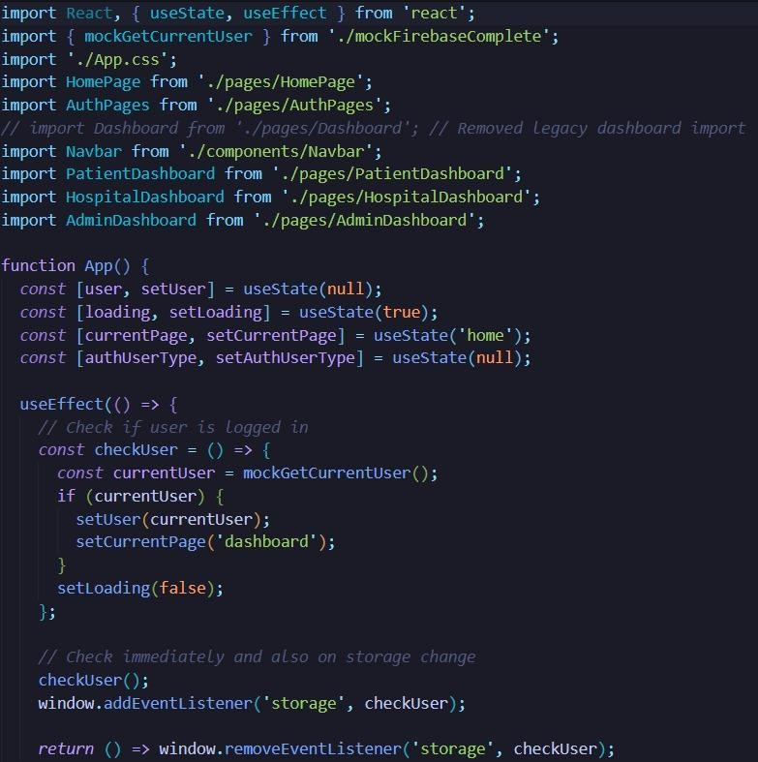

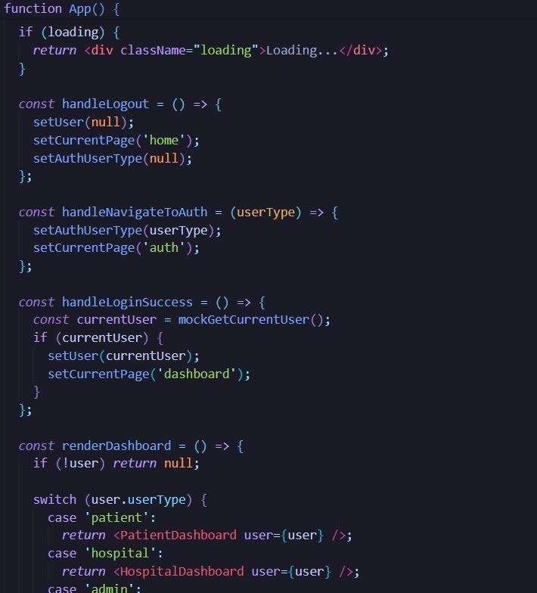
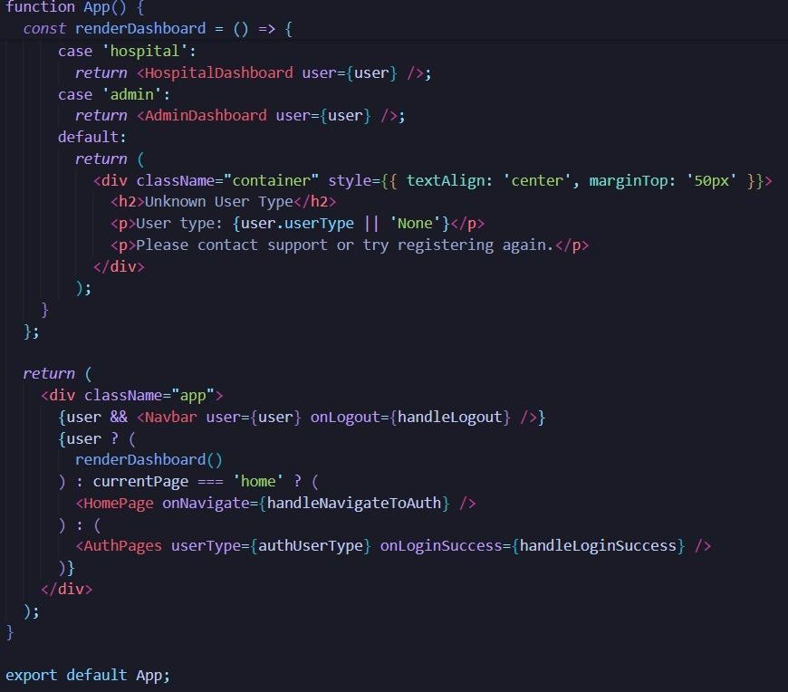

CSS

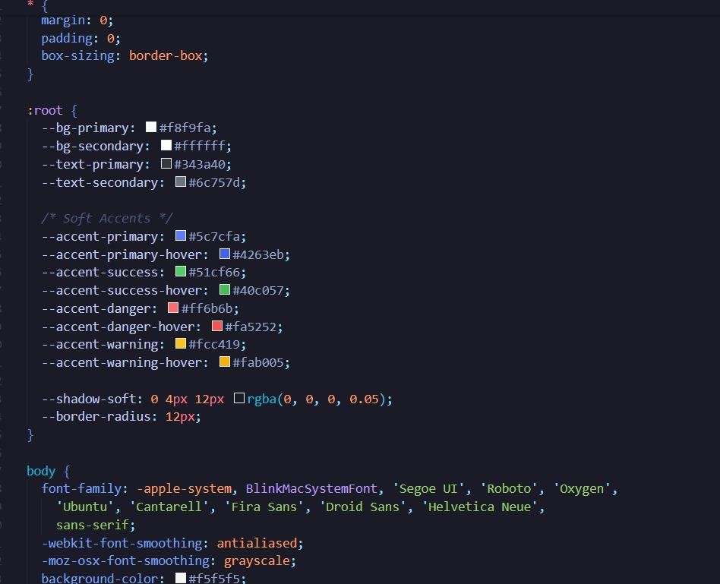

Firebase
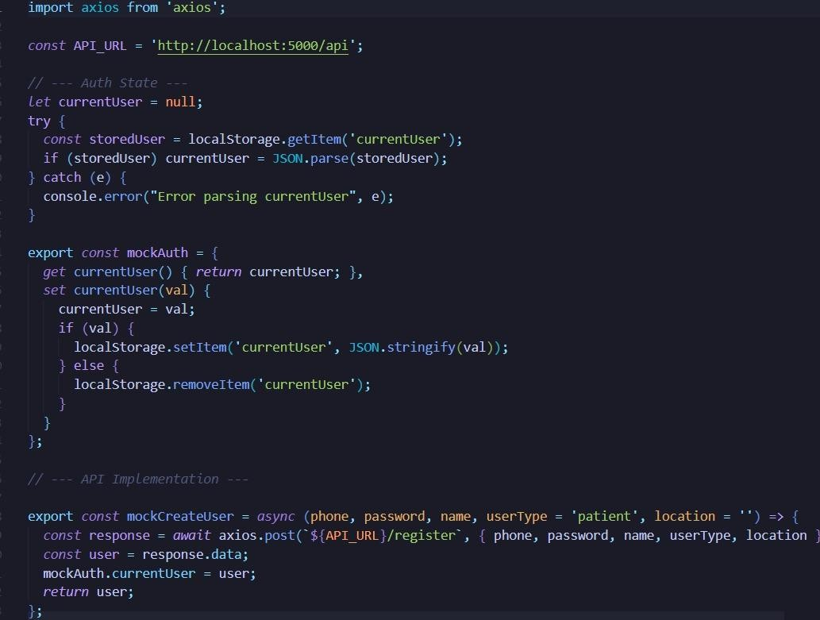
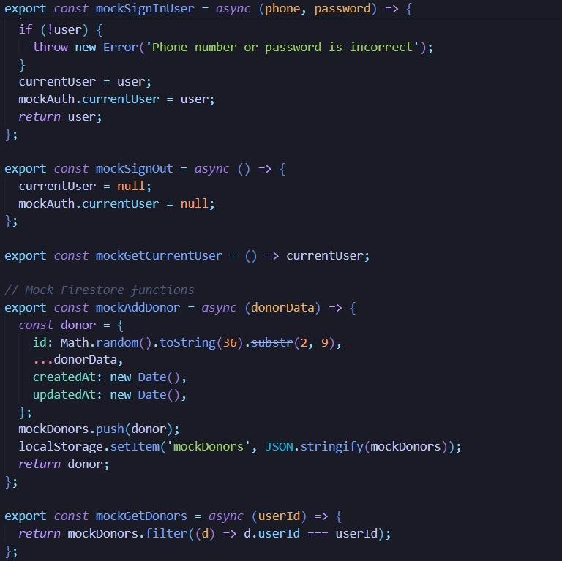

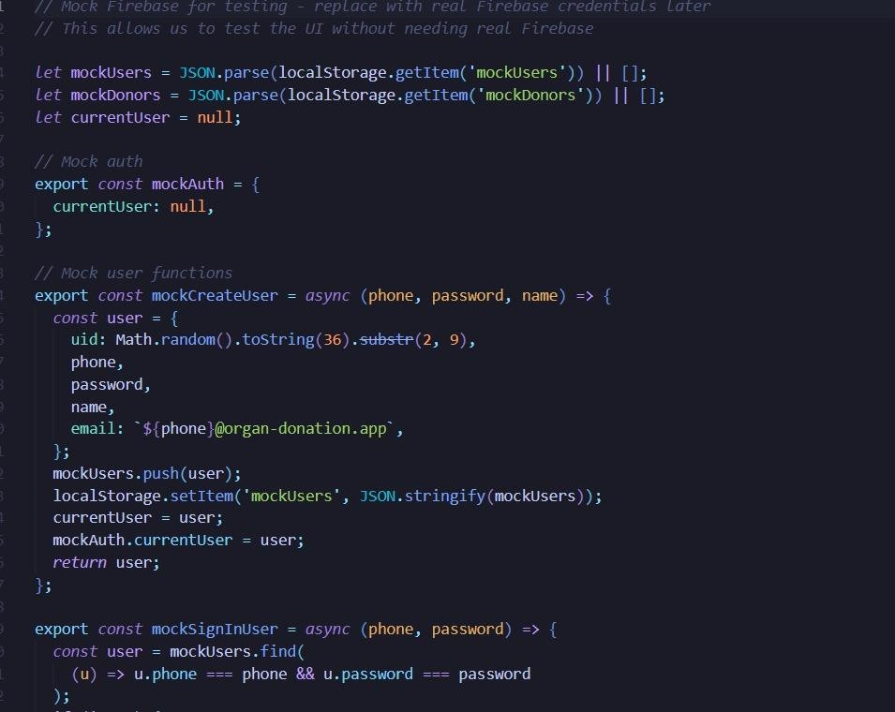
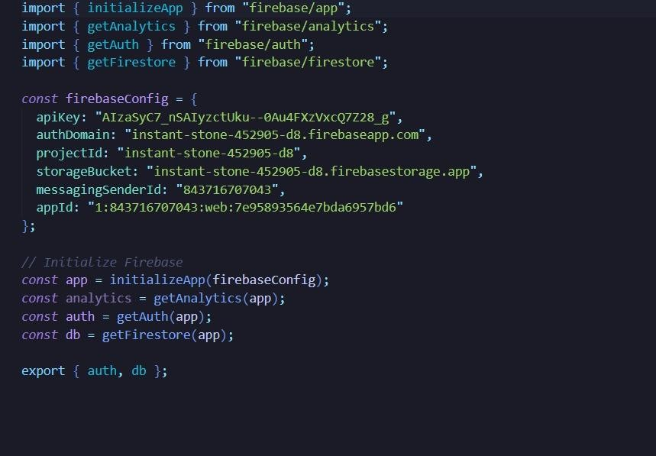

RESULTS (ACCURACY) / OUTPUT SCREENS
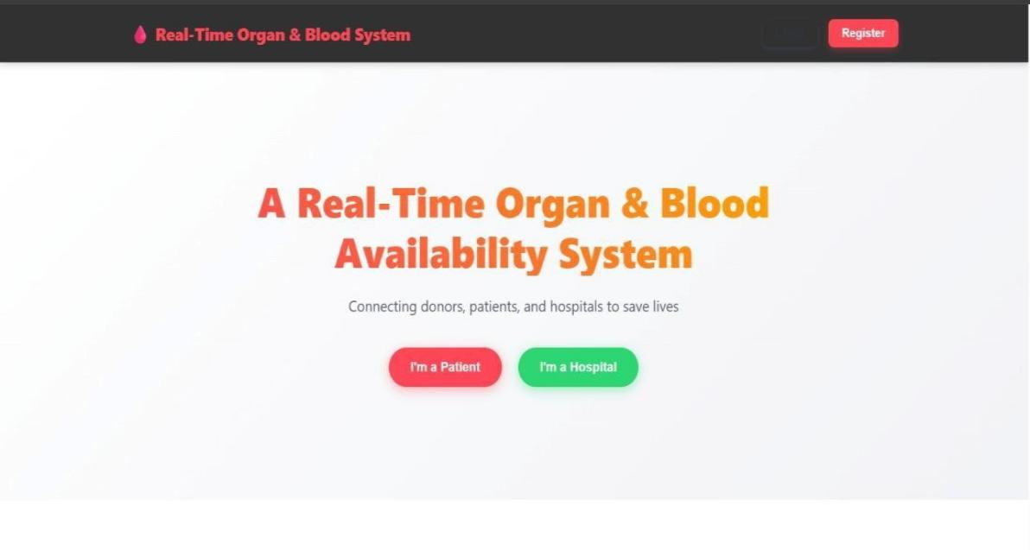
Figure-7: Presents the system landing interface enabling users to initiate access as a patient or hospital within the LifeLink platform.

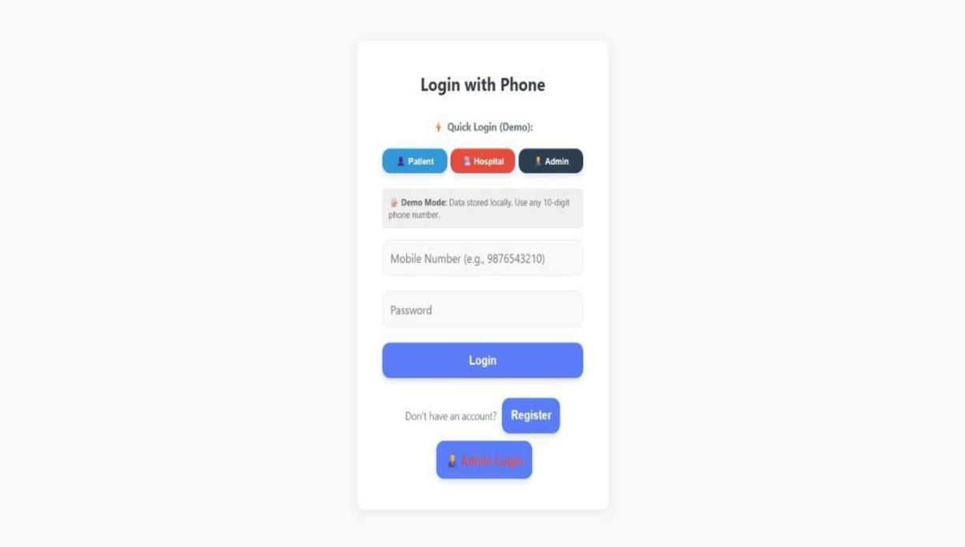

Figure-8: Displays the user authentication interface facilitating secure login and registration through mobile-based credentials.

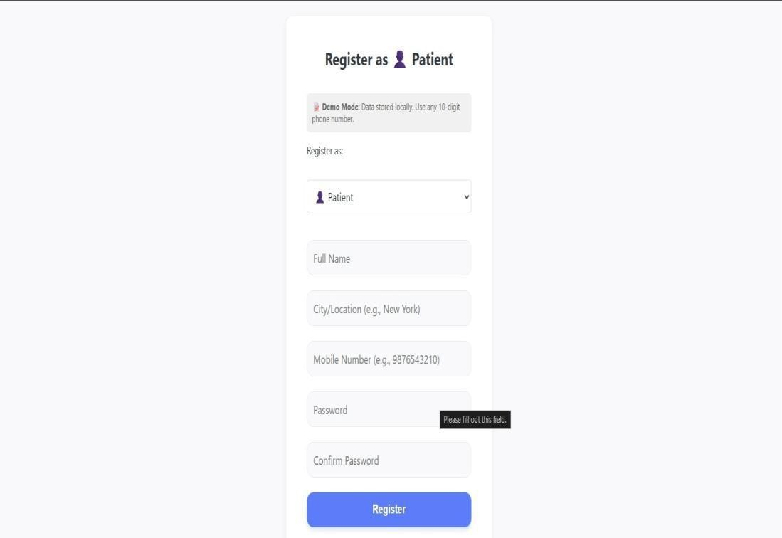

Figure-9: Captures user registration details to create a verified patient the system

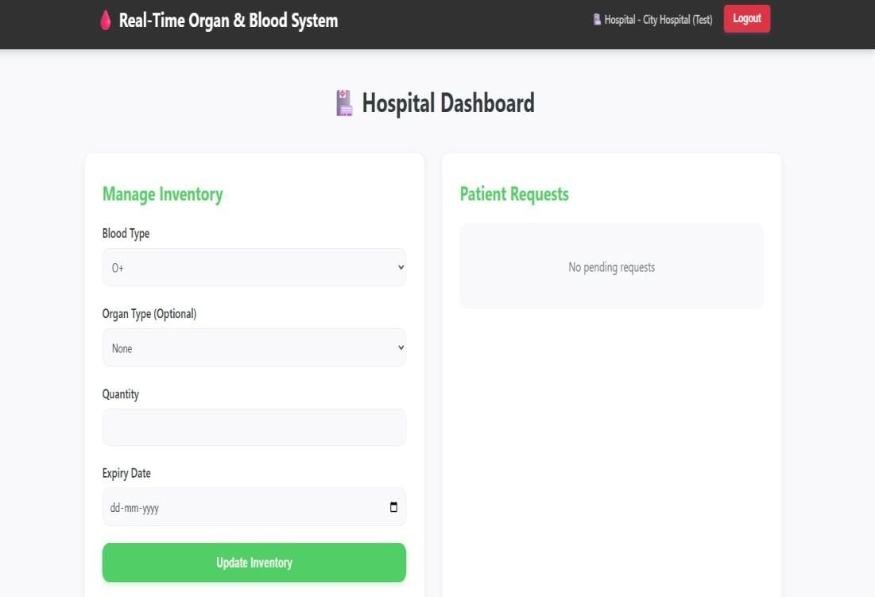

Figure-10: Illustrates the hospital interface for managing inventory and responding to incoming patient requests.

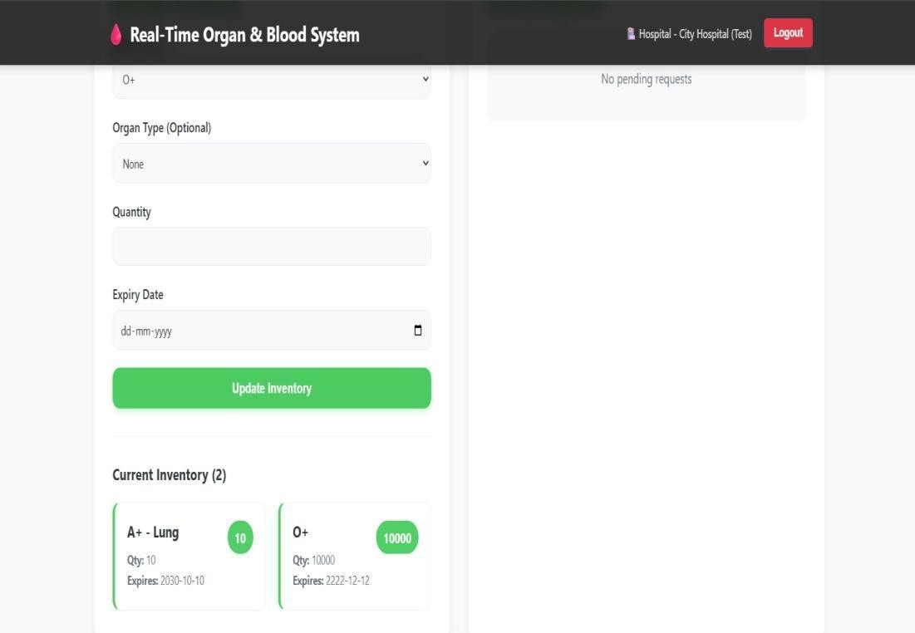

Figure-11: Demonstrates the process of updating blood and organ inventory along with expiry details within the hospital module.

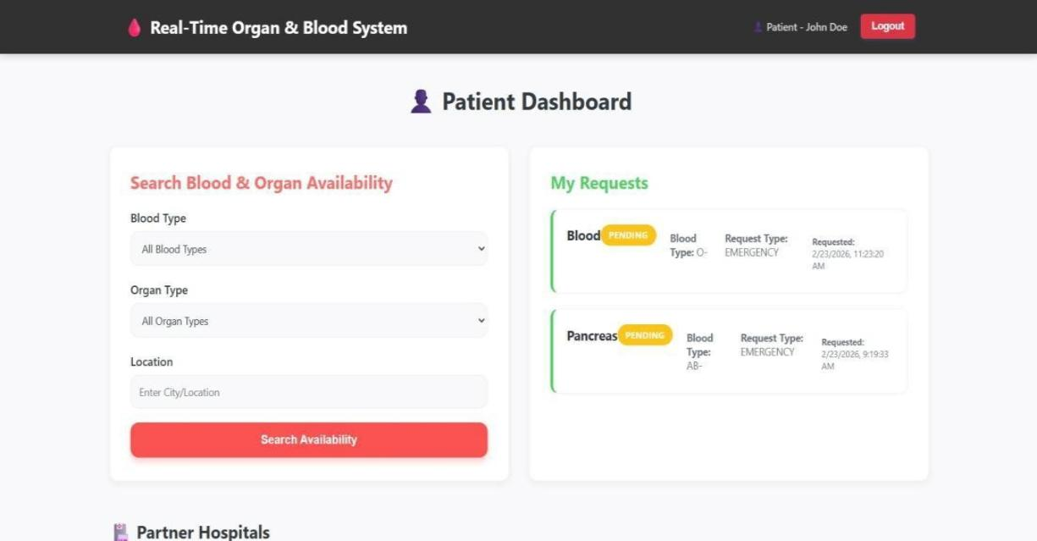

Figure-12: Represents the patient interface for searching resource availability and monitoring submitted requests.

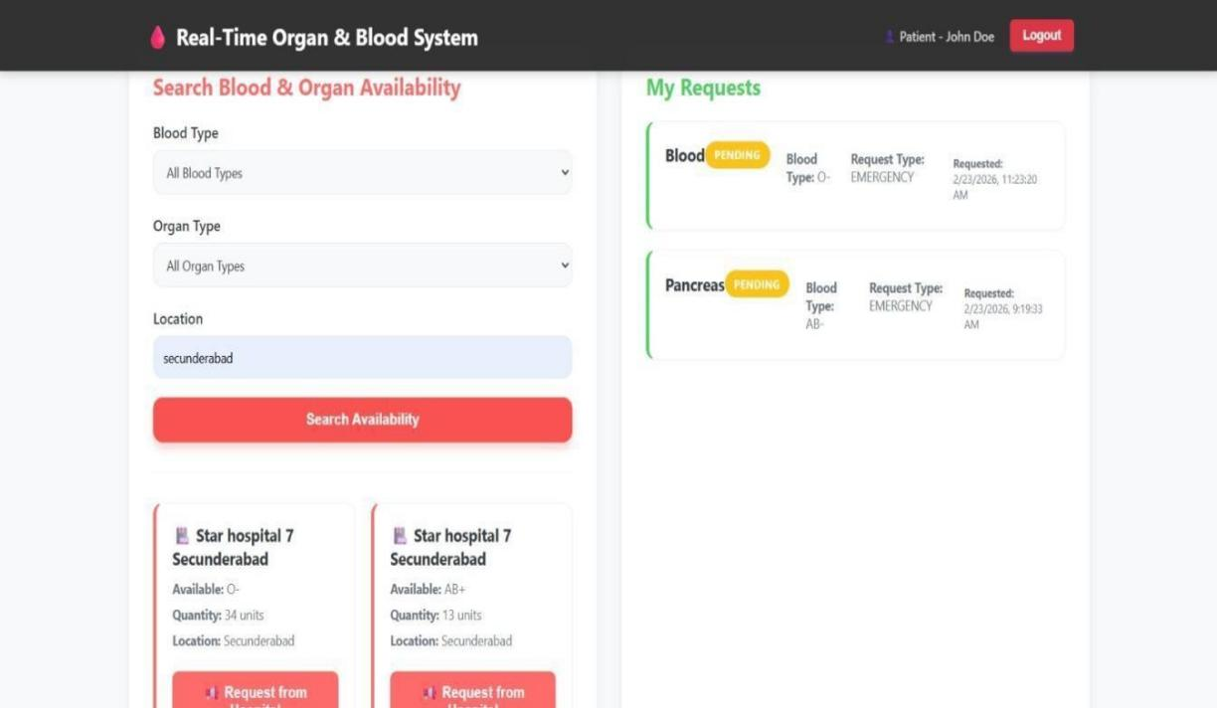

Figure-13: Displays filtered hospital results based on user input, enabling patients to identify and request available resources.

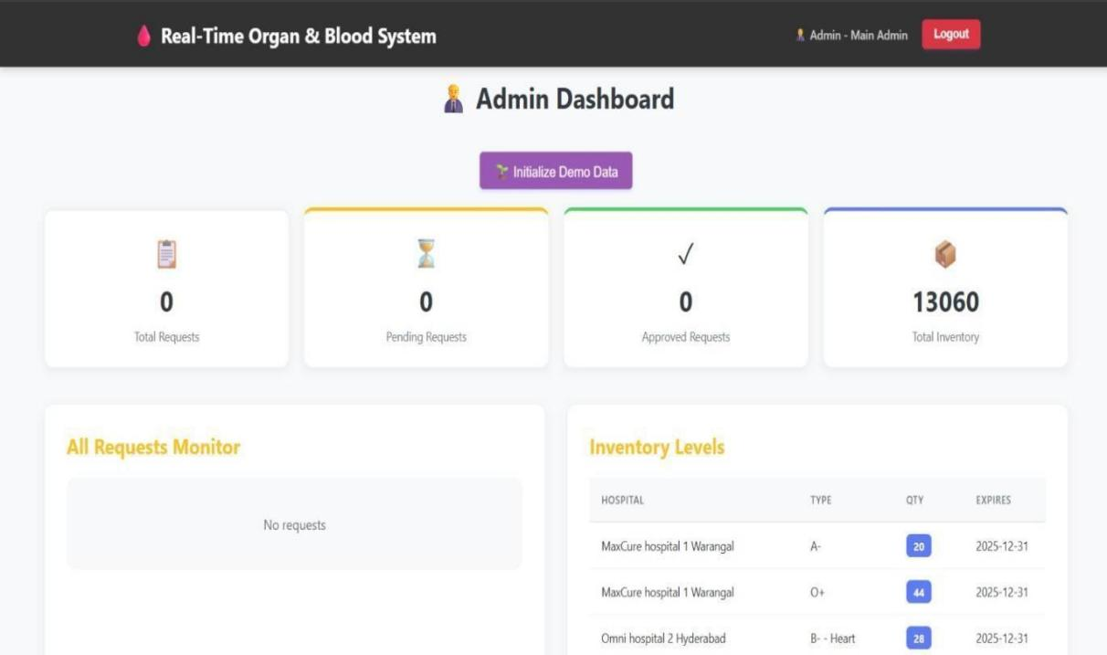

Figure-14: Showcases the administrative interface for monitoring system activity, verifying hospitals, and analyzing resource data.

TESTING

TESTING

TYPES OF TESTING

Unit Testing

Unit testing is the process of evaluating individual components or modules of a software system independently. Each module is tested separately to ensure that it performs its intended functionality correctly without relying on other parts of the system.

In the Real-Time Organ & Blood Availability System, unit testing was carried out on several key modules of the application. These modules include the hospital registration module, patient search module, data update module, authentication module, and notification module.

During unit testing, the backend API functions developed using Node.js and Express.js were individually verified. Each API endpoint was tested to confirm that it correctly processes incoming requests and generates appropriate responses. For example, the hospital registration module was tested to verify that valid hospital details are successfully stored in the database while invalid or incomplete entries are rejected.

Similarly, the patient search functionality was tested to confirm that the system accurately retrieves blood group and organ availability data from the MySQL database. Different search scenarios were evaluated, including valid searches, invalid inputs, and cases where no resources were available.

Unit testing also involved verifying the correctness of database operations such as inserting records, updating hospital inventory data, and retrieving information based on search queries. By testing these modules independently, developers were able to detect logical errors early in the development process.

The successful completion of unit testing ensured that each module performs its designated task correctly before integrating it with other parts of the system.

Data Flow Testing

Data Flow Testing focuses on verifying how data moves through different parts of the system. It ensures that information is correctly transmitted between components and that there are no inconsistencies or errors during data processing.

In the Real-Time Organ & Blood Availability System, data flow testing was performed to analyze how data is transferred from the user interface to the backend server and finally to the database. Since the application depends heavily on real- time information updates from hospitals, it was essential to ensure that the data flow process operates correctly.

The testing process examined how hospital administrators enter blood and organ availability information through the React.js frontend interface. Once the data is submitted, it is transmitted to the backend server through REST API requests handled by Express.js.

The backend server then processes the incoming information, validates the input data, and stores it in the MySQL database. Data flow testing ensured that each step in this process occurs without errors or data corruption.

Additionally, testing verified that when patients search for available blood units or organs, the request travels correctly through the application layers. The system retrieves the requested information from the database and sends the results back to the user interface.

By analyzing the data flow paths, developers were able to detect potential issues such as missing values, incorrect database queries, or communication failures between system layers. Ensuring proper data flow is particularly important in healthcare applications because incorrect information may lead to serious consequences.

Integration Testing
Integration testing is performed after individual modules have been tested successfully.

In the Real-Time Organ & Blood Availability System, several modules interact with each other during normal operation. For example, the hospital module interacts with the database module to store and update medical resource information. Similarly, the patient search module communicates with the backend APIs to retrieve relevant data from the database.

During integration testing, these interconnected modules were combined and tested as a group. The objective was to confirm that the communication between modules works as expected and that no errors occur when they operate together.

Developers tested scenarios such as hospital administrators updating blood inventory information and patients performing searches immediately after those updates. This ensured that newly entered data becomes available to users without delay.

Integration testing also evaluated the interaction between the authorization module and other components. Only verified hospitals were allowed to access the system and update resource information. The integration tests confirmed that unauthorized users could not perform restricted actions.

By conducting integration testing, the development team ensured that the system operates smoothly when multiple modules interact simultaneously.

Big Bang Integration Testing

Big Bang Integration Testing is a type of integration testing where all the individual units or modules of the software are integrated and tested together allat once. This results in a complete system that is tested as a whole.

This type of testing methodology is often used in small projects or in situations where the software is relatively simple and the individual units are not too complex. However, it can also be a risky approach as it does not focus on verifying the interaction between individual units, making it difficult to isolate and fix any errors or defects that may arise.
One of the major drawbacks of Big Bang Integration Testing is that it can be challenging to identify the source of any issues.

separately. This makes it more difficult to isolate and fix any errors that may arise.

Moreover, this type of testing can be time-consuming and expensive, as all the units need to be developed and ready for testing at the same time, and any issues or defects found during testing may require significant effort to resolve.

In conclusion, while Big Bang Integration Testing can be a quick and easy way to integrate all the units or modules of the software, it is often risky and can lead to difficulties in identifying and fixing issues or defects. As such, it is important to consider other integration testing approaches, such as incremental or modular integration testing, to ensure the overall quality and reliability of the software.

User Interface Testing

The evaluation technique of user interface testing pertains to the identification of potential faults within the graphical user interface (GUI) of a software program or application. The central objective of testing the user interface is to ascertain the software's ease of use, intuitiveness, and user-friendliness.

The practice of GUI testing involves the meticulous examination and evaluation of various constituents that comprise the user interface such as buttons, menus, icons, text boxes, and other graphical elements. The process of testing entails the rigorous examination of the layout and design of the interface, coupled with the validation of the complete functionality of all constituent elements, as well as their commendable responsiveness in reaction to user input.

In the process of conducting user interface testing, automated tools and scripts are frequently utilized by testers to emulate the actions of a user interfacing with the software. This aids in the detection of potential concerns or deficiencies that may present themselves during routine utilization of the software.

The primary aim of conducting user interface testing is to ascertain the extent to which software conforms to the usability and accessibility standards stipulated for end-users. The process encompasses confirming the consistency and aesthetic appeal of the interface, alongside guaranteeing its accessibility to users who have disabilities.

In essence, user interface (UI) testing constitutes a crucial element of software testing, given its capacity to verify the user-friendliness of software and its alignment with end-users' requirements. The process of Graphical User Interface (GUI) testing enables testers to discern anomalies and malfunctions that pertain to the graphical features of the software. Consequently, it provides an opportunity for the detection and eventual rectification of such discrepancies prior to the software's dissemination to end-users.

TEST CASES

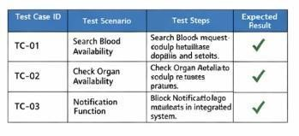

Table-1 Test Cases

CONCLUSION

CONCLUSION

Access to compatible blood units and transplantable organs is essential for effective emergency medical care. However, many healthcare systems struggle with delays when patients or medical staff attempt to locate these critical resources. A major reason for this problem is the absence of a unified platform that connects hospitals and provides updated information about available blood units and organs. In many cases, hospitals maintain their own independent records, which makes it difficult for patients and doctors to quickly identify where the required medical resources are available. This lack of coordination can slow down emergency response and may negatively impact patient outcomes. To overcome these challenges, the Real- Time Organ and Blood Availability System (RBOAS) was designed as a centralized web-based solution that allows hospitals to manage and share information about blood bank inventories and organ availability. The system enables healthcare institutions to update their resource data instantly, while patients can search for required blood groups or organ types through a single digital platform. By linking hospitals and patients within one system, the platform improves communication and ensures that vital medical information can be accessed quickly. The system was built using modern web development technologies, including React.js for the user interface, Node.js with Express.js for server-side operations, and MySQL for database management. This technology combination provides a reliable and scalable structure capable of handling frequent data updates and user requests. Hospitals can securely log into the platform and update the availability of blood units and organs, while patients can search the database to locate hospitals that currently have the required resources. One of the most important features of the system is the ability to update information in real time, ensuring that users always receive the latest availability data. The platform also incorporates an authorization mechanism that allows only verified hospitals to modify medical resource information, which improves the accuracy and credibility of the stored data. In addition, the system includes a notification feature that informs users about request approvals and important updates. Overall, the implementation of this platform demonstrates how digital healthcare systems can improve resource visibility, strengthen coordination between medical institutions, and support faster response during emergencies.

FUTURE SCOPE

FUTURE SCOPE

Although the Real-Time Organ & Blood Availability System (RBOAS) provides an effective platform for managing and accessing medical resource information, there are several opportunities to enhance the system in the future. The current implementation focuses primarily on connecting hospitals and patients through a centralized web-based application. However, additional features and technological advancements can further improve the system’s efficiency, accessibility, and impact in healthcare environments.

One of the most important improvements that can be introduced in the future is the development of a mobile application version of the system. While the current platform is accessible through web browsers, a dedicated mobile application for Android and iOS devices would allow users to access the system more conveniently. Mobile applications can provide faster notifications, improved user interfaces, and easier accessibility during emergencies when immediate access to medical information is required.

Another potential enhancement involves the integration of GPS-based hospital location services. By incorporating geolocation technology, the system could automatically identify hospitals that are closest to the patient’s current location. This feature would enable users to quickly locate nearby hospitals with available blood units or organs, thereby reducing travel time and improving emergency response.

The system can also be extended by integrating artificial intelligence and predictive analytics. Machine learning algorithms could analyze historical hospital data to predict blood demand patterns and identify potential shortages in advance. Such predictive capabilities would help hospitals prepare for high-demand situations and maintain adequate blood inventories. Predictive analytics could also assist healthcare administrators in making the informed decisions regarding blood donation campaigns and resource allocation. Another valuable improvement would be the integration of national organ donation registries and blood bank networks.

pool of available resources and improve coordination between multiple healthcare institutions. This integration would expand the system’s coverage beyond individual hospitals and create a more comprehensive national healthcare resource network.

Future versions of the system may also include advanced security mechanisms to protect sensitive healthcare data. Since the platform handles medical information and hospital records, implementing stronger security measures such as data encryption, multi-factor authentication, and secure access control mechanisms would further enhance system reliability and user trust.

Additionally, the notification system can be improved by incorporating multi- channel communication services. Instead of relying solely on email notifications, the system could send alerts through SMS messages, mobile push notifications, and emergency communication platforms. This improvement would ensure that patients receive timely updates regardless of the communication method they prefer.

Another potential enhancement is the inclusion of a blood donor registration and volunteer network module. Individuals willing to donate blood could register in the system and receive alerts whenever their blood group is required nearby. This feature would encourage community participation and increase the availability of blood units during emergencies.

Furthermore, the system could incorporate automated blood expiry management. Blood units have limited storage lifespans, and tracking their expiry dates is essential for maintaining safe medical practices. An intelligent expiry management module could automatically alert hospitals when blood units are nearing expiration and recommend redistribution to nearby healthcare facilities where demand is higher.

From an administrative perspective, future improvements may include advanced analytics dashboards for healthcare authorities. These dashboards could provide statistical insights such as blood demand trends, organ availability statistics, hospital performance metrics, and emergency response efficiency. Such analytical tools would support healthcare policymakers in planning medical resource.

Finally, the RBOAS platform can be expanded into a comprehensive healthcare emergency management system. In addition to blood and organ availability, the system could include information about ambulance services, emergency medical equipment, ICU bed availability, and specialized medical staff. This broader integration would transform the platform into a complete emergency healthcare coordination system.

In summary, the future scope of the Real-Time Organ & Blood Availability System is vast and promising. With advancements in mobile technology, artificial intelligence, data analytics, and healthcare integration, the system can evolve into a powerful digital infrastructure for managing critical medical resources. Continued development and collaboration with healthcare institutions can significantly enhance the system’s effectiveness and contribute to improving emergency healthcare services on a larger scale.

BIBLIOGRAPHY

BIBLIOGRAPHY
- Latha, A. P., Kumar, S., Sachdeva, R., & Singh, S. (2021). Realtime Blood Bank Data Repository.
International Journal of Engineering Technologies and Management Research, 8(6).
This research discusses the development of a centralized blood bank data repository designed to streamline emergency blood searches and maintain donor and inventory records efficiently.

- Eweoya, I., Oladipo, S., Sodiq, K., Ebodaghe, O., Adewuyi, J., Adigun, T., & Lawal, O. (2025).
Design and Implementation of a Scalable Real-Time Web-Based Blood Bank Management System.
FUOYE Journal of Engineering and Technology.
The study presents a scalable web-based system that improves blood inventory management and ensures efficient resource tracking across healthcare institutions.

- Bawankar, G., Raut, S., Sharnagate, D., Bhoyar, K., & Shende, T. (2024). Development of Blood Management System Application Using Machine Learning Techniques.
International Journal for Research in Applied Science and Engineering Technology. This work proposes a blood management application that uses predictive techniques to forecast donor availability and optimize blood supply planning.

- Khan, I., Jiya, K., Tanwar, Y., & Yadav, P. (2024).
A Comprehensive Blood Bank Management System for Efficient Resource and Staff Handling in Service Centers.
International Journal of Research – GRANTHAALAYAH.
The paper describes a system designed to automate blood bank operations, manage donor records, and improve hospital resource coordination.

- Chawhan, A., Kuhikar, H., Katekhaye, S., & Dongre, P. B. (2023).
MapBlood: An Intelligent Blood Bank System with Integrated Google Maps. International Journal for Research in Applied Science and Engineering Technology. The proposed system integrates location-based services to help users locate nearby blood banks.

- Raj, A., Singh, A., Ashraf, M. M., Samim, K., Sudha, D., & Mundichipparakkal,
J. (2025).
Cloud-Based Blood Banking with Real-Time Donor Tracking Using Machine Learning.
Atlantis Press Proceedings.
This research introduces a cloud-based architecture that tracks donors and blood inventory in real time, improving emergency response and resource allocation.

- Karbhare, B., & Naik, G. M. (2025).
Web-Based Blood Bank Management System: A Technical Case Study. Zenodo Research Repository.
The study presents a web application that automates donor registration, blood inventory monitoring, and hospital communication for improved healthcare efficiency.

- Valmiki, A. K., Sharma, G. S., Deepak, D., & Gour, M. M. (2024).
Deterministic Model for Blood Bank Inventory Control with Logistic Considerations.
Revista Electronica de Veterinaria.
The paper proposes mathematical models to optimize blood bank inventory levels and reduce shortages caused by increasing demand.

- Arani, M., Momenitabar, M., Dehdari Ebrahimi, Z., & Liu, X. (2021).
A Two-Stage Stochastic Programming Model for Blood Supply Chain Management. IEEE/Operations Research Publications.
This study analyzes blood supply chain disruptions and proposes optimization models to improve service levels and blood distribution efficiency.

- Belfarsi, E., Brubaker, S., & Valero, M. (2025).
Optimizing Blood Transfusions and Predicting Shortages in Resource-Constrained Areas.
Research Archive (Healthcare Analytics).
The research introduces predictive algorithms that analyze historical transfusion data to anticipate shortages and improve blood allocation strategies.

APPENDIX-A

APPENDIX- A: UNIFIED MODELING LANGUAGE

Introduction
Unified Modeling Language (UML) is a standardized general-purpose modeling language in the field of object-oriented software engineering. UML includes a set of graphic notation techniques to create visual models of object-oriented software systems. UML combines techniques from data modeling, business modeling, object modeling, and component modeling and can be used throughout the software development life-cycle and across different implementation technologies.

Modeling
There is a difference between a UML model and the set of diagrams of a system. A diagram is a partial graphic representation of a system’s model. The model also contains documentation that drives the model elements and diagrams (such as written use cases).

UML diagrams represent two different views of a system model:

Static (or structural) view
This view emphasizes the static structure of the system using objects, attributes, operations, and relationships. Ex: Class diagram, Composite Structure diagram.

Dynamic (or behavioral) view
This view emphasizes the dynamic behavior of the system by showing collaborations among objects and changes to the internal states of objects. Ex: Sequence diagram, Activity diagram, State Machine diagram.

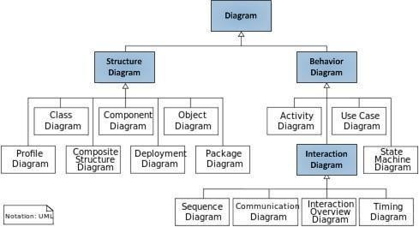

Structure Diagrams
These diagrams emphasize the things that must be present in the system being modeled. Since they represent the structure, they are used extensively in documenting the software architecture of software systems.
- Class Diagram
Describes the structure of a system by showing the system’s classes, their attributes, and the relationships among the classes.
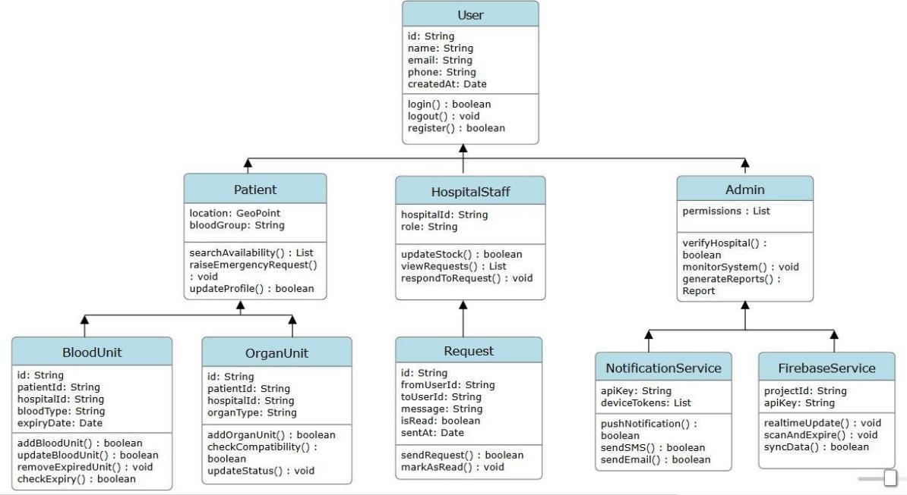

- Component Diagram
Describes how a software system is split-up into components and shows the dependencies among these components.
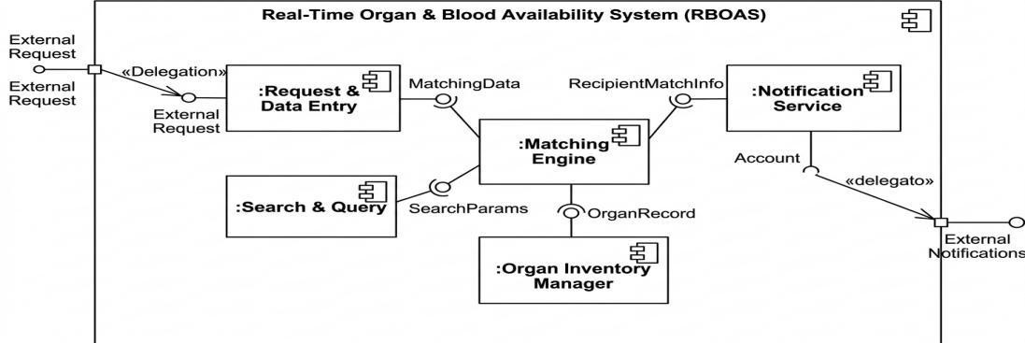

- Composite Structure Diagram
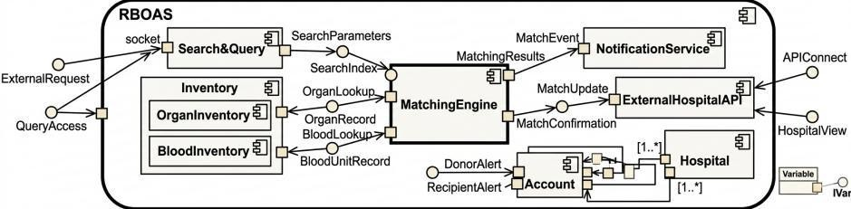
Describes the internal structure of a class and the collaborations that this structure makes possible.

- Deployment Diagram
Describes the hardware used in system implementations and the execution environments and artifacts deployed on the hardware.
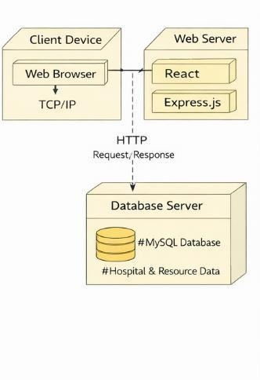
- Object Diagram
Shows a complete or partial view of the structure of an example modeled system at a specific time.
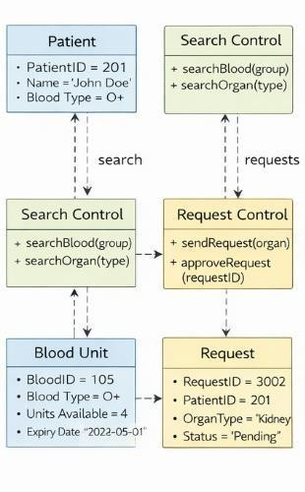

- Package Diagram
Describes how a system is split-up into logical groupings by showing the dependencies among these groupings.
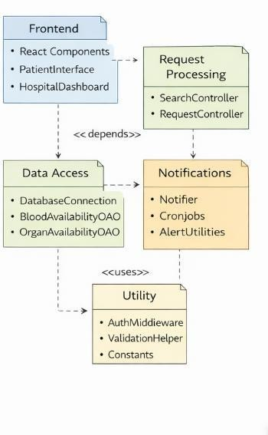
- Profile Diagram

Operates at the metamodel level to show stereotypes as classes with the <<stereotype>> stereotype, and profiles as packages with the <<profile>> stereotype. The extension relation (solid line with closed, filled arrowhead) indicates what metamodel element a given stereotype is extending.
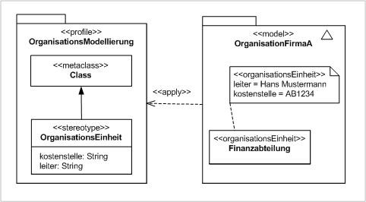

Behavior Diagrams
These diagrams emphasize what must happen in the system being modeled. Since they illustrate the behavior of a system, they are used extensively to describe the functionality of software systems.
- Activity Diagram
Describes the business and operational step-by-step workflows of components in a system. An activity diagram shows the overall flow of control.


- State Diagram
Describes the states and state transitions of the system.
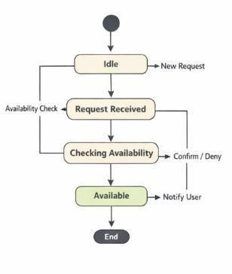
- Use Case Diagram
Describes the functionality provided by a system in terms of actors, their goals represented as use cases, and any dependencies among those use cases.

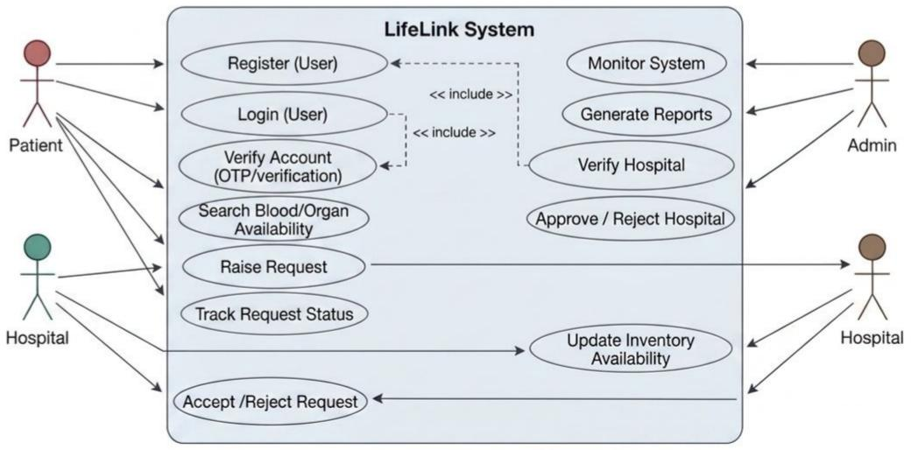

Interaction Diagrams
These diagrams are a subset of behavior diagrams, emphasizing the flow of control and data among the things in the system being modeled.
- Communication Diagram
Shows the interactions between objects or parts in terms of sequenced messages. They represent a combination of information taken from Class, Sequence, and Use Case Diagrams describing both the static structure and dynamic behavior of a system.

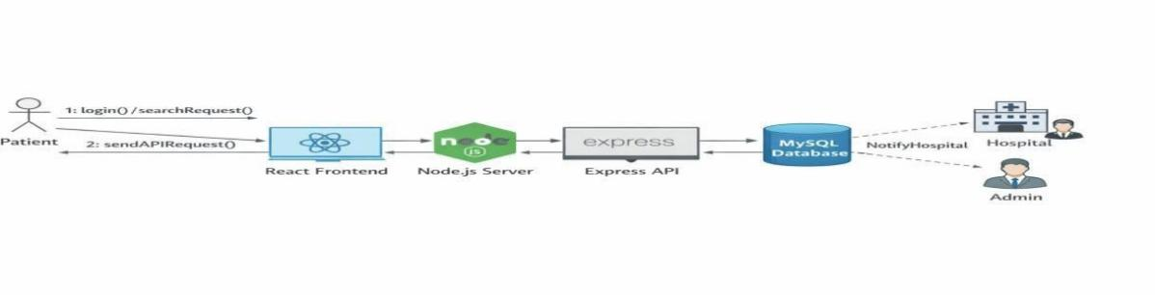

- Interaction Overview Diagram
Provides an overview in which the nodes represent communication diagrams. They are activity diagrams in which every node, instead of being an activity, is a rectangular frame containing an interaction diagram (i.e., a communication, interaction overview, sequence, or UML timing diagram).
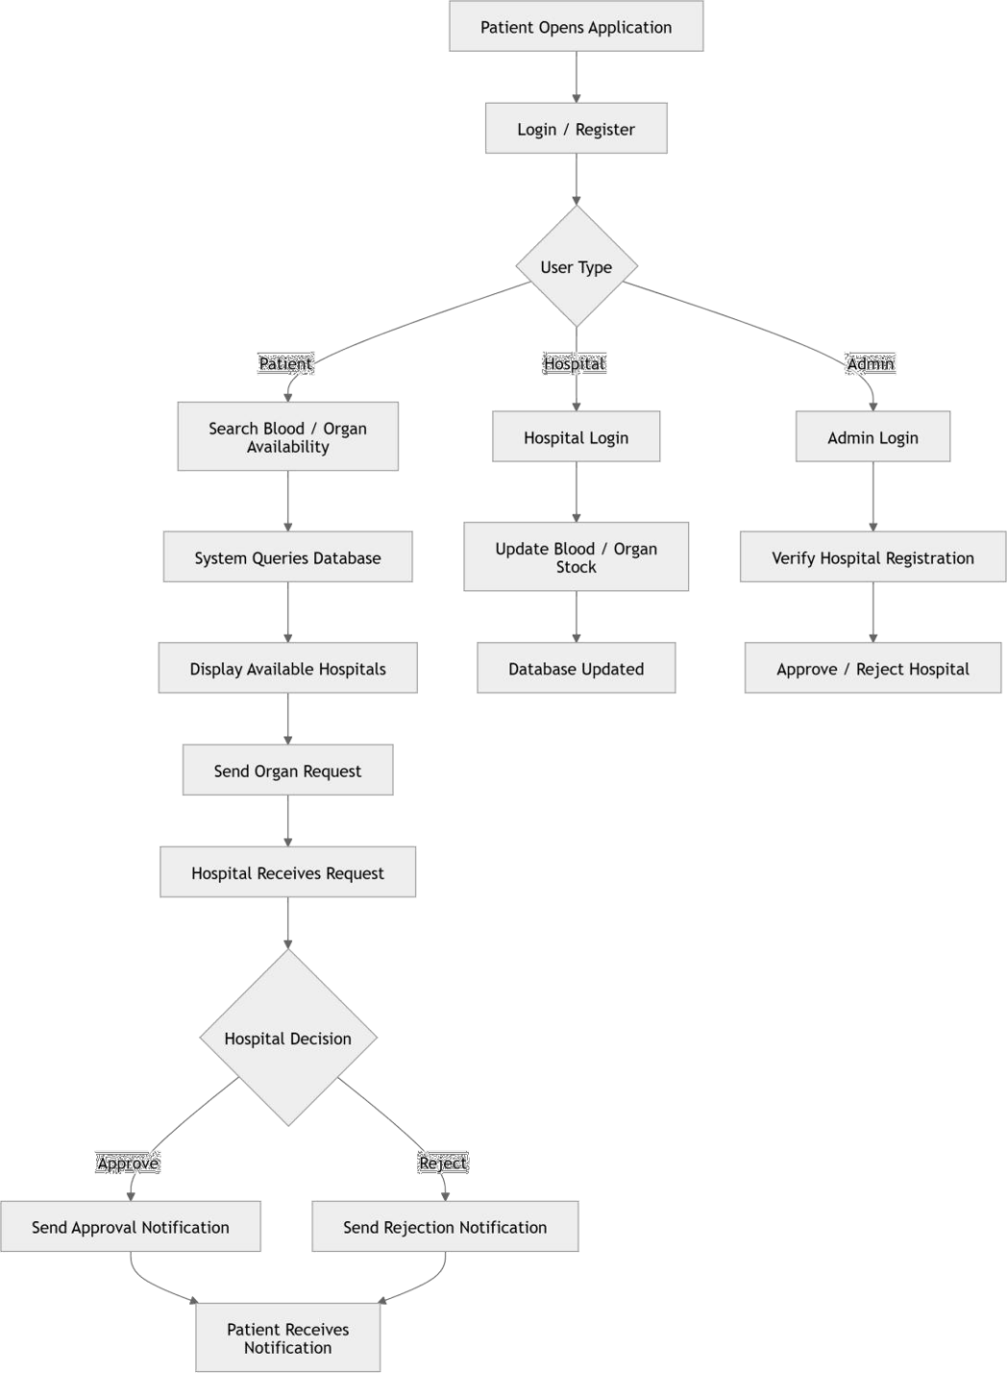

- Sequence Diagram
Shows how objects communicate with each other in terms of a sequence of messages. Also indicates the lifespans of objects relative to those messages.

- Timing Diagram
A specific type of interaction diagram where the focus is on timing constraints. Timing diagrams model sequence of events and their effects on states and property values. Time flows along a horizontal axis from left to right. They can be used to show method execution profiling or concurrency scenarios.
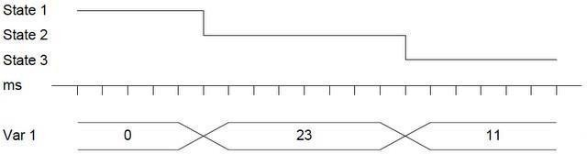

PLAGIARISM REPORT

D1

ORIGINALITY REPORT
7%
SIMILARITY INDEX

6%
INTERNET SOURCES

4%
PUBLICATIONS

0%
STUDENT PAPERS

PRIMARY SOURCES

www.jetir.org
1
Internet Source

Masood Habib, Zhelong Wang, Sen Qiu, Hongyu Zhao, Aparna S Murthy. "Machine Learning Based Healthcare System for Investigating the Association Between Depression and Quality of Life", IEEE Journal of Biomedical and Health Informatics, 2022
2
Publication

www.cse.griet.ac.in
3
Internet Source

www.researchgate.net
4
Internet Source

docplayer.gr
5
Internet Source

fr.coursera.org
6
Internet Source

github.com
7
Internet Source
1%
1%

1%
1%
<1%
<1%
<1%

pdfcoffee.com
8
Internet Source

www.coursehero.com
9
Internet Source

10 Sonia Díaz-Santos, Daniel Escanez-Exposito. "Classical vs. Quantum Machine Learning for
Breast Cancer Detection", 2023 19th International Conference on the Design of Reliable Communication Networks (DRCN), 2023
Publication

www.kdnuggets.com
11
Internet Source

12 He Yongbao. "A method of pattern recognition based upon synthetic technology
of fuzzy logic and neural network", Proceedings of TENCON 93 IEEE Region 10 International Conference on Computers Communications and Automation TENCON- 93, 1993
Publication

morioh.com
13
Internet Source

www.tutorialspoint.com
14
Internet Source
<1%
<1%
<1%

<1%
<1%

<1%
<1%

15 mafiadoc.com 96

Internet Source

www.ijiemr.org
16
Internet Source

www.softwaretestingclass.com
17
Internet Source

18 Francesca Lazzeri. "Machine Learning for Time Series Forecasting with Python®", Wiley,
2020
Publication

builtin.com
19
Internet Source

www.linuxlinks.com
20
Internet Source

towardsdatascience.com
21
Internet Source

analyticsindiamag.com
22
Internet Source

apessay.elementfx.com
23
Internet Source

24 cdck-file-uploads-global.s3.dualstack.us-west- 2.amazonaws.com
Internet Source

web.archive.org
25
Internet Source
<1%
<1%
<1%
<1%

<1%
<1%
<1%
<1%
<1%
<1%

<1%


www.geeksforgeeks.org
Internet Source

Avner Engel. "Verification, Validation, and Testing of Engineered Systems", Wiley, 2010
Publication

www.lambdatest.com
Internet Source

www.mdpi.com
Internet Source

Elissaios Sarmas, Panos Xidonas, Haris Doukas. "Multicriteria Portfolio Construction
with Python", Springer Science and Business Media LLC, 2020
Publication

Shibata, S.. "Nephritogenoside, the receptor glycoprotein for concanavalin a in rat
glomerular basement membrane", BBA - General Subjects, 19771025
Publication

ebin.pub
Internet Source

idoc.pub
Internet Source

ilsalottodellamoda.it
Internet Source
<1%
<1%

<1%
<1%
<1%

<1%

<1%
<1%
<1%

vocal.media
35
Internet Source
<1%

Exclude quotes Off Exclude bibliography On
Exclude matches Off

PAPER PUBLICATION

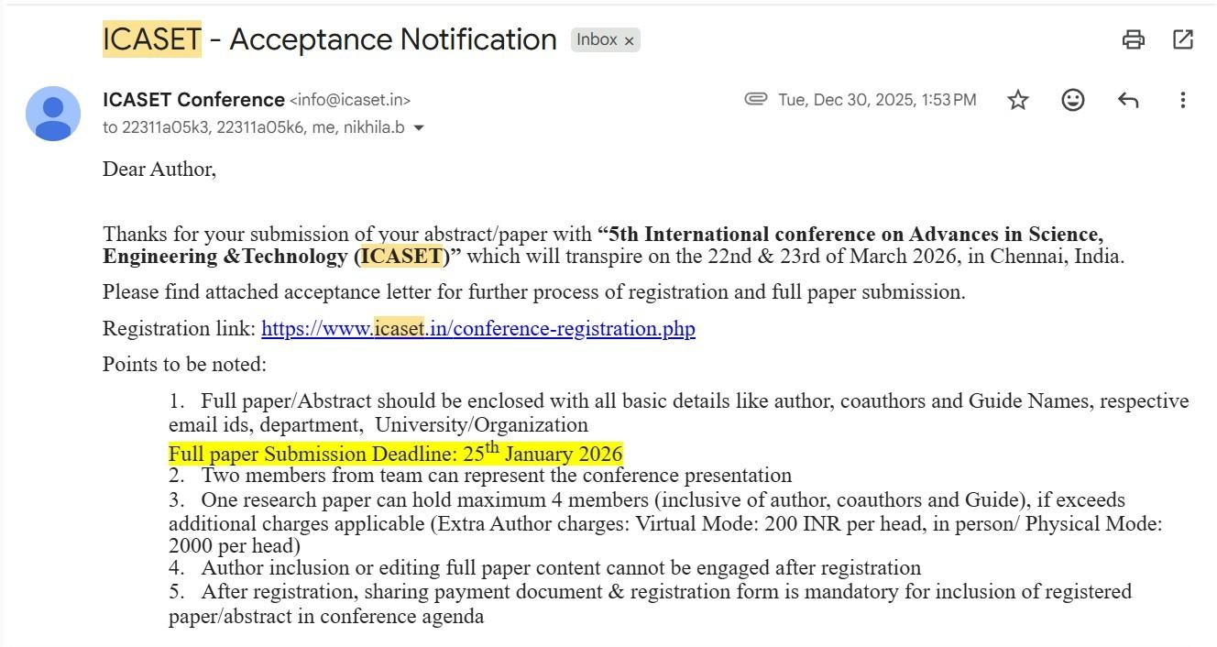

Transplant Track: A Life Link for Real-Time Organ and Blood Availability Intelligence Monitoring System

1S. Nikhil, ²A. Venu Gopal Reddy, ³P. Manas, ⁴B. Nikhila
1Dept of CSE, UG Student, Sreenidhi Institute of Science and Technology, Hyderabad. 2Dept of CSE, UG Student, Sreenidhi Institute of Science and Technology, Hyderabad. 3Dept of CSE, UG Student, Sreenidhi Institute of Science and Technology, Hyderabad. 4Asst.Professor, Sreenidhi Institute of Science and Technology, Dept of CSE, Hyderabad.
¹22311A05K0@cse.sreenidhi.edu.in, ²22311A05K3@cse.sreenidhi.edu.in,
322311A05K6@cse.sreenidhi.edu.in, ⁴ nikhila.b@sreenidhi.edu.in

ABSTRACT
The Speed is a necessity in emergency cases, but patients and family members tend to waste so much time trying to find hospitals in which they can get the necessary blood units or transplant organs. This can be life threatening given that critical situations can be transformed into life threatening situations by this delay that is brought about by fragmented and unreliable systems. We propose to solve this problem by introducing Life Link, a Real-Time Organ & Blood Availability System, which will serve the purpose of filling the gap that exists between the hospitals and the patients to provide them with timely and trusted information when it is required the most. Under this system, hospitals can safely replenish their existing stock of necessary materials like blood, kidney, liver and corneas and an authorizer verifies every hospital to have authenticity and reliability. Within seconds, patients and relatives can check availability, check only certified hospitals and place the most pressing requests.
Keywords: AI Life Link, Hospitals, Blood, Organs, Transplant, Health Care, Availability, Verification, Real-time Tracking.

INTRODUCTION
The necessity in efficient and transparent organ and blood managing system has grown in the last years with the number of medical accidents and lack of resources in time. The classical way of finding available organs or blood units tend to be slow, manual and relies on the phone communication between hospitals and blood banks. Such delay may cause essential time loss that will affect the survival of patients. Therefore, it is essential to develop a digital and real-time application that will allow The Real-
Time Organ & Blood Availability System suggested will be the means of automatizing and simplifying the blood and organ availability tracking with the help of cloud- based technologies. The system will combine in a single platform the patients, hospitals, and administrators, and the updates will be delivered in real-time using Firebase Firestore. The hospitals are able to refresh the current stock of blood and organs and the patients can search and order immediately depending on the medical demands. This minimizes mistakes in the manual, eradicates time wastages, and makes crucial medical materials readily available.

BACKGROUND AND PURPOSE
The Organ and blood shortage is still a major issue to the health care system across the world. A lot of patients die because of unavailability of compatible donors or delay at communicating between hospitals and blood banks. Old systems are also characterized by over dependence on manual coordination hence not being efficient and lack of transparency. It is highly demanded that a centralized platform is developed where availability is accessed in real-time.
The latest discovery in cloud computing and real time database has made automation of healthcare more efficient and scalable. Firebase Firestore and cloud functions are some of the technologies that enable the real-time synchronization of data between the user and hospitals. Utilization of these tools is a sure way of making patients aware of any changes regarding the availability of

organs and blood in real time. In such a way, an efficient healthcare management system is based on real time communication.
The Real-Time Organ & Blood Availability System does not only improve medical communication but also assists with decision- making with the help of analytics. This level of accuracy and reliability in the data is achieved by the tracking of hospital data, expiry dates and also by user activity, which is monitored by the admin module. The entire structure develops a digital ecosystem that links healthcare service providers and patients effectively. It shows the way in which the cloud-based technology can alter both access to healthcare and emergency response.
This project is mainly created with the aim of producing a cloud-based, real-time-based application which will enable patients to search information about available blood and organs in real-time. It is intended to remove delays in the manuals and enhance the emergency response time. The system allows hospitals, patients, and administrators to be connected digitally and therefore provides the accurate and up-to-date information in a case of an emergency in the medical situation.
The other aim of the system is to ensure transparency and accountability in the management of the medical resources. The data of the stock in hospitals can be updated and the system will keep track of the expiry dates automatically through the cloud functions. Patients will be able to make emergency requests, and all activities will be controlled by the administrators using analytics dashboards. This gives total control and easy coordination among all the stakeholders.
The project is also meant to minimize human reliance in the operation of healthcare logistics. The platform reduces the occurrence of errors and enhances the accuracy of data through automation and real-time synchronization. It has Firebase Firestore, which allows updating devices in real-time, which gives users immediate feedback and notifications. The outcome can be a smooth technological based solution to medical emergencies.
In general, the Real-Time Organ and Blood Availability System is associated with the modernization of healthcare services.

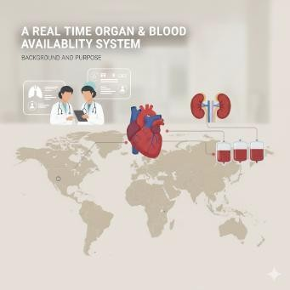
Fig1: Real Time organ & Blood Availability System
It can not only simplify communication but also feeds management with facts. The project is a scaled down version that can be replicated in the healthcare systems of a country. It has the final aim of making sure that no patient dies simply because they do not access the blood or organs on time.

METHODOLOGY
The research methodology is aimed at designing and developing a cloud-based real-time system that is useful in the management of blood and organs availability in various hospitals. The system suggested is designed in such a way that it will incorporate the patients, hospitals, and administrative authorities into a single digital network. It makes sure that there are no manual delays in the processing of availability, requests and responses of the blood and organ donations. It is all automated by real-time database synchronization so that as the information changes; it is immediately reflected on all the users associated with it. In this section, the step-by-step methodology to be applied during the design, the tools, datasets, and models to be applied during this research to attain a scalable and efficient healthcare solution are described.

SYSTEM ARCHITECTURE
This system architecture is three-tier and modular, with three modules; patient, hospital, and the admin module. Each of the modules has a specific function, but is constantly connected with each other via a centralized Firebase Firestore database. The patient module will allow registration, availability search, and emergency requests. The hospital module enables the authorized

personnel to log in, update inventory and address the needs of patients. The admin module is used to guarantee the integrity of the system by checking and verifying hospitals, tracking the activities and producing analytical reports. Interaction between these modules is managed on the basis of real-time event triggers and cloud functions that facilitate automatic tracking and notification.
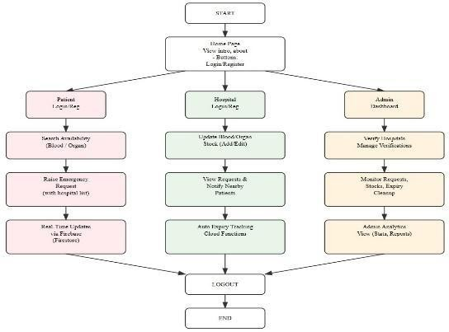

Fig2: System Architecture

Tools and Technologies Used
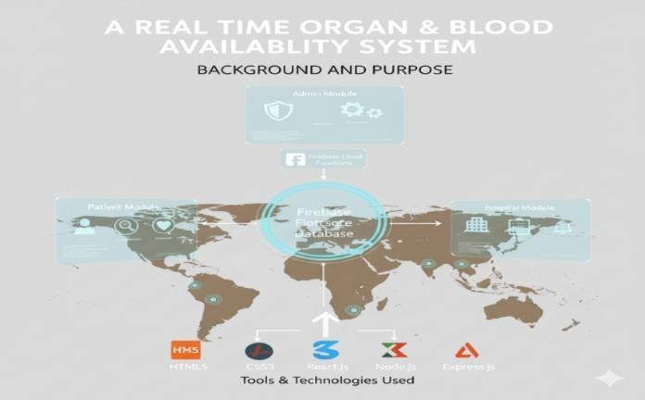
Fig3: Background & Purpose
The technological base of the given project is largely based on recent web and cloud-based applications that guarantee scalability and real- time synchronization. The interface is developed with HTML5, CSS3 and JavaScript and combined with React.js that makes the user interface responsive and interactive. The backend is based on Node.js and Express.js, which serves to handle requests, route and communicate with the API. Firebase is used as
hosting platform and real-time database that offers inbuilt authentication and cloud support. Firebase Firestore makes the synchronization of records in real time, whereas firebase Hosting makes the web application accessible worldwide with low latency. This integration of technologies improves the work of the system, as well as its stability.

Patient Module
It will have the patient module which will give the user an easy and quick interface to search and order blood or organs in the case of an emergency. After a patient makes a registration or logs in, he or she is immediately capable of accessing the availability of medical resources they need. Module provides direct communication with Firestore to access the real-time information about the hospital inventory. The patients will be able to issue an emergency request that will result in a notification to the local hospitals with the appropriate information like the type of blood that is needed or organ demands. With the implementation of Firebase Firestore, all the data is updated immediately, and the patient will have the access to the correct and up-to-date information without having to refresh it manually. This module is mostly concerned with accessibility and speedy response in emergency health circumstances.

Hospital Module
The hospital module is the heart of the system that manages the update of the data, stock management, and communication with the patients. Hospital authorized personnel may log in and control their inventories by adding, editing, or deleting the available blood or organs information. With a change in the stock levels, the updates are immediately reflected to the Firestore database and reflect in real-time on patient interfaces.
The notifications about the new availability posted or changes made to the existing stock are sent to the corresponding users with the help of cloud functions. Furthermore, the hospitals will be able to view the pending

requests and respond to them directly on the same platform.

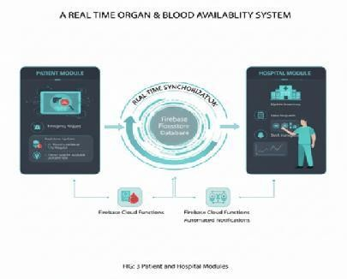
Fig4: Patient & Hospital Module

Admin Module
The platform has the admin module as a supervisory control system, which provides trust, security and consistency of the system. To address unauthorized use of network, the admin ensures that the hospital credentials are verified before one is granted access to the network. The administrators can use the dashboard to keep track of the active requests and to track the stock movement, as well as identify expired inventory and clean it up. Admins have an opportunity to examine the data of systems to obtain visual reports and insights regarding activities in the hospital, frequency of requests, and fulfilling rate. This is completely automated so that old or invalid records are automatically eliminated in the database. This high-level supervision keeps the data and operational transparency during the platform.

Dataset and Data Management
The dataset for this project is compiled from real organ transplant and blood donation inventory sources, including SRTR summaries, Kaggle blood bank datasets, and WHO/NOTTO donation statistics, resulting in nearly ten thousand cleaned records. Each entry contains realistic hospital inventory attributes such as hospital ID, organ type, blood group, compatibility status, storage or expiry date, availability state, donor category, and timestamped updates. The raw data was preprocessed through automated cleaning scripts to fix inconsistencies, handle missing values, and eliminate duplicates. Firestore’s indexing ensures fast querying across multiple fields including organ type, blood group,
location, and compatibility. Cloud Functions further automate data maintenance, expiry handling, and backup generation to ensure reliability and integrity of the dataset.

Data Flow and Communication
The system uses a real-time, event-driven communication model that keeps hospitals, patients, and administrators instantly synchronized. Any update to organ or blood availability is immediately pushed to all users through Firestore’s live update mechanism, while patient emergency requests are delivered to hospitals with minimal delay using Firebase real-time messaging. Web Socket-based channels enable continuous data streaming without page reloads, reducing latency and keeping average transaction response times below one second. This architecture ensures that changes in organ availability, compatibility updates, and urgent alerts are broadcast instantly, providing accurate and up-to-date information across all modules and maintaining seamless operational coordination throughout the platform.

Data Extraction Process
The Filtering and indexing play a major role in speeding up data retrieval. The system processes only the essential attributes including organ name, blood group, compatibility status, hospital location, and availability—which significantly reduces query overhead. Firestore’s optimized multi-field indexing allows efficient searches based on multiple parameters simultaneously. For example, a patient searching for AB- blood in Bengaluru receives relevant filtered records in under one second due to optimized compound indexing.
The extraction pipeline also incorporates data validation checks, preventing conflicting or redundant entries. Every transaction adding a new organ, updating blood stock, or marking an organ as allocated is validated and timestamped through Cloud Functions. Real-time synchronization ensures that all modules reflect identical records, preventing mismatches or stale data across the system.

By automating extraction, validation, and synchronization, the system maintains high accuracy and reliability in the flow of medical inventory information. This automation eliminates manual errors, improves scalability, and enhances the quality of communication between patients, hospitals, and administrators.

IMPLEMENTATION
The model execution incorporates real-time analytics and automation of data, which is streamlined on the cloud to streamline healthcare. Firebase Cloud Messaging uses a notification model that informs the users about stock changes, approvals, and updates on requests. The expiry-tracking model is automated and will automatically detect the old records and delete them based on scheduled cloud triggers to ensure that the invalid data will not get access to that data. An indexed query search model enables the patients to narrow down to the type of blood or organs to be offered to them based on where it is and in what hospital. The hospital verification model means that the system only allows authenticated institutions to join and this helps in strengthening data security and credibility. A combination of these models provides a strong and completely automated medical coordination ecosystem.
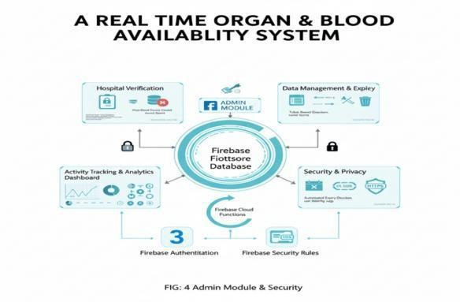
Fig5: Admin Module & Security

Security and Privacy measures
Healthcare data is sensitive in the way it is managed and security as well as privacy are paramount in the system as strict measures are adhered to in all levels. Firebase Authentication is used to verify the user by use of email-based or OTP-based registration. Role-based access control will limit access to data after the type of user and sensitive hospital information is not accessed by unauthorized personnel. The system of communication on the network is
encrypted by standards of HTTPS and SSL. The access control rules of Firestore only allow unauthorized access to the collections by reading or writing. In addition, user sessions are token-based which automatically expire upon inactivity reducing security risks. All these security provisions ensure that the platform adheres to the data protection guidelines and at the same time offers flawless functionality.

Key Findings of Methodology
The approach adopted by this study shows the efficiency of applying the integration of cloud computing and real-time databases in the management of healthcare resources. By using the Firebase Firestore, Cloud Functions, and a modular architecture, the system is highly performance, scalable, and automated. The patient, hospital, and admin modules will be present making coordination and transparency across all operations smooth. The system is improved with automated expiry notification, live notification, and automatic data synchronization, which improves its reliability. In general, the methodology offers a sustainable and technologically enhanced system of enhancing the supply of organs and blood in life-threatening situations.
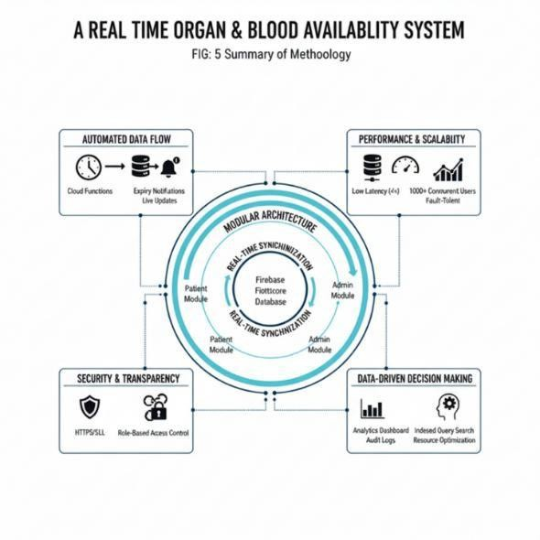
Fig6: Key Findings of Methodology

DISCUSSIONS
The suggested Real-Time Organ and Blood Availability System illustrates the way the cloud-based technology can transform the logistics of healthcare and the management of emergency resources. The system makes patients, hospitals, and administrators one

and the same digital system to provide real-time transparency and immediate availability of essential information. Its modular structure makes it easy to synchronize data with Firebase Fire store and cloud functions will run background processes like expiry clean up and notification delivery. The design of the project is a well-balanced plan considering simplicity to the end-users and strength to a large-scale hospital user queries.
The system was also meant to deal with real time data effectively besides reducing human interdependence in the decision-making process. The proposed solution is dynamic in updating data, automatic response processing, and validation of the data unlike the current hospital databases. Firebase cloud technology together with role-based access control ensures high level of data security and reliability in operations. It will lead to a smooth automated healthcare communication network that can greatly eliminate any delays and errors in life- threatening cases.

Performance Evaluation
In the course of testing, the system was tested with varying workloads to time the speed, accuracy and stability of the system. It had over one thousand users at the same time and the cloud infrastructure worked efficiently without any loss of data or latency. Real-time notifications worked very well, and the alerts were sent to the concerned hospitals and patients with a minimum time delay. The expiry tracking that was automated was able to eliminate the outdated records and provide a clean dataset with no error. In total, the accuracy rate of the platform was more than ninety-eight percent

RESULTS
The suggested system effectively proved the real-time synchronization and instant reaction to the changes in the blood and organs availability. Firebase Firestore was integrated, which enabled all the modules, such as patients, hospitals, and administrators, to retrieve the most up-to-date information in milliseconds. The time of responding to emergency requests was registered to be less than one second, which is much quicker compared to the conventional hospital coordination processes. There was a high level of consistency and reliability within
the entire system in the case of multi-user interactions and this proved its scalability and applicability in the real world.
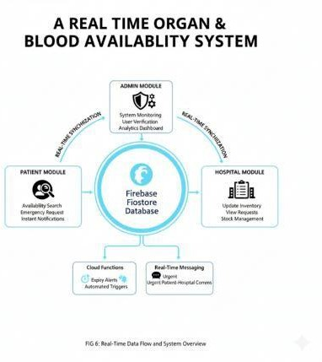
Fig7: Data flow System Overview
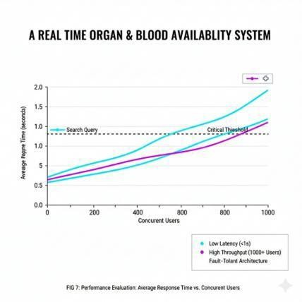
Fig8: Average Response vs Concurrent Users

Comparative Advancement compared with the current systems.

Feature | Traditio nal | Proposed System | Advance ment
Data Managem ent | Manual records or slow, localized database s | Cloud- Based & Decardinal ized | Real-time updates and accessibilit y from any  any location
Data Redundan cy | High risk of duplicate or inconsist ent data across different  locations | Eradicated | Decentrali zed desires a single source of original,  in-time data
System Speed | High risk of duplicate or envious locations | High Efficiency | Faster data processing in operations

Emergenc y Resting | Manual or delayed tracking of expiry  stock levels. | Automate d Tracking | Auto- expiry tracking prevents wastage and loss
Emergenc y Response | Slower response due manual checks and data  lag | Automate d Effications | Guarantees quicker response to emergency needs
Transpare ncy | Limited visibility into the  resource status | Instant non- transparen cy | All authorized user access  to updated data
Table1: Comparison of traditional and proposed system
The proposed system offers great efficiency, automation, and transparency compared to the traditional hospital management system and the currently existing blood bank databases. The earlier systems were either manual or slow to synchronize the database and this project provides real time updates cloud based. Auto- expiry tracking and instant notifications guarantee none of it will be wasted and the quicker reaction to an emergency. Moreover, the decentralized cloud-computerized design eradicates the redundancy of data, and therefore any user has access to original and in-time data at all times.
The general findings prove the idea that the Real-Time Organ & Blood Availability System can be successfully used to close the gap between the patients and health care providers. Responsiveness in the project is complemented by real-time capabilities, whereas the automation of the key background processes is achieved through the integration of cloud functions. Dashboards of visualization give administrators more intelligent resource control and automated alerts eliminate manual reliance.
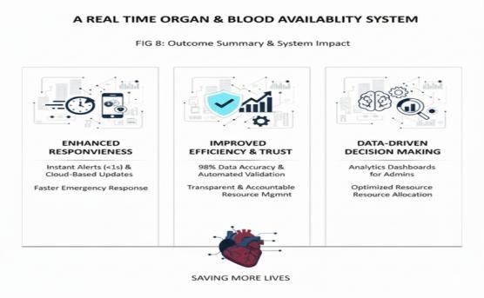
Fig9: Outcome Summary

CONCLUSION
The suggested Real-Time Organ & Blood Availability System is effective in obtaining the severe lag times in the availability of medical resources. It also offers a cloud- based platform that provides faster coordination between the hospitals, patients, and administrators because it gives them a single platform. The system shows how real-time data synchronization can help to save lives under emergency medical conditions. Firebase Fire store was introduced to allow automatic updates on the data. The expiry tracking and automated notification system removed the possibility of outdated information and data reliability was achieved. The development forms a powerful basis of intelligent and open health care communication.

FUTURE SCOPE
The given system can be improved further by incorporating the artificial intelligence to forecast the demand of blood and organs according to the health rates in the region and past data. Machine learning models would be able to predict shortages in advance, which would enable hospitals to arrange inventory effectively. Also, the blockchain technology may be integrated to enhance the transparency of the data and authenticity of the donors, minimizing the chances of abuse or replication of healthcare transactions.

REFERENCES
- P. Singh and R. Verma, “Design of a Real-Time Blood Bank Management System Using Cloud Technologies,” in International Journal of Advanced Research in Computer Science, vol. 13, no. 5, pp. 112–118, 2022.
- M. Gupta, S. Chauhan, and A. Sharma, “A Real-Time Organ Donation Management System Using IoT and Cloud,” in IEEE International Conference on Computational Intelligence and Communication Technology (CICT), 2021.
- N. K. Reddy and V. Kumar, “Cloud- Based Blood and Organ Availability Tracking System for Emergency

Healthcare,” in Journal of Medical Systems, vol. 46, no. 9, pp. 1–9, 2022.
- A. Banerjee and S. Patra, “Integration of Real-Time Database and Notification Framework Using Firebase for Medical Applications,” in International Journal of Computer Applications, vol. 183, no. 20, pp. 22–29, 2021.
- R. S. Pillai and D. Thomas, “Automation of Blood Inventory Management Using Real-Time Data Analytics,” in International Conference on Smart Computing and Communication (ICSCC), IEEE, 2023.
- K. Jaiswal and P. S. Rao, “A Smart Healthcare System for Organ Availability Using Cloud Firestore and Machine Learning,” in International Journal of Emerging Technologies in Engineering Research (IJETER), vol. 10, no. 3, pp. 64–71, 2022.
- S. Ali and H. Ahmed, “Development of a Web-Based Real-Time Blood Donation and Request Platform,” in IEEE Access, vol. 9, pp. 127845–127853, 2021.
- R. Das and B. Mehta, “Enhancing Hospital Communication Through Real-Time Cloud Synchronization,” in International Conference on Cloud Computing and Big Data Analysis (ICCCBDA), IEEE, 2022.
- T. Khan and J. Fernandes, “Design and Implementation of an Intelligent Blood and Organ Donor Matching System,” in International Journal of Healthcare Information Systems and Informatics, vol. 18, no. 2, pp. 45–58, 2023.

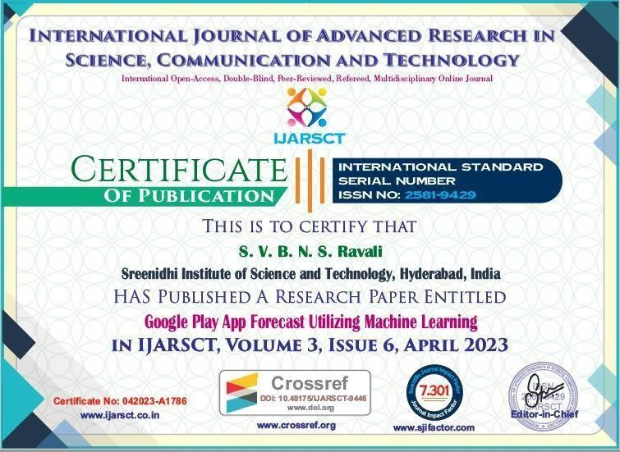

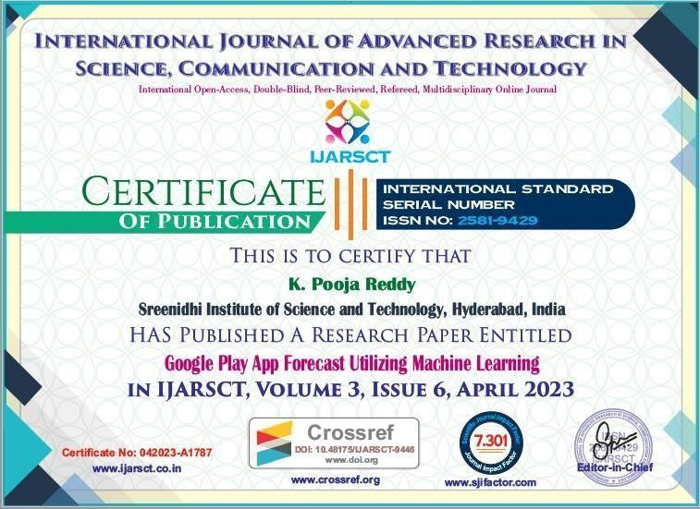

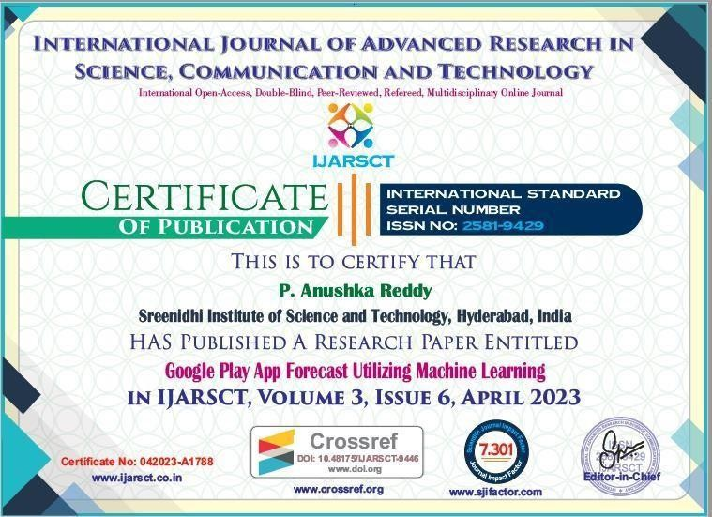

ABSTRACT

Sreenidhi Institute of Science and Technology Department of Computer Science and Engineering

MAJOR PROJECT (8E896)
Batch No: D18 |  | Title of the Project
Roll No | Name
22311A05K0 | S. NIKHIL | Transplant Track: A Life Link for Real-Time Organ and Blood Availability Intelligence Monitoring System
22311A05K3 | A. VENU GOPAL  REDDY
22311A05K6 | P. MANAS KUMAR

ABSTRACT
Future healthcare reforms are being influenced by new technological developments. Finding the elements that contribute to depression may inspire fresh research and therapeutic approaches. Because depression is an illness that is increasingly posing a major community health threat. In order to handle and study the heterogeneous data and better understand the correlation between aspects of quality of life and depression, this paper uses machine learning techniques. The experimental investigation is then primarily split into two components. The consolidation strategy provided a foundation for the development and verification of the research idea. To further confirm the effectiveness of the posterior probability multi-class Support Vector Machine, the classification problems were selected from the clustered data and solved by the Self organising map, which also offered eight cluster solutions. The importance sampling's expectations led to the development of depressive-causing elements. The suggested model was used to enhance classification performance, and the results indicated 91.16% accuracy.

Batch No:D18 |  | Title of the Project
Roll No | Name
22311A05K0 | S. NIKHIL | Transplant Track: A Life Link for Real-Time Organ and Blood Availability Intelligence Monitoring System
22311A05K3 | A. VENU GOPAL REDDY
22311A05K6 | P. MANAS KUMAR

H | High | M | Moderate | L | Low

SREENIDHI INSTITUTE OF SCIENCE AND TECHNOLOGY DEPARTMENT OF COMPUTER SCIENCE AND ENGINEERING
Project Correlation with POs/PSOs
PO1 |   PO2 | PO3 | PO4 | PO5 | PO6 | PO7 | PO8 | PO9 | PO10 | PO11 | PO12 | PSO1 | PSO2 | PSO3
M | H | M | H | H | H | M | M | H | M | M | H | H | H | M

Table 1: Project correlation with appropriate POs/PSOs (Please specify level of Correlation, H/M/L against POs/PSOs)

Batch No:D18 |  | Title of the Project
Roll No | Name
22311A05K0 | S. NIKHIL | Transplant Track: A Life Link for Real-Time Organ and Blood Availability Intelligence Monitoring System
22311A05K3 | A. VENU GOPAL REDDY
22311A05K6 | P. MANAS KUMAR

Batch No. | Title | Nature of the Project
 |  | Product | Application | Research
D18 | Transplant Track: A Life  Link for Real-Time Organ and Blood Availability Intelligence Monitoring System |  | √
Table 2: Nature of the Project (Please tick √ Appropriate for your project)
Batch No:D18 |  | Title of the Project
Roll No | Name
22311A05K0 | S. NIKHIL | Transplant Track: A Life Link for Real-Time Organ and Blood Availability Intelligence Monitoring System
22311A05K3 | A. VENU GOPAL REDDY
22311A05K6 | P. MANAS KUMAR

Batch No. | Title of the Project | Domain of the Project
 |  | ARTIFICIAL INTELLIGENC E, MACHINE LEARNING AND DEEP LEARNING | COMPUTER NETWORKS, INFORMATION SECURITY, CYBER SECURITY | DATA WAREHOUSI NG, DATA MINING, BIG DATA ANALYTICS | CLOUD COMPUTING, INTERNET OF THINGS | SOFTWARE ENGINEERING, IMAGE PROCESSING
D18 | Transplant Track: A Life Link for Real-Time Organ and Blood Availability Intelligence Monitoring  System | √
Table 3: Domain of the Project (Please tick √ Appropriate for your project)

S. Nikhil | Internal Guide | HOD CSE
A. Venu Gopal Reddy | Mrs. B Nikhila | Dr. K Shirisha
P. Manas Kumar | Assistant Professor | Professor

