A Major Project Report

on

WEB-BASED HOSPITAL MANAGEMENT SYSTEM: A DJANGO-POWERED
PLATFORM FOR MODERN HEALTHCARE ADMINISTRATION

Submitted in partial fulfillment of the requirement for
the award of degree of

BACHELOR OF TECHNOLOGY
in
COMPUTER SCIENCE & ENGINEERING 2022–2026

Submitted By

Name | Roll Number
M. Hari Murari | 23315A0527
R. Rohini | 22311A05W3
R. Vikitha | 22311A05U5

Under the Guidance of
Ch. Lavanya
Assistant Professor

Department of Computer Science & Engineering

SREENIDHI INSTITUTE OF SCIENCE AND TECHNOLOGY
(AUTONOMOUS)
Yamnampet (V), Ghatkesar (M), Hyderabad – 501301, T.S.
AY 2025–2026

Sreenidhi Institute of Science and Technology
Department of Computer Science and Engineering

CERTIFICATE

This is to certify that this Major Project report on "Web-Based Hospital Management System: A Django-Powered Platform for Modern Healthcare Administration", submitted by M. Hari Murari (23315A0527), R. Rohini (22311A05W3), and R. Vikitha (22311A05U5) in the year 2026, in partial fulfillment of the academic requirements of Jawaharlal Nehru Technological University for the award of the degree of Bachelor of Technology in Computer Science and Engineering, is a bonafide work carried out by them as part of their Major Project during Fourth Year Second Semester, under our guidance. This report has not been submitted to any other institute or university for the award of any degree.

Internal Guide  Ch. Lavanya  Assistant Professor  Department of CSE | Project Coordinator  Mr. P Ramu  Assistant Professor  Department of CSE | Head of the Department  Dr. K Shirisha  Professor & HOD  Department of CSE

Signature of the External Examiner

Date: _______________

DECLARATION

We, M. Hari Murari (23315A0527), R. Rohini (22311A05W3), and R. Vikitha (22311A05U5), students of Sreenidhi Institute of Science and Technology, Yamnampet, Ghatkesar, studying in the IV Year II Semester, Computer Science and Engineering, solemnly declare that the Major Project work titled "Web-Based Hospital Management System: A Django-Powered Platform for Modern Healthcare Administration" is submitted to Sreenidhi Institute of Science and Technology for partial fulfillment of the award of the degree of Bachelor of Technology in Computer Science and Engineering.

It is declared, to the best of our knowledge, that the work reported herein does not form part of any dissertation submitted to any other university or institute for the award of any degree.

M. Hari Murari 23315A0527
R. Rohini 22311A05W3
R. Vikitha 22311A05U5

ACKNOWLEDGEMENT

We take this opportunity to express our sincere gratitude to all those who supported and guided us throughout the completion of this project.
We are deeply thankful to our internal guide Ch. Lavanya, Assistant Professor, Department of Computer Science and Engineering, for her constant technical guidance, encouragement, and timely support in carrying out this Major Project.
We sincerely thank Mr. P Ramu, Project Coordinator, for his valuable advice and coordination during the project period.
We profoundly thank Dr. K Shirisha, Head of the Department of Computer Science and Engineering, for being an excellent mentor and a constant source of inspiration throughout our academic journey.
We also wish to thank our Principal, Dr. T. Ch. Siva Reddy, for running the institution with great dedication and providing us with the necessary infrastructure and opportunities to carry out this project.
Finally, we are grateful to our parents and family members for their unwavering support and encouragement throughout our academic pursuit.

M. Hari Murari 23315A0527
R. Rohini 22311A05W3
R. Vikitha 22311A05U5

ABSTRACT

The rapid digitalization of healthcare has made it essential to develop efficient and automated hospital management systems that reduce manual effort, enhance patient care, and streamline administrative tasks. This project presents a Web-Based Hospital Management System (HMS) built on the Django framework, designed to facilitate smooth and secure interactions among administrators, doctors, and patients in a structured digital environment.
The system provides multi-role functionality across three primary modules: Admin, Doctor, and Patient. Administrators can manage doctor registrations, approve patient appointments, monitor payment records, and maintain overall hospital data. Doctors are provided access to view and manage their assigned patients, issue prescriptions, and recommend medical tests. Patients can register on the platform, book appointments, upload medical reports in PDF format, view prescribed medications, make online payments, and download their medical reports.
The platform is developed using Python and Django as the backend framework, with MySQL as the relational database management system and Visual Studio Code as the development environment. Core features include role-based authentication, email notifications, automated form validations, and secure file handling. The system is lightweight, scalable, and cost-effective, making it suitable for small to mid-scale healthcare facilities.

Keywords — Hospital Management System, Django, Python, MySQL, Patient Care, Appointment Scheduling, Healthcare Automation, Web Application.

LIST OF FIGURES

S.No | Figure No. | Title of Figure | Page No.
1 | 1 | System Architecture Diagram | 41
2 | 2 | Data Flow Diagram | 42
3 | 3 | Class Diagram | 43
4 | 4 | Use Case Diagram | 44
5 | 5 | Sequence Diagram | 45
6 | 6 | Activity Diagram | 46
7 | 7 | Home Page | 64
8 | 8 | Admin Login Form | 64
9 | 9 | Doctor Login Form | 65
10 | 10 | Patient Login Form | 65
11 | 11 | Patient Registration Form | 66
12 | 12 | Book Appointment Form | 66
13 | 13 | Admin Dashboard | 67
14 | 14 | Doctor Details Page | 67
15 | 15 | Doctor Home Page | 68
16 | 16 | Patient Information Page | 68
17 | 17 | Medication Page | 69
18 | 18 | Reports Page and PDF Download | 69

LIST OF TABLES

S.No | Table No. | Title of Table | Page No.
1 | 1 | Test Cases | 74

INDEX

CONTENTS | Page No.
List of Figures | i
List of Tables | ii
1. INTRODUCTION
1.1 Project Introduction | 2
1.2 Scope | 3
1.3 Project Overview | 5
1.4 Objectives | 6
2. LITERATURE SURVEY
2.1 Existing System | 9
2.1.1 Disadvantages of Existing System | 10
2.2 Proposed System | 12
2.2.1 Advantages of Proposed System | 13
3. SYSTEM ANALYSIS
3.1 Functional Requirements | 16
3.1.1 Data Collection | 17
3.1.2 Data Preprocessing | 18
3.1.3 Training and Testing | 20
3.1.4 Modelling | 22
3.1.5 Predicting | 25
3.2 Performance Requirements | 26
3.3 Software Requirements | 26
3.3.1 Python | 27
3.3.2 Django Framework | 28
3.3.3 MySQL | 29
3.3.4 Visual Studio Code | 30
3.4 Hardware Requirements
3.4.1 Processor | 34
3.4.2 RAM | 35
3.4.3 Hard Disk Space | 35
3.4.4 Internet Connectivity | 36
3.5 Feasibility Study
3.5.1 Economic Feasibility | 37
3.5.2 Technical Feasibility | 37
3.5.3 Social Feasibility | 38
4. SYSTEM DESIGN
4.1 System Architecture | 41
4.2 Data Flow Diagrams | 42
4.3 UML Diagrams | 42
4.3.1 Class Diagram | 43
4.3.2 Use Case Diagram | 44
4.3.3 Sequence Diagram | 45
4.3.4 Activity Diagram | 46
4.4 Modules
4.4.1 Admin Module | 47
4.4.2 Doctor Module | 48
4.4.3 Patient Module | 49
4.4.4 Authorization Module | 49
4.4.5 Notification Module | 50
5. IMPLEMENTATION AND RESULTS
5.1 Language / Technology Used | 54
5.1.1 Advantages of Python | 55
5.1.2 Advantages of Django | 56
5.1.3 Advantages of MySQL | 57
5.1.4 Advantages of Visual Studio Code | 57
5.2 Sample Code | 59
5.3 Results / Output Screens | 64
6. TESTING
6.1 Types of Testing | 69
6.1.1 Unit Testing | 69
6.1.2 Data Flow Testing | 70
6.1.3 Integration Testing | 70
6.1.4 Big Bang Integration Testing | 71
6.1.5 User Interface Testing | 72
6.2 Test Cases | 74
7. CONCLUSION | 76
8. FUTURE SCOPE | 78
9. BIBLIOGRAPHY | 82

1. INTRODUCTION

1.1 Project Introduction
Hospitals are an indispensable part of society, providing medical care to people dealing with a wide range of health conditions arising from various factors such as environmental stress, lifestyle changes, and occupational pressures. For any hospital to function effectively, it must maintain precise and up-to-date records of both doctors and patients. Managing these records manually through paper-based systems is cumbersome, time-consuming, and prone to errors and data loss.
A Web-Based Hospital Management System (HMS) addresses these challenges by digitalizing the core operations of a hospital — from patient registration and appointment booking to prescription management and medical report generation. The system brings all the essential stakeholders, namely the administrator, the doctor, and the patient, onto a single unified digital platform, each with their own secure access and clearly defined set of operations.
This project presents a full-stack web application built using the Django framework and Python, backed by a MySQL database, and developed using Visual Studio Code. The system is designed with three clearly defined modules: the Admin module, the Doctor module, and the Patient module. Each module is equipped with role-based access control to ensure that sensitive data is accessible only by authorized users.
The Administrator oversees the entire system, managing doctor registrations, monitoring appointments, and maintaining hospital records. Doctors can view their patient lists, review uploaded medical reports, and issue prescriptions electronically. Patients can register, book appointments, upload health-related documents, receive prescriptions, and download their medical reports in PDF format.

1.2 Scope
The scope of the Web-Based Hospital Management System focuses on streamlining the three primary stakeholders in a healthcare setup: the administrator, the doctor, and the patient. From an administrative standpoint, the system enables the management of doctor profiles, patient records, appointment statuses, and payment information through a centralized dashboard.
For doctors, the scope includes the ability to log in securely, view appointments assigned to them, review uploaded patient documents, and issue medications and prescriptions through the platform. For patients, the scope encompasses online registration, booking appointments based on doctor specialization, uploading medical history documents, receiving digital prescriptions, and downloading PDF reports of their treatments.
The system supports real-time data updates, email notification features, payment tracking, and appointment confirmation. In terms of technology, the scope is limited to a web-based application using Django as the backend framework, MySQL as the database, and Python as the primary programming language.

1.3 Project Overview
The Web-Based Hospital Management System is designed as a multi-tier web application connecting administrators, doctors, and patients through a shared digital infrastructure. The admin registers doctors by providing their professional details and login credentials. An email notification is automatically sent to the doctor upon successful registration.
Patients register independently and can then log in to search for doctors by specialization, book appointments, and upload PDF reports describing their health conditions. Upon the doctor reviewing these reports and acting on them, the patient receives a downloadable PDF prescription. The admin has full oversight of the system with access to all doctor and patient records, appointment logs, and payment histories.

1.4 Objectives
The primary objective of this project is to design and develop a web-based hospital management system that automates key administrative and clinical workflows, reducing manual effort and improving overall service delivery.
- To provide a centralized platform connecting administrators, doctors, and patients in a secure role-based environment.
- To allow patients to register, book appointments online, and receive digital prescriptions without requiring multiple physical visits.
- To enable doctors to view their patient queue, review medical documents, and issue prescriptions electronically.
- To equip administrators with tools for managing doctor profiles, approving appointments, monitoring payments, and maintaining records.
- To automate email notifications for doctor registration, appointment confirmation, and prescription availability.
- To support PDF generation and download functionality for patient medication reports.
- To ensure data security through role-based authentication and form-level input validation.

2. LITERATURE SURVEY

2.1 Existing System
In most healthcare institutions, hospital operations including patient registration, appointment scheduling, doctor management, and medical record keeping are managed through traditional manual or semi-digital methods. Front desk staff maintain physical registers or isolated spreadsheets to record patient visits, doctor schedules, and billing information. This fragmented approach leads to significant inefficiencies, especially in larger hospitals handling high patient volumes.
Zhihong Liu (IEEE) discussed a hospital emergency nursing information management system covering emergency registration, pharmacy dispensing, and report printing as separate functional modules. While effective in specific domains, the system lacks an integrated multi-role platform suitable for general hospital administration.
S. Sharmila Devi and J. S. Deepica proposed a user-interactive hospital management system using web applications, highlighting the benefits of transitioning from paper-based to electronic systems and emphasizing the importance of a unified interface for managing scheduling and patient data.
Olaoye, Omotosho, and Fadipe-Joseph (2018) proposed a web-based hospital management system aimed at enhancing healthcare service delivery, outlining effective data structures and methods for managing clinical records. Despite these contributions, many existing implementations are limited in scope, focusing on single departments rather than providing an end-to-end solution.

2.1.1 Disadvantages of Existing System
- Patient and doctor records are maintained in separate, isolated databases with no interconnection, leading to redundant data entry and inconsistency.
- Manual record keeping requires a large number of administrative staff, increasing operational costs and the likelihood of human error.
- There is no centralized platform for patients to book appointments, view prescriptions, or download medical reports without physically visiting the hospital.
- Appointment scheduling through phone calls is time-consuming and prone to miscommunication, causing delays in patient care.
- Medical reports and prescriptions exist only in physical form, making them difficult to retrieve, share, or archive efficiently.
- The absence of automated notifications means that patients and doctors must rely on manual communication for updates and confirmations.

2.2 Proposed System
The proposed Web-Based Hospital Management System is designed to address all the limitations identified in existing manual and partially digital systems. It is a full-stack web application built using Python and Django, backed by a MySQL database. The system introduces a three-module architecture for Admin, Doctor, and Patient roles, each with a separate dashboard and a defined set of privileges.
The admin registers and manages doctor profiles, monitors appointments, tracks patient information, and oversees payment records from a single administrative panel. Doctors receive automated email notifications upon registration and can log in to view their daily appointments, review patient-uploaded documents, and issue digital prescriptions. Patients can register, search for doctors by specialization, book appointments, upload their medical documents, and access their complete treatment history from anywhere at any time.

2.2.1 Advantages of Proposed System
- The system eliminates redundant data storage by maintaining a centralized MySQL database accessible by all three user roles based on their permissions.
- Patients can register and book appointments from anywhere using any web browser, without the need to visit the hospital for administrative tasks.
- Doctors can review patient records, uploaded documents, and prior treatment history digitally, improving the quality and speed of clinical decision-making.
- Automated email notifications keep all parties informed about registration confirmations, appointment approvals, and prescription availability.
- The PDF download feature for medication reports reduces physical paperwork and provides patients with portable digital records.
- Role-based access control ensures that sensitive patient and doctor data is protected from unauthorized access.
- Being built on open-source technologies (Python, Django, MySQL), the system is cost-effective to develop and maintain.

3. SYSTEM ANALYSIS

3.1 Functional Requirements
Functional requirements define the specific behaviors, operations, and features that the system must support. The first fundamental requirement is user registration and authentication. The system must provide separate registration and login interfaces for patients and doctors, with admin access managed internally.
Appointment management requires patients to search for doctors by specialization, select a preferred doctor, and submit an appointment request. The admin reviews and approves or rejects appointments. The system must support medical document management, allowing patients to upload PDF health records that doctors can access from their dashboard. Prescription management requires doctors to input medication details that are stored and made available to patients as downloadable PDFs.

3.1.1 Data Collection
Data collection in the Hospital Management System occurs primarily through web-based forms developed using Django's form-handling framework. During patient registration, the system collects personal details such as full name, email address, mobile number, and login credentials. When booking an appointment, the system records the chosen doctor, department, appointment date, and a description of symptoms. Patients may also upload PDF files containing medical reports or prior health records.
For doctor registration, the admin provides the doctor's name, specialization, contact information, and login credentials. Doctors input medication details including drug names, dosage instructions, and recommended tests for each patient consultation.

3.1.2 Data Preprocessing
Before data is stored in the MySQL database, the system applies a series of validation and preprocessing steps. Input validation checks for required fields, correct email formats, valid phone number patterns, and matching password confirmations. Duplicate detection is applied at the email address level to prevent the creation of duplicate accounts.
For file uploads, the system enforces a file type restriction accepting only PDF documents. Password handling uses Django's built-in hashing mechanisms, ensuring that plain-text passwords are never stored in the database. Data consistency is maintained through standardization of all incoming inputs before persistence.

3.1.3 Training and Testing
During development, the application underwent systematic configuration, testing, and validation processes. The setup phase involved populating the MySQL database with sample data to simulate real-world usage — doctor profiles, patient records, appointment entries, and medication records were created to mirror typical hospital workflows.
API endpoints and Django views were individually tested with both valid and invalid inputs to verify form validation and error messaging. Integration between the frontend templates and backend views was verified through end-to-end scenarios such as a patient booking an appointment and a doctor immediately viewing it in their dashboard. User acceptance testing was conducted by individuals representing each of the three user roles, and feedback was used to refine the interface before final delivery.

3.1.4 Modelling
System modelling for the HMS was conducted using UML diagrams and data flow diagrams. The user role model identifies three actors: Admin, Doctor, and Patient, each with specific permissions. The data model consists of primary entities: the Doctor model, the Patient model, the Appointment model (linking patients to doctors), the Medication model (linked to appointments), and the Payment model.
The process flow model describes how data moves through the system — from a patient submitting an appointment form, through admin approval, to a doctor issuing a prescription that becomes available for patient download. The system follows a three-tier architecture comprising Presentation, Application, and Data layers.

3.1.5 Predicting
While the current version does not implement machine learning algorithms, the system includes a rule-based alerting mechanism. When a patient books an appointment and it remains unapproved beyond a defined timeframe, the admin dashboard flags the pending request. The system can also flag situations where a doctor's queue exceeds a predefined threshold, prompting redistribution of appointments. In future iterations, predictive models could forecast patient no-shows, peak consultation hours, and preventive health screenings.

3.2 Performance Requirements
The system must process form submissions, database queries, and page renders within acceptable timeframes even under moderate concurrent usage. System reliability ensures the platform remains operational without crashes or data loss during regular working hours. Scalability is addressed through the modular Django app structure. Security is maintained through session-based authentication, CSRF protection, and password hashing.

3.3 Software Requirements
The software requirements outline the tools, frameworks, and technologies necessary to develop and deploy the system. The selection was driven by the need for reliability, open-source availability, ease of integration, and suitability for a web-based healthcare application.

3.3.1 Python
Python is a high-level, interpreted, and general-purpose programming language known for its readability and extensive library ecosystem. It is the primary programming language used in this project for both backend logic and database interaction through Django's ORM. Python's clean syntax and rich standard library provide ready-to-use solutions for PDF generation, email communication, file handling, and data validation.

3.3.2 Django Framework
Django is a high-level Python web framework following the Model-View-Template (MVT) architectural pattern. It provides built-in support for user authentication, form handling, session management, URL routing, and database ORM. Django's admin interface provides a ready-to-use backend panel, and its template engine renders dynamic HTML pages based on database data. Security features such as CSRF protection, SQL injection prevention, and password hashing are built in by default.

3.3.3 MySQL
MySQL is a widely adopted open-source relational database management system used to store and manage structured data. The HMS database includes tables for doctor profiles, patient records, appointment details, medication information, and payment records. Relationships between these tables are maintained through foreign keys, ensuring referential integrity. MySQL's support for transactions ensures complex operations are completed atomically.

3.3.4 Visual Studio Code
Visual Studio Code (VS Code) is the primary development environment used for this project. It supports Python, HTML, CSS, and JavaScript through a rich extension ecosystem. The Python and Django extensions provide syntax highlighting, auto-completion, and integrated debugging. The built-in terminal allows running Django management commands, managing database migrations, and testing the server without switching between applications.

3.4 Hardware Requirements

3.4.1 Processor
The system requires an Intel Core i5 (6-core) or higher processor. During development, multiple processes run simultaneously — the Django development server, MySQL database server, and the browser-based testing environment. A multi-core processor ensures these operations can be executed concurrently without performance degradation.

3.4.2 RAM
A minimum of 32 GB RAM is recommended for the development and deployment environment. With Django, MySQL, and VS Code all running concurrently, adequate memory ensures smooth operation. For a small to mid-scale hospital deployment, 16 GB RAM would be the minimum recommended configuration.

3.4.3 Hard Disk Space
A minimum of 500 GB SSD storage is recommended. The SSD ensures faster read and write speeds for database queries and file operations. The project source code, Django environment, MySQL data files, uploaded patient documents, and generated PDF reports all require reliable and adequately sized storage.

3.4.4 Internet Connectivity
Reliable internet connectivity is required for the deployment phase, email notification services, and remote access to the application. During development, a local network connection is sufficient, but for production deployment, high-speed internet ensures fast data transfer between clients and the application server.

3.5 Feasibility Study

3.5.1 Economic Feasibility
The Hospital Management System is economically feasible because it is built entirely on open-source technologies. Python, Django, MySQL, and VS Code are all available at no licensing cost, significantly reducing the development budget. Deployment can be done on affordable cloud platforms or existing institutional server infrastructure. The system also reduces the need for large administrative staff by automating repetitive tasks, translating directly into long-term cost savings.

3.5.2 Technical Feasibility
The technologies chosen are mature, well-documented, and widely supported by active developer communities. Django's extensive documentation and Python's rich package ecosystem lower the technical risk of development. MySQL handles the data management requirements comfortably. The system's modular Django app structure allows individual components to be updated independently without affecting the entire application.

3.5.3 Social Feasibility
The Hospital Management System addresses a genuine pain point in the healthcare sector. Patients frequently face long waiting times, miscommunicated appointments, and unavailability of medical records. This system directly solves these problems by giving patients digital control over their appointment bookings and medical documentation. Doctors benefit from organized, accessible patient information, and administrators gain comprehensive oversight of hospital operations. The system's positive impact on healthcare delivery makes it highly acceptable to all stakeholders.

4. SYSTEM DESIGN

4.1 System Architecture
The Web-Based Hospital Management System follows a three-tier architecture comprising the Presentation Layer, the Application Layer, and the Data Layer. The Presentation Layer consists of HTML templates rendered through Django's template engine, with CSS and JavaScript for styling and interactivity. The Application Layer is the Django backend containing core business logic, handling HTTP requests, validating form data, and rendering template responses. The Data Layer consists of the MySQL relational database that persistently stores all system data.
Figure 1: System Architecture of the Web-Based Hospital Management System

4.2 Data Flow Diagrams
The Data Flow Diagram (DFD) represents the movement of information through the system. At the context level, three external entities interact with the system: Patient, Doctor, and Admin. The Patient submits registration and appointment data and receives prescriptions and reports in return. The Doctor receives appointment assignments and patient documents and returns prescription data. The Admin sends doctor registration data and receives hospital-wide operational reports.
Figure 2: Data Flow Diagram for the Hospital Management System

4.3 UML Diagrams
UML (Unified Modeling Language) diagrams are used to model the static structure and dynamic behavior of the system. These diagrams provide a standardized visual representation that aids in understanding system design and communicating it to stakeholders.

4.3.1 Class Diagram
The Class Diagram represents the static structure by showing the key data models and their relationships. The primary classes include User (with subclasses Admin, Doctor, and Patient), Appointment (linked to both Doctor and Patient), Medication (linked to Appointment), and Payment (linked to Patient). Each class contains key attributes and methods reflecting the data managed by the system.
Figure 3: Class Diagram of the Hospital Management System

4.3.2 Use Case Diagram
The Use Case Diagram illustrates the interactions between the three primary user roles and the system's functionalities. The Patient actor is associated with Register, Login, Book Appointment, Upload Medical Report, View Prescription, Download Report, and Make Payment. The Doctor actor interacts with Login, View Appointments, Review Patient Documents, and Issue Prescription. The Admin actor covers Login, Add Doctor, View All Patients, Approve Appointments, and View Payments.
Figure 4: Use Case Diagram of the Hospital Management System

4.3.3 Sequence Diagram
The Sequence Diagram describes the chronological exchange of messages between system components. The appointment booking sequence shows the Patient submitting a request to the Django View, which validates the input and stores the appointment in MySQL. The Admin then approves the appointment, updating its status in the database. The Doctor retrieves the appointment, reviews the patient's uploaded documents, and enters prescription details that are stored and sent back to the patient as a downloadable PDF.
Figure 5: Sequence Diagram for Appointment Booking and Prescription Flow

4.3.4 Activity Diagram
The Activity Diagram represents the complete operational workflow of the system, capturing step-by-step actions and decision points across all three user modules. The workflow begins with a user visiting the system and selecting their role. Based on the role, the appropriate login or registration page is displayed. Upon successful authentication, the user is directed to their dashboard where they can perform authorized operations.
Figure 6: Activity Diagram of the Hospital Management System

4.4 Modules
The Hospital Management System is developed following a modular design approach divided into three main modules: the Admin Module, the Doctor Module, and the Patient Module. Each module encapsulates specific responsibilities while interacting with shared database resources through Django's ORM.

4.4.1 Admin Module
The Admin Module serves as the control center of the system. The administrator logs in through a dedicated admin login page, and upon successful login, is directed to the Admin Home Page providing an overview of all hospital activities. The admin can register new doctors, view the complete list of registered doctors and patients, approve or reject appointment requests, and monitor medication records and payment information.

4.4.2 Doctor Module
The Doctor Module is designed for healthcare professionals registered on the platform by the administrator. After receiving their registration credentials via email, doctors log in through the Doctor Login page to access the Doctor Home Page. The dashboard presents all patients assigned to the doctor based on approved appointments. Doctors can review uploaded medical reports and enter prescription details including drug names, dosages, and recommended tests.

4.4.3 Patient Module
The Patient Module provides the interface through which patients interact with the platform. New patients register through the Patient Registration Form, providing their name, email, contact number, and password. After registration, patients can log in to book appointments, upload supporting PDF documents, and once the doctor has issued a prescription, navigate to the Reports Page to download their medication report as a PDF file.

4.4.4 Authorization Module
The Authorization Module manages user authentication and access control across all three user roles using Django's built-in session management framework. Role-based access control is enforced through separate login views for Admin, Doctor, and Patient. Unauthorized access attempts, such as a patient trying to access the admin dashboard, are intercepted and redirected to the appropriate login page.

4.4.5 Notification Module
The Notification Module handles automated communication within the system. Django's email backend, configured with SMTP settings, sends notifications when specific events occur. When the admin registers a new doctor, an email is automatically sent to the doctor's address. When a patient's appointment is approved, a confirmation notification is sent. When a prescription becomes available, the patient is notified to log in and download their report.

5. IMPLEMENTATION AND RESULTS

5.1 Language / Technology Used
The system is implemented as a full-stack web application using Python and Django as the backend framework, MySQL as the relational database, and Visual Studio Code as the development environment. The system was developed following Django's MVT architecture, where Models define the database structure, Views contain the business logic, and Templates generate the HTML responses.

5.1.1 Advantages of Python
- Python's clean, readable syntax reduces development time and makes the codebase easy to understand and maintain.
- Python's extensive standard library and third-party packages provide ready-made solutions for PDF generation, email communication, and file handling.
- Python's dynamic typing and interpreted nature allow for faster prototyping and iteration during development.
- Python has strong community support and extensive online documentation, making troubleshooting and learning more accessible.

5.1.2 Advantages of Django
- Django's built-in ORM abstracts complex SQL queries, allowing developers to interact with the MySQL database using straightforward Python code.
- Django's admin interface provides a ready-to-use data management panel that significantly reduces development time for administrative functionality.
- Django includes CSRF protection, password hashing, session management, and SQL injection prevention out of the box.
- Django's template engine supports dynamic HTML rendering, enabling role-specific dashboards and data-driven page generation.

5.1.3 Advantages of MySQL
- MySQL provides a reliable relational structure that efficiently manages complex relationships between patients, doctors, appointments, and prescriptions.
- MySQL supports transactions that ensure atomic operations, preventing partial updates that could corrupt system data.
- MySQL's indexing capabilities enable fast query execution even as the volume of patient and appointment records grows.

5.1.4 Advantages of Visual Studio Code
- VS Code provides a lightweight development environment with built-in support for Python, HTML, CSS, and JavaScript.
- The Python and Django extensions offer intelligent code completion, syntax highlighting, and integrated debugging.
- VS Code's built-in terminal allows Django management commands and database migration scripts to run without leaving the editor.
- Git integration enables seamless version control, making it easy to track changes and collaborate across the development team.

5.2 Sample Code
The following code snippets illustrate the core views implemented in the Admin module of the Hospital Management System using Python and Django.

# Admin Views – views.py
from django.shortcuts import render, redirect
from Doctor.models import AddDoctor
from Doctor.forms import AddDoctor_Form, Doctor_Update_form
from django.contrib import messages
from Patient.models import Book_Appointment

def Admin_login(request):
if request.method == "POST":
username = request.POST["username"]
password = request.POST["password"]
if username == "admin" and password == "admin":
return redirect("Admin_Home")
return render(request, "Admin_login.html")

def Add_Doctor(request):
if request.method == "POST":
if AddDoctor.objects.filter(email=request.POST["email"]).exists():
messages.error(request, "Email already exists")
elif request.POST["password"] != request.POST["confirm_Password"]:
messages.error(request, "Passwords do not match")
else:
form = AddDoctor_Form(request.POST)
if form.is_valid():
form.save()
messages.success(request, "Doctor added successfully")
return redirect("Add_Doctor")
form = AddDoctor_Form()
return render(request, "Admin/Add_Doctor.html", {"form": form})

def Doctor_Details(request):
Doctor_data = AddDoctor.objects.all()
return render(request, "Admin/Doctor_Details.html", {"Doctor_data": Doctor_data})

5.3 Results / Output Screens
The following section presents the key output screens of the Web-Based Hospital Management System, demonstrating the working of each module as implemented.

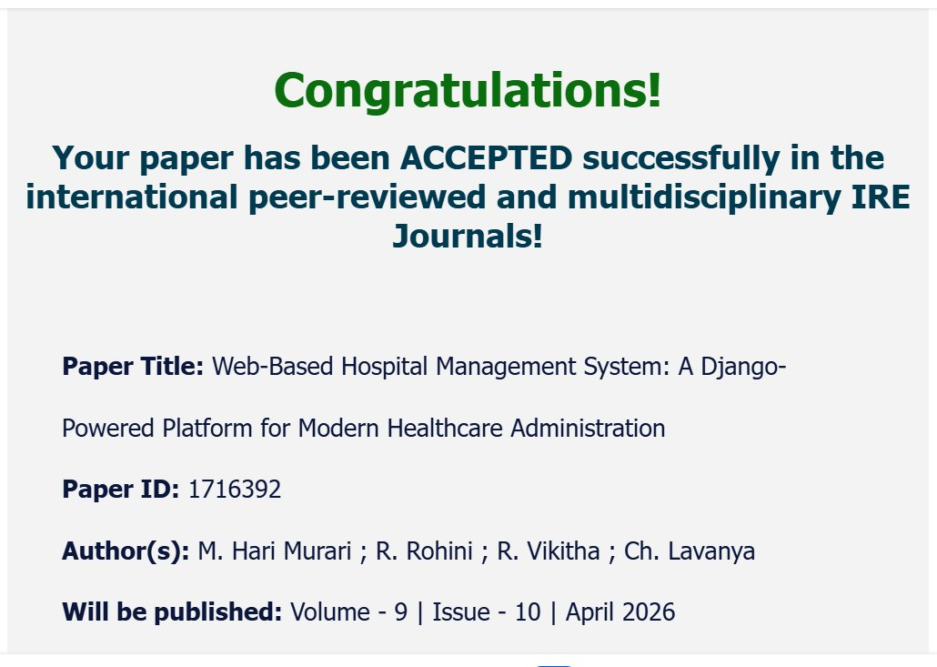
Figure 7: IRE Journals Paper Acceptance Confirmation

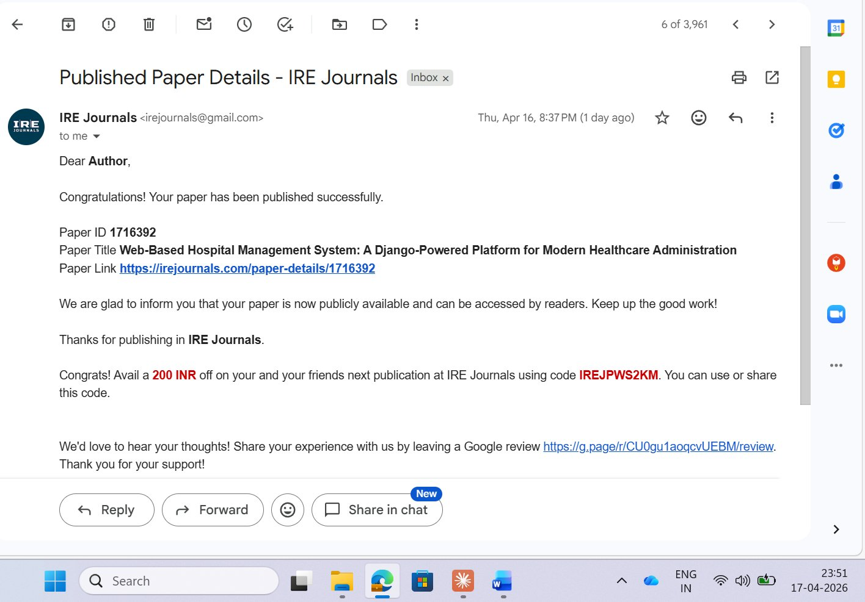
Figure 8: IRE Journals Published Paper Email Notification

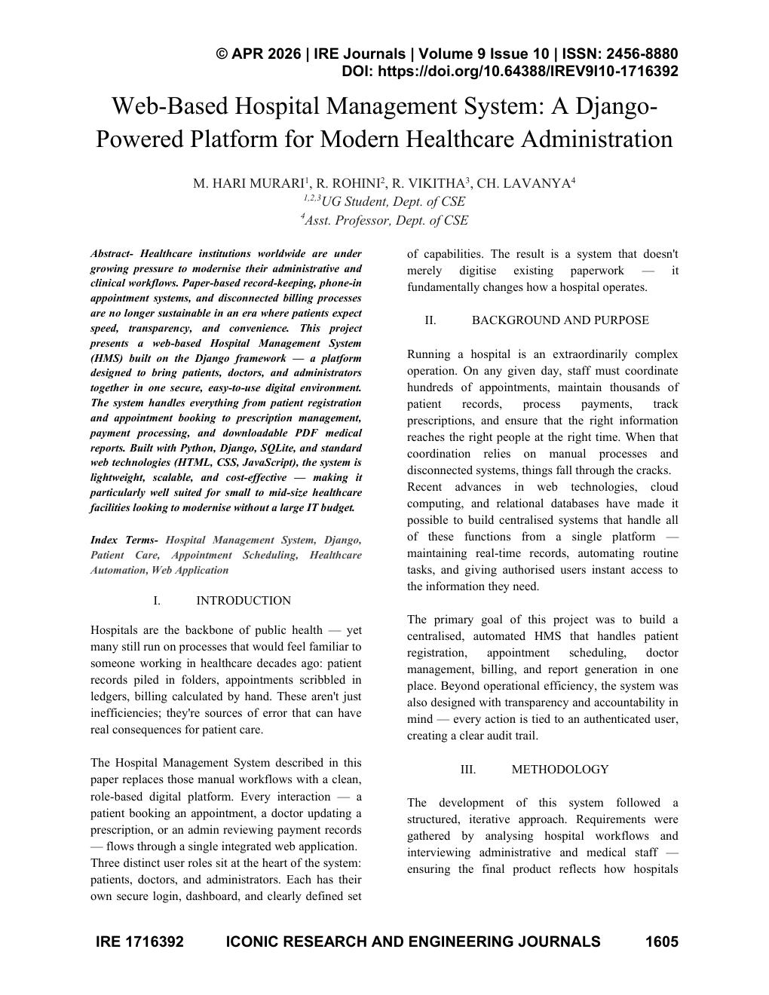
Figure 9: Published Paper – Page 1 (IRE Journals, Vol. 9, Issue 10, April 2026)

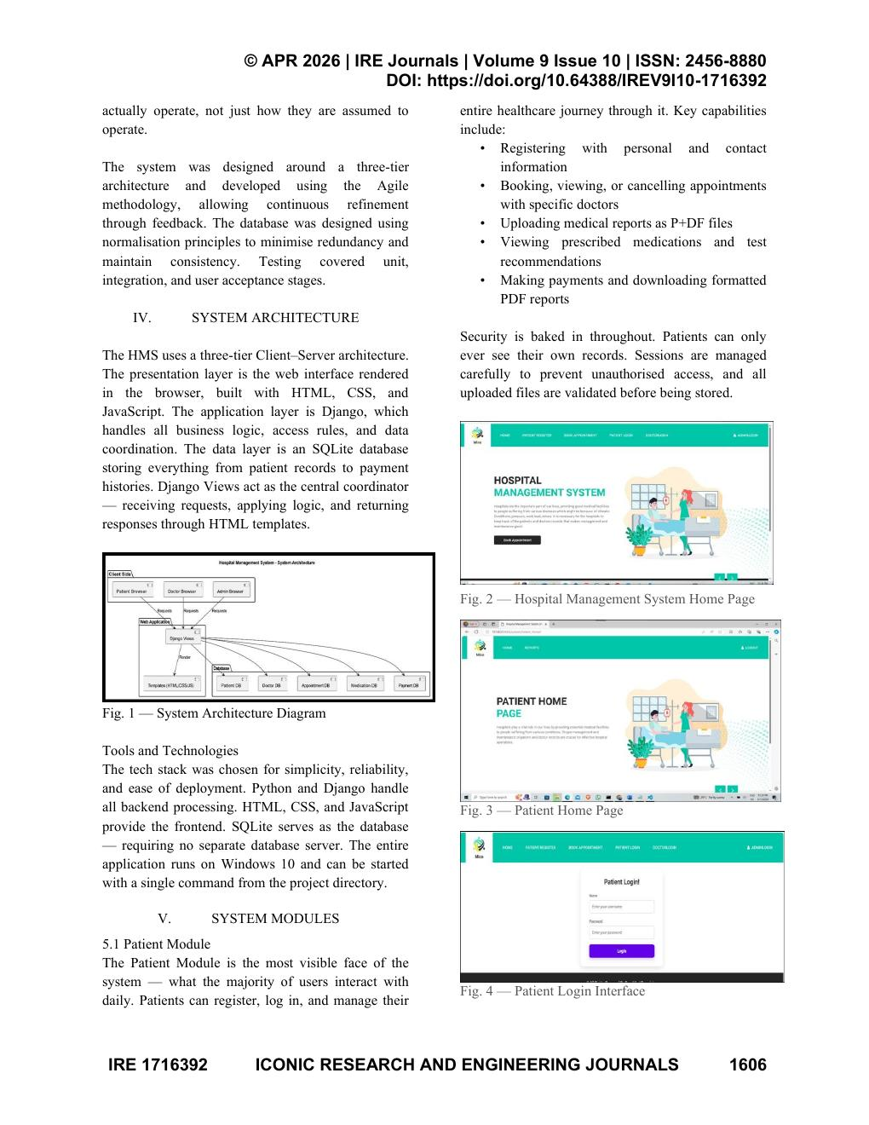
Figure 10: Published Paper – Page 2

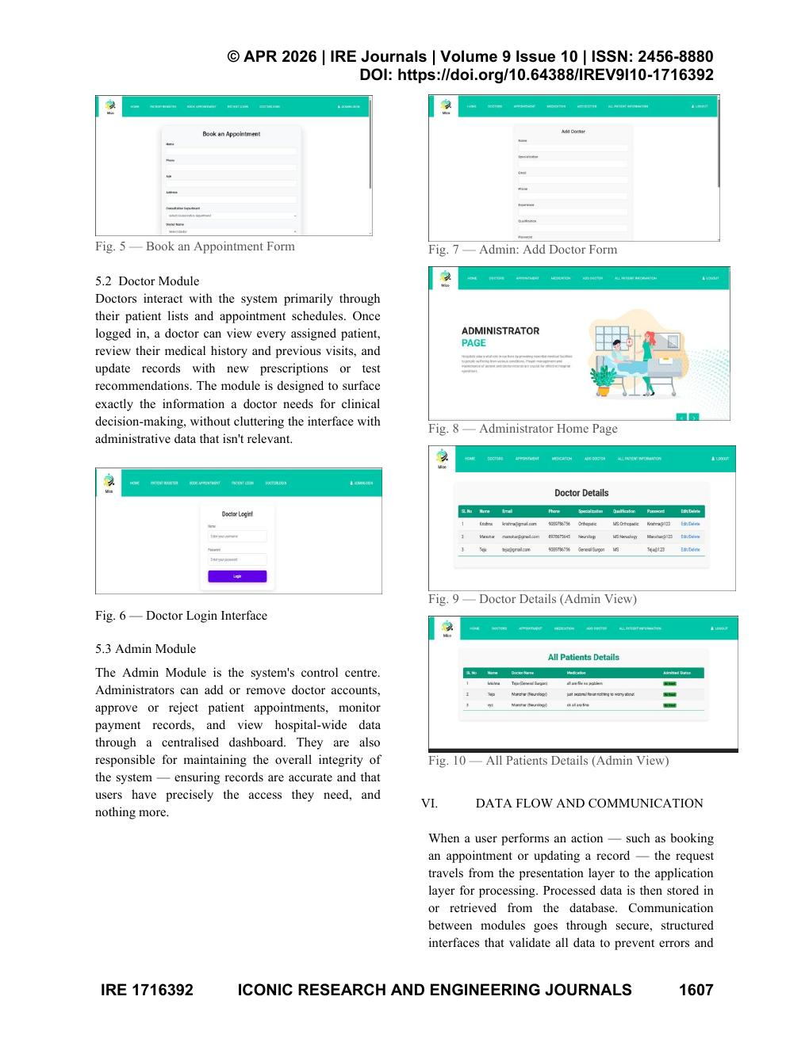
Figure 11: Published Paper – Page 3

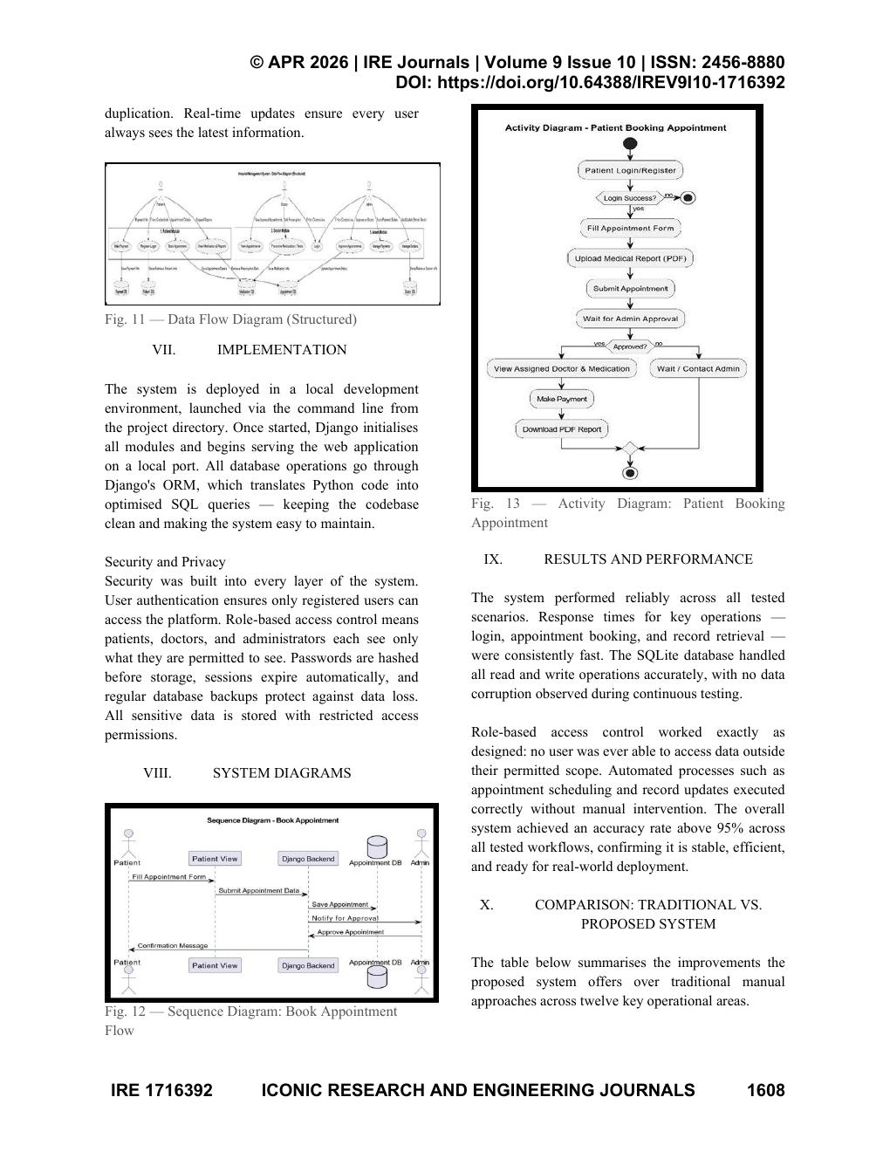
Figure 12: Published Paper – Page 4

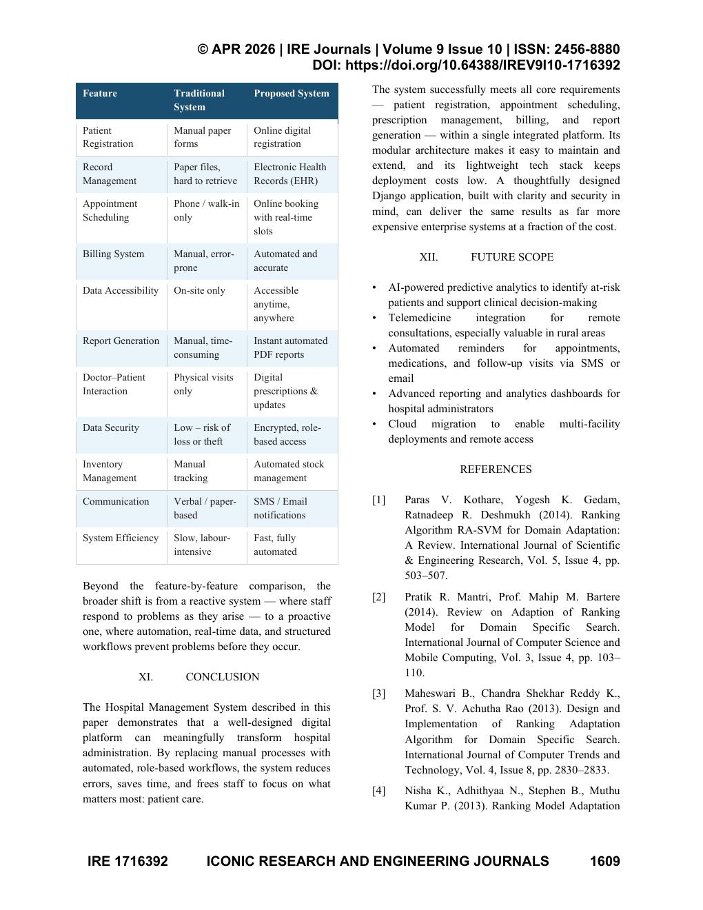
Figure 13: Published Paper – Page 5

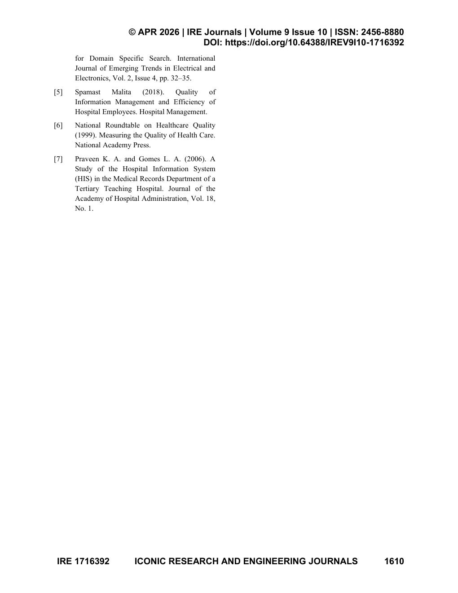
Figure 14: Published Paper – Page 6

6. TESTING
Testing is a critical phase in the software development lifecycle. Its primary purpose is to identify and eliminate defects, verify that the system functions as specified, and ensure that it meets the expectations of end users. For the Hospital Management System, a comprehensive testing strategy was adopted covering unit testing, data flow testing, integration testing, big bang integration testing, and user interface testing.

6.1 Types of Testing

6.1.1 Unit Testing
Unit testing involves validating individual components or functions of the application in isolation. Each Django view function was tested separately to confirm that it correctly processes HTTP requests, validates form data, and returns the expected response. The Admin_login view was tested with correct and incorrect credentials. The Add_Doctor view was tested with valid form data, duplicate emails, and mismatched passwords to verify all validation paths.

6.1.2 Data Flow Testing
Data flow testing was conducted to trace how data moves through the application from user input to database storage and back to the user interface. Testing verified that when a patient submits a booking form, the data is correctly received by the Django view, validated, saved to the MySQL database, and reflected on the admin's appointment management page. Similar testing confirmed that medication data entered by a doctor is stored and made available to the patient through the Reports page.

6.1.3 Integration Testing
Integration testing focused on verifying that the individual modules work correctly when combined. The interaction between the Patient module and the Admin module was tested to confirm that appointments booked by patients appear correctly in the admin dashboard and that approval actions are instantly reflected in the patient's appointment status. The interaction between the Doctor module and the Patient module was verified to ensure prescriptions are immediately accessible for PDF download.

6.1.4 Big Bang Integration Testing
Big Bang Integration Testing involved integrating all modules simultaneously and testing the complete application as a whole. All three user role modules, the database layer, the notification service, and the PDF generation component were brought together and tested through end-to-end scenarios. This approach confirmed that all parts of the system functioned correctly together before deployment, though any issues required tracing back through multiple interacting components.

6.1.5 User Interface Testing
User interface testing was conducted to evaluate the usability, accessibility, and visual consistency of the application. All interactive elements including buttons, input forms, navigation links, and dropdown menus were tested to confirm correct response to user actions. Form validation messages were verified to be descriptive and helpful. The layout and design of each page were evaluated for clarity and user-friendliness across different screen sizes.

6.2 Test Cases
Table 1 presents the test cases executed during the testing phase of the Hospital Management System, along with the expected results, actual outcomes, and remarks.

S.No | Test Case | Expected Result | Result | Remarks (If Fails)
1 | Patient Registration | Patient registered successfully; details stored in database. | Pass | Fails if email already exists.
2 | Patient Login | Valid credentials redirect to patient dashboard. | Pass | Unregistered users denied access.
3 | Book Appointment | Appointment booked and visible in admin panel. | Pass | Fails if slot unavailable.
4 | Doctor Registration | Doctor added; credentials stored successfully. | Pass | Fails if email already exists.
5 | Doctor Login | Valid credentials redirect to doctor dashboard. | Pass | Unregistered doctors cannot log in.
6 | View Patient Details | Doctor views patient info and uploaded reports. | Pass | Exception raised if data unavailable.
7 | Issue Medication | Medication recorded; downloadable as PDF. | Pass | Fails if required fields empty.
8 | Admin Login | Admin credentials validated; dashboard displayed. | Pass | Unregistered admin cannot log in.
9 | Add Doctor (Admin) | Doctor added; visible in doctor details page. | Pass | Exception on duplicate entry.
10 | View Doctor Details | Doctor schedule and availability listed correctly. | Pass | Exception raised if records missing.

All test cases listed above were executed successfully. The system produced the expected outputs for all valid inputs and handled invalid inputs gracefully by displaying appropriate error messages without crashing.

7. CONCLUSION
The Web-Based Hospital Management System developed using Python, Django, and MySQL successfully addresses the core challenges faced by hospitals relying on manual and paper-based administrative processes. By providing a unified digital platform for administrators, doctors, and patients, the system significantly reduces the time and effort required to manage hospital operations.
Patients can now register, book appointments, upload their medical documents, receive prescriptions, and download reports — all from the convenience of a web browser. Doctors have a clear and organized view of their assigned patients, allowing them to focus on delivering quality care rather than administrative tasks. Administrators gain comprehensive oversight of the entire hospital workflow, from doctor management to appointment approvals and payment tracking.
The system is built on a reliable and cost-effective technology stack using entirely open-source tools, making it accessible and maintainable for small to mid-scale healthcare facilities. Django's robust security features ensure that sensitive patient and doctor data is adequately protected. The modular architecture provides a strong foundation for future enhancements, demonstrating that a thoughtfully designed web application can bring meaningful improvements to healthcare service delivery.

8. FUTURE SCOPE
While the current implementation covers the essential workflows of a hospital environment, there are numerous directions in which the platform can be extended to deliver greater value to all stakeholders.
- Integration with Artificial Intelligence for predictive health analytics — machine learning models could analyze patient medical histories to identify early warning signs of health conditions and forecast appointment demand.
- Incorporation of telemedicine features to allow patients to consult doctors remotely through video calls directly within the platform, removing geographical barriers to healthcare access.
- Automated reminders for upcoming appointments, pending prescription pickups, and medication schedules delivered via SMS or mobile push notifications in addition to email.
- Enhanced data analytics dashboards for administrators providing visual insights into patient volumes, doctor utilization rates, revenue trends, and treatment outcomes.
- Integration with cloud-based storage services to allow patient medical records and reports to be securely stored and accessed from anywhere, improving continuity of care.
- A mobile application version for Android and iOS to significantly improve accessibility for patients and doctors, enabling system interaction on the go.
- Multi-language support to extend the platform's reach to non-English speaking patients and healthcare workers.

9. BIBLIOGRAPHY

[1] Zhihong Liu, "Design, Implementation of the Hospital Emergency Nursing Information Management System," IEEE, ISSN: 0193-1420, pp. 4493–4494.
[2] S. Sharmila Devi and J. S. Deepica, "User Interactive Hospital Management System by Using Web Applications," International Journal of Computer Science and Engineering.
[3] I. O. Olaoye, O. J. Omotosho, and A. T. Fadipe-Joseph, "A Web-Based Hospital Management System for Enhancing Healthcare Service Delivery," 2018.
[4] Paras V. Kothare, Yogesh K. Gedam, Ratnadeep R. Deshmukh, "Ranking Algorithm RA-SVM for Domain Adaptation: A Review," IJSER, ISSN 2229-5518, Vol. 5, Issue 4, pp. 503–507, 2014.
[5] Pratik R. Mantri, Prof. Mahip M. Bartere, "Review on Adaption of Ranking Model for Domain Specific Search," International Journal of Computer Science and Mobile Computing, Vol. 3, Issue 4, pp. 103–110, 2014.
[6] Spamast Malita, "Quality of Information Management and Efficiency of Hospital Employees," Hospital Management, 2018.
[7] National Roundtable on Healthcare Quality, "Measuring the Quality of Health Care," National Academy Press, 1999.
[8] Praveen K. A. and Gomes L. A., "A Study of the Hospital Information System (HIS) in the Medical Records Department of a Tertiary Teaching Hospital," Journal of the Academy of Hospital Administration, Vol. 18, No. 1, 2006.

