23CSE202 DATABASE MANAGEMENT SYSTEMS
S3 B.Tech CSE
Department of Computer Science and Engineering
Amrita School of Computing, Amritapuri Campus

PROJECT REPORT

Group No : C16
Team Members :
Roll No | Student Name
AM.SC.U4CSE25221 | HarinandhReddy A
AM.SC.U4CSE25223 | Ganesh Innamuri
AM.SC.U4CSE25211 | Nitesh Reddy
AM.SC.U4CSE25255 | Thummalapalli Vardhan
AM.SC.U4CSE25241 | P.V.V.Charan Raj

Project Title : Alumni Mentorship Matcher
Live application: https://harinandhreddy0411.github.io/alumni-mentorship-matcher/
Source code: https://github.com/harinandhreddy0411/alumni-mentorship-matcher

CONTENTS

Sl. No | Chapter | Page No
1 | Abstract | 3
2 | Introduction | 4
3 | Requirements (Functional & Non-functional) | 5
4 | UI Design | 7
5 | Database Design | 9
6 | Database Selection & Justification | 14
7 | Implementation | 15
8 | Testing & Validation | 20
9 | Results & Screenshots | 23
10 | Challenges faced & solutions | 30
11 | Conclusion & future enhancements | 31
 | References | 33

1. Abstract
Students in the early years of an engineering programme rarely have a structured way to reach alumni who could guide their careers, and alumni who are willing to help have no convenient way to manage the requests they receive. This project, the Alumni Mentorship Matcher, addresses that gap with a full-stack web application that connects current students with alumni mentors. The objectives were to design a normalized relational database for the mentorship process, expose it through a secure REST API, and build role-specific interfaces for students, alumni and administrators. Students browse the alumni who are currently accepting mentees and send a mentorship request containing a focus area and a pitch; alumni accept or decline each request and control their own capacity (open or paused, maximum mentees, preferred contact hours); administrators manage user accounts and audit or override matches. The data layer is a MySQL database of four tables (USERS, ALUMNI_DETAILS, MENTORSHIP_REQUESTS and SESSIONS), each in Boyce-Codd Normal Form, which uses an ISA specialization for alumni-only attributes, ENUM-typed status columns, UNIQUE constraints to give each user a single active session, and ON DELETE CASCADE foreign keys to keep dependent rows consistent. Passwords are stored as bcrypt hashes and every protected route checks a server-side session token and the caller's role. The system is deployed with a GitHub Pages frontend, a Node.js and Express backend on Render and a hosted MySQL database on Aiven, and was validated with 28 test cases covering normal, exceptional and constraint-violation scenarios. The outcome is a working three-role mentorship platform together with an honest record of the integrity rules that are enforced by the schema and those that are still enforced only by application code.

2. Introduction

2.1 Problem domain and background
Mentorship from alumni is one of the most effective ways for students to learn how an academic programme translates into a career: which skills industry values, how to prepare for interviews, how to choose a specialization. Institutions usually have a large and willing alumni community, yet the connection between a particular student and a suitable alumnus is made by chance, through personal contacts, or through occasional events. The core problem is a coordination problem, and coordination problems are exactly what a database is good at: many people, with attributes and availability, need to be matched through a request that moves through well-defined states.

2.2 Existing scenario and its limitations
In the absence of a dedicated system, students typically approach alumni through general-purpose channels such as email, messaging groups or professional networking sites. These channels have several limitations for a mentorship programme:
- There is no single directory of alumni who are actually willing to mentor and currently have capacity, so students contact people who may be unavailable.
- A request is a free-form message with no status. Neither side can see whether it is pending, accepted or declined, and nothing records the outcome.
- Alumni cannot limit the number of mentees they take on or pause new requests without ignoring messages.
- The institution has no overview of how many mentorships exist, and no way to correct or revoke a match.
- Identity and roles are not controlled, so there is no guarantee that a person writing as "alumnus" is one.

2.3 Proposed system
The Alumni Mentorship Matcher replaces these informal channels with a single database-backed application. Every person has one account with a role (student, alumni or admin), and a mentorship request is a database record that links a student to an alumnus and carries a status of pending, accepted or declined. The application provides three role-specific dashboards:
- Students browse available alumni, send requests, and see their request status and accepted mentor.
- Alumni review incoming requests, accept or decline them, see their active mentees, and set their capacity and preferred contact hours.
- Administrators see platform statistics, create, edit and terminate accounts, and audit, cancel or revoke matches.
The database design is the centre of the project. It separates identity (USERS) from alumni-only data (ALUMNI_DETAILS), models the student-to-alumni relationship as its own relation (MENTORSHIP_REQUESTS), and stores login tokens server-side (SESSIONS). The schema is normalized to BCNF, uses referential integrity with cascading deletes, and is accessed only through parameterised SQL from the Node.js backend. The remainder of this report documents the requirements, the interface, the database design and its justification, the implementation, the testing carried out, the results, the challenges met, and the improvements that remain.

3. Requirements (Functional & Non-functional)

3.1 Functional requirements
ID | Requirement | Role
FR1 | Register an account as Current Student or Alumni Mentor with a unique username; the password is stored as a bcrypt hash. Registering as alumni also creates the alumni capacity record. | Public
FR2 | Log in with username and password; the server issues a session token and the client is routed to the dashboard for its role. | Public
FR3 | Log out, which deletes the server-side session. | Any
FR4 | View and update own profile: full name, email, focus track and bio. | Any
FR5 | Browse the directory of alumni who are accepting mentees. Alumni who are paused, or to whom the student already has a pending or accepted request, are not offered. | Student
FR6 | Send a mentorship request to an alumnus with a focus area and a pitch message. | Student
FR7 | View own requests with their status, the connected mentor, and counts of active requests and connected mentors. | Student
FR8 | View incoming pending requests with the requesting student's name, track and pitch. | Alumni
FR9 | Accept or decline an incoming request (only requests addressed to the logged-in alumnus). | Alumni
FR10 | View accepted students under "My Active Mentees". | Alumni
FR11 | Set capacity: open or paused, maximum mentees, and preferred contact hours. | Alumni
FR12 | View dashboard statistics: total users, active matches and pending requests. | Admin
FR13 | List, create, edit and terminate user accounts; admin accounts cannot be terminated; changing a user to alumni creates the alumni record. | Admin
FR14 | View the audit log of pending and accepted matches, and force-cancel or revoke any of them. | Admin
FR15 | Reject any request to a protected route that has no valid session token (401) or the wrong role (403). | System

3.2 Non-functional requirements
Quality | Requirement and how it is met
Security | Passwords hashed with bcrypt (cost factor 10); 32-byte random session tokens; role check on every protected route; all SQL parameterised to prevent injection; CORS restricted to the GitHub Pages origin; admin accounts protected from termination.
Data integrity | InnoDB tables with primary keys, NOT NULL, UNIQUE, ENUM and foreign-key constraints; ON DELETE CASCADE so that terminating a user leaves no orphan rows.
Performance | Connection pool (up to 10 connections); every query uses primary-key, unique-key or foreign-key lookups on small tables; no per-request heavy computation.
Reliability | ACID storage engine; global Express error handler returns a clean 500 instead of crashing; unhandled promise rejections are logged. Free hosting tiers sleep when idle (see Chapter 10).
Usability | One login page that routes by role; one task per page; confirmation messages after every action; consistent visual language across all screens.
Scalability | The API holds no per-user state in memory (sessions live in the database), so it can be restarted or replicated; the schema separates alumni-only data so student rows stay narrow.
Portability | Separate schema files for a local MySQL server and the hosted database; configuration through environment variables.
Maintainability | Backend split into route modules (auth, mentorship, profile, admin) and a middleware module; all frontend logic in one script with a single API helper.

4. UI Design

4.1 Design approach
The interface is plain HTML, CSS and vanilla JavaScript with a bold, high-contrast visual style: thick black borders, flat offset shadows, and a yellow, navy and crimson palette. Every page shares one stylesheet and one script. The pages are intentionally task-focused: a dashboard for orientation and navigation, and a separate page for each data-entry task. Screenshots of every screen are given in Chapter 9; this chapter explains the design and the navigation.

4.2 Navigation flow
All users enter through the login page. After a successful login the server returns the role, and the client sends the user to the matching dashboard. Every other page is reached from a dashboard, and every page has a Back button and a Logout button.
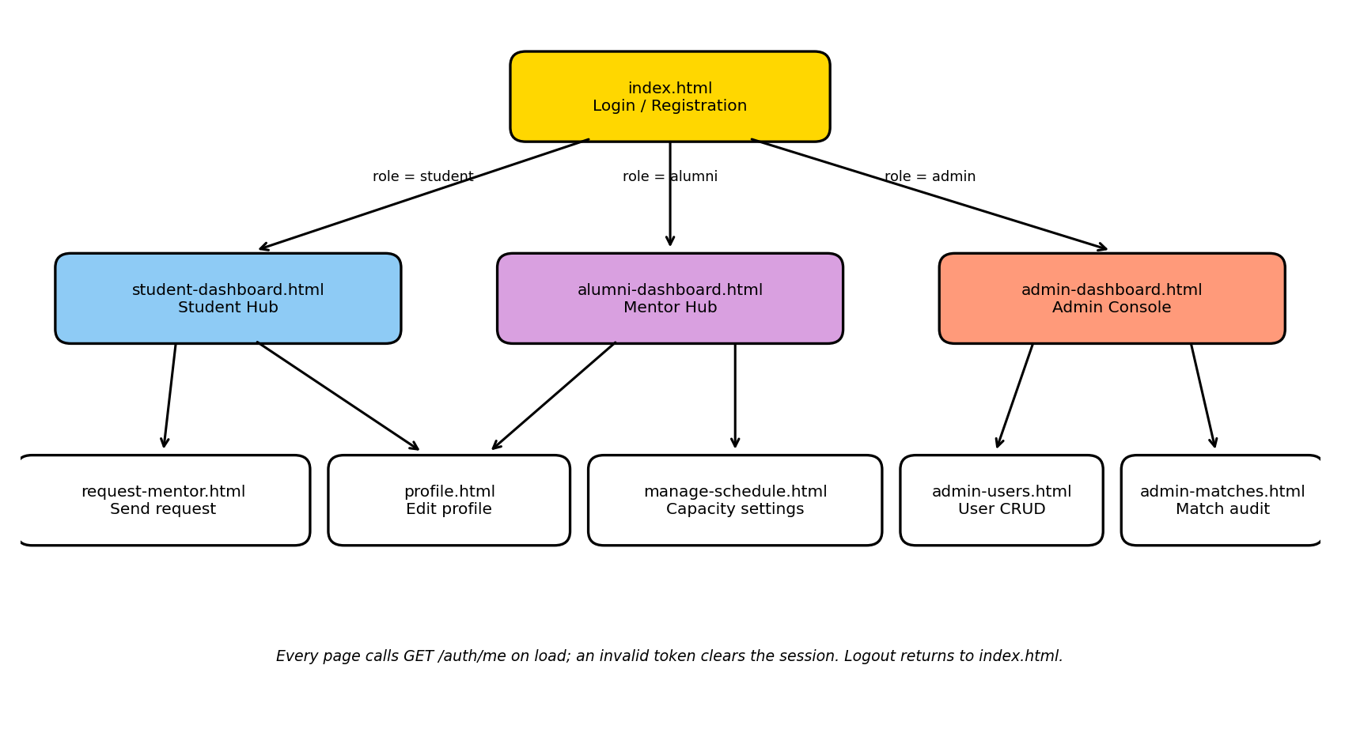
Figure 4.1: Navigation flow of the application

4.3 Screens
Screen (file) | Role | Elements and interaction | Data used
Login and registration (index.html) | Public | Username and password form; registration form with account type (Current Student or Alumni Mentor). Invalid credentials show an error message. | USERS, SESSIONS
Student Hub (student-dashboard.html) | Student | Counters for active requests and connected mentors; "Update profile"; cards for available alumni, each with a Request Match button; My Mentor section. | USERS, ALUMNI_DETAILS, MENTORSHIP_REQUESTS
Request a mentor (request-mentor.html) | Student | Mentor name (pre-filled from the card), focus area drop-down (resume review, technical interview prep, system architecture, industry networking) and pitch text; submit. | MENTORSHIP_REQUESTS
Profile (profile.html) | Student, alumni | Full name, email, academic or industry track (drop-down) and bio; save. | USERS
Mentor Hub (alumni-dashboard.html) | Alumni | Counters for pending requests and active mentees; incoming requests with Accept Match and Decline buttons; My Active Mentees list. | MENTORSHIP_REQUESTS, USERS
Capacity constraints (manage-schedule.html) | Alumni | Accepting new mentees (active or paused), maximum active mentees (1 to 10), preferred contact hours; save. | ALUMNI_DETAILS
Admin Console (admin-dashboard.html) | Admin | Counters for total users, active matches and pending requests; quick user table; links to user management and match audit. | USERS, MENTORSHIP_REQUESTS
User management (admin-users.html) | Admin | Provision-new-user form (role, username, password); global registry with Edit and Terminate per row; admin rows show Locked. | USERS, ALUMNI_DETAILS
Match audit (admin-matches.html) | Admin | Table of pending and accepted matches with Force Cancel (pending) or Revoke (accepted). | MENTORSHIP_REQUESTS, USERS

4.4 How users interact with the system
Student
- Log in and land on the Student Hub, which lists only alumni who are accepting mentees and to whom the student has no pending or accepted request.
- Click Request Match on a card, choose a focus area, write a pitch and submit. The request is stored with status pending and the counter "Active Requests" increases.
- When the alumnus accepts, that alumnus disappears from the directory and appears under My Mentor with a Connected badge.
Alumni
- Log in and land on the Mentor Hub, which shows the pending requests addressed to this alumnus.
- Press Accept Match or Decline on a request. The status is updated in the database; accepted students appear under My Active Mentees.
- Open Capacity Constraints to pause new requests (the alumnus then disappears from every student's directory) or to change the maximum mentees and preferred hours.
Administrator
- Log in to the Admin Console to see live counts, then open User Management to create, edit or terminate accounts; terminating a user removes all of that user's requests and session.
- Open Match Audit to force-cancel a pending request or revoke an accepted match; both set the status to declined.
Feedback is given by message boxes after each action (success or the server's error text), and a friendly message explains the delay when the free-tier server is waking up.

5. Database Design

5.1 Entities, attributes and relationships
The mentorship process was analysed into four entities. USERS is the supertype that represents every person regardless of role, and stores the identity data common to students, alumni and administrators together with two profile fields (focus_track and professional_bio) that all roles can fill in. ALUMNI_DETAILS is a subtype that stores the three attributes that only make sense for an alumnus who is mentoring: capacity status, maximum mentees and preferred contact hours. MENTORSHIP_REQUESTS records a student asking an alumnus for mentorship and the status of that request. SESSIONS stores the single active login token of a user.
Student and administrator have no subtype table, deliberately: neither role has an attribute that is not already on USERS. A student's participation is fully expressed by the USERS row plus the MENTORSHIP_REQUESTS rows in which the student appears, and an administrator carries no data beyond identity and role.
Relationship | Between | Cardinality | Participation
ISA (specialization) | USERS and ALUMNI_DETAILS | 1 : 0..1 | Disjoint, partial: only rows with role = alumni take part
submits | USERS (student) and MENTORSHIP_REQUESTS | 1 : N | A request must have a student; a user may have zero requests
receives | USERS (alumni) and MENTORSHIP_REQUESTS | 1 : N | A request must have an alumnus; an alumnus may have zero requests
has | USERS and SESSIONS | 1 : 0..1 | A session needs its user; a user need not be logged in
mentors (derived) | Student and alumnus | M : N | Resolved by MENTORSHIP_REQUESTS: many students may ask many alumni

5.2 ER diagram
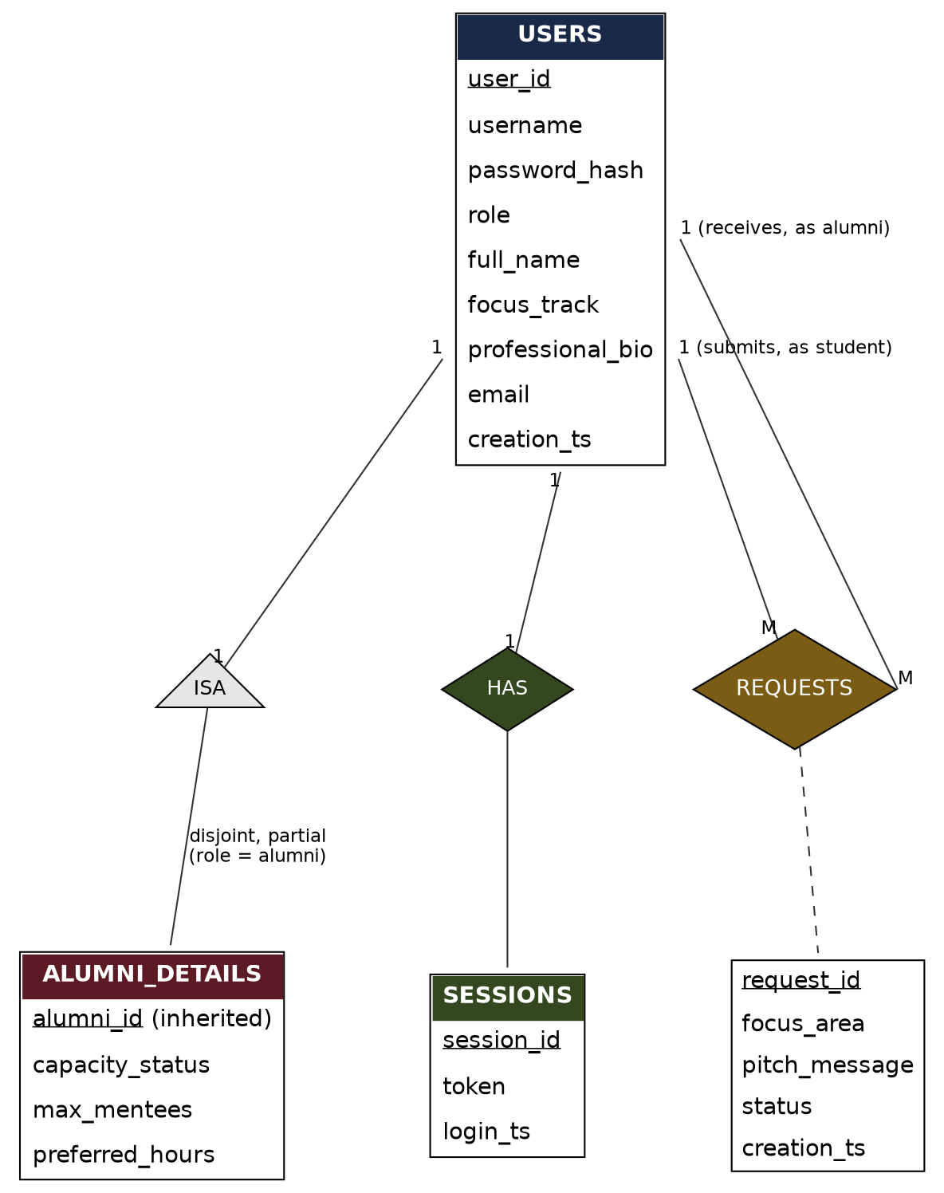
Figure 5.1: Entity-Relationship diagram of the Alumni Mentorship Matcher database
Rectangles are entities with their attributes, primary keys underlined. The triangle is the ISA specialization between USERS and ALUMNI_DETAILS, disjoint and partial. The two edges into MENTORSHIP_REQUESTS both originate from USERS because a request links one student-role row and one alumni-role row of the same entity set. The has relationship into SESSIONS is one-to-one and mandatory on the SESSIONS side.

5.3 Conversion of the ER model to relational tables
- Strong entities. USERS, MENTORSHIP_REQUESTS and SESSIONS each become a table with a surrogate primary key (user_id, request_id, session_id), because the natural candidates (username, token) are long strings and the pair (student_id, alumni_id) is not unique over time.
- ISA specialization. The subtype ALUMNI_DETAILS becomes a table whose primary key alumni_id is also a foreign key to USERS.user_id. This is the standard encoding of a disjoint, partial specialization: a row exists only for users who are alumni.
- One-to-many relationships. submits and receives are implemented as the foreign keys student_id and alumni_id in MENTORSHIP_REQUESTS, both referencing USERS.user_id.
- One-to-one relationship. has is implemented as SESSIONS.user_id, a foreign key that is also declared UNIQUE.
- Many-to-many relationship. The student-alumnus relationship is realised by MENTORSHIP_REQUESTS itself. No separate MATCHES table exists because the request row already is the match, and it carries the relationship attributes (focus_area, pitch_message, status, creation_ts).

5.4 Relational schema
Primary keys are marked PK and foreign keys FK. The schema below is the one in db/schema.sql.
USERS
Attribute | Type / constraint
user_id | INT, PK, AUTO_INCREMENT
username | VARCHAR(50), UNIQUE, NOT NULL
password_hash | VARCHAR(255), NOT NULL (bcrypt)
role | ENUM('student','alumni','admin'), NOT NULL
full_name | VARCHAR(100), NOT NULL
focus_track | VARCHAR(30), NULL allowed
professional_bio | TEXT, NULL allowed
email | VARCHAR(120), NULL allowed
creation_ts | DATETIME, DEFAULT CURRENT_TIMESTAMP

ALUMNI_DETAILS
Attribute | Type / constraint
alumni_id | INT, PK, FK to USERS.user_id, ON DELETE CASCADE
capacity_status | ENUM('active','paused'), NOT NULL, DEFAULT 'active'
max_mentees | INT, NOT NULL, DEFAULT 3
preferred_hours | VARCHAR(100), NULL allowed

MENTORSHIP_REQUESTS
Attribute | Type / constraint
request_id | INT, PK, AUTO_INCREMENT
student_id | INT, FK to USERS.user_id, NOT NULL, ON DELETE CASCADE
alumni_id | INT, FK to USERS.user_id, NOT NULL, ON DELETE CASCADE
focus_area | VARCHAR(50), NULL allowed
pitch_message | TEXT, NULL allowed
status | ENUM('pending','accepted','declined'), NOT NULL, DEFAULT 'pending'
creation_ts | DATETIME, DEFAULT CURRENT_TIMESTAMP

SESSIONS
Attribute | Type / constraint
session_id | INT, PK, AUTO_INCREMENT
user_id | INT, FK to USERS.user_id, UNIQUE, NOT NULL, ON DELETE CASCADE
token | VARCHAR(64), UNIQUE, NOT NULL
login_ts | DATETIME, DEFAULT CURRENT_TIMESTAMP

All four foreign keys are declared ON DELETE CASCADE, so removing a USERS row also removes its ALUMNI_DETAILS, MENTORSHIP_REQUESTS and SESSIONS rows. The application relies on this when an administrator terminates a non-admin account.

5.5 Constraints enforced by the schema and by the application
Rule | Enforced by | Mechanism
Usernames are unique | Schema | UNIQUE on users.username
Role is one of student, alumni, admin | Schema | ENUM type
Request status is pending, accepted or declined | Schema | ENUM type, default pending
A request needs an existing student and alumnus | Schema | Two NOT NULL foreign keys
One active session per user | Schema | UNIQUE on sessions.user_id
No orphan rows after a user is deleted | Schema | ON DELETE CASCADE
student_id refers to a student and alumni_id to an alumnus | Application only | Not checked by the schema
An ALUMNI_DETAILS row exists only for role = alumni | Application only | Created at registration or on role change
Status only moves from pending to accepted or declined | Application only | Alumni may only send accepted or declined
Admin accounts cannot be terminated | Application only | Role check before DELETE
An alumnus has at most max_mentees accepted mentees | Not enforced | Setting is stored and displayed only

5.6 Functional dependencies and normalization
Each relation was checked in order: 1NF, 2NF, 3NF and BCNF. In every relation all attributes are atomic with no repeating groups, so 1NF holds. Every candidate key is a single attribute, so a partial dependency is impossible and 2NF holds. In every relation the only determinants are candidate keys, so no non-key attribute determines another, which gives 3NF and BCNF.
Relation | Functional dependencies | Candidate keys | Highest normal form
USERS | user_id → all other attributes  username → all other attributes | user_id, username | BCNF
ALUMNI_DETAILS | alumni_id → capacity_status, max_mentees, preferred_hours | alumni_id | BCNF
MENTORSHIP_REQUESTS | request_id → student_id, alumni_id, focus_area, pitch_message, status, creation_ts | request_id | BCNF
SESSIONS | session_id → user_id, token, login_ts  user_id → session_id, token, login_ts  token → session_id, user_id, login_ts | session_id, user_id, token | BCNF

The one substantive normalization decision was to factor capacity_status, max_mentees and preferred_hours out of USERS into ALUMNI_DETAILS. These attributes describe an alumnus's mentoring capacity and are meaningless for a student or an administrator; left on USERS they would be NULL for every non-alumnus row. focus_track and professional_bio stay on USERS because students and alumni fill them in through the same profile screen. In MENTORSHIP_REQUESTS the pair (student_id, alumni_id) is deliberately not a candidate key: the current implementation lets the same pair appear in more than one row, so a surrogate request_id is the correct key. Redundancy is minimised because the student's and alumnus's names are never copied into MENTORSHIP_REQUESTS; they are obtained by joining to USERS, so renaming a person is a single-row update and cannot create an update anomaly.

6. Database Selection & Justification
The project uses MySQL 8 as its DBMS: a local MySQL server during development and a hosted MySQL service (Aiven, free tier) for the deployed application. Tables use the InnoDB storage engine and the Node.js backend connects through the mysql2 driver.

6.1 Why MySQL suits this application
- Relational fit. The data is highly structured: people, a typed relationship between them, and a request with a small set of states. The queries that matter are joins between USERS and MENTORSHIP_REQUESTS and simple aggregates, which is what a relational engine is built for.
- Integrity features. InnoDB provides ACID transactions and enforces foreign keys with ON DELETE CASCADE, which the design relies on. ENUM columns constrain role and status values directly in the schema, and UNIQUE constraints implement the one-session-per-user rule.
- Security. MySQL supports TLS connections (used with the hosted service through a CA certificate), user accounts and privileges, and parameterised statements through the driver.
- Cost and availability. MySQL is open source and available on a free hosting tier, which allowed a live deployment without any cost.
- Ease of use and support. The SQL dialect matches the course material, the tooling is widely available, and the Node.js ecosystem has a mature driver with promise support and connection pooling.
- Performance and scalability. For tables of this size and lookups by key, MySQL needs no tuning. It can later be scaled with indexes, read replicas or a managed service.

6.2 Alternatives considered
DBMS | Strengths for this project | Reasons not chosen
PostgreSQL | Rich constraint support (CHECK, partial unique indexes, deferrable constraints) that could enforce more of the role rules in the schema. | Team and course material centre on MySQL; no feature requirement forced the change.
Oracle | Powerful PL/SQL and enterprise features. | Commercial licensing and heavier setup; no free hosted tier suitable for a student deployment.
MongoDB (NoSQL) | Flexible documents. | The data is relational with referential integrity requirements; the course objective is relational design and SQL.

Limitations of the choice are acknowledged in Chapter 11: MySQL has no partial unique index, so a rule such as "at most one pending request per student and alumnus" needs either a unique index on a generated column or a trigger.

7. Implementation

7.1 Architecture and environment
Layer | Implementation
Frontend | HTML, CSS and vanilla JavaScript (system-core.js holds all logic and API calls); hosted on GitHub Pages.
Backend | Node.js with Express; mysql2 (promise API, connection pool), bcryptjs, cors, dotenv, express-async-errors; hosted on Render.
Database | MySQL 8, InnoDB; hosted on Aiven for the deployed system, local MySQL for development.
Communication | JSON over HTTPS; the session token is sent in the x-session-token header.

A note on the outputs in this chapter and in Chapters 8 and 9: they were produced by running the project's own schema.sql, seed script, backend and frontend unchanged against a local MySQL-compatible server (MariaDB 10.11) loaded with demonstration data. The wording of a few server error messages can differ slightly between MariaDB and MySQL 8.

7.2 Database and table creation
The database is created once by running db/schema.sql. The script below is the complete DDL; it creates the four tables with their keys, defaults and constraints.
CREATE DATABASE IF NOT EXISTS alumni_matcher;
USE alumni_matcher;

CREATE TABLE users (
user_id INT AUTO_INCREMENT PRIMARY KEY,
username VARCHAR(50) NOT NULL UNIQUE,
password_hash VARCHAR(255) NOT NULL,
role ENUM('student','alumni','admin') NOT NULL,
full_name VARCHAR(100) NOT NULL,
focus_track VARCHAR(30),
professional_bio TEXT,
email VARCHAR(120),
creation_ts DATETIME DEFAULT CURRENT_TIMESTAMP
) ENGINE=InnoDB;

CREATE TABLE alumni_details (
alumni_id INT PRIMARY KEY,
capacity_status ENUM('active','paused') NOT NULL DEFAULT 'active',
max_mentees INT NOT NULL DEFAULT 3,
preferred_hours VARCHAR(100),
FOREIGN KEY (alumni_id) REFERENCES users(user_id) ON DELETE CASCADE
) ENGINE=InnoDB;

CREATE TABLE mentorship_requests (
request_id INT AUTO_INCREMENT PRIMARY KEY,
student_id INT NOT NULL,
alumni_id INT NOT NULL,
focus_area VARCHAR(50),
pitch_message TEXT,
status ENUM('pending','accepted','declined') NOT NULL DEFAULT 'pending',
creation_ts DATETIME DEFAULT CURRENT_TIMESTAMP,
FOREIGN KEY (student_id) REFERENCES users(user_id) ON DELETE CASCADE,
FOREIGN KEY (alumni_id) REFERENCES users(user_id) ON DELETE CASCADE
) ENGINE=InnoDB;

CREATE TABLE sessions (
session_id INT AUTO_INCREMENT PRIMARY KEY,
user_id INT NOT NULL UNIQUE,
token VARCHAR(64) NOT NULL UNIQUE,
login_ts DATETIME DEFAULT CURRENT_TIMESTAMP,
FOREIGN KEY (user_id) REFERENCES users(user_id) ON DELETE CASCADE
) ENGINE=InnoDB;

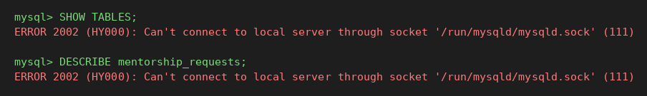
Figure 7.1: Tables created by schema.sql, and the structure of MENTORSHIP_REQUESTS

7.3 Sample data
Sample data is loaded the same way real data is: through the application. The seed script creates the administrator, and the demonstration students and alumni were registered through POST /auth/register and completed through the profile and capacity screens. Each registration executes parameterised INSERT statements; registering as alumni additionally inserts the ALUMNI_DETAILS row.
INSERT INTO users (username, password_hash, role, full_name) VALUES (?, ?, ?, ?);
INSERT INTO alumni_details (alumni_id) VALUES (?); -- only when role = 'alumni'

Figure 7.2: USERS table after loading the demonstration data (nine rows, three roles)
Passwords are never stored in clear text. The query below shows only the algorithm prefix and length of the stored values: every value is a 60-character bcrypt hash.
mysql> SELECT user_id, username, role, LEFT(password_hash,7) AS hash_prefix, LENGTH(password_hash) AS hash_len FROM users LIMIT 3;
+---------+-------------+--------+-------------+----------+
| user_id | username | role | hash_prefix | hash_len |
+---------+-------------+--------+-------------+----------+
| 1 | admin | admin | $2a$10$ | 60 |
| 2 | priya_nair | alumni | $2a$10$ | 60 |
| 3 | arjun_menon | alumni | $2a$10$ | 60 |
+---------+-------------+--------+-------------+----------+

7.4 CRUD operations
Operation | SQL executed (representative) | API route
Create | INSERT INTO users (...) VALUES (?, ?, ?, ?)  INSERT INTO mentorship_requests (student_id, alumni_id, focus_area, pitch_message) VALUES (?, ?, ?, ?) | POST /auth/register  POST /requests  POST /admin/users
Read | SELECT ... FROM users WHERE username = ?  SELECT ... FROM mentorship_requests r JOIN users u ON ... WHERE r.alumni_id = ? AND r.status = 'pending' | POST /auth/login  GET /requests/incoming  GET /admin/matches
Update | UPDATE mentorship_requests SET status = ? WHERE request_id = ? AND alumni_id = ?  UPDATE alumni_details SET capacity_status = ?, max_mentees = ?, preferred_hours = ? WHERE alumni_id = ?  UPDATE users SET username = ?, full_name = ?, role = ? WHERE user_id = ? | PATCH /requests/:id  PUT /capacity  PUT /admin/users/:id
Delete | DELETE FROM users WHERE user_id = ? (cascades)  DELETE FROM sessions WHERE token = ? | DELETE /admin/users/:id  POST /auth/logout

7.5 Joins and aggregate queries
Directory of available alumni (join of USERS and ALUMNI_DETAILS)
mysql> SELECT u.user_id, u.full_name, u.focus_track, ad.capacity_status FROM users u JOIN a...
+---------+-------------+---------------+-----------------+
| user_id | full_name | focus_track | capacity_status |
+---------+-------------+---------------+-----------------+
| 2 | Priya Nair | backend | active |
| 3 | Arjun Menon | data | active |
| 4 | Sneha Iyer | cybersecurity | active |
| 5 | Rahul Varma | frontend | active |
+---------+-------------+---------------+-----------------+

Incoming requests for one alumnus (join with the student's USERS row)
mysql> SELECT r.request_id, r.status, r.focus_area, u.full_name AS student_name, ...
+------------+---------+------------+--------------+---------------+
| request_id | status | focus_area | student_name | student_track |
+------------+---------+------------+--------------+---------------+
| 2 | pending | technical | Meera S | data |
| 3 | pending | resume | Sai Teja | backend |
+------------+---------+------------+--------------+---------------+

Match audit log (self-join pattern: USERS joined twice, as student and as alumnus)
Figure 7.3: Audit-log query joining MENTORSHIP_REQUESTS to USERS twice
Dashboard statistics (scalar subqueries)
mysql> SELECT (SELECT COUNT(*) FROM users) AS totalUsers, (SELECT COUNT(*) ... accepted) AS activeMatches, (...pending) AS pending;
+------------+---------------+---------+
| totalUsers | activeMatches | pending |
+------------+---------------+---------+
| 9 | 1 | 4 |
+------------+---------------+---------+

Accepted mentees against capacity (aggregate with GROUP BY)
mysql> SELECT a.full_name AS mentor, COUNT(*) AS accepted_mentees, ad.max_mentees ... GROUP BY ...;
+------------+------------------+-------------+
| mentor | accepted_mentees | max_mentees |
+------------+------------------+-------------+
| Priya Nair | 1 | 3 |
+------------+------------------+-------------+

Requests received per alumnus (LEFT JOIN, so alumni with none still appear)
mysql> SELECT a.full_name AS alumnus, COUNT(r.request_id) AS requests_received ... LEFT JOIN ... GROUP BY ... ORDER BY ...;
+-------------+-------------------+
| alumnus | requests_received |
+-------------+-------------------+
| Priya Nair | 3 |
| Sneha Iyer | 2 |
| Arjun Menon | 1 |
| Rahul Varma | 0 |
+-------------+-------------------+

Update with ownership check (accepting a request)
The WHERE clause includes alumni_id, so an alumnus can only change requests addressed to them; if no row matches, the API returns 404. The statement below was run inside a transaction and rolled back so that the sample data was left unchanged.
mysql> UPDATE mentorship_requests SET status = 'accepted' WHERE request_id = 4 AND alumni_id = 3;
status before: pending
status after : accepted

7.6 Constraints and referential integrity in action
The following statements were run directly against the database to show that the schema itself rejects invalid data: a duplicate username (UNIQUE), a request to a user that does not exist (FOREIGN KEY), and a second session for the same user (UNIQUE on sessions.user_id). An invalid role value is rejected by the ENUM type with error 1265.
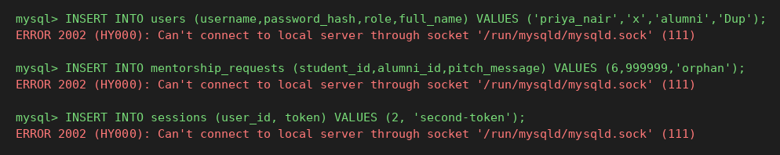
Figure 7.4: Constraint violations rejected by the database
Cascading delete was demonstrated inside a transaction that was rolled back. Deleting one student removed that student's two requests and one session automatically.
stage users requests sessions
before 9 6 9
after 8 4 8

7.7 Application-level implementation of database rules
Login uses a single upsert so that a user always has exactly one session; logging in again replaces the previous token, which invalidates it.
INSERT INTO sessions (user_id, token) VALUES (?, ?)
ON DUPLICATE KEY UPDATE token = VALUES(token), login_ts = CURRENT_TIMESTAMP;

Every protected route first resolves the token to a user and role with a join, then a role guard allows or rejects the request.
SELECT s.user_id, u.role, u.full_name FROM sessions s
JOIN users u ON u.user_id = s.user_id
WHERE s.token = ?;

When an administrator changes a user to alumni, the matching capacity row is created if it does not exist; the statement is idempotent.
INSERT INTO alumni_details (alumni_id) VALUES (?)
ON DUPLICATE KEY UPDATE alumni_id = alumni_id;

7.8 Connection and deployment configuration
The backend reads database settings from environment variables and uses a pool of up to 10 connections. TLS is switched on automatically when the Aiven CA certificate (db/ca.pem) is present, which is why the certificate is moved aside when running against a local server. A separate file, schema-aiven.sql, contains the same DDL without CREATE DATABASE, because the hosted service supplies one pre-created database. CORS accepts only the GitHub Pages origin and the null origin used when pages are opened directly from disk.

8. Testing & Validation

8.1 Approach
Testing combined three activities. First, a scripted client sent real HTTP requests to the running backend, exercising both successful operations and error paths and checking the HTTP status and response body. Second, SQL statements were run directly against the database to confirm that the schema rejects invalid data and cascades deletes. Third, the screens were used manually in a browser to confirm that what the API returns is what the user sees (Chapter 9). Each API test case records the input, the expected output, the actual output and a Pass or Fail result.

8.2 Functional and exceptional test cases
ID | Scenario | Input | Expected | Actual | Result
TC01 | Register a new student | username=test_student1, role=student | HTTP 200, success true, new userId returned | HTTP 200 {success, "userId":9} | Pass
TC02 | Register with an existing username | username=test_student1 (already present) | HTTP 409, "Username unavailable" | HTTP 409 {error: "Username unavailable"} | Pass
TC03 | Register with missing password | username=nopass, no password | HTTP 400, "Missing required fields" | HTTP 400 {error: "Missing required fields"} | Pass
TC04 | Register with a forbidden role | role=admin via public route | HTTP 400, "Invalid role" | HTTP 400 {error: "Invalid role"} | Pass
TC05 | Login with valid credentials | test_student1 / correct password | HTTP 200, token and role=student | HTTP 200 {success, "role":"student","token":"<64 hex chars>"} | Pass
TC06 | Login with wrong password | test_student1 / wrong | HTTP 401, "Authentication failed" | HTTP 401 {error: "Authentication failed"} | Pass
TC07 | Protected route without a token | GET /mentors, no x-session-token | HTTP 401, "No session token" | HTTP 401 {error: "No session token"} | Pass
TC08 | Student calls an alumni-only route | student token on GET /requests/incoming | HTTP 403, "Forbidden" | HTTP 403 {error: "Forbidden"} | Pass
TC09 | Alumni calls an admin-only route | alumni token on GET /admin/stats | HTTP 403, "Forbidden" | HTTP 403 {error: "Forbidden"} | Pass
TC10 | Old token after a second login (1 session per user) | login twice, reuse first token | HTTP 401, "Invalid or expired session" | HTTP 401 {error: "Invalid or expired session"} | Pass
TC11 | Token after logout | logout, then GET /auth/me with the same token | HTTP 401 (session row deleted) | HTTP 401 {error: "Invalid or expired session"} | Pass
TC12 | Student sends a mentorship request | alumniId=priya_nair, pitch text | HTTP 200, requestId returned, status defaults to pending | HTTP 200 {success, "requestId":1} | Pass
TC13 | Request without a pitch message | pitchMessage omitted | HTTP 400, "Missing mentor or pitch" | HTTP 400 {error: "Missing mentor or pitch"} | Pass
TC14 | Request to a non-existent alumnus (FK check) | alumniId=999999 | Rejected by FOREIGN KEY constraint | HTTP 500 {error: "Internal server error"} (MySQL error 1452: foreign key constraint fails) | Pass
TC15 | Alumni sets an invalid status | status=maybe | HTTP 400, "Invalid status"; row unchanged | HTTP 400 {error: "Invalid status"} | Pass
TC16 | Alumni acts on another alumnus's request | arjun_menon patches priya_nair's request | HTTP 404, "Request not found"; row unchanged | HTTP 404 {error: "Request not found"} | Pass
TC17 | Alumni accepts own pending request | status=accepted | HTTP 200, status becomes accepted | HTTP 200 {success, } | Pass
TC18 | Alumni declines own pending request | status=declined | HTTP 200, status becomes declined | HTTP 200 {success, } | Pass
TC19 | Paused alumnus hidden from directory | rahul_varma set to paused, student lists mentors | Rahul Varma absent from list | HTTP 200, mentors = [Priya Nair, Arjun Menon, Sneha Iyer] | Pass
TC20 | Admin dashboard counts | GET /admin/stats | Counts match the table contents | HTTP 200 {success, "stats":{"totalUsers":9,"activeMatches":1,"pending":1}} | Pass
TC21 | Terminate an admin account | DELETE /admin/users/1 | HTTP 403, "Cannot terminate an admin account" | HTTP 403 {error: "Cannot terminate an admin account"} | Pass
TC22 | Admin creates an alumni account | role=alumni | users row + alumni_details row created | HTTP 200 {success, "userId":10} | Pass
TC23 | Admin changes student to alumni | PUT role=alumni | alumni_details row auto-created | HTTP 200 {success, } | Pass
TC24 | Admin edits user to a taken username | username=anil_kumar | HTTP 409, "already taken" | HTTP 409 {error: "That username is already taken by another account"} | Pass
TC25 | Admin force-cancels a pending request | PATCH /admin/matches/4 | status becomes declined | HTTP 200 {success, } | Pass
TC26 | Terminate a student (ON DELETE CASCADE) | DELETE /admin/users/7 | user, session and request rows removed | HTTP 200 {success, } | Pass
TC27 | Duplicate request to the same alumnus | anil_kumar requests priya_nair again | Ideally rejected | HTTP 200 {success, ...} (accepted; documented limitation) | Fail
TC28 | Request addressed to a user who is not an alumnus | alumniId = user_id of a student | Rejected: target must have role alumni | HTTP 200 {success, requestId: 6}; accepted, target role is not checked | Fail

Summary: 28 test cases were run; 26 passed and 2 failed. TC14 is marked Pass because the database did reject the orphan row through the foreign key, but the API reports it as a generic 500 error rather than a 400 or 404, which is a weakness in error reporting.

8.3 Analysis of the failed cases
The two failures are real gaps, not test mistakes, and both are consequences of the design choice described in Chapter 5 that these rules live in the application rather than the schema.
- TC27, duplicate request. The backend does not check whether the student already has a pending request to the same alumnus. The student interface hides such alumni from the directory, so a normal user cannot do this, but a direct API call can.
- TC28, wrong target role. POST /requests accepts any existing user id as alumniId. The foreign key only guarantees that the id exists in USERS, not that its role is alumni. The same applies to a student sending a request to themselves.
A related gap found by reading the code is that max_mentees is stored and displayed but is not checked when an alumnus accepts a request. These items are listed with their remedies in Chapter 11.

8.4 Data integrity validation at database level
ID | Check | Result observed | Mechanism
V1 | Insert a user with an existing username | ERROR 1062: Duplicate entry 'priya_nair' for key 'username' | UNIQUE
V2 | Insert a user with role = teacher | ERROR 1265: Data truncated for column role | ENUM
V3 | Insert a request for a non-existent alumnus (id 999999) | ERROR 1452: foreign key constraint fails | FOREIGN KEY
V4 | Insert a second session for user 2 | ERROR 1062: Duplicate entry '2' for key 'user_id' | UNIQUE on user_id
V5 | Delete one student (inside a transaction, rolled back) | users 9 to 8, requests 6 to 4, sessions 9 to 8 | ON DELETE CASCADE
V6 | Inspect stored passwords | All values start with $2a$10$ and are 60 characters long | bcrypt hashing

9. Results & Screenshots
This chapter presents the results obtained from the implemented system: the user interface for each role, and the database content behind it. The screenshots were taken from the running application connected to a database loaded with the demonstration data described in Chapter 7.
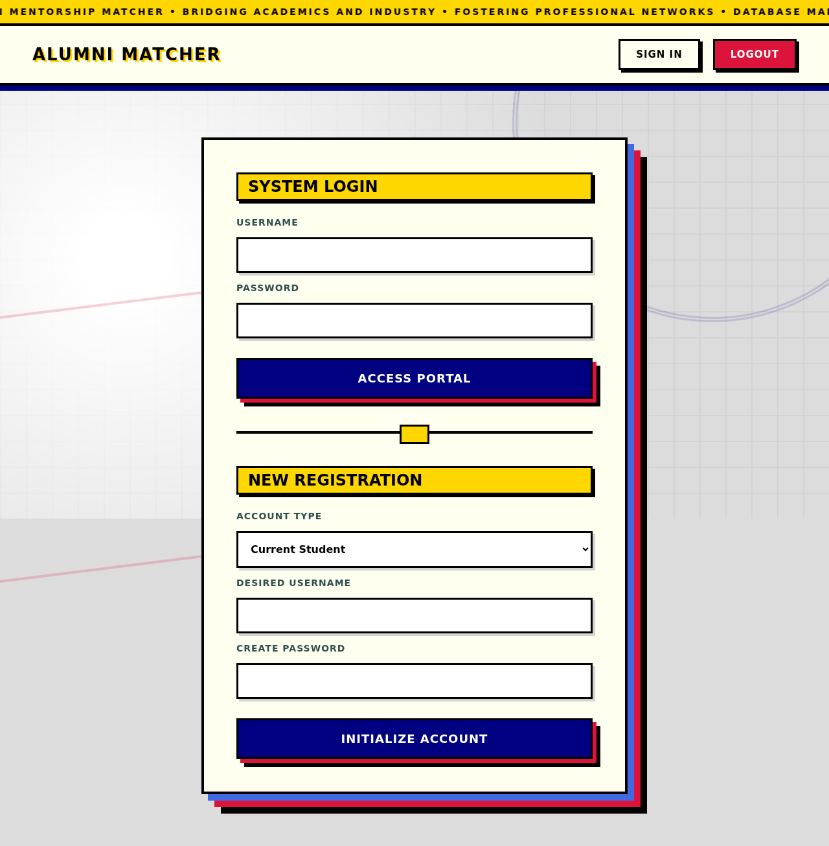
Figure 9.1: Login and registration page
The single entry point. The upper form signs in an existing user; the lower form registers a new Current Student or Alumni Mentor account.
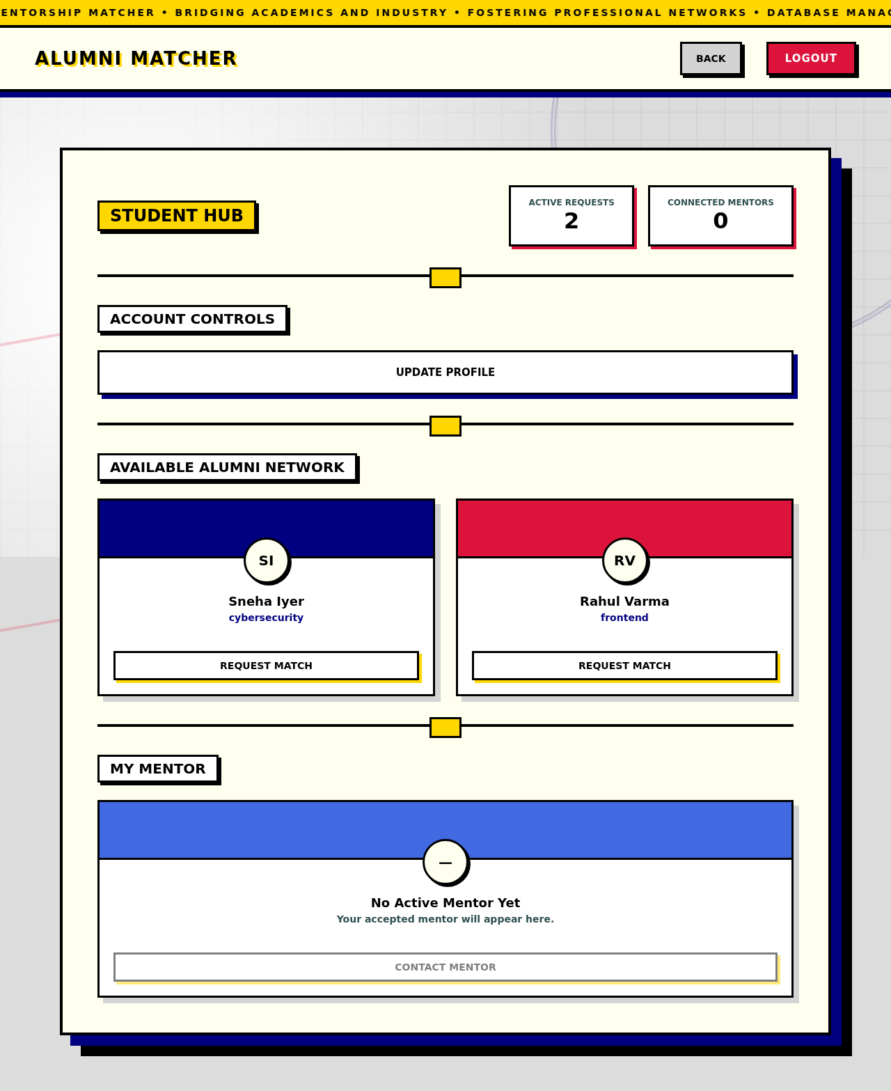
Figure 9.2: Student Hub
Counters show active requests and connected mentors. The directory lists only alumni who are accepting mentees and to whom this student has no pending or accepted request.
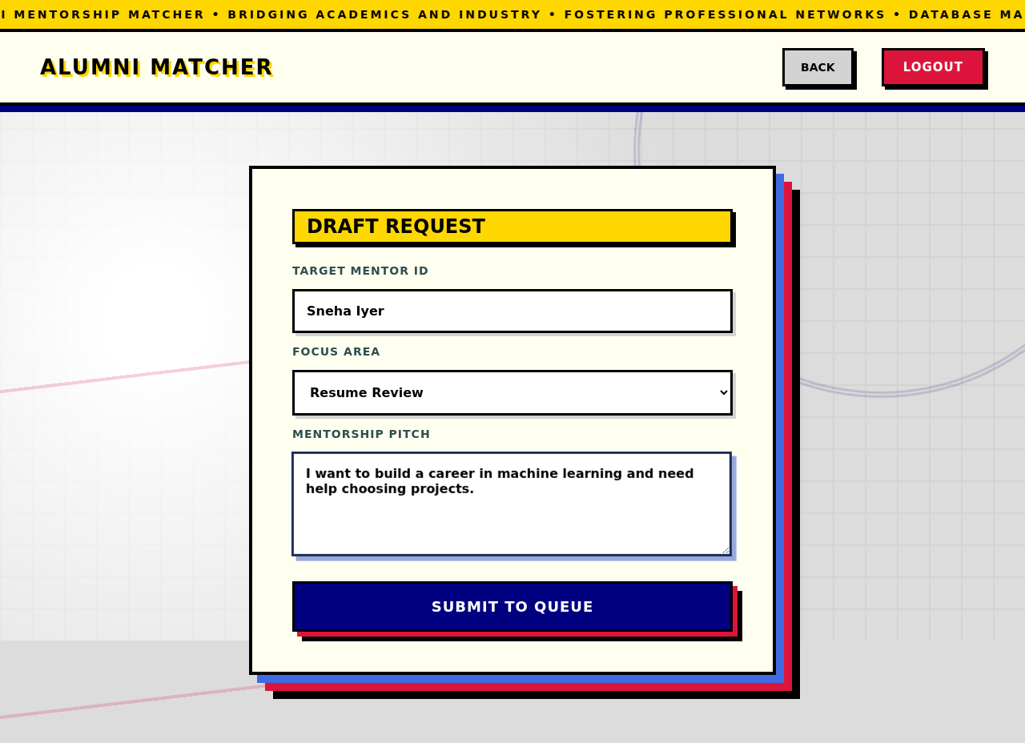
Figure 9.3: Request a mentor form
The mentor name is carried over from the card clicked. The student chooses a focus area and writes a pitch; submitting inserts a pending row in MENTORSHIP_REQUESTS.
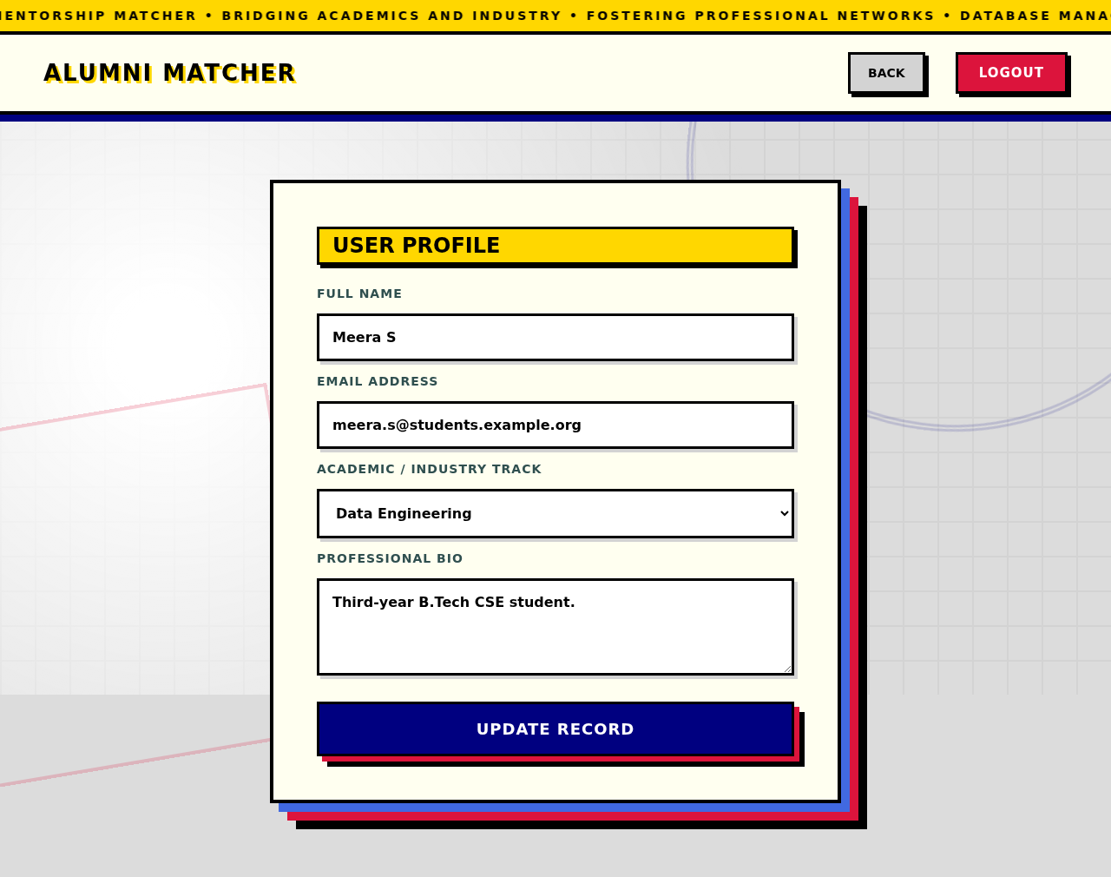
Figure 9.4: Profile page
Loads the current user's name, email, track and bio from USERS and saves changes with an UPDATE.
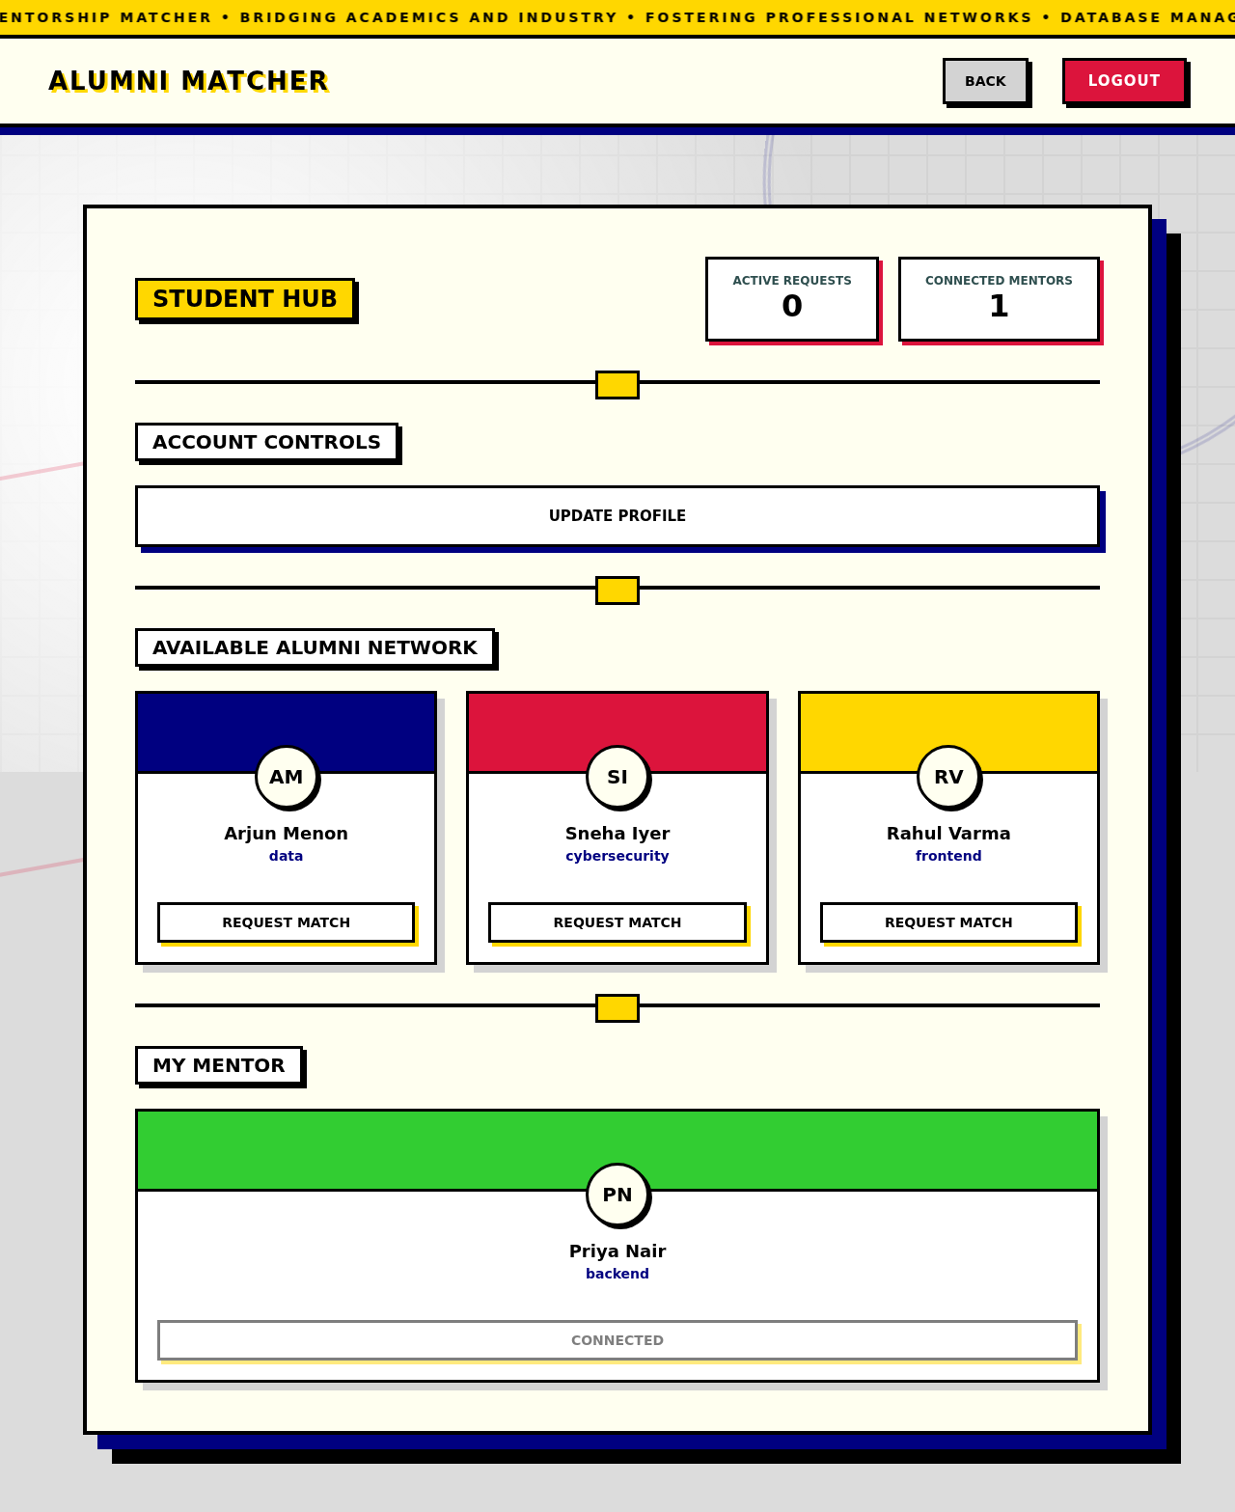
Figure 9.5: Student with an accepted mentor
After the alumnus accepts, the mentor leaves the directory and appears under My Mentor with a Connected button; the counter "Connected Mentors" is 1.
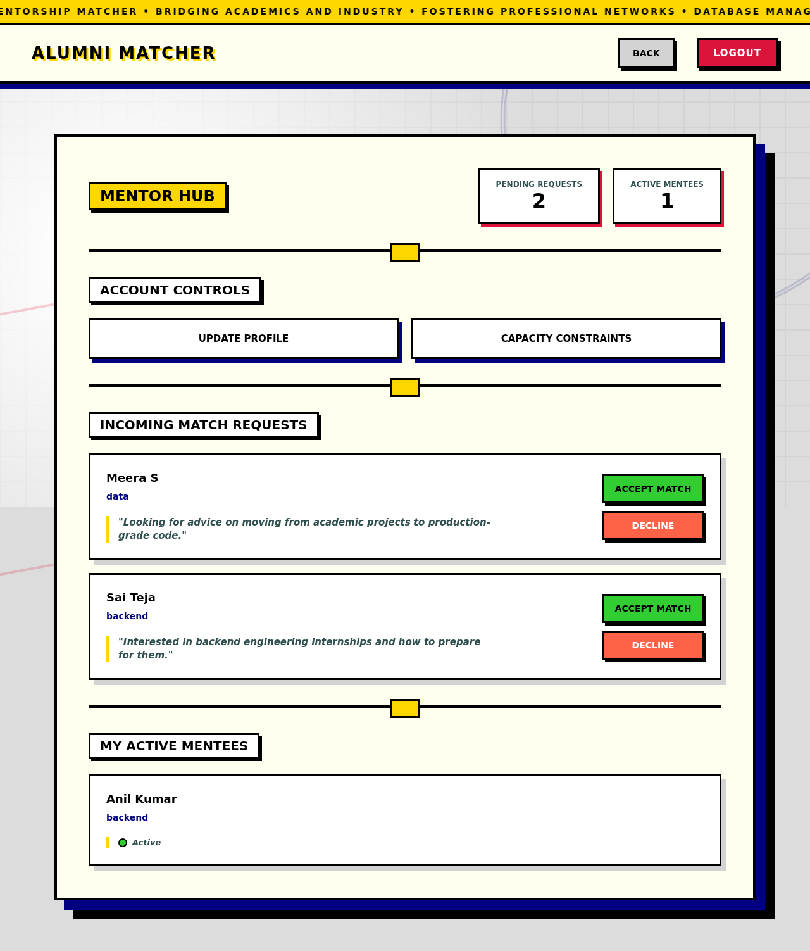
Figure 9.6: Mentor Hub
Incoming pending requests show the student's name, track and pitch with Accept Match and Decline buttons. Accepted students are listed under My Active Mentees.
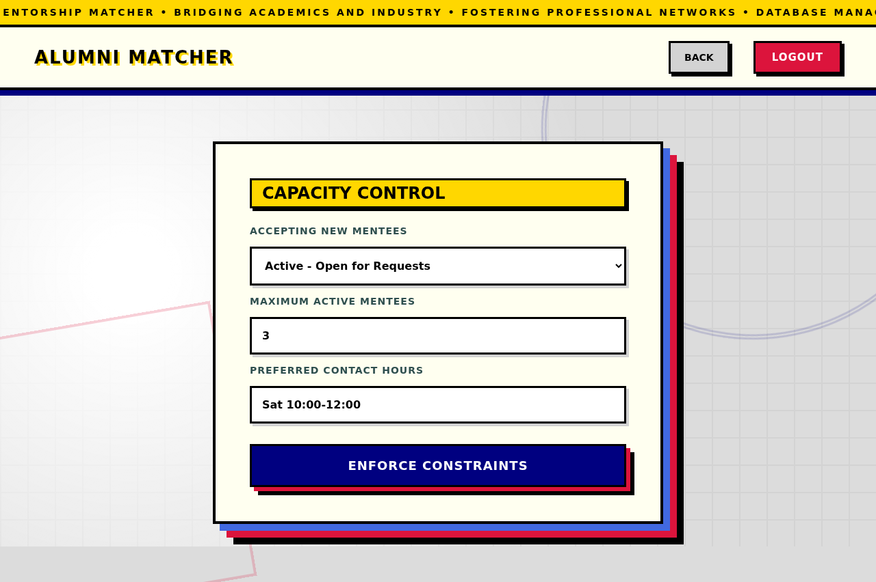
Figure 9.7: Capacity constraints
Writes capacity_status, max_mentees and preferred_hours to ALUMNI_DETAILS. Setting Paused removes the alumnus from every student's directory.
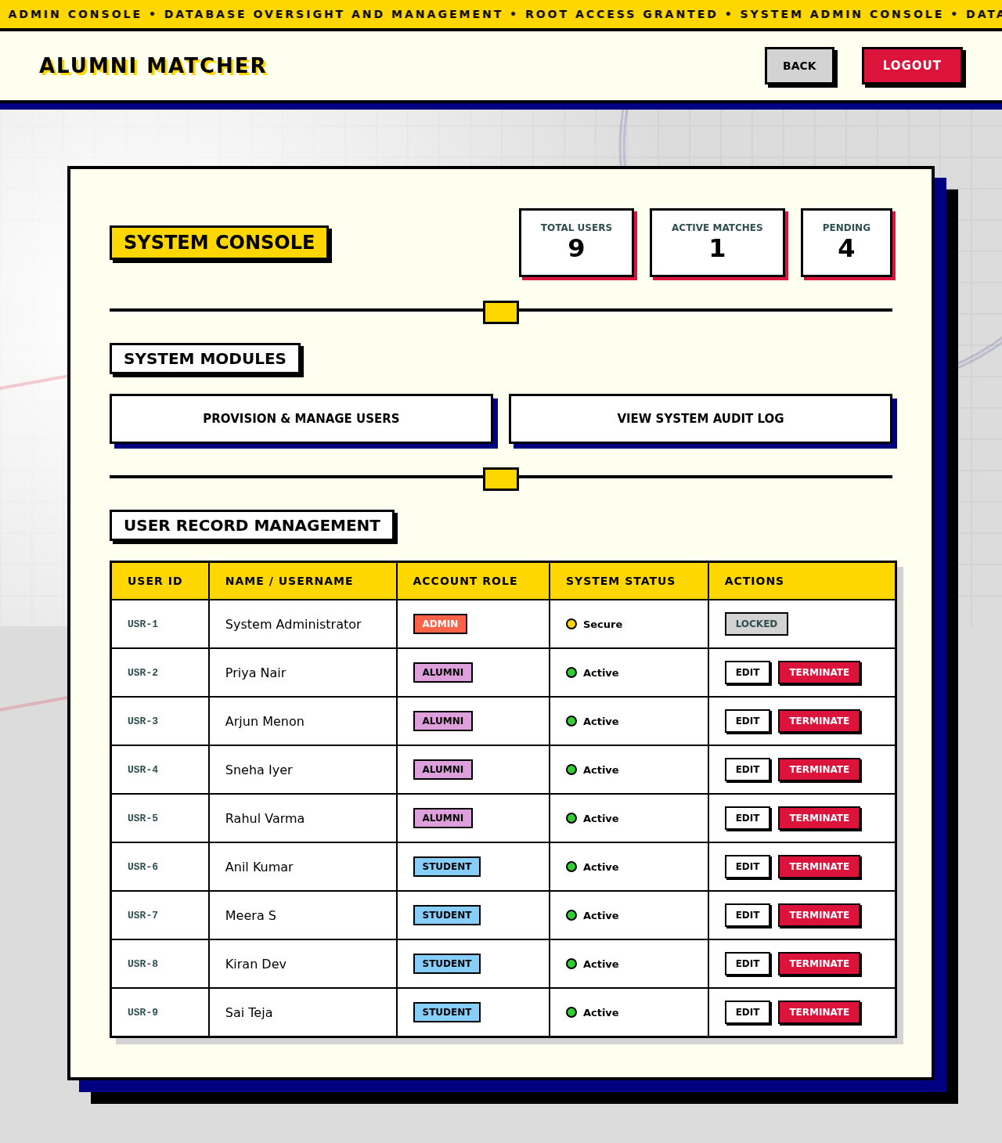
Figure 9.8: Admin Console
Live counts of users, active matches and pending requests computed by aggregate queries, with a user table and links to the management screens.
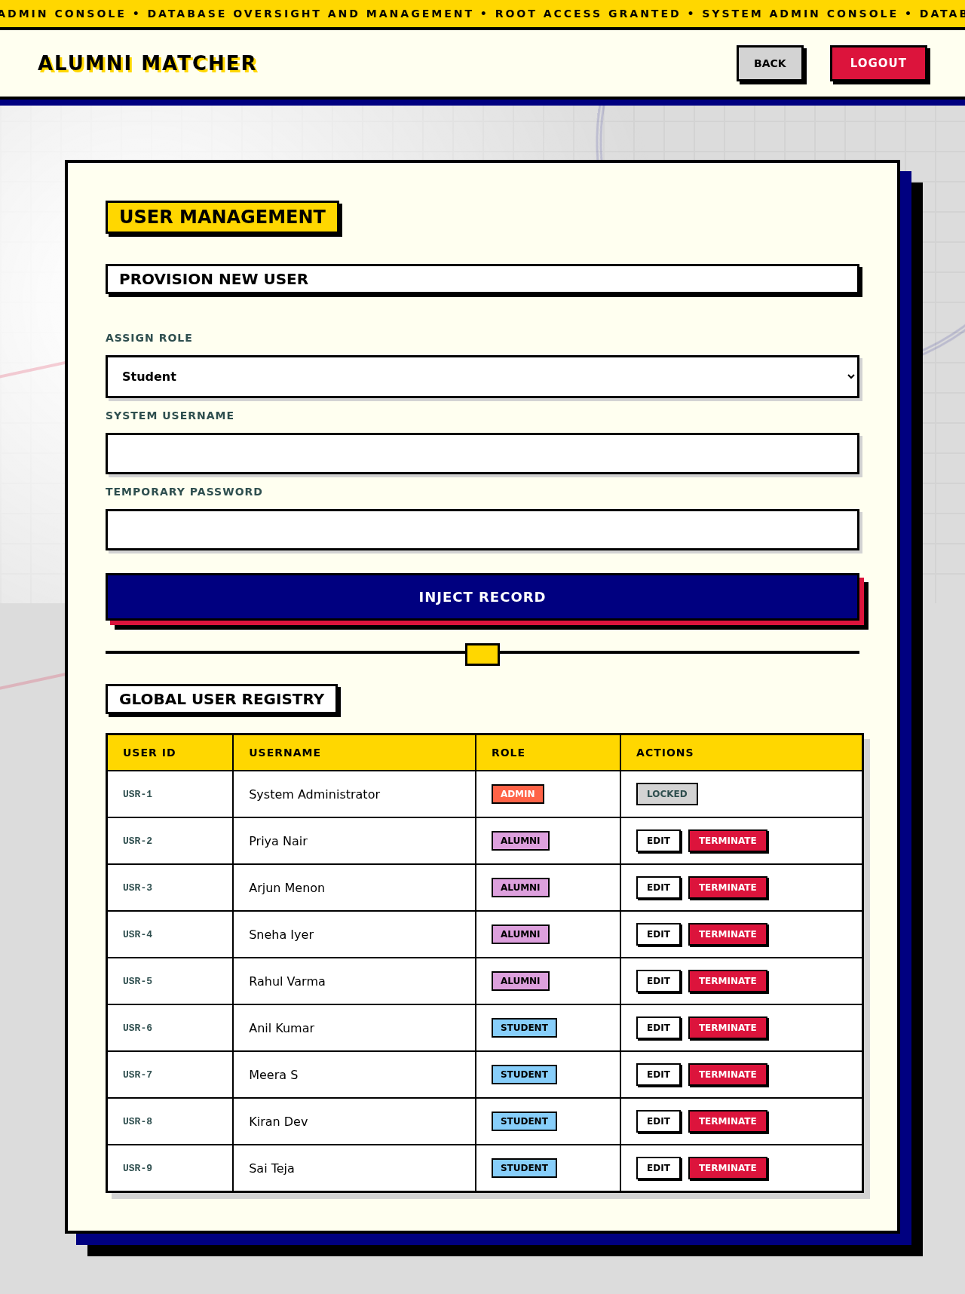
Figure 9.9: User management
Provision a user with a role, or edit and terminate existing users. The administrator row shows Locked because admin accounts cannot be terminated.
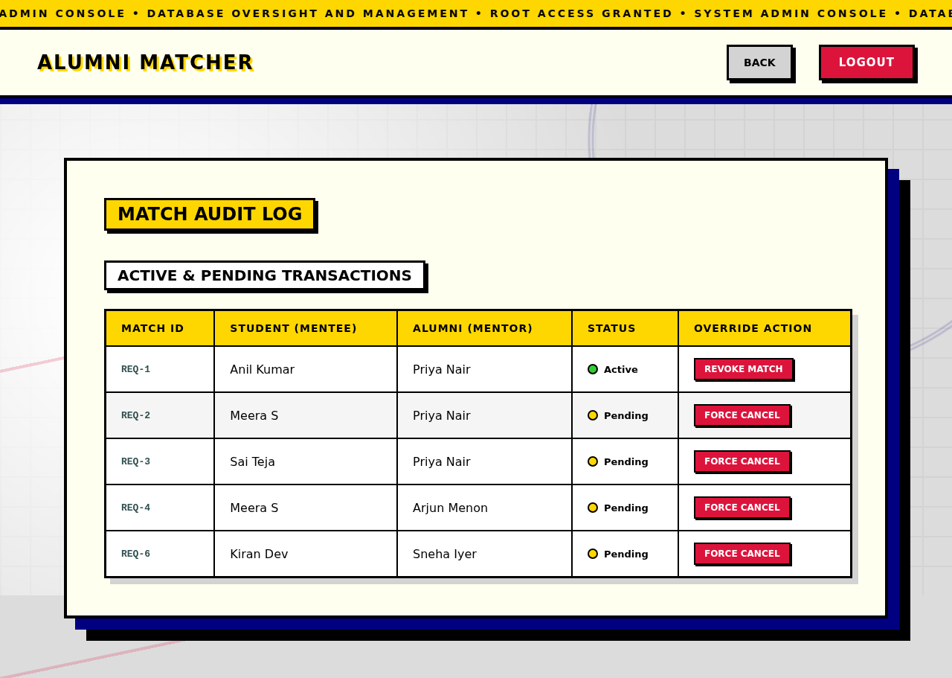
Figure 9.10: Match audit log
Pending and accepted matches from a double join on USERS. Force Cancel and Revoke set the request status to declined.

Database results
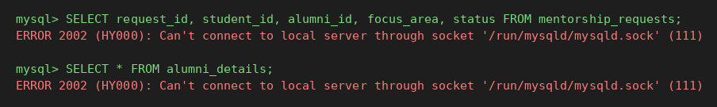
Figure 9.11: MENTORSHIP_REQUESTS and ALUMNI_DETAILS contents
Six requests (one accepted, four pending, one declined) and the four capacity rows created when the alumni registered. The focus_area values are those offered by the request form.
Figure 9.12: Dashboard statistics and requests received per alumnus
The first query returns the three counters shown on the Admin Console (Figure 9.8): 9 users, 1 active match and 4 pending requests. The second uses a LEFT JOIN, so Rahul Varma appears with zero requests.

10. Challenges Faced & Solutions
Challenge | What happened | Solution
Replacing placeholder data with live data | The first interface had hard-coded cards and counters (for example fixed names and fixed statistics) that did not reflect the database. | Built the REST API and a single apiFetch helper; each screen now renders from JSON returned by queries such as the directory, incoming-request and audit queries.
Allowing exactly one session per user | Login could create several tokens for one user, so old tokens would remain valid. | Declared sessions.user_id UNIQUE and used INSERT ... ON DUPLICATE KEY UPDATE, so a new login replaces the token (test TC10).
Modelling alumni-only attributes | Capacity fields would have been NULL for every student and admin if kept on USERS. | Applied an ISA split into ALUMNI_DETAILS, created automatically at registration, and on role change by an admin through an idempotent insert.
Role rules that the schema cannot express | Foreign keys only prove that an id exists in USERS, not that it has the right role. | Role guards in the middleware and checks in the routes enforce who may call what; the remaining gaps are documented (tests TC27 and TC28).
Terminating users safely | Deleting a user must remove dependent rows, but administrators must never be deleted. | Foreign keys use ON DELETE CASCADE, and the delete route checks the role first and returns 403 for admins (TC21, TC26).
Cross-origin access | The frontend (GitHub Pages) and backend (Render) are on different origins, and local testing opens pages from disk. | Configured CORS with an explicit allow-list containing the Pages origin and the null origin used by local files.
Local versus hosted database | The hosted MySQL requires TLS with a CA certificate; a local server does not, and the hosted service provides one pre-created database. | pool.js enables TLS only when ca.pem exists; a second DDL file (schema-aiven.sql) omits CREATE DATABASE.
Free-tier behaviour | The Render service sleeps after about 15 minutes idle, and the free MySQL service can be powered off, so first requests fail or take 30 to 60 seconds. | The client shows a message explaining that the server may be waking up; the README tells testers to check that the Aiven service is Running.
Unhandled errors in asynchronous routes | A failed query inside an async route could leave the request hanging or crash the process. | Added express-async-errors, a global error handler returning a 500 JSON response, and a handler that logs unhandled promise rejections.

11. Conclusion & Future Enhancements

11.1 Conclusion
The project set out to replace informal, untracked alumni outreach with a database-backed mentorship platform, and that objective was met. A normalized four-table MySQL database models users, alumni capacity, mentorship requests and sessions; a Node.js API exposes it through role-protected routes; and three role-specific interfaces let students request mentors, alumni accept and manage their capacity, and administrators govern the system. The deployed application runs on free hosting tiers, and 28 test cases show that authentication, authorization, the request lifecycle, administration and the database constraints behave as designed, with two gaps identified and documented rather than hidden.
The main lesson is about where integrity rules should live. The schema enforces uniqueness, value domains, mandatory relationships, one session per user and cascading deletes. The rules that depend on a row's role or on counts across rows are still enforced only in application code, and the two failed tests show exactly where that is not enough.

11.2 Known limitations
- Sessions do not expire; a token stays valid until the user logs out.
- A student can send more than one pending request to the same alumnus when calling the API directly (TC27).
- The target of a request is not checked to be an alumnus (TC28), and max_mentees is not enforced when accepting.
- Registration inserts into USERS and ALUMNI_DETAILS as two separate statements without a transaction, so a failure between them would leave an alumnus without a capacity row.
- The administrator edit screen uses browser prompt dialogs instead of a styled form, and the free hosting tiers sleep when idle.

11.3 Future enhancements
Enhancement | Approach
Session expiry | Add an expires_at column to SESSIONS, check it in the session middleware, and purge expired rows periodically.
One pending request per pair | Add a unique index over (student_id, alumni_id) and a generated column that is non-NULL only while status = pending, or use a trigger.
Role integrity in the schema | Use triggers (or CHECK and composite foreign keys) so student_id must reference a student, alumni_id an alumnus, and the two differ.
Enforce capacity | Accept requests inside a transaction that counts accepted mentees with SELECT ... FOR UPDATE and rejects the acceptance beyond max_mentees.
Atomic registration | Wrap the USERS and ALUMNI_DETAILS inserts in one transaction.
Indexes and analytics | Add a composite index on (alumni_id, status) and SQL views for mentor load, acceptance rate and request volume.
Notifications and messaging | Email or in-app notifications when a request is made or answered; a messages table for connected pairs.
Security hardening | Password policy, login rate limiting, token rotation, and moving the session token to an HTTP-only cookie.
Usability | Replace prompt dialogs with a proper edit form, add search and filter by track in the directory, and add a mobile-friendly layout.
Quality and operations | Automated API test suite in continuous integration, database backups, and monitoring on the hosted deployment.

References
[1] Elmasri, R. and Navathe, S. B., Fundamentals of Database Systems, Pearson.
[2] Silberschatz, A., Korth, H. F. and Sudarshan, S., Database System Concepts, McGraw-Hill.
[3] Codd, E. F., "A Relational Model of Data for Large Shared Data Banks", Communications of the ACM, vol. 13, no. 6, 1970.
[4] Oracle Corporation, MySQL 8.0 Reference Manual (InnoDB, FOREIGN KEY constraints, ENUM type, INSERT ... ON DUPLICATE KEY UPDATE). https://dev.mysql.com/doc/refman/8.0/en/
[5] Aiven, Aiven for MySQL documentation. https://docs.aiven.io
[6] Render, Render documentation (web services and free instance behaviour). https://render.com/docs
[7] GitHub, GitHub Pages documentation. https://docs.github.com/en/pages
[8] Node.js documentation. https://nodejs.org/docs/latest/api/
[9] Express, Express.js documentation. https://expressjs.com
[10] mysql2, MySQL client for Node.js. https://github.com/sidorares/node-mysql2
[11] bcrypt.js, Optimized bcrypt in JavaScript. https://github.com/dcodeIO/bcrypt.js
[12] Provos, N. and Mazieres, D., "A Future-Adaptable Password Scheme", USENIX Annual Technical Conference, 1999.
[13] OWASP, Password Storage Cheat Sheet. https://cheatsheetseries.owasp.org
[14] Group C16, alumni-mentorship-matcher (project source code). https://github.com/harinandhreddy0411/alumni-mentorship-matcher

