|  |
| --- |
|  |

**Table of Contents**

**1.** **Initial Spec** 2

**2.** **Technology Stack** 2

**3.** **SRS – User Side Features** 3

**4.** **SRS – Service Provider Features** 7

**5.** **SRS – Admin Side Features** 10

**6.** **Project & Payment Terms** 11

**7.** **Post Delivery Support** 12

**8.** **Conclusion** 12

1. **Initial Spec**

**Scope:**

Needs to develop a Responsive website and mobile app for B2B Website which is a place for the Users to find the right persons for their services. The site will have wonderful UI to attract the user and basic social media features for the real time communications like profile, instant chat, Multi Language (English and Arabic), Reviews etc.…

1. **Technology Stack**

To develop and deploy this portal, our suggestion is to use the following technologies for the efficiency.

1. **SRS – User Side Features**

This project will be having the following features.

1. **Registration / Login:** This module allows the user to get registered to the portal and login
   1. Registration: This module allows the users to register to the portal. User can register using their email account or use their social media (Facebook, Twitter, Email) login as well. For the Registration, the system will the details like Name, City, Location, Profile Picture, Mobile Number and address, etc. User will be verifying by the OTP
   2. Login: This module allows users to login to the portal using their registered account / social media profile.
2. **My Profile:** Users can manage their profile through this module.
   1. Account Info: Here the account holder can view the details they have entered while registration. If needed they can change the email ID, Name, Profile Photo, contact information, Address, Personal Appearance Details, and so on. Also they can hide the details service provider except name and Location.
   2. My Fav: Here you could to see the products/services you have added to the Wishlist. The Wish List function itself serves as a way for your customers to select and track their desired items for purchase later.
   3. Booking History: It’s a place to see your past bookings and track the newly booked service.
3. **Search:**
   1. Basic Search: You could search peoples by Country, Keyword, suggestions, nearby location and service name, etc.…
   2. Filter Results: To improve the findability, this option will help user by giving the filtration by country and Product/ Service Category, ratings & reviews, etc.
4. **Book My Service:** This module allows the user to get their needful service.
   1. Service Info: After the fine search user will have a list of service providers profile. The profile will contain the services info they offer, related images, videos, their availability info and so on.
   2. Send Service Request: Once you chose a service provider you can send them a request to book them by simply clicking button.
   3. Book Service: If the service provider accepts your request means, you service has been booked. Once it booked the service provider will let you know the Price, Date, Time, location for the service. If needed user could reschedule the service.
5. **Payment:** 
   1. Pay Online: For each service you booked will have the related amount which has been already agreed by you and the service provider. Once the service has been complete user can pay the amount through the site.
6. **Live chat:** 
   1. Private Chat: For the real time communication, this system is having the Private message board. Here you could text to the selected person which visible to only you and the person whom you want to chat.
7. **Ratings and Reviews:** 
   1. Ratings & Reviews: Registered user could able to rate and comment on products/service which they have consumed. Also, they can give the start ratings out of 5. This will help other users to choose the best providers on bookings.
8. **SRS – Service Provider Features**
9. **Registration / Login:**
   1. Registration: This module allows the service providers to register to the portal. While the signup, the service provider is requested to fill the Name, contact info, location and email ID. Also they can register using social media (Facebook, Twitter, Email) login as well. And the system will verify the user by sending OTP to their Email ID.
   2. Login: This module allows users to login to the portal using their registered account / social media profile.
10. **My Profile:**
    1. Account Info: Here the account holder can view the details they have entered while registration. Also, it will ask some other additional information too like Short Description, Location, ID Proof, License, and so on to show in the profile
    2. My Services: Here the provider can enter what are the services he is offering, and its related information, images.
    3. My Bookings: It’s a place to see past bookings you served, booking requests, and scheduled bookings.
11. **Manage Bookings:**
    1. Past Bookings: It shows you the details about the service you made, to whom, is they paid or not and the ratings, reviews, comments they issued for your service.
    2. Booking Requests: It’s a place where you will can see whom all are interested or in need of your service. You will have the option to accept or deny the requests.
    3. Scheduled Bookings: Once you have accepted the request you and the end user can discuss and fix a date for the service. So, the calendar will mark your bookings and send you a reminder. As well as it helps the user to see your availabilities.
12. **SRS – Admin Side Features**

This portal administrator will have the following features.

1. **Project & Payment Terms**

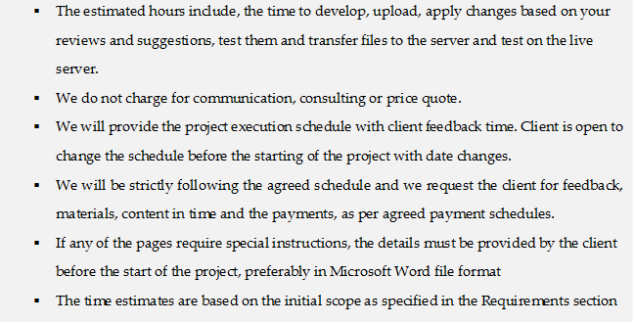

1. **Post Delivery Support**

* IStrides will provide 2 months free Post Delivery Support (PDS) from the date of project Signoff.
* During the PDS if any bugs / issues found or raised in the final delivered portal, it will be fixed free of cost.
* Within the PDS tenure, the code delivered by IStrides shall not be modified / changed by client and anyone representing client and if found that the code is modified / changed then the support will be terminated in immediate effect.
* During the PDS IStrides will allot a total of 60 man-hours to do any minor changes / modifications to the portal. If any change request goes beyond the allotted 60 hours, then it will be treated as new development and will be billed separately. This 60 hours will not be carried forward or extended.

1. **Conclusion**

* We wanted to thank you for giving us this opportunity to bid on your project requirement.
* Hope we have completely covered your project specification.
* Also, we have tried our best to provide the best possible rates and hope you will find it satisfactory.
* Looking forward for a positive reply and a great opportunity to work with you.