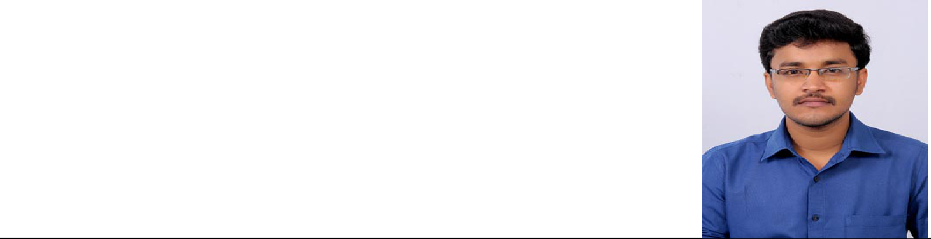**MUTHUKUMAR M**

 mckumaran8794@gmail.com  +91-8220433307

**Objective**

To seek a Job that will enable me to utilize my ability and further develop my innovative

skills to work with different emerging technologies.

**Educational Background**

**Master of Computer Applications,** Kalasalingam Academy of Research And Education, KrishnanKoil, Srivilliputtur.

* CGPA **–** 7.5

**Bachelor of Science (CS & IT ) –** Ayya Nadar Janaki Ammal College, (Autonomous)Sivakasi.

* CGPA **–** 6.2

**HSC –** C.M.S Hr.Sec School, Srivilliputtur.

* 70% Marks

**SSLC –** G.S Hindu.Hr.Sec School, Srivilliputtur.

* 75% Marks

**Computer Proficiency**

|  |  |  |
| --- | --- | --- |
| O | Language | : JAVA, C++, C |
| O | Web Technologies | : PHP, HTML, CSS, Javascript |
| O | Database | : MYSQL |

**Academic Projects**

* **Blood And Organ Donor Administration System**

This application is intermediate between the donors and hospitals. This contains the full details about the donor. The person also can register in this application who is willing to donate the blood. This application also contains the details about the hospitals. The user can know full details about the donor like blood group. The admin can view and generate the reports like both district and blood group wise.

**Technologies used:** PHP, MYSQL, HTML, CSS.

* **Linga Global School**

It contains the full details about the school. The new announcement will be shown on the website. The admissions is done through online. The admin can view the details about the students and also send the informations about the students through mail.

**Technologies used:** PHP, MYSQL, HTML, CSS.

**Link: www.linga school.com**

**Area of Interest**

* Object Oriented Programming Concept

**Achievements**

* Won Lots of prizes in Intra and Inter college competitions.
* Organized 2nd **International Conference on “Applied Soft Computing Techniques** **(ICASCT’18)”** held at Kalasalingam Academy of research and Education.
* Organized National Level Symposium **“Softnival-2k17”** held at Kalasalingam Academy of research and Education.
* Organized State Level Symposium **“QMAZE 2k15”** held at Ayya Nadar Janaki Ammal College.

**Strength**

* Leadership Skills
* Good Team Player
* Amphibian

**Other Interests**

* Playing Chess
* Teaching
* Designing

**Declaration**

I honestly declare that above mentioned details are true to the best of my knowledge. Yours Truly,

Date :

Place : (M.Muthukumar)