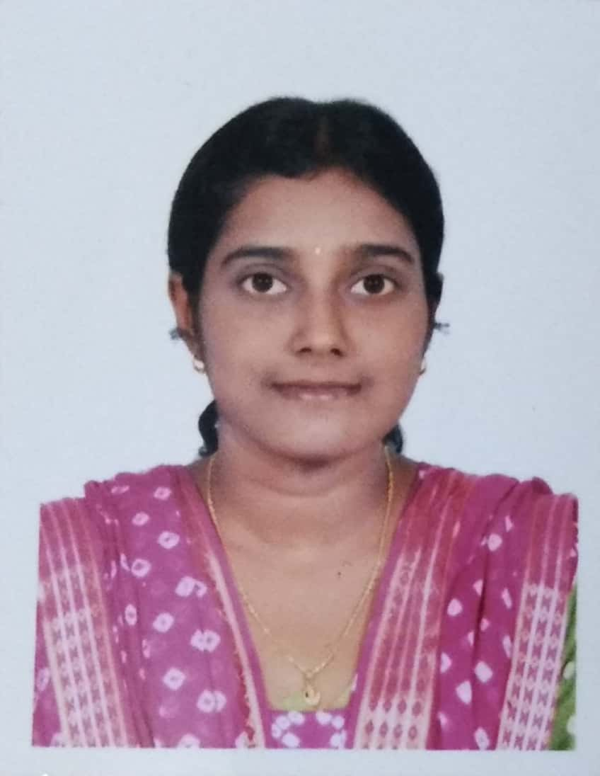**RESUME**

**ABIRAMI M** contact no.: 9445810515(mob.)

email-saiabirami24@gmail.com

**__________________________________________**

**OBJECTIVE:**

Seeking a career in an organization that has an environment which encourages continuous learning and provides exposure to new technologies and to achieve personal and professional growth along with the organization.

**EDUCATION:**

|  |  |  |  |
| --- | --- | --- | --- |
| **COURSE** | **SCHOOL/UNIVERSITY** | **PERCENTAGE** | **YEAR OF PASSING** |
| **X** | ST.John’s matriculation higher secondary school | 83.6 | 2005 |
| XII | ST.John’s matriculation higher secondary school | 90.9 | 2007 |
| B.Sc.,Physics | Sri Sathya Sai Institute of Higher Learning,  Anantapur | 79.6 | 2010 |
| M.Sc.Materials Science | CEG Campus ,Anna University | 91.4 | 2012 |

**SOFT SKILLS:** HTML, CSS, BOOTSTRAP, JAVA, PHP, MYSQL,

Software testing course in NIIT.

**EXPERIENCE:** DEC 2017 – Present: Software Engineer in Mercu**.**

* Working as full time PHP Web developer.
* Have Knowledge and interest in Web designing too.

**ACHIEVEMENTS :**

* Received a gold medal for securing 1st rank in M.Sc.
* Received JayashreeShyamSundar Endowment Award for securing highest mark in M.Sc.
* Received Senthil Natarajan Endowment Award for securing 1st rank in M.Sc.
* Received proficiency awards in VI and XI standards.

**EXTRA CURRICULAR :** Participated in seminars and projects in collage.

**ACTIVITIES** Participation in tamil debates.

**LANGUAGES KNOWN :** English, Tamil

**HOBBIES :** Sketching, listening to music, watching cricket.

**PERSONAL DATA** **:** Date of birth : 24-09-1989

Birth Place : Madurai

Father’s Name : Late Mr. M. Maraimalai

Mother’s Name : Mrs. PL.Visalakshi

Gender : Female

Nationality : Indian

**DECLARATION**

I hereby declare that the above information is true to the best of my knowledge and belief.

Date : ABIRAMI.M

Place : Chennai