Twin-Electra 2026 · Engineer's Day · Digital Twin Machine Arena
AI-Based Digital Twin for Eccentricity Fault Diagnosis in Axial and Radial Flux PMSMs
Explanation document
Team: N Harikrishnan (CB.EN.U4EEE23110) · P Manish (CB.EN.U4EEE23125) · Srivarshan P (CB.EN.U4EEE23152)
Mentor: Dr. Praveen Kumar N · Amrita Vishwa Vidyapeetham

1. Objective and problem statement
Rotor eccentricity (the rotor sitting off-centre inside the stator) is one of the commonest mechanical faults in permanent-magnet synchronous machines. It makes the air gap uneven, adds harmonics to the stator current, increases torque ripple and vibration, and can finally let the rotor touch the stator. Detecting it early, and knowing how severe it is, avoids unplanned outages.
The objective of this work is a digital twin that, from the three-phase stator current alone (no extra sensor), tells an operator:
- whether the machine is healthy or has an eccentricity fault,
- what kind of fault it is (static or dynamic eccentricity for the radial machine; rotor tilt or X-displacement for the axial machine),
- how severe it is, as an eccentricity percentage, with an uncertainty band,
- how far the answer can be trusted (validation on severity levels that the models have never seen).
The twin is built for two machine topologies, an axial flux PMSM (AFPMSM) and a radial flux PMSM (RFPMSM), so that the same current-based method can be compared on both.

2. System being modelled
Both machines are 0.55 kW, 220 V, 1500 rpm, 8-pole surface-mounted PMSMs fed by a PWM inverter at 100 Hz electrical frequency. They were modelled with the finite-element method in ANSYS Maxwell (2-D/3-D) and driven through a PWM converter circuit (Simplorer). The block diagram below shows the drive, and where the current signal is taken.
Parameter | Axial flux PMSM | Radial flux PMSM
Rated output power | 550 W | 550 W
Rated speed | 1500 rpm | 1500 rpm
Rated voltage / frequency | 220 V / 100 Hz | 220 V / 100 Hz
Poles | 8 | 8
Rated torque | 3.502 N·m | 3.511 N·m
Back-EMF (phase RMS) | 88.13 V | 63.13 V
Air-gap flux density | 471 mT | 712 mT
Total losses | 81.04 W | 101.64 W
Efficiency | 89.91 % | 84.44 %
Total weight | 7.12 kg | 11.14 kg
Control / PWM | PWM, modulation index 0.9 | PWM, modulation index 0.9

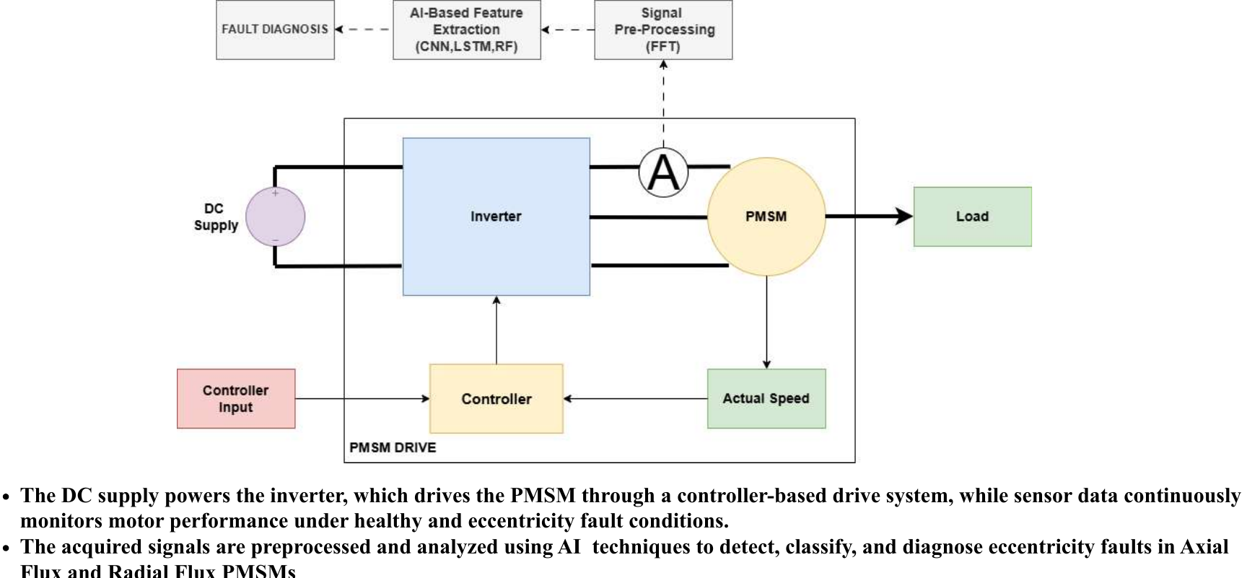
Figure 1. Drive and signal-acquisition block diagram (DC supply, inverter, PMSM, controller; stator current taken for AI-based diagnosis).

3. Modelling methodology

3.1 Fault modelling in ANSYS Maxwell
- Radial flux machine. Eccentricity ratio ε = e / g, with air gap g = 0.5 mm and rotor offset e (for example ε = 20 % gives e = 0.1 mm). Static eccentricity (SE): the rotor is shifted and rotates about its own, shifted axis, so the minimum air-gap position is fixed. Dynamic eccentricity (DE): the rotor rotates about the stator axis while its own centre is displaced, so the minimum air-gap position rotates with the rotor.
- Axial flux machine. Two fault families were simulated: rotor tilt (angular eccentricity; for example a 20 % tilt with a 1 mm nominal gap and 47.5 mm mean radius gives a displacement of 0.2 mm and a tilt angle of about 0.24°) and rotor X-displacement (rotor shifted in the plane, axis kept parallel).
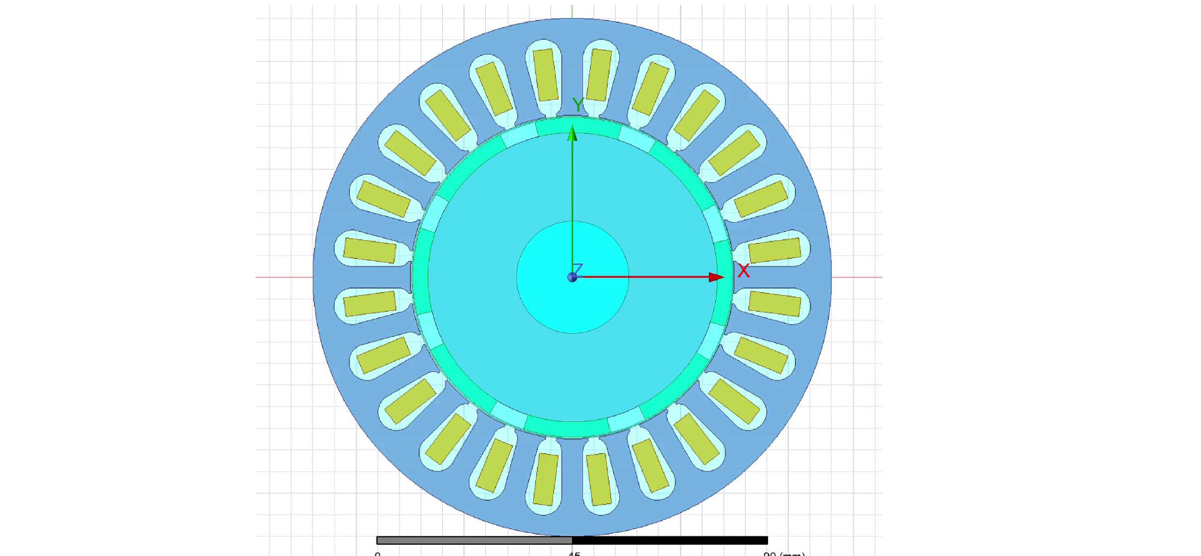
Figure 2a. Radial machine, static eccentricity model.
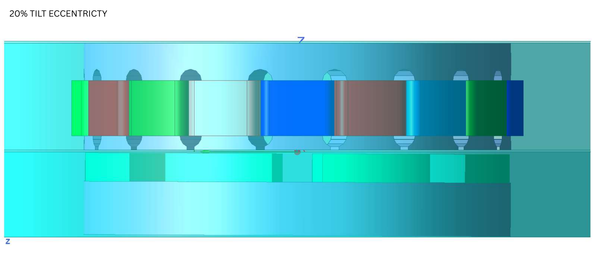
Figure 2b. Axial machine, 20 % rotor-tilt eccentricity model.

3.2 Signals and datasets
For each fault case the three phase currents (Ia, Ib, Ic) were exported as CSV files (columns: Time, Phase A, Phase B, Phase C). The file name carries the label (for example "Currents_static_35.csv", "Stator Currents-tilt-30%.csv").
Machine | Training files | Unseen test files
Axial flux | healthy; tilt 10 %, 30 %; X-displacement 4 %, 20 % (5 files) | tilt 20 %; X-displacement 10 % (2 files)
Radial flux | healthy; static 10, 20, 35, 40, 60 %; dynamic 10, 20, 35, 40, 60 % (11 files) | static 15, 25 %; dynamic 15, 25, 50 % (5 files)

The test files use severity levels that do not appear in training, so every test asks the twin about a severity it has never seen, not about a memorised file.

3.3 Signal processing and learning
The two machines use two different pipelines because their data are different.
- Axial pipeline (window based). Each record is cut into overlapping 1024-sample windows (step 128, up to 300 per file; 410 windows from the 5 training files). For each window, 224 features are computed: time-domain statistics and a 48-band log power spectrum for each phase and for the A+B+C combination. Five classical models vote on the fault class (random forest, LS-SVM with RBF kernel, KNN, back-propagation neural network, extreme learning machine). Five deep-learning models read the raw three-phase waveform (1D-CNN, LSTM, BiLSTM, GRU, CNN-LSTM, trained in the browser with back-propagation through time). A deep model that does not learn (under 70 % training accuracy) is shown but excluded from the vote. Severity is estimated by regressors (random-forest regression, kernel ridge, KNN, ELM and the deep models), combined by a weighted median whose weights come from each model's hold-out error.
- Radial pipeline (recording based). The irregular simulation time axis is resampled to a regular 400 kHz grid and decimated to 20 kHz with an anti-alias filter. The three currents are turned into a Park vector. The first 20 ms (start-up transient) and the last 1 ms are discarded, the supply frequency f0 is located, and Fourier coefficients are computed over a whole number of cycles. From these we take the fundamental, the 5th, 7th, 11th and 13th harmonics, asymmetry (forbidden-line) indices and harmonic phases. One recording gives one sample (its cycles are identical, so they are not counted as separate samples). Severity is the average of a ridge regression and a linear SVR, each tuned by an inner leave-one-level-out loop. The type (SE or DE) is decided by an Extra-Trees classifier (an RBF-SVM is reported for comparison). The method follows our scikit-learn reference script, which is included in the source folder.

3.4 Validation method
- Leave-one-level-out (radial): all files of one severity level are held out together, the models are fitted on the rest and asked about the held-out files. This is the honest test for "a severity the model has not seen".
- Bootstrap 95 % confidence intervals on every metric; label-permutation tests (100 shuffles) show whether a result is better than chance.
- A classification result is called reliable only when the permutation p-value is at most 0.05 and the accuracy beats the majority-class guess.
- Separate unseen test files (the official test split) are analysed last and reported file by file.

4. Digital twin architecture
The twin is a single web page (Twin-Electra_Dashboard.html). It needs no server and no installation, and the files never leave the computer. The page has two machine tabs. In step 1 the operator uploads a training zip; the page learns the twin in the browser and stores it in the browser database (IndexedDB), so it survives a restart. In step 2 the operator drops new current files (.csv, .xls, .xlsx) and the twin answers in a few seconds.
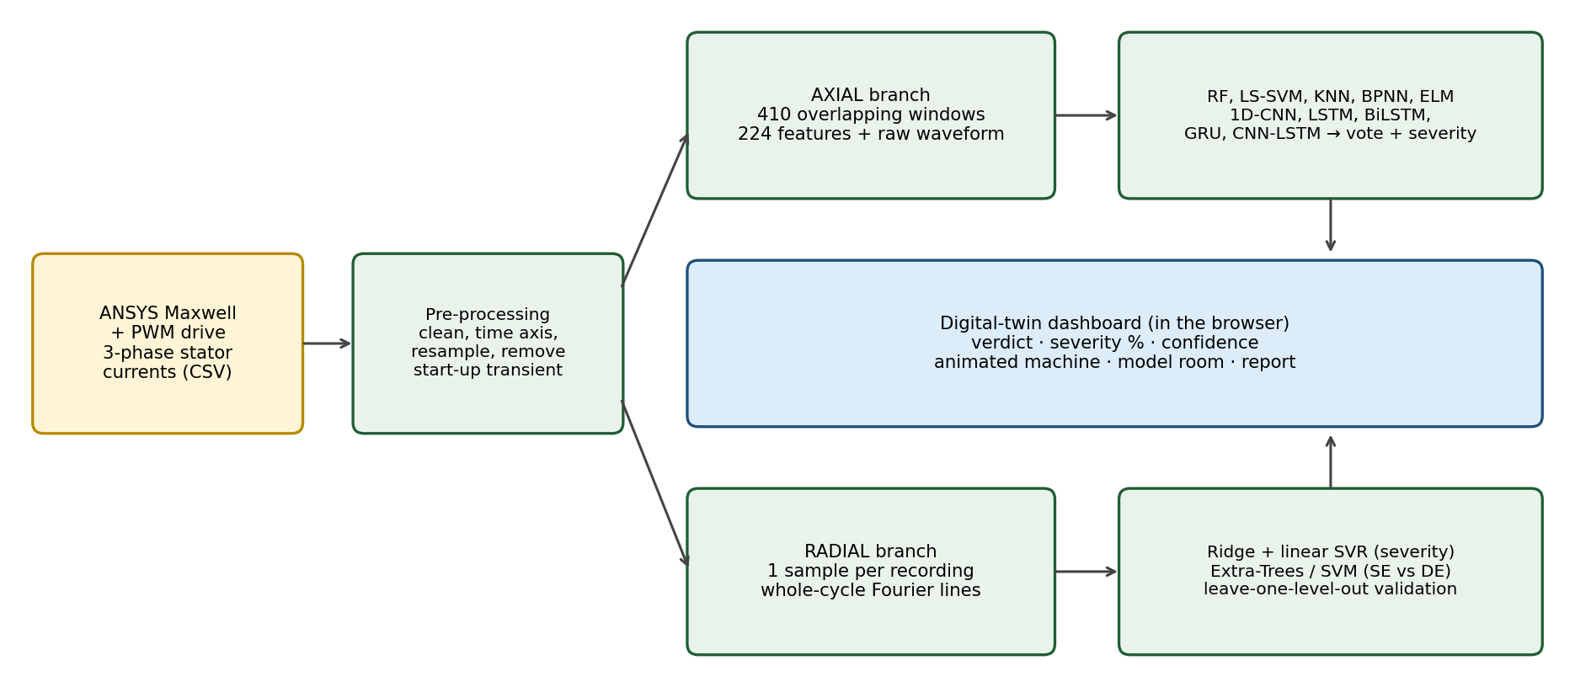
Figure 3. Architecture of the digital twin.
Outputs shown for each analysed record:
- Verdict banner with fault type and estimated severity (%), plus a health index and an animated machine drawing that tilts, shifts or orbits according to the estimate.
- Axial: per-model class votes, severity predicted by each model, ensemble confidence, and a data-familiarity check (is this record inside the training range?).
- Radial: severity with an 80 % interval (from errors on unseen levels), P(dynamic), a reliability flag for the SE/DE type, out-of-range feature warning, Park-vector locus and line spectrum.
- "Model room" with the validation tables and plots, and a "Batch & report" tab with copy-ready text.
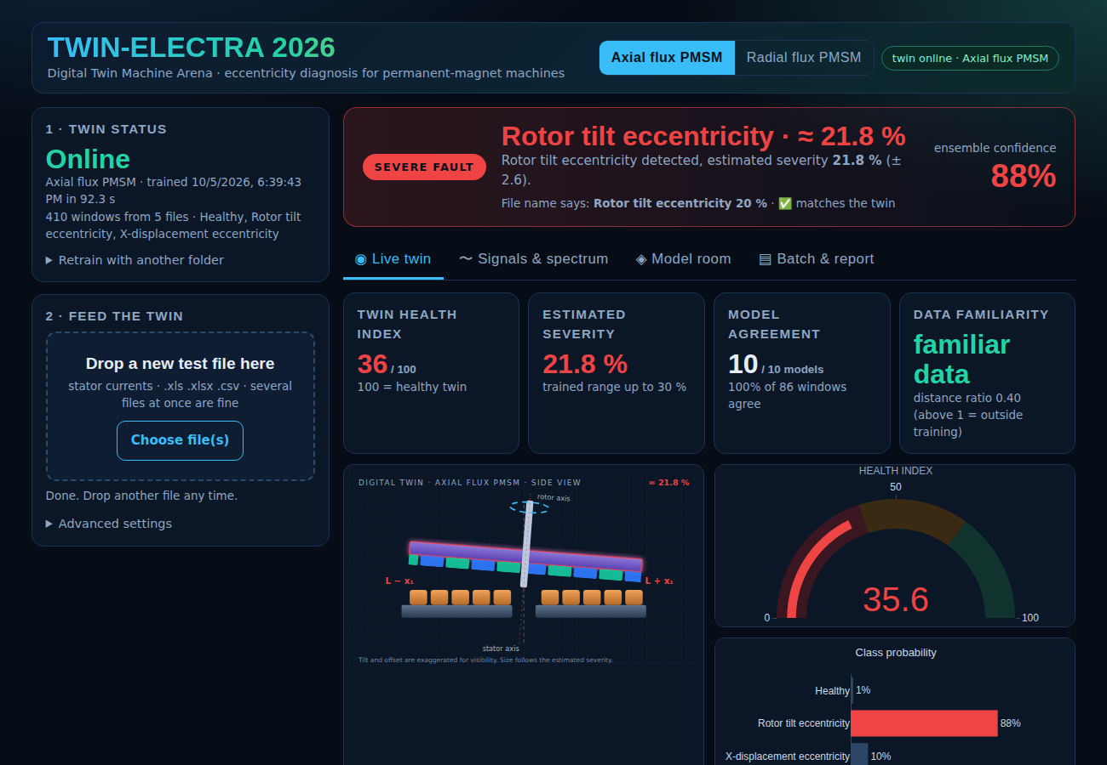
Figure 4. Dashboard, axial machine, unseen test file "tilt 20 %".

5. Case studies / scenarios

5.1 Axial flux PMSM (2 unseen files)
Test file | True label | Twin verdict | Severity estimate | Confidence
tilt-20% | Rotor tilt, 20 % | Rotor tilt eccentricity (correct) | 21.8 % (± 2.6) | 88 %
x(disp)-10% | X-displacement, 10 % | X-displacement eccentricity (correct) | 7.1 % (± 2.2) | 81 %

5.2 Radial flux PMSM (5 unseen files)
Test file | True label | Twin type | Severity estimate | Error (points) | 80 % interval
static_15 | Static 15 % | SE (correct) | 22.5 % | +7.5 | 7–38 %
static_25 | Static 25 % | SE (correct) | 26.1 % | +1.1 | 11–41 %
dynamic_15 | Dynamic 15 % | DE (correct) | 14.2 % | −0.8 | 0–29 %
dynamic_25 | Dynamic 25 % | DE (correct) | 19.6 % | −5.4 | 4–35 %
dynamic_50 | Dynamic 50 % | DE (correct) | 43.8 % | −6.2 | 29–59 %

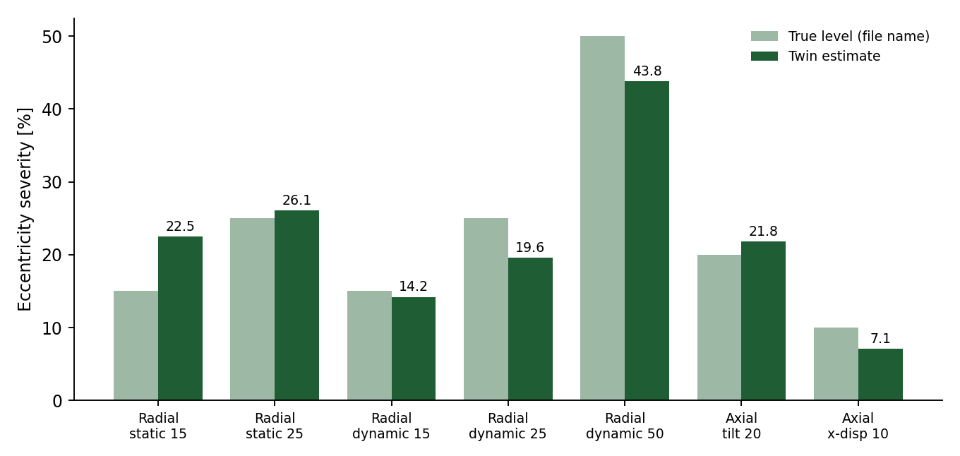
Figure 5. True eccentricity level (from the file name) versus the twin's estimate for all seven unseen files.

6. Results and observations
- Severity is learnable. On the seven unseen files the mean absolute error is 3.7 percentage points (radial 4.2, axial 2.4 on two files). On the radial training set, leave-one-level-out gives a mean error of 12.8 points over all levels (10.8 on interior levels) against 18.3 for always guessing the average, i.e. 30 % better than the baseline (permutation test p = 0.05). The error on whole held-out levels is larger than on the 5 test files because holding out a level removes one of only five levels from training.
- Axial fault type is recognised. Both axial test files were assigned to the right fault family, with 81–88 % ensemble agreement, and the dashboard marked both records as familiar data.
- Radial SE versus DE is not statistically proven. All five radial test files were typed correctly, but the leave-one-level-out accuracy on the training set is 50 % (the majority guess), with permutation p = 0.55. With only 10 faulty files, 5 per type, the data cannot show that SE and DE are separable from the stator current. The dashboard therefore flags the type as "tentative". We report this openly rather than hide it: five correct answers out of five could be luck, and the validation says so.
- Why SE and DE look alike in the current. Both faults add very similar harmonic and asymmetry content to the current (the asymmetry index stays between 0.1 and 0.2 % of the fundamental on this data), and severity changes the features more than type does.
- Models. On the axial data the deep models trained to 84–100 % training accuracy and agreed with the classical models; the severity estimates of the individual models differ (for x-disp 10 %: 2.6 % to 9.1 %), which is why a weighted median and an uncertainty band are shown instead of a single model.
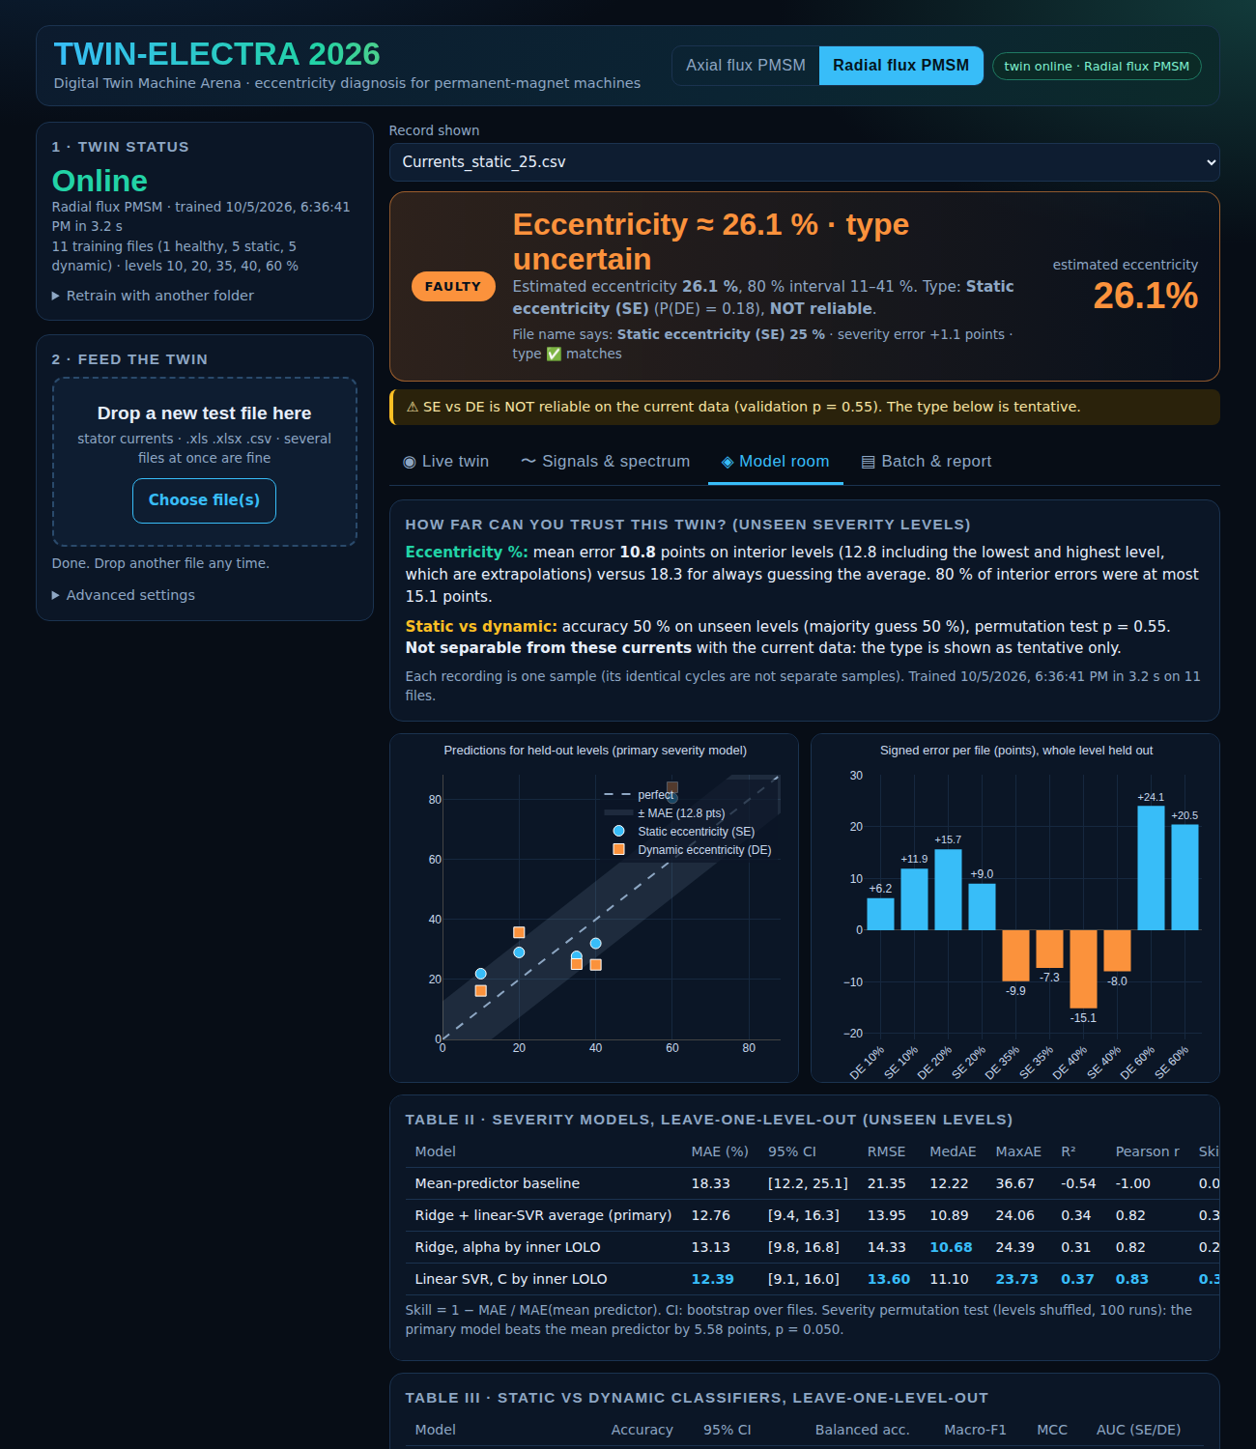
Figure 6. Radial "Model room": validation of the severity model on held-out levels and the trust statement.

7. Limitations and assumptions
- All data come from finite-element simulation, not from a physical test bench. Real machines add noise, manufacturing asymmetry and load changes. The results have not yet been verified on a physical test bench.
- Small data: 5 axial and 11 radial training files. Results on unseen files are therefore indicative, and the confidence statements shown in the dashboard are the real measure of trust.
- Only pure faults are modelled: mixed eccentricity (SE + DE) and other faults (demagnetisation, inter-turn short circuit) are not in the training data and would be mis-labelled.
- The twin is trained at one operating point (1500 rpm, 100 Hz, one load). Other speeds or loads need new training data.
- The simulated current is almost exactly periodic from cycle to cycle (cycle deviation about 0.02–0.12 %), so the radial method uses one sample per recording; a measured current would need averaging over cycles.
- Severity levels outside the training range (for example 70 % when training stops at 60 %) are extrapolations; the dashboard warns when a record is outside the range seen in training (radial) or unfamiliar (axial).
- Axial severity regression is trained on only two fault families with two or three levels each; its ± band is an ensemble spread, not a statistical confidence interval.
- Everything runs in the browser, so the training time depends on the computer (about 3 s radial, about 90 s axial, mostly the deep models).

8. Other information needed to understand the model
- Naming convention. The label is read from the file name: "healthy", "static"/"dynamic" or "tilt"/"x(disp)", and the percentage. Files in a folder called "train" are used for training and a folder called "test" for hold-out checks.
- Reproducibility. Radial results can be re-created in Python with the reference script in 3_Source_Code/reference_modules. The JavaScript port reproduces the scikit-learn features to about 1e-7, the severity models to within 0.012 percentage points and the batch labels exactly. Extra-Trees uses a different random generator, so tree-level details differ.
- Privacy. No data are uploaded; the page works offline once opened (the web fonts are optional).
- Folder contents. See README.md for the layout and for step-by-step instructions to reproduce the demonstration.

