**19CSE463 - Mobile App development with Java**

**Calculator Assignment**

**Name : Harin B S**

**Roll no: AM.EN.U4EAC21030**

1. Draw the detailed class Diagram for your solution.

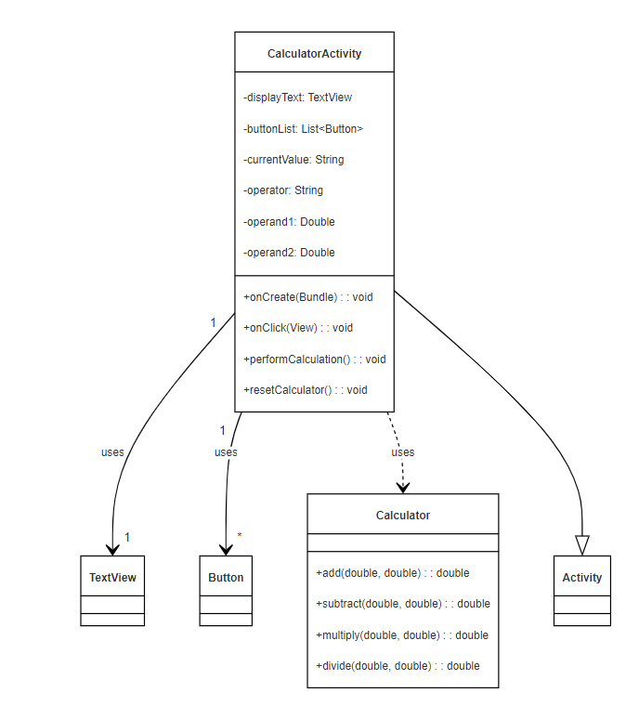

This class diagram represents the structure of a simple calculator application built with Android components, showing the relationship between the CalculatorActivity, Calculator, and other UI elements such as Button and TextView.

**Classes:**

1. **CalculatorActivity**
   1. This class is the main controller of the calculator app and inherits from Activity (which represents any Android activity).
   2. **Attributes:**
      1. displayText: TextView: Displays the current value or result of the calculations.
      2. buttonList: List<Button>: Holds all the buttons for digits and operators.
      3. currentValue: String: The current input value entered by the user.
      4. operator: String: Stores the current operator selected (e.g., +, -, *, /).
      5. operand1: Double and operand2: Double: Stores the operands for performing calculations.
   3. **Methods:**
      1. onCreate(Bundle): void: Initializes the activity and sets up the UI components (buttons, display).
      2. onClick(View): void: Handles button click events for digits and operators.
      3. performCalculation(): void: Executes the selected arithmetic operation.
      4. resetCalculator(): void: Resets the calculator state for a new calculation.
2. **Calculator**
   1. This class is responsible for performing the arithmetic operations.
   2. **Methods:**
      1. add(double, double): double: Adds two numbers.
      2. subtract(double, double): double: Subtracts the second number from the first.
      3. multiply(double, double): double: Multiplies two numbers.
      4. divide(double, double): double: Divides the first number by the second, with error handling for division by zero.
3. **Button**
   1. Represents the individual buttons in the calculator's UI, such as digits (0-9) and operators (+, -, *, /).
4. **TextView**
   1. A user interface element that displays the current value or result of the calculation.
5. **Activity**
   1. A base class in Android that CalculatorActivity extends. It represents the window in which the app’s UI is drawn and where interaction occurs.

**Relationships:**

* **CalculatorActivity "1" --> "1" TextView**: CalculatorActivity uses a single TextView to display the current value or result.
* **CalculatorActivity "1" --> "*" Button**: CalculatorActivity uses multiple Button objects to represent the calculator's buttons (for digits and operators).
* **CalculatorActivity ..> Calculator**: CalculatorActivity interacts with the Calculator class to perform arithmetic operations.
* **CalculatorActivity --|> Activity**: CalculatorActivity is a subclass of Activity, meaning it inherits its behavior from Android's Activity class.

**Summary:**

This diagram represents a simple structure where CalculatorActivity handles the UI and user interaction, while the Calculator class handles the logic for the arithmetic operations. The TextView and Button classes represent Android's standard UI components, and CalculatorActivity inherits essential functionality from the Android Activity class.

1. Attach the User interface screen shots.

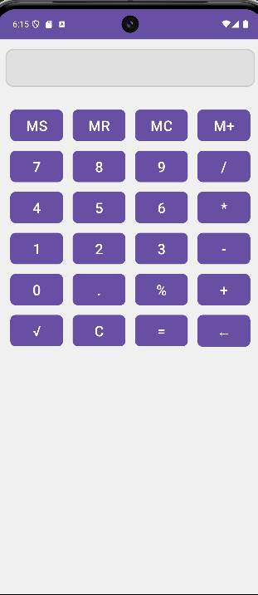

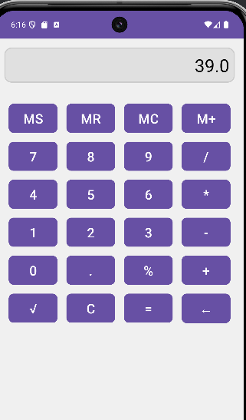

|  |  |  |  |  |
| --- | --- | --- | --- | --- |
| Assignment Delivery | Yes(5) | Partially(3) | No(1) | Marks |
| **OOPS concepts used making it easily extendable** |  |  |  |  |
| **Assignment zip file**  **Contains all**  **required files and**  **compiles** |  |  |  |  |
| **Detailed class diagram matches the source code** |  |  |  |  |
| **Add works** |  |  |  |  |
| **Subtract works** |  |  |  |  |
| **Divide works** |  |  |  |  |
| **Multiply works** |  |  |  |  |
| **Class, Variable, and**  **Method naming** |  |  |  |  |