**IS 1011 System Analysis and Designing**



**ASSIGNMENT NO: 03**

**GROUP ASSIGNMENT**

**GROUP: 04**

**NAME OF LECTURE: Dr. G.K.A. DIAS**

**COURSE CODE : IS1011**

**Group Members**

|  |  |  |
| --- | --- | --- |
| **Index Number** | **Registration Number** | **Name** |
| **15020622** | **2015/IS/062** | **P.P.A.U.D.Ruupasingha** |
| **15020053** | **2015/IS/005** | **G.G.M.S.Ariyasena** |
| **15020657** | **2015/IS/065** | **P.H.Samarasekara** |
| **15020568** | **2015/IS/056** | **Piumali.H.I.S** |

**Table of Content**

1. User Roles

Executive

Meeting organizer

Participant

Mobile app user

Time

Secretary

1. Use Stories

Make a booking

View calendar

Cancel booking

Maintain executive calendar

Reschedule booking

Respond to invitation

Send secretary booking information

Make a booking (secretary)

View calendar (secretary)

Cancel booking (secretary)

Maintain conference room calendar

1. Use Case diagram
2. Class  diagram
3. Sequence diagram

Sequence diagram for Make a Booking

Sequence diagram for make a booking

Sequence diagram for cancel booking

Sequence diagram for view calendar

1. User interfaces

Make a booking

Cancel booking

Reschedule a booking

View calendar

**User Roles**

**Executive**

Executive is an actor who can maintain executive calendar, view calendar.

* Meeting organizer

Meeting organizer is an actor and he/she can view calendar, cancel booking, make a booking, reschedule booking.

* Participant

Participant is an actor who can respond to invitation and work as an executive.

* Mobile app user

Mobile app user is an actor who can send booking information to secretary.

**Secretary**

Secretary is an actor who can perform the same functionality of the meeting organizer .IN addition secretary can maintain conference room calendar.

**Time**

Time is a n actor who can send remind a SMS to participant before 15 minutes

**User Stories**

* Make a booking

**AS a** Executive

**I want to** I want to book a meeting by online time management system

* View calendar

**As an** executive

**I want to** view calendar of conference and executive calendar

**So that** I can check the availability of any executives or any conference rooms and pick a free time slot or update the calendar

* Cancel booking

**As a** meeting organizer

**I want to** cancel a meeting according to the participation responses.

**So that** I can cancel my reservation and I can inform the participant

* Maintain executive calendar

**As an** executive

**I wan**t to maintain and update the records for a meeting form my calendar when a meeting was canceled and rescheduled.

**So that** I can make sure I don’t miss any

* Reschedule booking

**As a** meeting organizer

**I wan**t to reschedule a meeting for another time slot by checking availability of a conference room.

**So that** I can change my reservation and i can inform the participant about the rescheduled

* Respond to invitation

**As a** participant

**I want to** respond to a meeting invitation by email as

“Accept”, ”Decline”, ”Tentative”

* Send secretary booking information

**As a** mobile app user

**I want to** send details of meeting to the secretary

**So that** I can inform secretary or the meeting organizer about the attendance to the meeting

* Send reminder SMS to participant before 15 minutes

**As a** Time

**I want to** send a reminder SMS to participant 15 minutes before the scheduled start time

* Make a booking

**AS a** secretary

**I want to** I want to book a meeting by online time management system

* Cancel booking

**As a** secretary

**I want to** cancel a meeting according to the participation responses.

So that I can cancel my reservation and I can inform the participant

* Reschedule booking

**As a** secretary

**I want to** reschedule a meeting for another time slot by checking availability of a conference room.

**So that**   I can change my reservation and i can inform the participant about the rescheduled

* Maintain conference room calendar

**As a** secretary

**I want to** maintain and update the conference room calendar if there is available time slot in that day. Because of the cancellation and reschedule meeting

Actors

* Executive
  + Participant
  + Meeting organizer
  + Web based system user
  + mobile app user
* Time
* Secretary

**Use case of actors**

* Executive

Maintain executive calendar

View calendar

Cancel booking

Make a booking

Reschedule booking

Respond to invitation

Send secretary booking information

Assumption:

*Meeting organizer is as an executive.

* Time

Send reminder SMS to participant before 15 minutes**.**

* Secretary

Make a booking

Cancel booking

Reschedule booking

Maintain conference room calendar

**Use Case diagram**



Assumptions: Executive specialized as meeting organizer and participant

Meeting organizer specialized as mobile app user and web based system user

**Class Diagram**



**Sequence diagram for Make a Booking**



**Sequence diagram for cancel a booking**



**sequence diagram for reschedule booking**



**Sequence diagram for view calendar**



Use case Narratives

Reschedule booking

|  |  |
| --- | --- |
| Use case name | Reschedule booking |
| Brief description | Reschedule the booked meeting |
| Primary actors | Meeting organizer, secretary |
| Secondary actors |  |
| Pre_conditions | User must login to the system |
| Main flow of events | 1. User enter the ID and name.  2. System prompts booking details.  3. User enter new details.  4. System check availability.  5. If details are correct  5.1 Conform booking. |
| Alternative flow | 5.a) If details are not correct  5. a) 1. System prompts “Wrong details” massage. |
| Post condition | Calendar display rescheduled time slots. |

Cancel a meeting

|  |  |
| --- | --- |
| Use case name | Cancel a meeting |
| Brief description |  |
| Primary actors | Meeting organizer, secretary |
| Secondary actors |  |
| Pre_conditions | Cancel meeting request  User logged in to the system |
| Main flow of events | 1. User select the “Booking” button.  2. System prompt the booking details.  3. User select the cancel booking button.  4. After cancel booking, System update conference room calendar and executive calendar. |
| Alternative flow | - |
| Post condition | Both executive and conference room calendars updated with reserved time |

Make a booking

|  |  |
| --- | --- |
| Use case name | Make a booking |
| Brief description | Make a booking for a meeting, checking for an available Time slot in a conference room. |
| Primary actors | Meeting organizer, secretary |
| Secondary actors |  |
| Pre_conditions | User must login to the system |
| Main flow of events | 1. User select booking type.  2. User enter time, date and duration.  4. System check availability  5. If available  5.1 System prompts the availablility  5.2 participants enter the name and employee ID.  5.3 If the details are correct  5.3.1 Conform booking details. |
| Alternative flow | 5) If not available  5.3.a 1) System prompts ‘Date/Time not available’ |
| Post condition | According to the meeting time conference calendar and executive calendar are updated. |

View Calendar

|  |  |
| --- | --- |
| Use case name | View calendar |
| Brief description | Meeting organizer, executive member, secretary |
| Primary actors |  |
| Secondary actors |  |
| Pre_conditions | User should  logged in to the system |
| Main flow of events | 1. User select “view calendar”.  2. System prompts calendar details.  3. User enter name and ID.  4.If valid  4.1System display calendar. |
| Alternative flow | 4.a) If not valid  4.a.1)System prompts not valid message. |
| Post condition | According to the user requirements, System prompts calendar. |

**User Interfaces**

Make a booking

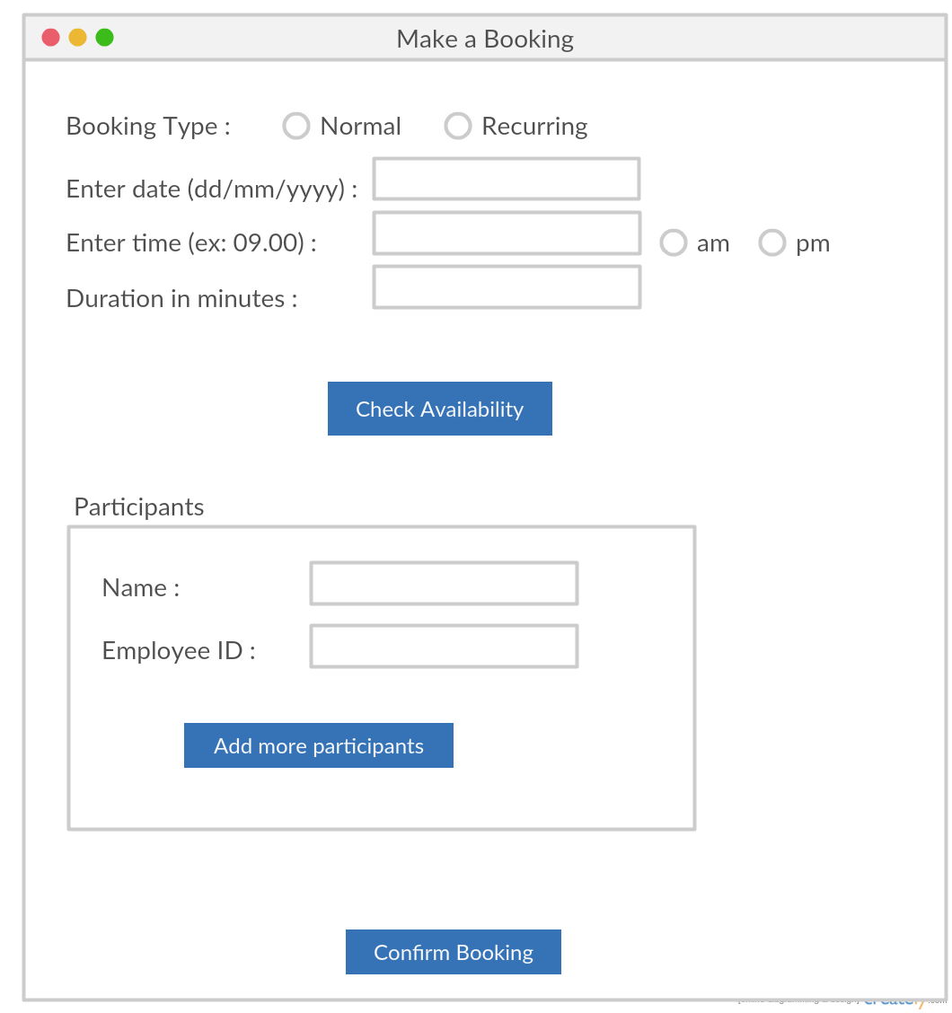

Rescheduled a booking

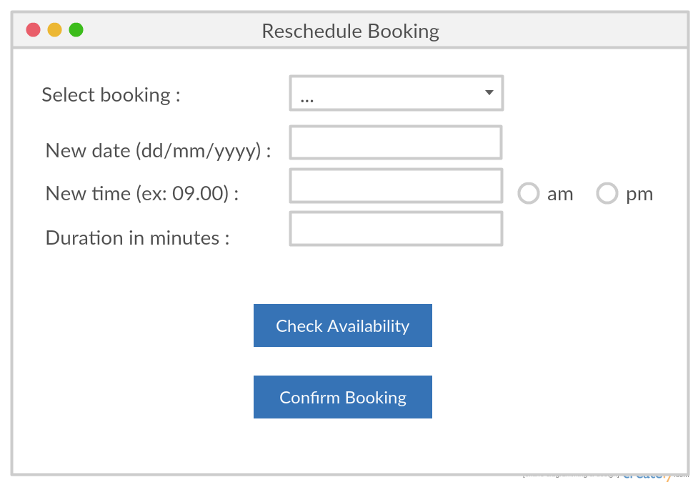

Cancel booking

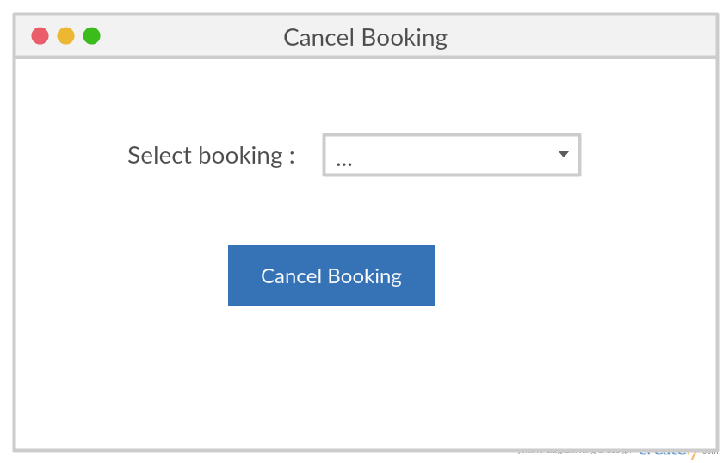

View calendar

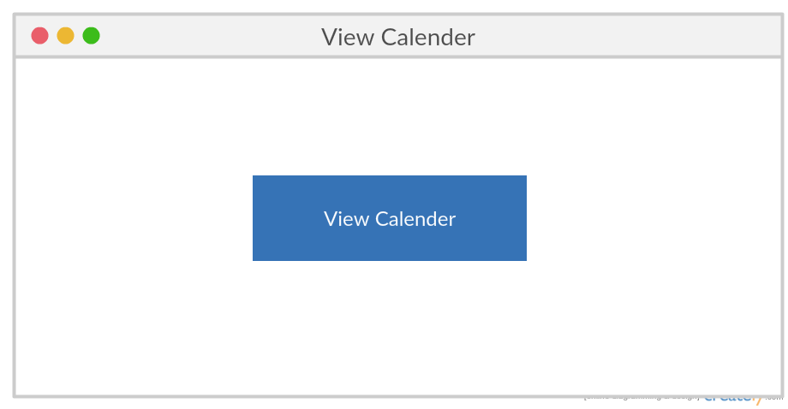

Members’ collaboration

|  |  |  |
| --- | --- | --- |
| 15020622  2015/IS/062 | P.P.A.U.D. Ruupasingha | User Roles  Use case Narrative: Cancel booking  Sequence Diagram: Cancel a booking  User interface for cancel booking |
| 15020053  2015/IS/005 | G.G.M.S. Ariyasena | Class diagrams  User Stories  Use case Narrative: View Calendars  Sequence Diagram: View Calendars  User interface for View calendar |
| 15020657  2015/IS/065 | P.H. Samarasekara | Use case Diagrams  Use case Narrative: Make a Booking  Sequence Diagram: Make a Booking  User interface for Make a booking |
| 15020568  2015/IS/056 | Piumali H.I.S | Use case Narrative: Reschedule a booking  Sequence Diagram: Reschedule a booking  User interface for Reschedule a booking |