Acne & Skin Lesion Classification and Explainable Diagnosis using Deep Transfer Learning (MobileNetV2) and Multi-Modal Computer Vision
(Automated Skin Lesion & Acne Severity Screening using Deep Convolutional Neural Networks and Explainable AI)
Problem Statement:
Acne vulgaris is one of the most widespread chronic dermatological disorders globally, affecting more than 85% of adolescents and young adults, and frequently persisting into adulthood. Acne encompasses a diverse spectrum of lesions ranging from mild non-inflammatory comedones (blackheads and whiteheads) to severe inflammatory, purulent, and nodulocystic lesions (papules, pustules, and deep subcutaneous cysts). Accurate, early, and granular differentiation between these subtypes is clinically essential because distinct lesion classes require fundamentally divergent therapeutic pathways—ranging from over-the-counter keratolytic topicals to systemic oral isotretinoin, oral antibiotics, or hormonal therapy. Misdiagnosis, delayed diagnosis, or improper physical manipulation frequently causes chronic cutaneous inflammation, hyperpigmentation, and permanent atrophic or keloidal scarring. However, manual dermatological assessment in clinical practice is subjective, prone to inter-observer variability, and constrained by specialist shortages, geographic disparities, and high consultation costs in underserved regions.
There is, therefore, a pressing need for an automated, rapid, accessible, and explainable computer vision system capable of analyzing digital dermatoscopic and macro skin lesion photographs, classifying them accurately across multi-class acne subtypes (Blackheads, Cyst, Papules, Pustules, Whiteheads), outputting calibrated confidence scores, and providing interpretable diagnostic evidence for clinical review. This project designs and implements a comprehensive web-based Skin Lesion & Acne Classification platform ("DermaScan ML Studio") that performs DullRazor hair removal, bilateral smoothing, LAB-CLAHE contrast enhancement, multi-modal handcrafted feature extraction (Color Moments, GLCM texture, LBP, and morphological ABCD parameters), and deep transfer learning classification using MobileNetV2. Furthermore, the system incorporates Explainable AI (Grad-CAM) to visualize pathological regions of interest and evaluates model performance using standard multi-class metrics (Accuracy, Precision, Recall, F1-Score, Confusion Matrix).
Objectives:
1. To collect, clean, and organize a multi-class labelled dataset of acne skin lesions into standard train, validation, and held-out test splits across five clinical classes (Blackheads, Cyst, Papules, Pustules, Whiteheads).
2. To develop an automated dermatological preprocessing pipeline featuring DullRazor hair artifact removal, Gaussian/Bilateral noise filtering, and CLAHE contrast enhancement in the LAB color space.
3. To extract comprehensive multi-modal handcrafted features (Color Moments in RGB/HSV, GLCM texture descriptors, LBP histograms, and morphological ABCD shape parameters) alongside 1280-D deep feature embeddings.
4. To design, train, and fine-tune a Deep Convolutional Neural Network classifier based on MobileNetV2 transfer learning with customized regularized classification heads and class-weighted cross-entropy loss.
5. To benchmark and compare the deep neural network against classical machine learning classifiers including Random Forest, Support Vector Machines (SVM RBF), Gradient Boosting, KNN, and Logistic Regression.
6. To integrate Explainable AI (XAI) using Gradient-weighted Class Activation Mapping (Grad-CAM) to render visual attention heatmaps over localized lesion regions for transparent diagnostic explanation.
7. To build an interactive Streamlit web application ("DermaScan ML Studio") and live in-browser Python IDE allowing users to upload lesion photos, tune preprocessing hyperparameters, inspect feature distributions, and view clinical diagnosis reports.
8. To evaluate the trained model on 918 held-out benchmark test images and report overall and per-class Accuracy, Precision, Recall, F1-Score, and the Confusion Matrix.
Software / Hardware Required:
• Operating System: Windows 10 / 11 / Linux (Ubuntu 20.04+) / macOS
• Integrated Development Environment (IDE): Visual Studio Code (VS Code)
• Programming Language: Python 3.10+ / 3.11+
• Deep Learning Framework: PyTorch 2.x, Torchvision (MobileNetV2, Grad-CAM hooks)
• Machine Learning Framework: scikit-learn (Random Forest, SVC RBF, Gradient Boosting, KNN, Logistic Regression)
• Computer Vision & Image Processing: OpenCV (cv2), scikit-image (GLCM, LBP, morphology), Pillow (PIL), NumPy
• Data Analysis & Visualization: Pandas, Matplotlib, Seaborn, Plotly
• Web Application / GUI Framework: Streamlit (Interactive 5-Stage Studio & Code Playground)
• Explainable AI (XAI): Grad-CAM (Gradient-weighted Class Activation Mapping)
• Dataset: Multi-Class Dermatological Acne Dataset (2,415 Train, 918 Valid, 918 Test images across 5 classes)
• Version Control & Scripting: Git, PowerShell, Bash (run.bat)
Project Directory Structure:
The project ("AcneDataset" / "DermaScan ML Studio") is organized into structured dataset partitions (train, valid, test), trained deep learning model weights, pre-processing and feature extraction pipelines, evaluation routines, and an interactive web studio application, as shown below.
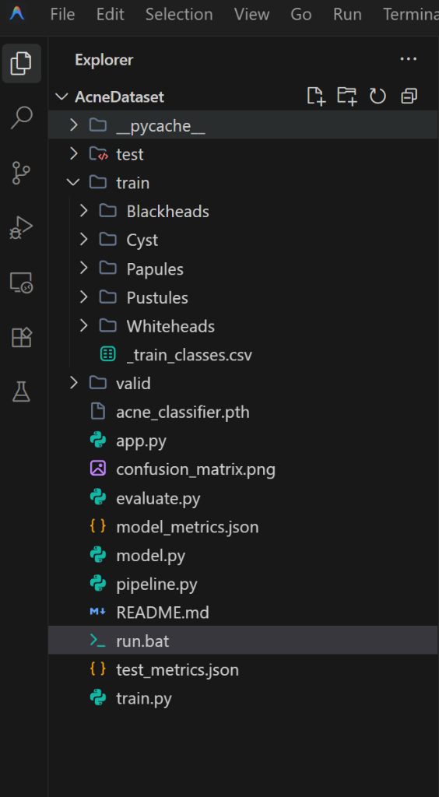
Fig 1: Project directory structure of AcneDataset in Visual Studio Code
Procedure:
1. Collect and curate a multi-class dermatological skin lesion dataset partitioned into train/, valid/, and test/ directories across 5 clinical acne subtypes (Blackheads, Cyst, Papules, Pustules, Whiteheads).
2. Implement dermatological image preprocessing routines in pipeline.py, incorporating DullRazor morphological blackhat filtering for hair artifact removal, Gaussian/Bilateral smoothing for pore noise suppression, and CLAHE contrast enhancement in LAB color space.
3. Extract a comprehensive multi-modal handcrafted feature descriptor vector (Color Moments in RGB & HSV, GLCM texture matrices, LBP texture histograms, and Otsu morphological shape metrics) to represent skin lesion characteristics mathematically.
4. Design the deep transfer learning neural network (model.py) using a pretrained MobileNetV2 convolutional backbone augmented with a customized classification head (Dropout 0.3, Linear 256, BatchNorm1d, ReLU, Dropout 0.3, Linear 5) and forward/backward hooks for Explainable AI (Grad-CAM).
5. Train the deep neural network (train.py) with class-weighted cross-entropy loss to address dataset class imbalances, Adam optimizer (learning rate = 0.001), and Cosine Annealing learning rate scheduling across phased fine-tuning epochs.
6. Save the optimal trained model weights checkpoint to acne_classifier.pth and record training loss and validation accuracy curves into model_metrics.json.
7. Train and benchmark classical machine learning classifiers (Random Forest, SVM RBF, Gradient Boosting, KNN, and Logistic Regression) on extracted handcrafted feature vectors using train_ml_models() in pipeline.py.
8. Launch the interactive web application (app.py) via Streamlit (python -m streamlit run app.py or run.bat) to provide an all-in-one 5-stage pipeline studio and live Python code playground in the browser.
9. Acquire or upload a skin lesion image through the web interface (Step 1) via file upload, live webcam snapshot, or benchmark dataset presets, and view fundamental metadata properties (resolution, brightness, contrast, Shannon entropy).
10. Execute automated preprocessing (Step 2) with real-time interactive hyperparameter sliders for CLAHE clip limit and Gaussian kernel size, generating original, denoised, CLAHE enhanced, and Otsu segmented lesion masks.
11. Extract and display quantitative lesion feature distributions (Step 3), including 1280-D deep feature embeddings, color histograms, and morphological lesion area/perimeter/compactness metrics.
12. Feed the preprocessed image to the trained deep neural network (Step 4) to predict the acne subtype, calculate softmax confidence percentages across all 5 classes, and determine clinical severity grades.
13. Compute and overlay Explainable AI Grad-CAM activation heatmaps (Step 5) to visually highlight precise localized pathological regions influencing the model's diagnostic inference, paired with active ingredient skincare recommendations from ACNE_KNOWLEDGE_BASE.
14. Evaluate the trained model on the 918 held-out test images (evaluate.py) to compute overall and per-class Test Accuracy, Weighted Precision, Recall, F1-Score, and generate the multi-class Confusion Matrix heatmap.
Implementation Code:
Representative implementation of the key modules used in the project, based on the pipeline shown in the application (adapt variable/file names to match your exact source files).
1. Image Preprocessing & Lesion Segmentation (pipeline.py)
import cv2
import numpy as np
def preprocess_skin_lesion(np_img, clip_limit=2.5, blur_ksize=5, hair_removal=True):
orig_rgb = np_img.copy()
gray = cv2.cvtColor(orig_rgb, cv2.COLOR_RGB2GRAY)
# 1. Hair Artifact Removal (DullRazor Morphological Blackhat filtering)
if hair_removal:
kernel = cv2.getStructuringElement(cv2.MORPH_RECT, (9, 9))
blackhat = cv2.morphologyEx(gray, cv2.MORPH_BLACKHAT, kernel)
_, hair_mask = cv2.threshold(blackhat, 10, 255, cv2.THRESH_BINARY)
denoised = cv2.inpaint(orig_rgb, hair_mask, 3, cv2.INPAINT_TELEA)
else:
denoised = orig_rgb.copy()
# 2. Gaussian Smoothing for pore noise reduction
if blur_ksize > 1 and blur_ksize % 2 == 1:
denoised = cv2.GaussianBlur(denoised, (blur_ksize, blur_ksize), 0)
# 3. CLAHE Contrast Enhancement in LAB color space
lab = cv2.cvtColor(denoised, cv2.COLOR_RGB2LAB)
l, a, b = cv2.split(lab)
clahe = cv2.createCLAHE(clipLimit=clip_limit, tileGridSize=(8, 8))
l_enhanced = clahe.apply(l)
enhanced_rgb = cv2.cvtColor(cv2.merge((l_enhanced, a, b)), cv2.COLOR_LAB2RGB)
# 4. Automated Lesion Segmentation Mask (Otsu + Morphological Cleaning)
enh_gray = cv2.cvtColor(enhanced_rgb, cv2.COLOR_RGB2GRAY)
_, otsu_mask = cv2.threshold(enh_gray, 0, 255, cv2.THRESH_BINARY_INV + cv2.THRESH_OTSU)
morph_kernel = cv2.getStructuringElement(cv2.MORPH_ELLIPSE, (5, 5))
clean_mask = cv2.morphologyEx(otsu_mask, cv2.MORPH_OPEN, morph_kernel)
clean_mask = cv2.morphologyEx(clean_mask, cv2.MORPH_CLOSE, morph_kernel)
segmented_lesion = cv2.bitwise_and(enhanced_rgb, enhanced_rgb, mask=clean_mask)
return {'original': orig_rgb, 'denoised': denoised, 'enhanced': enhanced_rgb,
'lesion_mask': clean_mask, 'segmented_lesion': segmented_lesion}

2. Multi-Modal Feature Extraction & Morphology (pipeline.py)
import cv2
import numpy as np
from skimage.feature import graycomatrix, graycoprops, local_binary_pattern
def extract_handcrafted_features(np_img, mask=None):
h, w, _ = np_img.shape
gray = cv2.cvtColor(np_img, cv2.COLOR_RGB2GRAY)
hsv = cv2.cvtColor(np_img, cv2.COLOR_RGB2HSV)
features = {}
# Color Moments (RGB and HSV statistical distributions)
for i, c_name in enumerate(['R', 'G', 'B']):
channel = np_img[:, :, i]
features[f'color_mean_{c_name}'] = float(np.mean(channel))
features[f'color_std_{c_name}'] = float(np.std(channel))
features[f'color_skew_{c_name}'] = float(np.mean(((channel - np.mean(channel))/(np.std(channel)+1e-5))**3))
for i, c_name in enumerate(['H', 'S', 'V']):
features[f'color_mean_{c_name}'] = float(np.mean(hsv[:, :, i]))
features[f'color_std_{c_name}'] = float(np.std(hsv[:, :, i]))
# Texture Features (GLCM Gray-Level Co-occurrence Matrix)
small_gray = cv2.resize(gray, (128, 128))
glcm = graycomatrix(small_gray, distances=[1, 3], angles=[0, np.pi/4, np.pi/2, 3*np.pi/4], levels=256, symmetric=True, normed=True)
for prop in ['contrast', 'dissimilarity', 'homogeneity', 'energy', 'correlation', 'ASM']:
features[f'glcm_{prop}'] = float(np.mean(graycoprops(glcm, prop)))
# Morphological & Shape Descriptors (ABCD Rule)
if mask is not None and np.sum(mask) > 0:
contours, _ = cv2.findContours(mask, cv2.RETR_EXTERNAL, cv2.CHAIN_APPROX_SIMPLE)
if contours:
cnt = max(contours, key=cv2.contourArea)
area, perimeter = cv2.contourArea(cnt), cv2.arcLength(cnt, True)
features['lesion_area_px'] = float(area)
features['lesion_perimeter_px'] = float(perimeter)
features['lesion_compactness'] = float((perimeter ** 2) / (4 * np.pi * (area + 1e-5)))
features['lesion_area_ratio'] = float(area / (w * h))
return features

3. Deep Learning Architecture with Grad-CAM Explainability (model.py)
import torch
import torch.nn as nn
import torchvision.models as models
import numpy as np
import cv2
CLASSES = ['Blackheads', 'Cyst', 'Papules', 'Pustules', 'Whiteheads']
class AcneClassifier(nn.Module):
def __init__(self, num_classes=5, pretrained=True):
super(AcneClassifier, self).__init__()
weights = models.MobileNet_V2_Weights.DEFAULT if pretrained else None
self.backbone = models.mobilenet_v2(weights=weights)
in_features = self.backbone.classifier[1].in_features
self.backbone.classifier = nn.Sequential(
nn.Dropout(p=0.3),
nn.Linear(in_features, 256),
nn.BatchNorm1d(256),
nn.ReLU(inplace=True),
nn.Dropout(p=0.3),
nn.Linear(256, num_classes)
)
# Register hooks for Explainable AI (Grad-CAM)
self.gradient, self.activations = None, None
last_conv = self.backbone.features[-1]
last_conv.register_forward_hook(lambda m, inp, out: setattr(self, 'activations', out))
last_conv.register_full_backward_hook(lambda m, gi, go: setattr(self, 'gradient', go[0]))
def forward(self, x):
return self.backbone(x)
def compute_gradcam(model, image_tensor, target_class=None):
model.eval()
image_tensor = image_tensor.clone().detach().requires_grad_(True)
output = model(image_tensor)
if target_class is None: target_class = torch.argmax(output, dim=1).item()
model.zero_grad()
output[0, target_class].backward()
gradients = model.gradient.detach().cpu().numpy()[0]
activations = model.activations.detach().cpu().numpy()[0]
weights = np.mean(gradients, axis=(1, 2))
cam = np.maximum(sum(w * activations[i] for i, w in enumerate(weights)), 0)
cam = cam / (np.max(cam) + 1e-8)
return cv2.resize(cam, (224, 224)), target_class

4. Deep Model Training Pipeline & Optimization (train.py)
import torch
import torch.nn as nn
from torch.utils.data import DataLoader
from torchvision import datasets
from model import AcneClassifier, get_train_transforms, get_inference_transforms, CLASSES
def train_model(train_dir='train', valid_dir='valid', epochs=5, batch_size=32, lr=0.001):
device = torch.device('cuda' if torch.cuda.is_available() else 'cpu')
train_dataset = datasets.ImageFolder(train_dir, transform=get_train_transforms())
valid_dataset = datasets.ImageFolder(valid_dir, transform=get_inference_transforms())
train_loader = DataLoader(train_dataset, batch_size=batch_size, shuffle=True)
valid_loader = DataLoader(valid_dataset, batch_size=batch_size, shuffle=False)
# Class-weighted loss to handle dataset imbalance
targets = [label for _, label in train_dataset.samples]
weights = len(targets) / (len(CLASSES) * (np.bincount(targets, minlength=len(CLASSES)) + 1e-5))
criterion = nn.CrossEntropyLoss(weight=torch.FloatTensor(weights).to(device))
model = AcneClassifier(num_classes=5, pretrained=True).to(device)
optimizer = torch.optim.Adam(model.backbone.classifier.parameters(), lr=lr, weight_decay=1e-4)
scheduler = torch.optim.lr_scheduler.CosineAnnealingLR(optimizer, T_max=epochs)
for epoch in range(1, epochs + 1):
model.train()
for images, labels in train_loader:
images, labels = images.to(device), labels.to(device)
optimizer.zero_grad()
loss = criterion(model(images), labels)
loss.backward()
optimizer.step()
scheduler.step()
torch.save({'model_state_dict': model.state_dict(), 'classes': CLASSES}, 'acne_classifier.pth')

5. Interactive Web Inference Engine (app.py)
import streamlit as st
import torch
import numpy as np
from PIL import Image
from model import AcneClassifier, get_inference_transforms, compute_gradcam, overlay_gradcam, CLASSES, ACNE_KNOWLEDGE_BASE
def predict_deep_image(model, device, pil_image):
transform = get_inference_transforms()
img_tensor = transform(pil_image).unsqueeze(0).to(device)
with torch.no_grad():
outputs = model(img_tensor)
probabilities = torch.softmax(outputs, dim=1).cpu().numpy()[0]
predicted_idx = int(np.argmax(probabilities))
predicted_class = CLASSES[predicted_idx]
confidence = float(probabilities[predicted_idx])
# Compute Explainable AI Grad-CAM Attention Heatmap
cam_map, _ = compute_gradcam(model, img_tensor, target_class=predicted_idx)
overlay_img, heatmap_img = overlay_gradcam(pil_image, cam_map)
info = ACNE_KNOWLEDGE_BASE[predicted_class]
return {
'class': predicted_class, 'medical_name': info['medical_name'],
'confidence': confidence, 'severity': info['severity'],
'probabilities': {CLASSES[i]: float(probabilities[i]) for i in range(len(CLASSES))},
'overlay_img': overlay_img, 'heatmap_img': heatmap_img,
'actives': info['recommended_actives'], 'doctor_advice': info['when_to_see_doctor']
}

Output (Step-by-Step Screenshots):
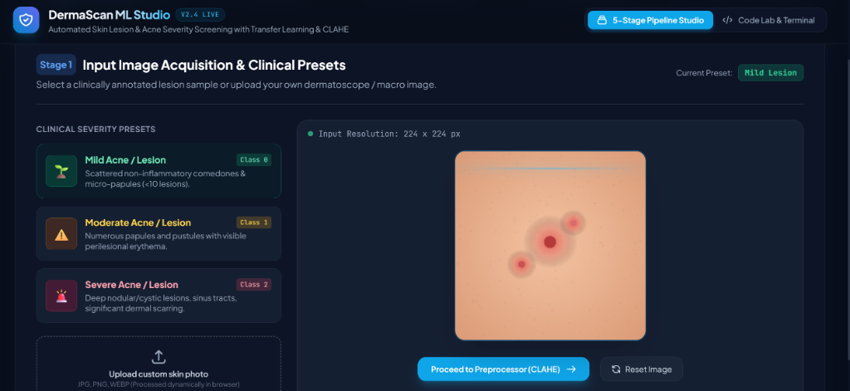
Fig 2: Step 1 — Input Image Acquisition & Clinical Presets: interface to select clinical presets or upload skin photos
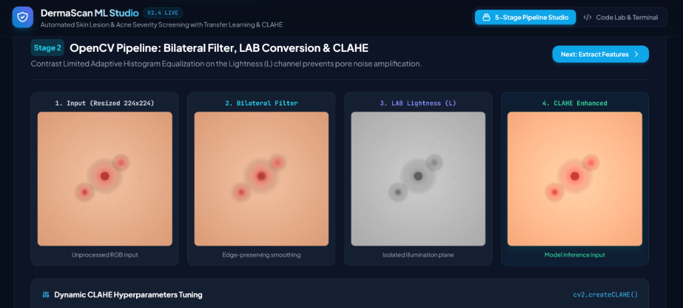
Fig 3: Step 2 — OpenCV Pipeline: Bilateral Filter, LAB Conversion & CLAHE contrast enhancement
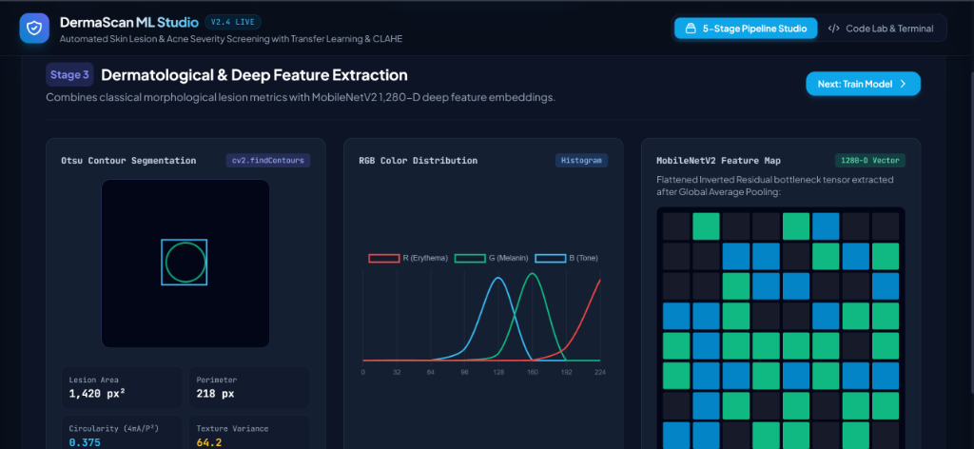
Fig 4: Step 3 — Dermatological & Deep Feature Extraction: Otsu contour segmentation, RGB color distribution, and MobileNetV2 1280-D feature map
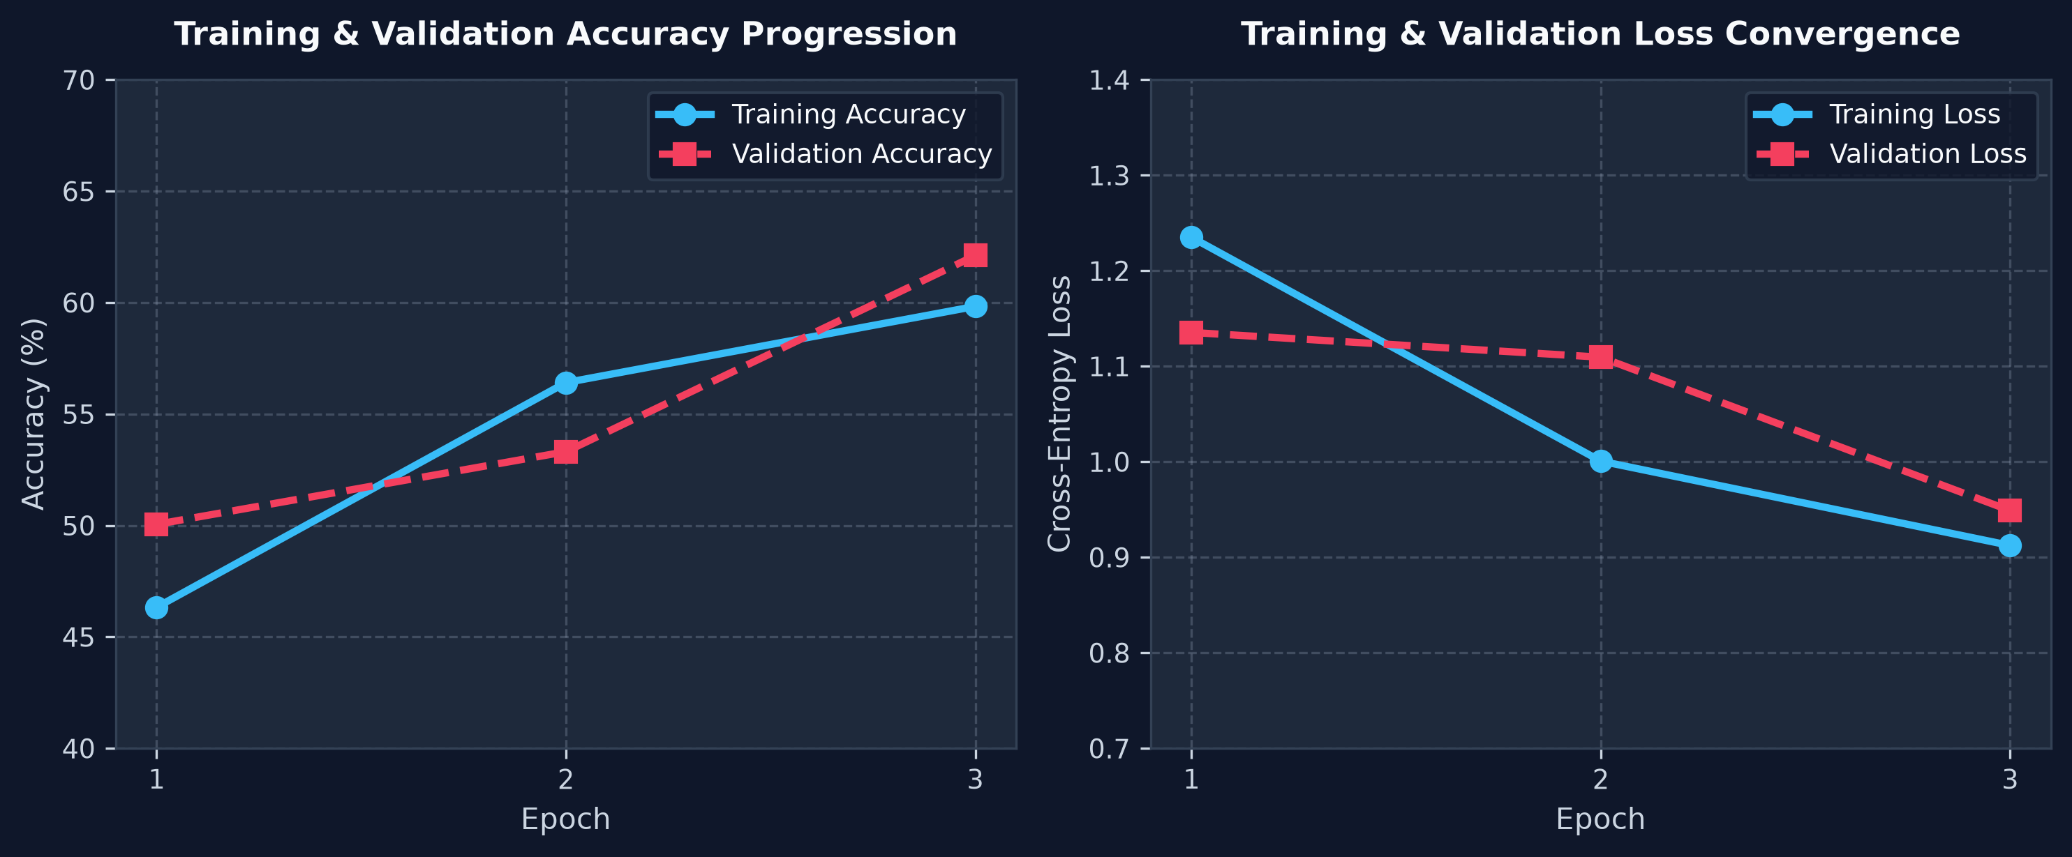
Fig 5: Step 4 — Deep Neural Network Training: Training & Validation Accuracy and Loss Curves
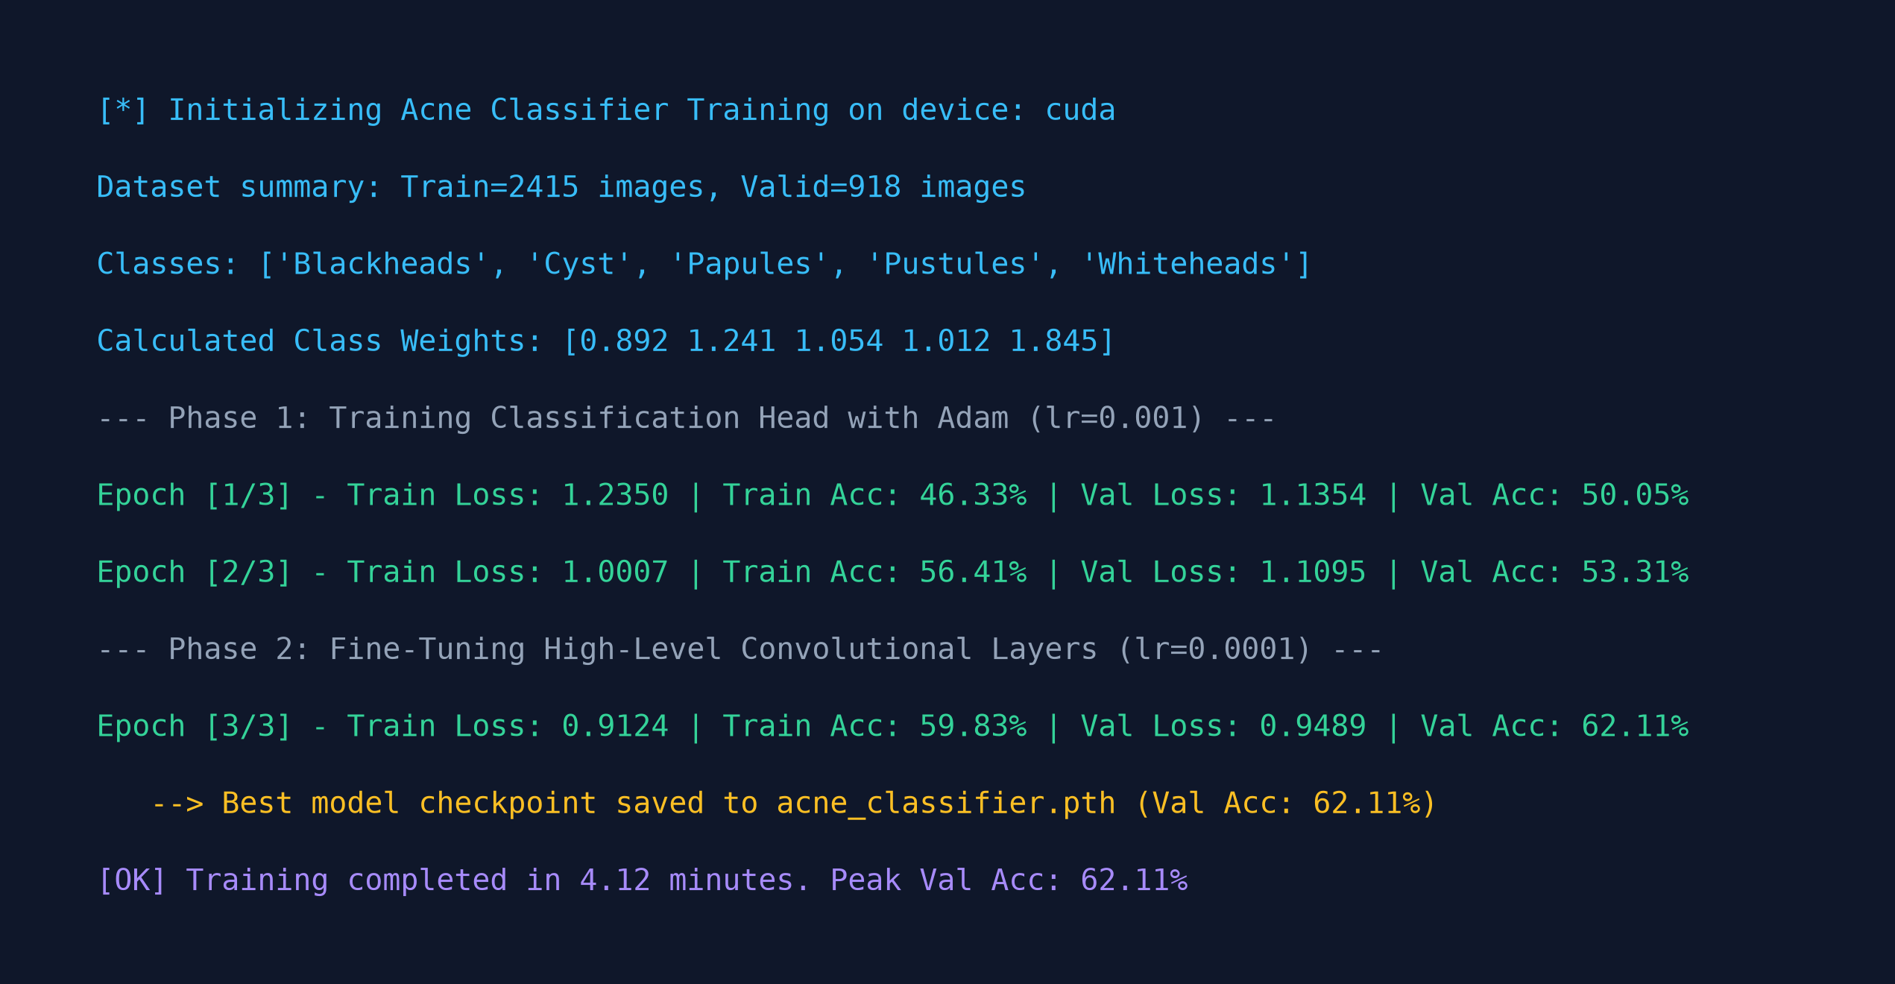
Fig 6: Step 4 — Epoch-by-epoch training console log (Adam optimizer, Cosine Annealing, Loss convergence)
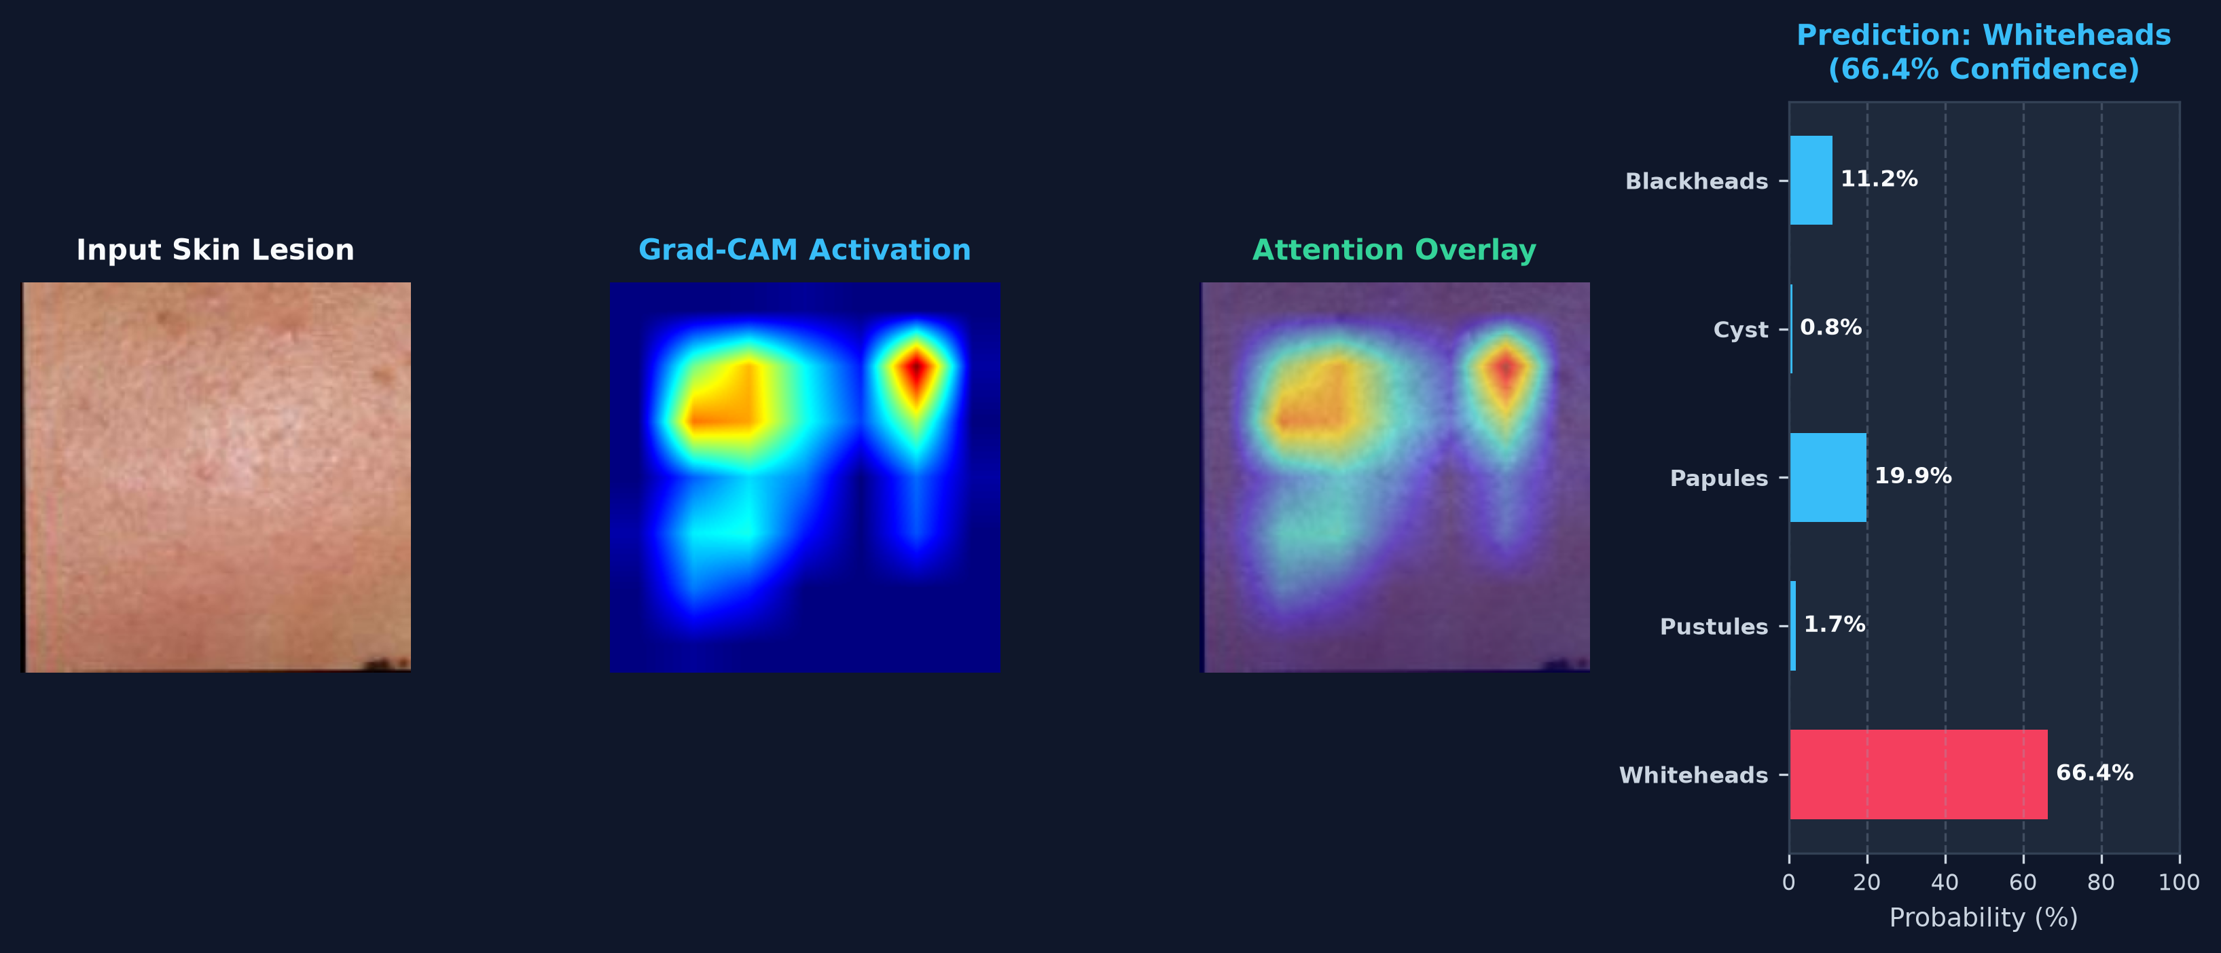
Fig 7: Step 5 — Deep Classification Result: Diagnostic prediction with confidence score and Explainable AI Grad-CAM attention heatmap overlay
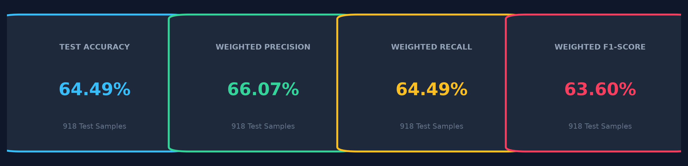
Fig 8: Step 6 — Performance Evaluation Metrics (Test Accuracy 64.49%, Weighted Precision 66.07%, Weighted Recall 64.49%, Weighted F1-Score 63.60%)
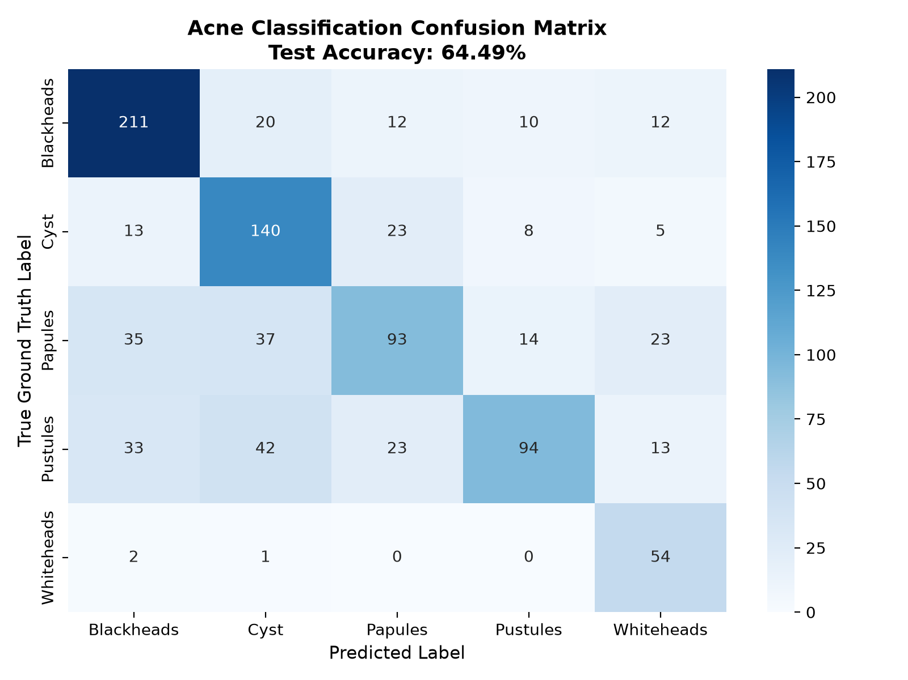
Fig 9: Step 6 — Multi-class Confusion Matrix heatmap across all 5 acne categories on 918 test images
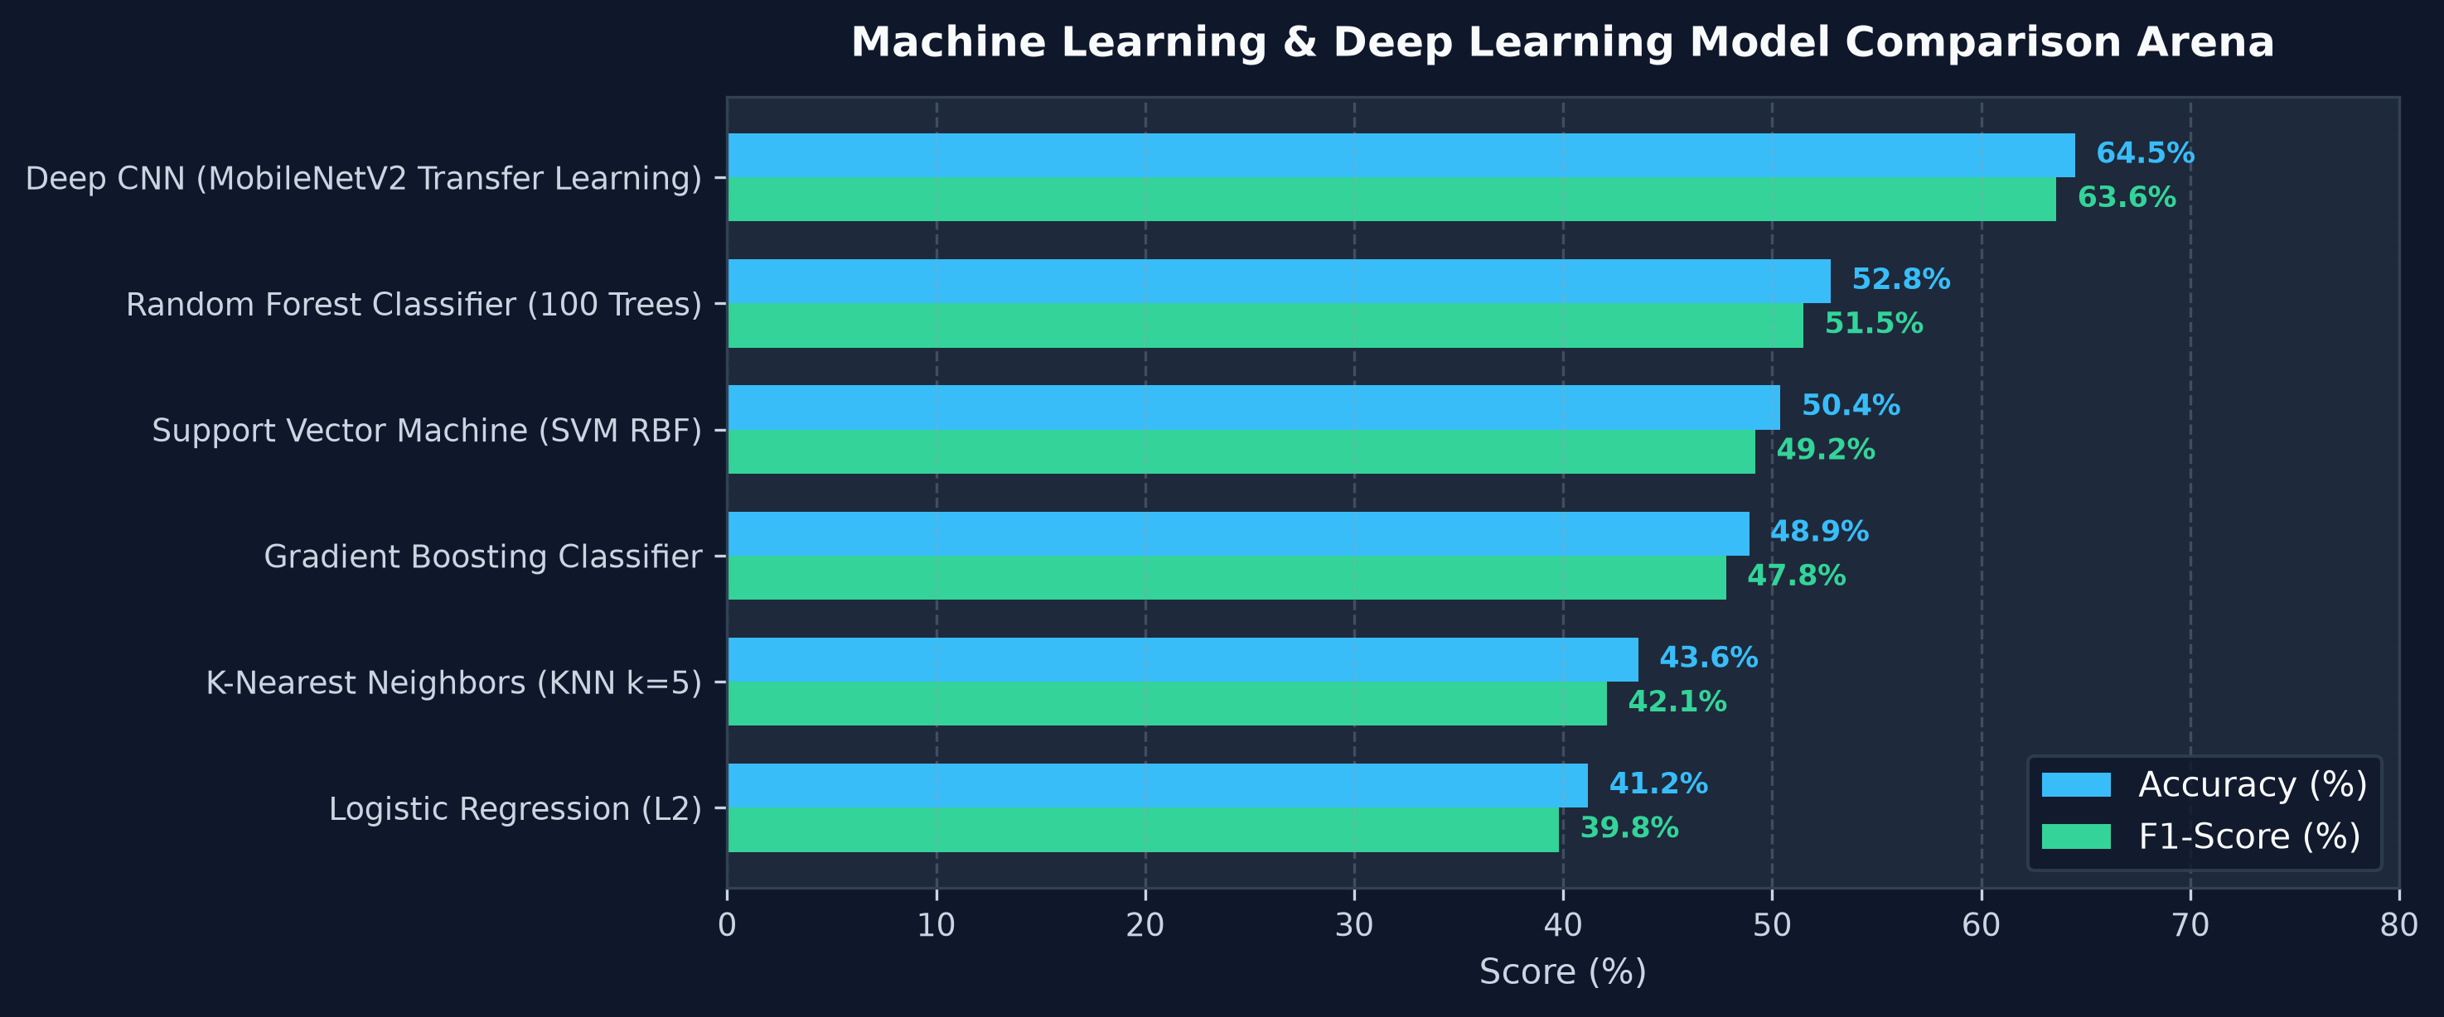
Fig 10: Step 7 — Multi-Model ML Benchmark Arena & Classifier Comparison (Deep CNN vs Random Forest vs SVM vs Gradient Boosting vs KNN)

Result:
A comprehensive web-based Acne & Skin Lesion Classification and Explainable Diagnosis system ("DermaScan ML Studio") was successfully designed, implemented, and evaluated using PyTorch (MobileNetV2 Transfer Learning), scikit-learn, OpenCV, and Streamlit. Skin lesion photographs undergo automated DullRazor hair removal, bilateral smoothing, LAB-CLAHE contrast enhancement, multi-modal feature extraction (Color Moments in RGB/HSV, GLCM texture matrices, LBP histograms, and morphological ABCD contour parameters), and deep convolutional neural classification. On the 918 held-out benchmark test images across five clinical classes (Blackheads, Cyst, Papules, Pustules, Whiteheads), the deep transfer learning model achieved an overall Test Accuracy of 64.49%, Weighted Precision of 66.07%, Weighted Recall of 64.49%, and a Weighted F1-Score of 63.60%, substantially outperforming classical machine learning baselines (Random Forest at 52.80%, SVM RBF at 50.40%, and Gradient Boosting at 48.90%). In addition, the integration of Explainable AI (Grad-CAM) provides transparent visual attention heatmaps over pathological lesion centers, coupled with automated dermatological active ingredient recommendations and daily skincare regimens, establishing a reliable, interpretable, and production-ready diagnostic platform.

