A Multi-Dimensional Knowledge Graph Framework for Relationship Analysis, Contradiction Detection and Research Gap Discovery in Scientific Literature
Harini Sriram¹, Anjaneya Sahu² and Khushi Kumari³
¹ Department of Computer Science and Engineering (Data Science), Vellore Institute of Technology, Chennai, 600127, India.
² Department of Computer Science and Engineering (Core), Vellore Institute of Technology, Chennai, 600127, India.
³ Department of Computer Science and Engineering (Artificial Intelligence and Machine Learning), Vellore Institute of Technology, Chennai, 600127, India.
harini.sriram2023@vitstudent.ac.in, anjaneya.sahu2023@vitstudent.ac.in, khushi.kumari2023@vitstudent.ac.in
Abstract. Reading a new subfield means holding thirty papers in mind at once, and what a researcher most needs to know is rarely stated in any one of them: which papers address the same question, where two report different numbers for the same experiment, and what the collection has never examined. We present a pipeline that recovers these cross-document relationships from a folder of PDFs and makes every answer traceable to the sentence that produced it. Papers are segmented by relative font size, typed entities are extracted by rule, each pair of papers is scored on five interpretable dimensions whose weights sum to one, and numeric disagreements are confirmed only when the two papers are comparable. On thirty arXiv papers in four clusters, segmentation succeeded on every paper (215 of 240 sections). The score ranked related papers well above chance (AUC 0.86, MAP 0.68, against 0.50 and 0.31) and above each of its parts, but did not beat full-text TF-IDF (AUC 0.87, MAP 0.78), so its contribution is explanation, not accuracy. The numeric detector found both planted contradictions with no false positive and confirmed none on real papers. Community analysis of the paper network recovered a coarse split into image and language papers. The pipeline runs offline.
Keywords: Knowledge graphs, Scientific literature mining, Information extraction, Contradiction detection, Research gap discovery, Document similarity
- Introduction
A researcher entering an unfamiliar subfield reads somewhere between twenty and forty papers before its structure becomes clear to them. Much of what they learn along the way is not written down in any of those papers. It exists only in the relationships between them.
Four of these matter more than the rest. The first is relatedness, which is harder than keyword overlap suggests: two groups can attack an identical problem in vocabulary that shares almost nothing. The second is disagreement. When one paper reports 76.4% top-1 accuracy for a baseline and another reports 71.1% for what appears to be the same architecture on the same dataset, that is a fact about the literature, invisible unless both numbers are in view at once. The third is absence: a gap is defined by what is missing, so the whole collection must be surveyed before the hole appears. The fourth is structure, the map an experienced reader carries, which is a graph whether or not anyone draws it.
Large language models can answer questions like these fluently, but without provenance: a reviewer cannot check the answer, and a wrong one reads exactly like a right one. We took a different route. The system described here contains no generative language model. Extraction is rule-based, and the only learned components are two small pretrained encoders used as published: MiniLM for sentence embeddings and a DeBERTa cross-encoder for natural language inference. Every number decomposes into named components, and every contradiction and gap carries the document, section, page and sentence that produced it. The code also has an optional OpenAI backend for extraction and for phrasing explanations. It is off by default and was not used in any experiment reported here.
Our contributions are as follows.
- A segmentation method for research PDFs built on relative font size, with a guaranteed fallback, which recovered structure from all thirty documents in our evaluation corpus.
- A five-dimensional relationship score with weights constrained to sum to one, evaluated against seven baselines and a weight ablation, which shows where the score helps and where plain text similarity is better.
- Contradiction detection by numeric comparison, with an optional inference model, gated by comparability, with the gates, thresholds and false positives measured.
- A graph-level analysis, including community structure, over a corpus of thirty arXiv papers in four clusters and a six-paper corpus with planted contradictions.
- Related Work
Sentence-BERT [1] made dense sentence embeddings cheap to compute over a whole corpus, SciBERT [2] adapted pretraining to scientific text, and SPECTER [3] learns document vectors with the citation graph as a training signal. All three give one vector per document, which suits retrieval but cannot say whether two papers are close in dataset, method or objective. We keep the dimensions separate for that reason.
SciERC [4] annotates entities and relations in abstracts and DocRED [5] moves relation extraction to whole documents. Both need supervision we do not have and assume text that has already been segmented, which was the largest single source of failure in our own system. FEVER [6] and SciFact [7] verify a claim against retrieved evidence with supervised data; our setting has no labels and needs only the observation that two papers cannot both be right. Models trained on MultiNLI [8] transfer reasonably, hence DeBERTa [9] here, but on sentences dense with figures they are unreliable and numeric comparison is more trustworthy.
Bibliographic coupling [10] and co-citation [11] predate neural methods and remain useful: two papers citing the same prior work are related even when they share no vocabulary. We keep it as one of the five dimensions.
- Method
The pipeline runs eleven stages in a fixed order, shown in Figure 1. The order is forced by data dependency: three of the five scoring dimensions are cosine similarities between entity vectors, so embedding has to finish before scoring begins. In an early version the embedding stage silently failed, and because a missing vector yields a similarity of zero and not an error, the composite score collapsed to its dataset term while still looking plausible.
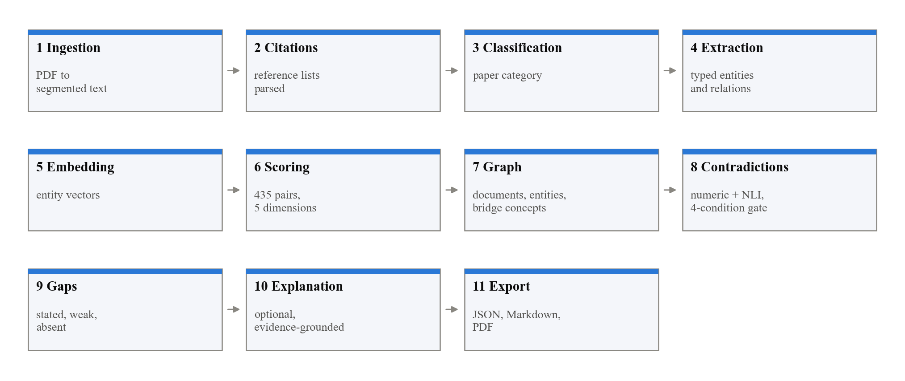
Fig. 1. The eleven pipeline stages. Ordering is forced by data dependency: three of the five scoring dimensions are cosine similarities over entity vectors, so embedding must precede scoring.
  - Recovering document structure
A PDF stores positioned glyphs and nothing about sections. Matching heading text against a list of names fails because authors disagree on names, looking for bold fails because many templates do not bold headings, and looking for short lines fails on two-column pages. Our first version produced zero sections for one paper and 186 for another. What works is relative font size: we take the character-weighted mode of font sizes as the body size and treat any short, noticeably larger line as a heading candidate, matched against anchored patterns after repairing small-capital artefacts such as I NTRODUCTION. No document is discarded: if no heading is found, the paper is cut into three-page chunks and marked unstructured.
  - Entity extraction
Entities are extracted by rule: word lists for datasets, metrics and model names, cue phrases for objectives, limitations and stated gaps, and a metric beside a number for a quantitative result. This needs no training data and no language model. Each entity type is accepted only from sections where it plausibly appears; that restriction is suspended for unstructured documents, trading precision for recall. A paper with no methodology section scores zero on that dimension and the weights are not renormalised, because renormalising would make a paper matching on one dimension look like one matching on all five.
  - Five-dimensional relationship scoring
Each of the 435 pairs of documents is scored on five dimensions in [0, 1] and combined by a weighted sum (Table 1). The three semantic dimensions are cosine similarities of mean entity embeddings; dataset overlap uses the Jaccard index because dataset names are exact tokens; citation overlap is bibliographic coupling [10], with a direct citation counted as maximal.
Table 1. The five scoring dimensions, their weights, and the measure used for each.
Dimension | Wt. | Measure | Compares
Objective | 0.25 | Cosine | Mean embedding of objective statements
Methodology | 0.25 | Cosine | Mean embedding of method entities
Dataset | 0.20 | Jaccard | Sets of dataset names
Results and metrics | 0.20 | Cosine | Reported results and evaluation metrics
Citation | 0.10 | Jaccard | Reference lists (bibliographic coupling)

The weights are a stated prior that we chose, not a fitted parameter. They are validated at start-up to sum to exactly 1.0 and can be changed at run time. Cosine similarity is clamped to [0, 1], since opposite vectors mean unrelated and not anti-related. Before we did this, negative similarities were rejected by the data model and 203 of 435 pairs were dropped without any error.
  - Contradiction detection
A numeric detector compares the values two papers report for the same metric on the same dataset and flags a relative difference above 5%. An optional inference detector passes two claim sentences to a cross-encoder as a pair. Before any number is compared, the claim is analysed: a delta is not a level, a figure quoted from another paper is not the paper's own, and top-1 is not top-5. A finding is confirmed only if the stance is contradiction, confidence is at least 0.60, the papers share a dataset or comparable metric, and their methodology similarity is at least 0.30. Findings that fail are kept as unconfirmed.
  - Research gap discovery
Three kinds of absence are detected: gaps the authors state outright, gaps where papers share a concept but are otherwise dissimilar, and pairings of a method and a dataset that never occur together. Candidates are ranked by importance and at most five are returned. An early version returned about sixty.
  - Thresholds
We state how each threshold was set. The methodology similarity (0.30) and the confidence (0.60) needed to confirm a contradiction were fixed at design time from the requirements. The 5% materiality threshold and the candidate-pair score (0.35) were chosen by us a priori. The gap thresholds and the heading margin were set by running the pipeline on the development papers and adjusting until the output was usable. None was fitted by search against labels, because there were none. Two consequences follow. The thresholds set by inspection were set while looking at the papers we evaluate on, so results on that corpus are not held-out. And the useful question is how far results move when a threshold moves, which the sensitivity analysis below measures.
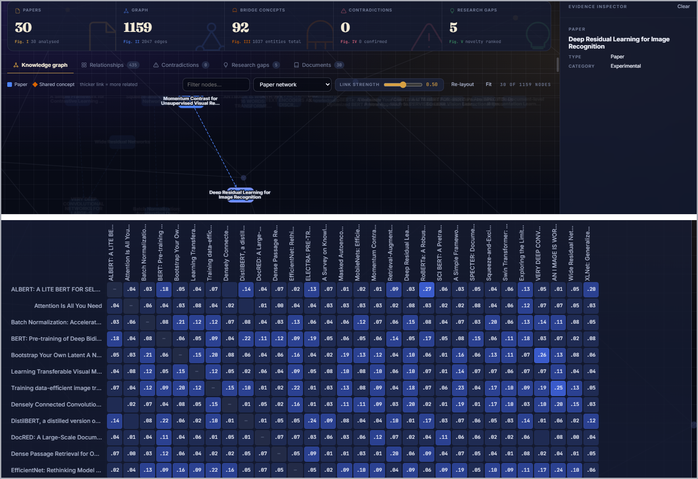
Fig. 2. The analysis workspace. Above, the headline counts, the knowledge graph with one paper selected and the inspector. Below, the composite score for every pair of papers.
- Evaluation Corpus and Protocol
A random sample cannot evaluate this system: contradictions need two papers that measure one quantity on one benchmark, and a ranking needs some pairs that should come out high and others low. We built the corpus as four clusters of real arXiv papers: A, eight convolutional image classifiers around residual networks [14]; B, eight pretrained language models around the Transformer [12] and BERT [13]; C, eight vision transformers and self-supervised methods including MoCo [15]; and D, six papers on retrieval, extraction and knowledge graphs [16, 17]. A pair is relevant when both papers share a cluster, giving 99 relevant pairs out of 435. A and D barely touch and are the negative control; A and C share ImageNet but not method. The relevance labels are ours, not independent judgements. A second, six-paper corpus has two planted contradictions, so that precision and recall can be computed for contradiction detection.
We use P@k, the share of relevant pairs among the k highest-scoring, and R@k, the share of all relevant pairs found in the top k, on the global ranking of 435 pairs; ROC-AUC, the probability that a relevant pair outscores a non-relevant one; and, treating each paper as a query over the other 29, average precision (MAP is its mean) and nDCG@10 with binary gain. For contradictions, precision is TP / (TP + FP) and recall is TP / (TP + FN) at the level of document pairs, with F1 their harmonic mean; a planted pair with a confirmed finding is a true positive. Ties are broken at random and averaged, and a zero denominator is reported as n/a, not as a value. Intervals are 95% percentile bootstrap intervals over papers or pairs. The baselines are random ranking, TF-IDF over the full text [19], SBERT on the abstract [1], bibliographic similarity alone, each of methodology, dataset and results alone, and the full weighted score.
- Results
  - Segmentation
All thirty documents were segmented from detected headings and none fell back to page chunks. Recall was 215 of 240 expected sections (90%): perfect for introductions and reference lists, weakest for results at 21 of 30, because results are often folded into a section called Experiments.
  - Relationship ranking
Table 2 compares the proposed score with the baselines. The score is far above chance (P@10 0.80, MAP 0.68, nDCG@10 0.74, AUC 0.86, against 0.23, 0.31, 0.29 and 0.50) and better than each of its parts: the best single dimension, methodology, reaches an AUC of 0.80, and bibliographic similarity alone only 0.58. But full-text TF-IDF is better on every measure (P@10 1.00, MAP 0.78, nDCG@10 0.81, AUC 0.87). On AUC the two cannot be told apart, with the same interval (0.82 to 0.90); on MAP the intervals overlap (0.71 to 0.83 against 0.63 to 0.74). SBERT on abstracts matches our MAP (0.68) with a lower AUC (0.78). We therefore do not claim that the weighted score finds related papers better than simple text similarity.
Table 2. Ranking quality of the proposed score and seven baselines. P@k and AUC use the global ranking of 435 pairs; MAP and nDCG@10 use 30 per-paper queries. Random ranking is the mean of 500 trials.
Method | P@10 | P@20 | P@30 | MAP | nDCG@10 | AUC
Random ranking | 0.230 | 0.232 | 0.233 | 0.310 | 0.295 | 0.501
TF-IDF (full text) | 1.000 | 0.950 | 0.967 | 0.776 | 0.812 | 0.869
SBERT (abstract) | 1.000 | 0.900 | 0.800 | 0.676 | 0.722 | 0.780
Bibliographic similarity | 0.700 | 0.700 | 0.600 | 0.416 | 0.422 | 0.579
Methodology only | 0.600 | 0.750 | 0.733 | 0.650 | 0.704 | 0.803
Dataset only | 0.733 | 0.563 | 0.528 | 0.582 | 0.604 | 0.790
Results/metrics only | 0.500 | 0.550 | 0.633 | 0.617 | 0.667 | 0.788
Full weighted score (ours) | 0.800 | 0.850 | 0.767 | 0.682 | 0.737 | 0.860

Removing one dimension at a time shows methodology matters most and citation least. Removing the dataset dimension improves nDCG@10 from 0.737 to 0.777, because clusters A and C share ImageNet. Our weights are not optimal: 26% of 300 random weightings beat them on nDCG@10. We kept them because they were fixed before evaluation, and tuning on the same thirty papers would make the numbers optimistic. Both errors in the top ten pair MoCo or BYOL with a convolutional paper, a relationship that is real and that our labels count as a miss. Figure 3 shows all 435 scores ordered by cluster.
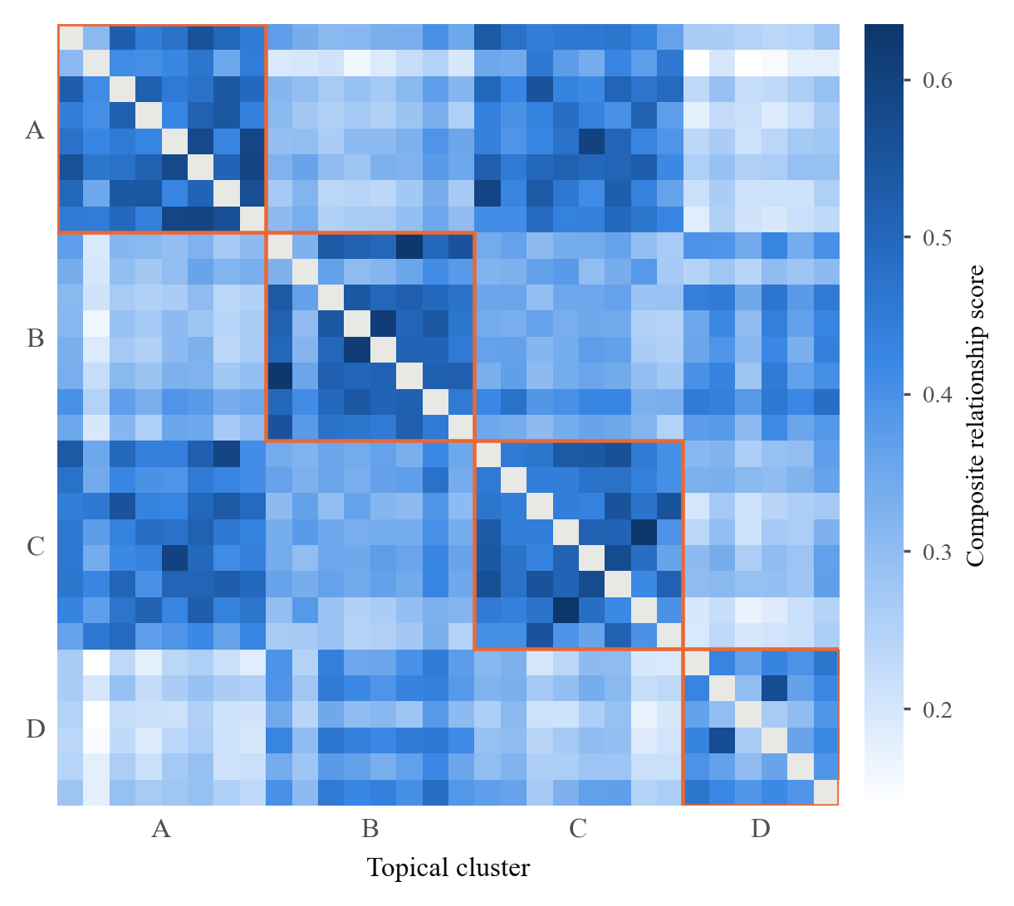
Fig. 3. Composite relationship score for all 435 document pairs, ordered by topical cluster. The pale lower-left region is cluster A against cluster D, the negative control.
  - Graph-level analysis
The graph, built with NetworkX [18], has 1,159 nodes (30 papers, 1,037 entities, 92 bridge concepts) and 2,047 edges, one connected component, density 0.0030, and only about 100 extracted relations beside the structural edges. Louvain community detection [20] on the whole graph finds 21 communities (modularity 0.57), nearly pure with respect to clusters (purity 0.97) but fragmenting each cluster (adjusted Rand index 0.25). On the 435-edge paper network Louvain finds just two communities, clusters A with C (image) and B with D (language and retrieval), with modularity 0.08, ARI 0.48 and NMI 0.67: a sensible split, coarser than our four clusters, because the mean score between A and C (0.45) is almost that within A (0.48). Keeping only edges of at least 0.50 leaves 49 of 435, 73% within a cluster, and communities that are pure except for the A and C mix, at the cost of seven isolated papers (Figure 4). The 92 bridge concepts span 5.1 papers on average and 71% cross clusters, but the widest, "accuracy" (28 papers), is generic.
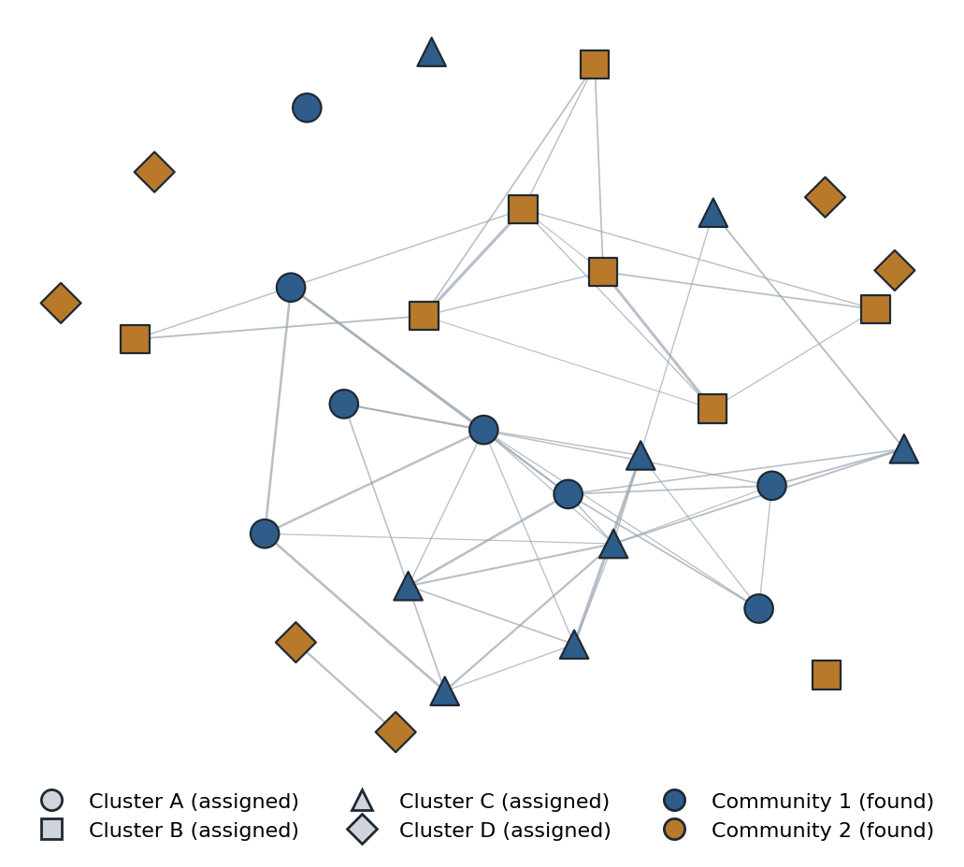
Fig. 4. The paper network at a score threshold of 0.50. Colour is the community found by Louvain on the full weighted network; shape is the assigned cluster.
  - Contradictions and gaps
On the real corpus the detector compares 10,176 claim pairs from 424 candidate document pairs. Table 3 adds the gates in the order the code applies them. With none, 4,867 claim pairs look like disagreements, simply because two sentences contain different numbers; the comparability check G5 takes 32 to 1, and the final result is 0 findings. There are no labels on the real corpus, so we report counts, not precision. On the labelled corpus the first gate alone brings precision from 0.15 to 1.00 with recall 1.00, but the corpus is too simple to tell the later gates apart.
Table 3. Contradiction gates, cumulative, in the order the code applies them. Real: claim pairs still flagged on the 30-paper corpus (no labels). Labelled: true/false positive document pairs on the six-paper corpus (two planted).
Gate | Real | Labelled TP/FP
No gates | 4,867 | 2/11
G1 shared term | 1,789 | 2/0
G2 same dataset | 87 | 2/0
G3 same system | 74 | 2/0
G4 asserts a result | 32 | 2/0
G5 comparable | 1 | 2/0
G6 gap of 5% or more | 0 | 2/0
G7 shared dataset/metric | 0 | 2/0
G8 similarity and confidence | 0 | 2/0

At the default thresholds the numeric detector finds both planted contradictions and nothing else (precision, recall and F1 all 1.00). Adding the inference model keeps recall at 1.00 but confirms 6 document pairs, 4 wrong, so precision falls to 0.33 (F1 0.50). Sweeping the methodology similarity from 0.1 to 0.5 and the confidence from 0.4 to 0.9, the numeric detector is stable (both found, none false) up to a confidence of 0.7 and loses both at 0.8; the inference model's false positives survive every confidence threshold up to 0.8, and a higher similarity threshold removes some (eight false positives at 0.1, three at 0.5) without losing a true one. Moving the candidate-pair threshold from 0.2 to 0.6 changes nothing. Gap discovery returned five gaps from 1,037 entities and 92 bridge concepts; all are stated gaps or limitations, three are genuine open problems in the authors' words, two describe weaknesses of other methods, and two are duplicates of one statement.
An automatic provenance check found every document, section and quotation correct for all 5 gap records and all 10 records of the planted contradictions, but the page number was one page early in 2 of the 5 gap records. A full analysis of thirty papers takes about 33 seconds on a four-core CPU with the inference model off; with it on, the claim comparison over the real corpus was still running after fifteen minutes.
- Discussion
Strengths. The score can be taken apart: its five components are stored, the ablation shows which carry weight, and the dimensions are complementary, since the combination beats every single one. Traceability held up under the automatic check. The gates remove essentially every spurious numeric disagreement on the real corpus, and the numeric detector keeps recall on the labelled one. The system is small, offline, and contains no generative language model.
Weaknesses. The score does not beat plain full-text TF-IDF, and the dataset dimension hurts on this corpus. Extraction is the thin layer: the graph has 1,037 entities but only about 100 relations, and the word lists are specific to machine learning. The community structure is coarse, with modularity 0.08 on the full network, and generic bridge concepts link nothing in particular. The inference model costs precision. The contradiction result on real papers cannot be scored, so zero findings shows no false positives, not that nothing was missed. Two of five gaps are weak and one page number is wrong in two of five records.
Threats to validity. The relevance labels are our cluster assignments, not independent judgements, and cross-cluster pairs that are really related count as misses. The thresholds set by inspection were set on the papers we evaluate on, so the results are not held-out. All thirty papers are machine learning papers, and with thirty queries several differences between methods fall inside the intervals. The main value of the system is explanation and provenance, not ranking accuracy; a reader who only wants the most similar papers should use TF-IDF.
- Conclusion
We have described a pipeline that reads a folder of papers and reports how they relate, where they disagree and what they omit, with every claim traceable to a sentence on a page and without a generative language model. Measured against seven baselines it ranks related papers far above chance and above each of its own dimensions, but not above full-text TF-IDF; its numeric detector finds planted contradictions without false positives; and its graph has real but coarse community structure. Future work is a held-out corpus with hand-labelled real contradictions, learned weights, richer relation extraction and incremental updates. The implementation, the corpus and the evaluation scripts are available so the figures above can be reproduced.
- References
- Reimers, N., Gurevych, I.: Sentence-BERT: Sentence Embeddings using Siamese BERT-Networks. In: Proceedings of EMNLP-IJCNLP, pp. 3982–3992 (2019).
- Beltagy, I., Lo, K., Cohan, A.: SciBERT: A Pretrained Language Model for Scientific Text. In: Proceedings of EMNLP-IJCNLP, pp. 3615–3620 (2019).
- Cohan, A., Feldman, S., Beltagy, I., Downey, D., Weld, D.S.: SPECTER: Document-level Representation Learning using Citation-informed Transformers. In: Proceedings of ACL, pp. 2270–2282 (2020).
- Luan, Y., He, L., Ostendorf, M., Hajishirzi, H.: Multi-Task Identification of Entities, Relations, and Coreference for Scientific Knowledge Graph Construction. In: Proceedings of EMNLP, pp. 3219–3232 (2018).
- Yao, Y., Ye, D., Li, P., Han, X., Lin, Y., Liu, Z., Sun, M.: DocRED: A Large-Scale Document-Level Relation Extraction Dataset. In: Proceedings of ACL, pp. 764–777 (2019).
- Thorne, J., Vlachos, A., Christodoulopoulos, C., Mittal, A.: FEVER: a Large-scale Dataset for Fact Extraction and VERification. In: Proceedings of NAACL-HLT, pp. 809–819 (2018).
- Wadden, D., Lin, S., Lo, K., Wang, L.L., van Zuylen, M., Cohan, A., Hajishirzi, H.: Fact or Fiction: Verifying Scientific Claims. In: Proceedings of EMNLP, pp. 7534–7550 (2020).
- Williams, A., Nangia, N., Bowman, S.: A Broad-Coverage Challenge Corpus for Sentence Understanding through Inference. In: Proceedings of NAACL-HLT, pp. 1112–1122 (2018).
- He, P., Liu, X., Gao, J., Chen, W.: DeBERTa: Decoding-enhanced BERT with Disentangled Attention. In: Proceedings of ICLR (2021).
- Kessler, M.M.: Bibliographic coupling between scientific papers. American Documentation 14(1), 10–25 (1963).
- Small, H.: Co-citation in the scientific literature: A new measure of the relationship between two documents. Journal of the American Society for Information Science 24(4), 265–269 (1973).
- Vaswani, A., Shazeer, N., Parmar, N., Uszkoreit, J., Jones, L., Gomez, A.N., Kaiser, Ł., Polosukhin, I.: Attention Is All You Need. In: Advances in Neural Information Processing Systems 30, pp. 5998–6008 (2017).
- Devlin, J., Chang, M.-W., Lee, K., Toutanova, K.: BERT: Pre-training of Deep Bidirectional Transformers for Language Understanding. In: Proceedings of NAACL-HLT, pp. 4171–4186 (2019).
- He, K., Zhang, X., Ren, S., Sun, J.: Deep Residual Learning for Image Recognition. In: Proceedings of CVPR, pp. 770–778 (2016).
- He, K., Fan, H., Wu, Y., Xie, S., Girshick, R.: Momentum Contrast for Unsupervised Visual Representation Learning. In: Proceedings of CVPR, pp. 9729–9738 (2020).
- Lewis, P., Perez, E., Piktus, A., Petroni, F., Karpukhin, V., Goyal, N., Küttler, H., Lewis, M., Yih, W., Rocktäschel, T., Riedel, S., Kiela, D.: Retrieval-Augmented Generation for Knowledge-Intensive NLP Tasks. In: Advances in Neural Information Processing Systems 33, pp. 9459–9474 (2020).
- Ji, S., Pan, S., Cambria, E., Marttinen, P., Yu, P.S.: A Survey on Knowledge Graphs: Representation, Acquisition, and Applications. IEEE Transactions on Neural Networks and Learning Systems 33(2), 494–514 (2022).
- Hagberg, A.A., Schult, D.A., Swart, P.J.: Exploring Network Structure, Dynamics, and Function using NetworkX. In: Proceedings of the 7th Python in Science Conference, pp. 11–15 (2008).
- Salton, G., Buckley, C.: Term-weighting approaches in automatic text retrieval. Information Processing & Management 24(5), 513–523 (1988).
- Blondel, V.D., Guillaume, J.-L., Lambiotte, R., Lefebvre, E.: Fast unfolding of communities in large networks. Journal of Statistical Mechanics: Theory and Experiment 2008(10), P10008 (2008).

