**1.ReactJS-HOL**

**Create a new React Application with the name “myfirstreact”, Run the application to print “welcome to the first session of React” as heading of that page.**

**Code:**

function App() {

  return (

  <h1>Welcome the first session of React</h1>

  );

}

export default App;

**Output:**

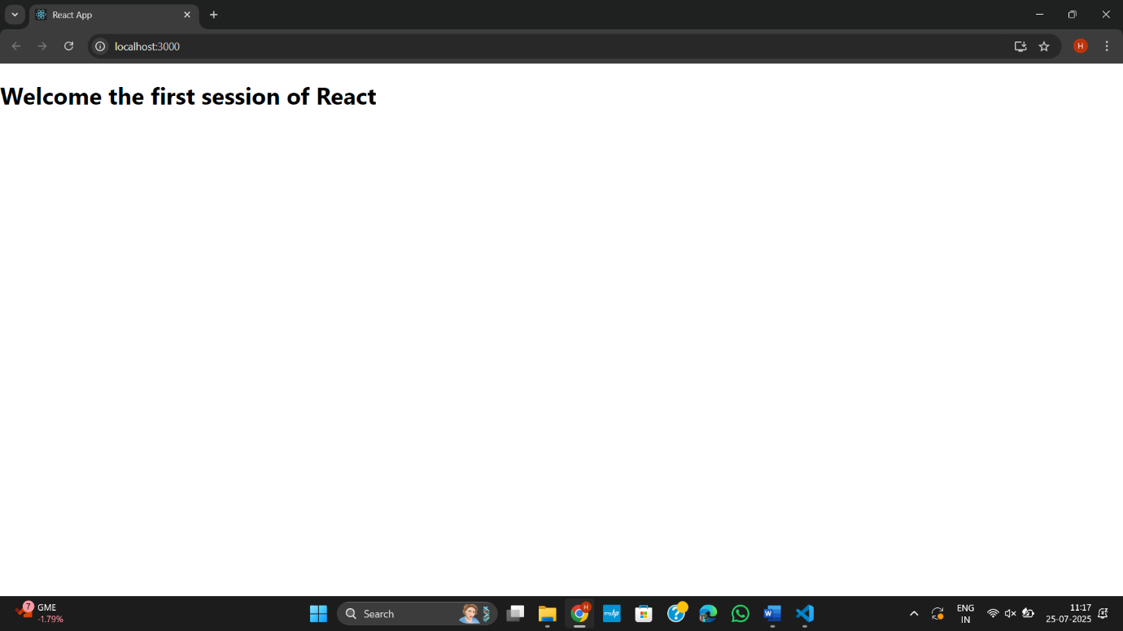

**2.ReactJS-HOL**

**Create a react app for Student Management Portal named StudentApp and create a component named Home which will display the Message “Welcome to the Home page of Student Management Portal”.**

**Code:**

**Home.js**

import React, { Component } from 'react';

class Home extends Component {

  render() {

    return (

      <div>

        <h3>Welcome to the Home page of Student Management Portal</h3>

      </div>

    );

  }

}

export default Home;

**App.js**

import './App.css';

import Home from './Components/Home';

import About from './Components/About';

import Contact from './Components/Contact';

function App() {

  return (

    <div className="container">

      <Home />

      <About />

      <Contact />

    </div>

  );

}

export default App;

**About.js**

import React, { Component } from 'react';

class About extends Component {

  render() {

    return (

      <div>

        <h3>Welcome to the About page of the Student Management Portal</h3>

      </div>

    );

  }

}

export default About;

**Contact.js**

import React, { Component } from 'react';

class Contact extends Component {

  render() {

    return (

      <div>

        <h3>Welcome to the Contact page of the Student Management Portal</h3>

      </div>

    );

  }

}

export default Contact;

**Output:**

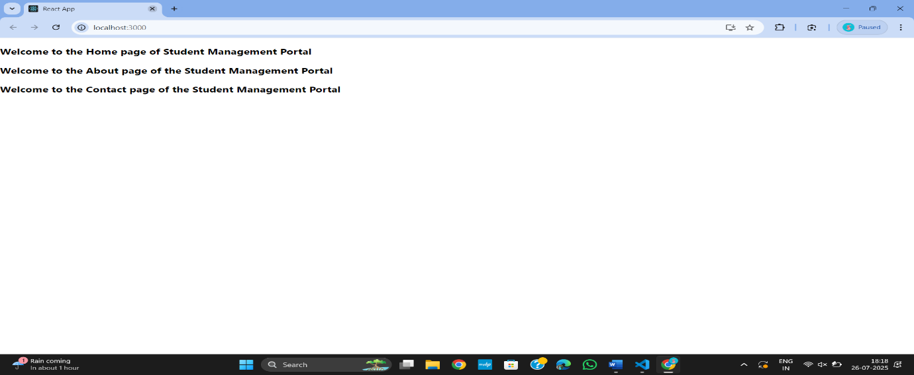

**3.ReactJS-HOL**

**Create a react app for Student Management Portal named scorecalculatorapp and create a function component named “CalculateScore”**

**CalculatorScore.js**

import'../Stylesheets/mystyle.css'

const percentToDecimal= (decimal) => {

return (decimal.toFixed(2) + '%')

}

const calcScore = (total, goal) => {

return percentToDecimal(total/goal)

}

export const CalculateScore = ({Name, School, total, goal}) => (

<div className="formatstyle">

<h1><font color="Brown">Student Details:</font></h1>

<div className="Name">

<b> <span> Name: </span></b>

<span>{Name}</span>

</div>

<div className="School">

<b> <span> School: </span> </b>

<span>{School}</span>

</div>

<div className="Total">

<b><span>Total:</span></b>

<span>{total}</span>

<span>Marks</span>

</div>

<div className="Score">

<b>Score:</b>

<span>

{calcScore(

total,

goal

)}

</span>

</div>

</div>

);

**Mystyle.css**

.Name

{

    font-weight: 300;

    color: blue;

}

.School{

    color: crimson;

}

.Total{

    color: darkmagenta;

}

.formatstyle

{

    text-align: center;

    font-size: large;

}

.Score{

    color: forestgreen;

}

**App.js**

import logo from './logo.svg';

import './App.css';

import { CalculateScore } from './Components/CalculateScore';

function App() {

  return (

    <div>

      <CalculateScore Name={"Steeve"}

      School={"DNV Public School"}

      total={284}

      goal={3}

      />

    </div>

  );

}

export default App;

**Output:**

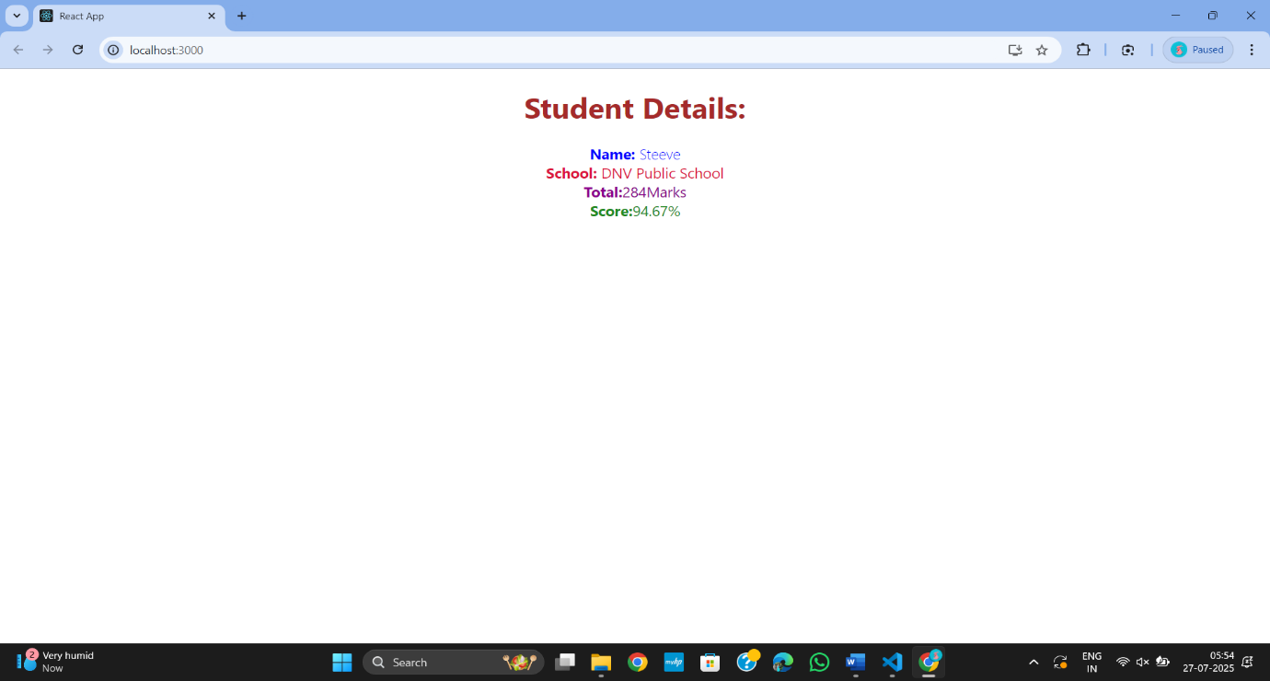

**4.ReactJS-HOL**

**Hook Methods**

**Code:**

import React, { Component } from 'react';

import Post from './Post';

class Posts extends Component {

  constructor(props) {

    super(props);

    this.state = {

      posts: [],

      error: null,

    };

  }

  loadPosts() {

    fetch('https://jsonplaceholder.typicode.com/posts')

      .then((response) => {

        if (!response.ok) {

          throw new Error('Network response was not ok');

        }

        return response.json();

      })

      .then((data) => {

        this.setState({ posts: data });

      })

      .catch((error) => {

        this.setState({ error: error.message });

      });

  }

  componentDidMount() {

    this.loadPosts();

  }

  componentDidCatch(error, info) {

    alert(`Error occurred: ${error}`);

  }

  render() {

    const { posts, error } = this.state;

    if (error) {

      return <p>Error: {error}</p>;

    }

    return (

      <div>

        <h1>Blog Posts</h1>

        {posts.map((post) => (

          <Post key={post.id} title={post.title} body={post.body} />

        ))}

      </div>

    );

  }

}

export default Posts;

**App.js**

import React from 'react';

import Post from './Post';

function App() {

  return (

    <div className="App">

      <Post />

    </div>

  );

}

export default App;

**Output:**

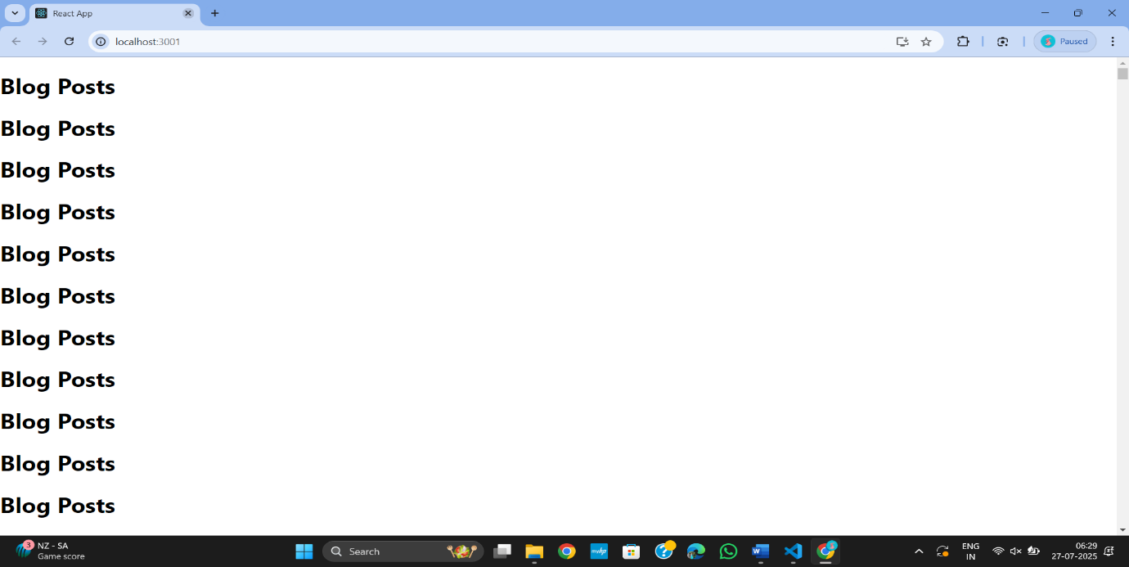

**5.ReactJS-HOL**

**Cohort Details**

**Code:**

**App.js**

import React from 'react';

import CohortDetails from './CohortDetails';

function App() {

  const cohorts = [

    {

      name: 'INTADMDF10 - .NET FSD',

      startDate: '22-Feb-2022',

      status: 'Scheduled',

      coach: 'Aathma',

      trainer: 'Jojo Jose'

    },

    {

      name: 'ADM21JF014 - Java FSD',

      startDate: '10-Sep-2021',

      status: 'Ongoing',

      coach: 'Apoorv',

      trainer: 'Elisa Smith'

    },

    {

      name: 'CDBJF21025 - Java FSD',

      startDate: '24-Dec-2021',

      status: 'Ongoing',

      coach: 'Aathma',

      trainer: 'John Doe'

    }

  ];

  return (

    <div>

      <h2>Cohorts Details</h2>

      {cohorts.map((cohort, index) => (

        <CohortDetails key={index} cohort={cohort} />

      ))}

    </div>

  );

}

export default App;

**Index.js**

import React from 'react';

import ReactDOM from 'react-dom/client';

import App from './App';

const root = ReactDOM.createRoot(document.getElementById('root'));

root.render(<App />);

**CohortDetails.js**

import React from 'react';

import styles from './CohortDetails.module.css';

const CohortDetails = ({ cohort }) => {

  const statusColor = cohort.status === 'Ongoing' ? 'green' : 'blue';

  return (

    <div className={styles.box}>

      <h3 style={{ color: statusColor }}>{cohort.name}</h3>

      <dl>

        <dt>Started On</dt>

        <dd>{cohort.startDate}</dd>

        <dt>Current Status</dt>

        <dd>{cohort.status}</dd>

        <dt>Coach</dt>

        <dd>{cohort.coach}</dd>

        <dt>Trainer</dt>

        <dd>{cohort.trainer}</dd>

      </dl>

    </div>

  );

};

export default CohortDetails;

**CohortDetails.module.css**

.box {

  width: 300px;

  display: inline-block;

  margin: 10px;

  padding: 10px 20px;

  border: 1px solid black;

  border-radius: 10px;

  vertical-align: top;

}

dt {

  font-weight: 500;

}

**Output:**

