**Assignment-12.1**

Name: E.Harini ,

Enrollnumber:2503A51L40,

Batch number: 20,

Course: AI assisted coding.

**TASK1:** (sorting-merge sort implementation)

Task: Use AI to generate a Python program that implements the  
Merge Sort algorithm.

**1. Prompt**:

Implement the merge sort algorithm in python and demonstrate its usage with an example .

**2. Code**:

**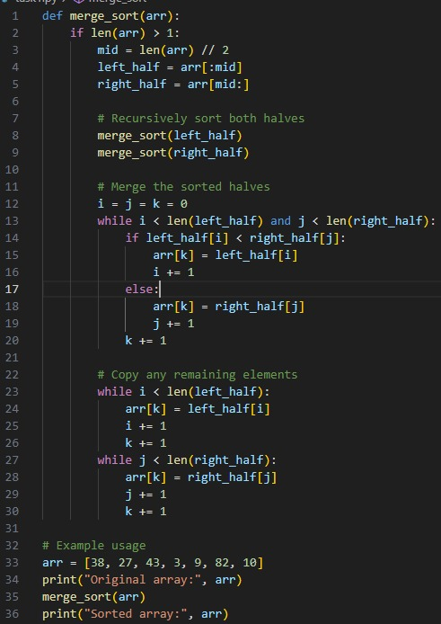**

**3. Output:**

**C:\Users\nishc\AppData\Local\Packages\5319275A.WhatsAppDesktop_cv1g1gvanyjgm\TempState\596A3D04481816330F07E4F97510C28F\WhatsApp Image 2025-09-16 at 12.01.36_45696db9.jpg**

**4. Observation:** The merge sort function correctly sorts the provided list .The output matches the expected sorted order.

**Task 2:**

(Searching – Binary Search with AI Optimization)  
• Task: Use AI to create a binary search function that finds a target element in a sorted list.

**1. prompt:**

Implement a binary search function that finds a target element in a sorted list, with an example.

**2. Code:**

**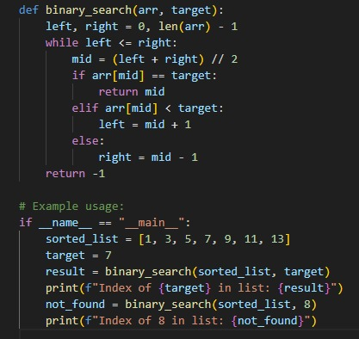**

**3. Output:**

**C:\Users\nishc\AppData\Local\Packages\5319275A.WhatsAppDesktop_cv1g1gvanyjgm\TempState\0267AAF632E87A63288A08331F22C7C3\WhatsApp Image 2025-09-16 at 12.09.51_54a37d3b.jpg**

**4. Observation:**

The binary search function returns the correct index for the target elements if found, or -1 if not found . The example demonstrates both cases.

**Task3:**

(Real-Time Application – Inventory Management System)  
• Scenario: A retail store’s inventory system contains thousands of  
products, each with attributes like product ID, name, price, and  
stock quantity. Store staff need to:  
1. Quickly search for a product by ID or name.  
2. Sort products by price or quantity for stock analysis.  
• Task: The most efficient search and sort.

1. **Prompt:**

Write a python function to find the maximum element in a list and provided an example.

1. **Code:**

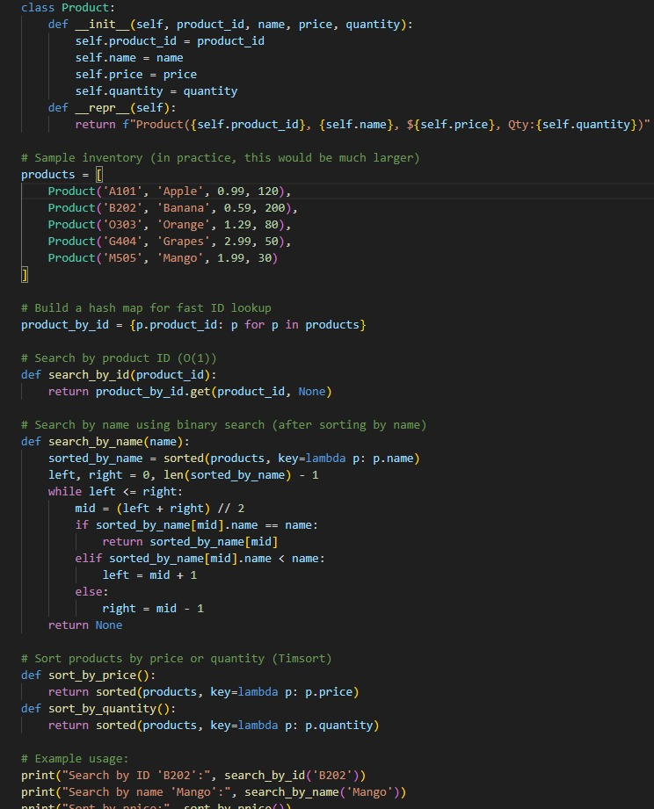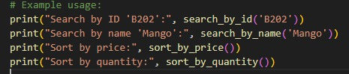

1. **Output:**

****

1. **Observation:**

The function accurately identifies and return the maximum value from the list.