IR_Text_Classification_Assignment
Name: Harini K K
Reg No: RA2411026050041
Class: CSE AIML A
Year: 3rd Year
GitHub Repository
https://github.com/harini-kk-1606/IR_Text_Classification_Assignment
Project Overview
This project classifies real technical discussion posts from the 20 Newsgroups dataset into six classes: Cryptography, Electronics, Graphics, PC Hardware, Space and Windows OS. It extends the Task 1 TF-IDF system, which worked on computing-topic documents, from ranking documents to labelling them. Each post is first cleaned by removing its e-mail header, quoted replies and signature. It is then preprocessed with lowercasing, tokenization, stop word removal and Porter stemming, and represented as a TF-IDF vector. Decision Tree, KNN, SVM and Naive Bayes are trained on the same 75/25 stratified split and compared using Accuracy, Precision, Recall, F1-score and confusion matrices. As a what-if experiment, the feature representation was changed between bag-of-words counts, TF-IDF unigrams and TF-IDF unigrams+bigrams.
Code and Execution Screenshots
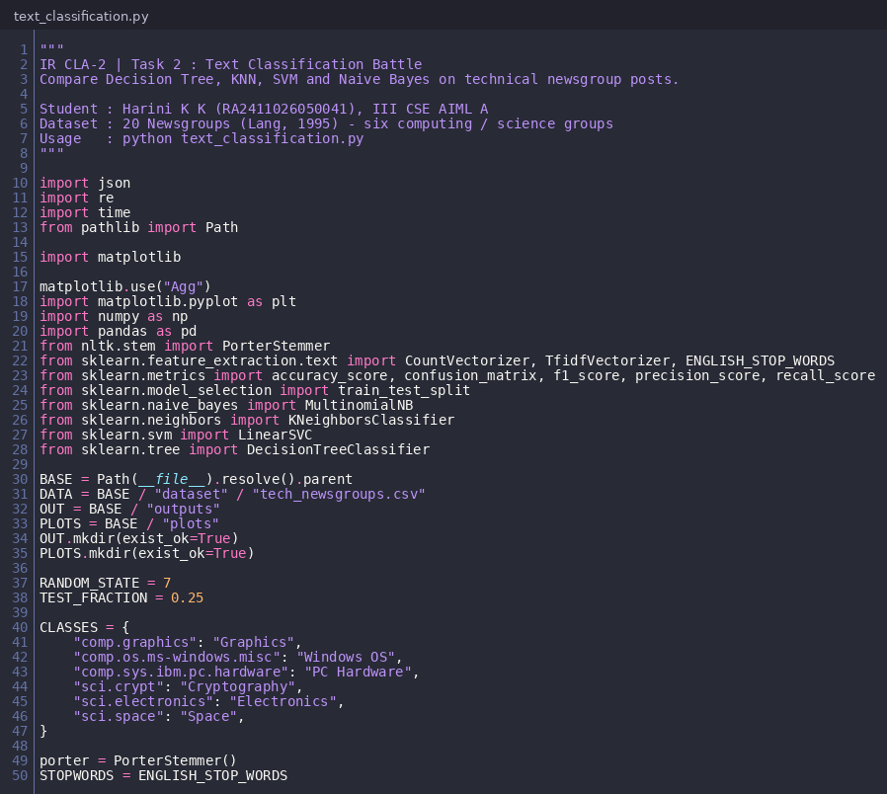
Figure 1: Imports, dataset path and class definitions
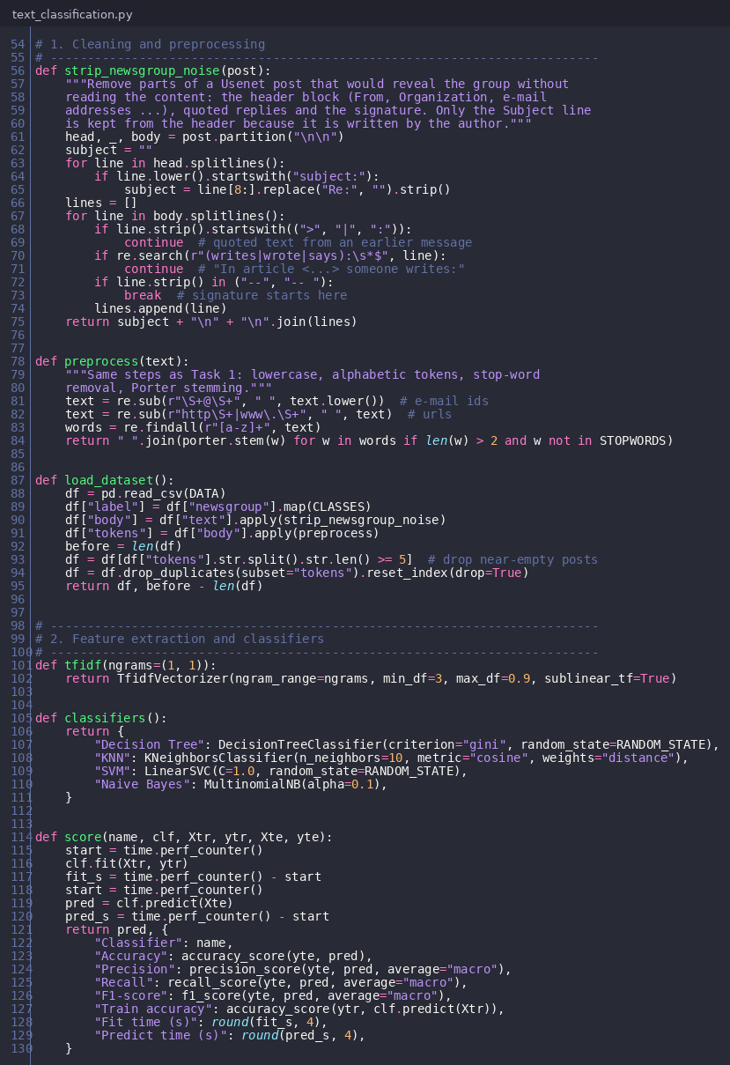
Figure 2: Post cleaning, preprocessing, TF-IDF and the four classifiers
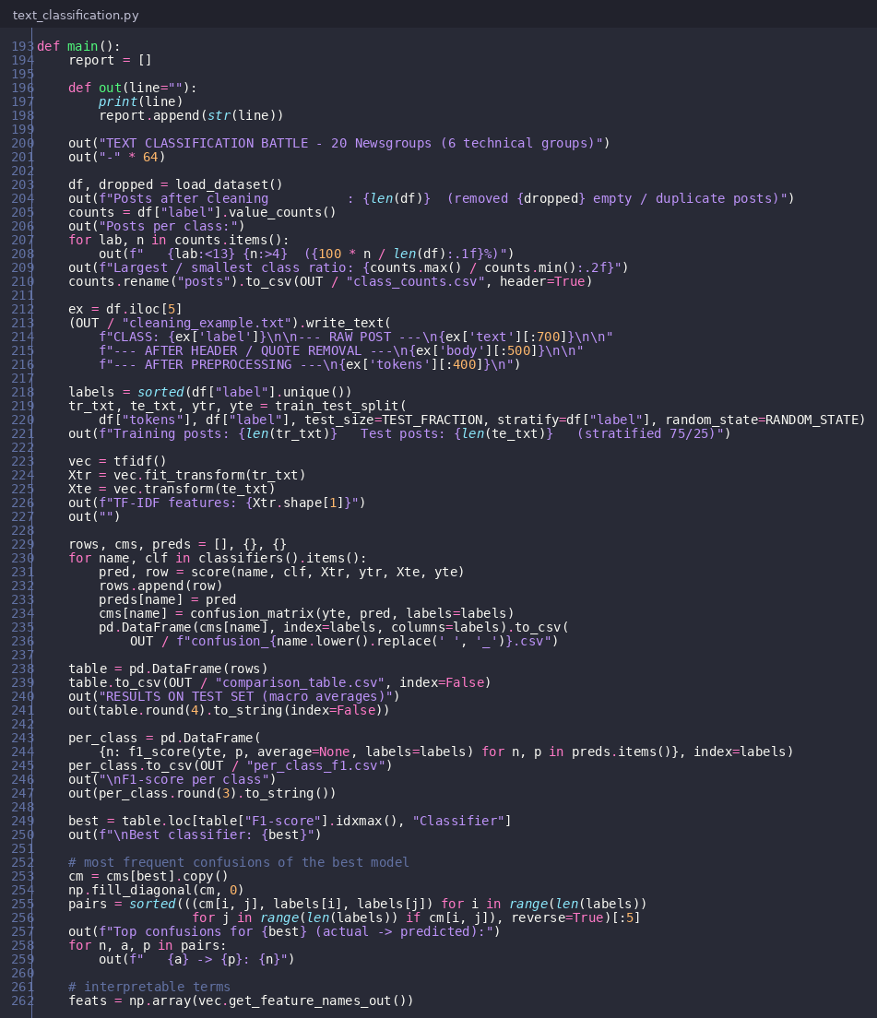
Figure 3: Main experiment – split, training, evaluation and confusion analysis
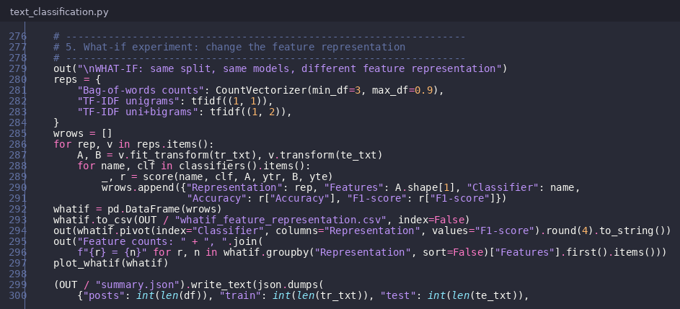
Figure 4: What-if experiment on feature representation
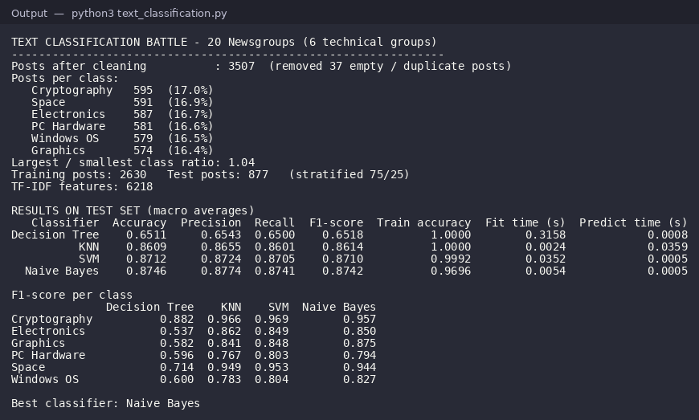
Figure 5: Execution output – dataset, results table, per-class F1 and best model
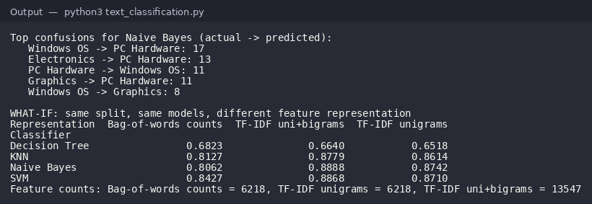
Figure 6: Execution output – what-if experiment
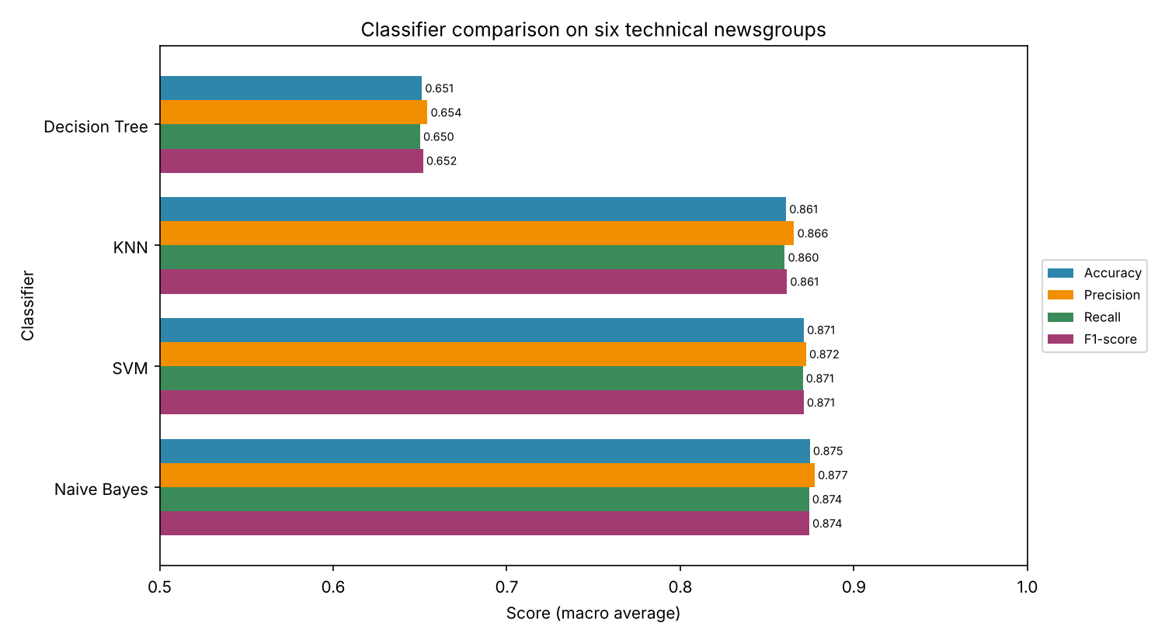
Figure 7: Performance comparison of the four classifiers
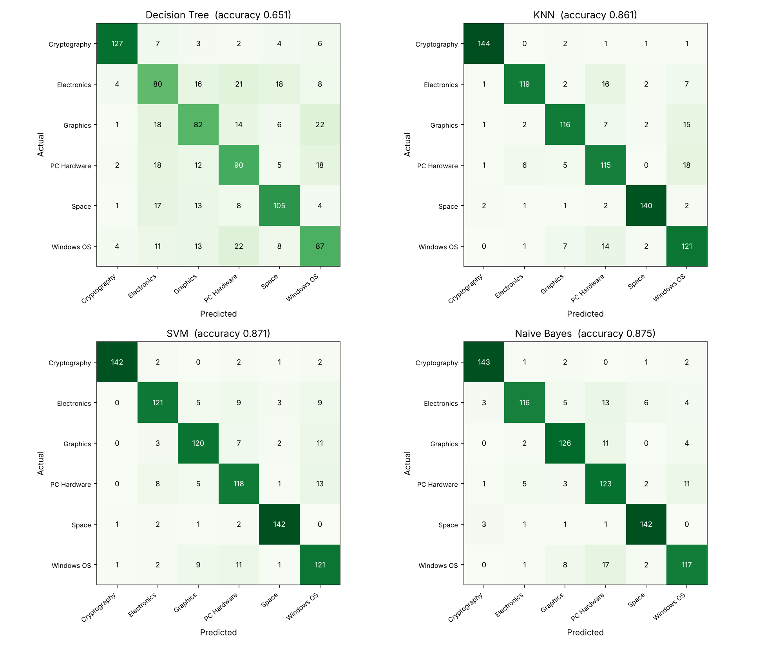
Figure 8: Confusion matrices
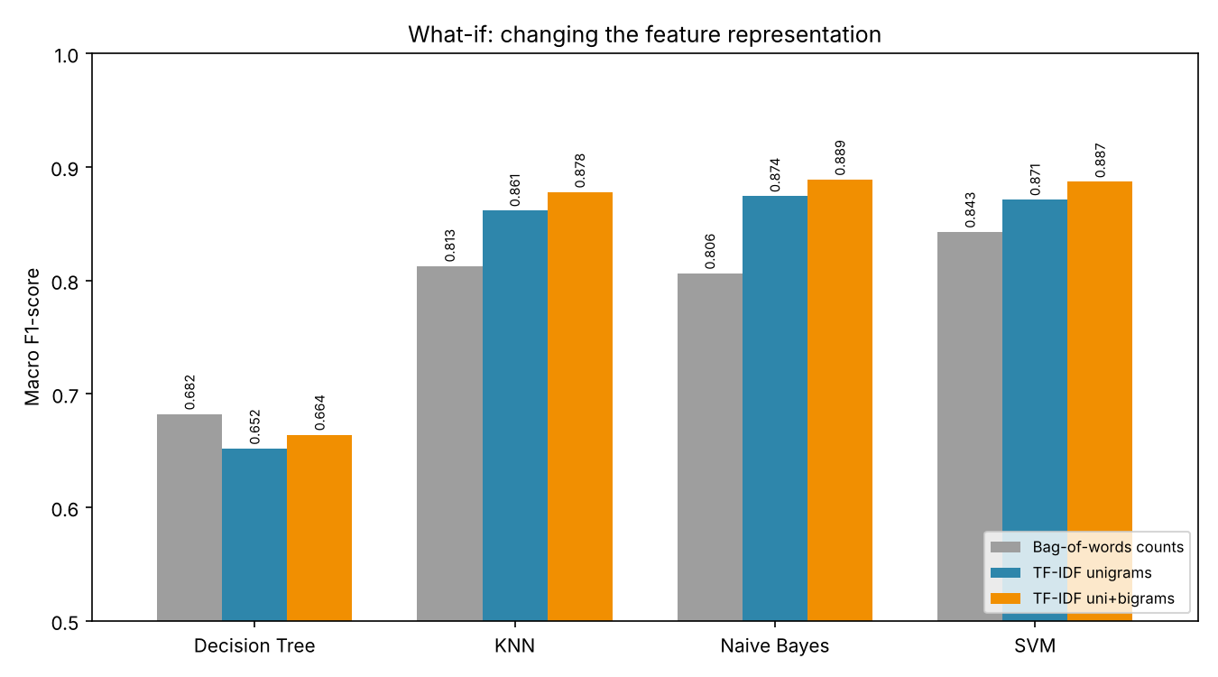
Figure 9: What-if – effect of the feature representation
Project Result
The program processed 3,507 newsgroup posts, built 6,218 TF-IDF features and evaluated the four classifiers on 877 test posts. Naive Bayes gave the best result, with an accuracy of 0.8746 and a macro F1-score of 0.8742. It was closely followed by SVM (0.8710) and KNN (0.8614), while Decision Tree was much lower (0.6518) because it overfits the training data: it scores 100% on training posts. Cryptography and Space were the easiest classes, while most errors came from the closely related Windows OS, PC Hardware and Electronics groups. In the what-if experiment, adding bigrams to TF-IDF improved every model except Decision Tree, and raised Naive Bayes to the highest score of 0.8888. Plain word counts gave the lowest scores for KNN, SVM and Naive Bayes. Naive Bayes with TF-IDF unigram and bigram features is therefore recommended for this task.

