**Day 4**

**1. Doctor Class**

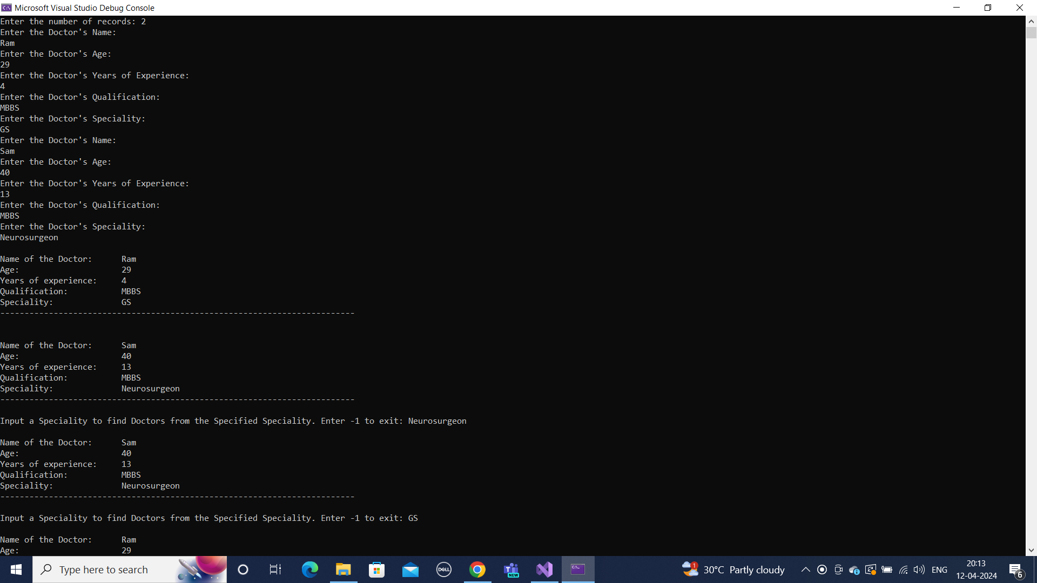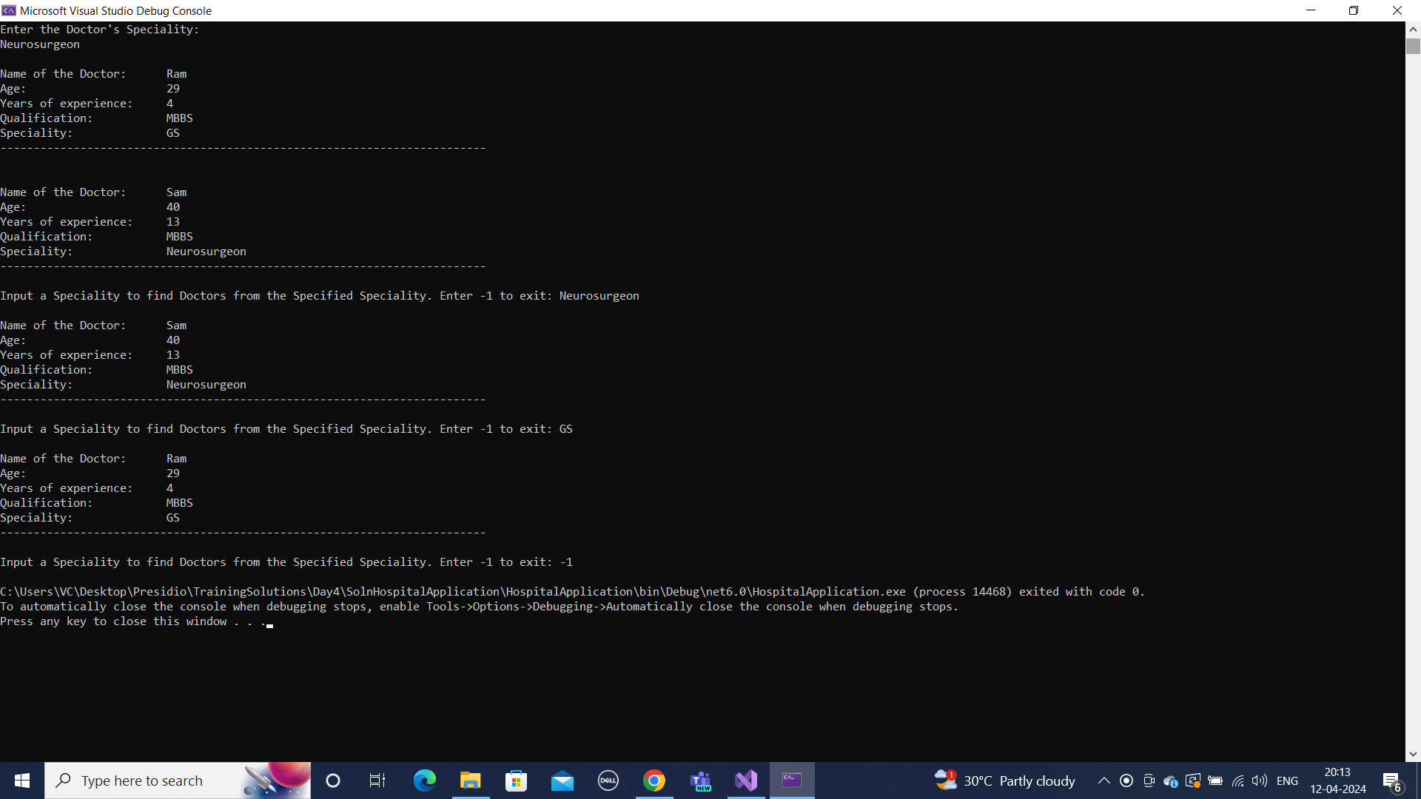

**2. Card Validation**

**Invalid Input**

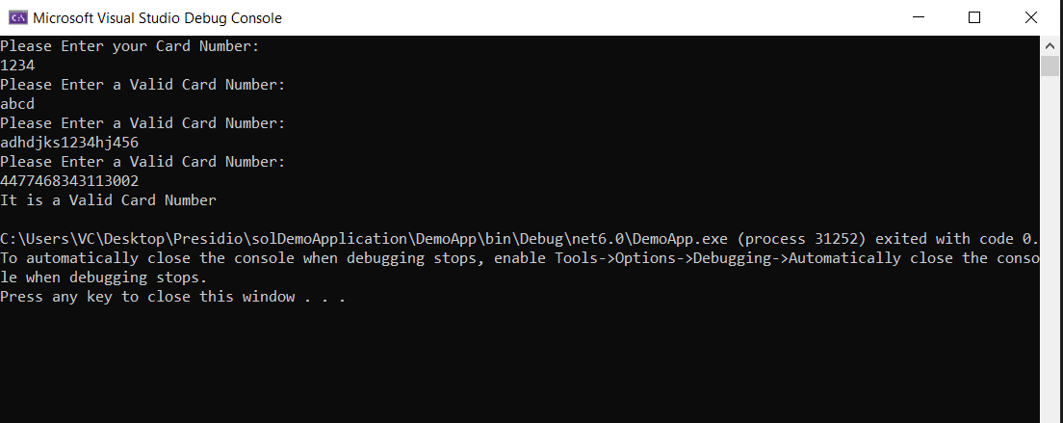

**Invalid Card Number**

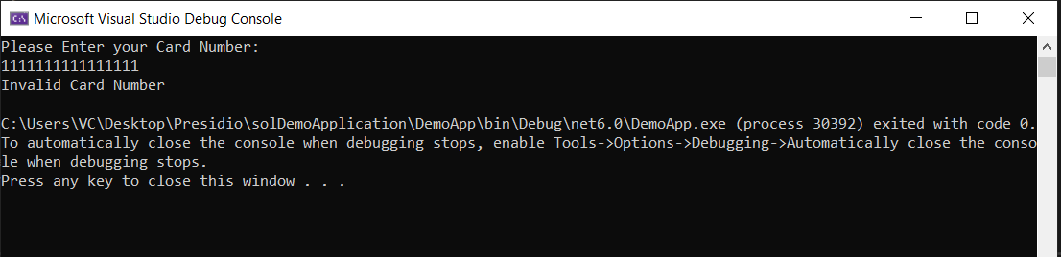

**Valid Card Number**

