**Day 5**

**1. Cows and Bulls Leetcode:**

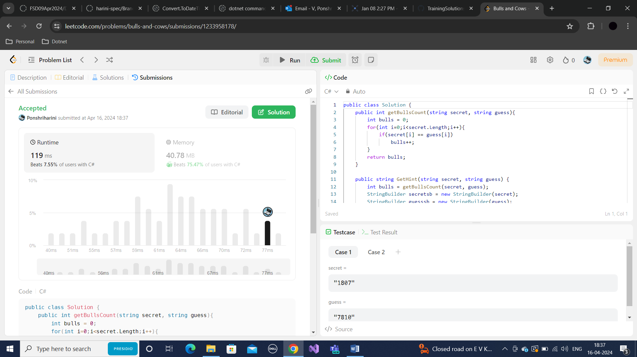

**2. Cows and Bulls Console – 2 Player game:**

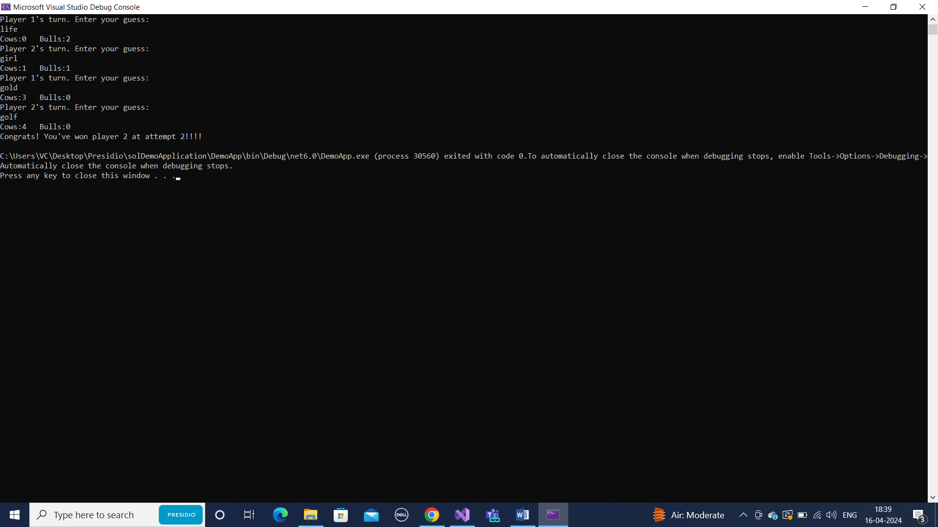

**3. 3-Digit numbers with same digits count:**

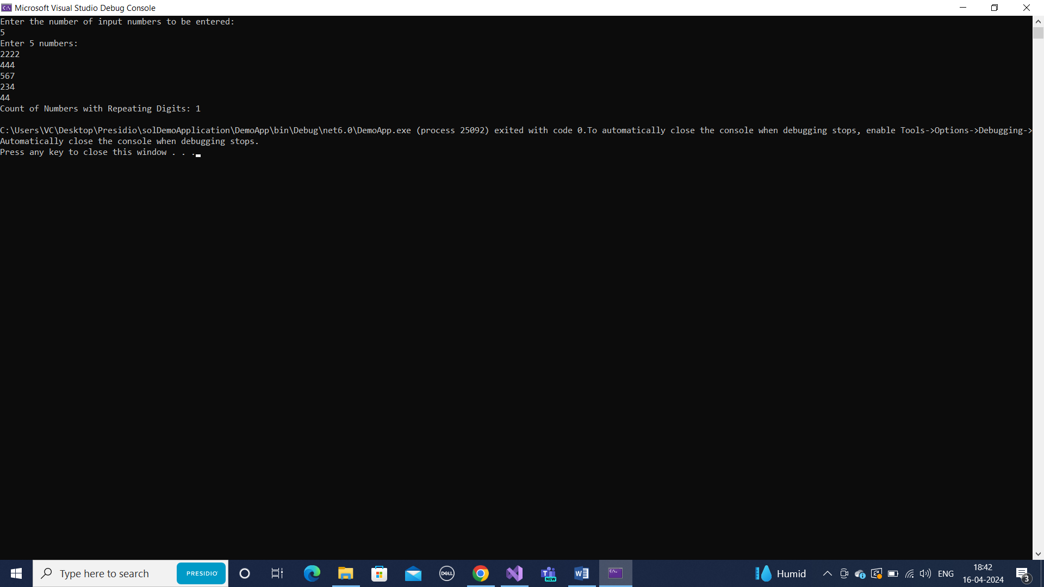

Checks only 3 digit numbers as the question mentioned.

**4. CRUD Employee Request Tracker:**







