
HEALTHCARE DATA ANALYSIS

Introduction :
This project analyzes a healthcare dataset using SQL and Power BI to explore patient information, hospital performance, and billing trends. The dataset contains patient-related information such as demographics, medical conditions, hospital details, billing amounts. SQL was used for data cleaning and analysis, while Power BI visualized key insights through interactive dashboards for better healthcare decision-making.

Objectives :
• To analyze and manage healthcare data using SQL queries.
• To identify key insights from patient and hospital records.
• To create interactive Power BI dashboards for data visualization.
• To support data-driven decisions in healthcare management.


create database healthcare;
- Created a new database named ‘healthcare’ to store and manage healthcare-related data.
- Provided a structured environment for efficient data storage and analysis
use [Healthcare]
- Selected the ‘Healthcare’ database for performing SQL operations.

- Ensured that all upcoming queries were executed within the healthcare database.

- Helped maintain focus on relevant patient and hospital datasets.

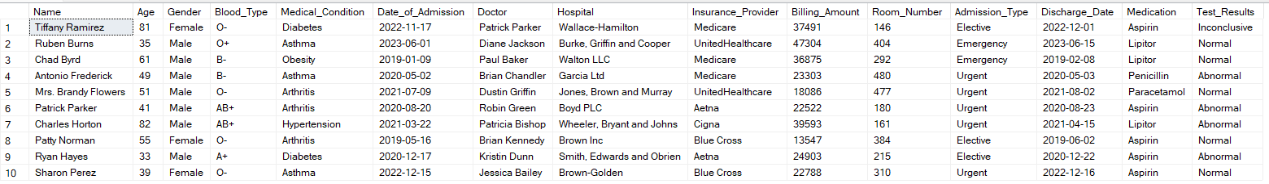
SELECT TOP 10* FROM [dbo].[healthcare_dataset];

- Retrieved the first 10 records from the healthcare_dataset table.
- Used to preview the dataset and understand its structure and fields.
- Helped verify that the data was successfully loaded into the database.

SELECT *
FROM Healthcare_Dataset
WHERE Name IS NULL
OR [Age] IS NULL
OR [Gender] IS NULL
OR [Billing_Amount] IS NULL;

- Retrieved all records from the Healthcare_Dataset table that contain missing (NULL) values.
- Focused on key columns like Name, Age, Gender, and Billing_Amount
- Helped in identifying incomplete or missing data in the dataset.
- Supported the data cleaning process by locating records that required correction or removal.

WITH CTE AS (
SELECT *,
ROW_NUMBER() OVER(PARTITION BY [Name], [Date_of_Admission], [Hospital] ORDER BY Name) AS rn
FROM Healthcare_Dataset
)
DELETE FROM CTE WHERE rn > 1;

- Created a Common Table Expression to identify duplicate records.
- Used the ROW_NUMBER() function to assign a unique number to each duplicate entry.
- Partitioned data by Name, Date_of_Admission, and Hospital to detect repetition.

UPDATE Healthcare_Dataset
SET Gender = CASE
WHEN Gender LIKE 'M%' THEN 'Male'
WHEN Gender LIKE 'F%' THEN 'Female'
ELSE Gender
END;

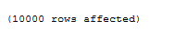

- Created a Common Table Expression (CTE) to identify duplicate records.
- Used the ROW_NUMBER() function to assign a unique number to each duplicate entry.
- Partitioned data by Name, Date_of_Admission, and Hospital to detect repetition.
- Deleted records where row number > 1, ensuring only unique records remained in the dataset.

UPDATE Healthcare_Dataset
SET [Blood_Type] = REPLACE([Blood_Type], ' ', '');

- Updated the Blood_Type column in the Healthcare_Dataset table.
- Used the REPLACE() function to remove unwanted spaces from blood type values.
- Helped ensure data consistency and accuracy in the dataset.

ALTER TABLE Healthcare_Dataset
ALTER COLUMN [Billing_Amount] DECIMAL(18,0);

- Modified the Billing_Amount column data type to DECIMAL(18,0).
- Ensured that billing values are stored as numeric data for accurate calculations.
- Improved data precision and consistency in financial fields.

SELECT COUNT(DISTINCT [Name] ) AS patientcount
FROM Healthcare_Dataset;

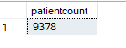

- Counted the number of unique patients in the Healthcare_Dataset table.
- Used the COUNT(DISTINCT [Name]) function to avoid duplicate patient entries.
- Helped determine the total number of individual patients in the dataset.

SELECT AVG([Billing_Amount]) AS AverageBilling FROM Healthcare_Dataset;

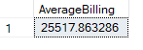

- Calculated the average billing amount from the Healthcare_Dataset table.
- Used the AVG() function to find the mean value of all billing records.
- Helped analyze the overall billing trend among patients.

SELECT [Medical_Condition], COUNT(*) AS PatientCount
FROM Healthcare_Dataset
GROUP BY [Medical_Condition]
ORDER BY PatientCount DESC;

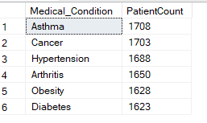
- Grouped patients based on their Medical_Condition.
- Used the COUNT() function to find the number of patients under each condition.
- Ordered the results in descending order to show the most common conditions first.
- Helped identify frequent health issues for better understanding of patient trends.

SELECT Gender, COUNT(*) AS Total
FROM Healthcare_Dataset
GROUP BY Gender;

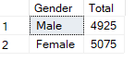

- Grouped the dataset by Gender to count the number of patients in each category.
- Used the COUNT() function to calculate the total patients by gender.
- Helped analyze the gender distribution of patients in the dataset.

SELECT Hospital, AVG([Billing_Amount]) AS AvgBill
FROM Healthcare_Dataset
GROUP BY Hospital
ORDER BY AvgBill DESC;

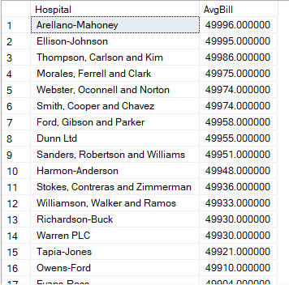

- Grouped data by Hospital to calculate the average billing amount for each one.
- Used the AVG() function to find the mean billing value per hospital.
- Ordered the results in descending order to highlight hospitals with higher average bills.
- Helped compare hospital-wise billing performance for financial insights and Power BI visualization.

SELECT [Test_Results], COUNT(*) AS Total
FROM Healthcare_Dataset
GROUP BY [Test_Results];

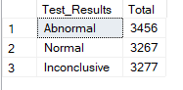

- Grouped the dataset by Test_Results to count how many patients fall under each result category.
- Used the COUNT() function to calculate the total records for each test result.
- Helped identify the distribution of test outcomes across patients.

SELECT
AVG([Billing_Amount]) AS AvgBilling,
STDEV([Billing_Amount]) AS StdDevBilling
FROM Healthcare_Dataset;
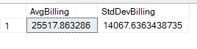

- Calculated the average (mean) and standard deviation of the Billing_Amount column.
- Used AVG() to find the typical billing amount and STDEV() to measure variation.
- Helped understand the spread and consistency of hospital billing data.

SELECT *
FROM Healthcare_Dataset
WHERE Age < 50 OR Age > 10;

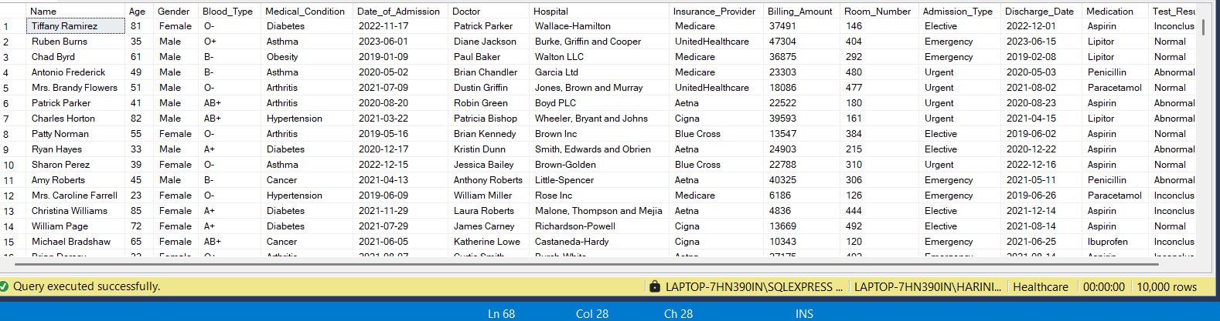

- Retrieved all patient records where Age is below 50 or above 10.
- Used the WHERE clause to apply an age-based filter on the dataset.
- Helped focus on a specific age group of patients for analysis.

DASHBOARD
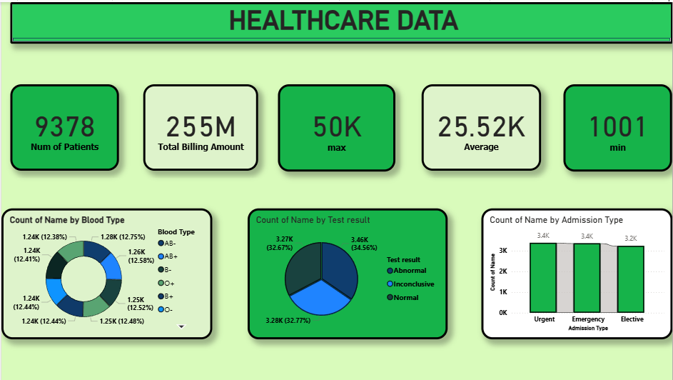

- Designed a Healthcare Data Dashboard to visualize key insights from the SQL-analyzed dataset.
- Displayed important KPIs such as Total Patients (9378), Total Billing Amount (255M), Maximum (50K), Average (25.52K), and Minimum Billing (1001).
- Created a Donut Chart showing the distribution of patients by Blood Type for demographic understanding.
- Used a Pie Chart to show the count of patients by Test Result (Normal, Abnormal, Inconclusive).
- Designed a Bar Chart to represent Admission Type (Urgent, Emergency, Elective) for hospital management insights.
- Helped visualize patient patterns, test results, and financial data in an interactive and easy-to-read format.
- Supported data-driven decision-making by integrating cleaned SQL data into Power BI visuals.
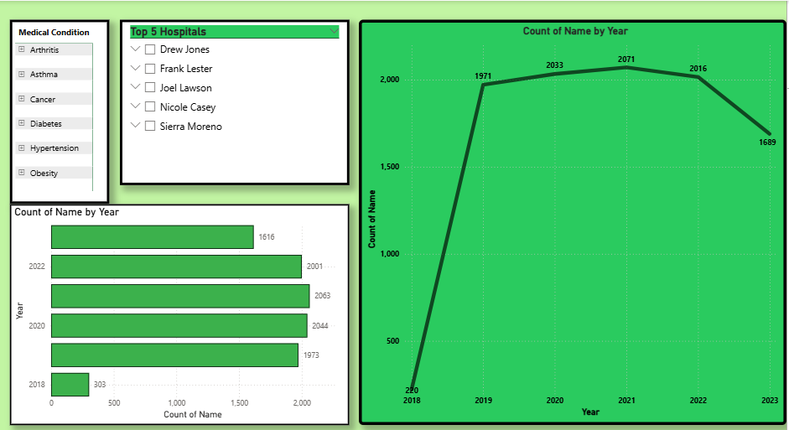

- Included slicers for Medical Condition and Top 5 Hospitals to allow easy filtering and focused analysis.
- Created a Bar Chart showing the count of patients by year, highlighting yearly trends.
- Added a Line Chart to visualize the overall yearly growth and decline in patient count from 2018 to 2023.
- Enabled quick insights into which years and hospitals had the highest number of patient admissions.
- Helped identify patterns and performance trends across multiple hospitals and time periods.

CONCLUTION
This project successfully demonstrated how SQL and Power BI can be used together to analyze and visualize healthcare data effectively. SQL was utilized for data cleaning, transformation, and extraction of key insights, while Power BI provided interactive dashboards for better understanding of patient trends, hospital performance, and financial data. The analysis helped identify meaningful patterns such as patient distribution, average billing, and yearly trends. Overall, the project supports data-driven decision-making and highlights the importance of analytics in improving healthcare management.

