**IoT Based Air Pollution Monitoring System**

A Project report submitted in partial fulfilment of the requirements for the degree of B.E in Computer Science and Engineering

By

# I.HARINI (513221104008)

Under the supervision of

Professor & HOD Department of Computer Science and Engineering

# Air quality monitoring system

**PHASE 1: PROBLEM DEFINITION AND DESIGN THINKING**

* Problem Statement
* Design Thinking Approach

**PROBLEM STATEMENT**

* It refers to the contamination of the atmosphere by harmful chemicals or biological materials. It may cause diseases, allergies, and severe health problems in humans and other living organisms and may damage the natural environment.
* The problem statement is your opportunity to explain why you care and what you propose to do in the way of researching the problem. A problem statement is an explanation in research that describes the issue that is in need of study.

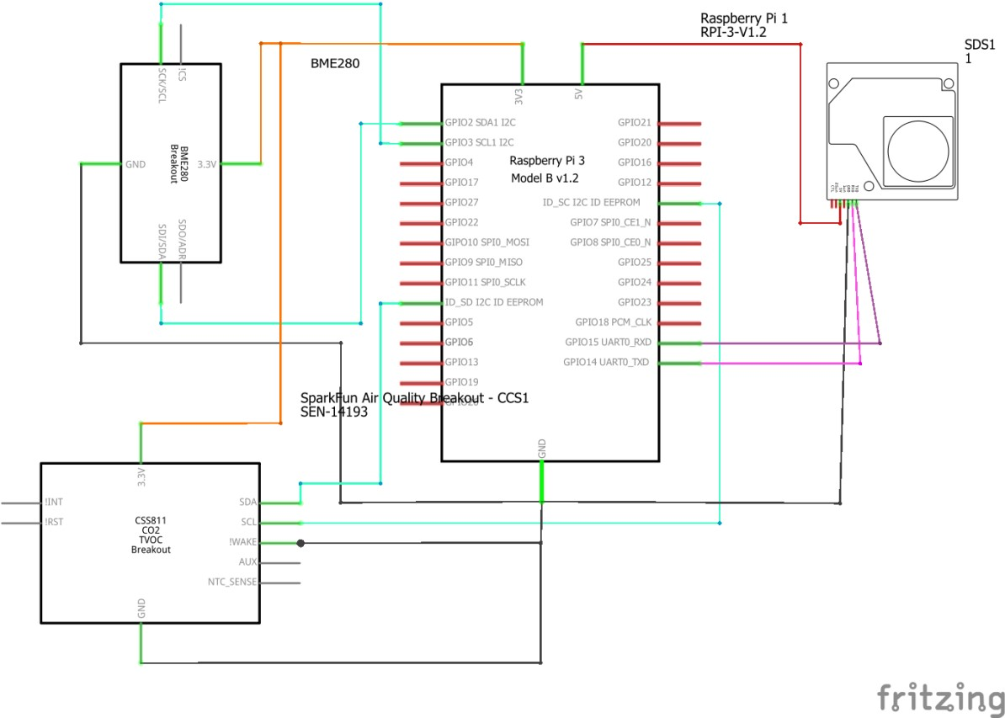

* Here's an example of a basic problem statement: Voter turnout in the southwest

region of Florida has been significantly decreasing over the past decade, while other areas of the state continue to see increasing numbers of voters at the polls.

* Air pollution is one of environmental issues that cannot be ignored.
* Inhaling pollutants for a long time causes damages in human health.• Traditional air quality monitoring methods, such as building air quality

monitoring stations, are typically expensive

* This project is suitable for air quality monitoring in real time.
* Design a tool which will sense quality of air and display it in the form of percentage, Sense how much carbon mono-oxide(CO) is present in air and display in the form of percentage, Sense the temperature and display it in degreeCelsius.

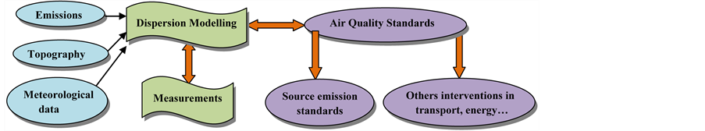

# **DESIGN THINKING APPROACH**

* Detailed concentration distributions and temporal variations of H2S for Gaussian puff model, referring to the guideline models for pollution detection and source identification were given by the environmental risk assessment.
* The source area analysis method was employed to perform the area by means of meteorological data and concentration .

source identification. It provides an approach to obtain the source

measurements

* and wood stove use. Avoid burning leaves, trash, and other materials Reduce the number of trips you take in your car.

Reduce or eliminate fireplace.

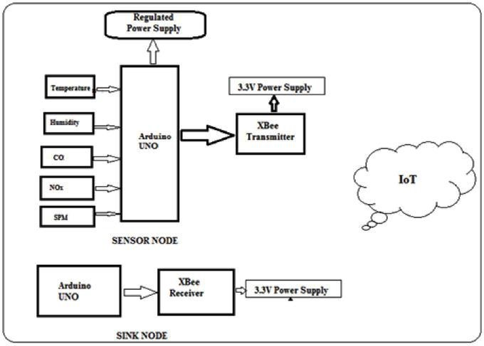

* 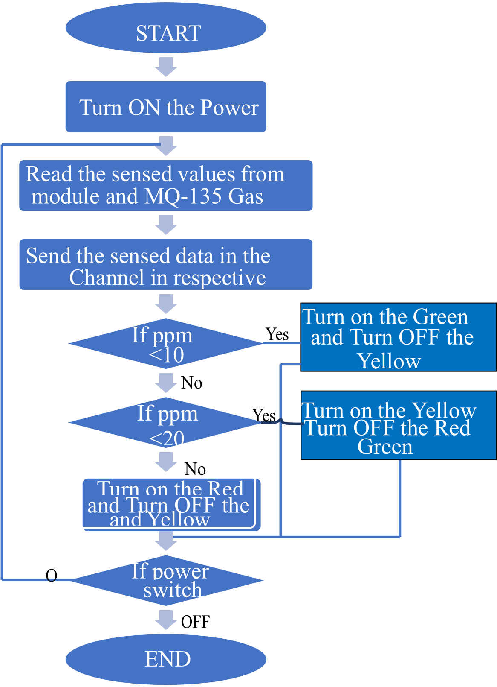Air pollution is not often perceived as a priority for village apparatus and community members, because from their standpoint it rarely results in immediate health effects or causes massive disruption of activities.
* In order for air pollution-related health information to lead to behavior change, continuous and specific support is needed from village apparatus and health cadres within the communities.
* Context-specific information on what to do and when to take action is critical to encourage mitigating actions at the community level.