**UNIT-2**

**MANAGING HUMAN RESOURCES**

2.1Managing human resources:-

Managing [human resources](https://www.thebalancecareers.com/what-is-the-human-resource-department-1918141) refers to the functions that a manager performs relative to the organization's employees. Managing Human Resources can also refer to the act of providing the management actions the employees of the Human Resource Department

Managing human resources includes, but is not limited to:

**1.Planning and Allocating Resources**

No business has unlimited resources. Managers must divide salary budgets among their employees. Workloads must be divided. Managers decide who gets what training and who gets the best projects.  
Who gets the newest computer and who is stuck with the old one until the new budgeting cycle rolls around? In addition to physical resources, where does a manager spend her time? Who does she help? All of these things are part of the planning and allocating resources.

**2.Providing Direction, Vision, and Goals**

A manager should be the leader of the group. Managers not only divide the work but direct how employees should accomplish the work. They set the goals. Depending on the type and level of the group, managers may set overarching goals, allowing the employees the opportunity to set their own lower-level goals, or they may take control of the entire process. Both are appropriate, depending on the situation.  
[Vision is a key task](https://www.thebalancecareers.com/build-a-strategic-framework-through-strategic-planning-1916834) in managing your human resources. If your employees cannot see the big picture, they are less likely to perform to their highest level. Managers need to have a vision and share it properly with the team.

**3.Developing an Environment in which Employees Choose Motivation and Contribution**

Managers determine what type of environment is best for their department. Good managers ensure that gossips, bullies, and slackers are all either coached into proper performance or terminated. Bad managers allow these people to overrun the department, creating a tense and unhappy environment. A good environment will motivate employees, and they will choose to perform at a high level.

Supplying or Asking for the Metrics that Tell People How Successfully They Are Performing

Managers must provide feedback. Without that framework, employees don't know where they need to improve and where they are doing well. This is most successful when metrics are built around clear, measurable goals.

**4.Offering Opportunities for Both Formal and Informal Development**

A manager's job isn't just to get the work done but to help his or her reporting employees succeed. Managers should personally coach employees, and provide opportunities for formal [developmental training](https://www.thebalancecareers.com/developing-your-employees-2275869), such as classes and stretch projects. You can provide coaching through formal mentoring relationships or by providing feedback on a regular basis.

Setting an Example in Work Ethics, Treatment of People, and Empowerment Worthy of Being Emulated by Others

A good manager shows her staff how to behave. She is ethical, treats people fairly, and gives people the independence they've earned. Managers who play favorites, steal credit or discriminate against their staff are damaging the business's most important resource - their people.

**5.Leading Organization Efforts to Listen to and Serve Customers**

Managers often see the customers as more important than their own staff. This is not true - good staff management leads to good relationships with the customers. Customer relationships are critical and the business profits by managers who make customer service a priority.  
Managers have a duty to both the customer and employees, and when she takes care of both, success is more likely.

**6.Removing Obstacles that Impede the Employees' Progress**

Managers help their people when they clear the path for success. Should employees need approval from senior leadership for something, the manager helps facilitate the approval. Should an employee need a training course, or specialized instructions, or assistance with a project, the [manager](https://www.thebalancecareers.com/sample-human-resources-manager-job-description-1919125) helps facilitate that.

A manager is interested in her employees' success and works hard to clear the pathway for that success. A manager who wishes to succeed focuses her efforts on ensuring the success of her employees.

# 2.2Role of a Project Manager:-

The term “project manager” is so broad that it can encompass various tasks and mean different things to different people. So what is the typical job description for a project manager? A project manager is responsible for overseeing a project from start to finish. The responsibilities of a project manager include:

* Planning the project
* Creating a schedule and timeline
* Executing each phase
* Managing the budget
* Serving as the liaison among all stakeholders
* Troubleshooting and maintenance

Project managers must be highly organized, detail-oriented, and possess excellent people skills — after all, they are responsible for leading the team and communicating clearly and regularly with all relevant parties.

### What is the role of a project manager?

[The Project Management Institute](https://www.pmi.org/about/learn-about-pmi/who-are-project-managers) describes the role of the project manager as that of a change agent. They’re someone who “makes project goals their own and uses their skills and expertise to inspire a sense of shared purpose within the project team.” Project managers are leaders — they not only ensure projects are delivered on time and within budget but must also engage and encourage their teams and inspire their clients. They need strong critical thinking capabilities to solve problems as they arise and finely-tuned communication skills (like a knack for customer service) to ensure everyone remains informed, motivated, and on board. It’s no wonder that project managers are [considered critical to the success](https://smallbusiness.chron.com/important-organizations-use-project-management-46723.html) of any venture.

### What are the responsibilities of a project manager?

The tasks that a project manager is responsible for typically include:

* **Planning:**A project manager is responsible for formulating a plan to meet the project’s objectives while adhering to an approved budget and timeline. This blueprint will guide the project from ideation to fruition. It will include the project’s scope, the resources necessary, the anticipated time and financial requirements, the communication strategy, a plan for execution and documentation, and a proposal for follow-up and maintenance. If the project has not yet gained approval, this plan will serve as a critical part of the pitch to key decision-makers.
* **Leading:** An essential part of any project manager’s role is to assemble and lead the project team. This requires excellent communication, people, and leadership skills, as well as a keen eye for others’ strengths and weaknesses. Once the team has been created, the project manager assigns tasks, sets deadlines, provides necessary resources, and meets regularly with the members. An ability to speak openly and frequently with all stakeholders is critical.
* **Execution:**The project manager participates in and supervises the successful execution of each stage of the project. Again, this requires frequent, open communication with the project team members and stakeholders.
* **Time management:**Staying on schedule is crucial to completing any project, and time management is one of the key responsibilities of a project manager. Project managers are responsible for resolving derailments and communicating effectively with team members and other stakeholders to ensure the project gets back on track. Project managers should be experts at risk management and contingency planning to continue moving forward even when roadblocks occur.
* **Budget:** Project managers devise a budget for a project and stick to it as closely as possible. If certain parts of the project end up costing more (or, in a perfect world, less) than anticipated, project managers moderate the spend and re-allocate funds when necessary.
* **Documentation:**A project manager must develop effective ways to measure and analyze the project’s progress. Common strategies for documenting a project include data collection and verbal and written status reports. It’s also a project manager’s job to ensure that all relevant actions are approved and that these documents are archived for future reference.
* **Maintenance:** The work doesn’t end once a project has been completed. There needs to be a plan for ongoing maintenance and troubleshooting. The project manager devises methods for properly supporting the final deliverable going forward, even if they are not directly overseeing its day-to-day operations.

### What does a project manager do?

You might wonder, “What does a project manager do on a day-to-day basis?” Each project is unique and, as a result, no two days are alike. A project manager’s job is to keep the project moving forward and clear a path for their team members to succeed. Daily, this will involve:

* Answering emails related to the execution or maintenance of a project
* Meeting with team members for status reports and tackling any new issues
* Checking in with the client or other stakeholders to update them on the project’s progress
* Reviewing the appropriate documentation to assess budget, schedule, and scope
* Dealing with project changes by re-allocating resources, including team members
* And maybe — just maybe — drinking a cup of coffee or two!

**2.3 Building a project team:-**

The key to successful project lies with the team orchestrating it. The stronger the team, the more successful the project. But a strong team doesn’t just magically happen; here are five key characteristics that help to create a successful project team.

## 1. Clear Goals

Goals should be well-defined and measurable so that everyone in the team is on the same page and understands the direction in which the project is going. Even if just one person is unsure, it can have a domino effect on the rest of the team and risk de-railing the whole project.

Involving team members in the goal setting process can also be very valuable, as a [**Gallup study**](https://www.gallup.com/workplace/238064/re-engineering-performance-management.aspx) proved that employees are 3.6 times more likely to be engaged if included in the process. A typical framework to follow when creating clear goals is SMART:

**S**pecific – is it well-defined so that everyone in the team is able to understand the vision and purpose?

**M**easurable – have you broken down each stage into measurable steps?

**A**ttainable – is it achievable and realistic, in line with the resources, knowledge and time available?

**R**elevant – is it the right time to implement and how much does it matter to the project?

**T**imely – what is the timeframe and is there enough time for completion?

## 2. Well-defined roles

In many sports teams, there are set positions and responsibilities to abide by, and this applies to project teams as well. Having set roles and responsibilities helps define how the team will work together, set expectations and assign tasks to the appropriate people. Not only this, taking on certain roles and responsibilities can make people feel more valued, thus boosting morale and generating a positive impact on the project’s effectiveness. So, it’s a win-win for everyone!

## 3. Open communication

Communication is a fundamental element in any team, especially project teams. Open and clear communication helps avoid the classic Chinese whispers scenario, where the original message gets distorted along the communication channel and the final recipient ends up with completely different message. This also heightens the importance of listening skills, as without the ability to listen, how do you know what to communicate?

## 4. Leadership

Whilst co-operative working is encouraged, it’s important to have effective leadership and management as well. This is especially important in the event of conflict, which can cause a ripple effect throughout the team and negatively impact the projects progress too. A leader is therefore in charge of managing the project, as well as the individual team members to increase the project team’s success. The [**PMP certification**](https://www.projectmanagementqualification.com/geolocate/uk/training/view/project-management-professional-pmp/certification/online) is a great course that recognises demonstrated competence in leading and directing project teams and helps you solidify your project management skills.

## 5. Positive atmosphere

Morale and well-being are crucial to building a successful project team. Team members that are disengaged and negative can create a sour environment that disrupts communication and harmonious working. In any team, there will inevitably be varying personalities, but a positive atmosphere can help neutralise any risk of conflict or negativity.

Every project team works in different ways and what works for one, may not work for the other. However, these five characteristics will help create a harmonious and effective project team that will generate a successful project.

**2.4Dealing with issues:-**

## 8 steps to problem solving

**Step 1**. **Define the problem.** What exactly is going on? Sometimes a problem just seems too big to tackle. However, if you make a list and break it down into smaller parts that you can make a start on solving, it’ll feel more manageable.

**Step 2**. **Set some goals.** Focus on the steps you can take to resolve things, rather than just thinking about what you’d like to happen. Maybe you wish you had more money. Make a list of all the ways you can save or earn more. It could mean walking to school rather than taking the bus, or applying for a part-time job.

**Step 3. Brainstorm possible solutions.** Be creative and come up with as many solutions as you can think of. Some ideas may be way out there, but don’t worry about evaluating them yet. If you want to solve a conflict you’re having with your parents by escaping on a rainbow unicorn, write it down! Keep an open mind and list anything that comes to mind, plausible or not.

**Step 4. Rule out any obvious poor options.** Okay, reality check. Evaluate your list of ideas and rule out the ones that are unrealistic or unhelpful. Bye-bye, rainbow unicorn. But how about trying to see things from your parents’ point of view? That option should probably stay on your list.

**Step 5. Examine the consequences.** Go through the options you’ve got left and for each one write a list of their pros and cons.

**Step 6. Identify the best solutions**. Now it’s time to make a decision. Look at your list of options, and pick out the ones that are most practical and helpful. There may be one obvious solution, or some might work in combination.

**Step 7. Put your solutions into practice.** Have faith in yourself and make the commitment to try out one of your solutions.

**Step 8. How did it go?** So, you tried it out. What happened? If you had more than one solution and the first didn’t work, move on to another one.

## What to do when you can’t fix the issue

Despite your best efforts, you may still not be able to fix something. If you’ve tried a few strategies but haven’t had any success, you might try to focus on your coping skills instead, to help you deal with things as they are.

If you’re experiencing a lot of negative feelings because of your issue, it’s important to look after yourself. Take time out to do something you enjoy. You might also find it helpful to talk to someone you trust who can give you moral support. If your situation is interfering with your day-to-day life, it’s a good idea to get some [professional help](https://au.reachout.com/mental-health-issues/professional-help).

Step consist of issue management:-

### 1. Create Register

The only way to start is by identifying issues and collecting them in a document so that you can start to respond and track progress in resolving them. Ideally, create a collaborative document online. In the same way, you might manage risks or changes, you want to manage issues by tracking them in a log or register. Without a process or a [tool to report](https://www.projectmanager.com/software/reporting) on the issue, it’ll be lost in the shuffle of the project. You need to report on issues and notify others so that others can confirm if the issue remains.

### 2. Report Promptly

Timing is important. If you allow reporting to lag, you lose the opportunity to resolve the issue before it becomes too large to fix or requires so many resources as to be a project-buster. Communication is key and channels must be open to get that information out to the right people as fast as possible. If you’re [reporting promptly](https://www.projectmanager.com/project-tracker), you better resolve promptly. Sitting on a known issue is asking for trouble.

### 3. Log Issues

Make sure people know who can log issues and that they do so. If there isn’t someone who logs the issue, then you are going to have issues falling through the cracks. That makes more cracks in your project until it eventually just falls apart. You want to keep a [detailed record](https://www.projectmanager.com/blog/project-decision-log) of this process. There is nothing too small. It might seem insignificant to you, but it could hold the key to unlocking the solution to the issue. Plus, a log provides an archival tool for future use.

### 4. Assign Actions

Put a name next to action, too, so there is clear responsibility defined. Issues are only resolved when there is clear ownership, someone who is tasked with identifying, tracking and closing the issue. You need to have a point person who is tasked with everything related to that issue and doesn’t move on from it until the issue is closed. Accountability is critical in issue management.

**Related:** [Free action plan template](https://www.projectmanager.com/templates/action-plan-template)

### 5. Monitor Progress

Are people following up on their [action items](https://www.projectmanager.com/templates/action-items-template)? Validate status regularly. The status of the issue is a crucial distinction. If the issue has been resolved but resources are still working on it unnecessarily, then that’s another issue. Notify everyone frequently. To prevent allocating unneeded resources to an issue, you want to have complete transparency. Everyone must know the status of the issue to work most efficiently. [Project dashboards](https://www.projectmanager.com/software/dashboard) can keep everyone aware of the issue status.

### 6. Assess Impact

Define the escalation scale and make sure the actions taken are being measured. But escalate appropriately. You don’t want to throw all your resources where only some are needed. That said, you also don’t want to create any unnecessary roadblocks to stall a speedy recovery.

### 7. Approve Resolution

Make sure that issues are double-checked after they are marked as resolved. While there is an owner to the issue, there must be someone who is managing the process, so they can check the work and make sure it aligns with the overall project and strategic goals of the organization. Only once all those ducks are in a row can the issue be closed.

### 8. Close It Out

That’s when we come to our final step. Closing the issue. Move resolved issues off the list. That feels good, doesn’t it?

**2.5project development models:-**

### When starting any new app or software development project, it’s important to consider the various steps necessary for its final rollout. The steps needed for the software to function properly include, development, implementation/coding, testing, and regular maintenance.

No matter the type of software or app you’re creating, a development and testing plan is an imperative aspect to the successful completion of any project.

We’ll review the most popular development and software lifecycle management models below, along with their respective advantages and disadvantages.

## 8 Types of Software Development Models:

* [Waterfall Model](https://ca.insight.com/en_CA/content-and-resources/2016/07152016-types-of-software-development-models.html#waterfall-model)
* [V-Model](https://ca.insight.com/en_CA/content-and-resources/2016/07152016-types-of-software-development-models.html#v-model)
* [Incremental Model](https://ca.insight.com/en_CA/content-and-resources/2016/07152016-types-of-software-development-models.html#incremental-model)
* [RAD Model](https://ca.insight.com/en_CA/content-and-resources/2016/07152016-types-of-software-development-models.html#rad-model)
* [Agile Model](https://ca.insight.com/en_CA/content-and-resources/2016/07152016-types-of-software-development-models.html#agile-model)
* [Iterative Model](https://ca.insight.com/en_CA/content-and-resources/2016/07152016-types-of-software-development-models.html#iterative-model)
* [Spiral Model](https://ca.insight.com/en_CA/content-and-resources/2016/07152016-types-of-software-development-models.html#spiral-model)
* [Prototype Model](https://ca.insight.com/en_CA/content-and-resources/2016/07152016-types-of-software-development-models.html#prototype-model)

# 2.6Choosing the right Software development life cycle model

Selecting a Software Development Life Cycle (SDLC) methodology is a challenging task for many organizations and software engineers. What tends to make it challenging is the fact that few organizations know what are the criteria to use in selecting a methodology to add value to the organization. Fewer still understand that a methodology might apply to more than one Life Cycle Model. Before considering a framework for selecting a given SDLC methodology, we need to define the different types and illustrate the advantages and disadvantages of those models (please see [the Software Development Life Cycle Models and Methodologies](https://melsatar.blog/2012/03/15/software-development-life-cycle-models-and-methodologies/)).

## How to select the right SDLC

Selecting the right SDLC is a process in itself that the organization can implement internally or consult for. There are some steps to get the right selection.

## STEP 1: Learn the about SDLC Models

SDLCs are the same in their usage. In order to select the [right SDLC](https://melsatar.blog/2017/05/05/the-best-sdlc-model/), you should have enough experience and be familiar with the SDLCs that will be chosen and understand them correctly.

As described in [the software development life cycle models](https://melsatar.blog/2012/03/15/software-development-life-cycle-models-and-methodologies/) article, models are similar to the tools that important to know each tool usage to know which context it can fit into.

Imagine the image below by Jacob Lawrence, if the carpenter did not know the tools he will use, what will be the results? Did you visualize the disaster?

By Jacob Lawrence

## STEP 2: Assess the needs of Stakeholders

We must study the business domain, stakeholders concerns and requirements, business priorities, our technical capability and ability, and technology constraints to be able to choose the right SDLC against their selection criteria.

## STEP 3: Define the criteria

Some of the selection criteria or arguments that you may use to select an SDLC are:

* Is the SDLC suitable for the size of our team and their skills?
* Is the SDLC suitable for the selected technology we use for implementing the solution?
* Is the SDLC suitable for client and stakeholders concerns and priorities?
* Is the SDLC suitable for the geographical situation (distributed team)?
* Is the SDLC suitable for the size and complexity of our software?
* Is the SDLC suitable for the type of projects we do?
* Is the SDLC suitable for our software engineering capability?
* Is the SDLC suitable for project risk and quality insurance?

## What are the criteria?

Here are my recommended criteria, It will be good to share any new criteria you see that it will be valid

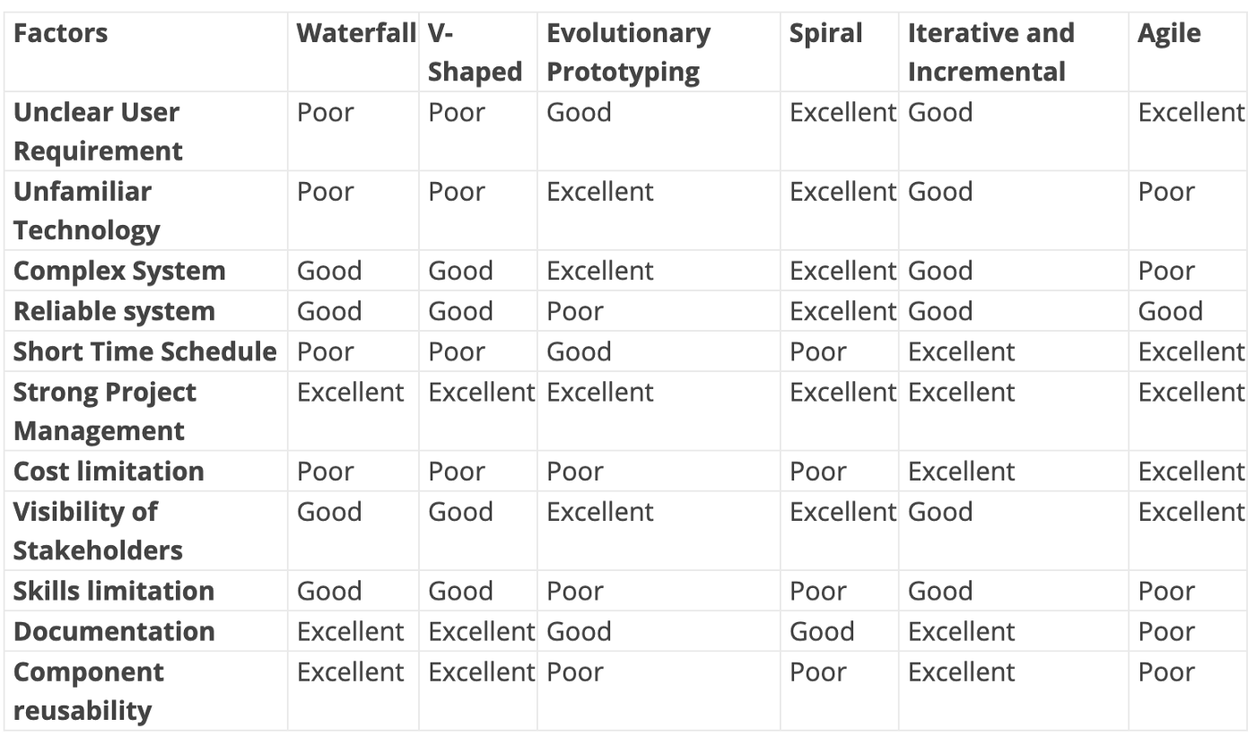

## STEP 4: Decide

When you define the criteria and the arguments you need to discuss with the team, you will need to have [a decision matrix](https://melsatar.blog/2017/09/23/trade-off-analysis-technique-make-the-decision-easier/) and give each criterion a defined weight and score for each option. After analyzing the results, you should document this decision in the project artifacts and share it with the related stakeholders.

## STEP 5: Optimize

You can always optimize the SDLC during the project execution, you may notice upcoming changes do not fit with the selected SDLC, it is okay to align and cope with the changes. You can even make your own SDLC model which optimum for your organization or the type of projects you are involved in.

**2.7 Object-oriented model:-**

The Object-Oriented approach of Building Systems takes the objects as the basis. For this, first the system to be developed is observed and analyzed and the requirements are defined as in any other method of system development. Once this is often done, the objects in the required system are identified. For example, in the case of a Banking System, a customer is an object, a chequebook is an object, and even an account is an object. Object-oriented model employs an object-oriented strategy. The primary objectives are:

**1.** Object-oriented analysis,

**2.** Object-oriented design,

**3.** Object-oriented programming

Object-oriented analysis develops an object-oriented model of the application domain. Object-oriented design develops an object-oriented model of the software system. Object oriented programming realizes the software design with an object-oriented programming language that supports direct implementation of objects, classes, and inheritance. There are a variety of object-oriented methodologies such as:

* **Object Identification:** System objects and their characteristics and events.
* **Object Organization:** Shows how objects are related via “part-of” relationships.
* **Object Interfaces:** Shows how objects interact with other objects.

These activities tend to be overlapping and in general and parallel.   
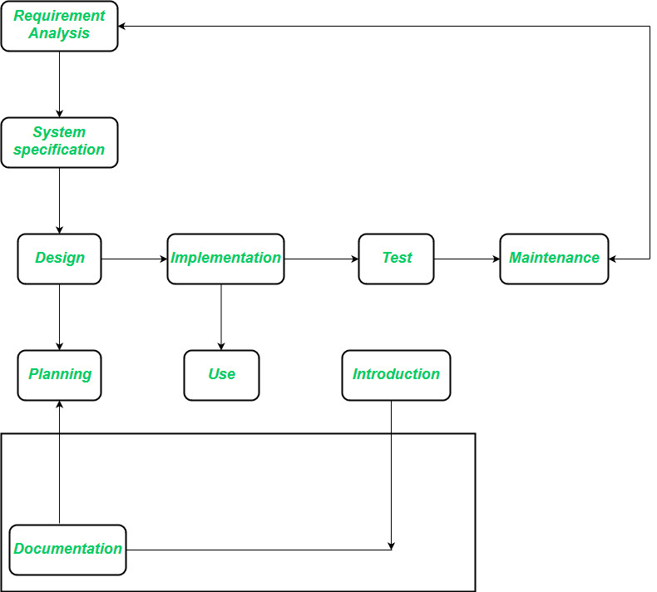   
The requirements analysis stage strives to achieve an understanding of the client’s application domain. The task that a software solution must address emerge in the course of requirement analysis. The requirement analysis phase remains completely independent of an implementation technique that might be applied later. In the system specification section, the wants definition describes what the software product must do, but not how this goal is to be achieved. One point of divergence from conventional phase model arises because implementation with object-oriented programming is marked by the assembly of already existing components. The class library serves as a tool that extends beyond the scope of an individual project because class provided by one project can increase productivity in subsequent projects. **Advantages of Object-Oriented Life Cycle Model:**

* Design is no longer carried out independently of the later implementation because during the design phase we must consider which components are available for the solution of the problem.
* Design and implementation become more closely associated.
* Duration of the implementation phase is reduced.
* A new job title emerges, the class librarian, who is responsible for ensuring the efficient usability of the class library.