AI ASSISTED CODING
LAB-15.5
Y.Harini
2303A51796 Batch-12
Task 1 – Student Attendance API
Task:
Create a RESTful API for student attendance tracking.
Instructions:
- Endpoints required: o GET /attendance → View attendance records o POST /attendance → Mark attendance o PUT /attendance/{id} → Update attendance record o DELETE /attendance/{id} → Remove attendance entry
- Ensure JSON-based request and response handling.
Expected Output:
- API for maintaining and updating attendance records.
PROMPT:
"""Generate a Python Flask REST API for student attendance with in-memory storage.
Implement GET /attendance, POST /attendance, PUT /attendance/<id>, DELETE /attendance/<id>.
Use JSON request/response and add comments."""
GIVEN CODE:
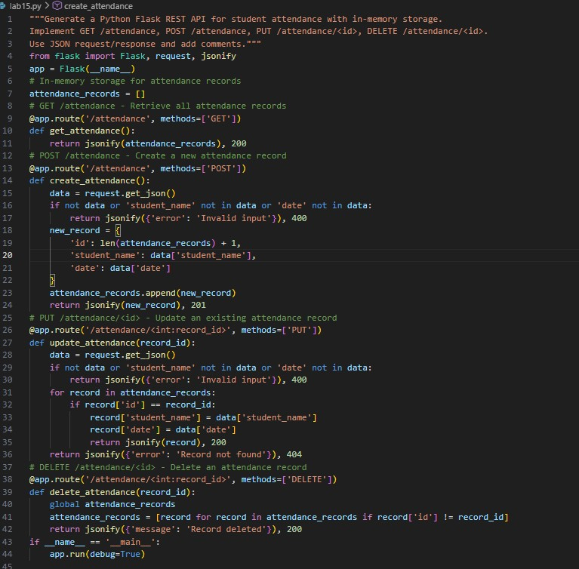

Task 2
–

Inventory Management API

Task:
Develop a REST API for warehouse inventory management.
Instructions:
- Endpoints required:
o GET /inventory → List all items o POST /inventory → Add new item o PUT /inventory/{id} → Update stock quantity o DELETE /inventory/{id} → Remove an item
- Implement validation for stock values.
Expected Output:
- API capable of managing inventory stock levels.
PROMPT:
"""Create a Flask REST API for inventory management with item id, name, and quantity.
Implement GET, POST, PUT, DELETE endpoints for /inventory.
Add validation so stock quantity cannot be negative.""" GIVEN CODE AND OUTPUT:
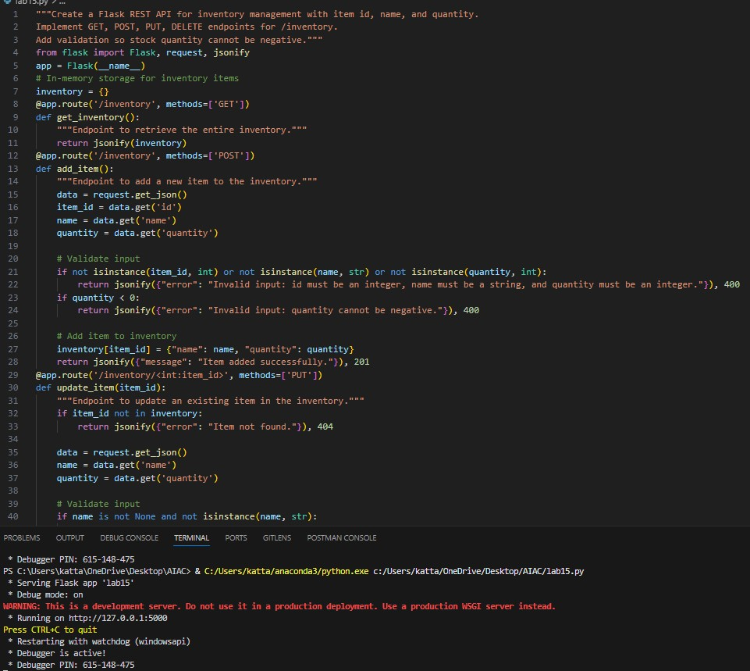
Task 3 – Hotel Room Booking API
Task:
Develop a RESTful API for hotel room booking.
Instructions:
- Endpoints required:
o GET /rooms → View available rooms o POST /rooms/book → Book a room o GET /rooms/{id} → View booking details o DELETE /rooms/{id} → Cancel booking • Implement error handling for unavailable rooms.
Expected Output:
- API simulating hotel room booking operations.
PROMPT:
"""Generate a Flask REST API for hotel room booking using in-memory data.
Endpoints: GET /rooms, POST /rooms/book, GET /rooms/<id>, DELETE /rooms/<id>.
Add error handling if a room is already booked."""
GIVEN OUTPUT:
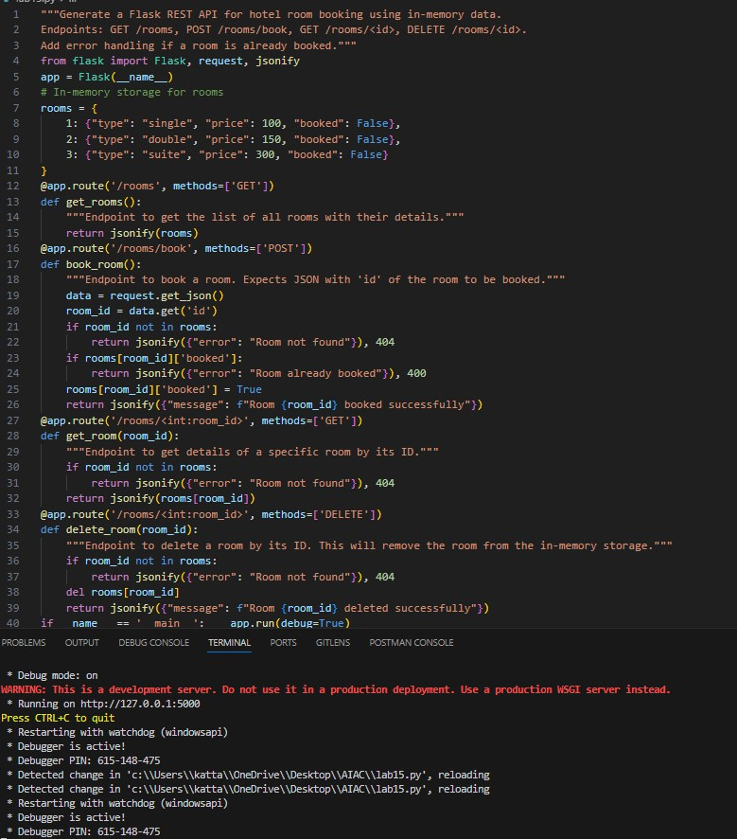
Task 4 – Online Voting API
Task:
Create a RESTful API for an online voting system.
Instructions:
- Endpoints required:
o GET /candidates → List candidates o POST /vote → Cast a vote o GET /results → View voting results
- Ensure one vote per user using in-memory validation.
Expected Output:
- API simulating a secure online voting process.
PROMPT:
"""Create a Flask REST API for an online voting system.
Endpoints: GET /candidates, POST /vote, GET /results.
Ensure each user can vote only once using in-memory validation.""" GIVEN OUTPUT:
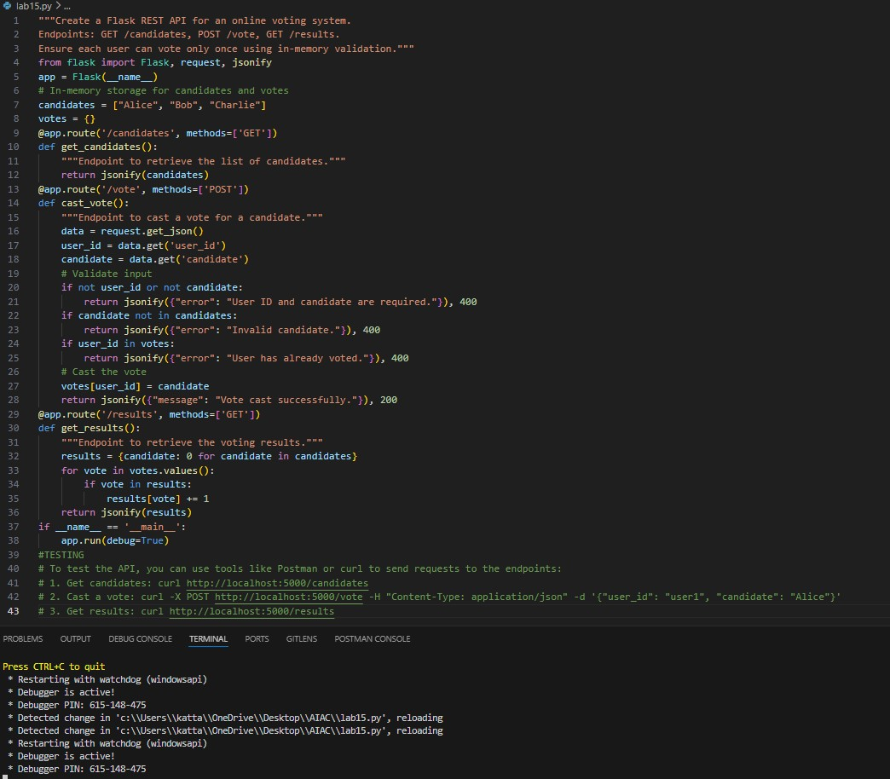
Task 5 – Teacher Management API
Task:
Develop a RESTful API to manage teacher records.
Instructions:
- Endpoints required:
- GET /teachers → List all teachers
- POST /teachers → Add a new teacher o PUT /teachers/{id} → Update teacher details o DELETE /teachers/{id} → Remove a teacher • Ensure proper error handling and JSON responses.
Expected Output:
• Functional API for managing teacher information.
PROMPT:
"""Generate a Flask REST API to manage teachers with id, name, and subject.
Implement GET, POST, PUT, DELETE endpoints for /teachers.
Return JSON responses and handle errors properly."""
GIVEN OUTPUT:
