AI ASSISTED CODING LAB-6.5
Y.Harini
2303A51796
Batch-12
Task Description #1 (AI-Based Code Completion for Conditional Eligibility Check)
Task: Use an AI tool to generate eligibility logic.
Prompt:
“Generate Python code to check voting eligibility based on age and citizenship.”
Expected Output:
- AI-generated conditional logic.
- Correct eligibility decisions.
- Explanation of conditions.
Prompt:
# Give a python code to check whether a person is eligible to vote or not based on their age and citizenship
Given Code and Output:
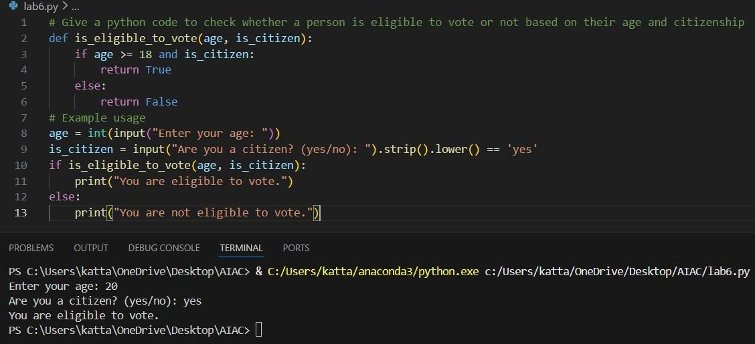
Task Description #2(AI-Based Code Completion for Loop-Based String Processing)
Task: Use an AI tool to process strings using loops.
Prompt:
“Generate Python code to count vowels and consonants in a string using a loop.”
Expected Output:
- AI-generated string processing logic.
- Correct counts.
- Output verification.
Prompt:
#Given a python code to count vowels and consonants in a string using a loop Given Code and Output:
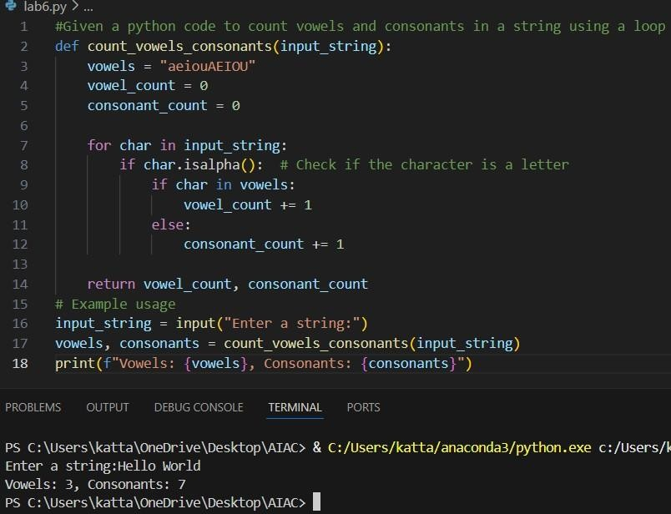

Task Description #3 (AI-Assisted Code Completion Reflection
Task)
Task: Use an AI tool to generate a complete program using classes, loops, and conditionals.
Prompt:
“Generate a Python program for a library management system using classes, loops, and conditional statements.”
Expected Output:
- Complete AI-generated program.
- Review of AI suggestions quality.
- Short reflection on AI-assisted coding experience.
Prompt:
#Give a python code for library management system using classes, loops and conditional statements
Given Code:
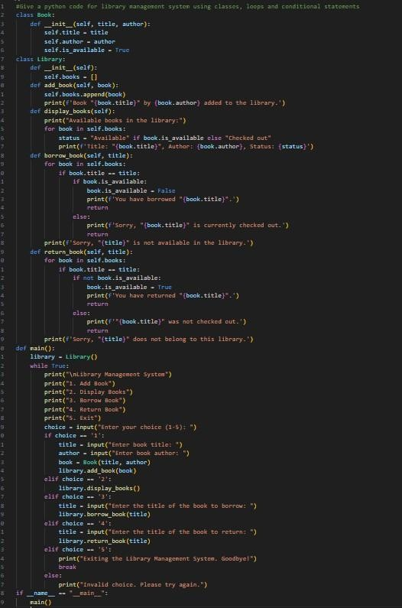

Output:
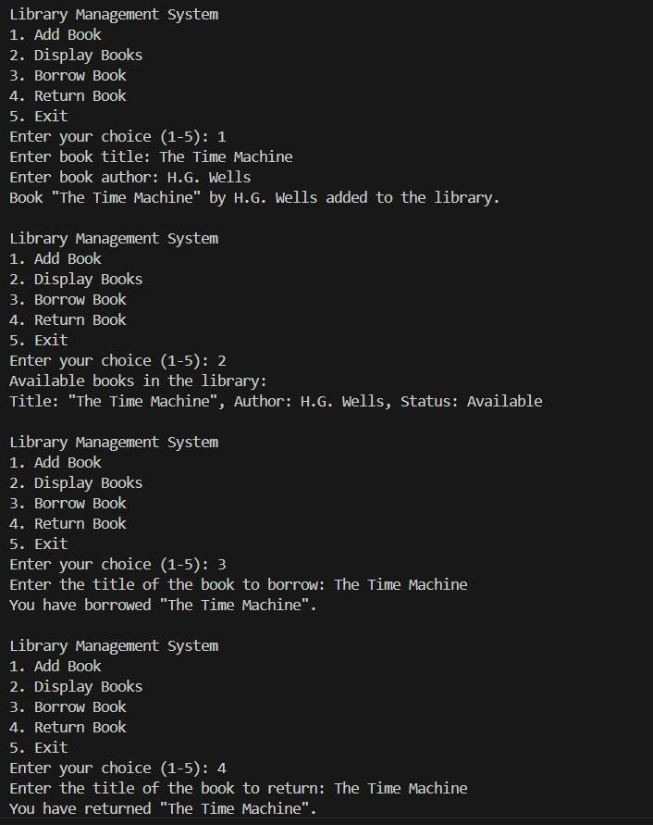

Task Description #4 (AI-Assisted Code Completion for Class-Based Attendance System) Task:
Use an AI tool to generate an attendance management class.
Prompt: “Generate a Python class to mark and display student attendance using loops.”
Expected Output:
- AI-generated attendance logic.
- Correct display of attendance.
- Test cases.
Prompt:
# Give a python code to mark and display student attendance using loops.
Given Code:
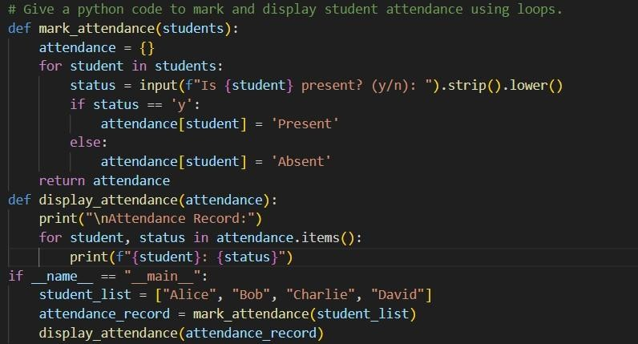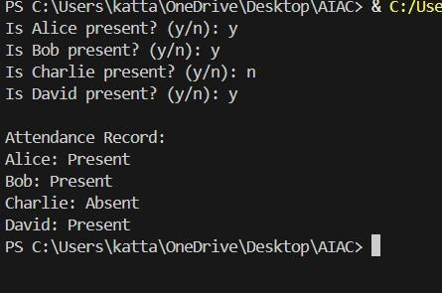

Output:

Task Description #5 (AI-Based Code Completion for Conditional Menu Navigation)
Task: Use an AI tool to complete a navigation menu.
Prompt: “Generate a Python program using loops and conditionals to simulate an ATM menu.” Expected Output:
- AI-generated menu logic.
- Correct option handling.
- Output verification.
Prompt:
# Give a python code using loops and conditional statements to create an ATM menu Given Code:
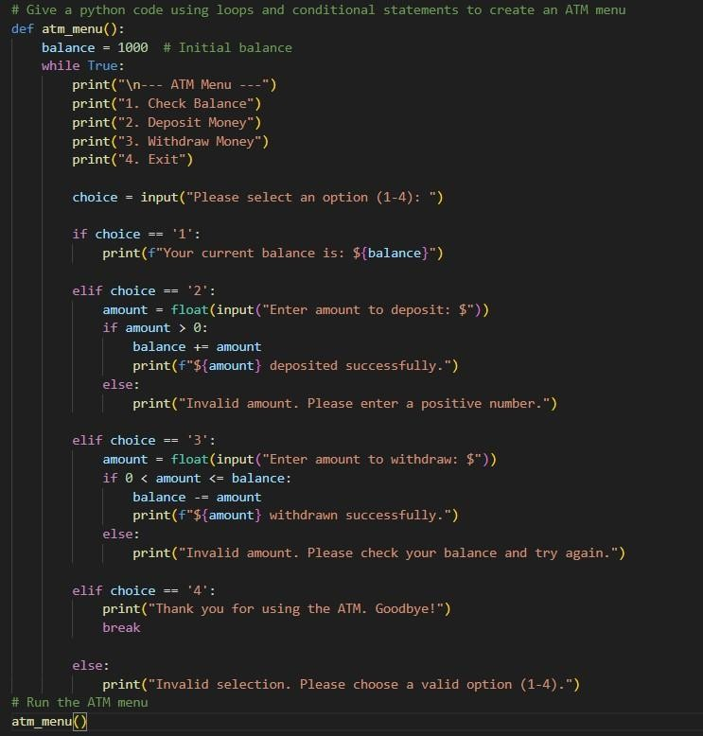

Output:
