Assignment-19.1
HT.NO:2303A51796
Batch: 12 Task 1 – Python to Java Conversion
Task:
Translate a simple Python class into Java using AI assistance.
Instructions:
- Prompt AI to convert a Python class with attributes and methods into equivalent Java code.
- Verify that constructors, method signatures, and data types are properly handled.
- Run both versions (Python & Java) to compare expected outputs.
Expected Output:
- Equivalent working Java class translated from Python.
CODE:
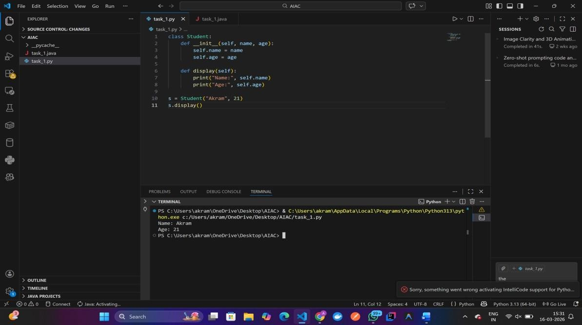
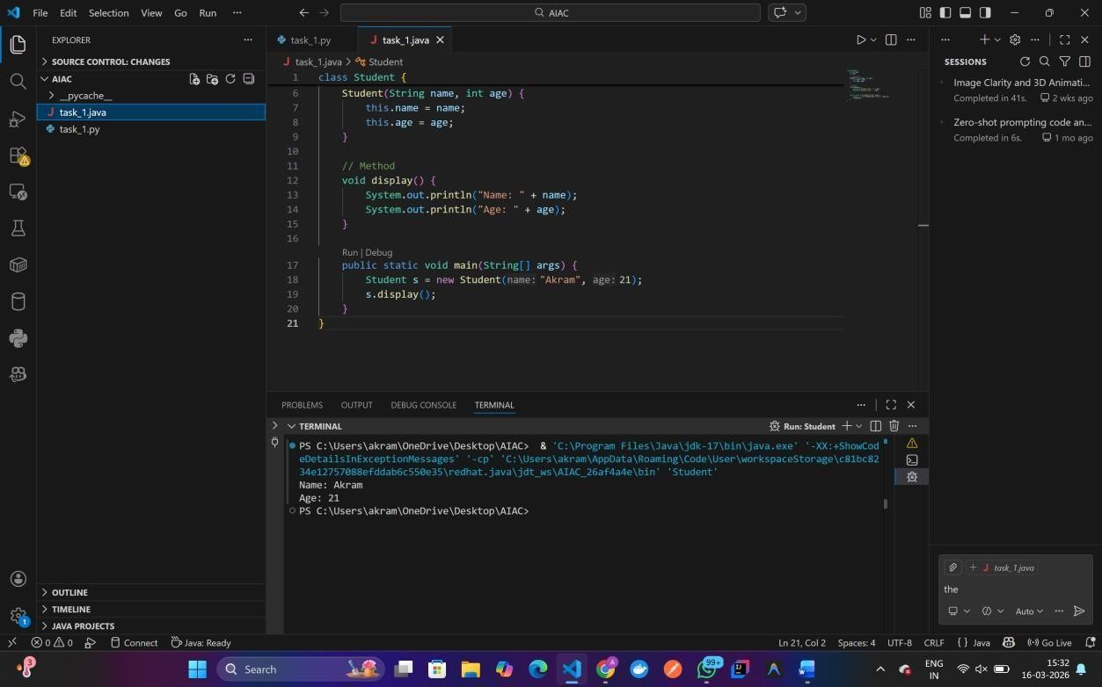
Task 2 – C++ to Python Function Conversion
Task:
Convert a C++ function for factorial calculation into Python.
Instructions:
- Ask AI to translate a recursive C++ factorial function into
Python.
- Validate correctness by testing with sample inputs.
- Ensure Python version follows Pythonic conventions.
Expected Output:
- A correct Python implementation equivalent to the original
C++ factorial function.
CODE:
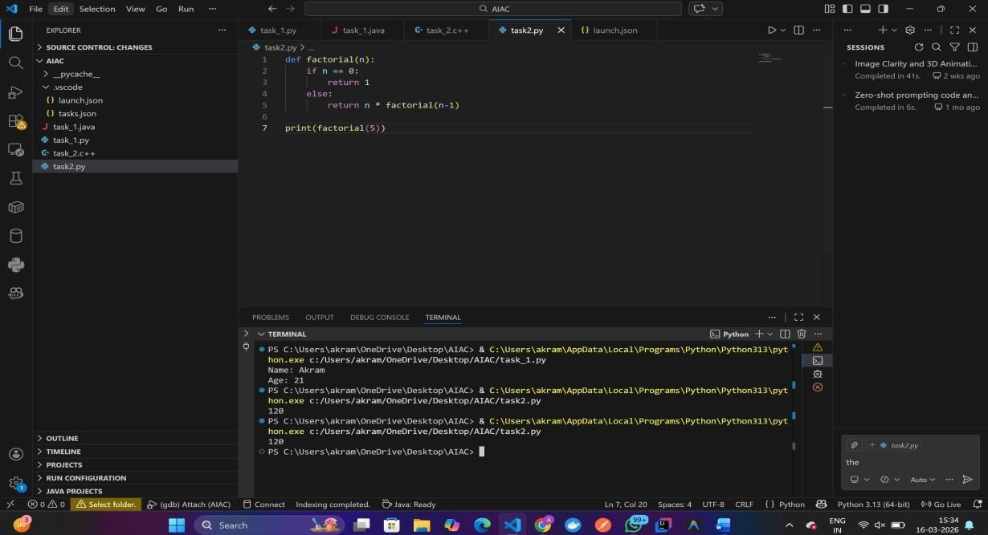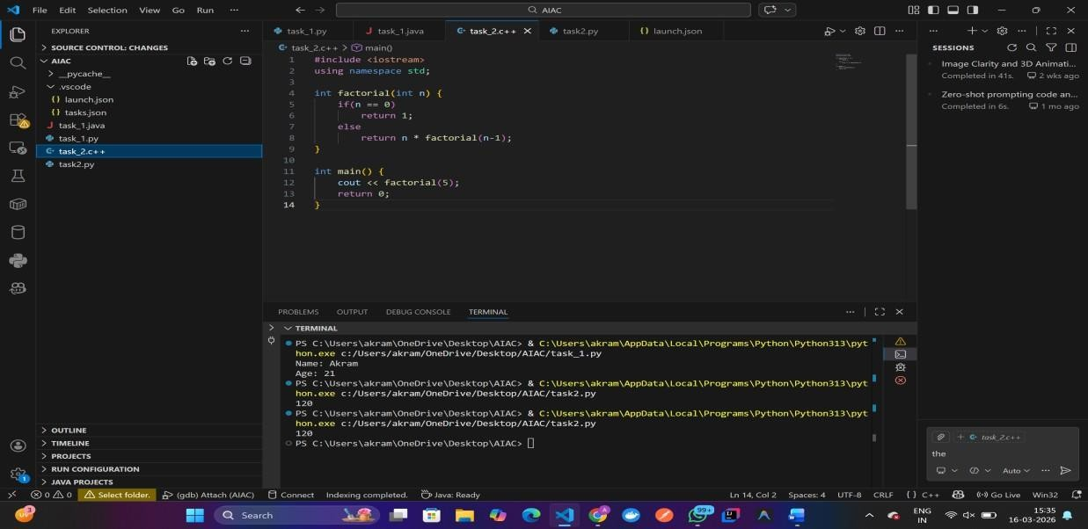
Task 3 – SQL to Pandas Query
Task:
Translate a SQL query into a Pandas DataFrame operation in
Python.
Instructions:
- Provide AI with a SQL query (e.g., SELECT name, salary
FROM employees WHERE salary > 50000).
- Ask AI to generate equivalent Pandas code.
- Test the generated code on a sample DataFrame.
Expected Output:
- Equivalent Pandas query that retrieves the correct subset of
data.
CODE:
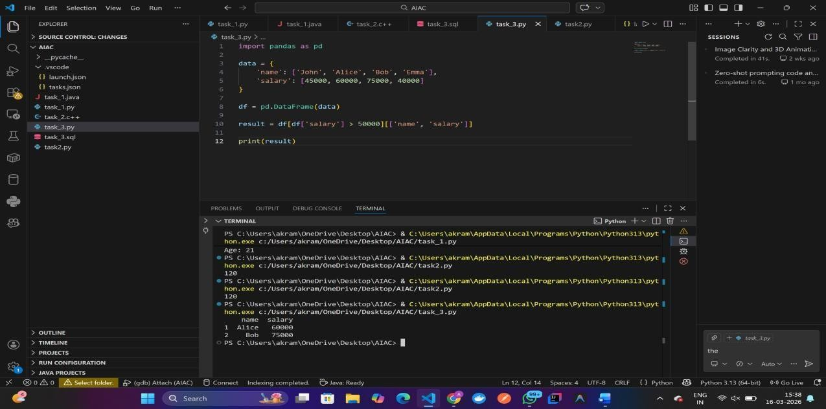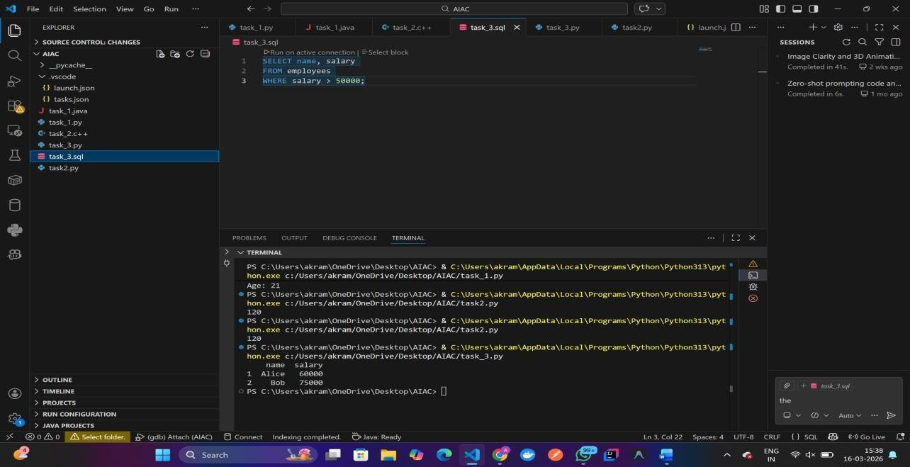
Task 4 – Real-Time Application: Multi-Language Snippet
Converter
Scenario:
Students will choose a real-time use case where they need code in multiple languages. Example:
- Converting a Python web scraping snippet into JavaScript for browser automation.
- Translating a Java method into C# for enterprise applications.
Instructions:
- Prompt AI to translate code between two chosen languages.
- Test both implementations to ensure they produce the same
results.
- Document challenges faced during translation (e.g., syntax,
libraries).
Expected Output:
- Working equivalent code snippets in at least two different
programming languages CODE:
