ASSIGNMENT-10.5
HT.NO:2303A51796
Y. Harini
Batch-12
Task Description #1 – Variable Naming Issues Task: Use AI to improve unclear variable names.
Sample Input Code:
def f(a, b): return a + b print(f(10, 20))
Expected Output:
- Code rewritten with meaningful function and variable names.
CODE:
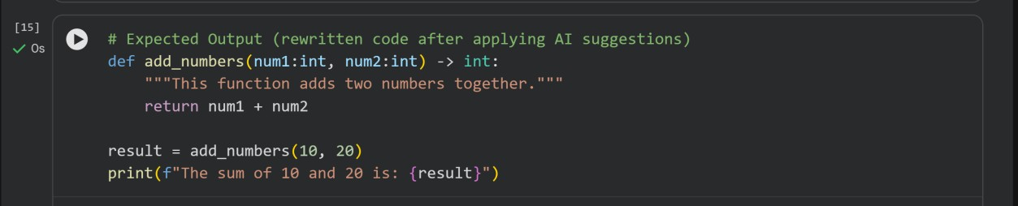
OUTPUT:
Task Description #2 – Missing Error Handling
Task: Use AI to add proper error handling.
Sample Input Code:
def divide(a, b): return a / b print(divide(10, 0))
Expected Output:
- Code with exception handling and clear error messages
CODE:
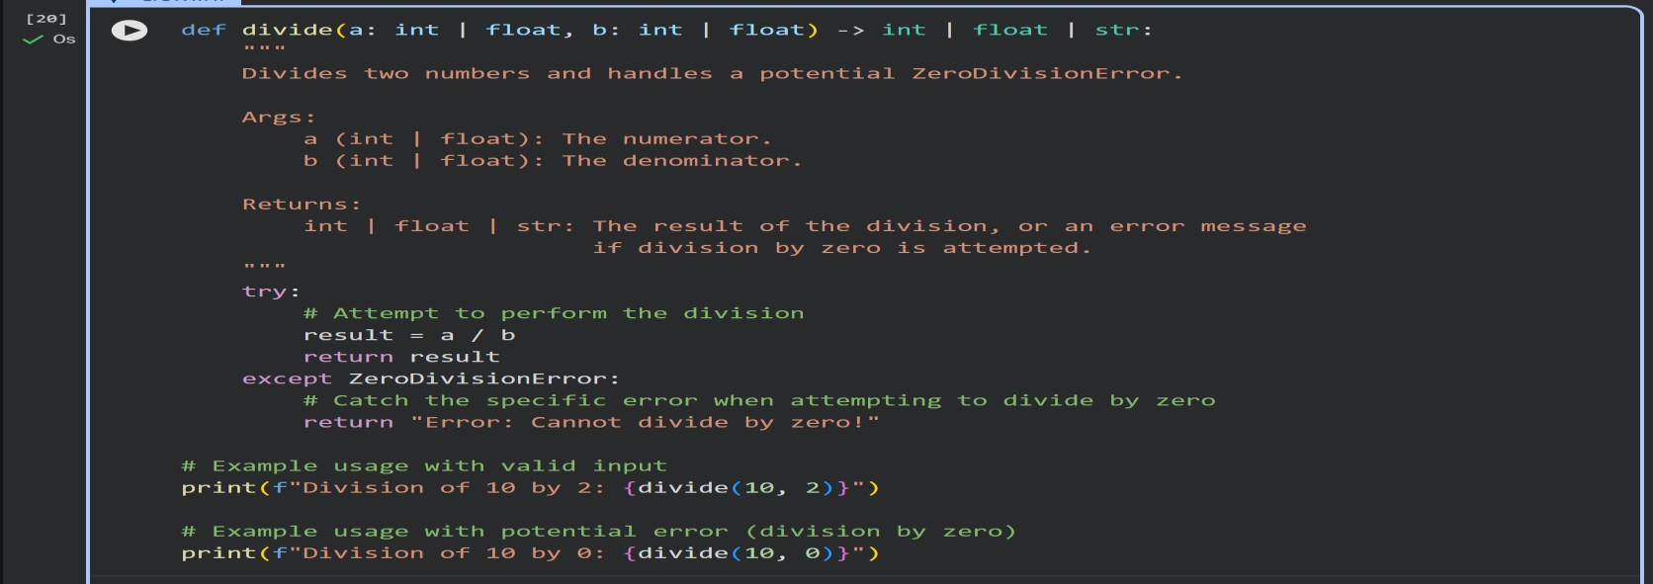
OUTPUT:
Task Description #3: Student Marks Processing System The following program calculates total, average, and grade of a student, but it has poor readability, style issues, and no error handling.
marks=[78,85,90,66,88] t=0 for i in marks: t=t+i
a=t/len(marks) if a>=90: print("A") elif a>=75: print("B") elif a>=60: print("C") else:
print("F")
Task:
- Use AI to refactor the code to follow PEP 8 standards.
- Add meaningful variable names, functions, and comments.
- Add basic input validation and documentation.
CODE:
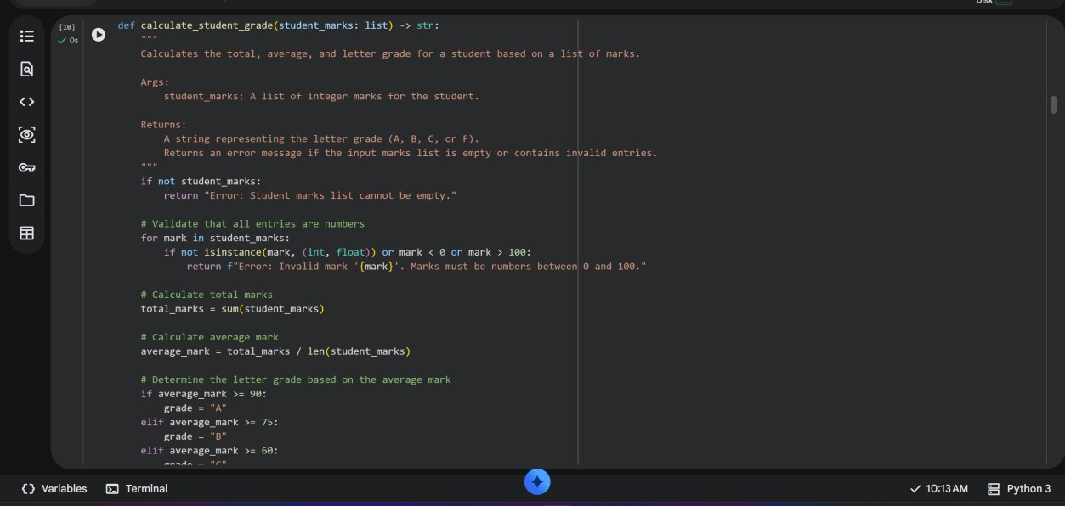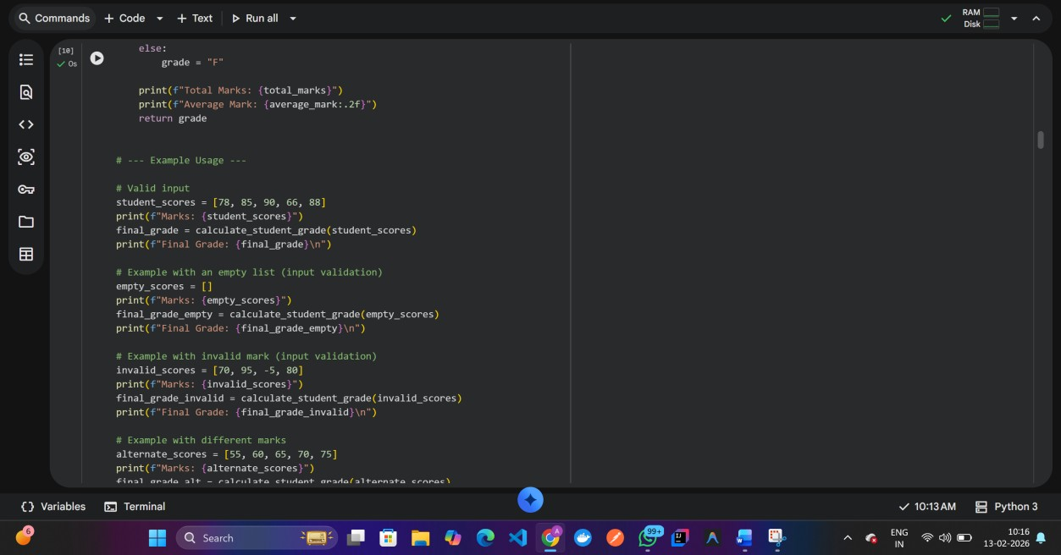
OUTPUT:
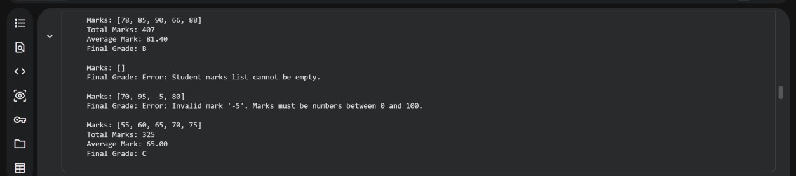
EXPLANATION:
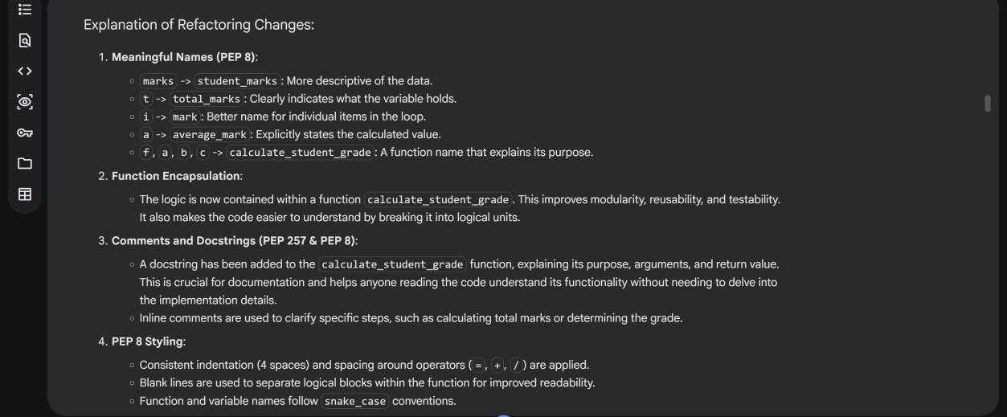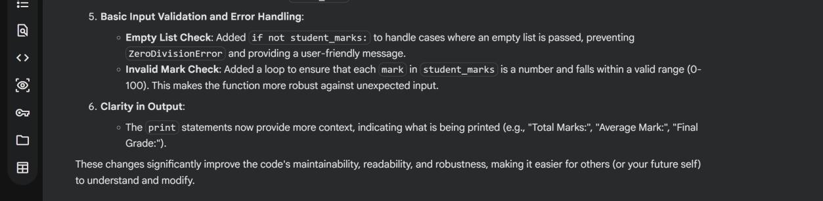
Task Description #4: Use AI to add docstrings and inline comments to the following function. def factorial(n):
result = 1 for i in range(1,n+1):
result *= i return result CODE:
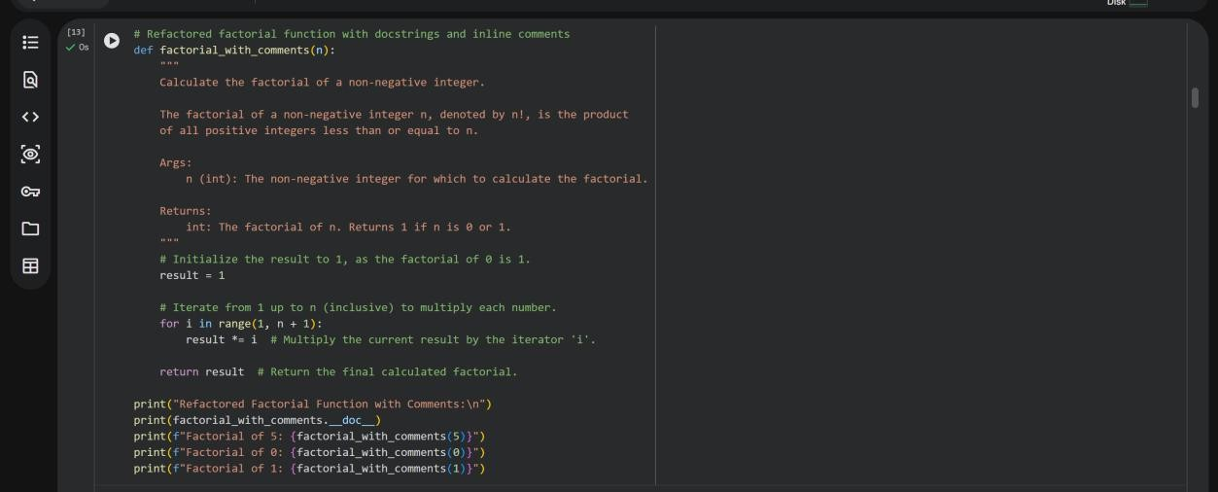
OUTPUT:
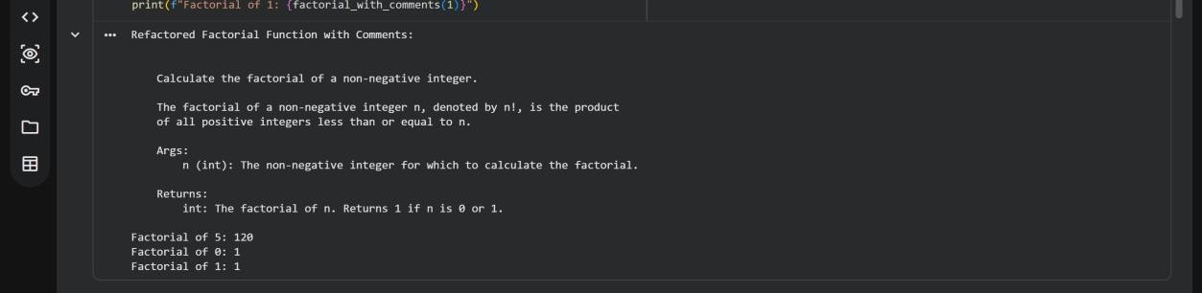
Task Description #5: Password Validation System (Enhanced) The following Python program validates a password using only a minimum length check, which is insufficient for real-world security requirements.
pwd = input("Enter password: ") if len(pwd) >= 8: print("Strong") else: print("Weak")
Task:
- Enhance password validation using AI assistance to include multiple security rules such as: o Minimum length requirement o Presence of at least one uppercase letter o Presence of at least one lowercase letter o Presence of at least one digit o Presence of at least one special character
- Refactor the program to:
o Use meaningful variable and function names o Follow PEP 8 coding standards o Include inline comments and a docstring
3. Analyze the improvements by comparing the original and AI- enhanced versions in terms of: o Code readability and structure o Maintainability and reusability
o Security strength and robustness
4. Justify the AI-generated changes, explaining why each added rule and refactoring decision improves the overall quality of the program.
TASK EXPLANATION:
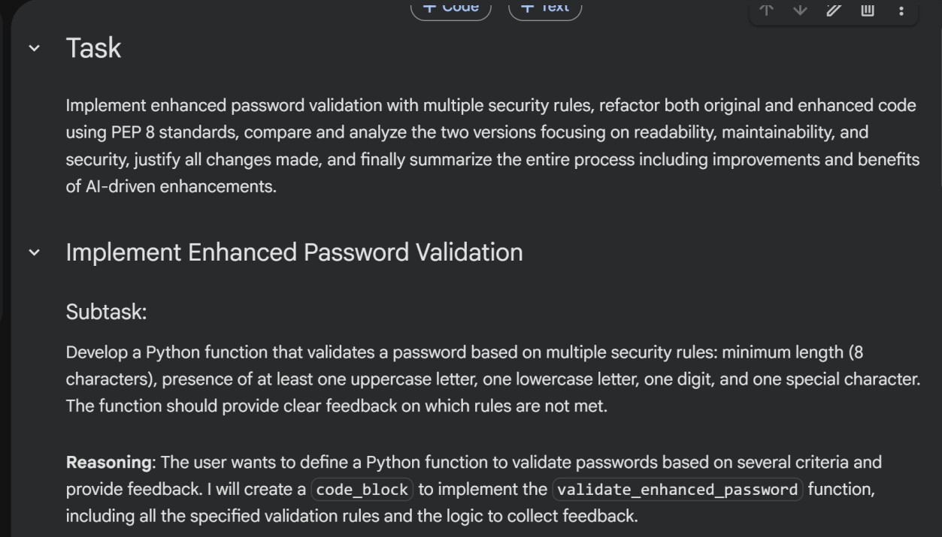
CODE:
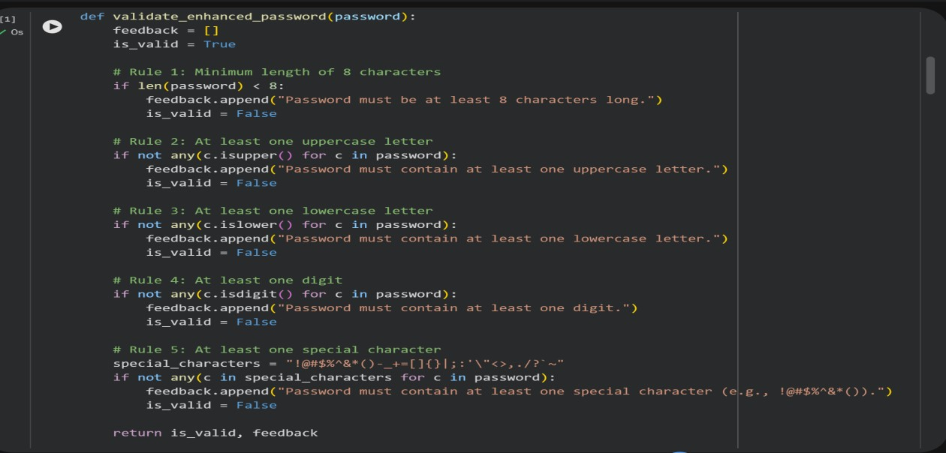
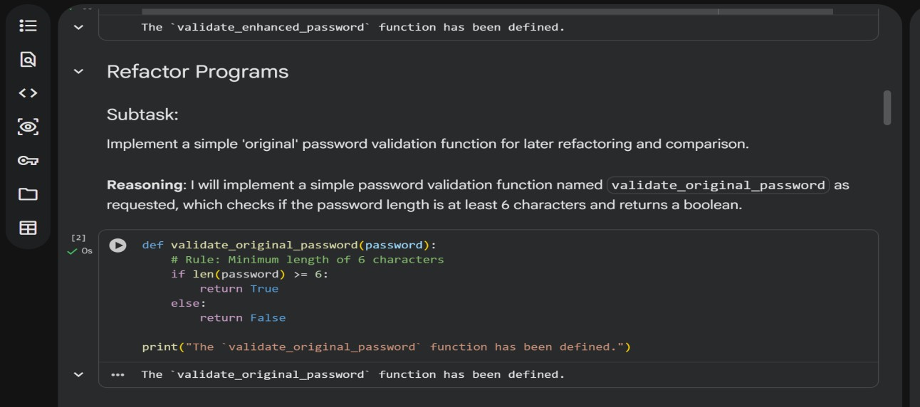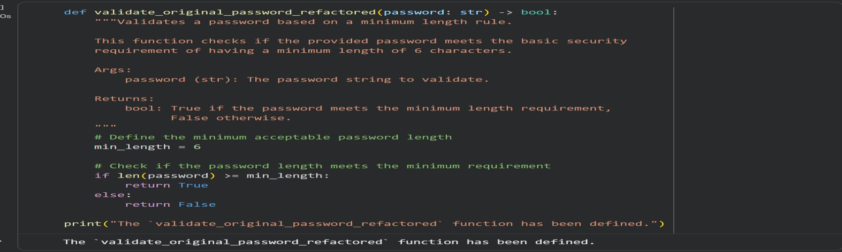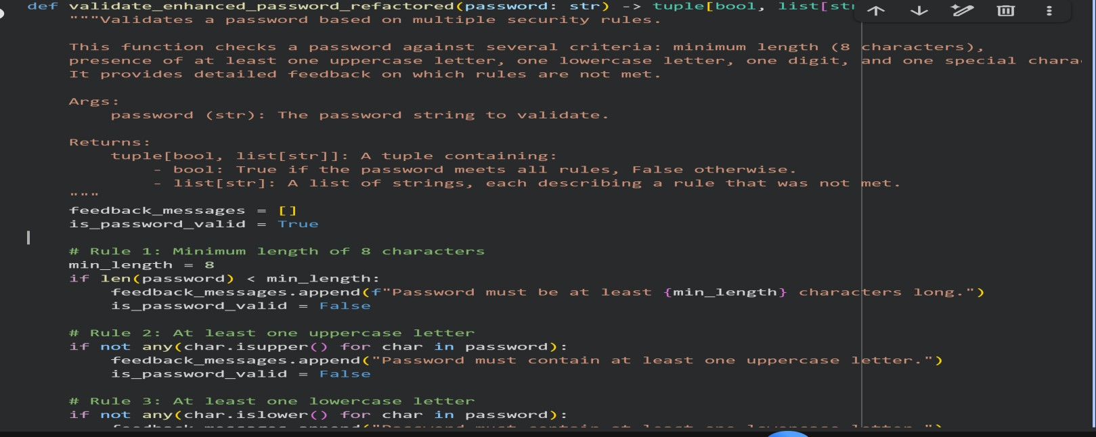

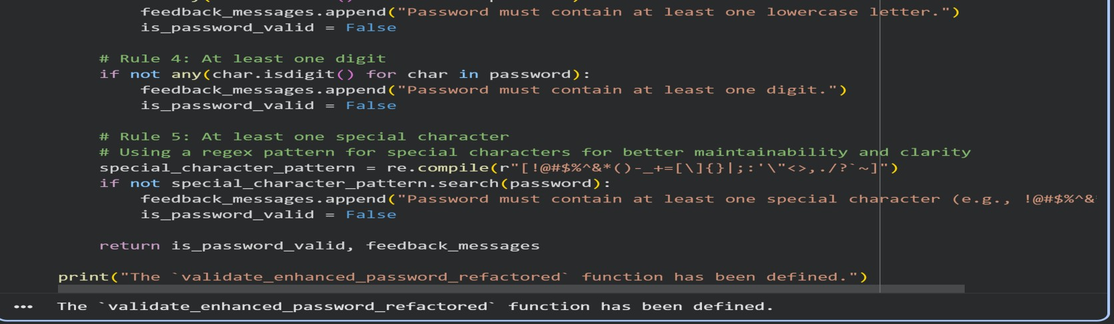
TEST CASES: test_cases = [
{
"password": "short",
"description": "Too short, fails both",
"expected_original": False,
"expected_enhanced_is_valid": False,
"expected_enhanced_feedback_contains": [
"Password must be at least 8 characters long.",
"Password must contain at least one uppercase letter.", "Password must contain at least one digit.",
"Password must contain at least one special character."
]
},
{
"password": "password123",
"description": "Meets original length, fails enhanced (no uppercase/special)",
"expected_original": True,
"expected_enhanced_is_valid": False,
"expected_enhanced_feedback_contains": [
"Password must contain at least one uppercase letter.",
"Password must contain at least one special character."
]
},
{
"password": "Password!1",
"description": "Passes enhanced validation",
"expected_original": True,
"expected_enhanced_is_valid": True,
"expected_enhanced_feedback_contains": []
},
{
"password": "Pass123!",
"description": "Passes enhanced validation",
"expected_original": True,
"expected_enhanced_is_valid": True,
"expected_enhanced_feedback_contains": []
},
{
"password": "NoSpecialChar1",
"description": "Fails enhanced (no special char)",
"expected_original": True,
"expected_enhanced_is_valid": False,
"expected_enhanced_feedback_contains": [
"Password must contain at least one special character."
]
},
{
"password": "NOUPPERCASE!1",
"description": "Fails enhanced (no lowercase)",
"expected_original": True,
"expected_enhanced_is_valid": False,
"expected_enhanced_feedback_contains": [
"Password must contain at least one lowercase letter."
]
},
{
"password": "nouppercase!_",
"description": "Fails enhanced (no uppercase/digit)",
"expected_original": True,
"expected_enhanced_is_valid": False,
"expected_enhanced_feedback_contains": [
"Password must contain at least one uppercase letter.",
"Password must contain at least one digit."
]
},
{
"password": "NOLOWERCASENODIGIT!",
"description": "Fails enhanced (no lowercase/digit)",
"expected_original": True,
"expected_enhanced_is_valid": False,
"expected_enhanced_feedback_contains": [
"Password must contain at least one lowercase letter.",
"Password must contain at least one digit."
]
}
]
print(f"Defined {len(test_cases)} password test cases.") OUTPUT:
