HIGH PERFORMANCE COMPUTING

ASSIGNMENT – 10

Name : Y.Harini

Batch no : 12

HALL TICKET:2303A51796
Task 1: MPI Hello World
Step 1: Create a file named hello.c with the following code:
#include <mpi.h> #include <stdio.h>
int main(int argc, char** argv) { MPI_Init(&argc, &argv);
// Initialize MPI int rank, size;
MPI_Comm_rank(MPI_COMM_WORLD, &rank);
// Get process rank MPI_Comm_size(MPI_COMM_WORLD, &size);
// Get total number of processes
printf("Hello from rank %d of %d\n", rank, size);
MPI_Finalize(); // Clean up MPI return 0;
}

Step 1:
Create a file named reduction_bad.c Implement parallel summation using: #pragma omp critical
inside the loop. Compile:
gcc -O2 -fopenmp reduction_bad.c -o reduction_bad Run with:
export OMP_NUM_THREADS=1 export OMP_NUM_THREADS=4 Record execution time.

Step 2: Compile the program using mpicc:
> mpicc -o hello hello.c
Step 3: Run the program with different numbers of processes (e.g., 2, 4) and observe the output:
mpirun -np 2 ./hello

mpirun -np 4 ./hello
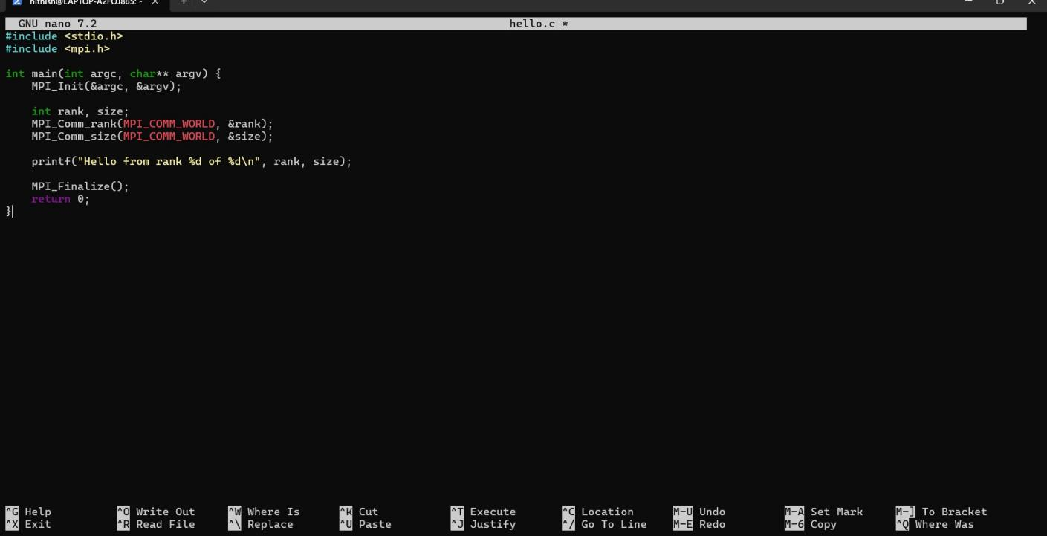



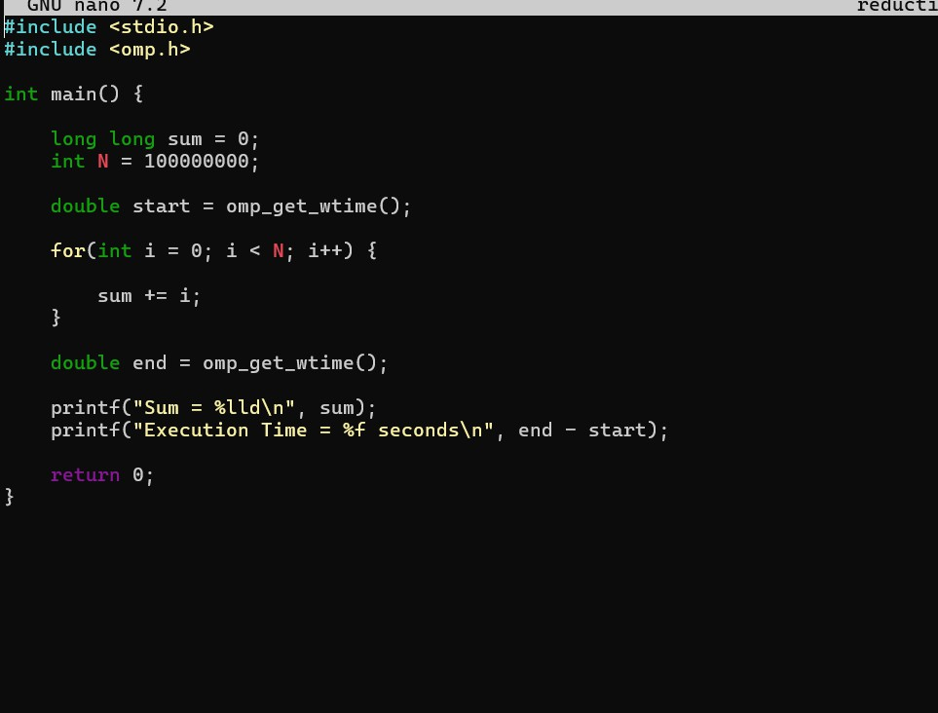

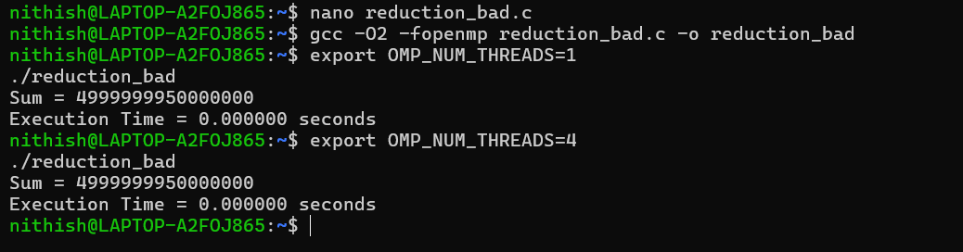
Step 4:Answer the following questions:
- What do MPI_Init and MPI_Finalize do?
- What is the range of ranks for a given number of processes?
- Why can the output order be different each time you run?

- What do MPI_Init and MPI_Finalize do?

MPI_Init is used to start the MPI (Message Passing Interface) environment. It prepares all the processes so they can communicate with each other during parallel execution. In simple terms, it tells the program: “Now we are entering parallel mode.”
MPI_Finalize is used to safely end the MPI environment.
It cleans up resources and stops communication between processes. After this function, no MPI commands should be used. It basically means: “Parallel work is finished.”
- What is the range of ranks for a given number of processes?
Each process in MPI gets a unique rank (ID number) so it can be identified. If there are N processes, the ranks start from 0 and go up to N − 1.
Example:
If total processes = 4
Then ranks will be: 0, 1, 2, 3
So, the range of ranks is:
0 to (number of processes − 1)
- Why can the output order be different each time you run?
In MPI programs, multiple processes run simultaneously (in parallel).
Since they execute independently and the operating system schedules them differently each time, one process may finish earlier or later in different runs.
Because of this, the print statements from different processes may appear in a different order every time you execute the program — even though the program itself is correct.

Task 2: Simple Send/Receive – One-way Communication
Step 1: Create a file named ping.c that sends an integer from rank 0 to rank 1. #include <mpi.h>
#include <stdio.h>
int main(int argc, char** argv) { MPI_Init(&argc, &argv);
int rank; MPI_Comm_rank(MPI_COMM_WORLD, &rank); int data;

if (rank == 0) { data = 42;
MPI_Send(&data, 1, MPI_INT, 1, 0, MPI_COMM_WORLD);
printf("Rank 0 sent value %d\n", data);
} else if (rank == 1) {
MPI_Recv(&data, 1, MPI_INT, 0, 0, MPI_COMM_WORLD, MPI_STATUS_IGNORE);
printf("Rank 1 received value %d\n", data);
}
MPI_Finalize(); return 0;
}

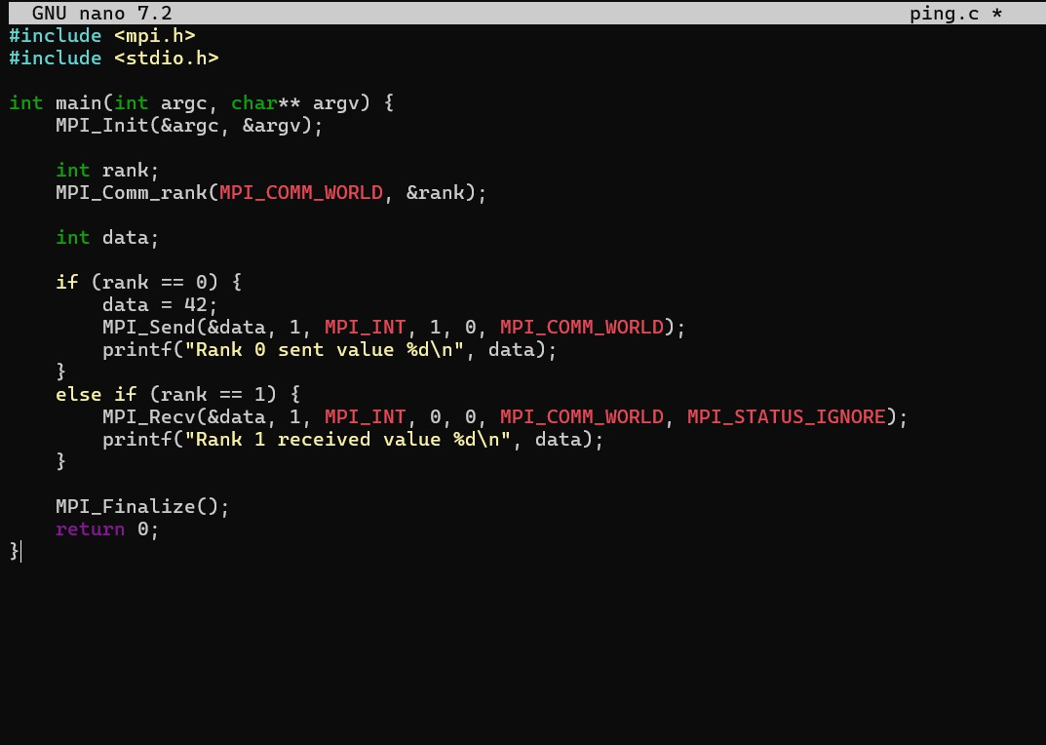

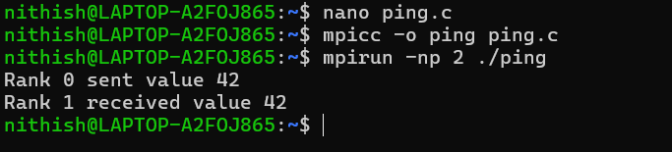

Step 2: Compile and run with exactly 2 processes:
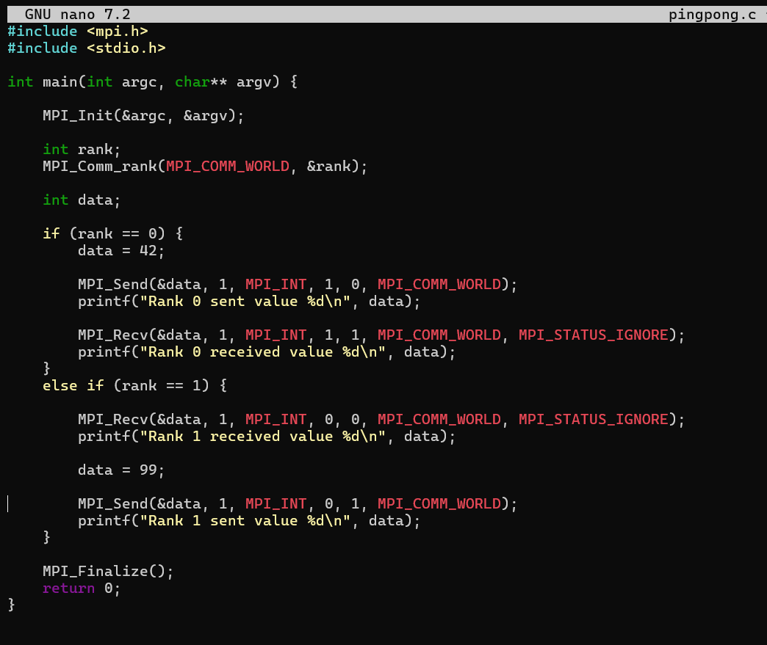
mpicc -o ping pong.c mpirun -np 2 ./ping



Step 4: Answer the following:
- What would happen if you run the program with more than 2 processes? Why?
- What is the purpose of the tag parameter in MPI_Send and MPI_Recv?
- What does MPI_STATUS_IGNORE do?

- What would happen if you run the program with more than 2 processes? Why? If the program is run with more than 2 processes, only rank 0 and rank 1 will participate in communication because the code is written only for them.
Other ranks (like 2, 3, etc.) will simply start and finish without doing anything. In some cases, extra processes may remain idle or cause confusion if communication is expected but not defined for them.

- What is the purpose of the tag parameter in MPI_Send and MPI_Recv? The tag acts like a message label or identifier.
It helps the receiving process know which message it is receiving, especially when multiple messages are being sent between the same processes. This prevents mixing up different messages.

- What does MPI_STATUS_IGNORE do?

MPI_STATUS_IGNORE tells MPI that the program does not need detailed information about the received message (such as sender details or message size). It simplifies the code when that extra information is not required.

Task 3: Deadlock and Avoidance
Step 1: Create a file named deadlock_bad.c that attempts a circular send/receive:
#include <mpi.h> #include <stdio.h>
int main(int argc, char** argv) { MPI_Init(&argc, &argv);
int rank; MPI_Comm_rank(MPI_COMM_WORLD, &rank);

int data = rank; if (rank == 0) {
MPI_Send(&data, 1, MPI_INT, | 1, | 0, | MPI_COMM_WORLD);
MPI_Recv(&data, 1, MPI_INT, | 1, | 0, | MPI_COMM_WORLD,

MPI_STATUS_IGNORE);
} else if (rank == 1) {
MPI_Send(&data, 1, MPI_INT, | 0, | 0, | MPI_COMM_WORLD);
MPI_Recv(&data, 1, MPI_INT, | 0, | 0, | MPI_COMM_WORLD,
MPI_STATUS_IGNORE);
}
MPI_Finalize(); return 0;
}

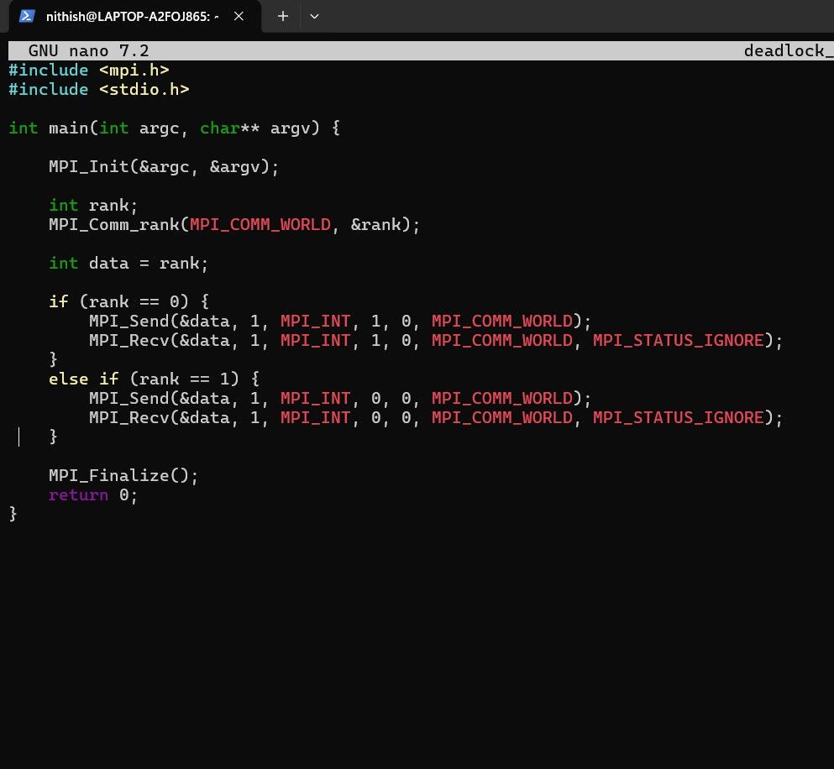

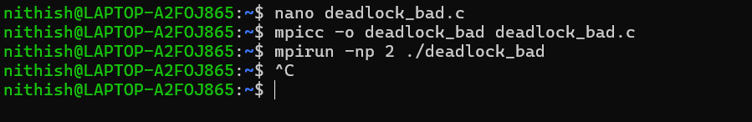
Step 2: Compile and run with 2 processes. Observe what happens (the program will hang – you may need to kill it with Ctrl+C).

Step 3: Now create a fixed version deadlock_fixed.c by reordering the calls so that one process receives first:
#include <mpi.h>

#include <stdio.h>
int main(int argc, char** argv) { MPI_Init(&argc, &argv);
int rank; MPI_Comm_rank(MPI_COMM_WORLD, &rank); int data = rank;
if (rank == 0) {
MPI_Send(&data, 1, MPI_INT, | 1, | 0, | MPI_COMM_WORLD);
MPI_Recv(&data, 1, MPI_INT, | 1, | 0, | MPI_COMM_WORLD,
MPI_STATUS_IGNORE);
} else if (rank == 1) {
MPI_Recv(&data, 1, MPI_INT, 0, 0, MPI_COMM_WORLD, MPI_STATUS_IGNORE);
MPI_Send(&data, 1, MPI_INT, 0, 0, MPI_COMM_WORLD);
}
MPI_Finalize(); return 0;
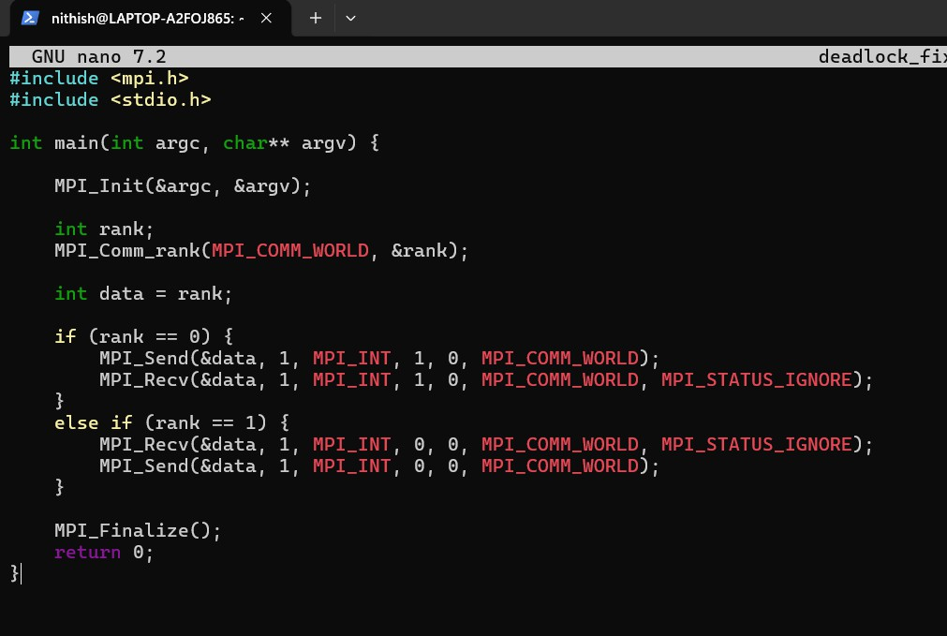
}

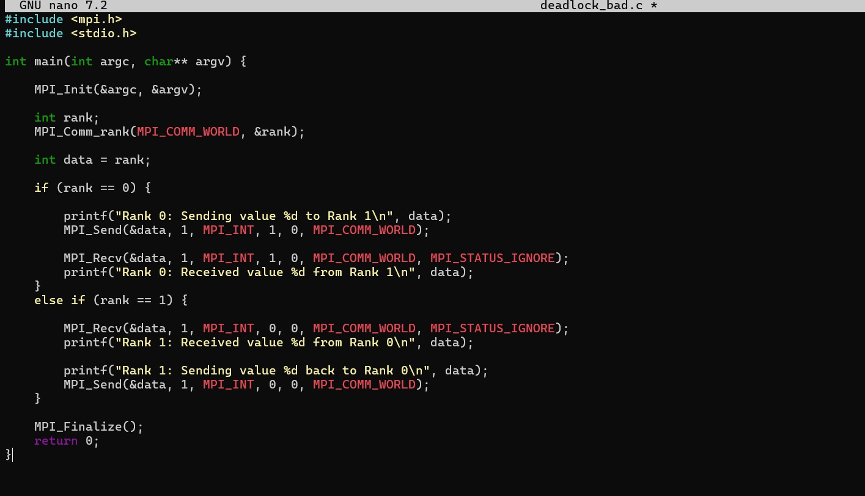
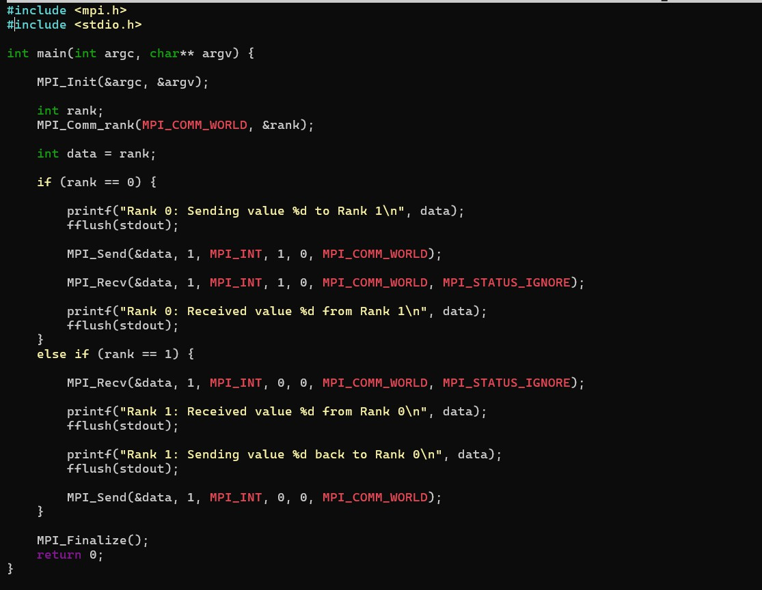

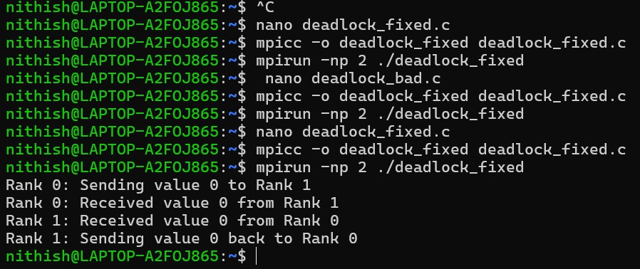
Step 4: Compile and run the fixed version. It should complete without hanging.

Step 5: Answer the following questions:
- Why does the first version deadlock? Explain in terms of the order of calls. In the first program, both processes (rank 0 and rank 1) try to send data at the same time before receiving anything. Since MPI_SENDS waits until the other process is ready to receive, each process keeps waiting for the other one. Because neither process moves to the receive step, the program gets stuck forever. This situation is called deadlock.

- How does the fixed version avoid deadlock?
In the fixed program, the order of operations is changed. One process sends first while the other process receives first. Since a receiver is already ready, the send operation completes successfully. After that, the reply message is sent back normally. Because both processes are no longer waiting on each other at the same time, the program runs and finishes correctly.

- Could buffering ever prevent this deadlock? Why is it unsafe to rely on buffering?
Sometimes MPI may temporarily store messages in memory (buffering), which can allow a send operation to finish even if the receiver has not started yet. This might make the program seem like it works.
But relying on buffering is risky because buffer size is limited and depends on the system. A program that works on one computer may fail or hang on another. So, it is always better to design the communication order correctly instead of depending on buffering.

