EXP-5 : Product Selling System
Aim
To create a simple cloud-based Product Selling System using Zoho Creator, a cloud-based SaaS platform, for managing products, customer details, orders, and sales information.
Procedure
- Log in to Zoho Creator.
- Create a new application named Product Selling System.
- Create a form named Product Details.
- Add the required fields such as Product Name, Product ID, Category, Price, Stock Quantity, and Description.
- Create another form named Customer Order.
- Add fields such as Customer Name, Email, Phone Number, Product Name, Quantity, Price, and Total Amount.
- Create a workflow to automatically calculate the Total Amount based on the quantity and product price.
- Create reports to display available products, customer orders, and sales details.
- Save and publish the application.
- Test the application by entering sample product and customer order details and verify that the total amount is calculated correctly.
OUTPUT
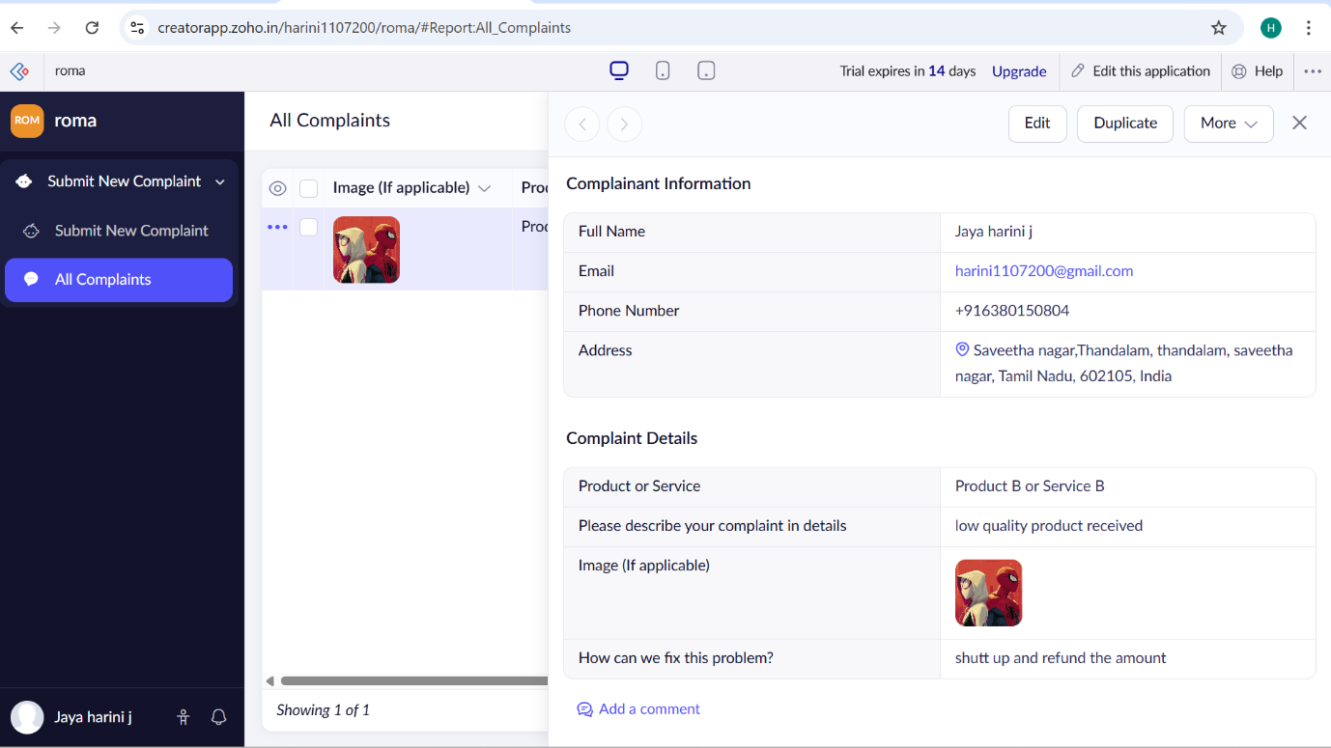

Result
The Product Selling System was successfully created using Zoho Creator, enabling users to manage products, customer orders, and sales information through a cloud-based SaaS application.

