ALTER TABLE STUDENTNEW

RENAME COLUMN STUDENT_REG TO STUDENT_REGNO;

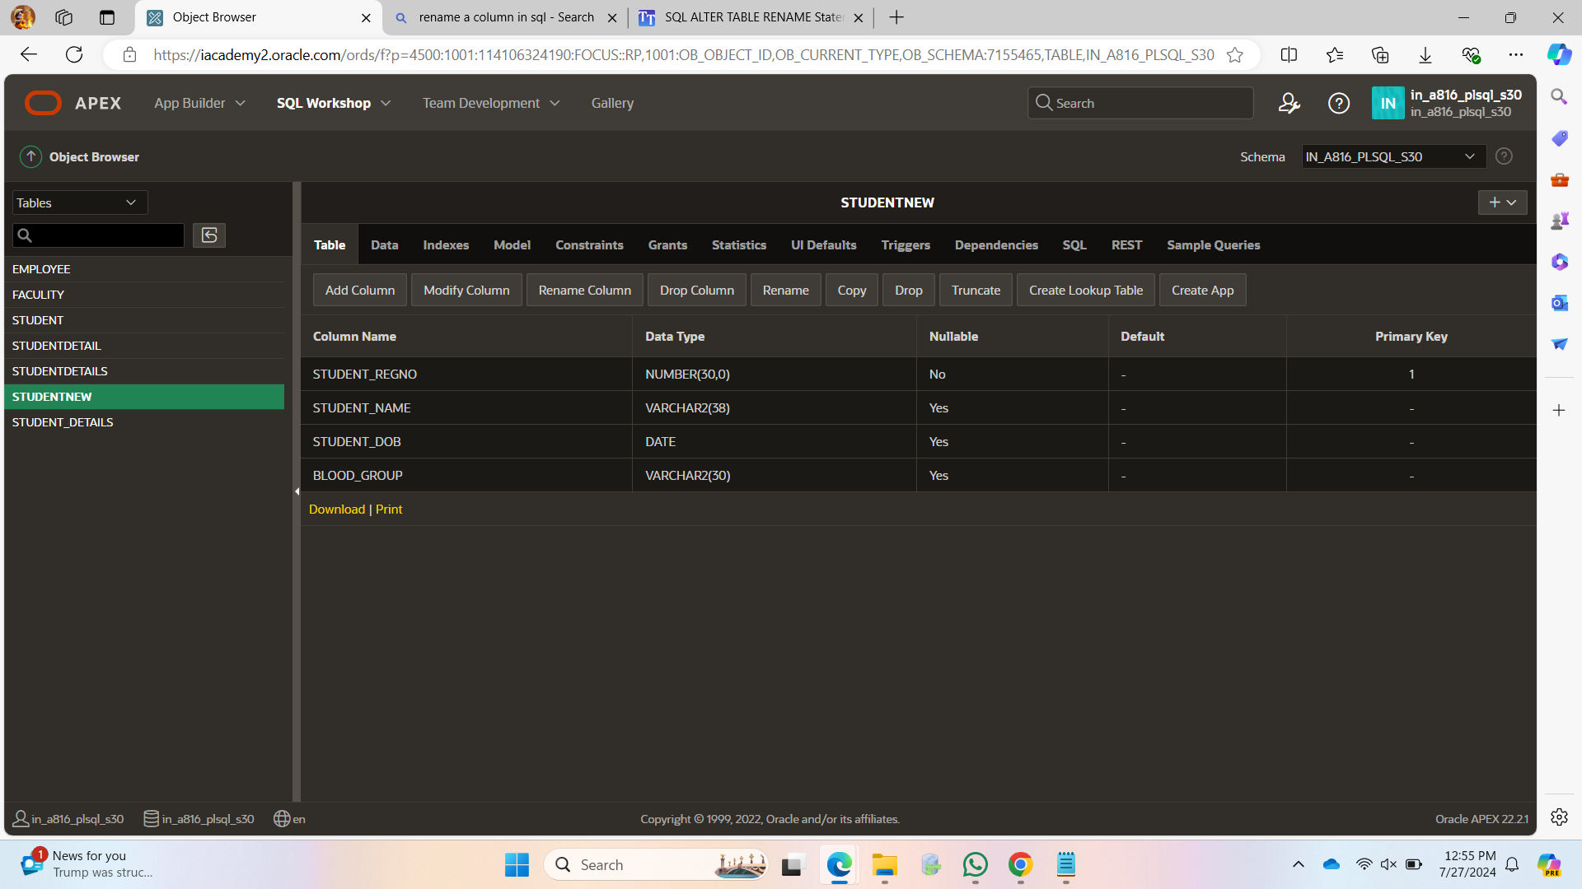

ALTER TABLE STUDENTNEW

MODIFY STUDENT_NAME VARCHAR2(38) NOT NULL;

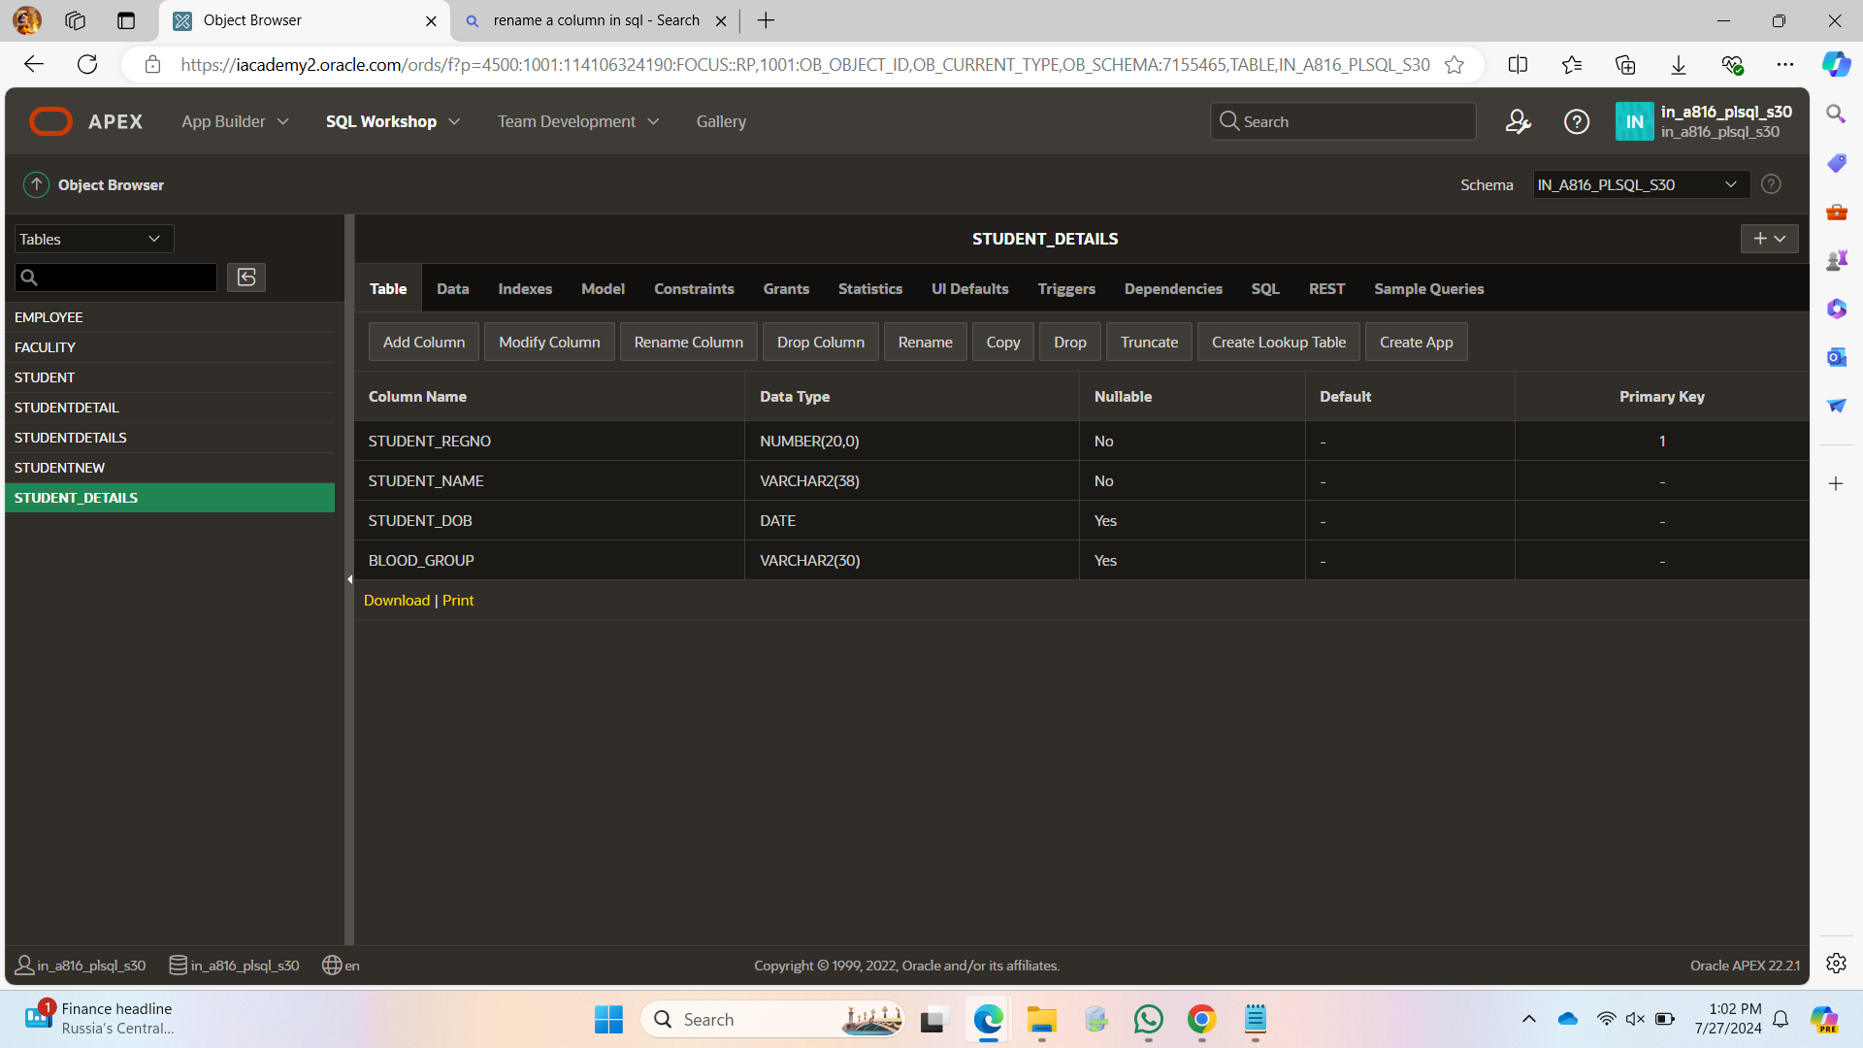

ALTER TABLE STUDENTNEW

MODIFY STUDENT_DOB NUMERIC NOT NULL;

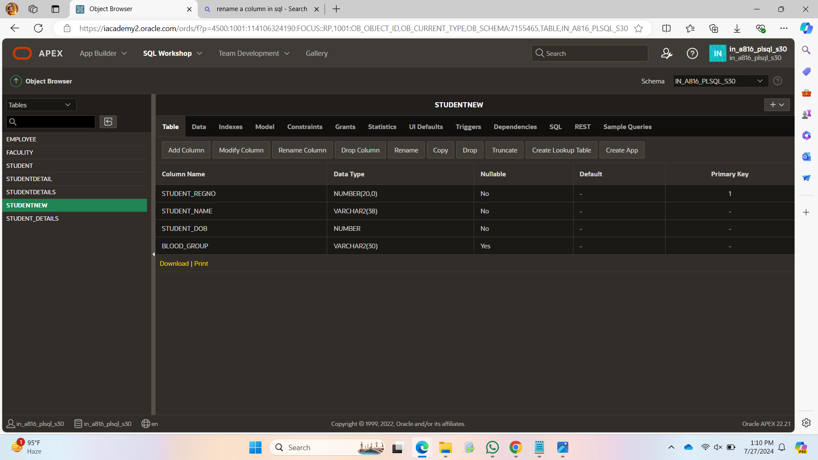

INSERT INTO STUDENTNEW VALUES(192371040,' ',2006,'Apositive');

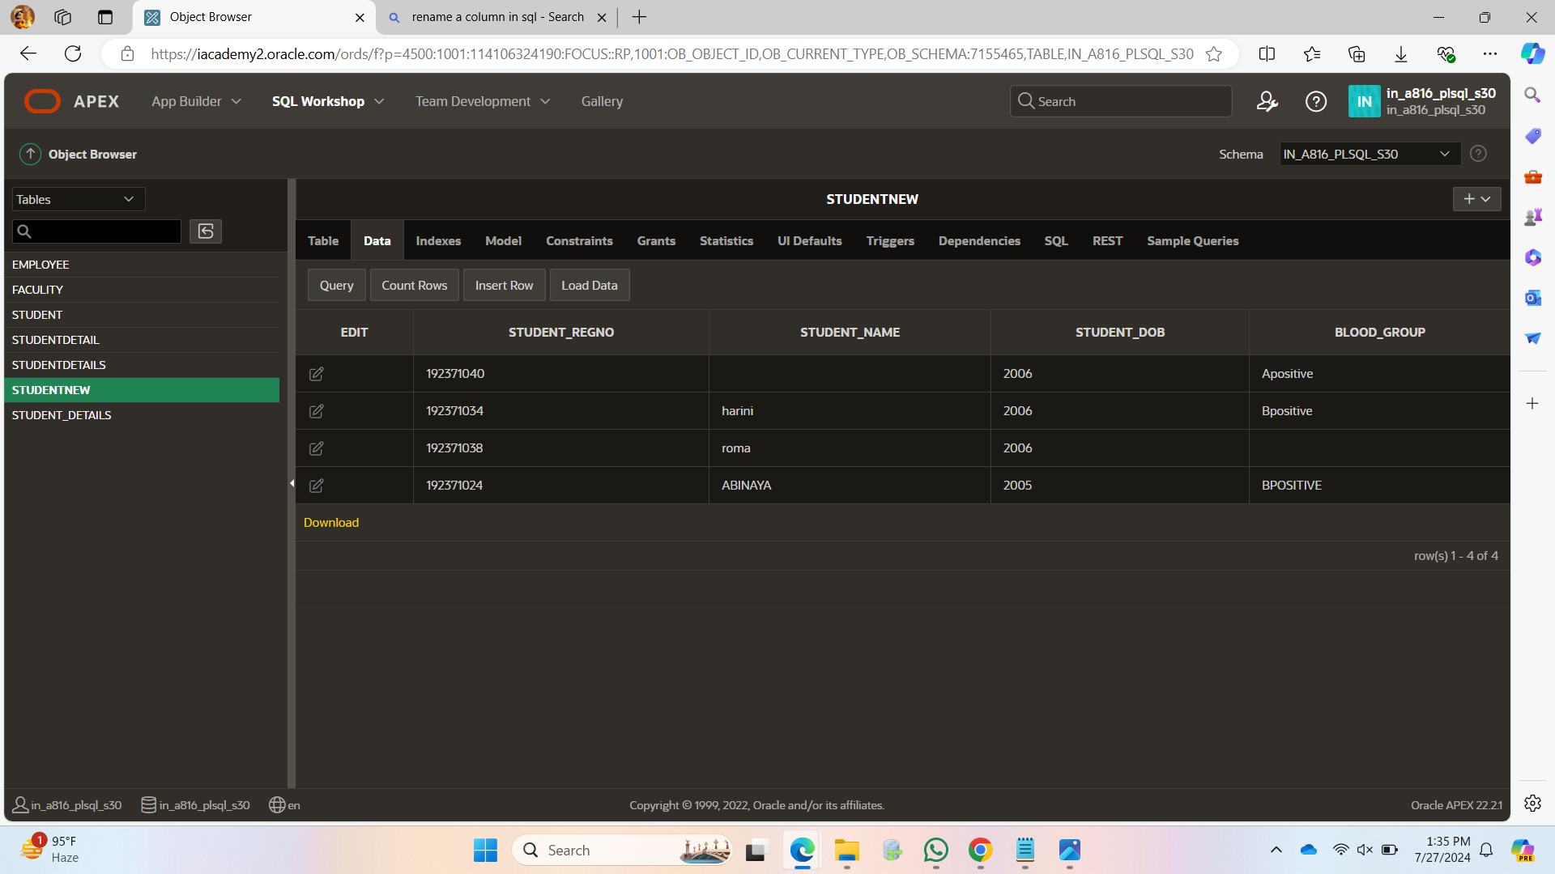

SELECT * FROM STUDENTNEW

ORDER BY STUDENT_REGNO DESC;

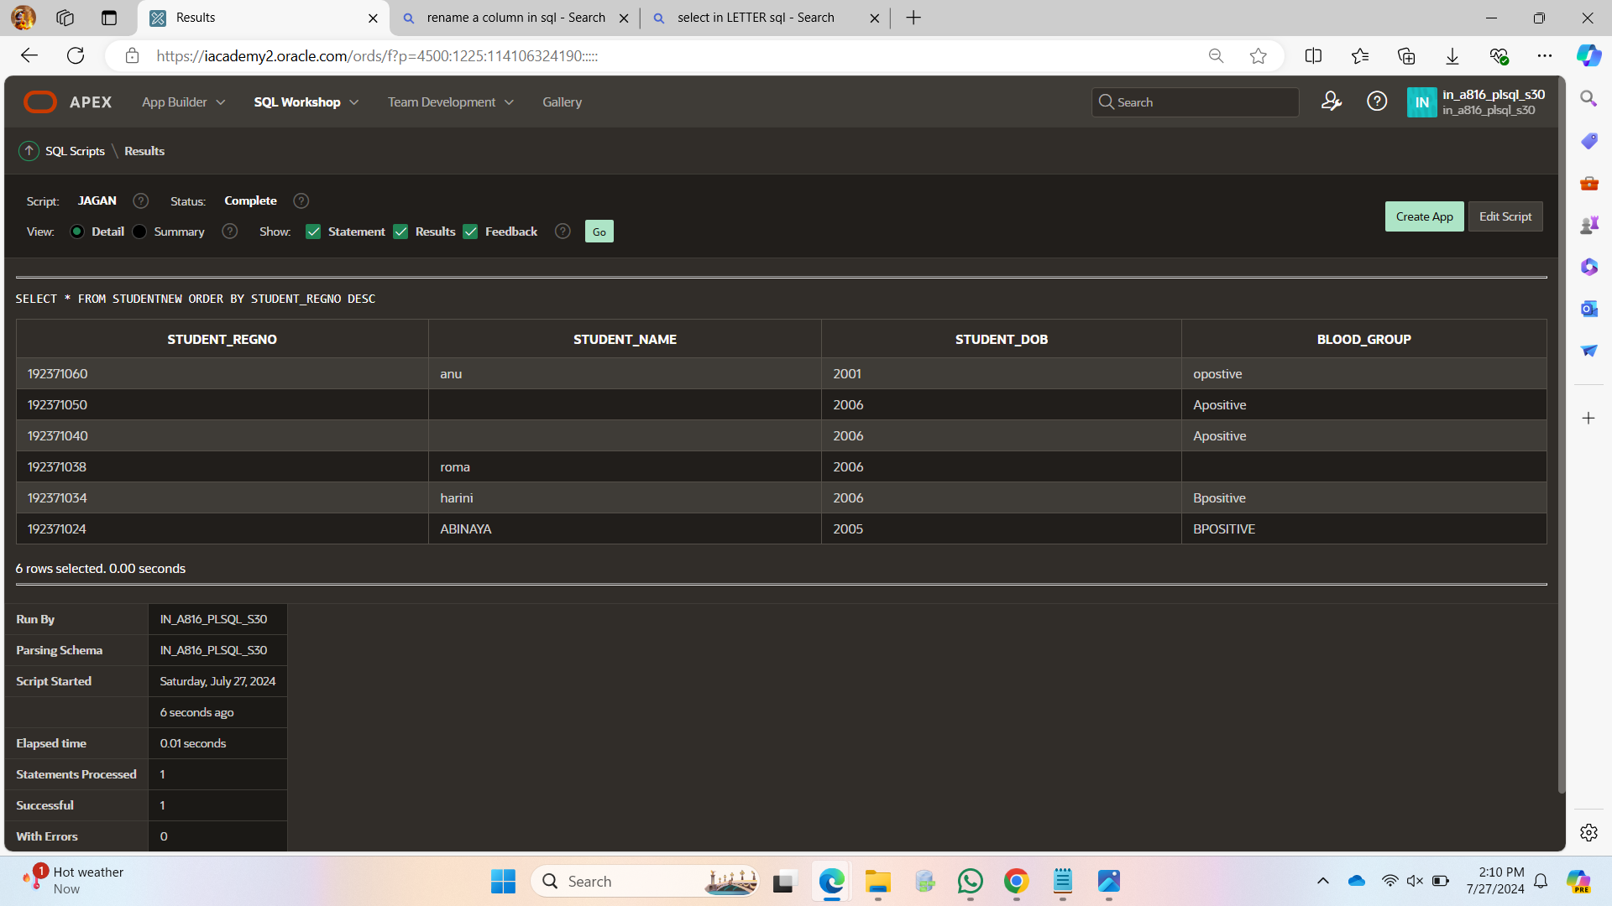

SELECT STUDENT_NAME FROM STUDENTNEW WHERE STUDENT_NAME LIKE 'A%';

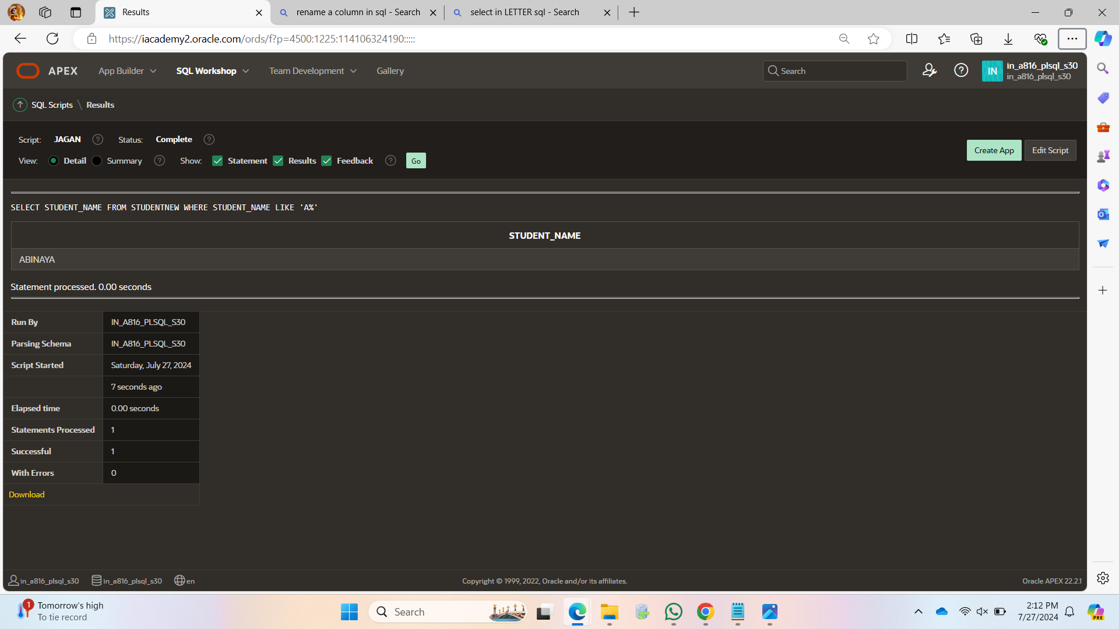

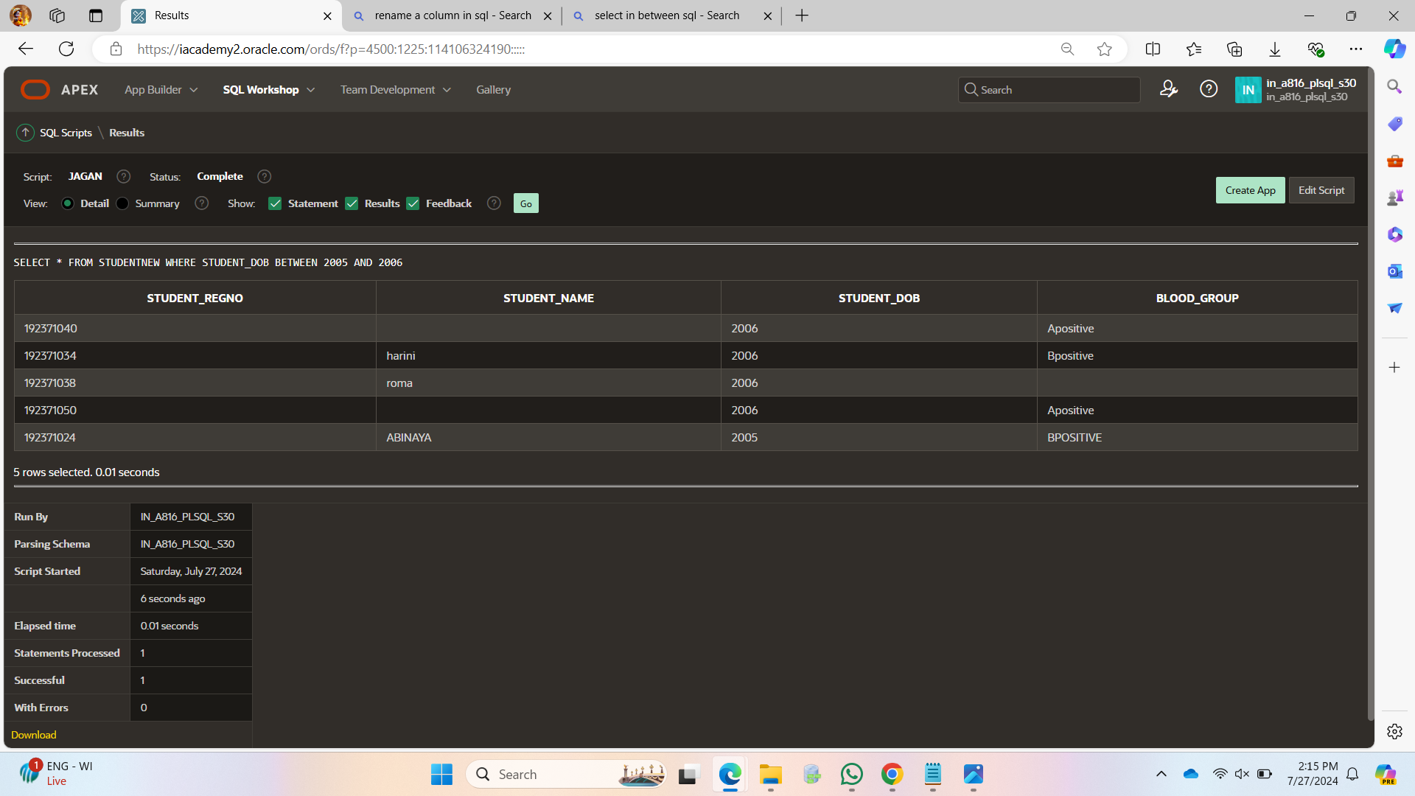

SELECT STUDENT_DOB, STUDENT_DOB+1 AS "STUDENT_DOB+1"

FROM STUDENTNEW;

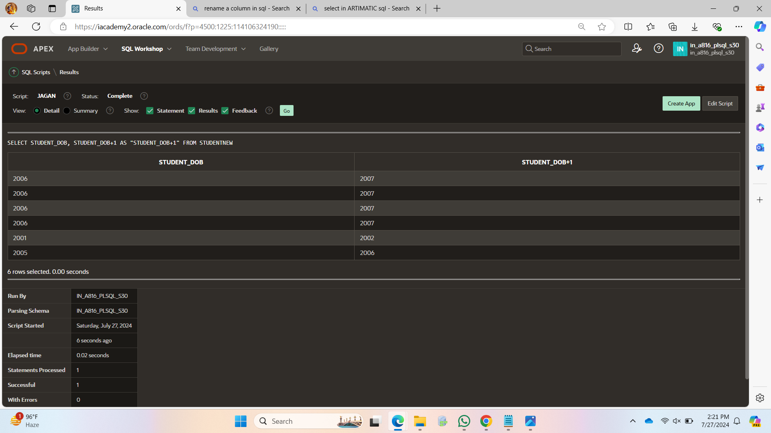SELECT * FROM STUDENTNEW WHERE STUDENT_DOB>2006

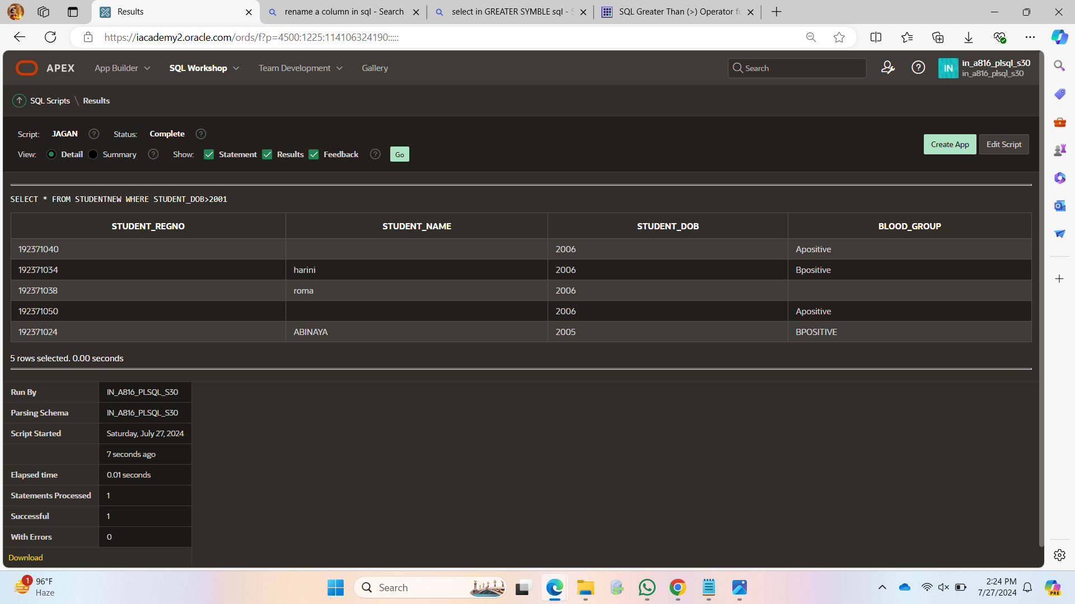SELECT * FROM STUDENTNEW WHERE STUDENT_REGNO = 192371024 OR STUDENT_REGNO = 192371034 _REGNO = 192371034;

