EXP-24
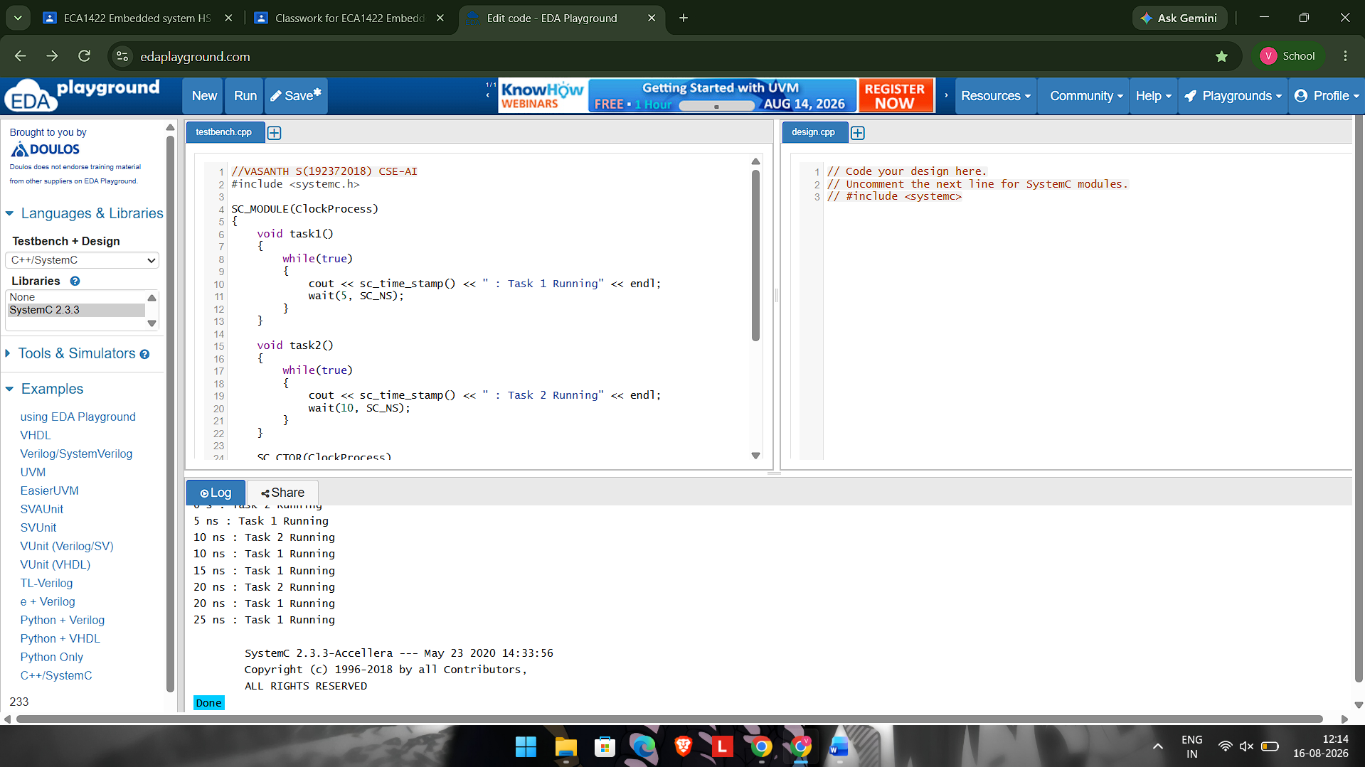
#include <systemc.h>

SC_MODULE(ClockProcess)
{
void task1()
{
while(true)
{
cout << sc_time_stamp() << " : Task 1 Running" << endl;
wait(5, SC_NS);
}
}

void task2()
{
while(true)
{
cout << sc_time_stamp() << " : Task 2 Running" << endl;
wait(10, SC_NS);
}
}

SC_CTOR(ClockProcess)
{
SC_THREAD(task1);
SC_THREAD(task2);
}
};

int sc_main(int argc, char* argv[])
{
ClockProcess obj("obj");
sc_start(30, SC_NS);
return 0;
}

