EXP-28

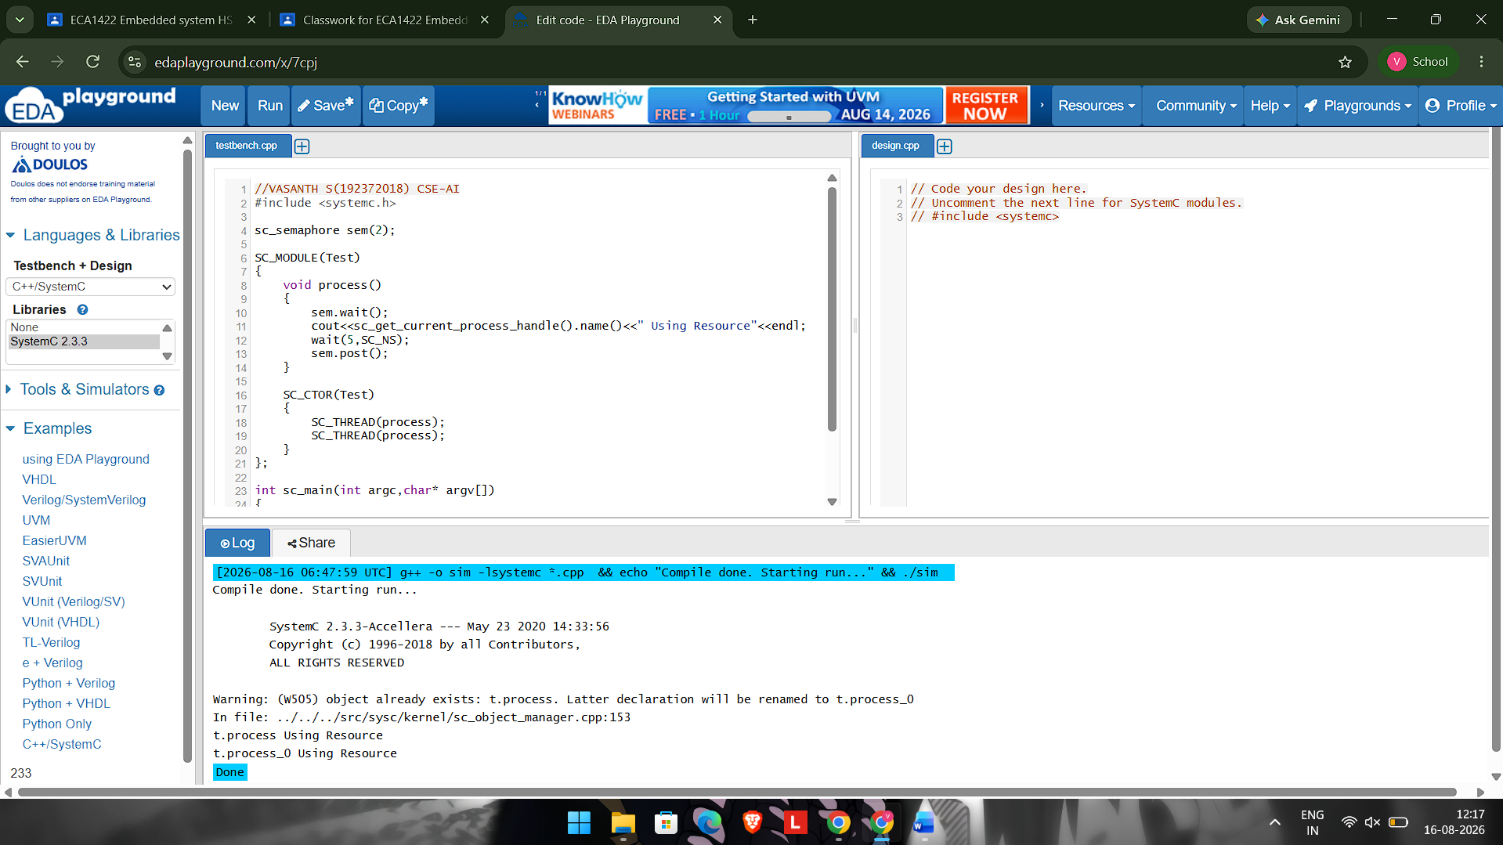
#include <systemc.h>

sc_semaphore sem(2);

SC_MODULE(Test)
{
void process()
{
sem.wait();
cout<<sc_get_current_process_handle().name()<<" Using Resource"<<endl;
wait(5,SC_NS);
sem.post();
}

SC_CTOR(Test)
{
SC_THREAD(process);
SC_THREAD(process);
}
};

int sc_main(int argc,char* argv[])
{
Test t("t");
sc_start();
}

