EXP-29

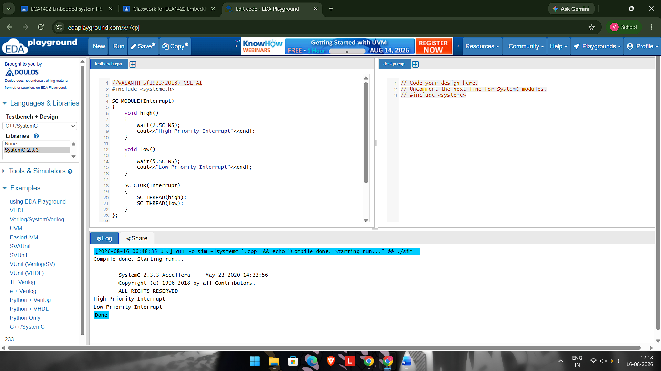

#include <systemc.h>

SC_MODULE(Interrupt)
{
void high()
{
wait(2,SC_NS);
cout<<"High Priority Interrupt"<<endl;
}

void low()
{
wait(5,SC_NS);
cout<<"Low Priority Interrupt"<<endl;
}

SC_CTOR(Interrupt)
{
SC_THREAD(high);
SC_THREAD(low);
}
};

int sc_main(int argc,char* argv[])
{
Interrupt obj("obj");
sc_start();
}

