Exp-9 : ULTRASONIC SENSOR IN PROTEUS ARDUINO
AIM :
To write an Embedded C program for interfacing Ultrasonic Sensor using Arduino UNO and Proteus
SOFTWARE REQUIRED :
  - Proteus 8 software
  - Arduino IDE software
CIRCUIT DIAGRAM :
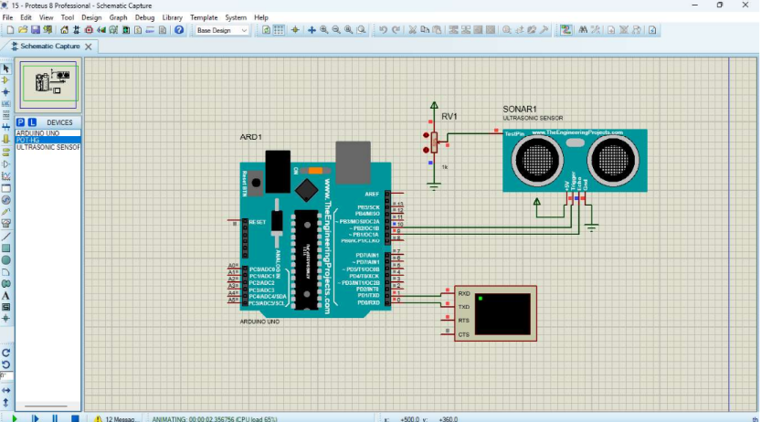
PROGRAM CODE :
//Program Sketch

int trig=10;

int echo = 9;

long duration;

int cm;

void setup() (

// put your setup code here, to run once:

pinMode(trig, OUTPUT);

pinMode(echo, INPUT);

1

Serial.begin(9600);

void loop() (//Sketch to calculate ultrasonic distance

1

digitalWrite(trig, LOW);

delayMicroseconds(10);

digitalWrite(trig, HIGH);

delayMicroseconds(10);

digitalWrite(trig, LOW);

delayMicroseconds(10);

duration pulseIn(echo, HIGH);

cm (duration/2) 0.034;

Print Value on Serial Monitor

Serial.print(" Distance -");

Serial.print(cm),

Serial println("cm");
OUTPUT :
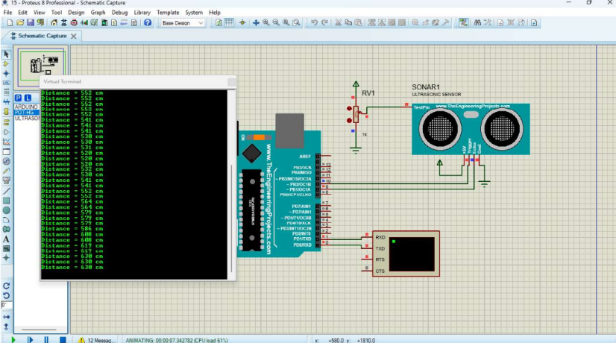
RESULT :
Thus the program is successfully verified and excuted .

