Exp-7 : SERIAL COMMUNICATION USING ARDUINO WITH PROTEUS
AIM:
To write an Embedded C program for serial communication using Arduino Uno and
Proteus
SOFTWARE REQUIRED:
Proteus 8 software.
Arduino IDE software
CIRCUIT DIAGRAM:
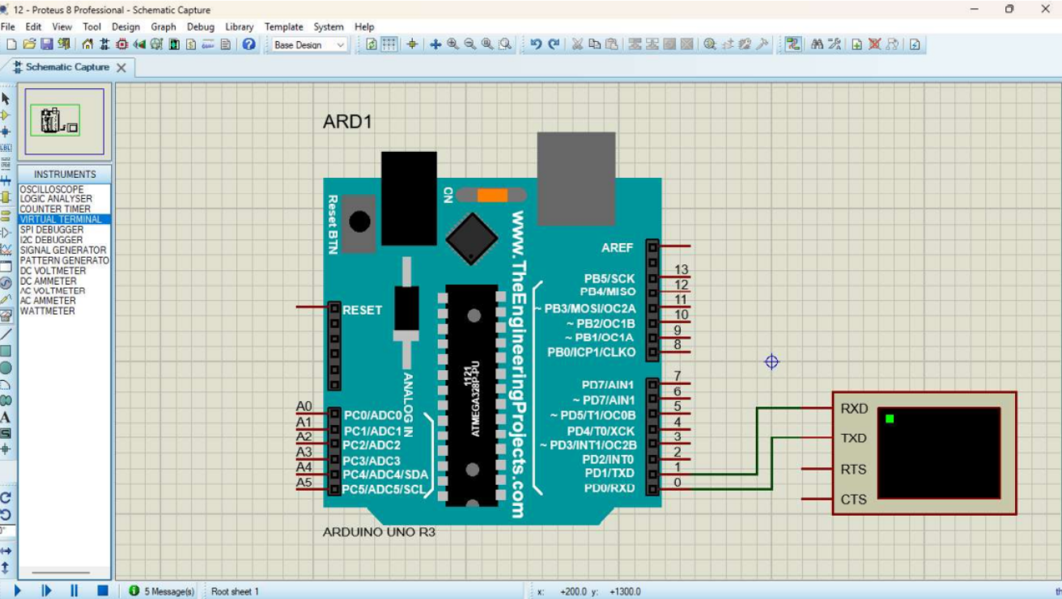
PROGRAM CODE:
void setup(){

Serial.begin(9600); // send and receive at 9600 baud

}

M

int number = 0;

I

void loop()
{
Serial.print("Number is ");

Serial.println(number); // print the number

delay(500); // delay half second between numbers
number ++;
}

OUTPUT:

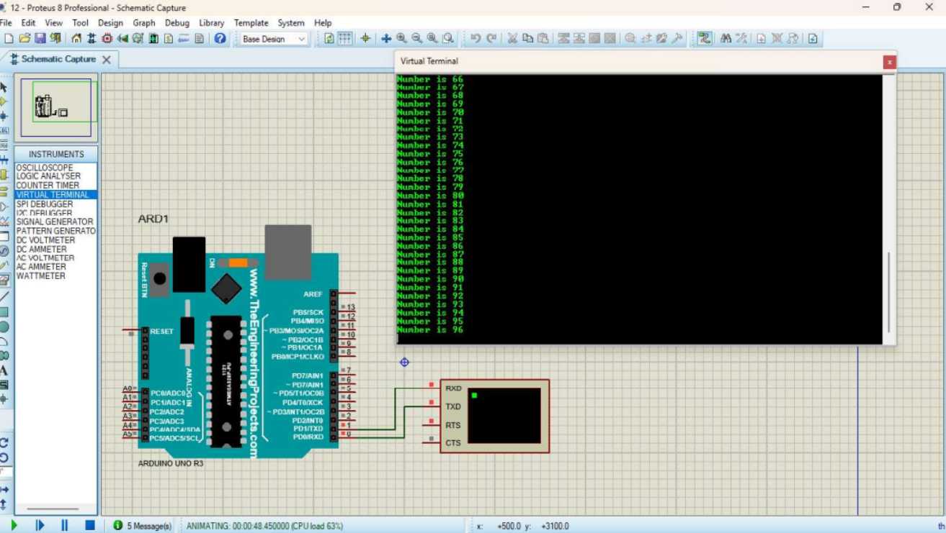
RESULT :
Thus the program is successfully executed and verified.

