EXP-3 :STEPPER MOTOR USING AT89C51 USING PROTEUS

AIM:
To write an assembly language program for Stepper Motor Using AT89C51 using Keil and
Proteus

SOFTWARE REQUIRED:
Proteus 8 software.
ORG 0000H

UP: MOV P2,#09H
ACALL DELAY
MOV P2,#0CH
ACALL DELAY
MOV P2,#06H
ACALL DELAY
MOV P2,#03H
ACALL DELAY
SJMP UP

DELAY: MOV R4,#18
H1: MOV R3,#255
H2: DJNZ R3,H2
DJNZ R4,H1
RET

END

OUTPUT: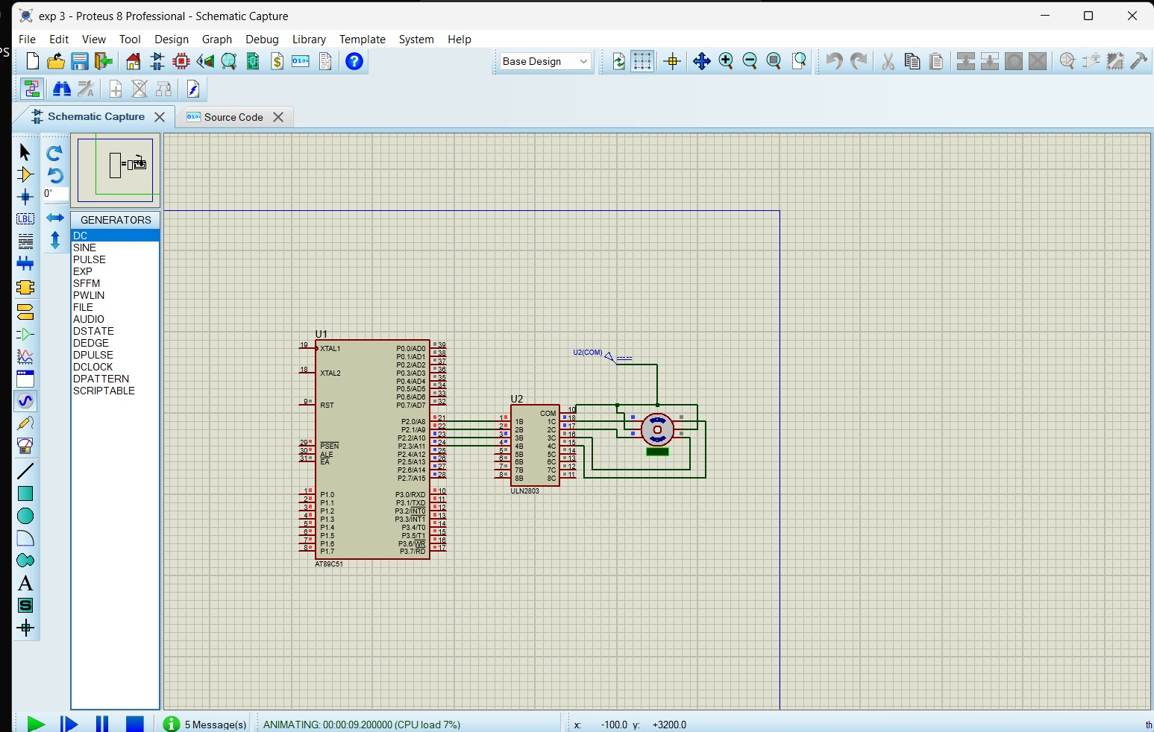
RESULT :
Thus the program has been successfully verified and executed

