EXP-5 : ARDUINO BASED MANUAL ELECTRONIC COUNTER USING PROTEUS
AIM:
To write an Embedded C program for Manual Electronic counter using Arduino IDE and
Proteus

SOFTWARE REQUIRED:
Proteus 8 software

Arduino IDE
int x0,x1,x2,x3,x4,x5,x6,x7,x8,x9;
int delay_time=200;

void setup() {

pinMode(12, INPUT_PULLUP);

for(int i=1;i<=7;i++)
pinMode(i,OUTPUT);

}

void loop() {

int sensorVal = digitalRead(12);

if (sensorVal == LOW) {
x0=true;
}

while(x0){
zero();
if (digitalRead(12)==LOW){
x1=true;
x0=false;
delay(300);
}
}

while(x1){
one();
if (digitalRead(12)==LOW){
x2=true;
x1=false;
delay(300);
}
}

while(x2){
two();
if (digitalRead(12)==LOW){
x3=true;
x2=false;
delay(300);
}
}

while(x3){
three();
if (digitalRead(12)==LOW){
x4=true;
x3=false;
delay(300);
}
}

while(x4){
four();
if (digitalRead(12)==LOW){
x5=true;
x4=false;
delay(300);
}
}

while(x5){
five();
if (digitalRead(12)==LOW){
x6=true;
x5=false;
delay(300);
}
}

while(x6){
six();
if (digitalRead(12)==LOW){
x7=true;
x6=false;
delay(300);
}
}

while(x7){
seven();
if (digitalRead(12)==LOW){
x8=true;
x7=false;
delay(300);
}
}

while(x8){
eight();
if (digitalRead(12)==LOW){
x9=true;
x8=false;
delay(300);
}
}

while(x9){
nine();
if (digitalRead(12)==LOW){
x0=true;
x9=false;
delay(300);
}
}
}

/* ===== 7 Segment Functions ===== */

void zero(){
digitalWrite(1,HIGH);
digitalWrite(2,HIGH);
digitalWrite(3,HIGH);
digitalWrite(4,HIGH);
digitalWrite(5,HIGH);
digitalWrite(6,HIGH);
digitalWrite(7,LOW);
}

void one(){
digitalWrite(1,LOW);
digitalWrite(2,HIGH);
digitalWrite(3,HIGH);
digitalWrite(4,LOW);
digitalWrite(5,LOW);
digitalWrite(6,LOW);
digitalWrite(7,LOW);
}

void two(){
digitalWrite(1,HIGH);
digitalWrite(2,HIGH);
digitalWrite(3,LOW);
digitalWrite(4,HIGH);
digitalWrite(5,HIGH);
digitalWrite(6,LOW);
digitalWrite(7,HIGH);
}

void three(){
digitalWrite(1,HIGH);
digitalWrite(2,HIGH);
digitalWrite(3,HIGH);
digitalWrite(4,HIGH);
digitalWrite(5,LOW);
digitalWrite(6,LOW);
digitalWrite(7,HIGH);
}

void four(){
digitalWrite(1,LOW);
digitalWrite(2,HIGH);
digitalWrite(3,HIGH);
digitalWrite(4,LOW);
digitalWrite(5,LOW);
digitalWrite(6,HIGH);
digitalWrite(7,HIGH);
}

void five(){
digitalWrite(1,HIGH);
digitalWrite(2,LOW);
digitalWrite(3,HIGH);
digitalWrite(4,HIGH);
digitalWrite(5,LOW);
digitalWrite(6,HIGH);
digitalWrite(7,HIGH);
}

void six(){
digitalWrite(1,HIGH);
digitalWrite(2,LOW);
digitalWrite(3,HIGH);
digitalWrite(4,HIGH);
digitalWrite(5,HIGH);
digitalWrite(6,HIGH);
digitalWrite(7,HIGH);
}

void seven(){
digitalWrite(1,HIGH);
digitalWrite(2,HIGH);
digitalWrite(3,HIGH);
digitalWrite(4,LOW);
digitalWrite(5,LOW);
digitalWrite(6,LOW);
digitalWrite(7,LOW);
}

void eight(){
digitalWrite(1,HIGH);
digitalWrite(2,HIGH);
digitalWrite(3,HIGH);
digitalWrite(4,HIGH);
digitalWrite(5,HIGH);
digitalWrite(6,HIGH);
digitalWrite(7,HIGH);
}

void nine(){
digitalWrite(1,HIGH);
digitalWrite(2,HIGH);
digitalWrite(3,HIGH);
digitalWrite(4,HIGH);
digitalWrite(5,LOW);
digitalWrite(6,HIGH);
digitalWrite(7,HIGH);
}

OUTPUT :
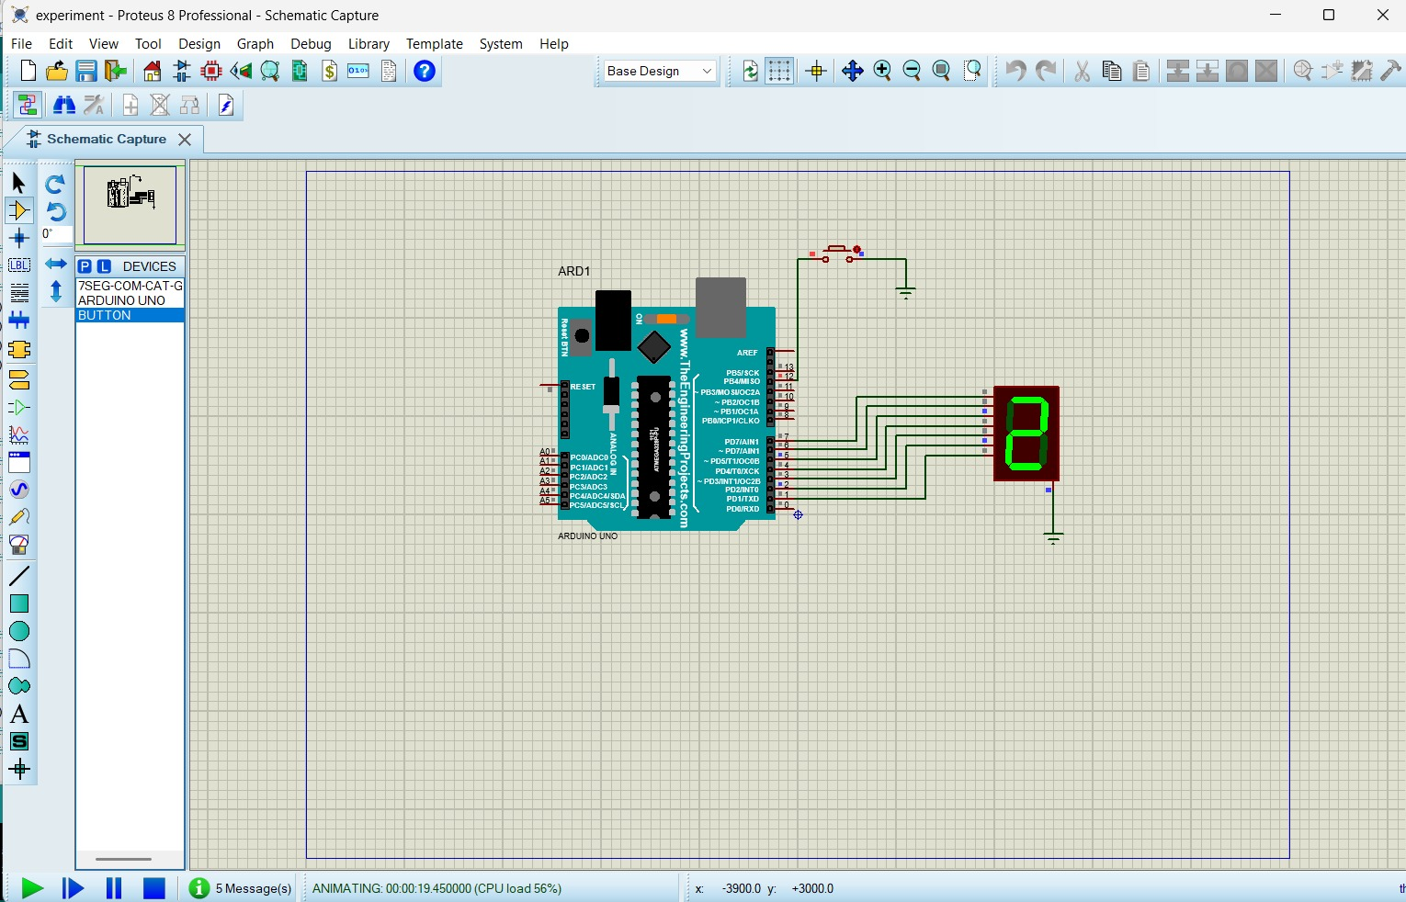

RESULT :
Thus the program has been successfully verified and exceuted .

