EXP-1 : FLASHING OF LED USING AT89C51 MICROCONTROLLER USING PROTEUS

AIM:
To Write an assembly language program to flash the LED using AT89C51 SOFTWARES REQUIRED:

Proteus software
PROGRAM
ORG 0000H
UP: SETB P2.0
ACALL DELAY
CLR P2.0
ACALL DELAY
SJMP UP
DELAY: MOV R4,#35
H1:MOV R3,#255
H2:DJNZ R3,H2
DJNZ R4,H1
RET
END

CIRCUIT DIAGRAM:
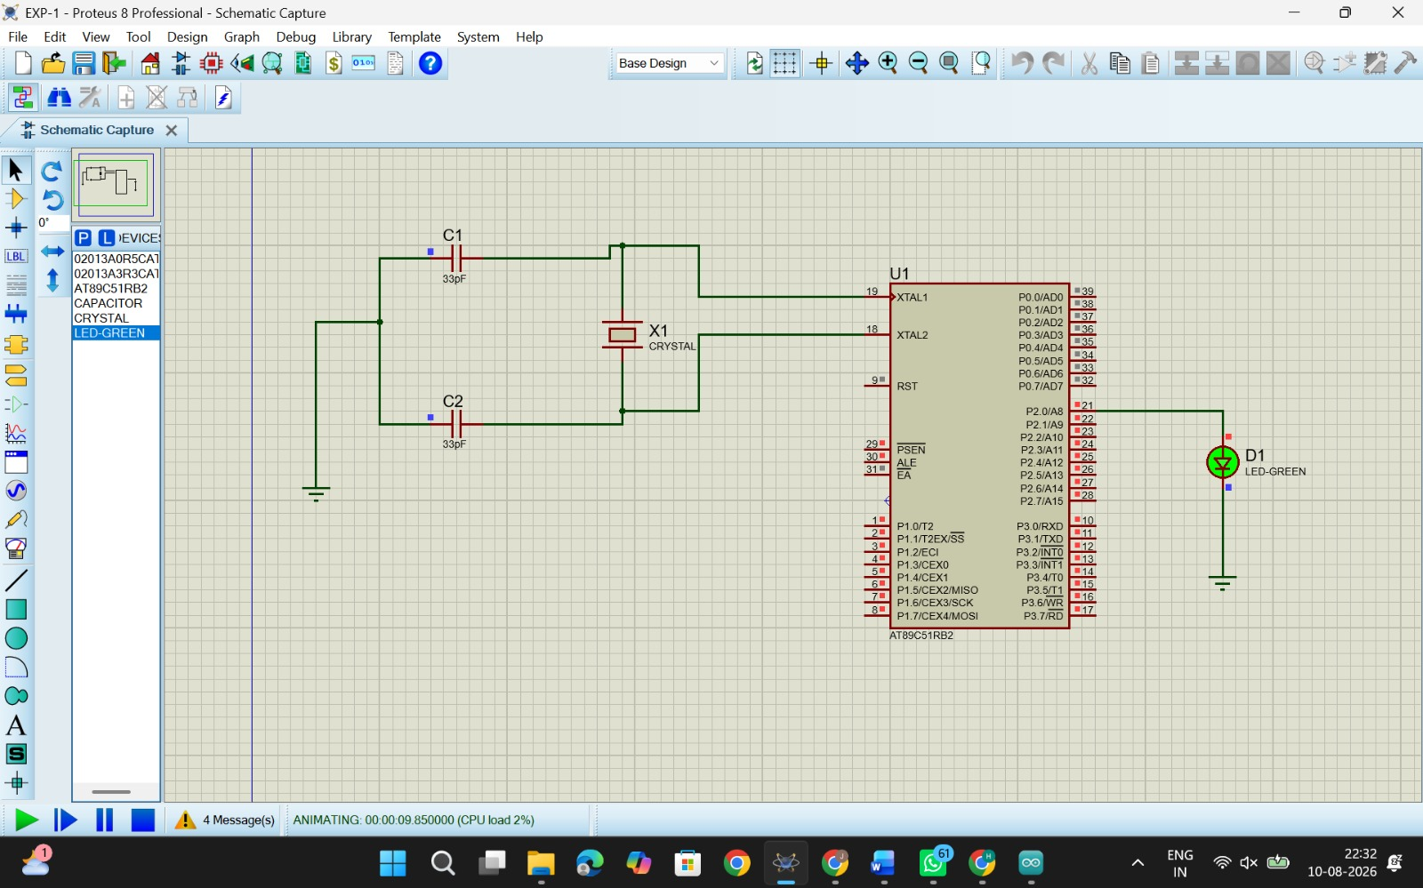

RESULT
Thus the program has been successfully verified and executed.

