EXP-8 GAS SENSOR MQ-2 IN PROTEUS USING ARDUINO
AIM:
To write an Embedded C program for interfacing Gas Sensor MQ-2 using Arduino Uno
and Proteus
SOFTWARE REQUIRED:
Proteus 8 software.
Arduino IDE software
PROGRAM
Adeline Groented 13
Refine Sensor AD
pinMode(13.OUTPUTS
pinMode 12,0UTPUTS
pinModel ALINPUT)
Serial hegin(9600)
void hoop
int value analogical As
Serial print("Analogic Valor coming from the sensor
Serial printinvalue't
delay(100);
if(value-600)
digitalWrite(13,HIGHX
1
1
else
digitalWrite(13.LOWE
delay(201
Code for MQ6 минг:

int moriPin All MQ-5 analog pin connected to All
void setup()
Serial.begin(9600),
void loop()
int sensor Value analogReadingPink
Serial.print("MQ5 Sensor Value:"
Serial.printing sensor Value):
delay(1000);//1-second delay
}
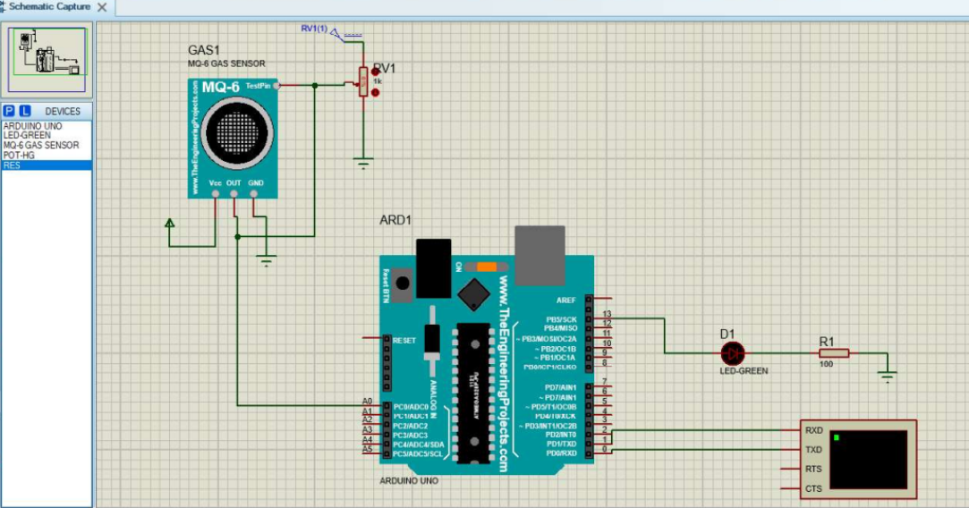

RESULT:
Thus the program has been successfully verified and executed.

