EXP-10 : PIR SENSOR IN PROTEUS USING ARDUINO
AIM :
To write an Embedded C program for interfacing PIR Sensor using Arduino Uno and
Proteus
SOFTWARE REQUIRED:
- Proteus 8 software.
- Arduino IDE software
CIRCUIT DIAGRAM :
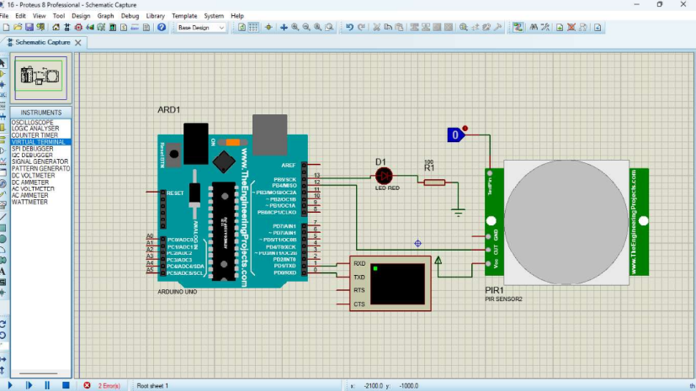
PROGRAM CODE :
int Status 13; // Digital pin D6

int sensor = 12; // Digital pin D7

void setup() {

Serial.begin(9600);

pinMode(sensor, INPUT); // declare sensor as input

pinMode(Status, OUTPUT); // declare LED as output

void loop() {

long state = digitalRead(sensor);

Serial.println(state);

if(state = HIGH) {

}

digitalWrite (Status, HIGH);

Serial.println("Motion detected!");

delay(1000);

else {

digitalWrite (Status, LOW);

Serial.println("Motion absent!");

delay(1000);

OUTPUT :
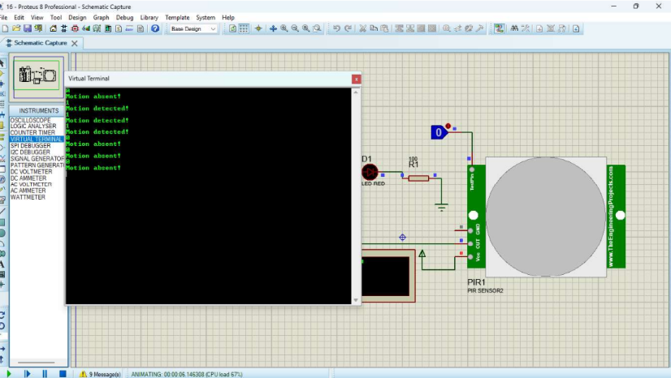
RESULT :
Thus the program code is successfully excuted and verified

