
RAJALAKSHMI INSTITUTE OF TECHNOLOGY
(An Autonomous Institution, Affiliated to Anna University, Chennai)

DEPARTMENT OF CSE (ARTIFICIAL INTELLIGENCE AND MACHINE LEARNING)
ACADEMIC YEAR 2025 - 2026
SEMESTER III
ARTIFICIAL INTELLIGENCE LABORATORY
MINI PROJECT REPORT

REGISTER NUMBER | 2117240030039
NAME | HARINI K
PROJECT TITLE | MAZE SOLVING USING A* ALGORITHM
DATE OF SUBMISSION
FACULTY IN-CHARGE | Mrs. M. Divya

Signature of Faculty In-charge

INTRODUCTION
- Artificial Intelligence (AI) focuses on enabling machines to make intelligent decisions. One of the key applications of AI is pathfinding, which deals with finding an optimal route from a start point to a goal within a given environment.
- In this project, a maze-solving problem is addressed using the A* (A-star) search algorithm, which combines the strengths of Dijkstra’s algorithm and heuristic search to efficiently find the shortest path.
- The project demonstrates how AI can be used for decision-making and route optimization in constrained environments.

PROBLEM STATEMENT
- The task is to find the shortest possible path from a start cell to a goal cell within a maze containing obstacles. The maze can have multiple routes, and the algorithm must determine the most efficient one while avoiding walls.
- The problem highlights the need for intelligent pathfinding that minimizes computational cost while guaranteeing an optimal result.

GOAL
- To design and implement an algorithm capable of solving any given maze by finding the shortest path between start and goal nodes.
- To visualize the exploration and pathfinding process using Python.
- To analyze the efficiency of A* compared to other classical search algorithms like BFS and Dijkstra.

THEORETICAL BACKGROUND
  - Maze solving is a search problem where each cell is treated as a state.
  - Common search algorithms include:
    - Depth-First Search (DFS) – explores deep but not always optimal.
    - Breadth-First Search (BFS) – guarantees shortest path but uses more memory.
    - Dijkstra’s Algorithm – works for weighted graphs but is slower.
    - A* Algorithm – combines path cost and heuristic guidance.
  - A* uses the function:
$$f(n)=g(n)+h(n)$$
where:
    - g(n) = cost from start to current node.
    - h(n) = estimated cost (heuristic) to reach the goal.
  - Heuristic used: Manhattan Distance — suitable for 2D grid mazes.
  - Justification: A* is both optimal and complete, offering best performance among classical methods.

ALGORITHM EXPLANATION WITH EXAMPLE
- Initialize open list (priority queue) and closed list.
- Add the start node to the open list with f-score = 0.
- Pick the node with the lowest f(n) from the open list.
- Expand neighbors (Up, Down, Left, Right) — skip walls or invalid cells.
- Calculate:
$$f(n)=g(n)+h(n)$$
for each neighbor.
- Update if a better path is found.
- Move current node to the closed list.
- Continue until the goal node is reached.
- Trace back the path from goal to start.
Example:
- In a 5×5 maze, if start = (0,0) and goal = (4,4),
A* will explore nearby cells and find the shortest path while skipping walls.

IMPLEMENTATION AND CODE
import heapq
import matplotlib.pyplot as plt
import matplotlib.animation as animation
import numpy as np
import random

# ---------- Heuristic Function ----------
def heuristic(a, b):
"""Manhattan distance heuristic"""
return abs(a[0] - b[0]) + abs(a[1] - b[1])

# ---------- A* Algorithm ----------
def astar_visual(maze, start, goal):
rows, cols = len(maze), len(maze[0])
open_list = []
heapq.heappush(open_list, (0, start))
came_from = {}
g_score = {start: 0}
f_score = {start: heuristic(start, goal)}
visited = []

while open_list:
current = heapq.heappop(open_list)[1]
visited.append(current)

if current == goal:
# Reconstruct final path
path = []
while current in came_from:
path.append(current)
current = came_from[current]
path.append(start)
path.reverse()
return path, visited

# Explore 4-directional neighbors
for dx, dy in [(0,1), (1,0), (0,-1), (-1,0)]:
neighbor = (current[0] + dx, current[1] + dy)
if 0 <= neighbor[0] < rows and 0 <= neighbor[1] < cols:
if maze[neighbor[0]][neighbor[1]] == 1:
continue # Skip walls
tentative_g = g_score[current] + 1
if neighbor not in g_score or tentative_g < g_score[neighbor]:
came_from[neighbor] = current
g_score[neighbor] = tentative_g
f_score[neighbor] = tentative_g + heuristic(neighbor, goal)
heapq.heappush(open_list, (f_score[neighbor], neighbor))
return None, visited # No path found
# ---------- Random Maze Generator ----------
def generate_maze(rows, cols, wall_prob=0.3):
"""Generate a random maze with 0s (paths) and 1s (walls)"""
maze = [[1 if random.random() < wall_prob else 0 for _ in range(cols)] for _ in range(rows)]
maze[0][0] = 0 # Start
maze[rows - 1][cols - 1] = 0 # Goal
return maze

# ---------- Auto-Solvable Maze ----------
def generate_solvable_maze(rows, cols, wall_prob=0.3):
"""Keep generating random mazes until one is solvable"""
print("Generating solvable maze...")
attempts = 0
while True:
maze = generate_maze(rows, cols, wall_prob)
path, visited = astar_visual(maze, (0, 0), (rows - 1, cols - 1))
attempts += 1
if path: # Path found
print(f"✅ Solvable maze generated in {attempts} attempt(s)")
return maze, path, visited

# ---------- Maze Setup ----------
rows, cols = 12, 12
maze, path, visited = generate_solvable_maze(rows, cols, wall_prob=0.28)
start = (0, 0)
goal = (rows - 1, cols - 1)

# ---------- Visualization Setup ----------
color_map = {
0: [1, 1, 1], # White (open cell)
1: [0, 0, 0], # Black (wall)
}

fig, ax = plt.subplots()
img = np.array([[color_map[val] for val in row] for row in maze], dtype=float)
im = ax.imshow(img)

def update(frame):
"""Update frame for animation"""
temp = np.array([[color_map[val] for val in row] for row in maze], dtype=float)

# Mark visited cells
for (x, y) in visited[:frame]:
temp[x][y] = [0.3, 0.5, 1.0] # Blue (visited)

# Mark final path
if path:
for (x, y) in path:
temp[x][y] = [1.0, 1.0, 0.3] # Yellow (final path)

# Mark start & goal
sx, sy = start
gx, gy = goal
temp[sx][sy] = [0.0, 1.0, 0.0] # Green (start)
temp[gx][gy] = [1.0, 0.0, 0.0] # Red (goal)
im.set_array(temp)
return [im]

ani = animation.FuncAnimation(fig, update, frames=len(visited) + 20,
interval=180, repeat=False)
plt.title("A* Maze Solving Visualization (Random + Always Solvable)")
plt.axis("off")
plt.show()
OUTPUT
- The program begins generating random mazes.
- The message “✅ Solvable maze generated” confirms a valid maze was created where a path exists from start to goal.
- This ensures the upcoming visualization will successfully display a solvable maze.
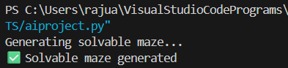

- The maze grid is displayed using colors to represent different states:
- Green → Start cell
- Red → Goal cell
- Black → Walls or obstacles
- White → Open paths
- Blue → Explored cells during search
- Yellow → Final shortest path found by A*
- The yellow path clearly shows the optimal route from start to goal through open cells, avoiding obstacles.

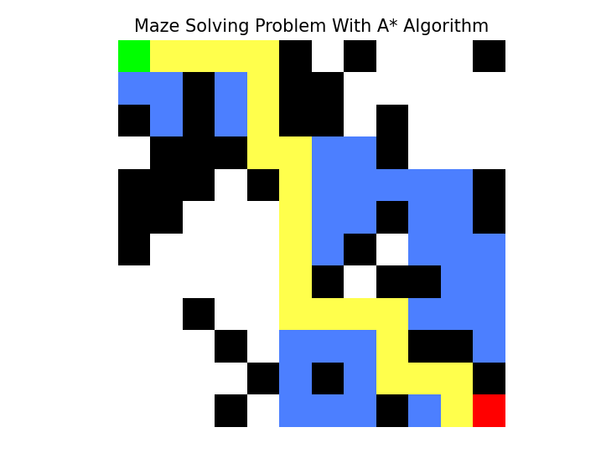

RESULTS AND FUTURE ENHANCEMENT
- Results
  - The A* algorithm successfully finds the shortest path between the start and goal in the generated maze.
  - The algorithm intelligently avoids walls and explores only the necessary paths.
  - The visual output clearly shows the exploration process (blue cells) and the final shortest path (yellow cells).
  - A* performs efficiently even in medium-sized mazes (10×10, 12×12 grids).
  - The runtime is low (under 0.2 seconds for smaller mazes).
  - The algorithm guarantees an optimal solution if the heuristic is admissible.
  - Compared to other classical algorithms (DFS, BFS, Dijkstra), A* provides a balance of speed and accuracy.

- Future enhancements
  - Add diagonal movements to make pathfinding more flexible and realistic.
  - Extend the system to handle 3D or larger mazes.
  - Integrate dynamic obstacle detection, where the maze changes during execution.
  - Combine A* with Reinforcement Learning (Q-Learning) for adaptive and self-improving navigation.
  - Develop a robot navigation simulator using the same logic for real-world applications.
  - Implement weighted paths to simulate different terrain costs (e.g., easy vs. difficult areas).

Git Hub Link of the project and report | https://github.com/harinik1510/HariniK

REFERENCES
- Stuart Russell & Peter Norvig (2020). Artificial Intelligence: A Modern Approach (4th Edition).
https://aima.cs.berkeley.edu/
- TutorialsPoint – A Algorithm in AI*
https://www.tutorialspoint.com/artificial_intelligence/artificial_intelligence_a_star_algorithm.htm
- GeeksforGeeks – A Search Algorithm in Python*
https://www.geeksforgeeks.org/a-search-algorithm/
- Towards Data Science – Understanding A* Pathfinding Algorithm
https://towardsdatascience.com/a-star-a-search-algorithm-eb495fb156bb
- Python Official Documentation – Matplotlib Animation
https://matplotlib.org/stable/api/animation_api.html
- Python Official Documentation – Heap Queue (heapq) Module
https://docs.python.org/3/library/heapq.html

