
RAJALAKSHMI INSTITUTE OF TECHNOLOGY
(An Autonomous Institution, Affiliated to Anna University, Chennai)

DEPARTMENT OF CSE (ARTIFICIAL INTELLIGENCE AND MACHINE LEARNING)
ACADEMIC YEAR 2025 - 2026
SEMESTER IV
AL23421 - MACHINE LEARNING LABORATORY
MINI PROJECT REPORT

REGISTER NUMBER | 2117240030039
NAME | K Harini
PROJECT TITLE | Comparative Study On Decision Tree and Support Vector Machine For Loan Approval Prediction
DATE OF SUBMISSION
FACULTY IN-CHARGE | Mrs. M. Divya

Signature of Faculty In-charge Signature of HoD

Internal examiner External examiner
INTRODUCTION
The loan approval process is a crucial task in the banking and financial sector, as it determines an applicant’s eligibility for financial assistance. Traditional manual evaluation methods are often time-consuming and prone to inconsistencies and bias. Machine learning provides an efficient and data-driven approach by analyzing historical applicant information—such as income, credit history, employment status, and property area—to accurately predict whether a loan should be approved or rejected.
This project develops a loan approval prediction system using two supervised machine learning algorithms: Decision Tree and Support Vector Machine (SVM). The Decision Tree offers an interpretable rule-based model, while SVM effectively handles complex patterns through an optimal decision boundary. An interactive Streamlit-based dashboard enables users to input applicant details and receive real-time predictions. The models are evaluated and compared using metrics such as accuracy, precision, recall, and F1-score, demonstrating the effectiveness of machine learning in supporting fair and efficient financial decision-making.
PROBLEM STATEMENT
Financial institutions face significant challenges in accurately assessing the creditworthiness of loan applicants while ensuring fairness and minimizing the risk of default. Traditional loan evaluation methods rely heavily on manual analysis and expert judgment, which can be time-consuming, inconsistent, and prone to human bias. These limitations may lead to incorrect approval decisions, resulting in financial losses for lenders or the unfair rejection of eligible applicants. Therefore, there is a growing need for an automated and reliable system that can assist in making objective and data-driven loan approval decisions.
This project addresses the problem by developing a machine learning–based prediction system that determines whether a loan application should be approved or rejected based on key socio-economic and financial attributes such as income, credit history, employment status, education, and property area. By implementing and comparing Decision Tree and Support Vector Machine (SVM) algorithms, the system aims to enhance the accuracy, efficiency, and transparency of the loan approval process, thereby supporting fair and informed decision-making in the banking sector.
GOAL
The goal of this project is to develop an accurate and reliable loan approval prediction system using Decision Tree and Support Vector Machine (SVM) algorithms. The system is expected to analyze key applicant attributes such as income, credit history, employment status, and property area to predict whether a loan should be approved or rejected. The performance of both models will be evaluated using metrics such as accuracy, precision, recall, and F1-score, and the results will be presented through an interactive Streamlit-based dashboard that enables real-time user input and prediction.
Additionally, the project demonstrates the potential of machine learning as a decision-support tool for financial institutions by reducing manual effort and minimizing bias in the loan evaluation process. The developed framework can be extended for real-world applications by incorporating larger datasets and advanced algorithms, making it scalable and adaptable for future enhancements.
THEORETICAL BACKGROUND
Machine Learning Algorithms Used: Decision Tree and Support Vector Machine (SVM)
Decision Tree:
Decision Tree is a supervised learning algorithm used for classification that splits the dataset into subsets based on feature values. It uses impurity measures such as Gini Index to determine the best split.
Mathematical Representation:
Gini Index is calculated as:
$$Gini=1-\sum_{i=1}^{n}{p_{i}^{2}}$$
Where:
$p_{i}$= probability of class $i$
Decision Tree predicts the output by following decision rules from root to leaf node.
Why we use Decision Tree:
- Easy to understand and interpret
- Handles both categorical and numerical data
- Provides feature importance

Support Vector Machine (SVM):
SVM is a supervised learning algorithm that finds the optimal hyperplane to separate data into different classes with maximum margin.
Mathematical Representation:
$$f(x)=w^{T}x+b$$
Objective Function:
$$min⁡\frac{1}{2}∣∣w∣∣^{2}$$
Where:
$w$= weight vector
$b$= bias
Why we use SVM:
- Effective in high-dimensional data
- Works well with non-linear data using kernels
- Provides high accuracy and generalization

Literature Survey:
- Logistic Regression (simple but less effective for complex patterns)
- Decision Trees (interpretable but may overfit)
- Support Vector Machine (high accuracy but less interpretable)
- Random Forest (reduces overfitting but more complex)
- Gradient Boosting (very accurate but computationally expensive)

Justification:
Decision Tree is chosen for its simplicity and interpretability, making it easy to understand how decisions are made. Support Vector Machine is selected for its strong classification performance and ability to handle complex and non-linear relationships. The combination of these two algorithms allows the system to achieve both interpretability and high accuracy, making it suitable for loan approval prediction.
ALGORITHM EXPLANATION WITH EXAMPLE
Decision Tree and Support Vector Machine (SVM) are supervised machine learning algorithms used for classification problems such as loan approval prediction. The Decision Tree algorithm works by splitting the dataset into smaller subsets based on important features like credit history, income, and loan amount, forming a tree-like structure. Each path from the root to a leaf node represents a decision rule, and the final node gives the prediction.
Support Vector Machine (SVM) is another powerful classification algorithm that finds an optimal boundary (hyperplane) to separate approved and rejected loan applications. It maps input features into a higher-dimensional space and classifies them based on their position relative to the decision boundary. These two algorithms together provide both interpretability (Decision Tree) and high accuracy (SVM), making the system robust and reliable.
Working of the Algorithm
The working of the Decision Tree and SVM algorithms can be explained in the following steps:
• Step 1: Load and preprocess the dataset (loan applicant data).
• Step 2: Select important features such as income, loan amount, credit history, and property area.
• Step 3: Convert categorical data into numerical form and scale numerical features.
• Step 4: Split the dataset into training and testing sets.
• Step 5: Train the Decision Tree model using rule-based splitting.
• Step 6: Train the SVM model by finding the optimal hyperplane.
• Step 7: For a new input, both models predict loan approval or rejection.
• Step 8: Display final prediction along with confidence scores.
Mathematical Representation
Decision Tree (Gini Index):
$$Gini=1-\sum_{i=1}^{n}{p_{i}^{2}}$$
SVM Decision Function:
$$f(x)=w^{T}x+b$$
Where:
• $f(x)$= predicted output
• $w$= weight vector
• $b$= bias
• $p_{i}$= probability of class $i$
Sample Input Data
Gender | Income | Loan Amount | Credit History | Property Area | Loan Status
Male | 50000 | 500000 | 1 | Urban | Yes
Female | 25000 | 300000 | 0 | Rural | No
Male | 60000 | 700000 | 1 | Semiurban | Yes
Female | 40000 | 400000 | 1 | Urban | Yes

Example Prediction
Suppose a new applicant has the following details:
• Income = 52000
• Loan Amount = 500000
• Credit History = 1
• Property Area = Urban
Predictions by Models:
• Decision Tree = Yes
• SVM = Yes
Final Prediction = Loan Approved
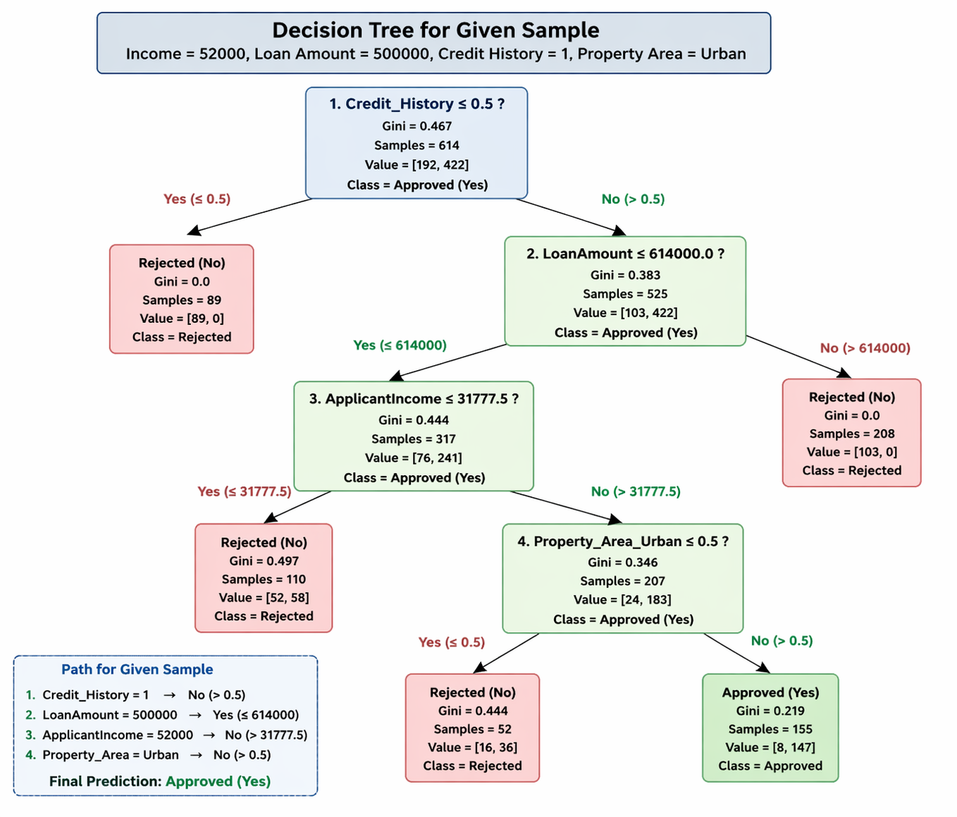
Graphs Representation
• Decision Tree Visualization: Shows the tree structure with nodes and branches, explaining how features like credit history, income, and loan amount lead to loan approval or rejection.
• Feature Importance Graph: Displays the importance of each feature (credit history, income, loan amount, property area) in influencing the loan approval prediction.
• Loan Approval vs Rejection Graph: Shows the distribution of approved and rejected loans using a bar chart or pie chart.
• Confusion Matrix: Represents correct and incorrect predictions of Decision Tree and SVM (true/false positives and negatives).
• Model Performance Graph: Compares Decision Tree and SVM using accuracy, precision, recall, and F1-score.
IMPLEMENTATION CODE AND DATASET USED
- Dataset Used – https://www.kaggle.com/datasets/architsharma01/loan-approval-prediction-dataset

Category | Description / Example
Dataset Name | Loan Approval Prediction Dataset
Domain | Banking and Finance
Objective | Classification (Approve / Reject Loan)
Data Source | Synthetic dataset (inspired from Kaggle Loan Dataset)
Number of Samples | 150
Data Type | Tabular
Instance Description | Each sample represents one loan applicant’s details
Features (Inputs) | Gender, Married, Dependents, Education, Self_Employed, ApplicantIncome, CoapplicantIncome, LoanAmount, Loan_Amount_Term, Credit_History, Property_Area
Feature Types | Numerical and Categorical
Target Variable | Loan_Status (Approved = Yes, Rejected = No)
Number of Classes | 2 (Approved, Rejected)
License | Academic Use (Synthetic Dataset)
Version | Version 1.0

PYTHON CODE
import streamlit as st
import pandas as pd
import numpy as np
import matplotlib.pyplot as plt
import seaborn as sns

from sklearn.model_selection import train_test_split
from sklearn.preprocessing import StandardScaler
from sklearn.tree import DecisionTreeClassifier, plot_tree
from sklearn.svm import SVC
from sklearn.metrics import (
accuracy_score, precision_score, recall_score, f1_score,
confusion_matrix, roc_curve, auc
)

# -------------------- Page Configuration --------------------
st.set_page_config(page_title="Loan Approval Prediction", layout="centered")

st.markdown("""
<style>
.main .block-container {
max-width: 900px;
padding-top: 2rem;
padding-bottom: 2rem;
}
</style>
""", unsafe_allow_html=True)

st.title("🏦 Loan Approval Prediction")
st.subheader("Comparison of Decision Tree and Support Vector Machine")

# -------------------- Load Dataset --------------------
@st.cache_data
def load_data():
# Update the path if necessary
return pd.read_csv("dataset/train.csv")

df = load_data()

# -------------------- Preprocessing Function --------------------
def preprocess_data(df):
df = df.copy()

# Drop Loan_ID if present (for Kaggle dataset compatibility)
df.drop("Loan_ID", axis=1, inplace=True, errors="ignore")

# Handle missing values
for col in ["Gender", "Married", "Dependents",
"Education", "Self_Employed", "Property_Area"]:
if col in df.columns:
df[col].fillna(df[col].mode()[0], inplace=True)

if "LoanAmount" in df.columns:
df["LoanAmount"].fillna(df["LoanAmount"].median(), inplace=True)

if "Loan_Amount_Term" in df.columns:
df["Loan_Amount_Term"].fillna(df["Loan_Amount_Term"].median(), inplace=True)

if "Credit_History" in df.columns:
df["Credit_History"].fillna(df["Credit_History"].mode()[0], inplace=True)

# Convert Dependents column
if "Dependents" in df.columns:
df["Dependents"] = df["Dependents"].replace("3+", 3).astype(int)

# Encode target variable
df["Loan_Status"] = df["Loan_Status"].map({"Y": 1, "N": 0})

# One-hot encoding for categorical variables
df = pd.get_dummies(
df,
columns=["Gender", "Married", "Education",
"Self_Employed", "Property_Area"],
drop_first=True
)

return df

# -------------------- Apply Preprocessing --------------------
df_processed = preprocess_data(df)

# -------------------- Feature and Target --------------------
X = df_processed.drop("Loan_Status", axis=1)
y = df_processed["Loan_Status"]

# -------------------- Feature Scaling --------------------
scaler = StandardScaler()
X_scaled = scaler.fit_transform(X)

# -------------------- Train-Test Split --------------------
X_train, X_test, y_train, y_test = train_test_split(
X_scaled, y, test_size=0.2, random_state=42, stratify=y
)

# -------------------- Train Models --------------------
@st.cache_resource
def train_models(X_train, y_train):
dt_model = DecisionTreeClassifier(max_depth=4, random_state=42)
svm_model = SVC(kernel='rbf', probability=True, random_state=42)

dt_model.fit(X_train, y_train)
svm_model.fit(X_train, y_train)

return dt_model, svm_model

dt_model, svm_model = train_models(X_train, y_train)

# -------------------- Evaluation Metrics --------------------
def compute_metrics(y_true, y_pred):
return {
"Accuracy": accuracy_score(y_true, y_pred),
"Precision": precision_score(y_true, y_pred),
"Recall": recall_score(y_true, y_pred),
"F1 Score": f1_score(y_true, y_pred)
}

dt_pred = dt_model.predict(X_test)
svm_pred = svm_model.predict(X_test)

dt_metrics = compute_metrics(y_test, dt_pred)
svm_metrics = compute_metrics(y_test, svm_pred)

# -------------------- User Input Form --------------------
st.header("📝 Enter Applicant Details")

with st.form("loan_form"):
col1, col2, col3 = st.columns(3)

with col1:
gender = st.selectbox("Gender", ["Male", "Female"])
married = st.selectbox("Married", ["Yes", "No"])
dependents = st.selectbox("Dependents", [0, 1, 2, 3])
education = st.selectbox("Education", ["Graduate", "Not Graduate"])

with col2:
self_emp = st.selectbox("Self Employed", ["Yes", "No"])
applicant_income = st.number_input("Applicant Income (₹)", min_value=0, value=50000)
coapplicant_income = st.number_input("Coapplicant Income (₹)", min_value=0, value=0)
loan_amount = st.number_input("Loan Amount (₹)", min_value=200000, max_value=1000000, value=500000)

with col3:
loan_term = st.selectbox("Loan Amount Term (Months)", [120, 180, 240, 300, 360])
credit_history = st.selectbox("Credit History", [1.0, 0.0])
property_area = st.selectbox("Property Area", ["Urban", "Semiurban", "Rural"])

submit_button = st.form_submit_button("🔍 Predict Loan Status")

# -------------------- Prediction and Dynamic Visualizations --------------------
if submit_button:

# Prepare input data
input_dict = {
"Dependents": dependents,
"ApplicantIncome": applicant_income,
"CoapplicantIncome": coapplicant_income,
"LoanAmount": loan_amount,
"Loan_Amount_Term": loan_term,
"Credit_History": credit_history,
"Gender_Male": 1 if gender == "Male" else 0,
"Married_Yes": 1 if married == "Yes" else 0,
"Education_Not Graduate": 1 if education == "Not Graduate" else 0,
"Self_Employed_Yes": 1 if self_emp == "Yes" else 0,
"Property_Area_Semiurban": 1 if property_area == "Semiurban" else 0,
"Property_Area_Urban": 1 if property_area == "Urban" else 0,
}

input_df = pd.DataFrame([input_dict])
input_df = input_df.reindex(columns=X.columns, fill_value=0)
input_scaled = scaler.transform(input_df)

# Predictions
dt_prediction = dt_model.predict(input_scaled)[0]
svm_prediction = svm_model.predict(input_scaled)[0]

dt_prob = dt_model.predict_proba(input_scaled)[0]
svm_prob = svm_model.predict_proba(input_scaled)[0]

# -------------------- Display Predictions --------------------
st.header("📊 Prediction Results")

col1, col2 = st.columns(2)
with col1:
st.metric(
"Decision Tree",
"Approved" if dt_prediction == 1 else "Rejected",
f"Confidence: {dt_prob[1]:.2%}"
)
with col2:
st.metric(
"Support Vector Machine",
"Approved" if svm_prediction == 1 else "Rejected",
f"Confidence: {svm_prob[1]:.2%}"
)

# -------------------- Dynamic Graphs --------------------
st.subheader("📊 Model Confidence Comparison")
fig1, ax1 = plt.subplots(figsize=(4, 3))
ax1.bar(["Decision Tree", "SVM"], [dt_prob[1], svm_prob[1]])
ax1.set_ylim(0, 1)
ax1.set_ylabel("Approval Probability")
st.pyplot(fig1)

st.subheader("📈 Approval vs Rejection Probability")
prob_df = pd.DataFrame({
"Outcome": ["Rejected", "Approved"],
"Decision Tree": dt_prob,
"SVM": svm_prob
})
fig2, ax2 = plt.subplots(figsize=(5, 3))
prob_df.set_index("Outcome").plot(kind="bar", ax=ax2)
ax2.set_ylabel("Probability")
st.pyplot(fig2)

# -------------------- Static Evaluation --------------------
st.subheader("📈 Model Performance Comparison")
metrics_df = pd.DataFrame({
"Decision Tree": dt_metrics,
"SVM": svm_metrics
})
fig3, ax3 = plt.subplots(figsize=(5, 3))
metrics_df.plot(kind="bar", ax=ax3)
ax3.set_ylim(0, 1)
st.pyplot(fig3)

# TXT Metrics
st.subheader("📄 Metrics Comparison")
metrics_text = f"""
Decision Tree:
Accuracy : {dt_metrics['Accuracy']:.4f}
Precision: {dt_metrics['Precision']:.4f}
Recall : {dt_metrics['Recall']:.4f}
F1 Score : {dt_metrics['F1 Score']:.4f}

Support Vector Machine:
Accuracy : {svm_metrics['Accuracy']:.4f}
Precision: {svm_metrics['Precision']:.4f}
Recall : {svm_metrics['Recall']:.4f}
F1 Score : {svm_metrics['F1 Score']:.4f}
"""
st.code(metrics_text, language="text")

# Confusion Matrices
st.subheader("📌 Confusion Matrices")
col1, col2 = st.columns(2)

with col1:
fig4, ax4 = plt.subplots(figsize=(4, 3))
sns.heatmap(confusion_matrix(y_test, dt_pred),
annot=True, fmt="d", cmap="Blues", ax=ax4)
ax4.set_title("Decision Tree")
st.pyplot(fig4)

with col2:
fig5, ax5 = plt.subplots(figsize=(4, 3))
sns.heatmap(confusion_matrix(y_test, svm_pred),
annot=True, fmt="d", cmap="Greens", ax=ax5)
ax5.set_title("SVM")
st.pyplot(fig5)

# Decision Tree Visualization
st.subheader("🌳 Decision Tree Visualization")
fig7, ax7 = plt.subplots(figsize=(8, 4))
plot_tree(
dt_model,
feature_names=X.columns,
class_names=["Rejected", "Approved"],
filled=True,
rounded=True,
fontsize=6,
ax=ax7
)
st.pyplot(fig7)

# Feature Importance
st.subheader("⭐ Feature Importance")
importance = pd.Series(
dt_model.feature_importances_,
index=X.columns
).sort_values(ascending=True)

fig8, ax8 = plt.subplots(figsize=(5, 3))
importance.plot(kind="barh", ax=ax8)
ax8.set_xlabel("Importance Score")
st.pyplot(fig8)

OUTPUT
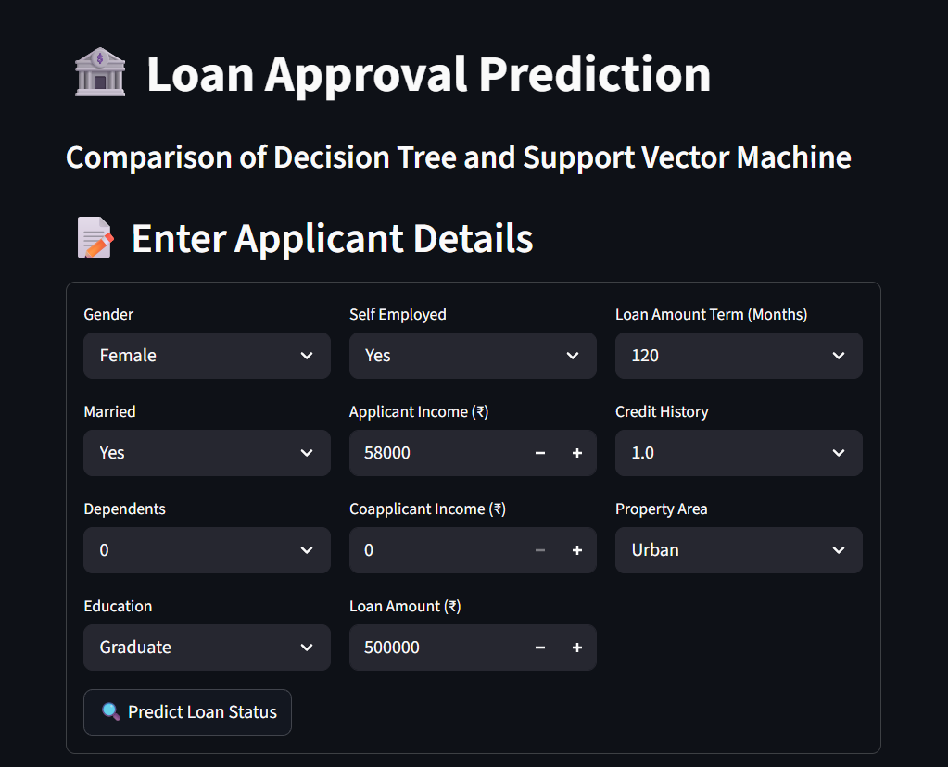
FIG 1: User Input Interface
- This screen displays the input form where the user enters applicant details such as gender, income, loan amount, credit history, and property area.
- The interface is designed using a structured layout with dropdowns and input fields for easy data entry.
- It ensures user-friendly interaction and validates inputs before prediction.

FIG 2: Prediction Result Output
- This screen shows the predicted loan status (Approved/Rejected) generated by Decision Tree and SVM models along with confidence scores.
- The results are displayed clearly for comparison between both models.
- It helps users understand how different algorithms respond to the same input data.

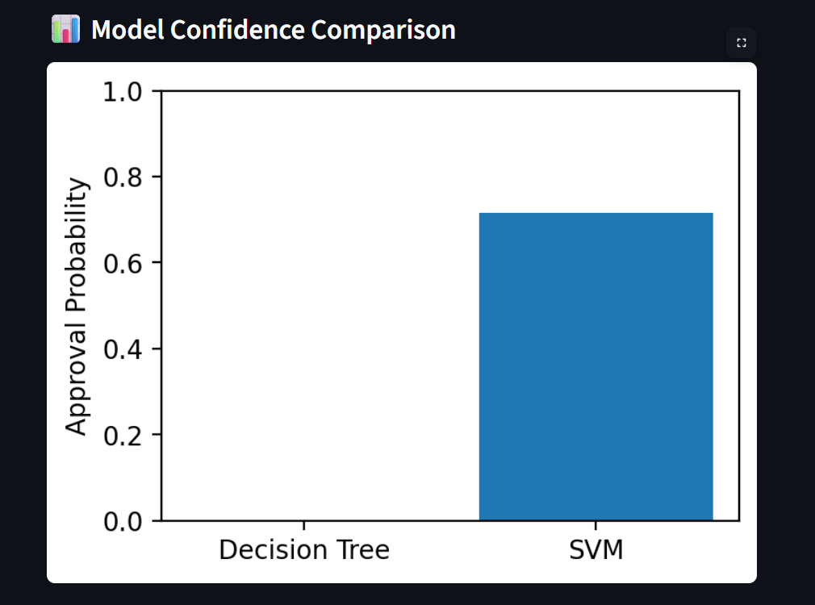
FIG 3: Model Confidence Comparison Graph
- This graph compares the confidence scores of Decision Tree and Support Vector Machine (SVM) for the given input.
- It shows the probability of loan approval predicted by each model. Higher confidence indicates stronger certainty in the prediction.
- This visualization helps in understanding which model is more confident about its decision for the same applicant data.
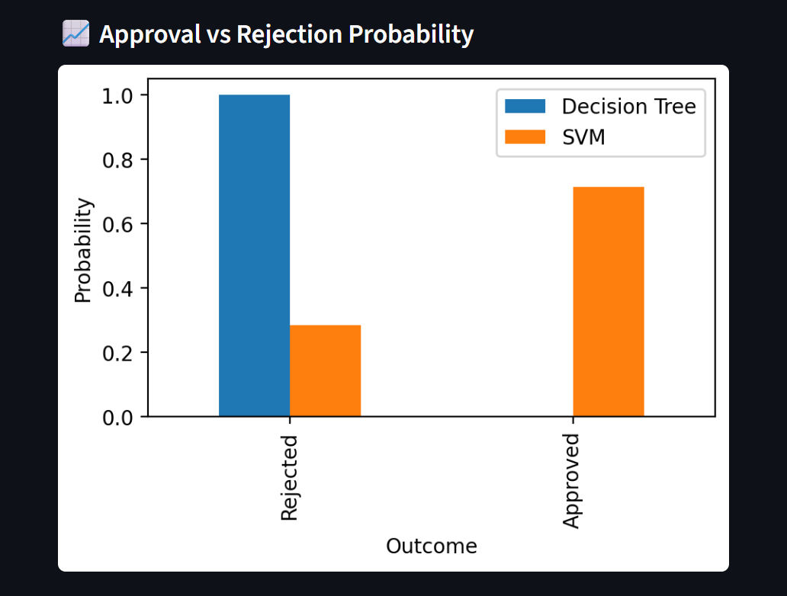
FIG 4: Loan Approval vs Rejection Graph
- This graph shows the distribution of approved and rejected loan applications.
- It helps in understanding whether the dataset is balanced or biased.
- This visualization also gives an overview of overall loan approval trends.

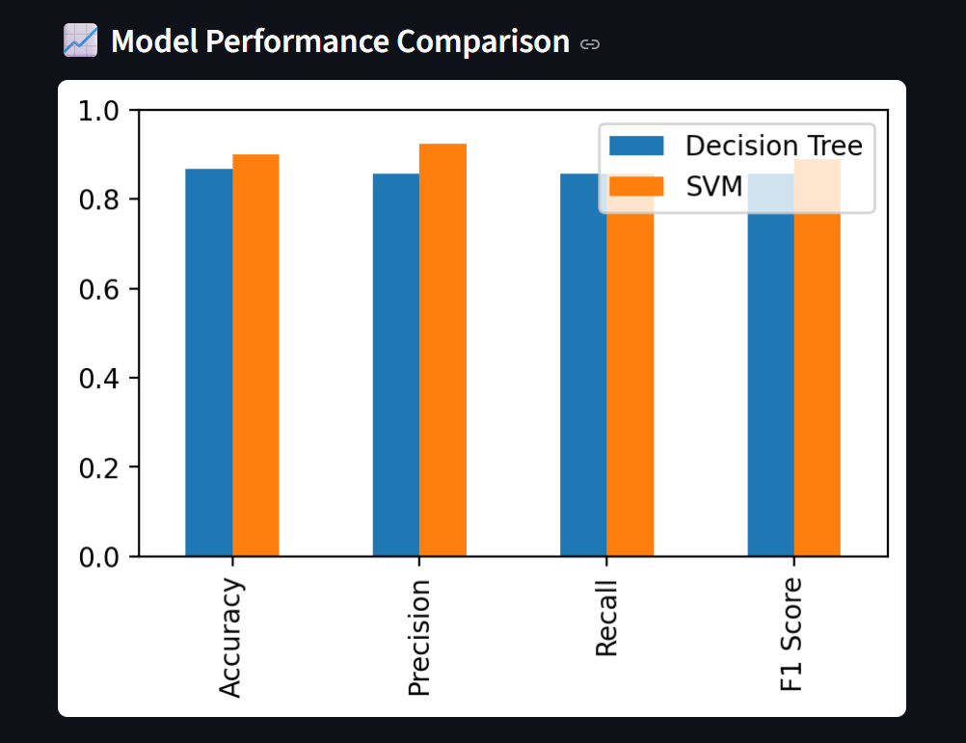
FIG 5: Model Performance Comparison Graph
- This bar chart compares Decision Tree and SVM using accuracy, precision, recall, and F1-score.
- It visually represents which model performs better across different evaluation metrics.
- This helps in selecting the most suitable model for loan prediction.
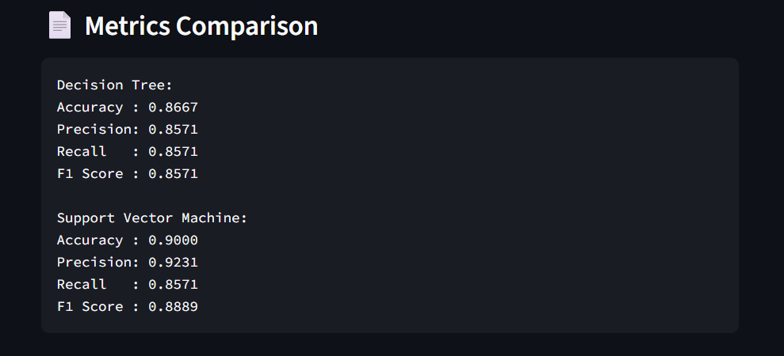
FIG 6: Metrics Comparison Output
- This screen displays the performance metrics of Decision Tree and Support Vector Machine (SVM) models in text format.
- It includes important evaluation measures such as accuracy, precision, recall, and F1-score for both models.
- The comparison helps in clearly understanding the effectiveness of each algorithm.
- It also allows users to identify which model performs better in predicting loan approval based on different evaluation criteria.

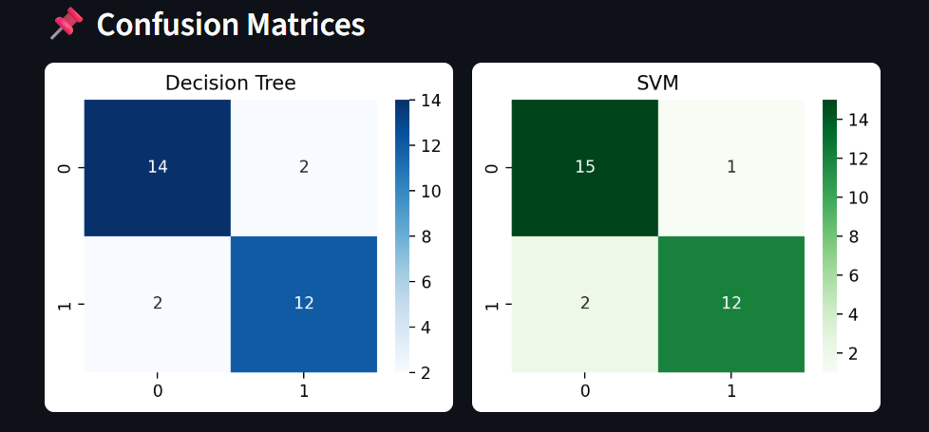
FIG 7: Confusion Matrix
- This matrix shows the performance of the models by displaying correct and incorrect predictions (true positives, true negatives, false positives, false negatives).
- It provides a detailed view of how well the model classifies loan approvals and rejections.
- This helps in identifying errors made by the model.
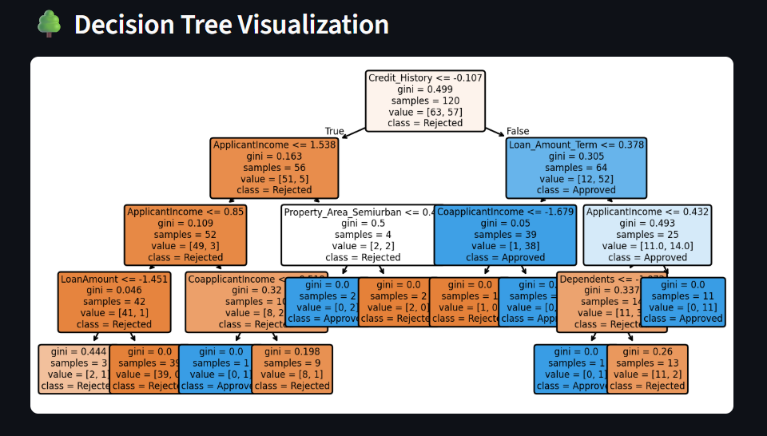
FIG 8: Decision Tree Visualization
- This graph represents the structure of the Decision Tree, showing how different features lead to the final prediction.
- Each node displays a condition, and branches represent possible outcomes.
- It helps in understanding the decision-making process and the logic followed by the model.

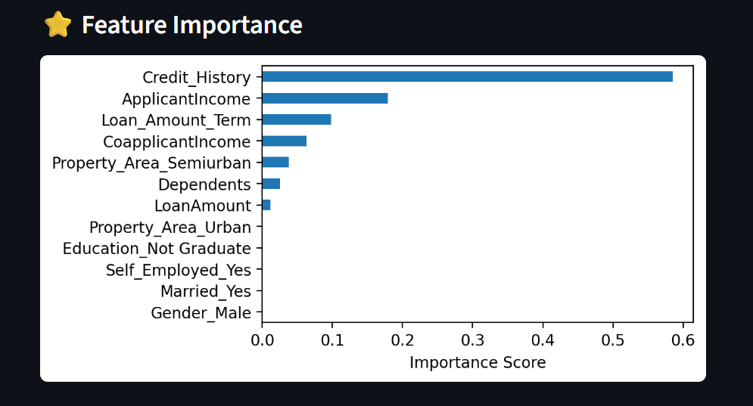
FIG 9: Feature Importance Graph
- This chart highlights the importance of features such as credit history, income, and loan amount in influencing loan approval.
- Features with higher importance have a greater impact on the model’s decision.
- This visualization helps in identifying key factors affecting loan approval.
RESULTS AND FUTURE ENHANCEMENT
Results
The Loan Approval Prediction System was successfully developed using Decision Tree and Support Vector Machine (SVM) algorithms to classify loan applications as approved or rejected based on applicant details such as income, loan amount, credit history, and property area. The models effectively learn patterns from the dataset and provide predictions along with confidence scores. The evaluation metrics such as accuracy, precision, recall, and F1-score indicate that both models perform efficiently, with SVM showing slightly better accuracy in handling complex data patterns, while Decision Tree provides clear interpretability. Additionally, the visualization dashboard, including graphs like feature importance, confusion matrix, and model comparison, helps in understanding how different features influence loan approval decisions.
Comparison with Existing Methods
Traditional loan approval processes are mostly manual and depend on human judgment, which can be time-consuming and prone to bias or inconsistency. Rule-based systems rely on fixed conditions and lack flexibility to handle diverse applicant profiles. Basic machine learning models like Logistic Regression may not effectively capture complex relationships between multiple features. In comparison, the Decision Tree algorithm provides a clear and interpretable decision-making process, while SVM offers higher accuracy by identifying optimal boundaries between classes. Together, these models provide a balanced approach with both transparency and performance, making the system more reliable than traditional methods.
Future Enhancements
In the future, the system can be enhanced by using larger and more realistic datasets to improve prediction accuracy and generalization. Additional features such as credit score, employment history, loan repayment history, and financial liabilities can be incorporated to make predictions more accurate and practical. Advanced machine learning algorithms like Random Forest, Gradient Boosting, or Neural Networks can be implemented to further improve performance. The system can also be extended into a real-time application by integrating it with banking systems or financial platforms for automated loan processing. Furthermore, deploying the model as a web or mobile application with user authentication and database support would make it more accessible and useful in real-world scenarios.

Git Hub Link of the project along with the report | https://github.com/harinik1510/ML_Mini_Project

REFERENCES
- Hands-On Machine Learning with Scikit-Learn, Keras, and TensorFlow — A comprehensive guide covering machine learning concepts and practical implementation using Python libraries.
- Pattern Recognition and Machine Learning — Provides theoretical foundations of machine learning algorithms and classification techniques.
- Introduction to Machine Learning with Python — Focuses on applying machine learning algorithms such as Decision Trees and SVM using Python.
- Kaggle — Loan Prediction Dataset:
https://www.kaggle.com/datasets/altruistdelhite04/loan-prediction-problem-dataset
- Scikit-learn Documentation — Official documentation for implementation of Decision Tree, SVM, and evaluation metrics:
https://scikit-learn.org/stable/

