PageSpeed Insights after optimizations

http://0b024911.ngrok.io/

MOBILE:

## 95 / 100Speed

### Consider Fixing:

#### Leverage browser caching

Show how to fix

#### Enable compression

Show how to fix

### 8 Passed Rules

Show details

## 100 / 100User Experience

### Congratulations! No issues found.

#### Avoid app install interstitials that hide content

Your page does not appear to have any app install interstitials that hide a significant amount of content. Learn more about the importance of [avoiding the use of app install interstitials](https://developers.google.com/webmasters/mobile-sites/mobile-seo/common-mistakes/avoid-interstitials).

#### Avoid plugins

Your page does not appear to use plugins, which would prevent content from being usable on many platforms. Learn more about the importance of [avoiding plugins](https://developers.google.com/speed/docs/insights/AvoidPlugins).

#### Configure the viewport

Your page specifies a viewport matching the device's size, which allows it to render properly on all devices. Learn more about [configuring viewports](https://developers.google.com/speed/docs/insights/ConfigureViewport).

#### Size content to viewport

The contents of your page fit within the viewport. Learn more about [sizing content to the viewport](https://developers.google.com/speed/docs/insights/SizeContentToViewport).

#### Size tap targets appropriately

All of your page's links/buttons are large enough for a user to easily tap on a touchscreen. Learn more about [sizing tap targets appropriately](https://developers.google.com/speed/docs/insights/SizeTapTargetsAppropriately).

#### Use legible font sizes

The text on your page is legible. Learn more about [using legible font sizes](https://developers.google.com/speed/docs/insights/UseLegibleFontSizes).

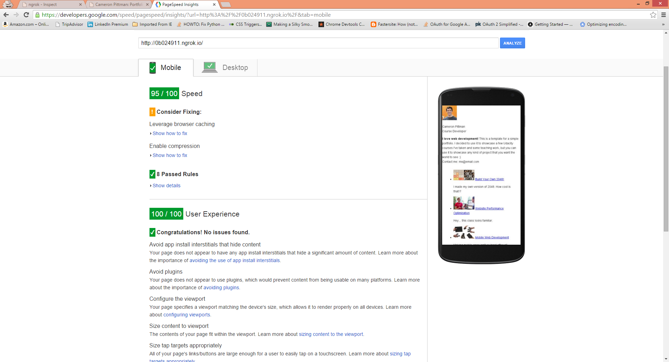

DESKTOP

## 96 / 100Suggestions Summary

### Consider Fixing:

#### Leverage browser caching

Show how to fix

#### Enable compression

Show how to fix

### 8 Passed Rules

Show details

