

PROJECT REPORT
Streamlining IT Procurement:
Automating Standard Laptop Orders with Flow Designer
A ServiceNow Flow Designer automation that creates a Catalog Task and assigns it to the Hardware team as soon as a Standard Laptop request is raised and approved.
Platform | ServiceNow (Now Platform)
Tool | Flow Designer (Process Automation)
Catalog Item | Standard Laptop (Service Catalog > Hardware)
Team ID | SWTID-2026-4357
Document type | Consolidated phase-wise project report (Ideation to Documentation)

Contents
1 | Introduction | 1.1 Project Overview · 1.2 Purpose
2 | Ideation Phase | 2.1 Problem Statement · 2.2 Empathy Map Canvas · 2.3 Brainstorming
3 | Requirement Analysis | 3.1 Customer Journey Map · 3.2 Solution Requirements · 3.3 Data Flow Diagram & User Stories · 3.4 Technology Stack
4 | Project Design | 4.1 Problem–Solution Fit · 4.2 Proposed Solution · 4.3 Solution Architecture
5 | Project Planning & Scheduling | 5.1 Project Planning (Backlog, Sprints, Velocity, Burndown)
6 | Functional and Performance Testing | 6.1 Performance Testing (UAT plan, test cases, bug tracking) · 6.2 UAT Execution Report
7 | Results | 7.1 Output Screenshots (Milestones 1–3 with procedure)
8 | Advantages & Disadvantages
9 | Conclusion
10 | Future Scope
11 | Appendix | Setup prerequisites, record references, configuration summary, links

1. Introduction

1.1 Project Overview
IT procurement teams regularly order standard laptops for employees. Every standard laptop needs to be configured when it arrives, but that follow-up step has been handled manually, so it is easy to forget or delay. The result is longer waiting times for users and uneven workload for the IT department.
This project automates that follow-up using ServiceNow Flow Designer. A flow named “Standard Laptop task” is triggered from the Service Catalog. For every requested item it creates a Catalog Task with the short description “Laptop needs to Configured”, assigns it to the Hardware assignment group and records the approval value as Approved. The flow is then attached to the Standard Laptop catalog item through its Process Engine tab, so every new order is handled the same way without manual intervention.
Item | Configuration used in this project
Flow name | Standard Laptop task (Application: Global, Run as: System User)
Trigger | Service Catalog
Action | Create Catalog Task (ServiceNow Core) on the Requested Item record
Task values | Short description and Description: Laptop needs to Configured; Assignment group: Hardware; Approval: Approved
Catalog item | Standard Laptop (Category: Hardware) with Process Engine set to the flow
Tested with | REQ0010001 → RITM0010001 → SCTASK0010001

1.2 Purpose
The purpose of the project is to implement an automated workflow using Flow Designer that supports the procurement and configuration of standard laptops. By building automation into the process, the project aims to:
- Create a seamless experience for users requesting standard laptops by ensuring timely configuration.
- Reduce manual intervention and potential errors in the procurement process.
- Improve resource utilisation within the IT department by optimising task allocation.
- Enhance overall efficiency and productivity in IT procurement operations.

2. Ideation Phase

2.1 Problem Statement
Ideation Phase
Define the Problem Statements
Date | 30th September 2026
Team ID | SWTID-2026-4357
Project Name | Streamlining IT Procurement: Automating Standard Laptop Orders with Flow Designer
Maximum Marks | 2 Marks

Problem description
The current IT procurement process lacks efficiency and automation, resulting in delays and manual overhead, particularly in handling standard laptop orders. Requests for standard laptops often require configuration, but this step is prone to oversight or delay, leading to frustration among users and inefficient resource allocation within the IT department.

Customer Problem Statement
The table below uses the Customer Problem Statement template (I am / I’m trying to / But / Because / Which makes me feel) to describe the problem from each stakeholder’s point of view.
Problem Statement (PS) | I am (Customer) | I’m trying to | But | Because | Which makes me feel
PS-1 | A member of the IT procurement team | order standard laptops so that they are configured as soon as they arrive | the configuration task is not created or assigned automatically | the hand-off to the hardware team depends on manual follow-up that is easy to miss | Frustrated and concerned about delays and errors
PS-2 | A hardware team member | configure each new laptop promptly | I am not always told that a laptop needs configuring | tasks are raised and routed by hand, so the right group is not always notified | Overloaded and unsure what to work on next
PS-3 | An employee waiting for a new laptop | start work on my new device | it takes longer than expected to be ready | the configuration step is delayed after the laptop arrives | Impatient and less productive

2.2 Empathy Map Canvas
Ideation Phase
Empathize & Discover
Date | 30th September 2026
Team ID | SWTID-2026-4357
Project Name | Streamlining IT Procurement: Automating Standard Laptop Orders with Flow Designer
Maximum Marks | 4 Marks

An empathy map captures what a user says, thinks, does and feels, which helps the team see the problem from the user’s perspective. The map below is for the primary user: a member of the IT procurement team who orders standard laptops.
User: IT procurement team member
SAYS  • “Has the hardware team been told about this laptop?”  • “I need laptops configured as soon as they arrive.”  • “Why do I have to chase this task every time?” | THINKS  • Manual follow-up is wasting time.  • A missed task will delay the user.  • This should happen automatically after the order.
DOES  • Places standard laptop orders through the catalog.  • Checks the request and approval status.  • Raises the configuration task and contacts the hardware team by hand. | FEELS  • Frustrated by repetitive manual steps.  • Anxious about delays and user complaints.  • Relieved when work is handled without chasing.

PAINS | GAINS
Configuration step is forgotten or delayed.  Manual hand-off causes errors.  Hardware team workload is unplanned. | Task is created and assigned automatically.  Laptops are configured promptly on arrival.  Less manual effort and a better experience for users.

2.3 Brainstorming
Ideation Phase
Brainstorm & Idea Prioritization
Date | 30th September 2026
Team ID | SWTID-2026-4357
Project Name | Streamlining IT Procurement: Automating Standard Laptop Orders with Flow Designer
Maximum Marks | 4 Marks

Step 1: Team gathering, collaboration and selection of the problem statement
The team agreed to work on PS-1: standard laptop orders need a configuration task, but creating and assigning that task is manual and easily missed. The goal is to remove the manual hand-off to the hardware team.

Step 2: Brainstorm, idea listing and grouping
Group | Ideas listed
Task automation | Create the configuration task automatically when a standard laptop is requested.  Assign the task directly to the Hardware group.  Pre-fill the short description so every task is worded the same way.
Approval handling | Create the task with the approval value recorded as Approved.  Let the approver act from the Approvers tab on the request.
Tooling options | Flow Designer flow attached to the catalog item.  Legacy workflow or execution plan.  Manual checklist or email reminder to the hardware team.
Visibility | Show the task in the Catalog Tasks tab of the Requested Item.  Let the requester follow the order through the REQ number.

Step 3: Idea prioritization
Idea | Impact | Effort | Decision
Flow Designer flow that creates and assigns the Catalog Task | High | Low | Selected (Priority 1)
Assign the flow through the Process Engine of the Standard Laptop item | High | Low | Selected (Priority 2)
Pre-filled short description and description on the task | Medium | Low | Selected (Priority 3)
Legacy workflow / execution plan | Medium | Medium | Not selected (Flow Designer is the current approach)
Manual checklist or email reminder | Low | Low | Not selected (does not remove manual effort)

3. Requirement Analysis

3.1 Customer Journey Map
Project Design Phase-II
Customer Journey Map: Ordering a Standard Laptop
Date: 31 January 2025 | Team ID: [Team ID – to be added] | Maximum Marks: 4 Marks
 | Identify need | Browse catalog | Place order | Approval | Task creation (automated) | Configure & close
Steps | IT procurement team needs a standard laptop for an employee. | Opens Service Catalog > Hardware and selects Standard Laptop. | Reviews specs and clicks Order Now. | Approver opens the request, goes to Approvers and selects Approve. | The “Standard Laptop task” flow runs and creates the Catalog Task. | Hardware team opens the task and configures the laptop.
Interactions | Service Catalog home | Hardware category page | Item page, Order Status page (REQ number) | Request form, Approvers tab | Requested Item (RITM), Catalog Tasks tab | Catalog Task form (SCTASK)
Goals | Get the right device ordered quickly. | Find the correct standard model. | Submit the request without extra steps. | Approval recorded quickly. | Task appears without anyone raising it. | Laptop ready soon after arrival.
Positive moments | Single catalog entry for standard laptops. | Specs and price are shown on the item page. | Immediate confirmation with a request number. | Simple right-click Approve action. | Task has short description and Hardware group already set. | Clear task, nothing to chase.
Negative moments (before automation) | Unclear who must configure the device. | – | – | Waiting on approval. | Task raised by hand, can be missed. | Configuration starts late.
Opportunities | Standardise the item for repeat orders. | Keep catalog content current. | Add notifications to the requester. | Add approval reminders. | Gate task creation on approval; add notifications. | Track completion time and report on it.

3.2 Solution Requirements
Project Design Phase-II
Solution Requirements (Functional & Non-functional)
Date | 30th September 2026
Team ID | SWTID-2026-4357
Project Name | Streamlining IT Procurement: Automating Standard Laptop Orders with Flow Designer
Maximum Marks | 4 Marks

Functional Requirements
Following are the functional requirements of the proposed solution.
FR No. | Functional Requirement (Epic) | Sub Requirement (Story / Sub-Task)
FR-1 | Flow Creation | Create a flow named “Standard Laptop task” in Flow Designer  Application set to Global; Run as System User
FR-2 | Trigger Configuration | Add the Service Catalog trigger to the flow
FR-3 | Catalog Task Action | Add the Create Catalog Task action  Map the trigger’s Requested Item record to the Requested Item field (table auto-populates as Catalog Task [sc_task])
FR-4 | Task Field Population | Short description: Laptop needs to Configured  Description: Laptop needs to Configured  Assignment group: Hardware  Approval: Approved
FR-5 | Flow Activation & Assignment | Save and activate the flow  Attach the flow to the Standard Laptop catalog item (Process Engine tab) and save
FR-6 | Ordering & Approval | Order the Standard Laptop from Service Catalog > Hardware using Order Now  Approver approves the request from the Approvers tab
FR-7 | Verification | Open the Requested Item and check the Catalog Tasks tab  Open the Catalog Task and confirm short description and assignment group

Non-functional Requirements
Following are the non-functional requirements of the proposed solution.
NFR No. | Non-Functional Requirement | Description
NFR-1 | Usability | Requesters use the standard Service Catalog and Order Now. The task text is fixed and clear, so the hardware team sees the same wording every time. No additional training is needed for requesters.
NFR-2 | Security | The flow runs as System User, so task creation does not depend on the requester’s roles. Approval is recorded through the platform’s approval records and only the assigned approver can approve.
NFR-3 | Reliability | The task is generated by the flow engine for every Standard Laptop request, removing dependence on manual follow-up. Flow executions can be reviewed in Flow Designer (Executions).
NFR-4 | Performance | The flow has a single action, so each execution is lightweight. In the tested run the catalog task was created and listed on the Requested Item.
NFR-5 | Availability | The solution runs on the ServiceNow instance, so it is available whenever the instance is available. It needs no extra servers or integrations.
NFR-6 | Scalability | The same pattern (trigger, Create Catalog Task, assignment group) can be reused for other catalog items. Additional actions can be added to the flow without changing the catalog item.

3.3 Data Flow Diagram & User Stories
Project Design Phase-II
Data Flow Diagram & User Stories
Date | 30th September 2026
Team ID | SWTID-2026-4357
Project Name | Streamlining IT Procurement: Automating Standard Laptop Orders with Flow Designer
Maximum Marks | 4 Marks

Data Flow Diagram
The diagram shows how data moves through the solution. The requester’s order creates the Request and Requested Item records (D1). The approver’s decision is stored as an approval record (D2). The Requested Item triggers the Standard Laptop task flow, whose Create Catalog Task action writes the task to the Catalog Task table (D3) and routes it to the Hardware team.
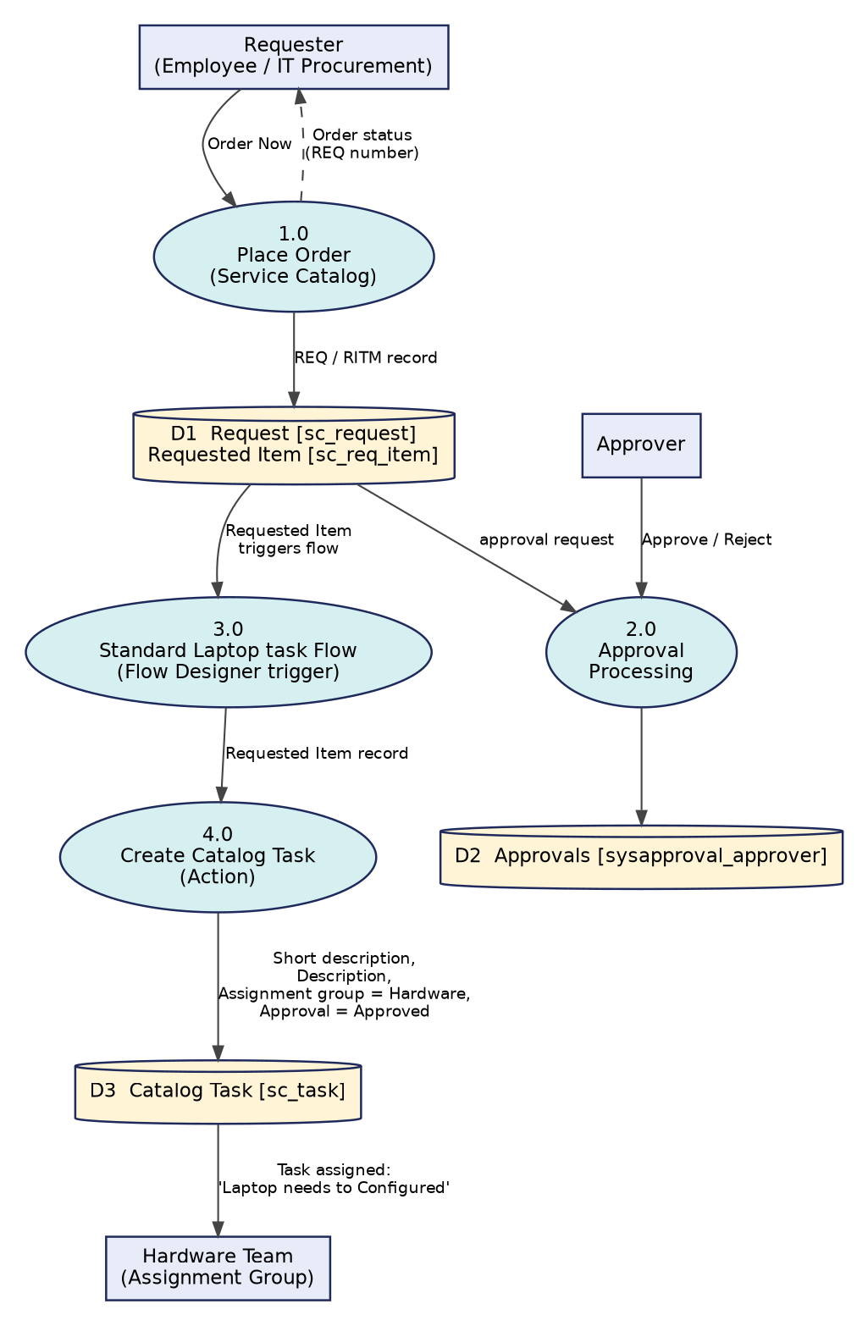
Figure 1: Data flow diagram for the Standard Laptop task automation

User Stories
The user stories below list the work for the product. The same story numbers (USN) are used in the project plan in Section 5.
User Type | Functional Requirement (Epic) | User Story No. | User Story / Task | Acceptance criteria | Priority | Release
Administrator / Flow developer | Flow Creation | USN-1 | As an administrator, I can create a Global flow named “Standard Laptop task” running as System User, so that the automation has the access it needs. | Flow is listed in Flow Designer with Application = Global. | High | Sprint-1
 |  | USN-2 | As an administrator, I can add the Service Catalog trigger, so that the flow starts when a catalog request is placed. | Trigger shows “Service Catalog” and is saved with Done. | High | Sprint-1
 | Catalog Task Automation | USN-3 | As an administrator, I can add the Create Catalog Task action using the Requested Item record, so that a task is generated for each requested item. | Table is auto-populated as Catalog Task [sc_task]. | High | Sprint-1
 |  | USN-4 | As an administrator, I can set the short description, description, assignment group (Hardware) and approval (Approved) on the task. | Created task shows the configured values. | High | Sprint-1
 |  | USN-5 | As an administrator, I can save and activate the flow. | Flow status shows Active. | High | Sprint-1
 | Flow Assignment | USN-6 | As an administrator, I can attach the flow to the Standard Laptop catalog item through its Process Engine tab. | Flow field shows the flow; Workflow and Execution Plan are empty. | High | Sprint-1
Requester / IT procurement team member | Ordering & Approval | USN-7 | As a requester, I can order the Standard Laptop from Service Catalog > Hardware using Order Now. | Order Status page shows a request number (REQ). | High | Sprint-2
Approver |  | USN-8 | As an approver, I can approve the request from the Approvers tab of the request. | Approval state changes to Approved. | High | Sprint-2
Hardware team member | Fulfilment & Verification | USN-9 | As a hardware team member, I can see the configuration task in the Catalog Tasks tab of the Requested Item, assigned to my group. | SCTASK is listed with Assignment group = Hardware. | High | Sprint-2
IT procurement team member |  | USN-10 | As an IT procurement team member, I can open the catalog task and check its short description and assigned group. | Task shows “Laptop needs to Configured” and Hardware. | Medium | Sprint-2
Project team | Testing & Documentation | USN-11 | As the project team, we can run user acceptance testing and record the results. | Test cases and results are documented. | Medium | Sprint-2

3.4 Technology Stack
Project Design Phase-II
Technology Stack (Architecture & Stack)
Date | 30th September 2026
Team ID | SWTID-2026-4357
Project Name | Streamlining IT Procurement: Automating Standard Laptop Orders with Flow Designer
Maximum Marks | 4 Marks

The technical architecture is shown in Section 4.3 (Figure 2). Table 1 and Table 2 give the components and application characteristics.

Table-1: Components & Technologies
S.No. | Component | Description | Technology
1 | User Interface | How users interact with the application | ServiceNow Service Catalog (Hardware category, Standard Laptop item, Order Now); Request and Requested Item forms
2 | Application Logic-1 | Automation that runs when a request is placed | Flow Designer flow “Standard Laptop task” with Service Catalog trigger
3 | Application Logic-2 | Generates the work item for the hardware team | Create Catalog Task action (ServiceNow Core spoke)
4 | Application Logic-3 | Approval of the request | Platform approval records, approved from the Approvers tab of the request
5 | Database | Tables used to store the data | sc_request, sc_req_item, sysapproval_approver, sc_task (ServiceNow platform tables)
6 | Cloud Database | Database service on cloud | Database of the hosted ServiceNow instance
7 | File Storage | File storage requirements | Not required
8 | External API-1 | External API used in the application | Not used
9 | External API-2 | External API used in the application | Not used
10 | Machine Learning Model | Purpose of machine learning model | Not used
11 | Infrastructure (Server / Cloud) | Application deployment | ServiceNow cloud instance; flow scope: Global

Table-2: Application Characteristics
S.No. | Characteristics | Description | Technology
1 | Open-Source Frameworks | None. The solution is built with the low-code tools of the ServiceNow platform. | Flow Designer, Service Catalog
2 | Security Implementations | Flow runs as System User; approvals are recorded against named approvers; access follows platform roles and ACLs. | ServiceNow roles and ACLs, approval records
3 | Scalable Architecture | Trigger plus action pattern that can be reused for other catalog items. | Flow Designer, Process Engine
4 | Availability | Runs wherever the ServiceNow instance runs; no separate servers to maintain. | ServiceNow cloud instance
5 | Performance | Single-action flow with a small payload (one requested item per run). | Flow Designer execution engine

4. Project Design

4.1 Problem–Solution Fit
Project Design Phase
Problem – Solution Fit Template
Date | 30th September 2026
Team ID | SWTID-2026-4357
Project Name | Streamlining IT Procurement: Automating Standard Laptop Orders with Flow Designer
Maximum Marks | 2 Marks

Problem–solution fit means the team has found a real problem for the customer and the solution actually solves it. The canvas below applies the template to the standard laptop ordering problem.
1. CUSTOMER SEGMENT(S)  • IT procurement team members who order standard laptops  • Hardware team who configure laptops  • Employees receiving the laptops | 6. CUSTOMER CONSTRAINTS  • Hardware team’s time and availability  • Laptop must arrive before configuration can start  • Existing Service Catalog and approval process must be kept | 5. AVAILABLE SOLUTIONS  • Manual task creation and email follow-up  • Legacy workflow / execution plan  • Pros / cons: manual works but is slow and error-prone
2. JOBS-TO-BE-DONE / PROBLEMS  • Get each standard laptop configured promptly on arrival  • Make sure the hardware team always has a task to act on | 9. PROBLEM ROOT CAUSE  • Configuration task is raised by hand, so it can be missed or delayed  • No link between the catalog item and the hardware team’s work queue | 7. BEHAVIOUR  • Orders laptops through the catalog  • Checks approvals  • Follows up manually with the hardware team
3. TRIGGERS  • A standard laptop request is placed in the Service Catalog  • Request approved by the approver | 10. YOUR SOLUTION  • Flow Designer flow “Standard Laptop task” attached to the Standard Laptop item  • Creates a Catalog Task with short description, Hardware assignment group and approval value | 8. CHANNELS of BEHAVIOUR  • Online: Service Catalog, Request / RITM forms, Approvers tab  • Offline: Verbal or email follow-up with hardware team (to be reduced)
4. EMOTIONS: BEFORE / AFTER
• Before: frustrated, anxious about delays
• After: confident, relieved, no chasing

4.2 Proposed Solution
Project Design Phase
Proposed Solution Template
Date | 30th September 2026
Team ID | SWTID-2026-4357
Project Name | Streamlining IT Procurement: Automating Standard Laptop Orders with Flow Designer
Maximum Marks | 2 Marks

S.No. | Parameter | Description
1. | Problem Statement (Problem to be solved) | Standard laptop orders need a configuration task, but the task is created and assigned by hand. This causes delays, oversights and uneven use of the IT department’s time.
2. | Idea / Solution description | A Flow Designer flow (“Standard Laptop task”) with a Service Catalog trigger and a Create Catalog Task action. It creates a task with the short description “Laptop needs to Configured”, assigns it to the Hardware group, and is attached to the Standard Laptop catalog item through its Process Engine.
3. | Novelty / Uniqueness | Fulfilment is tied directly to the catalog item, so the task is created for every order with no extra steps for the requester or procurement team. It is built with low-code configuration only.
4. | Social Impact / Customer Satisfaction | Users wait less for a ready laptop, procurement staff spend less time chasing tasks, and the hardware team gets a clear work queue.
5. | Business Model (Revenue Model) | Internal efficiency solution rather than a revenue product. The value is saved effort, fewer errors and faster onboarding of devices, using licences the organisation already has.
6. | Scalability of the Solution | The same flow pattern can be copied to other catalog items (for example monitors or peripherals) by changing the task text and assignment group.

4.3 Solution Architecture
Project Design Phase
Solution Architecture
Date | 30th September 2026
Team ID | SWTID-2026-4357
Project Name | Streamlining IT Procurement: Automating Standard Laptop Orders with Flow Designer
Maximum Marks | 4 Marks

Solution architecture bridges the gap between the business problem and the technology solution. For this project it:
- Uses the best-fit tool (Flow Designer) to solve the business problem of delayed laptop configuration.
- Describes the structure of the solution for stakeholders: catalog item, flow, action and task table.
- Defines the features and development phases (flow, flow assignment, ordering and approval).
- Provides the specification used to deliver and test the solution.

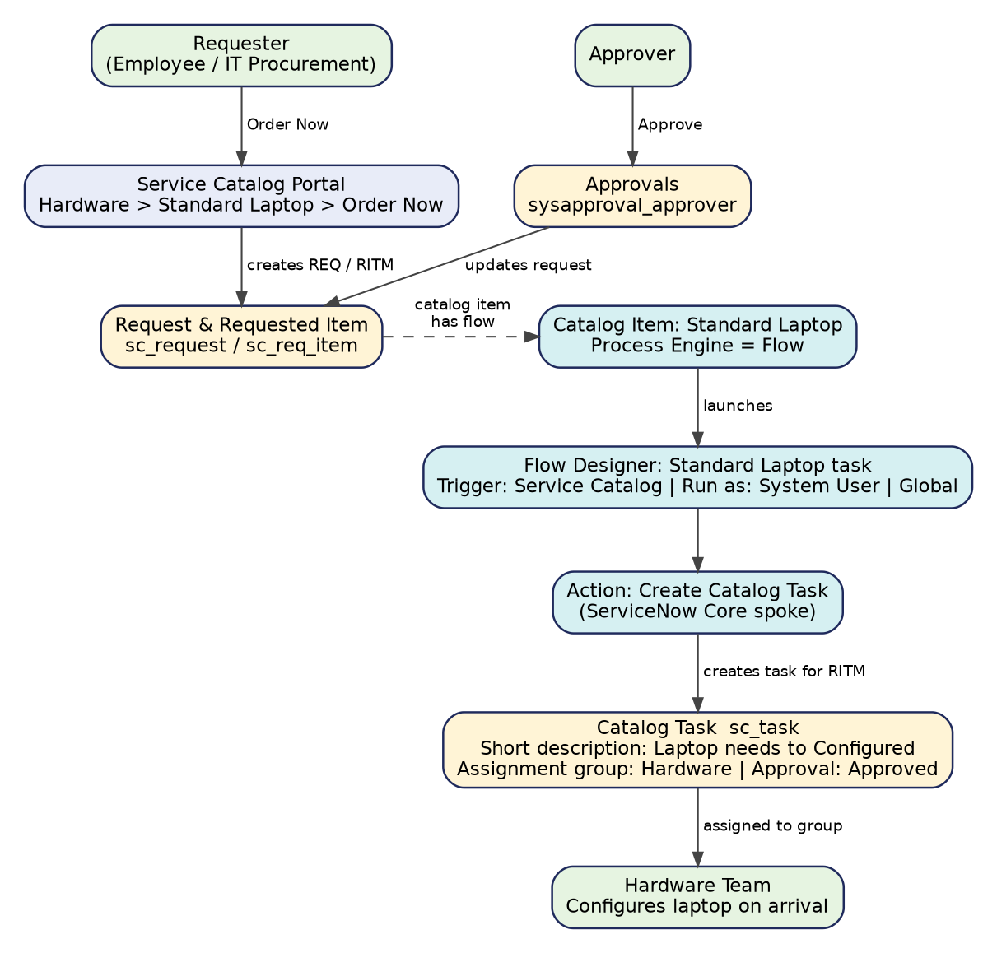
Figure 2: Solution architecture and data flow for the Standard Laptop task automation

How the architecture works
- The requester orders the Standard Laptop from Service Catalog > Hardware using Order Now.
- ServiceNow creates the Request (REQ) and Requested Item (RITM) records and an approval for the approver.
- The Standard Laptop catalog item has its Process Engine set to the flow Standard Laptop task.
- The flow’s Service Catalog trigger passes the Requested Item to the Create Catalog Task action.
- The action creates a Catalog Task (SCTASK) with the configured short description, description, assignment group (Hardware) and approval (Approved).
- The Hardware team sees the task in its queue and the task is visible in the Catalog Tasks tab of the Requested Item.

5. Project Planning & Scheduling

5.1 Project Planning
Project Planning Phase
Project Planning Template (Product Backlog, Sprint Planning, Stories, Story Points)
Date | 30th September 2026
Team ID | SWTID-2026-4357
Project Name | Streamlining IT Procurement: Automating Standard Laptop Orders with Flow Designer
Maximum Marks | 5 Marks

Planning terms used. A sprint is a fixed period in which the team completes a set of tasks. An epic is a large piece of work that is split into smaller stories. Story points show the effort of a story using the values 1 (very easy), 2 (normal), 3 (moderate) and 5 (difficult).

Product Backlog, Sprint Schedule, and Estimation (4 Marks)
Sprint | Functional Requirement (Epic) | User Story No. | User Story / Task | Story Points | Priority | Team Members
Sprint-1 | Flow Creation | USN-1 | As an administrator, I can create a Global flow named “Standard Laptop task” running as System User. | 2 | High | Admin / Developer
Sprint-1 |  | USN-2 | As an administrator, I can add the Service Catalog trigger to the flow. | 1 | High | Admin / Developer
Sprint-1 | Catalog Task Automation | USN-3 | As an administrator, I can add the Create Catalog Task action using the Requested Item record. | 3 | High | Admin / Developer
Sprint-1 |  | USN-4 | As an administrator, I can set short description, description, assignment group (Hardware) and approval (Approved). | 3 | High | Admin / Developer
Sprint-1 |  | USN-5 | As an administrator, I can save and activate the flow. | 1 | High | Admin / Developer
Sprint-1 | Flow Assignment | USN-6 | As an administrator, I can attach the flow to the Standard Laptop catalog item (Process Engine). | 2 | High | Admin / Developer
Sprint-2 | Ordering & Approval | USN-7 | As a requester, I can order the Standard Laptop from the Service Catalog using Order Now. | 2 | High | Requester / Tester
Sprint-2 |  | USN-8 | As an approver, I can approve the request from the Approvers tab. | 2 | High | Approver
Sprint-2 | Fulfilment & Verification | USN-9 | As a hardware team member, I can see the catalog task assigned to Hardware in the Requested Item. | 3 | High | Hardware team
Sprint-2 |  | USN-10 | As an IT procurement team member, I can open the catalog task and check the short description and assignment group. | 2 | Medium | Tester
Sprint-2 | Testing & Documentation | USN-11 | As the project team, we can run UAT and record results. | 5 | Medium | Project team

Story point totals. Sprint-1 = 2 + 1 + 3 + 3 + 1 + 2 = 12. Sprint-2 = 2 + 2 + 3 + 2 + 5 = 14. Total = 26 story points.

Project Tracker, Velocity & Burndown Chart (4 Marks)
Sprint dates are planned dates and can be changed to match the team’s calendar.
Sprint | Total Story Points | Duration | Sprint Start Date | Sprint End Date (Planned) | Story Points Completed (as on Planned End Date) | Sprint Release Date (Actual)
Sprint-1 | 12 | 6 Days | 15 Sep 2026 | 20 Sep 2026 | 12 | 20 Sep 2026
Sprint-2 | 14 | 6 Days | 22 Sep 2026 | 27 Sep 2026 | 14 | 27 Sep 2026

Velocity
Velocity = total story points completed ÷ number of sprints = (12 + 14) ÷ 2 = 13 story points per sprint.
Average velocity per day (sprint duration 6 days): 13 ÷ 6 ≈ 2.2 story points per day.

Burndown Chart
A burndown chart shows the work left to do against time. The planned line drops from 26 points at the start to 14 at the end of Sprint-1 and to 0 at the end of Sprint-2.
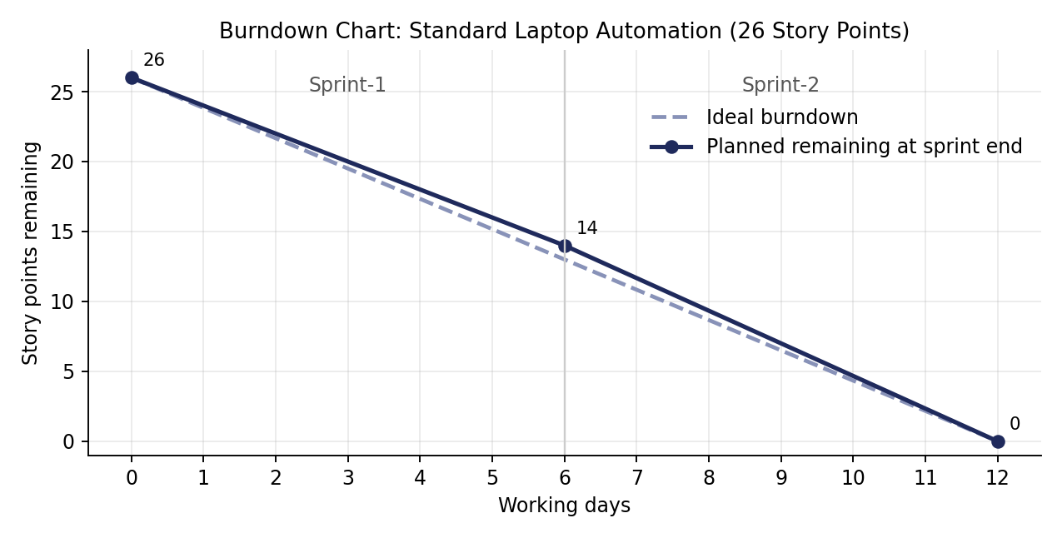
Figure 3: Planned burndown for the 26 story points over two 6-day sprints

6. Functional and Performance Testing

6.1 Performance Testing
This section follows the User Acceptance Testing (UAT) template. Results in the table come from the order, approval and verification run documented in Section 7 (REQ0010001, RITM0010001, SCTASK0010001).

Project Overview
Project Name | Streamlining IT Procurement: Automating Standard Laptop Orders with Flow Designer
Project Description | Flow Designer automation that creates a Catalog Task for the Hardware team when a Standard Laptop is ordered.
Project Version | 1.0
Testing Period | Planned within Sprint-2 (26 Apr 2026 to 27 Apr 2026)
Team ID | SWTID-2026-4357

Testing Scope
- Features: flow creation and activation, flow assignment to the catalog item, catalog ordering, approval, automatic catalog task creation.
- User stories tested: USN-1 to USN-10 (see Section 3.3).

Testing Environment
URL / Location | ServiceNow instance (Flow Designer, Maintain Items, Service Catalog)
Credentials | Administrator account used for the run; approver account as defined on the request. Credentials are not recorded in this document.

Test Cases
Test Case ID | Test Scenario | Test Steps | Expected Result | Actual Result | Pass / Fail
TC-001 | Create and activate the flow | 1. Open Flow Designer > New > Flow  2. Name it “Standard Laptop task”, Global, Run as System User  3. Add Service Catalog trigger and Create Catalog Task action  4. Save and Activate | Flow status shows Active. | Flow listed and shown as Active. | Pass
TC-002 | Assign flow to the catalog item | 1. Open Maintain Items > Standard Laptop  2. Open Process Engine tab  3. Set Flow to the created flow and save | Flow field shows “Standard Laptop task”; Workflow and Execution Plan empty. | Flow field shows Standard Laptop task. | Pass
TC-003 | Place an order | 1. Service Catalog > Hardware > Standard Laptop  2. Click Order Now | Order Status page shows “Thank you, your request has been submitted” with a REQ number. | Request REQ0010001 submitted. | Pass
TC-004 | Approve the request | 1. Open the REQ from Order Status  2. Open the Approvers tab  3. Right-click the record > Approve | Approval state changes to Approved. | Approval recorded for REQ0010001. | Pass
TC-005 | Catalog Task is created automatically | 1. Open the Requested Item (RITM)  2. Scroll to Catalog Tasks | One catalog task for the item, assigned to Hardware. | SCTASK0010001 listed under RITM0010001, group Hardware. | Pass
TC-006 | Check task field values | 1. Open the Catalog Task  2. Check short description, description, assignment group, approval | Short description and Description “Laptop needs to Configured”; Assignment group Hardware; Approval Approved. | Values as expected. | Pass
TC-007 | Negative: request is rejected (recommended) | 1. Place a new order  2. Reject the approval  3. Check Catalog Tasks | Behaviour to be confirmed with the business (see BG-003). | Not yet executed. | Not tested
TC-008 | Negative: a different catalog item is ordered (recommended) | 1. Order an item without this flow  2. Check Catalog Tasks | No “Laptop needs to Configured” task is created. | Not yet executed. | Not tested

Bug Tracking
No functional defects were found during the executed run. The items below are observations from reviewing the document and configuration.
Bug ID | Bug Description | Steps to reproduce | Severity | Status | Additional feedback
BG-001 | Task text differs between the build instructions (“Laptop need to Configured”) and the task created (“Laptop needs to Configured”). | 1. Compare the instruction text with the SCTASK | Low | Open | Agree one wording and update the document.
BG-002 | Flow is referred to as “Standard Laptop Task” in one step and “Standard Laptop task” elsewhere. | 1. Compare Milestone 2 text with the flow list | Low | Open | Use one name consistently.
BG-003 | Approval is set to a fixed value (Approved) on the task, and the flow has no step that waits for the request approval. | 1. Review the Create Catalog Task action  2. Review the flow for a wait or approval step | Medium | Open | Confirm required behaviour; consider a condition or Wait For Condition step (see Future Scope).

Sign-off
Tester Name
Date
Signature
Sign-off from the project manager and product owner is required before deployment.

6.2 UAT Execution Report
Purpose of document. This section summarises test coverage and open issues for the Standard Laptop task automation at the time of release to User Acceptance Testing.

Defect Analysis
Number of observations by severity and resolution (from the Bug Tracking table).
Resolution | Severity 1 | Severity 2 | Severity 3 | Severity 4 | Subtotal
Fixed | 0 | 0 | 0 | 0 | 0
Open (observation) | 0 | 0 | 1 | 2 | 3
Won’t Fix | 0 | 0 | 0 | 0 | 0
Totals | 0 | 0 | 1 | 2 | 3

Test Case Analysis
Section | Total Cases | Not Tested | Fail | Pass
Flow configuration (TC-001, TC-002) | 2 | 0 | 0 | 2
Ordering and approval (TC-003, TC-004) | 2 | 0 | 0 | 2
Automatic task creation (TC-005, TC-006) | 2 | 0 | 0 | 2
Negative scenarios (TC-007, TC-008) | 2 | 2 | 0 | 0
Totals | 8 | 2 | 0 | 6

7. Results

7.1 Output Screenshots
This section records the procedure followed in each milestone, together with the screen captures from the project run.

Milestone 1: Flow
Activity 1: Create a flow that creates a Catalog Task, updates the short description after approval of the service request, and assigns the task to the Hardware group.
Create the flow:
- Open ServiceNow.
- Click All and search for Flow Designer.
- Click Flow Designer under Process Automation.
- In Flow Designer, click New and select Flow.
- In Flow properties, enter the Flow name “Standard Laptop task”.
- Set Application to Global.
- Set Run As to System User.
- Click Submit.
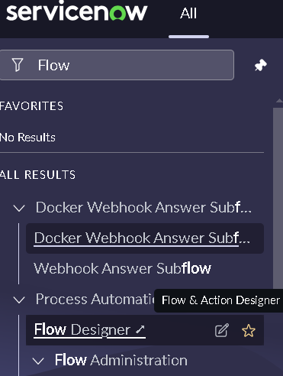
Figure 4: Opening Flow Designer from the All menu
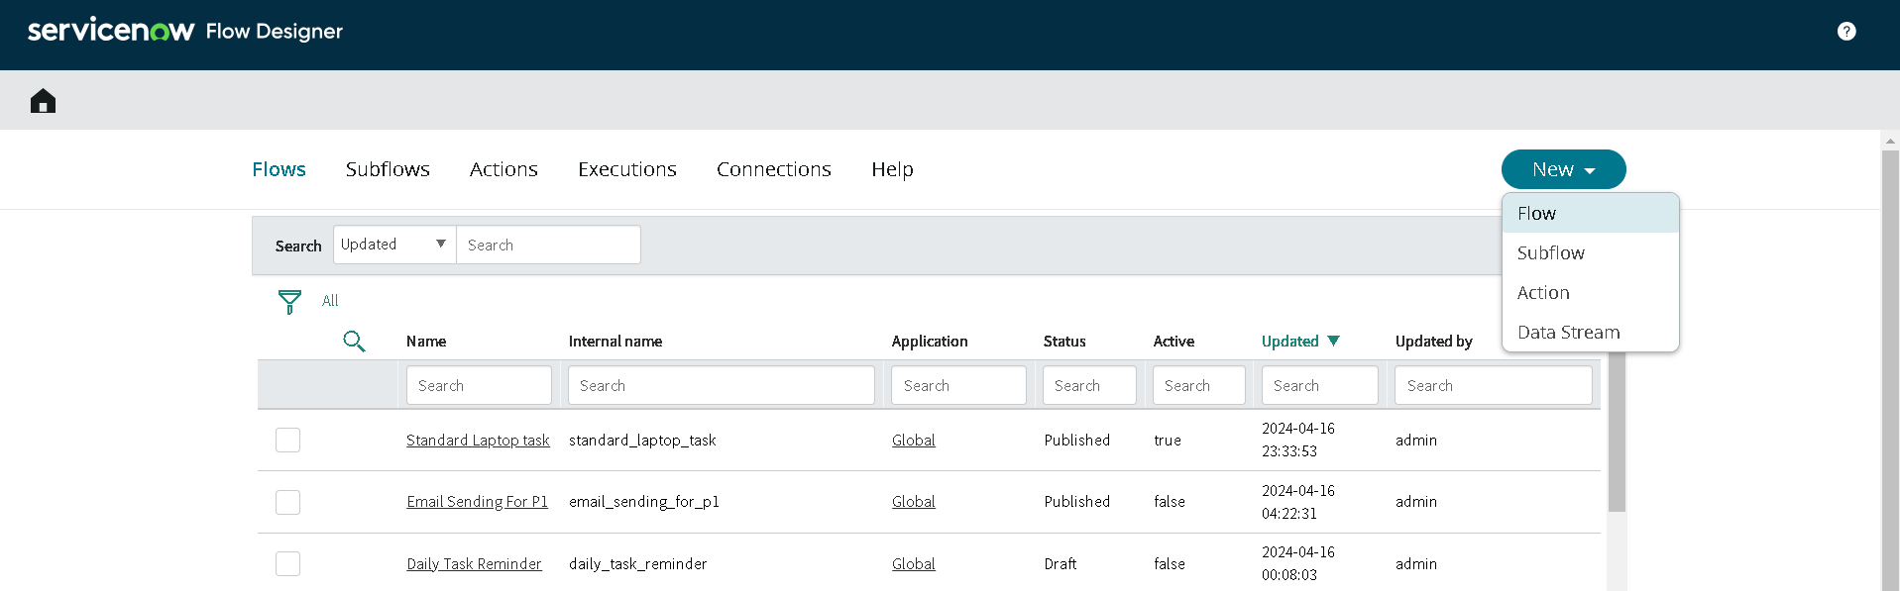
Figure 5: Flow Designer: New > Flow
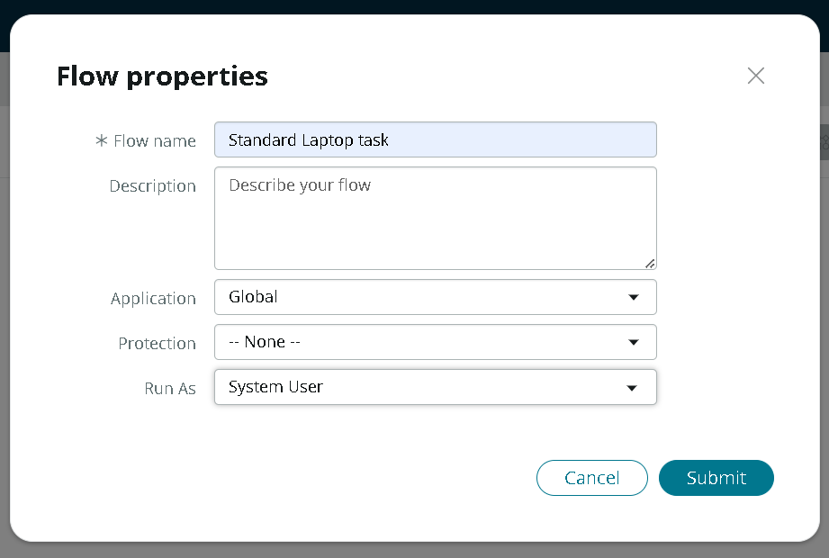
Figure 6: Flow properties: name, application and Run As
Add the trigger:
- Click Add a trigger.
- Search for “Service Catalog” and select it.
- Click Done.
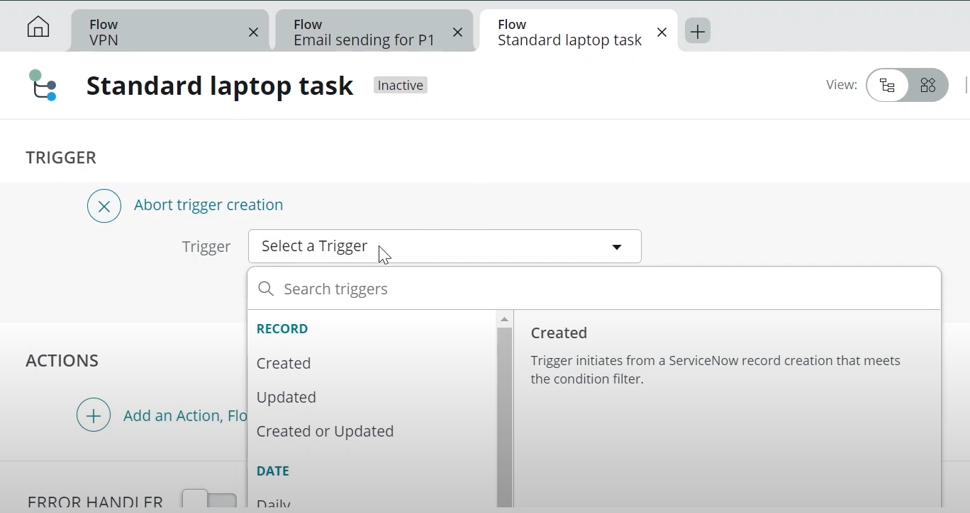
Figure 7: Selecting a trigger
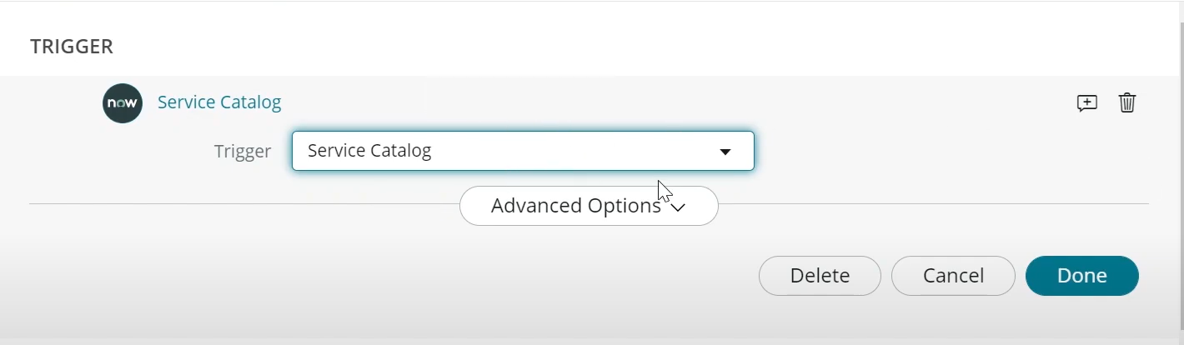
Figure 8: Service Catalog trigger configured
Add the action (under Actions):
- Click Add an action.
- Search for “Create Catalog Task” and select it.
- Set Action to Create Catalog Task.
- Drag and drop the Requested Item Record from the trigger into the Request Item field. The table is auto-populated as Catalog Task.
- Enter the short description “Laptop need to Configured” (shown as “Laptop needs to Configured” in the screenshots).
- Click Add field value and add: Description = Laptop needs to Configured; Assignment group = Hardware; Approval = Approved.
- Leave the remaining fields as default and click Done.
- Click Save, then Activate, and confirm Activate again.
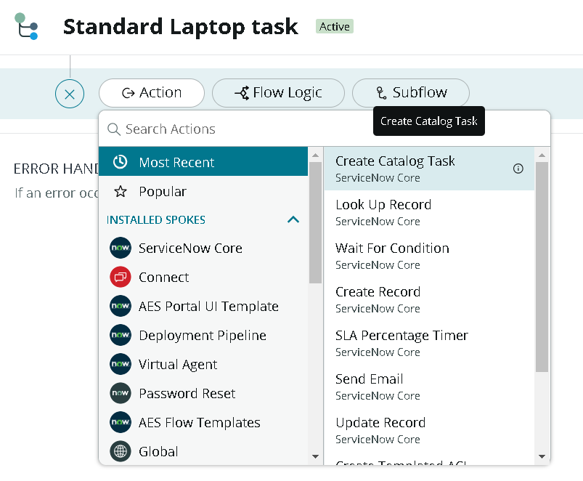
Figure 9: Selecting the Create Catalog Task action
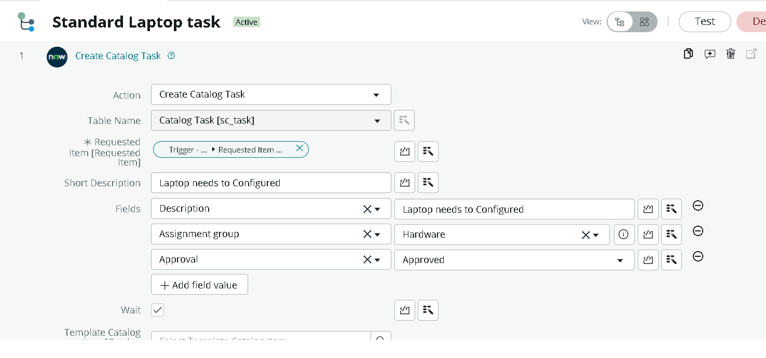
Figure 10: Create Catalog Task action: short description, description, assignment group and approval
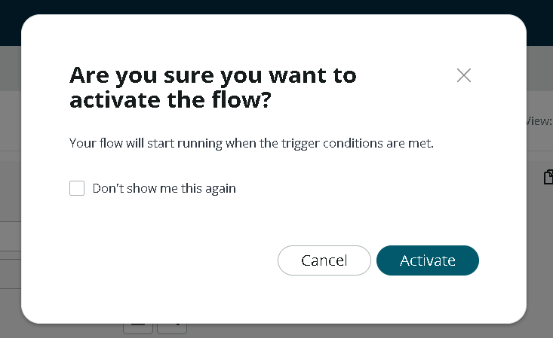
Figure 11: Activate flow confirmation

Milestone 2: Flow assignment
Activity 1: Assign the flow to the Standard Laptop service catalog item.
- Open ServiceNow.
- Click All and search for Maintain Items; select it.
- In the Name field, search for Standard Laptop and open that record.
- Open the Process Engine tab.
- Remove the remaining automations and add Flow.
- Select the flow created earlier, Standard Laptop task.
- Use the form menu to save the record.
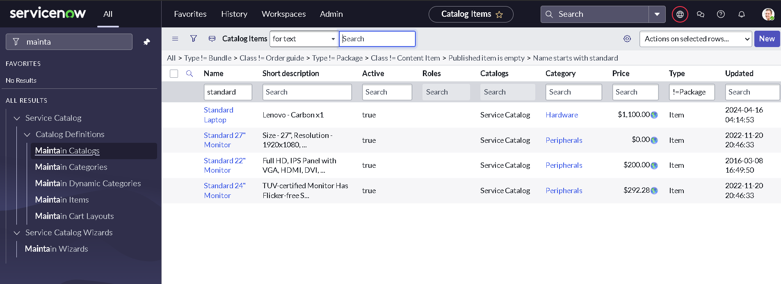
Figure 12: Maintain Items: locating the Standard Laptop catalog item
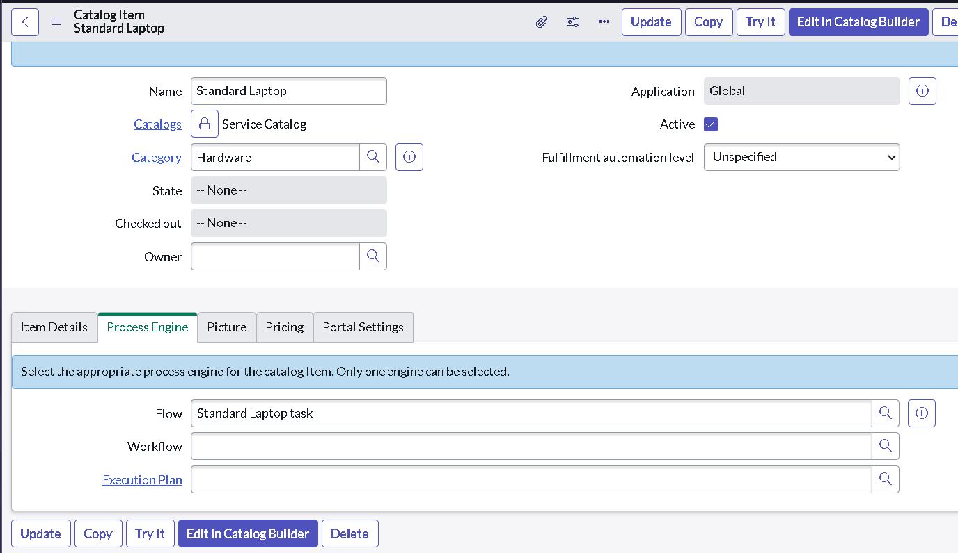
Figure 13: Process Engine tab with the flow assigned to the catalog item

Milestone 3: Service Catalog
Activity 1: Place the order through the Service Catalog and approve it.
- Click All and search for Service Catalog.
- Click Service Catalog, then Hardware.
- Scroll to Standard Laptop and click it.
- Click Order Now to place the request.
- View the Order Status page.
- Click the Request Number; the request record opens.
- Scroll down and open the Approvers section.
- Right-click the record and select Approve.
- Open the Requested Item section and then the Requested Item record.
- Scroll to Catalog Tasks and open the task to see the short description and assignment group.
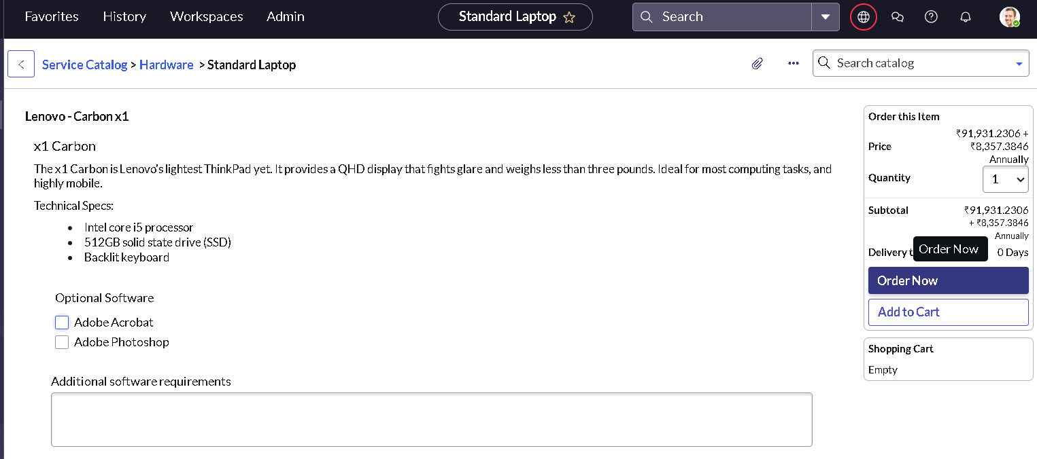
Figure 14: Standard Laptop item page with Order Now
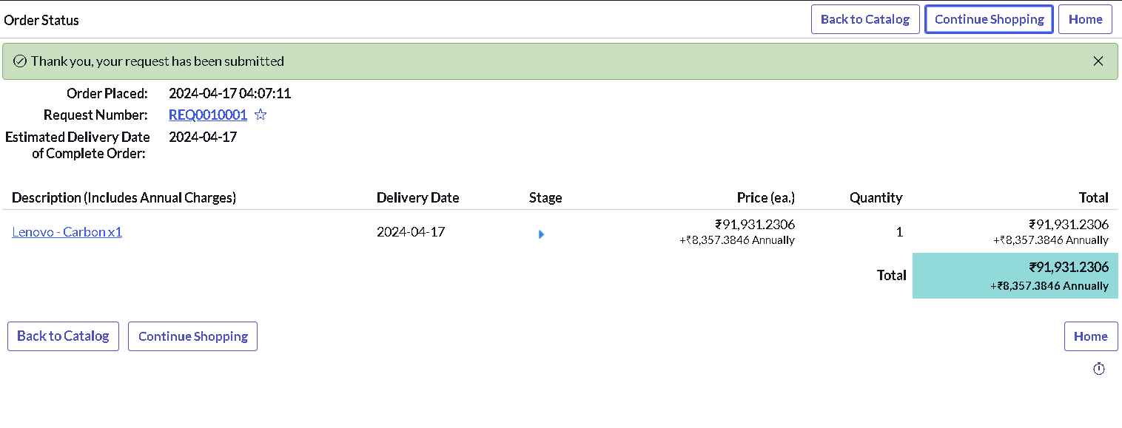
Figure 15: Order Status page showing request REQ0010001
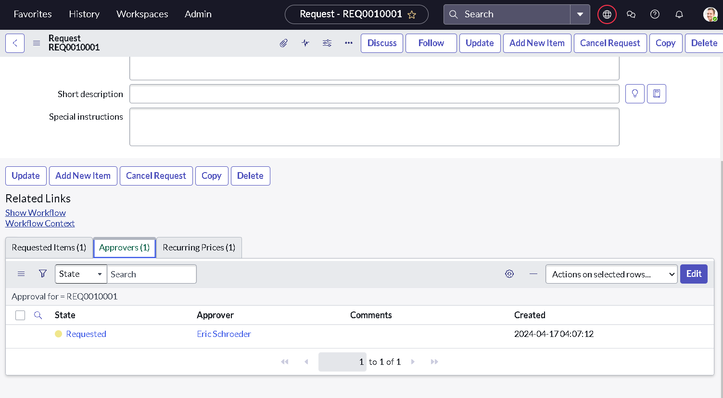
Figure 16: Request record: Approvers tab
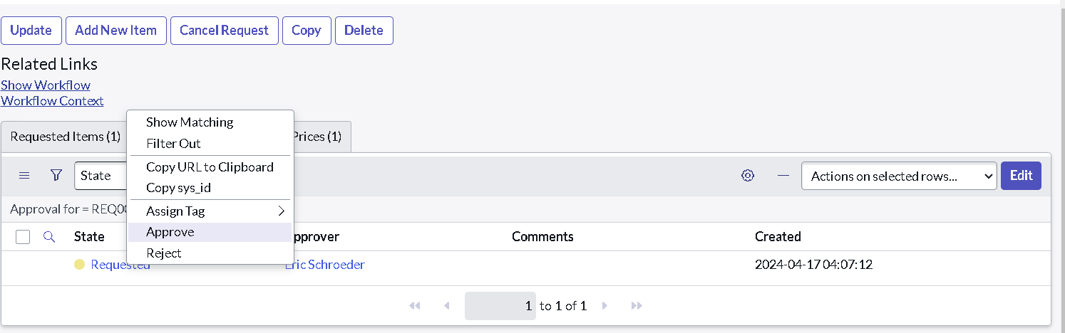
Figure 17: Approving the request from the Approvers list
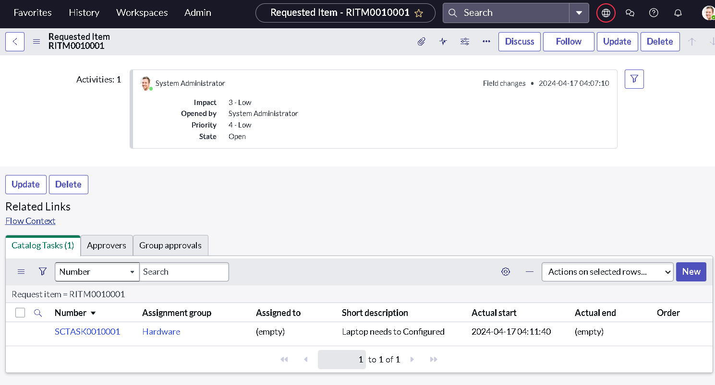
Figure 18: Requested Item RITM0010001: Catalog Tasks tab with SCTASK0010001 assigned to Hardware
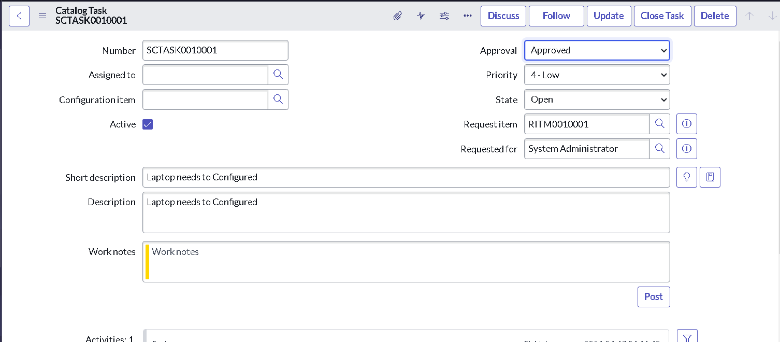
Figure 19: Catalog Task SCTASK0010001: short description, description and approval

Result summary
Check | Result
Flow “Standard Laptop task” created and activated | Achieved
Flow attached to Standard Laptop catalog item | Achieved
Order placed and request approved | Achieved (REQ0010001)
Catalog task generated automatically | Achieved (SCTASK0010001 under RITM0010001)
Task assigned to Hardware with short description “Laptop needs to Configured” | Achieved

8. Advantages & Disadvantages

Advantages
- The configuration task is created for every Standard Laptop request without anyone raising it by hand.
- Tasks go straight to the Hardware group, so workload is allocated consistently.
- Task wording is the same every time, which removes ambiguity.
- Built with low-code configuration (no scripting), so it is quick to build and easy to maintain.
- The pattern can be reused for other catalog items.
- Reduces user waiting time and manual errors, improving the overall procurement experience.

Disadvantages
- Task text, assignment group and approval value are fixed in the action; any change needs the flow to be edited.
- As configured, the flow has no explicit wait or condition tied to the approval outcome, so rejected requests need separate handling.
- No notifications are sent to the requester or the hardware team beyond the task appearing in the queue.
- Covers only the configuration task; it does not track the physical order, delivery or stock.
- Depends on the ServiceNow instance and on correct flow assignment in the catalog item’s Process Engine.

9. Conclusion
By automating the standard laptop procurement process with ServiceNow Flow Designer, the project addresses inefficiencies and reduces manual overhead. The workflow creates a Catalog Task for the Hardware team for each Standard Laptop request, which supports timely configuration of laptops, reduces user waiting time and improves productivity within the IT department.
The solution was built in three milestones (flow, flow assignment and service catalog ordering) and verified with a full test run from order (REQ0010001) to the generated task (SCTASK0010001). Optimising task allocation and giving users a smoother procurement experience meets the four objectives set out in Section 1.2.

10. Future Scope
- Add a condition or Wait For Condition step so the task is created only after the request is approved, and define what happens on rejection.
- Send notifications (Send Email action) to the requester and the Hardware team when the task is created and when it is closed.
- Assign the task to a named technician using rules for workload or location.
- Add SLA timers on the configuration task and track time to configure.
- Extend the pattern to other catalog items such as monitors, docking stations and peripherals.
- Use catalog variables (for example the optional software choices on the item) to add software installation instructions to the task.
- Report on request-to-ready time with dashboards.
- Complete the negative-scenario test cases (TC-007, TC-008).

11. Appendix

A. Setup prerequisites
- A ServiceNow instance with Flow Designer and the Service Catalog available.
- An account with rights to create and activate flows, edit catalog items (Maintain Items) and approve requests.
- An active Standard Laptop catalog item in the Hardware category, and a Hardware assignment group.

B. Record references from the test run
Record type | Number / value
Request | REQ0010001
Requested Item | RITM0010001
Catalog Task | SCTASK0010001
Flow | Standard Laptop task (Global, Run as System User, status Active)
Catalog item | Standard Laptop (Category: Hardware)

C. Source code
Not applicable. The solution is configured in Flow Designer and does not use custom source code.

D. Dataset link
Not applicable.

E. GitHub & project demo link
GitHub link: https://github.com/harinikarpagam/Naan-Mudhalvan-Project-.git
Demo link : https://drive.google.com/file/d/1xW0pWRzXD4tLWA7H4t9wioQvbrZqICd-/view?usp=drive_link\

