

Title: Intelligent Energy Consumption Analytics for Smart Buildings.

Domain
Energy Analytics
Smart Buildings
Machine Learning
Data Analytics

Dataset
I recommend using three benchmark datasets together:
1. Energy Efficiency Dataset (UCI Machine Learning Repository)
https://archive.ics.uci.edu/dataset/242/energy+efficiency
2. Appliances Energy Prediction Dataset (UCI Machine Learning Repository)
https://archive.ics.uci.edu/dataset/374/appliances+energy+prediction
3. ASHRAE – Great Energy Predictor III Dataset
https://www.kaggle.com/competitions/ashrae-energy-prediction
All three are well-known benchmark datasets and should be considered in this project. Together they provide information about building characteristics, weather conditions, appliance-level energy usage, and commercial building energy consumption.

Abstract
The increasing demand for energy and the rapid growth of smart buildings have made efficient energy management an important research area in sustainable development. Traditional energy monitoring systems mainly provide historical reports and are unable to accurately predict future energy consumption or identify hidden usage patterns. This project proposes an Intelligent Energy Consumption Analytics framework by integrating Exploratory Data Analysis (EDA), machine learning, and predictive analytics.
The framework utilizes the Energy Efficiency Dataset, Appliances Energy Prediction Dataset, and ASHRAE Great Energy Predictor III Dataset. Data preprocessing includes missing value handling, duplicate removal, encoding, outlier detection, and normalization. EDA includes dataset overview, descriptive statistics, missing value analysis, outlier analysis, univariate, bivariate and multivariate analysis, correlation analysis, feature engineering and feature selection.
Multiple regression models including Linear Regression, Decision Tree Regressor, Random Forest Regressor, XGBoost Regressor and CatBoost Regressor are trained and evaluated using MAE, MSE, RMSE and R² Score. Results are visualized through heatmaps, boxplots, correlation matrices, trend graphs, feature importance plots and dashboards. Comparative analysis identifies the most suitable model for accurate energy prediction, supporting sustainable smart building management and informed decision-making.

Approach
Data Analytics
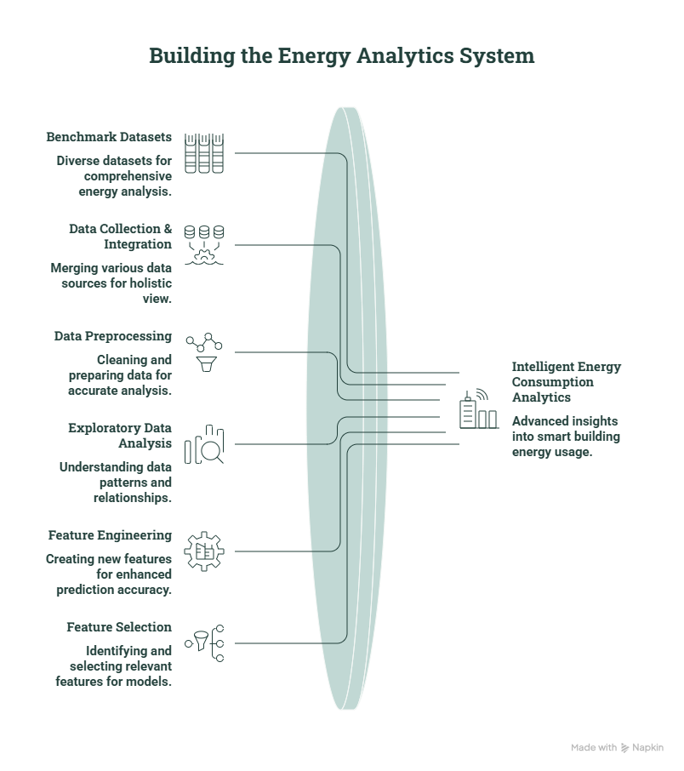

EDA Flow
Raw Dataset
↓
Dataset Overview
↓
Data Quality Assessment
↓
Descriptive Statistics
↓
Missing Values
↓
Duplicate Records
↓
Outlier Detection
↓
Univariate Analysis
↓
Bivariate Analysis
↓
Multivariate Analysis
↓
Correlation Analysis
↓
Energy Consumption Trend Analysis
↓
Feature Engineering
↓
Feature Selection
↓
Machine Learning Models

Preprocessing
• Missing Value Handling
• Duplicate Record Removal
• Outlier Detection
• Feature Encoding
• Normalization / Feature Scaling
• Date-Time Feature Extraction

ML Models
• Linear Regression
• Decision Tree Regressor
• Random Forest Regressor
• XGBoost Regressor
• CatBoost Regressor

Visualization
• Heatmap
• Boxplot
• Correlation Matrix
• Energy Consumption Trend Graphs
• Feature Importance Plot
• Dashboard

Comparative Analysis
Compare:
• Linear Regression
• Decision Tree Regressor
• Random Forest Regressor
• XGBoost Regressor
• CatBoost Regressor
Metrics:
• MAE
• MSE
• RMSE
• R² Score

Research Pipeline
Benchmark Dataset
↓
Data Cleaning
↓
EDA
↓
Feature Engineering
↓
Feature Selection
↓
Train-Test Split
↓
Machine Learning Models
↓
Performance Evaluation (MAE, MSE, RMSE, R²)
↓
Energy Consumption Prediction
↓
Visualization Dashboard
↓
Comparative Analysis
↓
Research Conclusions

BATCH: 20
HARINI - 2420030296
VARSHA- 2420030297
SHAILAJA-2420030447

